Ballads and Songs

Collected by the
MISSOURI FOLK-LORE SOCIETY

Edited by

H. M. BELDEN

THE UNIVERSITY OF MISSOURI PRESS
COLUMBIA

BALLADS AND SONGS
Collected by the Missouri Folk-Lore Society

Edited by

H. M. Belden

University of Missouri Studies
Volume XV, Number I

University of Missouri Press
Columbia

First Edition 1940
Second Edition 1955
Reprint 1966

L. C. Card Number
55-7519

To the Memory of
MARY ALICIA OWEN
1858-1935
Honorary Member of the British Folk-Lore Society
Councillor and Life Member of the American Folk-Lore Society
President of the Missouri Folk-Lore Society 1908-35
and to
the members of the Missouri Folk-Lore Society
and the friends of the editor who have made this publication possible

TABLE OF CONTENTS
Page Page
Foreword . . . . . . . . . . . . . . . . . . . . . | ix | The Oxford Girl . . . . . . . . . . . . . . . | 133
Author's Preface . . . . . . . . . . . . . | xi | The Rambling Boy . . . . . . . . . . . . . | 136
Abbreviations . . . . . . . . . . . . . . . . . | xvi | The Banks of Dundee . . . . . . . . . . | 137
The Elfin Knight . . . . . . . . . . . . . | 1 | Fair Fanny Moore . . . . . . . . . . . . . | 139
The False Knight upon the Road | 4 | The Fatal Wedding . . . . . . . . . . . . | 141
Lady Isabel and the Elf-Knight. . . | 5 | Little Mohea . . . . . . . . . . . . . . . . . . | 143
The Two Sisters. . . . . . . . . . . . . . . | 16 | The Isle of St. Helena . . . . . . . . . . | 146
Lord Randal . . . . . . . . . . . . . . . . . . | 24 | Wilkins and Dina . . . . . . . . . . . . | 147
Sir Lionel . . . . . . . . . . . . . . . . . . . . . | 29 | A Sweetheart in the Army . . . . . . | 148
The Three Ravens . . . . . . . . . . . . . . | 31 | The Mantle of Green . . . . . . . . . . . | 151
The Two Brothers . . . . . . . . . . . . . . | 33 | Mary and Willie . . . . . . . . . . . . . . . | 152
Young Hunting . . . . . . . . . . . . . . . | 34 | The Banks of Claudy . . . . . . . . . . . | 154
Lord Thomas and Fair Annet . . . . | 37 | Johnny German . . . . . . . . . . . . . . . | 155
Fair Margaret and Sweet William | 48 | William Hall . . . . . . . . . . . . . . . . . | 156
Lord Lovel . . . . . . . . . . . . . . . . . . . . | 52 | Green Beds . . . . . . . . . . . . . . . . . . | 160
The Lass of Roch Royal . . . . . . . . | 55 | Early, Early in the Spring . . . . . . | 163
The Wife of Usher's Well . . . . . . . | 55 | Charming Beauty Bright . . . . . . . | 164
Little Musgrave and Lady Barnard | 57 | The Faultless Bride . . . . . . . . . . | 165
Barbara Allen . . . . . . . . . . . . . . . . . | 60 | The Lover's Lament for her Sailor | 167
The Maid Freed from the Gallows | 66 | Locks and Bolts . . . . . . . . . . . . . . . | 168
The Bailiff's Daughter of Islington | 68 | Pretty Peggy O . . . . . . . . . . . . . . | 169
Sir Hugh, or The Jew's Daughter | 69 | King David Had a Pleasant Dream | 170
The Gypsy Laddie . . . . . . . . . . . . . | 73 | Jack Munro . . . . . . . . . . . . . . . . . | 171
Geordie . . . . . . . . . . . . . . . . . . . . . . . | 76 | Lisbon . . . . . . . . . . . . . . . . . . . . . . . | 177
The False Lover Won Back . . . . . . | 78 | The Lady Leroy . . . . . . . . . . . . . . . | 180
James Harris (The Daemon Lov- er) . . . . . . . . . . . . . . . . . . . . . . . . . | 79 | William Taylor . . . . . . . . . . . . . . . .  Polly Oliver . . . . . . . . . . . . . . . . . . . | 182  183
Henry Martin . . . . . . . . . . . . . . . . | 87 | The Sailor Boy . . . . . . . . . . . . . . . . | 186
Our Goodman . . . . . . . . . . . . . . . . . | 89 | The Rambling Beauty . . . . . . . . . . | 191
The Wife Wrapt in Wether's Skin | 92 | Last Friday Evening . . . . . . . . . . . | 194
The Farmer's Curst Wife . . . . . . . | 94 | I'm Despised for Being Poor . . . . | 194
The Golden Vanity . . . . . . . . . . . . | 97 | The Lonesome Scenes of Winter . . | 195
The Mermaid . . . . . . . . . . . . . . . . . . | 101 | Wounded Spirit . . . . . . . . . . . . . . | 196
Jesus and Joses . . . . . . . . . . . . . . . . | 102 | Courting too Slow . . . . . . . . . . . . . | 196
The Soldier's Wooing . . . . . . . . . . | 103 | Time Enough Yet . . . . . . . . . . . . . . | 197
The Greenland Whale Fishery . . . | 104 | Peggy Walker . . . . . . . . . . . . . . . . | 198
The Babes in the Wood . . . . . . . . . | 106 | The Maid of Prairie du Chien . . . | 201
The Maid on the Shore . . . . . . . . . | 107 | The Butcher Boy . . . . . . . . . . . . . . | 201
The Bramble Briar . . . . . . . . . . . . | 109 | Mary of the Wild Moor . . . . . . . . . | 207
A Brave Irish Lady . . . . . . . . . . . .  Bedroom Window (The Drowsy | 111 | All on Account of a Bold Lover  Gay . . . . . . . . . . . . . . . . . . . . . . . . | 208
Sleeper) . . . . . . . . . . . . . . . . . . . . . . | 118 | Fond Affection . . . . . . . . . . . . . . . . | 209
The Silver Dagger . . . . . . . . . . . . | 123 | Birdie Darling . . . . . . . . . . . . . . . | 210
Mary in the Silvery Tide . . . . . . . | 126 | Thou Hast Learned to Love An-
Edwin in the Lowlands Low. . . . . . 127 |  | other . . . . . . . . . . . . . . . . . . . . . . | 211
The Flying Cloud . . . . . . . . . . . . . . 128 |  | Ella Lea . . . . . . . . . . . . . . . . . . . . . | 211
The Sheffield Apprentice . . . . . . . . . 131 |  | The Broken Engagement . . . . . . . | 212
The Lily of the West . . . . . . . . . . . 132
(v)

vi
Page
The Finished Letter. . . . . . . . . . . 213
Katie's Secret . . . . . . . . . . . . . . . . 215
Faded Flowers . . . . . . . . . . . . . . . 216 The Dying Girl's Message . . . . . . . 217
The Dying Nun . . . . . . . . . . . . . . . 218
Little Rosewood Casket . . . . . . . . 220
The Old Elm Tree . . . . . . . . . . . . . 221
Lorena . . . . . . . . . . . . . . . . . . . . . . 222
Annie of the Vale . . . . . . . . . . . . . 222
Lovana . . . . . . . . . . . . . . . . . . . . . . 223
The Derby Ram . . . . . . . . . . . . . . . . 224
Father Grumble . . . . . . . . . . . . . . . . 225
Dog and Gun ( The Golden Glove) . 229
Kate and Her Horns . . . . . . . . . . . . 231
Love in the Tub . . . . . . . . . . . . . . . . 233
The Gray Mare . . . . . . . . . . . . . . . . 235
Johnny Sands . . . . . . . . . . . . . . . . . 237
The. Nightingale . . . . . . . . . . . . . . . 239
The Miller and His Three Sons . . . 244
Three Jolly Welshmen . . . . . . . . . . 246
Courting the Widow's Daughter . . . 248
The Monkey Turned Barber . . . . . . 249
Billy Grimes . . . . . . . . . . . . . . . . . . 251
Looking for Poppies . . . . . . . . . . . | 252 | The Texas Rangers . . . . . . . . |  | 336
Billy Barlow . . . . . . . . . . . . . . . . . . | 253 | Davy Crockett . . . . . . . . . . . . . . | 339
What's the Matter Now? . . . . . . . . . | 255 | Plains of Mexico . . . . . .. . . . . . . |  | 340
Old Rosin the Beau . . . . . . . . . . . . | 255 | Buena Vista . . . . . . . . . . . . . . |  | 340
At the Sign of the Apple . . . . . . . . | 258 | The Campaign of 1856 . . . . |  | 341
Old Grimes is Dead . . . . . . . . . . . . | 258 | Joe Bowers . . . . . . . . . . . . . . . . |  | 341
Prentice's Drinking Song . . . . . . . . | 259 | Betsy from Pike . . . . . . . . . . . . . |  | 343
The Little Brown Jug . . . . . . . . . . . | 261 | I’ve Just Got in Across the Plains |  | 345
I Wouldn’t Marry . . . . . . . . . . . . . . | 262 | When I Left the States for Gold |  | 347
The Old Bachelor . . . . . . . . . . . . . . The Old Man's Courtship . . . . . . . | 263  264 | Gold . . . . . . . . . . . . . . . . . . . . .  Come All Ye Poor Men of the |  | 347
The Quaker's Wooing . . . . . . . . . . . | 265 | North . . . . . . . . . . . . . . . . . . . . |  | 348
Hard of Hearing . . . . . . . . . . . . . . . | 265 | The Dreary Black Hills . . . . . . . |  | 349
Mother and Daughter . . . . . . . . . . . | 266 | The Dying Californian . . .. . . . . |  | 350
I Won't Be a Nun . . . . . . . . . . . . . . | 266 | The Rolling Stone . . . . . . . . . . . |  | 351
The Three Rogues . . . . . . . . . . . . . . | 268 | The Call of Quantrell . . . .. . . . . . |  | 353
The Carrion Crow . . . . . . . . . . . . . . | 270 | Blackfoot Rangers . . . . . . . . . . . |  | 354
The Jolly Miller . . . . . . . . . . . . . . . | 271 | Sterling Price . . . . . . . . . . . . . . |  | 355
A Farmer's Boy . . . . . . . . . . . . . . . | 272 | Kelley's Irish Brigade . . . . . . . . |  | 355
A Soldier’s Poor Little Boy . . . . . . | 273 | Old Honest Abe . . . . . . . . . . . . . |  | 356
The Blind Child . . . . . . . . . . . . . . . | 275 | The Bonny Blue Flag . . . . . . . . |  | 357
The Orphan Girl . . . . . . . . . . . . . . . | 277 | The Southern Oath . . . . . . . |  | 359
The Orphan . . . . . . . . . . . . . . . . . | 278 | The Homespun Dress . . . . . . . . . . |  | 360
Put Me in My Little Bed . . . . . . . . | 279 | Root, Abe, or Die . . . . . . . . . . . . . |  | 361
Over the Hills at the Poorhouse . . . | 280 | Joe Slinsworth . . . . . . . . . . . . . . . . |  | 362
Shule Aroon . . . . . . . . . . . . . . . . . . | 281 | Happy Land of Canaan . . . . . . |  | 363
Erin's Green Shore. . . . . . . . . . . . . | 282 | The Southern Wagon . . . . . . . . . . |  | 364
The Croppy Boy . . . . . . . . . . . . . . . | 283 | The War in Missouri in '61 . . . . . . |  | 366
Brennan on the Moor . . . . . . . . . . . | 284 | The Battle of Elkhorn Tavern . . |  | 368
Page
Rinordine . . . . . . . . . . . . . . . . . . . 286
William Riley . . . . . . . . . . . . . . . . 289 Joe Jimmy Murphy . . . . . . . . . . . 291
The Irish Girl . . . . . . . . . . . . . . . . 292 Paddy Darry . . . . . . . . . . . . . . . 293
Uncle Tahiah . . . . . . . . . . . . . . . . 294 War Song of the Revolution . . . . 295
James Bird . . . . . . . . . . . . . . . . . . 296 Andrew Jackson's Raid . . . . . . . . 297
The Hunters of Kentucky . . . . . . . 298
Springfield Mountain . . . . . . . . . . 299
The Waggoner . . . . . . . . . . . . . . . 300
The Wagoners . . . . . . . . . . . . . . . 301
Fuller and Warren . . . . . . . . . . . . 302
Young Charlotte . . . . . . . . . . . . . 308
McAfee 's Confession . . . . . . . . . 317
Henry Green . . . . . . . . . . . . . . . . . 321
Oma Wise . . . . . . . . . . . . . . . . . . 322
Florella (The Jealous Lover) . . . . . 324
Frankie and Albert . . . . .. . . . . . . . 330
Root Hog or Die . . . .. . . . . . . . . . . 334
Harrison Campaign Song . . . . . . . . 335
When This Old Hat was New . . . . . 336

TABLE OF CONTENTS
vii
Page Page
Victorious March . . . . . . . . . . . . .  Late Battle in the West . . . . . . . . .  The Goose Hangs High . . . . . . . . .  Give the Dutch Room . . . . . . . . . .  The Guerrilla Boy . . . . . . . . . . . . .  Brother Green . . . . . . . . . . . . . . . .  The Husband's Departure . . . . . . .  The Yankee Man of War . . . . . . . .  Fare You Well, My Darling . . . . .  When This Cruel War is Over . . . .  The Flag with the Thirty-Four Stars  The Last Fierce Charge . . . . . . . . .  The Lone Prairie . . . . . . . . . . . . . .  The Unfortunate Rake . . . . . . . . .  The Dying Cowboy . . . . . . . . . . . .  Cowboy's Challenge . . . . . . . . . . . .  Sam Bass . . . . . . . . . . . . . . . . . . . . .  Jesse James . . . . . . . . . . . . . . . .  The Meeks Family Murder . . . . . .  Charles Guiteau . . . . . . . . . . . . . . .  Maxwell's Doom . . . . . . . . . . . . . .  Jim Fisk . . . . . . . . . . . . . . . . . . . . . .  Martha Dexter . . . . . . . . . . . . . . . .  Harry Bale . . . . . . . . . . . . . . . . . . .  The Iron Mountain Baby . . . . . . .  The Brush Creek Wreek . . . . . . . .  The Chatsworth Wreck . . . . . . . . .  The Burning of the Bayou Sara . . .  Bill Stafford . . . . . . . . . . . . . . . . . .  Texan Boys . . . . . . . . . . . . . . . . . . .  Kansas . . . . . . . . . . . . . . . . . . . . . .  Comical Ditty . . . . . . . . . . . . . . . . .  The Good Old Days of Adam and  Eve . . . . . . . . . . . . . . . . . . . . . . . . .  The Lords of Creation . . . . . . . . . .  Song of the Times . . . . . . . . . . . . . .  The Beaver Cap . . . . . . . . . . . . . . .  Sim and the Widow . . . . . . . . . . . .  When I Was Single . . . . . . . . . . . .  The Young Man who Wouldn't Hoe his Corn . . . . . . . . . . . . . . . . . . . . .  The Juice 'Of the Forbidden Fruit .  Calomel . . . . . . . . . . . . . . . . . . . . .  The Steam Doctor . . . . . . . . . . . . .  The Farmer and the Shanty Boy . .  The Old Section Boss . . . . . . . . . .  The Blind Fiddler . . . . . . . . . . . . .  The Little Family . . . . . . . . . . . . .  Moses in the Bulrushes . . . . . . . .  The Romish Lady . . . . . . . . . . . .  O Adam . . . . . . . . . . . . . . . . . . . . | 369 | The Cap-Stone . . . . . . . . . . . . . . | 457
 | 371 | The Promised Land . . . . . . . . . . . 457
 | 372 | The Wicked Girl . . . . . . . . . . . . 460
 | 373 | Death is a Melancholy Call . . . . 464
 | 374 | Mourning Souls . . . . . . . . . . . . . . . 466
 | 377 | A Wife Bereaved of her Husband . . 467
 | 378  379  380  381  382  383  387  392  397  399  399  401  404  412  413  415  417  418  419  421  422  423  424  426  428  430  431  432  433  435  436  437  440  441  441  442  443  445  446  447  449  450  455 | The Husband Lamenting the
 |  | Death of the Wife . . . . . . . . . . . . . 467
 |  | The Railroad to Heaven . . . . . . . . . 468
The Drunkard's Doom . . . . . . . . . . 468
The Drunkard's Dream . . . . . . . . . 469
 |  | The Dramdrinker . . . . . . . . . . . . . | 470
 |  | The Gambler . . . . . . . . . . . . . . | 472
 |  | Folk-Lyric . . . . . . . . . . . . . . . . . . | 473
 |  | The Unconstant Lover . . . . . . . . . | 473
 |  | Little Sparrow . . . . . . . . . . . . . . . | 477
 |  | The Blue-Eyed Boy . . . . . . . . . . | 478
 |  | The False True-Lover . . . . . . . . . | 480
 |  | Under the Willow Tree . . . . . . . . | 482
 |  | Under the Willow . . . . . . . . . . . | 484
 |  | Banishment . . . . . . . . . . . . . . . . . | 484
 |  | The Dove . . . . . . . . . . . . . . . . . . | 486
 |  | Poor Stranger a Thousand Miles from Home . . . . . . . . . . . . . . . . . | 487
 |  | Down in the Valley . . . . . . . . . . . | 488
 |  | Bird in the Cage . . . . . . . . . . . . . | 488
 |  | I wish I Was a Little Bird . . . . . . | 489
 |  | Green Grows the Laurel . . . . . . . | 490
 |  | Adieu to Cold Weather . . . . . . . | 491
 |  | Love Me or No . . . . . . . . . . . . . | 493
 |  | Beautiful Light o’er the Sea . . . | 494
 |  | The Frog's Courtship . . . . . . . | 494
 |  | Billy Boy . . . . . . . . . . . . . . . . . . | 499
 |  | Tom Bo-lin . . . . . . . . . . . . . . . . | 501
 |  | Old Woman All Skin and Bone . | 502
 |  | Race of the Terrapin and the Deer | 504
 |  | Zip Coon . . . . . . . . . . . . . . . . . | 505
 |  | Singing Games . . . . . . . . . . . . . | 506
 |  | Madam, I Have Gold and Silver . | 506
 |  | A Paper of Pins . . . . . . . . . . . . . . .  Old Grumbler . . . . . . . . . . . . . . Play-Party Songs . . . . . . . . . . . . . The Twelve Days of Christmas . . . The New Year's 'Sermon' . . . . . . .  French Songs . . . . . . . . . . . . . . . .  La Guignolee . . . . . . . . . . . . . . . .  The Returned Soldier . . . . . . . . . . Mione . . . . . . . . . . . . . . . . . . . . . Chanson de l 'Annee du Coup . . .  Index . . . . . . . . . . . . . . . . . . . . . | 507  509  512  512  514  515  515  517  517  519  521

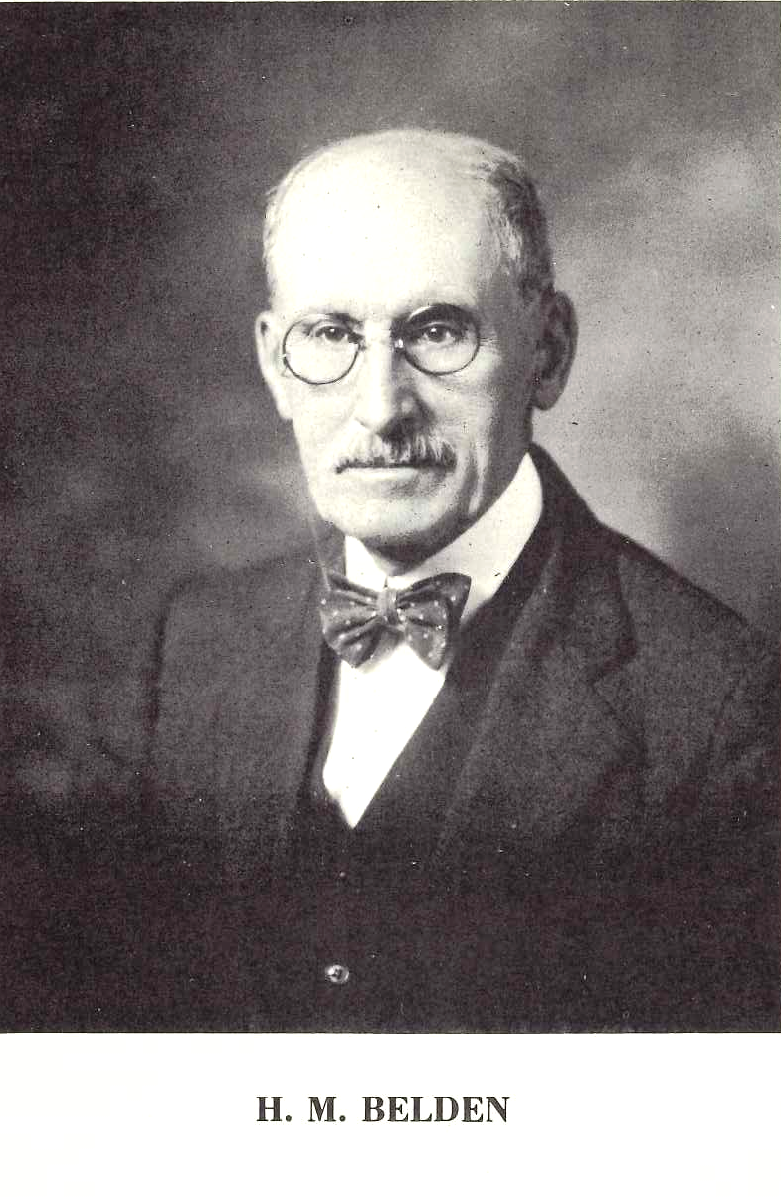

(ix)
FOREWORD

In the fall of 1895 Dr. Henry M. Belden came to the University of Missouri as Assistant Professor of English and thus began a connection with the University which was to last for nearly sixty years and to make him admired and loved by generations of Missouri students. Earlier he had studied at Trinity College, Connecticut, the University of Strassburg, and the Johns Hopkins University, and had taught for short periods at Lehigh University and the University of Nebraska. His teaching career at Missouri ended with his retirement in 1937, but his active interest in the University and in his own research continued undiminished until his death on May 17, 1954.
Few literary scholars have achieved such breadth of learning as Belden; in fact, he may be said to have taken all literary knowledge in his province. Something of his catholicity of interest may be suggested by a partial listing of courses which he taught at Missouri: English Life and Literature, the English Language, Beowulf, Spenser, Donne and His School, the Age of Reason, Dryden, Swift, the Age of Johnson, American Literature, the Popular Ballad, Versification, and Technical Composition. His research covered almost as broad a field and included such diverse subjects as Anglo-Saxon grammar, folklore and the ballads, Restoration and eighteenth-century literature, American literature, and versification. He also edited Shakespeare’s King John and a collection of Coleridge’s works. The extent of his scholarship is only partly indicated by his actual publication, for he was essentially a perfectionist in his research, reluctant to publish until he had exhausted the possibilities of a subject.
Belden’s greatest single scholarly work was without doubt the collection of ballads and folk songs of Missouri, which he edited and which is here being reprinted. First issued in 1940, it gained international recognition and became a model for other state and regional collections. In a very real sense it was a pioneer work. Not only did it record and preserve some 287 Missouri ballads and folk songs, many of them in a number of variant versions, but it also set a pattern for regional ballad collections that has been followed by later editors. There is hardly a recent book on the American ballad that has not acknowledged a substantial debt to his work. Vance Randolph’s four-volume Ozark Folksongs is dedicated to him and generously acknowledges his inspiration and aid.
Belden’s eminence in the field of folklore studies was further indicated by his selection as one of a group of associate editors of the Frank C. Brown Collection of North Carolina Folklore. IN collaboration with Professor A. P. Hudson of the University of North Carolina, Belden edited volume 2, Folk Ballads from North Carolina, and volume 3, Folk Songs from North Carolina, of this collection, which is perhaps the most ambitious recent work in the field of American folklore. These two volumes were published in 1952, when Belden was 85 years old.
Ballads and Songs Collected by the Missouri Folk-Lore Society is in many ways typical of Belden’s scholarship and of his personality. It is marked throughout by his

(x)
meticulous and yet broad and humane scholarship. Interested as he was in the techniques of literature, he was always wise enough to put its human values first. The scope and thoroughness of his work are also characteristic. The actual collection of the ballads and songs began in 1903 and continued for nearly forty years before the book was published. Belden’s work as editor went well beyond the mere reproduction of ballad texts. His introductions and notes give the historical background of the ballads and trace their connections with the English and Scottish ballads edited by Child and the Danish ballads in Grundvig’s monumental collection. It is also significant that Ballads and Songs Collected by the Missouri Folk-Lore Society was a group effort, for one of Belden’s salient characteristics was his ability to inspire enthusiasm for literary study and to share generously any credit arising from it. In all about a hundred persons contributed to the book. In a very real sense it is their book as well as his. He was the first to insist that it was, for he possessed to a marked degree the modesty and generosity of the truly great.
The original printing of the book was sold out soon after its publication, but the demand for copies has continued so consistently that the Committee on University Studies has decided to reissue it. In doing so, it is making a valuable study available to students of folk literature and to persons interested in the history and culture of Missouri.
This foreword would not be complete without a tribute to Belden’s teaching. Few teachers have inspired such admiration and affection among students and colleagues. Not that he courted popularity; on the contrary, he was almost reticent in manner, and the affection he inspired came as a spontaneous tribute to his qualities of heart and mind. Although his most significant research was done in American folklore, he seemed to take unusual pleasure in teaching eighteenth-century English literature, possibly because he felt a spiritual kinship with the great masters of that period. To many of his students and colleagues he seemed to embody the virtues of the eighteenth century at its best: its humanity, clearsightedness, tolerance, and wisdom. His teaching was also marked by an unobtrusive but pervasive and delightful sense of humor. Graduate students developed the habit of listening for the flashes of with and wisdom in his side remarks. Above all, he had the gift of intellectual zest; the pursuit of knowledge was an absorbing adventure that never ceased to fascinate him.
To those of us who had the privilege of knowing and working with Henry Belden the reissue of his major work at this time seems a particularly appropriate memorial to his distinguished teaching and scholarship and to his long and devoted service to the University of Missouri.
The text of this issue is approximately identical with that of the original printing; a very few corrections and additions made by Belden and found in his personal copy have been incorporated.

Edward H. Weatherly

(xi)

AUTHOR’S PREFACE

The collection of traditional songs and ballads here printed is the work almost entirely of persons who were at the time of recording, or had been, students at the University of Missouri. In the spring of 1903, at a meeting of the English Club which I was privileged to attend, a local-color story was read in which one of the characters sang a song that I recognized as one of the old English ballads recorded by Child. Upon inquiry, I was told that many such songs were known and sung by country folk in Missouri. I suggested that it might be worth while to set down all such songs that members of the club had heard or could find. That was the beginning. Before the year was out Miss Maude Williams (now Mrs. Frank Martin of Warrensburg), (where the contributor’s name has been changed by marriage since the contributions were made I have in the headnotes used the name under which the contributions were made) had sent in texts of eight of the ballads in Child’s collection (Child Nos. 4, 10, 73, 74, 75, 84, 155, 243) and several other songs as known traditionally in Clinton County. The next two years brought in a fine sheaf from Miller County, the findings of Mr. W. S. Johnson of Tuscumbia, and very interesting Civil War memories from Carroll County, Arkansas (just over the border from Missouri), sent in by Miss Emma Gertrude Simmons. From 1905 to 1907 Mr. C. H. Williams and his brother George made extensive additions from their home in Bollinger County. For several years beginning in 1906 Miss Lois Welty found store of ballads, first in Linn County, where she was teaching school, and later in her home county, Holt—in both cases including manuscript ballad books, for ballad-loving folk in Missouri kept the songs they liked in this way. Miss Ethel Lowry has made contributions over many years; at first from Dade County (again including manuscript ballad books) and later from Columbus, Kansas, where Earl Cruickshank (now Professor of history and political science at Vanderbilt University) knew store of ballads, chiefly from his mother, who grew up in Lewis County, Missouri. (In a few cases—chiefly contributions from Miss Simmons and from Earl Cruickshank—items from just over the border of the state have been admitted to the Missouri collection. State lines in such cases are not culturally significant). In 1912 Miss Colquitt Newell (now Mrs. W. P. Koepp) found ballad lovers in Farmington, St. Francois County. A few years later, chiefly in 1915-1917, Mrs. Eva Warner Case (now Mrs. J. S. Lichtenberg of Kansas City) made especially valuable contributions, both texts and tunes, from her girlhood memories in Harrison County. Finally, Miss Goldy Hamilton—at first from her pupils at the Kirksville Normal School (now Teachers College), and last from her students at Palmer College in Albany, Gentry County—has made the largest contribution to the collection. I have named only the more important collectors. The headnotes will show that something like a hundred persons have contributed.

(xii)
The Missouri Folk-Lore Society was founded in 1906 with Dr. W. J. McGee of St. Louis as president and with thirty-one ‘regular’ and eleven ‘associate’ charter members. It held annual meetings up to 1920 inclusive, Miss Mary A. Owen of St. Joseph being president from 1908 on. A publication fund was established (to which Miss Owen was the chief contributor), and in 1918 a plan was formulated to print the findings of the society as a volume of the Memoirs of the American Folk-Lore Society. But by reason of Miss Owen’s failing health, and the general confusion of that post-war period, the plan was not carried thru. The publication fund remained, however, and has helped to make possible the issue of the present book. Friends of the editor, also, have contributed to finance its publication. The editor is very grateful for their assistance and for the good will that prompted it, and hopes that the book will not disappoint them.
The collection covers not all the counties but all sections of the state. And it does not show the hill country—the Ozarks—to be more given to ballad singing than the richer northern and middle region. Miller County near the center of the state and Harrison County in the northwest have contributed perhaps as many and on the whole better texts of the traditional ballads than the Ozarks, tho the Ozark counties have done their share.
The highly miscellaneous character of the collection needs perhaps justification. I have omitted some pieces that are really traditional song in Missouri on the ground of their known authorship or their evident derivation from print: John Lowe’s Mary’s Dream, Gay’s Black-eyed Susan, Bayly’s Under the Mistletoe Bough, Will Carleton’s Death-Doomed. But I have included Miner’s James Bird because it seemed interesting to find this relic of old the War of 1812 remembered in Missouri in the twentieth century; and the old broadside Love in the Tub for a like reason. And I have admitted various campaign songs of the Civil War, which are hardly living tradition, on the ground of their local historical interest. The same reason may be offered for the inclusion of a few memories of the early French settlers in the southeast part of the state. There are in the collection a number of play-party songs’ but these have been adequately presented by Mrs. Ames in her study of the subject in JAFL XXIV and Miss Hamilton in JAFL XXVIII. Miss Leah R. C. Yoffie of St. Louis collected for the society a considerable number of children’s singing games, and there are in the collection several items describes as negro songs’ but these are special fields of investigation in which I am not versed, and for that reason they are not included, with the exception of a few of the more widely known singing games. On the other hand, I have not hesitated to admit many pieces of stall ballad origin and many others of a decidedly ‘literary’ i. e. sentimental quality, so long as it appeared that they had become traditional song. For the student of folk-song it soon becomes apparent that the distinction attempted by Child and more definitely by Gummere between ‘genuine’ and ‘vulgar’ balladry does not hold for the singers of ‘song-ballets’ nowadays. Stall ballads, sentimental ditties, the work of the local minstrel, and what Child called ‘popular ballads’ exist side by side in their repertory

(xiii)
and without prejudice. Hence the varied character of the contents of this book.
It does not appear that ballads in Missouri belong to any particular age, sex, or class of society. A good many of the texts in the collection come from old people; but more from school children (especially in Miss Hamilton’s contributions from West Plains) and from college students. Some were learned from ‘the hired girl’ or ‘the hired man,’ but more from the contributor’s father or mother, grandfather or grandmother. Men and boys know and sing them equally with women and girls. The manuscript collections (several of which have passed thru the editor’s hands) are especially interesting to the student of folksong. They are not at all, as the handwriting and spelling frequently testify, the work of curious antiquarians. They are merely the setting down for their own convenience of songs that the singers heard and liked. As the ladies of sixteenth century Denmark wrote out the viser that they heard and sang in their manor-houses and so made possible Grundtvig’s great collection, as someone in seventeenth century England wrote out the ballads in the famous Folio Manuscript that is the basis of Percy’s Reliques, so the singers of ‘song ballets’ in Missouri set down the words of a song that pleased them. That the items are sometimes copied from print is altogether likely. Itinerant singers sometimes sell little booklets—garlands they would have been called in eighteenth century England—to their listeners. Single sheet ballads also are not by any means out of circulation yet. For instances of the former see The Goose Hangs High, The Fatal Wedding B, McAfee’s Confession D; of the latter, the headnote to The Rosewood Casket and The Wicked Girl B. But to get another printed copy is not always easy in rural communities; it is simpler, if one wishes to have the text at hand, to copy it from a friend’s print. Pocket songbooks were in use, of course. I have from Miller County a copy, or rather parts of a copy, for it has been worn out in service, of Nafis and Cornish’s Forget-Me-Not Songster, published in New York, Philadelphia, and St. Louis from 1835 to 1850, which contains several of the old English ballads along with many of the later songs popular in the first half of the last century. James Ashby of Holt County, whose ballad book is frequently cited as source in the following pages, I take to have been a Civil War veteran; James McAnally certainly was; Ada Belle Cowden’s ballad book, on the other hand was compiled b a schoolgirl, and Mrs. Singleton’s book was the collection of a young woman. In an age of print and in a (more or less) literate population like ours the printed page or sheet is of course an important means of communication and perpetuation even of traditional song. But many of the texts in the manuscript books bear unimpeachable evidence of having been written out from hearing or from memory; and all or nearly all of the songs here recorded may be accepted as being or having been in oral currency in Missouri.
No one believes more fully than I that the tune is an essential part of a ballad. I can only deplore the fact that I am entirely without competence in that aspect of the

(xiv)
subject. It is probable, too, that some of the sixty-odd tunes in the collection were set down by persons not sufficiently versed in the peculiarities of folk music to write them as they are actually sung. None the less, I am so convinced of the importance of the tune in balladry that I have given all the airs in the collection—to be taken by students of folksong for what they may be worth. I am greatly indebted to Mrs. Henry E. Bent of Columbia for her generosity, skill, and patience in transcribing them, sometimes from scarcely legible manuscripts, for the press.
Scientific classification of folksong is, so far as I know, a desideratum not yet attained. Even Child, as his correspondence with Grundtvig shows, was much perplexed with the problem of ordering the items in his collection, settling finally on the criterion of metrical form. This would be quite without significance in so miscellaneous a collection as we have here. After some experiments, I decided to arrange the items as follows—having however to find niches for some that did not fall properly under any or that seemed to belong under two, or three, of the categories:
The Child ballads
Romantic ballads and songs, mostly of British origin, including
the returned lover theme
the female soldier theme
the rejected lover theme
the forsaken girl theme
Humorous and comic pieces, mostly of British origin
The pathos of childhood
Irish songs
Songs dealing with American history, chronologically by topic
Later journalistic balladry
Regional and social satire, American
Religious and homiletic pieces
Folk-lyric
Children’s games and nursery rimes
and some miscellaneous items at the end, including the French pieces. The categories are by no means mutually exclusive, and are therefore not divided in the text. I have attempted, by a fairly exhaustive index, to help any reader looking for some particular song. Ballad titles are of course quite unreliable as a means of identification.
In the headnotes I have tried to check the appearance of each item in other collections, especially in the United States. Doubtless many items have escaped me. For Great Britain I have checked the publications of the English Folk-Lore Society, the Journal of the Folk-Song Society, and some of the more important special collections such as Keith’s Last Leaves of Traditional Ballads and Ballad Airs, Sharp’s Folk-Songs from Somerset, and Williams’s Folk Songs of the Upper Thames. A list of the abbreviations used in the headnotes is given on the following pages.

(xv)
Mr. Vance Randolph, whose books are so often cited in the headnotes, has a very extensive collection made in the Ozark country of both Missouri and Arkansas, including many items not in the present collection. When it is published I believe that the field of folksong in Missouri will have been pretty thoroly covered.

H. M. Belden
Columbia, Missouri
January, 1940

(xvi)
ABBREVIATIONS
used in the headnotes

Roman numerals indicate the volume and arabic numerals the page. In a few cases, as in Wehna’s and De Marsan’s serial ballad issues and in citations from FSSom, the reference is to number in a series, with ‘No.’ prefixed. The successive issues of BFSSNE bear arabic numerals, but for the sake of simplicity I have used roman numerals instead. References to Child’s English and Scottish Popular Ballads are by number. Were there is occasion to distinguish different versions of the same ballad in any particular work I have labeled them as in the source used: A, B, C, etc. Citations of the Roxburghe Ballads and the Bagford Ballads are to the edition published by the Ballad Society. In the following list dates in ( ) are dates of copyright or of preface or introduction.

ABFS American Ballads and Folk Songs. By John Avery Lomax and Alan Lomax. New York: Macmillan, 1934.
ABS American Ballads and Songs. By Louise Pound. New York: Charles Scribner’s Sons (1922).
AMS American Mountain Song. By Ethel Park Richardson and Sigmund Spaeth. New York: Greenberg (1927).
ANFS American Negro Folk-Songs. By Newman E. White. Harvard University Press, 1928.
AS American Speech. Baltimore: Williams and Wilkins Company, 1926—
Asb The American Songbag. By Carl Sandburg. New York: Harcourt, Brace and Company (1927).
BBM British Ballads from Maine. By Phillips Barry, Fannie H. Eckstorm, and Mary Smyth. Yale University Press, 1929.
BFSSNE Bulletin of the Folk-Song Society of the Northeast. Cambridge, Mass.: The Powell Printing company, 1930-8.
BKH Ballads of the Kentucky Highlands. By H. H. Fuson. London: The Mitre Press, 1935.
BMFSB Beech Mountain Folk-Songs of the Shanty-Boy. By Franz Rickaby. Harvard University Press, 1926.
BSSB Ballads and Sea Songs from Newfoundland. By Elizabeth B. Greenleaf and Grace Mansfield. Harvard University Press, 1933.
BSSNS Ballads and Sea Songs from Nova Scotia. By W. Roy Mackenzie. Harvard University Press, 1928.
BTFLS Bulletin of the Tennessee Folklore Society. Maryville, Tenn., 1936—
(xvii)
Christie Traditional Ballad Airs. By William Christie. Edinburgh, 1876-81
CS Cowboy Songs and Other Frontier Ballads (Revised and enlarged edition). By J. A. Lomax and Alan Lomax. New York: Macmillan, 1938. (In a few cases the earlier edition (New York: Sturgis and Walton, 1910) is cited).
CSV Country Songs of Vermont. By Helen Harkness Flanders and Helen Norfleet. New York: G. Schirmer, Inc. (1937).
DD Devil’s Ditties. By Jean Thomas. Chicago: Hatfield, 1931.
Dean Flying Cloud and One Hundred and Fifty Other Old Time Songs and Ballads. By M. C. Dean. Virginia, Minnesota: The Quickprint, n. d. (I have assumed that Dean’s texts are from Minnesota.)
DgF Danmarks gamle Flkeviser. By Svend Grundtvig, continued by Axel Olrik. Copenhagen, 1853—
ECS English County Songs. By Lucy E. Broadwood and J. A. Fuller Maitland. London: Leadenhall Press, 1893.
EFS English Folk Songs. By Wm. Alexander Barrett. London: Novello, n. d.
ETWVMB East Tennessee and Western Virginia Mountain Ballads. By C. P. Cambiaire. London: The Mitre Press, 1935. (Texts in this collection are not specifically located. They have been credited in my headnotes to Tennessee. The boundary line between the two states is not culturally significant.)
FB Frontier Ballads. By Charles J. Finger. New York: Doubleday, 1927.
FL Folk-Lore (journal of the Folk-Lore Society). London, 1890—
FLJ Folk-Lore Journal (predecessor of Folk-Lore). London, 1883-9
FLSH Folklore from the Schoharie Hills, New York. By Emelyn E. Gardner. Ann Arbor: University of Michigan Press, 1937.
FSE Folk-Songs of England. By Cecil J. Sharp. London: Novello, 1908-10.
FSKM Folk-Songs of the Kentucky Mountains. By Josephine McGill. New York: Boosey and Co. (1917).
FSM Folk-Songs of Mississippi. By Arthur Palmer Hudson. Chapel Hill: University of North Carolina Press, 1926.
FSMEU Folk-Songs du Midi des Etats-Unis. By J. H. Combs. Paris: Les Presses Universitaires, 1925.
FSN Folksongs from Newfoundland. By Maud Karpeles. Oxford University Press (1934).
FSS Folk-Songs of the South. By John Harrington Cox. Harvard University Press, 1925.
FSSH Folk-Songs from the Southern Highlands. By Mellinger E. Henry. New York: J. J. Augustin, 1938.
(xviii)
FSSM 30 and 1 Folk Songs from the Southern Mountains. By B. L. Lunsford and L. Stringfield. New York: Carl Fischer, Inc. (1929).
FSSom Folk Songs from Somerset. By Cecil J. Sharp and C. L. Marson. London: Simpkin, Marshall, Hamilton, Kent & Co., 1904-9.
FSUT Folk Songs of the Upper Thames. By Alfred Williams. London: Duckworth (1923).
FSWV Folk-Songs mainly from West Viginia. By John Harrington Cox. American Folk-Song Publications #5, National Service Bureau Publication No. 81-S, 1939.
FTM Folk Tunes from Mississippi. Collected by Arthur Palmer Hudson and edited by George Herzog. National Play Bureau (Public Research Department) Publication No. 25, July, 1937.
GCS A Garland of Country Song. By Sabine Baring-Gould and H. Fleetwood Sheppard. London: Methuen, 1895.
GGMS A Garland of Green Mountain Song. By Helen Harkness Flanders. Boston: John Morley Company, 1934.
Greig Folk-Song of the Nrtheast of Scotland. By Gavin Greig. Peterhead, Scotland, 1909-14.
JAFL The Journal of American Folk-Lore. 1888—
JEFDSS The Journal of the English Folk Dance and Song Society (successor to JFSS). London, 1931—
JFSS The Journal of the Folk-Song Society. London, 189901931.
JISHS Journal of the Illinois State Historical Society. Springfield, Ill., 1908—
JSS Jamaican Song and Story. By Walter Jekyll. London: David Nutt, 1907.
KNR Kalamazoo Normal Record IV, 297-302 (May, 1914); ‘Folk-Lore in Michigan,’ by Bertrand L. Jones.
LL Last Leaves of Traditional Ballads and Ballad Airs. By Alexander Keith. Aberdeen: The Buchan Club, 1925.
LT Lonesome Tunes. By Loraine Wyman and Howard Brockway. New York: H. W. Gray Company (1916).
MAFLS Memoirs of the American Folk-Lore Society. XIII, ‘Folk-Tales of Andros Island, Bahamas,’ by Elsie Clews Parsons, 1918; XXIX, ‘Folk-Lore from Iowa,’ by Earl J. Stout, 1936.
MLN Modern Language Notes. Baltimore, 1886—
MM Minstrelsy of Maine. By Fannie H. Eckstorm and Mary Smyth. Boston: Houghton Mifflin, 1937.
MP Modern Philology. University of Chicago Press, 1903—
MSHF More Songs of the Hill-Folk. By John J. Niles. New York: G. Schirmer, Inc. (1936).
(xix)
MSNC Mountain Songs of North Carolina. Collected by Susannah Wetmore and Marshall Bartholomew. New York: G. Schirmer, Inc., n. d.
NPM North Pennsylvania Minstrelsy. By H. W. Shoemaker. Second edition, revised and enlarged. Altoona, Pa.: Times Tribune Company, 1923.
NS The Negro and his Songs. By H. W. Odum and Guy B. Johnson. Chapel Hill: University of North Carolina Press, 1925.
NSS Novello’s School Songs (five ‘sets’ edited by Cecil J. Sharp). London: Novello, 1908-10.
OASPS The Ozarks: an American Survival of Primitive Society. By Vance Randolph. New York: The Vanguard Press (1931).
OIFMS Old Irish Folk Music and Songs. By P. W. Joyce. London: Longmans, 1909.
OMF Ozark Mountain Folk. By Vance Randolph. New York: The Vanguard Press (1932).
IOOEFS One Hundred English Folk Songs. By Cecil J. Sharp. Boston: Ditson, 1916.
Ord The Bothy Songs and Ballads of Aberdeen, Banff and Moray, Angus and the Mearns. By John Ord. Paisley: Gardner (1930).
PFLST Publications of the Folk-Lore Society of Texas. Austin, Texas, 1916--
PMLA Publications of the Modern Language Association of America. Baltimore, 1886—
Rollins The Pepys Ballads. Edited by Hyder E. Rollins. Harvard University Press, 1929-32.
SBML Songs and Ballads of the Maine Lumberjacks. By Roland Palmer Gray. Harvard University Press, 1924.
SBNS Songs and Ballads from Nova Scotia. By Helen Creighton. Toronto and Vancouver: J. M. Dent and Soncs, 1932.
SBW Songs and Ballads of the West. By Sabine Baring-Gould and H. Fleetwood Sheppard. London: Methuen (1891).
SCB South Carolina Ballads. By Reed Smith. Harvard University Press, 1928.
SCSM A Song Catcher in Southern Mountains. By Dorothy Scarborough. Columbia University Press, 1937.
SFLQ Southern Folklore Quarterly. Gainesville, Florida, 1937—
SFSEA Spiritual Folk-Songs of Early America. By George Pullen Jackson. New York: J. J. Augustin (1937).
SharpK English Folk Songs from the Southern Appalachians. By Cecil J. Sharp and Maud Karpeles. Oxford University Press, 1932.
(xx)
SHF Songs of the Hill-Folk. By John J. Niles. New York: G. Schirmer (1934).
SHV Songs from the Hills of Vermont. By Edith B. Sturgis and Robert Hughes. New York and Boston: G. Schirmer (1919).
SSSA Songs Sung in the Southern Appalachians. By Mellinger E. Henry. London: The Mitre Press (1933).
TBSSG Traditional Ballads, Songs, and Singing Games. By Richard Chase. The Institute of Folk Music, University of North Carolina. Chapel Hill, N. C., 1935.
TBV Traditional Ballads of Virginia. By Arthur Kyle Davis. Harvard University Press, 1929.
TBWV Traditional Ballads mainly from West Virginia. By John Harrington Cox. National Service Bureau Publication 75-S, March 1939; being American Folk-Song Publications No. 3 (mimeographed).
TNFS On the Trail of Negro Folk-Songs. By Dorothy Scarborough. Harvard University Press, 1925.
TSSI Tales and Songs of Southern Illinois. By Charles Neely and J. W. Spargo. Menasha, Wisc.: George Banta Publishing Company, 1938.
VFSB Vermont Folk-Songs and Ballads. By Helen H. Flanders and George Brown. Brattleboro, Vermont: Stephen Daye Press (second edition, 1932).
WSSU White Spirituals in the Southern Uplands. By George Pullen Jackson. Chapel Hill: University of North Carolina Press, 1934.

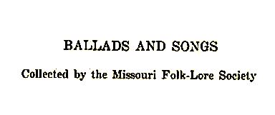

(1)
The Elfin Knight
(Child 2)
Of the riddle ballads admitted to Child’s collection this appears to be the best remembered both in the Old World and in the New. It has been recorded from Aberdeenshire (LL 1-2) and from Ireland (OIFMS No. 117, JFSS I 83), Wiltshire (JFSS II 212, III 274-5, FSUT 221-2), and Somerset (FSSom No. 64); from Maine (JAFL XXX 284-5, with and excellent bibliographical note by Kittredge; BBM 3-11), Vermont (VFSB 194-6, GGMS 58-9) Massachusetts (JAFL VII 228-9, XVIII 49-50, 212, 213-4) Rhode Island (JAFL XVIII 50-1, 213), Pennsylvania (NPM 129), Kentucky (SharpK I 1), North Carolina (SharpK I 2) Georgia (JAFL XIII 120-2), Texas (JAFL XXVI 174-5, PFLST X 137-8) Illinois (FSSH 31, by way of Missouri), Nebraska (Pound, Syllabus), and California (JAFL XIX 130-1) Barry (see JAFL XXX 284) found that it was printed in an American songbook about 1844 and as a Boston broadside a few years earlier. It has two types of refrain, represented respectively by the first and the second of the Missouri texts (the third Missouri text is really from Vermont). The ‘rosemary and thyme’ form is properly an intercalated refrain constituting the second and fourth lines of the stanza; but in Missouri it has been put together and reduced. The other refrain is also of the intercalated sort, but consists of nonsense syllables. As Child remarked, the elf is an interloper, and he has entirely disappeared from modern versions.

A
‘The Cambric Shirt.’ From Leroy Kinkade, University of Missouri, 1922; as learned from his mother, who in turn learned it from her mother in Harrison County about 1886. The last two lines of stanza 1 are a refrain, sung with each stanza.

Make me a cambric shirt
Without a stich of needle work,
And you shall be a true lover of mine,
Rosemary and thyme.

And wash it in yanders well
Where water never flowed and rain never fell.

And hang it on yanders thorn
That never bloomed or blossomed since Adam was born.

Buy me six acres of land
Between salt water and sea sand.

(2)
And plow it all over with a muly-cow’s horn,
And seed it all over with one grain of corn.

And harrow it with a sickle of leather,
And gather it in with a pea-fowl’s feather.

And thrash it against yanders wall
Without a grain of it to fall.

And take it to yanders mill
And every grain one barrel to fill,
And you shall be a true lover of mine,
Rosemary and thyme.

B
No title. From Mrs. E. A. McKay, January, 1921; from her husband, who learned it some twenty years earlier from a wandering hired man at his father’s farm in Knox County.

Are you a-going to London, sir?
Fum a lum la castle ony
Just five my love to a little girl there
Tum a keetle o keetle o taly a temple a tum a
Lum a la castle ony

Tell her to make me a cambric shirt
Without a needle or needler’s work.

Tell her to wash it in yonders well,
Where water never was, nor rain never fell.

Tell her to hang it on yonders line,
Where darkness never was nor the sun never shines.

Are you a-going to Boston, sir?
Just give my respects to an old man there.

Tell him to deed me an acre of land
Between salt water and sea sand.

Tell him to plow it with a sheep’s horn
And seed it down with three grains of corn.

Tell him to reap it with a pen knife
And haul it in with a single span of mice.

(3)
Tell him to put it in yonder barn,
That never was built since Adam was born.
Tell him to build me a ship of brick,
And come sailing over the deep.

Tell the old fool, when he’s done this work,
To bring me the land and I’ll give him the shirt.

C
‘The Cambric Shirt.’ Secured by Miss Hamilton in 1910 from Fred Wilkinson, West Plains High School, who got it from ‘an old manuscript collection made by his grandmother, Eliza Robbins, of Brownington, Vermont.’ The refrain here, as also in B, shows its kinship with the A version in BBM and with that in VFSB. Printed in JAFL XXIII 430-1.

Can you make me a cambric shirt
Fluma luma laky slomy
Without seam of fine needle work?
From a teaslum tasalum templum
Fluma luma laky sloomy

Can you wash it in a well
Where water never ran nor water never fell?

Can you dry it on a thorn
That never was seen since Adam was born?

Can you buy me an acre of land
Between the salt water and the sea land?
Can you plow it with a hog’s horn
And seed it all down with one pepper corn?

Can you put it in a horn
That never was seen since Adam was born?

When the fool has done his work
He may come to me and have his shirt.

(4)
The False Knight upon the Road
(Child 3)

This ballad is not of very frequent occurrence. It is not reported in JFSS or in LL. In America, however, it has been found in Nova Scotia (SBNS 1-2), New Brunswick (BBM 11-3, from Scotland), Maine (BBM 13, a single stanza, learned from an Irish girl; BFSSNE XI 8, learned in Prince Edward Island), Virginia (TBV 61, 549), North Carolina (SharpK I 3), and Tennessee (SharpK I 4). An interesting Irish version is reporter in Modern Language Review XII 203-5. Of these, the BBM version is the same as Child A (from Motherwell’s Minstrelsy). The Nova Scotia version is distinctive by reason of its stanza-long refrain of nonsense syllables and its use of regular riddle questions, the other have instead demands or wishes.

‘The False Knight.’ Sent to me in 1917 by Miss Jane D. Johns of St. Charles. She learned it from her uncle, Douglas Voss Martin, who learned it in his boyhood in Virginia from his grandmother, Eleanor Voss, a Scotchwoman. This text has already been printed in JAFL XXX 286, and from there in Miss Pound’s ABS.

‘Where are you going?’ said the false knight, the false knight,
‘Where are you going?’ said the false knight Munro.
‘Well,’ said the little boy, ‘I’m going to school,
But I’ll stand to my book also.’

‘What you got in your basket?’ said the false knight, false knight,
‘What you got in your basket?’ said the false knight Munro.
‘Well,’ said the little boy, ‘my breakfast and my dinner,
But I’ll stand to my book also.’

‘Give my dog some,’ said the false knight, false knight,
‘Give my dog some,’ said the false knight Munro.
‘Well,’ said the little boy, ‘I won’t give him none,
But I’ll stand to my book also.’

‘Then I’ll pitch you in the well,’ said the false knight, false, knight,
‘Then I’ll pitch you in the well,’ said the false knight Munro.
‘Well,’ said the little boy, ‘I’ll pitch you in first;
But I’ll stand to my book also.’
And he pitched him in the well and went on to school.

The third stanza of this version is not found in the other versions listed above.

(5)
Lady Isabel and the Elf-Knight
(Child 4)

This is one of the most widespread and persistent of ballads. ‘It is nearly as well known to the southern as to the northern nations of Europe. It has extraordinary currency in Poland. The German, Low and High, and the Scandinavians, preserve it, in a full and evidently ancient form, even in the tradition of this generation,’ says Child. The French know it as the ballad of racial bearings and its probable course of dissemination.
Among English-speaking peoples it is widely known and sung down to the present time, both in the Old World and in the New. IT has been reported in recent years from Aberdeenshire (LL 2-4), Yorkshire (JFSS II 282), Westmoreland (ibid.), Norfolk (JFSS IV 123) HErefoldshire (JFSS IV 122), Hertfordshire (JFSS IV 118), Sussex (JFSS IV 121), Wiltshire (FSUT 159-61), than twenty-three times in that shire—JFSS IV 119-21), Devonshire (JFSS IV 119), Cornwall (JFSS IV 116-7), and a Manx version is reported in JFSS VII 301. That it is or was not long ago well known in Ireland is evident from the numerous texts secured by Barry from Irish in America; Child’s G version is of Irish provenience. IT is reported also from Australia (FL XLII 347). The nineteenth century ballad printers Pitts, Such, and Catnach all issued it in stall ballad form. One this side of the water is has been found in Newfoundland (BSSN 3-6), Nova Scotia (BSSNS 3-8), New Brunswick (BBM 21), Maine (BBM 14-8, 22-3, 26-8), New Hampshire (BFSSNE I 3-4), Vermont (VFSB 190-2), Massachusetts (JAFL XVIII 132-3, XXII 374-5, XXIV 333-4, 344-5, all from Boston Irish; BBM 19-20, 24-5), New York (JADL XXIX 156, mentioned but text not given), Virginia (TBV 62-85, SharpK 9-10, 12), West Virginia (FSS 3-17), Kentucky (LT 82-7, SharpK I 6, 10-1, 13), Tennessee (JAFL XLII 25406, SharpK I 5, FSSH 32-6; it has even become a prose folktale among Tennessee mountain folk, JAFL XXXVIII 373), North Carolina (JAFL XXXVIII 148-9, SharpK I 5, 8, SCSM 127-8), South Carolina (SCB 97-100), Georgia (SharpK I 7-8), Mississippi (FSM 61-6), Texas (PFLST X 138-40, TNFS 43-5), Ohio (JAFL XXXV 338-9), Indiana (JAFL XLVIII 305-6) Illinois (JISHS XXXI 301-3), Michigan (JAFL XXVII 90-1), the Ozarks (OMF 216-9), Wisconsin (JAFL XXII 65-6), and Missouri (JAFL XIX 232-3, XLIX 2123-4; one of Barry’s texts, JAFL XXIV334-5, is from the ‘MS. of M. J. P., Peoria, Ill., native of Fulton, Mo.’).
As known to English-speaking people it consists essentially of three scenes, all of which are present in the nineteenth centrury stall prints. In the first scene the seducer persuades the girl to steal two of her father’s horses and some of her mother’s gold; and they rise away. Presently they come to a waterside where her tells her he has drowned six (the number varies) kings’ daughters and promises that she shall be the seventh. But first he bids her strip, because her

(6)
clothes are too fine to rot in the salt, salt sea, and she says her must turn his back and look up in the trees, for it is not fitting that such as he ‘a naked woman should see.’ When he does so she seizes him and throws him in to drown in her place. This modesty motif is present in most versions on both side of the Atlantic, tho sometimes rather inferred than elaborated. But not infrequently there is added to it (as in Sharp’s Exford text, FSSom No. 84) or substituted for it (Child F, from Roxburghe Ballads; JFFS IV 11, Cornwall;; JAFL XVIII 133, Massachusetts; JAFL XXVII 90, Michigan; TBV 72, Virginia; SharpK I 7, Georgia; SharpK 11, Kentucky) her demand that he clear away the nettles (brambles, briars, thistles) on the bank; and in one of Barry’s Irish versions (that mentioned above as derived from a Missourian) she begs that he turn his back while she prays. The third scene is that of her return and dialog with her parrot, who wants to know where she has been so late and is adjured not betray her to her father. This element is present in all but fragmentary versions.

A
‘The Pretty Golden Queen.’ Sent in by Miss Maude Williams, 1903, as ‘sung by an old lady near Kansas City. She learned it of a cousin when she was a girl, then living in South Missouri. She had never seen it in print,’ Miss Williams writes. Printed in JAFL XIX 232-3.

He followed her up and he followed her
down
Till he came to the place where she be.
‘O rise you up, my pretty golden queen,
And go along with me.’
(Repeat the last line of each stanza.)

She got on the pony young brown
And he got on the dapple gray,
And they rode and they rode
Till they came to the side of the sea.

And they rode and they rode
Till they came to the side of the sea;
‘It’s six king’ daughter I have drowned here,
And the seventh you shall be.

‘Take off, take off those fine silk robes,
And lay them on this land,
For they are too fine and costly here
To rot in the salt sea-sand.’

‘Just turn your eyes to the leaves on the trees
And your back to the sea.’
And she picked him up
And plunged him into the sea.

‘It’s take hold, take hold of the skirts of my coat,
And pull me out again.’
‘Lie there, lie there, you false-hearted wretch,
Lie there insteadof me.

‘You said you’d drowned six kings’ daughters here,
And the seventh you shall be.’
. . . . .
. . . . .
‘It’s take hold, take hold of the skirts of my coat
And pull me out again,
And I’ll take you down to old Scotland
And there we’ll be maintained.’

‘Lie there, lie there, you false-hearted wretch,
Lie there instead of me.
. . . . .
. . . . .

(7)
So she got on the pony young brown
And lead the dopple-gray,
And she rode and she rode through the merry green woods
Till she came to her father’s hall.

‘Hush up, hush up, my pretty parrot dear,
And tell no tales on me.
Your cage shall be of the finest gold
And swung on a willow tree.’

Her father was wakened by the noise
. . . . .
‘I woke, I woke, my pretty golden queen,
For to drive the cat away.’

B
‘Willie Came over the Ocean.’ Secured by Miss Hamilton, 1909, from Julia Rickman, one of her pupils in West Plains High school.

Willie came over the main, wide ocean,
Willie came over the sea,
Willie came over the main, wide ocean,
Willie came courting me.

I had no mind to tell him go away,
My mind was tell him sit down.
. . . . .
My mind was tell him sit down.

‘Hand me down your father’s gold,
Likewise your mother’s too,
Away we will go to the marigold country,
The length of a long summer day.’

She handed him down her father’s gold,
Likewise her mother’s too.
Away they went to the stable door,
Took choice of twenty and two.

He mounted upon the bally brown,
She took the dapple gray;
Away they went to t he marigold country,
The length of a long summer day.

‘Pull off your lily-white robe
And deliver it up to me.
It is too fine and cost too much
To rot in the bottom of the sea.’

She pulled off the lily-white robe
And delivered it up to him,
For it was too fine and cost too much
to rot in the bottom of the sea.

‘Turn your face to the green willow tree,
Your back to the bottom of the sea.’
‘Six Queen Ladies have I drowned here
And the seventh one you shall be.’*

She turned her face to the green willow tree,
Her back to the bottom of the sea;
She gathered him around the slender waist
And dipped him into the sea.

‘Lie here, lie here, you cruel-hearted man,
Lie here in the place of me.
Six Queen Ladies have you drowened here,
The seventh one you shall be.’

She mounted upon the bally brown
And led the dapple gray.
When she got home to her father’s house
IT was three long hours until day.

‘Hold your tongue, my pretty little parrot,
Tell no tales on me;
Your cage shall be of the yellowest gold
And hang in the green willow tree.’

*This speech appears to be misplaced—perhaps becase of American squeamishness about mention of a ‘naked woman.’ And ‘she’ and ‘her; in the next two lines should be ‘he’ and ‘his.’

(8)
C
No title. Seured by Miss Hamilton from another of her West Plains pupils, Mabel Davis, 1909.

‘Go steal your father’s weight in gold,
Likewise your mother’s fee,
And two of the best hourses that there are,
For there stands thirty-three.’

She stole her father’s weight in gold,
And likewise her mother’s fee,
And two of the best horses that there were,
For there stood thirty-three.

She mounted on a milk-white steed
And he upon a bay;
They rode, they rode through the merry green woods
Till they came to the side of the sea.

‘Dismount, dismount, my pretty fair maid,
Dismount, dismount, I say.
There are six king’s daughters I’ve drowned here
And you the seventh shall be.

‘You must take off those costly robes
And lay them down by me.
They are too costly, ah! by far
To rot in the bottom of the sea.’

‘If I take off these costly robes
And lay them down by thee,
You must turn yourself all round and round
All for to face that tree.’

HE turned himself all round and round
All for to face the tree;
And manfully she picked him up
And flung him into the sea.

‘Lie there, lie there, you false villain,
Lie there instead of me.
If there are six king’s daughters you’ve drowned here,
Go, keep them company.’

(9)
‘O, give me hold your lily-white finger,
Or give me your whole hand,
And you shall be the lady of my house,
And own one half of my land.’

‘I will not give you my lily-white finger,
I won’t give you my whole hand;
I will not be the lady of your house
Or own one half of your land.’

She mounted on the milk-white steed,
But now she led the bay.
She rode, she rode through the merry green woods
Till she came to the parrot’s tree.

‘O Polly, Polly, pretty Polly,
Don’t tell and tales on me,
And your cage shall be lined with the yellow beaded gold
And locked with a silver key.’

The old man heard the parrot’s cry
And unto her did say,
‘O Polly, Polly, pretty Polly,
What makes you cry so long today?’

‘The old cat came to my cage door,
And that’s what worried me.
I called upon your pretty Caroline
For to drive the old cat way.’

D
‘Polly and William.’ Secured by Miss Hamilton from Agnes Shibley, one of her students at the State Teachers College, Kirksville, 1911, who had it from ‘the old manuscript of Mr. Jenkins.’

He followed me up and he followed me down,
He followed me into the room;
And there I stole my father’s money
And a little of my mother’s fee, fee, fee,
And a little of my mother’s fee.
(Repeat thus the last line of each stanza)

‘Come on, come on, pretty Polly,’ said he,
‘Come on and go with me;
I’ll take thee to Scotland
And there I’ll marry thee.’

(10)
So she mounted on the milk-white steed;
He rode the iron-gray;
They rode off to the seashore
A while before it was day.

‘Light off, light off, pretty Polly,’ said he,
‘Light off like the leaf of the tree;
I’ve drowned six king’s daughters here
And you are the seventh one.

‘Pull off that robe, pretty Polly,’ said he,
‘Pull off that pretty robe,’ said he;
‘It is too neat, it is too sweet
To rot in the salt water sea, sea, sea,
To rot in the salt water sea.’

E
No title. Another version give to Miss Hamilton by Agnes Shibley, 1911, as leaned from her grandmother, Mrs. S. E. Husted, Putnam County.

‘Go fetch me some of your mother’s gold
And some of your father’s fee,
And two of the best horses out of yonder stable
Where there stood thirty and thee.

She mounted on the milk-white steed
And him on the dapple gray.
They rode and they rode out of yonder stable
Where there stodd thirty and three.

She mounted on the milk-white steed
And him on the dapple gray.
They rode and they rode until they came to the seaside
Three long hours before day.

‘Light off, light off that milk-white steed
And deliver it unto me;
For six pretty maids I have drowned here
And the seventh you shall be.

‘Pull off, pull off those silken clothes
And deliver them unto me;
For methinks they look too gay
To rot in the salt, salt sea.’

(11)
‘Oh, turn your back around to me,
For I don’t think that it is fit
For such a man as thee
An undressed woman to see.’

She gathered him round the waist so small
And pushed him in the sea.
She mounted on the milk-white steed
And led the dapple gray.

She rode and she rode
. . . . . .
Until she came to her father’s house
One long hour before day.

The parrot was in the window,
And unto her did say:
‘My pretty maiden, my pretty maiden,
Why do you travel so long before day?’

‘Hush up, hush up, my pretty parrot,
Don’t tell no tales on me;
Your cage shall be made of the glittering gold
And hang on a greenwood tree.’

A year later Miss Shibley added the following lines as ‘known by her mother when a girl;’ preseumably they belong where in E is only the truncated form of the story in stanza 7. The ‘druped high,’ ‘druped low’ seems to be a memory of what appears in Such’s print as
He groped high, and he groped low
And it Pitt’s as
He dropped high and he dropped low.

She catched him around the waist so small
And tumbled him into the sea.

He druped high, he druped low,
Until he came to the shore.
‘Take hold of my hand, my pretty Polly,
And I’ll make you my bride.’

‘Lie there, lie there, you false-hearted man,
Lie there in place of me;
For six pretty maids you’ve drowned here,
And the seventh I’ve drowned thee.’

(12)
F
No title. Contributed by Miss Frances Yeater of the University of Missouri in 1913.

‘Go bring me some of your mother’s gold,
And some of your father’s fee,
And two of the very best nags in the stall
Wherein there are thirty and three
(Reapeat thus the last line of each stanza.)

She brought him some of her mother’s gold,
And some of her father’s fee,
And two of the very best nags in the stall
Wherein were thirty and three.

She mounted on the milky white steed
And he on the dapple gray,
And they rode and they rode till they came to the sea
Six hours before it was day.

‘Mount off, mount off that milky white steed
And deliver it unto me.
Six pretty maids have I drowned in the sea
And the seventh shall be thee.’

. . . . . .
She took him in her two strong arms
And she threw him into the sea:
‘Six pretty maids has thou drowned in the sea
But the seventh shall drown thee.

‘Lie there, lie there, you hard-hearted wretch,
Lie there, lie there,’ said she;
‘Six pretty maids hast thou drowned in the sea
But the seventh shall drown thee.’

She mounted on the milky white steed
And she led the dapple gray
She rode and she rode till she came to the house
Three hours before it was day.

Up up spoke the pretty parrot,
Which in the house did stay:
‘What is that matter with our pretty goli*
So long before it is day?’

McIntosh’s Illinois text has here ‘golin.’ Perhaps a form of ‘colleen.’

(13)
‘Hush, hush, hush, my pretty parrot,
Don’t tell no tales on me;
Your cage shall be of the purest gold
And the doors of ivory.’

G
‘The King’s Seven Daughters.’ ‘The Seven King’s Daughters.’ Two texts, fairly similar, contributed by Mrs. George H. Barnett of Columbia, (a) from Mrs. J.T. Cooper of Warrensburg, who learned it in 1865 or 1866, and (b) from Mrs. Sarah Henry, who learned it in Saline County about 1865-70.

(a)
He followed her up and he followed her down
To the place where’er she lay;
She had no wings to fly away,
No tongue to say ‘Nay, nay, nay, nay,’
No tongue to say ‘Nay, nay.’
(Repeat thus the end of each stanza)

‘Bring me half of your father’s beaten gold,
And likewise your mother’s feem
And two of the best steed in your father’s stall,
Wherein stands thirty and three.’

She brought him half of her father’s beaten gold,
Likewise her mother’s fee,
And two of the best steeds in her father’s stall,
Wherein stood thirty and three.

She mounted all on her bonny young brown
And he on the dapple gray,
And they rodee and they rode through the merry green wood
Till they came to the side of the sea.

‘Alight you down, my pretty fair maid,
. . . . . . .
Six of the king’s daughters I’ve drowned here
And you the seventh shall be.

‘Alight you down, my pretty fair maid,
Take off those clothes so grand
For they’re too fine and too costly
To rub beneath the salt sea sand.’

(14)
‘O love, O love, is this what you promised me
When you sat by my side?
You promised to take me to old Scotland
And there make me your bride.’

She turned herself around and about
And gazed upon the tree,
She picked him up most manfully strong
And plunged him into the sea.

‘O love, O love, lend me your hand,
. . . . . . .
I’ll take you down to old Scotland
And there make you my bride.’

‘Lie there, lie there, you false young man,
Lie there instead of me;
Six of the king’s daughters you’ve drowned here
And the seventh has drowned thee.’

She mounted on the bonny young brown
And led the dapple gray;
She rode and she rode through the merry green wood
Two long hours before it was day.

. . . . . . .
‘O hush! O hush! my pretty Polly,
And tell no tales on me’
Your cage shall be made of pure beaten gold
And hung in the willow tree.’

‘Cheer up, cheer up my pretty young maid,
I’ll tell no tales on thee
If you will drive those cats away,
For they are troubling me.’

(b)
He followed her up, he followed her down,
And into the chamber where she lay;
She had no wings to fly from his arms
And no tongue to answer nay, nay, nay,
And no tongue to answer nay.

(15)
‘Go and take of your father’s gold,
And a part of your mother’s fee,
And two of the finest steeds in your father’s stall,
Wherein there’s thirty and three.’

She mounted on the milk-white steed
And him on the dell fine gray;
They rode till they came to the fair sea-shore,
Three hours before it was day.

‘Now pull off your satin gown
And lay it on my knee,
For it is too fine and costily
To rot in the watery sea.

‘Now turn your face unto the leaves
And your back unto the sea;
For here I have drowned six king’s daughters,
And you the seventh shall be.’

She tuend her face unto the leaves
And her back unto the sea;
She caught him around the middle so strong
And hse threw him into the sea.

‘Lend a hand, lend a hand, my pretty Polly,
Lend a hand unto me,’ cried he,
‘For all the promises I have made unto you
I’ll double one to three.’

‘Lie there, lie there, you falsehearted young man,
Lie there instead of me;
For here you have drowned six king’s daughters
And you the seventh shall be.’

Then she mounted on the milk-white steed
And led the dell fine gray,
And she rode till she came to her father’s gate
One hour before it was day.

No up speaks the pretty little parrot,
As it sits in its cage:
‘Oh, where have you been, my pretty Polly,
So long before it is day?’

(16)
‘Hold your tongue, my pretty little parrot,
And tell no tales on me,
And your cage shall be made of the glittering gold
And the doors of ivory.’

Then up speaks the old man,
As he lay in his room:
‘Oh, what is the matter, my pretty little parrot,
That you talk so long before day?’

‘The cat has come to my cage door
And said it would weary me;
I was calling for my pretty Polly
To come and drive the cat away.’

‘Hold your tongue, my pretty little parrot,
And talk no more until day,
And your cage shall be made of the glittering gold
And the doors of ivory.’

H
‘Pretty Polly.’ Taken down in 1917 from the singing of Minnie Doyel of Arlington,, Phelps County, by miss Frances Barbour of Washington University. Imperfectly remembered. Miss. Barbour has printed it in JAFL XLIX 213-4. The concluding stanza has been influenced by the bird stanzas of Young Hunting. It runs:

‘I won’t come down, I can’t come down
And sit upon your knee;
The way you’ve murdered your own true love
I’m afraid you’ll murder me.’

The Two Sisters
(Child 10)

For the spread and the affiliations of this ballad see Child’s headnote and the analyses made by Taylor (JAFL XLII 238-46) and by Barry (BFSSNE III 1104, VI 5-6, X 2-5, 10-1, XI 2-4, 16-8, XII 10-1). A detailed study of it is now being made by Mr. Paul G. Brewster. Most of the American texts belong blearly to what Taylor calls the English form of the ballad, marked by the refrain illustrated in the Missouri versions given below, the ‘beaver hat,’ and the absence of the supernatural. None of them show either the ‘Binnorie’ or the ‘Edinburg’ refrain. Two of them, however, one from Virginia (but learned in Scotland) and one from West Virginia, have refrains that associate them

(17)
with what Barry calls the Scoto-Irish tradition; and two, one from Tennessee and one from North Carolina, have taken over the familiar ‘rosemary’ refrain of The Elfin Knight. The ‘singing bones,’ the supernatural revelation of the murder by a harp or fiddle made from the drowned girl’s body, which Child (rightly, no doubt_ considered the germ of the ballad, has almost entirely vanished from the American texts, appearing only in BBM E, SharpK A (faded_, and one fo the texts reported by M. E. Henry from Tennessee. This reduction or elimination of the supernatural is in accord with the general tendency of American tradition in dealing with the old ballads. By and large, it may be said that American versions of this ballad belong to the English tradition exemplified by Child R (from Lancashire) and Y (from Kent).
The ballad has been recorded from tradition since Child’s time in Aberdeenshire (LL 9-13; also in Ord, 430-2), Yorkshire (JFSS II 283-5), and Liverpool (JFSS II 285-6, Irish); in Newfoundland (BSSN 9); in Maine (BBM 40-6), Vermont (BFSSNE VI 5-6, XI 16), Rhode Island (JAFL XVIII 130-1, from a midshipman at Newport), New York (Christian Science Monitor for 2 December, 1937), Virginia (TBV 93-104, SharpK I 27-9, 33-4, BFSSNE XII 10), West Virginia (FSS 20-2, BFSSNE IX 4-6), Kentucky (SharpK I 31, 33, 34, 35, DD 70-3, MSHF 8-9), Tennessee (JAFL XLV 4-8, FSSH 39-44), North Carolina (JAFL XLV 1-4, SharpK I 26-730, 32, 35, SCSM 164-5), Mississippi (FSM 68), Texas (PFLST X 141-3), Indiana (JAFL XLVIII 306-7), Illinois (JAFL XLII 245-6), Iowa (MAFLS XXIX 1-2), Nebraska (JAFL XXX 288-9), the Ozarks (OMF 211-3), and Missouri (JAFL XLIV 295-6, besides those mentioned below as having been printed in JAFL).

A
‘The Old Man in the North Countree.’ Contributed by Miss Williams, Cliinton County, in 1903, with the notation that the person that sand it learned it in her girlhood ‘from a hired man in Kentucky.’ Printed in JAFL XIX 233-4.

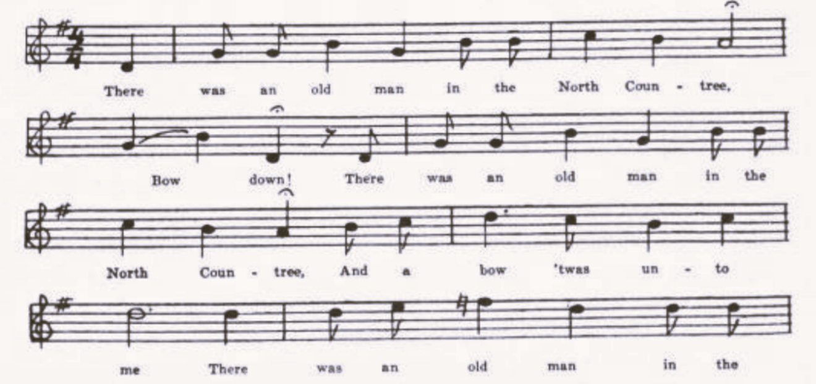
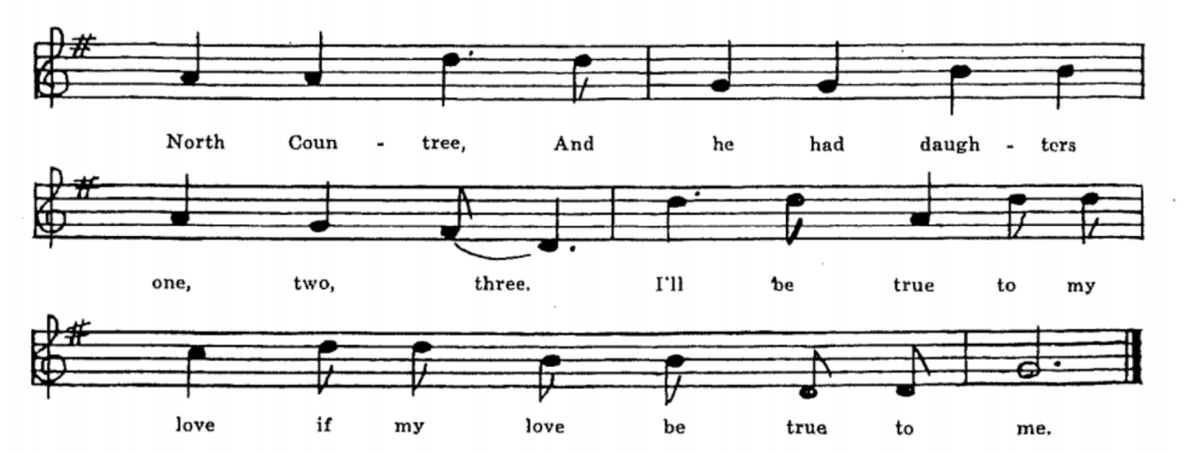

(18)
There was an old man in the North Countree,
Bow down!
There was an old man in the North Countree,
And a bow ‘twas unto me
There was an old man in the North Countree,
And he had daughters one, two, three.
I’ll be true to my love if my love be true to me

There was a young man came a-courting,
And he made choice of the youngest one.

He gave his love a beaver cape;
The second she thought much of that.

‘O sister, O sister, less us go down
And see the ships go sailing by.’

As they was a-walking by the saucy brimside
The oldest pushed the youngest in.

‘O sister, O sister, lend me your hand
And I’ll give you my house and land.’

‘What care I for house and lands?
All I want is your true love’s hand.’

Down she sank and away she swam
Till she came to the miller’s mill-dam.

The miller ran out with his fish hook
And fished this maiden out of the brook.

‘The miller shall be hung on his own mill-gate
For drownding my poor sister Kate.’

B
‘The Old Farmer in the Countree.’ Taken down by W. S. Johnson, Tuscumbia, Miller County, in 1903, from the singing of Tom Waters, the local fiddler. Variants from A noted in JAFL XIX 234.

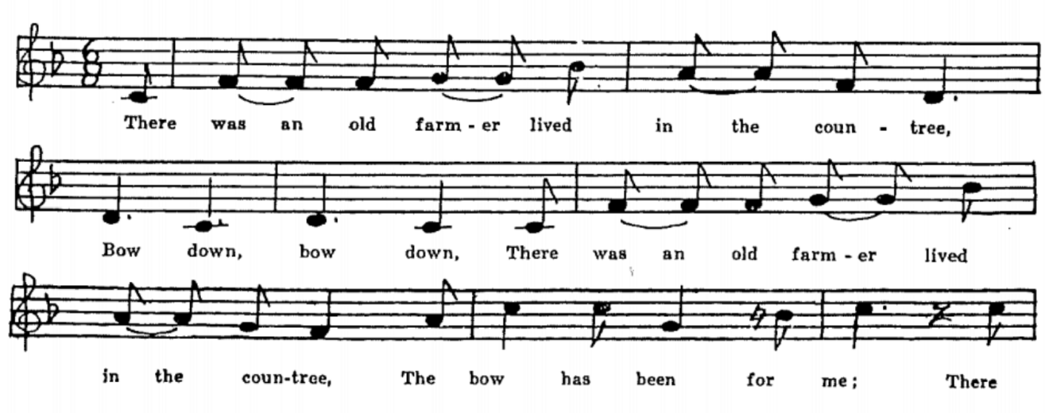

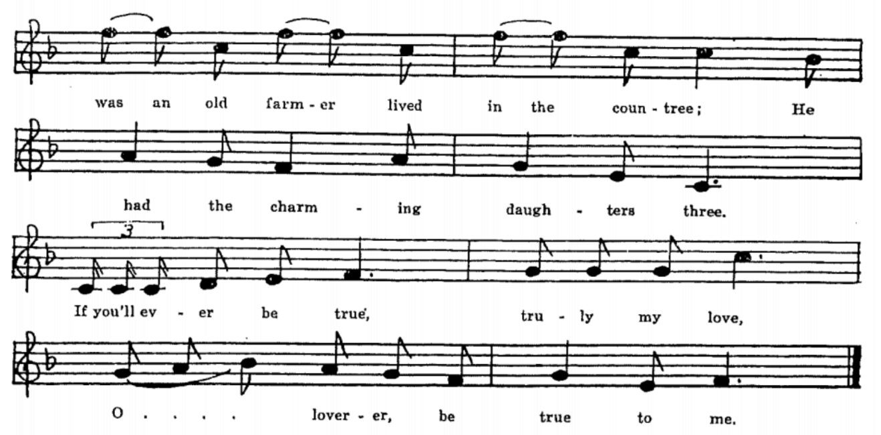
(19)
There was an old farmer lived in the countree,
Bow down, bow down
There was an old farmer lived in the countree,
The bow has been for me
There was an old farmer lived in the countree;
He had the charming daughters three.
If you’ll ever be true, truly my love, O lover be true to me.

There was a young man went courting there,
HE courted there the oldest fair.

HE gave the youngest a diamond ring,
The oldest not a single thing.

HE gave the youngest a beaver hat;
The oldest she got mad at that.

‘O sister, O sister, let us walk out
And view the boats sailing about.’

As they went round the river bend
The oldest shoved the youngest in.

‘O sister, O sister, lend me your hand
To help me to the native land.’

‘I will neither loan you my hand nor glove,
But I’ll take from you your own true love.’

‘O miller, O miller, yonder comes a swan
A-swimming down the old mill pond.’*

The miller threw out his old grab hook
And brought her safely from the brook.

HE robbed her of her golden ring
And plunged her in the brook again.

They hung him on his own mill gate
For drownding of poor sister Kate.

*Another reading given here was
Poor Kate went floating down the pond
But though her life was almost gone.

(20)
C
No title given. From the manuscript ballad book of James Ashby, Holt County, sent me by Miss Lois Welty in 1906. See JAFL XIX 234-5.

There was an old woman lived on the sea shore,
Bow down
There was an old woman lived on the sea shore,
Bow was bent to me
There was an old woman lived on the sea shore
And daughters she had three or four.
I will be true to my love if my love will be true to me.

The youngest one she caught her a beau;
Her beau he bought her a new beaver hat.

‘Oh sister, oh sister, come walk to the sea shore
And see the ships as they sail o’er.’

As they were walking all on the sea brim
The oldest shoved the youngest [in].

First she sunk and then she swum;
She swam into the miller’s mill [dam].

‘Oh miller, oh miller, yonder swims some swan
Or else some true and loving one.’

The miller threw out his great grab hook
And brought this lady from the brook.

‘Oh miller, oh Miller, I’ve gold rings ten
IF you’ll take me to my mother again.’

The miller he took the gold rings ten
And shoved her back in the brook again.

First she swam and then she sank
Into her eternal home.

The miller was hanged all on his mill gate
For drownding of our sister Kate.

February 22nd 1874. Snowing hard. J. A.

(21)
(D)
‘My sister Kate.’ Sent in by George Williams, Marble Hill, Bollinger County, in 1909. The pronous are somewhat mixed in the last two stanzas, and the miller has vanished from the story.

There was an old woman lived on the seashore,
Bow down to me
She had some daughters, some three or four.
Singingg, I’ll be true to my love
My love’ll be true to me.
Singing, I’ll be true to my love,
My love’ll be true to me.

The youngest one she caught a beau’
The oldest one did hate that so.

‘Sister, oh sister, let’s walk the seashore
And watch the ships come sailing o’er.’
As they walked on the shining sand
The oldest pushed the younger in.

‘Sister, oh sister, come lend me your hand
And all I have’s at your command.’

‘I’ll neither lend you my hand or my glove,
For all I want is your true love.’

The sea washed o’er my sister fair;
They found her there with her golden hair.

They hung her on the garden gate
For the murder of her sister Kate.

E
‘The West Countree.’ Contributed by Mrs. Case, as known to her in childhood in Harrison County. Printed in JAFL XXX 287-8.

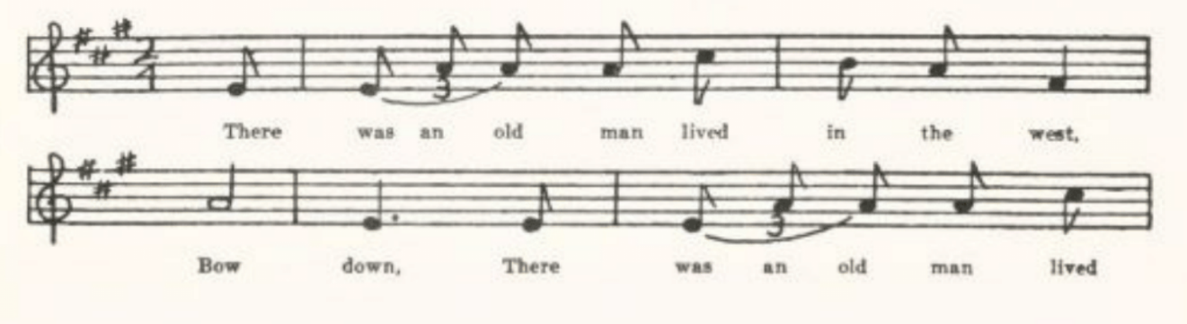
(22)
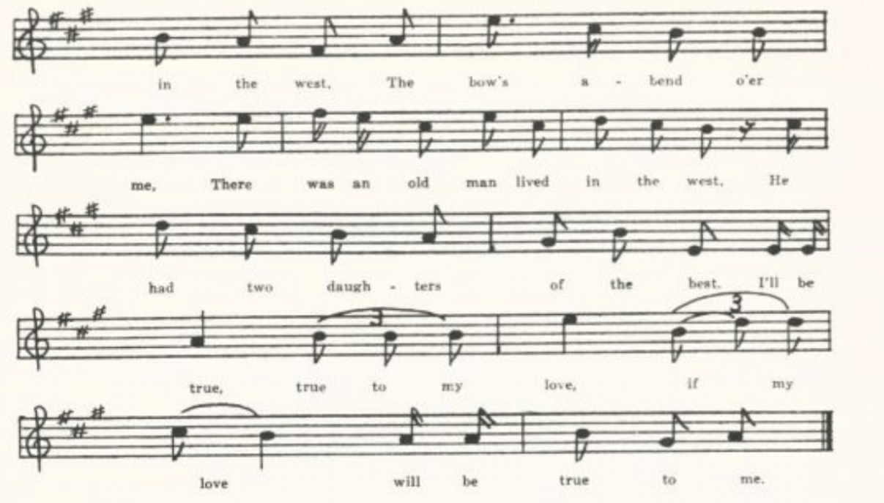
There was an old man lived in the west,
Bow down
There was an old man lived in the west,
The bow’s a-bend o’er me
There was an old man lived in the west,
He had two daughters of the best.
I’ll be true, true to my love, if my love will be true to me.

The squire he courted the older first,
But sill he loved the younger best.

The first that he bought her was a beaver hat;
The older thought right smart of that.
The next that he bought her was a gay gold ring.

‘Sister, oh sister, let’s walk out
And see the ships all sailing about.’

They walked all along the salt sea brim;
The older pushed the younger in.

‘Sister, oh sister, lend me your hand,
And then I’ll gain the promised land.’

(23)
‘It
s neither will I lend you my hand nor my glove,
And then I’ll gain your own true love.’

Sometimes she’d sink, sometimes she’d swim,
Sometimes she’d grasp a broken limb.

Down she sank and off she swam’
She swam into the miller’s dam.

The miller went fishing in his own mill-dam,
And he fished this lady out of the stream.

Off of her fingers he pulled three rings
And dashed her in the brook again.

The miller was handed on his own mill-gate
For the drowning of my sister Kate.

F
‘The Two Sisters.’ Taken down by Mrs. Frank Martin of Warrensburg (who earlier, when she was Maude Williams, contributed the A version above and many other items in this collection) in 1920 from the singing of a woman who had ‘spent her girlhood in Kentucky, where she learned this and a lot of other songs.’

There was an old woman lived by the sea shore,
Bow down,
There was an old woman lived by the sea shore,
Bow your bends to me,
THer was an old woman lived by the sea shore,
And she had dauthers three or four.
I’ll be true to my love if my love by true to me.

The youngest one she caught a beau;
The oldest one she didn’t know.

The beau he gave her a beaver hat;
The oldest one she didn’t live that.

‘Sister, dear sister, let’s walk the sea shore
And see the ships come sailing o’er.’

As they were walking upon the sea-brim
The oldest pushed the youngest in.

(24)
Siter, dear sister, lend me your hand
And I’ll give you my house and land.’

‘I’ll neither lend you my hand nor my glove,
For all you want is my true love.’

Down she sank and away she swam
Until she came to a miller’s mill-dam.

‘Miller, O miller, Lend me your hand,
And I’ll give you a golden ink-stand.’

The miller accepted the golden ink-stand
And then he pushed her in again.

The miller was hung on his mill-yard gate
For drownding my poor sister Kate.

The saddles and bridles are hanging on the shelf;
If you want any more you can sing it yourself.

Lord Randal
(Child 12)
Altho it cannot be traced further back) except in Italy, where it got into print early in the 1600’s) than the end of the eighteenth century, this ballad is widely known in both Europe and America, and always in substantially the same dialog form with repetition. See Child’s headnote, Barry in JAFL XVI 258-64, XVIII 195-207, and BBM 46-72, and Kittredge in JAFL XXIX 157 (footnotes) and XXX 289-90. It has been reported in recent times from popular tradition in Aberdeenshire (LL 6, Ord 458-9), Ross (JFSS V 119), Ireland (JFSS V 245, Modern Language Review XIII 325-7, and from Irish in America JAFL XVIII 200-1, 205-6, XXII 376-7, XXIV 345-6, BBM 54, 58-9, 59-60), Cumberland (JFSS III 43-4), Lancashire (JFSS V 117), Sussex (JFSS V 118), Surrey (JFSS V 122), and Somerset (JFSS II 24-32); an on this side of the Atlantic in New Brunswick (JAFL XVIII 116, BBM 55-6, 61-2, and indirectly JAFL XVIII 199-200), Maine (JAFL XXXIX 81-2, BBM 46-53, 57-8, 62-3), New Hampshire (JAFL XVIII 198-9, 204), Vermont (JAFL XVIII 207, 303-4, VFSB 197-8), Massachusetts (JAFL XVIII 196-7, 199-207), Rhode Island (JAFL XVIII 195), New York (JAFL XIII 116, XXX 290, BFSSNE I 4, TBV 118-9), New Jersey (BFSSNE I 4), Pennsylvania (NPM 139-40_, Virginia (TBV 105-18, SharpK I 43-5), West Virginia (FSS 23-8), Kentucky (SharpK I 42, FSKM 18-22), Tennessee (SharpK I 43), North Carolina (JAFL XLII 257-8, SharpK I 38-40, 44, FSSH 45-6, SCSM 179-80), South Carolina (SCB 101-3), Georgia (SharpK I

(25)
41), Mississippi (FSM 69-70), the Ozarks (OMF 215-6), Ohio (JAFL XIII 115, XXX 289), Indiana (JAFL XXIX 157, XXX 289), Illinois (JAFL XXXV 340), Nebraska (Pound, Syllabus), Colorado (ABS 3), and Texas (JAFL XXIX 157, listed but text not given). The name of the poisoned one varies greatly; one name, Tyranty, belongs exclusively, so far as the record goes, to New Engladn. The poisoner is commonly the victim’s sweetheart, but may be his stepmother, his grandmother, his sister, his wife, or even (BBM N) himself.* The poison is commonly snake venom (often described as ‘eels’ or spotted, striped, or speckled fish caught in a hedge or ditch) but may be simply ‘bread and poison’ or ‘a cup of cold poison;’ in Child M it is apparently and in the Cumberland version listed above it is specifically toads.
Altho there is little if anything that is distinctive in the MIsssouri versions, it seems best to give them here for the benefit of future students of this particular ballad story.

A
No title. Communicated in 1912 by Juliet L. Smith as learned by her father from a house-painter in Ray County. Imperfectly remembered.

‘Where have you been, John Randall, my son?
Where have you been, my dear little one?’
. . . . . . . .
. . . . . . . .

‘What had you for supper, John Randall, my son?
What had you for supper, my dear little one?’
‘I had eels fried in butter; mother, make my bed soon,
I’ve a pain in my heart and I want to lie down.’
. . . . . . . .
‘What do you will to your sister, John Randall, my son?
What do you will to your sister, my dear little one?’
‘A coach and forur horses that she may ride round.
I’ve a pain in my heart and I want to lie down.’

B
‘Johnny Randall.’ Communicated in 1914 by Celestine McDonald of Vernon County.

‘Where have you been to, Johnny Randall, my son?
Where have you been to, my dear and sweet one?’
‘To see pretty Polly; mother, make my bed soon,
For I am sick-hearted and fain would lie down.’

*In a text from family tradition in Vermont given me in 1920 by Mr. P. G. Perrin the poisoner is ‘grandpa’!

(26)
‘What did you have for your supper?’
‘Fried eels in fresh butter.’

‘What’ll you leave for your father?’
‘My house and fine farm.’

‘What’ll you leave for your mother?’
‘My coach and six horses.’

‘What’ll you leave for your sister?’
‘My horse and side-saddle.’

‘What’ll you leave for your brother?”
‘My trunk and fine clothing.’

‘What’ll you leave for your sweetheart, Johnny Randall, my son?
What’ll you leave for your sweetheart, my dear and sweet one?’
‘Fire and brimsone, to burn her bones brown;
For she is the cause of my lying down.’

C
‘Lord Randal.’ Contributed in 1916 by Mrs. Eva Warner Case (now Mrs. J. B. Lichtenberg) from recollections of her childhood in Harrison County, where , she says, the settlers were ‘of Virginia and Kentucky stock, with a sprinkling of Tennesseeans, and many of the songs had been in the family since the time of their coming from England.’ Printed in part in JAFL XXX 290.
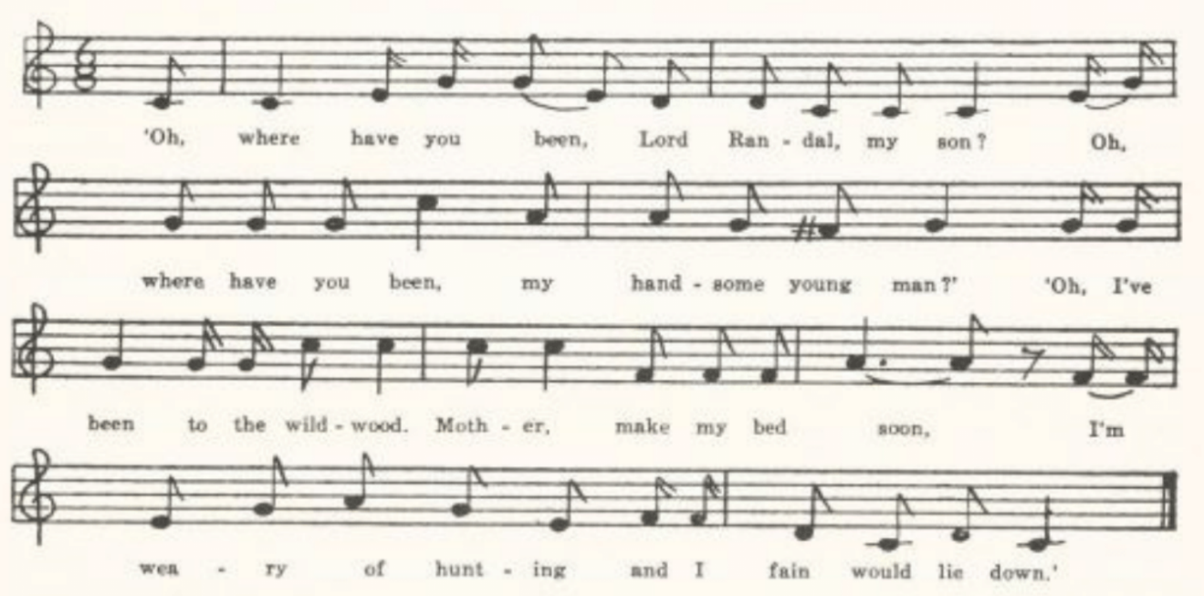
‘Oh where have you been, Lord Randal, my son?
Oh where have you been, my handsome young man?’
‘Oh, I’ve been to the wildwood; mother, make my bed soon,
I’m weary of hunting and I fain would lie down.’

(27)
‘And whom did you meet there, Lord Randal, my son?
And whom did you meet there, my handsome young man?’
‘Oh, I met with my true love; mother, make my bed soon,
I’m weary of hunting and I fain would lie down.’

‘What got you for supper, Lord Randal, my son?
What got you for supper, my handsome young man?’
‘I got eels boiled in broth; mother, make my bed soon,
I’m weary of hunting and I fain would lie down.’

‘And what did your dogs do, Lord Randal, my son?
And what did your dogs do, my handsome young man?’
‘Oh, they stretched out and died; mother, make my bed soon,
I’m weary of hunting and I fain would lie down.’

‘Oh, I fear you are poisoned, Lord Randal, my son,
Oh, I fear you are poisoned, my handsome young man.’
‘Oh, yes, I am poisoned; mother, make my bed soon,
For I’m sick at my heart and I fain would lie down.’

‘What will you leave your mother, Lord Randal, my son?
What will you leave your mother, my handsome young man?’
‘My house and my lands; mother, make my bed soon,
For I’m sick at my heart and I fain would lie down.’

‘What will you leave your sister, Lord Randal, my son?
What will you leave your sister, my handsome young man?’
‘My gold and my silver; mother make my bed soon,
For I’m sick at my heart and I fain would lie down.’

‘What will you leave your brother, Lord Randal, my son?
What will you leave your brother, my handsome young man?’
‘My horse and my saddle; mother, make my bed soon,
For I’m sick at my heart and I fain would lie down.’

‘What will you leave your true-love, Lord Randal, my son?
What will you leave your true-love, my handsom young man?’
‘A halter to hang her; mother, make my bed soon,
For I’m sick at my heart and I want to lie down.’

(28)
D
‘My Rambling Young Son.’ Communicated by Leroy Kinkade in 1922 from his mother’s singing, who learned it from her mother in Harrison County in the 80s of the last century. He did not remember all of it.

‘O where have you been, my rambling young son?
O where have you been, my handsome young man?’
‘I’ve been to my sweetheart’s; mother, make my bed soon,
For I’m weary with riding and wish to lie down.’

‘Have you been to your dinner, my rambling young son?
Have you been to your dinner, my handsome young man?’
‘Yes, I’ve been to my dinner and ate a half a snake’s head,
And I’m sick to my heart, and I wish to lie down.’

‘What do you will to your father?’
‘My horses and cattle.’

‘What do you will to your mother?’
‘My bed and my bedding.’

‘What do you will to your bother?’
‘My horse and my saddle.’

‘What do you will to your sister?’
‘My . . . . .’

‘What do you will to your sweetheart, my rambling young son?
What do you will to your sweetheart, your sweetheart less none?’
‘Oh, hell and damnation; mother, make my bed soon,
For I’m sick to my heart, and I wish to lie down.’

E
Miss E. M. Denny of Columbia remembered in 1934 the following as sung ‘more than thirty years ago’ by negroes in Randolph County.

‘O what have you left for your sweetheart, Jimmy Rando,
my sweet and pretty one?
O what have you left for your sweetheart, Jimmy Rando, my son?
‘Here’s hell-fire and brimstone to burn her bones brown,
For she is the cause of my wantin’ to lie down.’

(29)
Sir Lionel
(Child 18)

This appears to be an English ballad, and to have lasted better in America than in its native land. Only one of Child’s six versions is from Scotland, and he found nothing in other languages that corresponded at all closely to it. It is connected with, possibly derived from, the romance of Sir Eglamour of Artois. None of the Child versions shows the characteristic refrain of the American versions, which seem to belong to the same tradition as the Herefordshire and Wiltshire versions recorded since his time. The Herefordshire version printed in Ella M. Leather’s Folk-Lore of Herefordshire and reprinted in JAFL XXX 292-3 has the name ‘Brangywell’ instead of ‘Bangum’; the Wiltshire version (FSUT 118-9) has ‘Rylas’; Kidson’s text (JEFDSS III 46, provenience not known) has ‘Tom and Harry’; but all three have, with slight variations, the same refrain as the American texts. IN this country it is known in Maine (BBM 434-5, recognized by a sea-captain as a song he had heard his men sing, tho he could not himself recall the text), Virginia (TBV 125-32; SharpK I 54; TNFS 51-2, sung by negroes), Kentucky (FSKM 78-81, SharpK I 55), North Carolina (SharpK I 54), and Missouri. Some form of the name Bangum and the refrain of the Missouri texts (with some slight variations) are common to nearly all these American texts. One suspects a printed ballad or songbook text as the background of these traditional versions, but I have found no mention of such print.

A
‘Bangum and the Boar.’ Secured by Mrs. Case from Miss Josephine Casey of Kansas City, 1916. Mrs. Case writes: ‘Miss Casey is a grandniece of General Zachary Taylor of Mexican War fame… General Taylor and President James Madison were great-great-grandsons of James Tyler, who came from Carlisle, England, to Orange County, Virginia, in 1638, and both were hushed to sleep by their negro “Mammies” with the strains of Bangum and the Boar… The air itself is even older than the words. A Danish maid in the service of Miss Casey’s sister burst in to tears when she hard the song. When asked the reason she said, “It makes me homesick. In Dencmark, weyoung people used to dance to that air, which is a very old one.”’ The text (but not the tune) was printed in JAFL XXX 291-2. The first stanza seems to have been taken over from The Frog’s Courtship, for which see below, pp. 494-9.
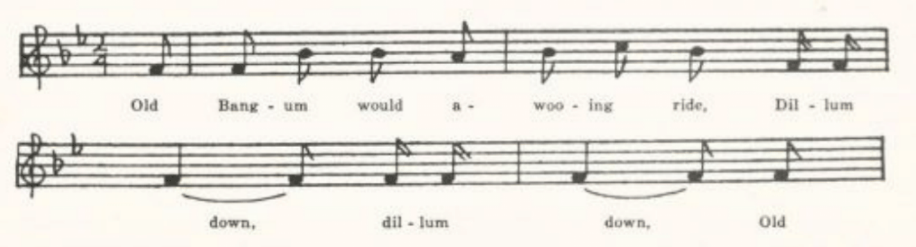
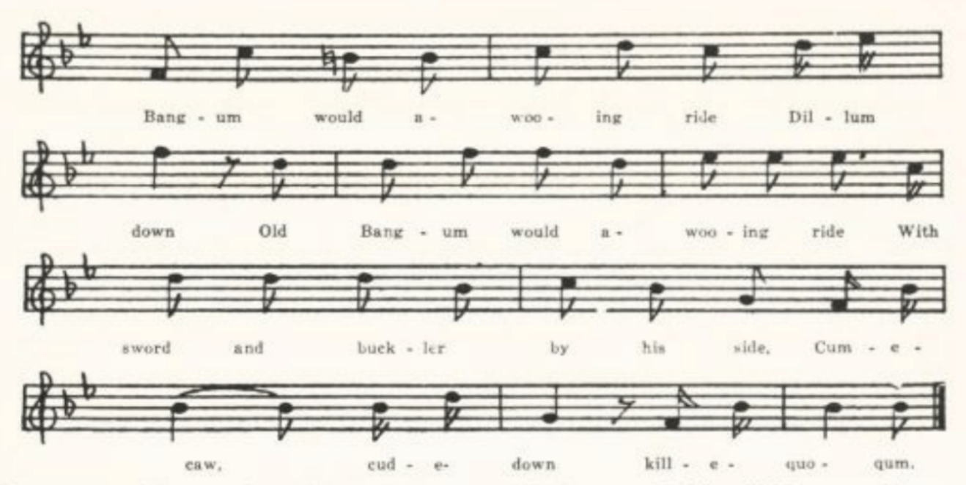
(30)
Old Banum would a-wooing ride,
Dillum down, dillum down
Old Bangum would a-wooing ride,
Dillum down
Old Bangum would a-wooing ride
With sword and buckler by his side.
Cum-e-caw, cud-e-down, kill-e-quo-qum

Old Bangum rode to the greenwood-side
And there a pretty maid he spied.

‘There is a wild boar in this wood
That’ll cut your throat and suck your blood.’

‘Oh, how can I this wild boar see?’
‘Blow a blast and he’ll come to thee.’

Old Bangum clapped his horn to his mouth
And blew a blast both loud and stout.

The wild boar came in such a rade
He made his way through oak and ash.

They fit three hours in the day.
At last he wild boar stole away.

Old Banum rode to the widld boar’s den
And spied the bones of a thousand men.

B
No title. Written out for me by Professor G. C. Broadhead, University of Missouri, about 1911, as known by him for nearly sixty years. Printed in JAFL XXV 175-6.

‘There is a wild boar in these woods
Dillum down dillum
There is a wild boar in these woods
Dillum down
There is a wild boar in tehse woods
Who’ll eat your flesh and drink your blood.’
Kobby ky cuddle down killy quo cum.

‘Oh, how shall I this wild boar see?
I’ll blow a blast and he’ll come to me.’

Old Bangum blew both loud and shrill;
The wild boar heard on Temple Hill.

The wild boar dashed with such a rash
He tore his way through oak and ash.
Old Banum drew his wooden knife
And swore he’d take the wild boar’s life.

They fought four hours in a day;
At last the wild boar stole away.

They raced the wild boar to his den,
And found the bones of a thousand men.

(31)
C
No title. Secured by Professor John Robert Moore, then living at Chillicothe, Missouri, through Mr. Francis Stewart, from J. W. Blue of Chula, Livingston County, in 1910. Blue describes the air as ‘a kind of long meter tune,’ but does not attempt to write it. Text essentially the same as in B except that it lacks the penultimate stanza and the refrain is somewhat different—tho clearly belonging to the same tradition:

There is a wild boar in the woods
Kio k kio kum
There is a wild boar in this woods
Who will eat your flesh and suck your blood
Kio k ko kum kuddle dum.

D
No title. A fragment, remembered, about 1905, by Professor Hugh Allison Smith from the singing of his father, whose home was in southern Missouri. Three stanzas, corresponding to the last three of B. The refrain, so far as remembered, is only

Come I cuttle down.kill him cary corn.

The Three Ravens
(Child 26)

The Missouri collection knows only the familiar American form of this song. Child records but three versions, one Scotch (‘The Twa Corbies’) and two English, and no analogs from other tongues. I have not found it in BRitich reports since Child’s time, not does it appear to have persisted in Canada.
In the American texts, except that from Iowa, it is not a man that the crows are preparing to eat but a horst (the text communicated by Beatty JAFL Barry’s ‘jury text,’ BBM 435-7, is only a recognition, by a Maine sea-captain, of the first seven stanzas of Child’s Melismata text as something he has heard sailors sing, not a text that he recalled himself). Most of these American texts have the ‘caw! caw! caw!’ refrain. The currency of the song is no doubt due, as Kittredge remarks (JAFL XXXI 273), ‘in large part to its vogue on the minstrel stage in the sixties and doubtless earlier.’ For bibliography see this note of Kittredge’s and the haednotes in FSS and TBV. Texts have been published, besides the Maine and Wisconsin items metioned above, from Virginia (TBV 137-22, SharpK I 63-4, SCSM 194), West Virginia (FSS 31-3), Texas, (PFLST VII 110), Ohio (JAFL XXXI 273), and Iowa (MAFLS XXIX 2-5).

(32)
One of the Virginia versions (TBV H) has taken up the following lines:

So said the blackbird to the crow,
‘Down in the cornfield we will go.

‘Ever since Adam and Eve were made
The picking of corn has been our trade,’

which are a form of what exists in Missouri as a separate bit of traditional song. Similar lines are reported from North Carolina in MSNC 10-2. Professor G. C. Broadhead gave me the following in 1910 as known to him for many years:
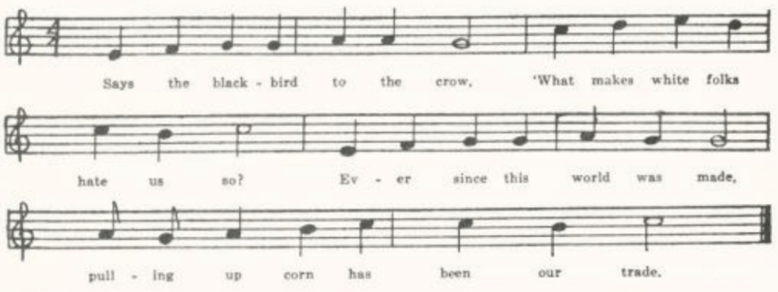
And W.S. Johnson in 1903 communicated the following tune as known in Miller County:
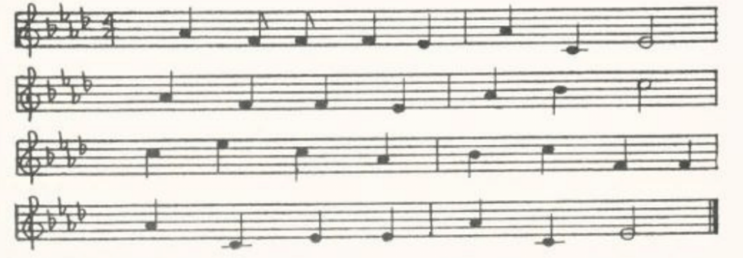
A
‘The Three Black Crowes.’ Communicated by T. C. Wrigth, Miller County, in 1916, from his father’s singing.

There were three crows sat on a tree,
And they were black as crows could be.

Said one crow unto his mate,
‘What shall we do for grub to eat?’

‘I see a horse on yonders plain
Whose body’s been but lately slain.

‘We’ll perch ourselves on his breast bone
And pick his eyes out one by one.’

(33)
No title. Given me by Miss Alice Kirtley, of Cole County, in 1918.

Three black crows sat on a tree,
And they were as black as crows could be.

Said one of them unto his mate,
‘What shall we do for grub to eat?’

‘You see that horse on yonder plain?
. . . . .

‘We’ll perch ourselves on his backbone
And pick his eyes out one by one.’

The Two Brothers
(Child 49)
Child give nine versions of this ballad, of which arll but two—one from Cheshire and one from America—are Scotch. He did not find it in other languages. Nor does it appear to have persisted in the country of its origin; at least I do not find it reported by British collectors since Child’s time. It is not found in the collections made in the North American British provinces . But it has been something of a favorite in the United States, texts having been published from Maine (BBM 99-100, a fragment), Vermont (BFSSNE V 6), Virginia (TBV 147-57, SharpK I 66-8), West Vriginia (FSS 33-5), Kentucky (FSKM 55-8, SharpK I 69-74, SFLQ II 65-6), Tennessee (SharpK I 76), North Carolina (SharpK I 65-6, 74-6, SCSM 166-7), Mississippi (FSM 73-4), Arkansas (OZARK Life V No. 12), Indiana (JAFL XXIX 158, XLVIII 298-9), and Nebraska (JAFL XXVI 361-2). And Child’s version G is from the singing of little girls in South Boston, with variants contributed by W. W. Newell from New York.
The sotry seems from the beginning to have been conceived in two ways, either as a tragic accident (Child A E F, TBV ?C ?D, SharpK ?F ?I, JAFL XXVI 361-2, XXIX 158) or as an intentional killing; and the motivation of this killing varies. In Child H the brother is killed ‘for your lands sa broad;’ in Child I because he ‘killed two pretty little birds;’ in the American texts it is often because of jealousy (TBV H, SharpK K, FSKM). A sweetheart is F H K L, SharpK E F G, SCSM. But that rivalry in love is the reason for the killing ins in most cases rather inferred than stated. The K version in SharpK lends perhaps some support to Barry’s idea (BFSSNE V 6ff.) that the theme was originally rivalry between the brothers for their sister’s love. Here the girl in the affair is ‘your sister Susan dear,’ and it is she that ‘harped her brother John from his grave’ and demanded ‘one sweet kiss from your ruby sweet lips’—a motive borrowed perhaps, as Child suggested, from Sweet William’s Ghost, and appearing in Child B C, BBM, TBV A B D F H I K, SharpK B C D F ?I, FSKM, JAFL XLVIII. Neither this, nor the Edward ending

(34)
(found in Child D E F G H I but in none of the Ameica texts) appears in the Missouri version.

No title. Communicated by Mrs. George H. Barnett, Columbia, in 1913, from the singing of her mother. Printed JAFL XXX 294.

‘Go away, go away, and let me alone,
For I am too young and small.’

His brother took out his little penknife
Both sharp and keen at the point,
And he pierced it in his younger brother’s heart
Between the short ribs and the long.

‘Oh brother, oh brother, when you go home
My mother will ask for me.
Tell her I’m down in Dublin-town
Playing beneath the churchyard tree.

‘Oh brother, oh brother, when you go home
My sister will ask for me.
Tell her I’m down in Dublin-town
Sleeping beneath the churchyard tree.’

His brother took off his shirt
And he ripped it from seam to seam,
And he bound it around his younger brother’s
Precious bleeding heart.

Young Hunting
(Child 68)

This Scotch ballad (all Child’s texts are northern) seems to have faded from memory in the British Isles, and no text of it has so far as I know been reported from the British provinces in America;* but it has maintained itself fairly well in the United Sates. Child mentions no America versions, but since his time it has been reported from Maine (BBM 122-8), Vermont (JAFL XVIII 295, tune only), Virginia (TBV 182-90, SharpK I 104-5, 111-2, SCSM 135-6), West Virginia (FSS 42-4), Kentucky (JAFL XX 252-3, XXX 298-9, SharpK I 108-11), Tennessee (ETWVMB 28-9), North Carolina (Sharp K I 101-3, 106-7, 113-4), South Carolina SCB 107-8), Georgia (JAFL XLIV 67-8, SharpK I 107-8), Mississippi (FSM 77-8), Texas (PFLST X 143), the Ozarks (OMF 203-5), and

(35)
Indiana (JAFL XXX 301-2; also a text privately communicated by Mr. Paul G. Brewster, a composite, apparently, of Young Hunting and Trooper and Maid). Two stanzas of it appear in connection with other matter in a song of the southern mountains, FSSM 22 and FSSH 145. The America versions have much in common, so much so that one suspects a stall ballad or songbook version, but the only print of that sort I have found mentioned is that in Delanely’s Scotch Song Book (published in New York) noted by Kittredge JAFL XXX 297, which I have not seen. None of the America versions has the folklore of the recovery of drowned bodies found in Child A B C H J K, nor the dressing up of the dead man and mounting him on his horse hound in Child A B C D G H J K, nor the making him drunk and stabbing him in bed found in Child A J K.* In most of them he is stabbed as he leans from his saddle to kiss her. Many of the American texts, notably TBV A, FSS A B, SharpK E M N, JAFL XXX 301, PFLST X 143, show a momentary remorse on the part of the murderess—possibly a misremembering or a misunderstanding of the colloquy between her and her waiting-woman as found in Child B C D E F H J K. Nearly all of them retain the bird-witness, tho in none of them does the bird actually reveal the murder as it does in Child J K. The dwelling-place of Young Hunting’s other love varies widely both in the Old World and the New. One suspects a single original for the ‘Archer’s land’ of the Missouri text, ‘Urgent land’ of JAFL XX 252, ‘Orkis land’ of PFLST; but I have no suggestion to make, unless it be that it is conceivably a perversion of the ‘Richard’s Wall’ of Child D F.

No title. Communicated by Miss Vivian Bresnehen in 1916 as known to her father, who learned it from a hired man on a farm in Linn County ‘about forty years ago.’ Printed in JAFL XXX 300-1.

‘Light down, light down, Young Henry,’ she said,
‘And spend a night with me.
Your bed shall be made of the softest down;
'Tis the best I can give thee.’

‘I won’t light down, I can’t light down
And spend a night with thee.
There’s another pretty girl in Archer’s land
I love much better than thee.’

As he bent over his saddle-bow
To give her kisses three,
With the penknife in her right hand
She pierced his heart full deep.

*There is perhaps a memory of it in the ‘over her soft pillow’ of TBV C D, SharpK D, JAFL XXX 301, the ‘in her parlor neat’ of Cambiaire’s text, and the ‘go to table’ of Brewster’s Indiana text.

(36)
‘Fie, fie, fair Eleanor,’ he said,
‘Why did you do that to me?
There’s not another girl in all the land
I love as well as thee.’

‘Live half an hour, Young Hentry,’ she said,
‘Live half an hour for me,
And all the men in our town
Shall give relief to thee.’

‘I can’t live half an hour,’ he said,
‘I can’t live half an hour for thee,
For don’t you see my own heart’s blood
Welling out of me?’*

Some took him by his yellow hair
And others by his feet,
And threw him into a pool of water
That was both cold and deep.

‘Lie there, lie there, Young Henry,’ she said,
’Till the flesh rots off your bones,
And that pretty girl in Archer’s land
Ashall long for your return home.’

A pretty parrot swinging in a willow tree,
Hearing all they had to say,
Said, ‘Yes, that pretty girl in Archer’s land
Shall long for his return home.’

‘Fly down, fly down, pretty parrot,’ said she,
‘And alight on my right knee,
And your cage shall be made of the yellow beaten gold
And swing in the willow tree.’

‘I can’t fly down, I won’t fly down,
I won’t fly down,’ said he,
‘For you have murdered your own true love
And soon would you murder me.’

‘If I had a bow in my right hand
And an arrow to the string,
I would shoot you a dart right through the heart
That you never should sing again.’

*Borrowed from Lord Thomas and Fair Annet. A like stanza in TBV A C D, FSS A B, SharpK D H, JAFL 298, 301, ETWVMB, PFLST.

(37)
‘If you had a bow in your right hand
And an arrow to the string,
I would raise my wings and fly away;
You never should see me again.’

Lord Thomas and Fair Annet
(Child 73)
Child has nine versions of this ballad (which has parallels in Scandinavian and Romance balladry), all but one of which are Scotch. This one, D, is an English broadside of the seventeenth century, frequently printed since and current also in oral tradition. And from it have come all the American versions as well as most of those gathered from oral tradtion in Great Britain since Child’s time. Two features that mark most of the Scotch texts: the contamination with Fair Margaret and Sweet William at the opening and the close, and Annie’s answer to the brown girl’s question about her complexion that she got it where the brown girl will never get the like, viz. in her mother’s womb—these have disappeared in the modern versions.* The rose and briar ending, too, which marks several of the Scotch versions and some ofteh later British texts (Aberdeenshire, Staffordshire, Gloucestershire, Devonshire) and is inconsistent wit hteh triple burial (with which it is none the less combined in Gloucestershire and Devonshire and in Child’s Dh, an Irish-American version), is infrequent in American texts, appearing only in NPM, TBV B, SCB B, SSSA, and Missouri J. In the broadside Lord Thomas is ‘a bold forester;’ and he is so called in the Staffordshire, Gloucestershire, Somerset, and Devonshire versions recently recorded. When this characterizations appears in American tests (as it does in BBM A B C, NPM, TBV A B C, SharpK K, SCB B, and the Vermont, Indiana, and Nebraska texts) we may infer a rather close relation to print. Thomas is so described in The Forget-Me-Not Songster, which had wide circulation in America in the middle of the last century. Thomas never sends a messenger to Eleanor, as in Child C E G H I, but goes himself. In the great majority of the modern texts the lovers consult their respective mother’s only, occasionally father and mother together; never does a sister (as in Child A B F G H) advise him to prefer the fair girl to the brown. Two elements of realism—or perhaps should we say brutality—are evidently vauled, for they persist in almost all the American versions: after Thomas has cut off the brown girl’s head he kicks it (or some equivalent phraseology) against the wall; and when he remarks Elanor’s pallor she asks him if he cannot see her own heart’s blood come trickling down her knee. There is considerable variety in the way the mother’s counsel is asked. Most often the language is ‘come riddle my riddle, come riddle it all in (as) one.’ In Missouri A it is ‘come riddle

*The first of these features is retained in the Aberdeenshire version, and what is perhaps a vestige of the second; and a like vestige is perhaps to be seen in TBV H and FSS E.

(38)
your sword,’ and in Missouri D J, TBV K L, SharpK L N it is ‘riddle my (the, these) sport(s).’ Many years ago (Modern Language Notes XXII 263-4) I ventured the suggestion that sport here is a mishearing of sword and that the latter word points to an earlier belief in the potency of weapons in soothsaying. This peculiar wording appears only in the American versions.
The ballad had been found in oral tradition since Child’s time in Aberdeenshire (LL 54-7, 256), Hertfordshire (JFSS V 130-1), Staffordshire (Burne, Shropshire Folk Lore 651), Herefordshire (JFSS II 107), Gloucestershire (FSUT 135-7), Hampshire (JFSS II 106, tune only), Somerset (JFSS II 105-6, 109), and Devonshire (JFSS II 107-8); in Nova Scotia (BSSNS 20-4, SBNS 8-10) and Newfoundland (BSSN 18-20); in mine (BBM 126-34), Vermont (JAFL XVIII 128-30, VFSB 209-13), Massachusetts (JAFL XVII 130, by way of New Jersey), Pennsylvania (JAFL XXIX 159, by way of Kansas; NPM 155-7), Maryland (ABS 27-31, by way of Nebraska), Virginia (TBV 191-220, SharpK I 120, 124, 127-9, FSSH 63-5, SCSM 106-13), West Virginia (FSS 45-64), Kentucky (JAFL XX 254-5, BKH 49-51, FSKM 26-33, TKMS 14-21, DD 88-90, SharpK I 124-6), Tennessee (JAFL XLII 262-5, SharpK I 119-20, 122-3, FSSH 60-3, SFLQ II 69), North Carolina (JAFL XXVIII 152, 119-20), Georgia (SharpK I 116-8, 121), Mississippi (FSM 78-87), Texas (PFLST X 144-6), Indiana (JAFL XLVIII 314-6), Illinois (TSSI 136-7), and Iowa (MAFLS XXIX 5-7). Thre of Child’s D tests, g h i, are from Irish in America, showing the ballad known in Ireland, and one, f, Is from New Brunswick, Cambiaire dows not exactly locate his texts, so that ETWVMB 34-6, 115-6 may represent either Tennessee or Virginia.
Since American texts are so much alike and so numerous (TBV prints eighteen, SharpK thirty-one (several of them however only fragment with tunes), FSS nine), I shall not print here all the twelve in the Missouri collection. Four of them have already been printed in JAFL XIX.

A
No title. Secured in 1903 by W. S. Johnson from Mr. Vaughan, principal of the high school at Tuscumbia, Miller County. Thirteen stanzas. Printed in JAFL XIX 237-8.

B
‘Lord Thomas.’ Contributed by Miss Maude Williams (now MRs. Frank Martin), in 1903. ‘The man who sang it learned it from a hired man years ago. He does not know of a printed copy. He had forgotten the last verse, but says it contained something about roses and briars growing out of their breast,’ Miss Williams noted on the MS; that is, it has the rose-and-briar ending. Fifteen stanzas. Printed JAFL XIX 235-7.

(39)
C
No title. Sent me in 1903 by Miss Emma Gertrude Simmons, who got it from Ethel Doxey, of Carroll County, Arkansas. Seventeen stanzas. Printed JAFL XIX 238-40.

D
‘The Brown Girl.’ From a MS complied apparently in Gentry County in the seventies of the last century, lent me in 1904 by Harry Fore, one of my students. Six stanzas. Printed JAFL XIX 240.

E
‘Lord Thomas.’ Sent me by Miss Calla Varner in 1906 from Maryville Nodaway County, with this notation: ‘obtained from an old lady who had sung it in her youth but who cannot recall much of it now—she procured the copy I sent from some young girls in her family. The girls wrote it down just as they sing it today… She thinks fer parents probably brought it from Virginia.’ In this as in a good many other tests the brown girl is apparently understood to be a girl of that family name.

‘Oh riddle, oh riddle, dear mother, dear,
Now riddle us both as one:
Msut I marry Fair Elinor
Or bring the Brown girl home?’
(Repeat the last two lines of each stanza)

‘The Brown girl has her house and lands,
Fair Elinor has none;
So let me charge you, with my blessing,
To bring the Brown girl home.’

Lord Thomas then went to Fair Elinor’s inn
And jingled hard at the ring;
And noe was as willing as Fair Elinor
To arise and let him in.

“Lord Thomas,’ she said, ‘have you any good news?
Have you any good news for me?’
‘I’ve come to invite you to my wedding,
And that is sad news for thee.’

‘Oh riddle, oh riddle, dear mother, dear,
Now riddle us both as one.
Must I go to Lord Thomas’ wedding
Or must I stay at home?’

(40)
‘Fair Elinor,’ she said, ‘you have but one friend,
And many may be your foes.
So let me charge you with my blessing
To Lord Thomas’ wedding don’t go.’

Fair Elinor then dressed in her fine array,
And then she put on her green;
And every village that she passed through
They took her to be some queen.

Fair Elinor then went to Lord Thomas’ inn,
And jingled hard at the ring;
And none was as willing as Lord Thomas was
To arise and let her in.

He took her by her lily-white hand
And led her through the hall;
And among the four-score and twenty ladies fair
She was the fairest of all.

‘Lord Thomas,’ she said, ‘is this your bride?
IT seems that she’s terribly brown;
You once could have married the fairest lady
That ever trod on the ground.’

The Brown girl had a knife in her hand,
’Twas long and keen and sharp;
And between the short ribs and the lungs
She pierced RFair Elinor’s heart.

‘Lord Thomas,’ she said, ‘Are you blind?
Or can’t you very well see?
Or can’t you see my own heart’s blood
Come trickling down my knee?’

Lord Thomas then said, ‘No, I am not blind
But I can very well see;
And for the shedding of your heart’s blood
Vengeance will I see.’

Lord Thomas had a sword by his side
And, as he passed through the hall,
He chopped off his own bride’s head
And kicked it against the wall.

(41)
Lord Thomas then said, ‘Go dig my grave,
Go dig it both wide and deep,
And bury Fair Elinor at my side,
And the Brown girl at my feet.’

Lord Thomas then put the helm to the floor
And the point into his heart.
And then they buried the three lovers together;
No sooner did they part.

F
‘Fair Ellener.’ Sent me by Miss Josephine Norville of Chillicothe in 1907, from a pupil of hers who ‘said her grandmother sang it in school when she was a girl living in the south part of the state,’ Miss Norville wrote. It is a fairly representative American text of fifteen stanzas, of which the following may be given here:

1
Lord Thomas he was so bold and fierce,
A charger of the king’s deer;
Fair Ellener was a fair young woman,
Lord Thomas he loved her dear.

9
‘Is this your bride, Lord Thomas?’ she said.
‘Methinks she looks very brown,
When you might have had as fair a young woman
As ever the sun shone on.’

10
‘Despise her not, despise her not,
Despise her not unto me,
For better I love your little finger
Than all her whole body.’

12
‘O, can’t you see, Lord Thomas,’ she said,
‘O, don’t you very well see,
O, can’t you see my poor heart’s blood
Run trinkling down my knee?’

13
Lord Thomas he had a sword by his side;
He walked across the hall
Where he cut off the brown girl’s head
And dashed it against the wall.

(42)
14
‘O, mother, mother, dig my grave,
And dig it both long, wide, and deep,
And bury Fair Ellener in my arms
And the brown girl at my feet.’

15
With the end of the swored upon the floor,
The point against his heart—
There never was three lovers, I’m sure,
Than sooner they all did part.

G
‘The Brown Girl.’ From the MS ballad book of Ada Belle Cowden, Woodlandville, Boone County, compiled about 1909; secured for me by Miss Lucy Laws of Christian College, Columbia. Another failry regular text, of sixteen stanzas, of which a few may be set down here:

3
He rode and rode till her came to her door,
He wrote a letter and handed it in.
So who was there so ready as she
To rise and welcome him in.

4
‘What news? What new, Lord Thomas?’ she cried,
‘What news do you bring to me?’
‘I have come to invite you to my wedding.
O! Isn’t that sad news to thee?’

5
‘Mother! O mother! come tell me true,
Come tell me quickly too;
Shall I go to Lord Thomas’s wedding
Or shall I tarry at home?

7
‘It’s friends will be many, it’s foes will be few
That’ll be there tonight;
I’ll venture life, I’ll venture death,
To Lord Thomas’s wedding I’ll go.’

(43)
9
She rode and she rode till she came to his door,
She wrote a letter and handed it in;
So who was there so ready as she
To arise and welcome him in.

This writing a letter and handing it in is peculiar to this version, as is also the confusion of persons in stanza 9.

H
‘Fair Eleanor.’ Secured by Miss G. M. Hamilton from one of her pupils in the Kirksville State Teachers College, Veronica Burns, in 1911. Miss Burns got it from her mother, who came to Missouri in 1909 from Illinois. Again a normal text, of eleven stanzas, some of them imperfectly remembered.

I
‘The Three True Lovers or The Brown Girl.’ Given me in 1912 by Ruth Sedwick, a student in the University from Mount Vernon, Lawrence County, who said it was ‘her mother’s father’s favorite.’ Sixteen stanzas. Only Thomas seeks counsel from his parents, in the following language:

Come riddle my mother, come riddle my father,
Come riddle us three in one;
Must I go marry fair Eleanor
Or bring the brown girl home?’

J
‘Lord Thomas and Fair Ellen.’ From Violet Webb of Norborne, Carroll Counnty, a student at the University, in 1914.

‘O mother, O mother, come riddle my sports,
Come riddle them three, two, one,
O shall I marry fair Ellen
Or bring the Brown Girl home?’
(Repeat last two lines of each stanza)

‘The Brown Girl she has houses and land,
Fair Ellen she has none;
Therefore I charge you with my blessing
To bring the Brown Girl home.’

‘Go saddle up my milk-white steed,
Also my speedy brown;
Go saddle me up the speediest horse
That ever hoofed the ground.’

(44)
He rode till he came to Fair Ellen’s hall
And tinkled at the ring;
No one so ready as Fair Ellen herself
To rise and let him in.

‘Lord Thomas, Lord Thomas, what news have you brought?
What news have you brought to me?’
‘I’ve come to invite you to my wedding.’
‘O that is sad news for me!

‘Go ask my ma, go ask my pa,
Get both of their consent;
Shall I attend Lord Thomas’ wedding
Or shall I stay at home?’

She dressed herself in scarlet red,
Her waiting-maids in green;
And every city she passed through
They took her to be the queen.

She rode till she came to Lord Thomas’ hall,
And tinkled at the ring.
No one so ready as Lord Thomas himself
To rise and let her in.

He took her by her lily-white hand
And led her through the hall,
And set her down at his bride’s right side
Among the ladies all

‘Lord Thomas, Lord Thomas, is this your bride?
I think she’s awful brown.
Why, you could have married the fairest lady
That ever the sun shone on.’

The Brown Girl had a little pen-knife,
’Twas very sharp and keen.
She pierced it through Fair Ellen’s side,
And the blood came trickling down.

Lord Thomas took her little brown hand
And led her through the hall,
Took down his own sword, cut off her head,
And kicked it against the wall.

(45)
‘O mother, O mother, come dig my grave,
Come dig it wide and deep;
And bury Fair Ellen in my arms
And the Brown Girl at my feet.

‘And plant a tame rose at my head
And a wild rose at my feet,
And let them grow to a steeple’s top
And twine in a lover’s knot!’

This is the only Missouri text that shows a memory of the rose-and-briar ending—a confused memory at that.

K
‘The Brown Girl.’ Sent me by Mrs. Case in 1916, one of the ballads known to her in childhood in Harrison County, where ‘the settlers were of Virginia and Kentucky stock, with a sprinkling of Tennesseeans, and many of the songs had been in the family from the time of their coming from England.’ Fourteen stanzas. The only text of this ballad in the Missouri collection given with the tune.
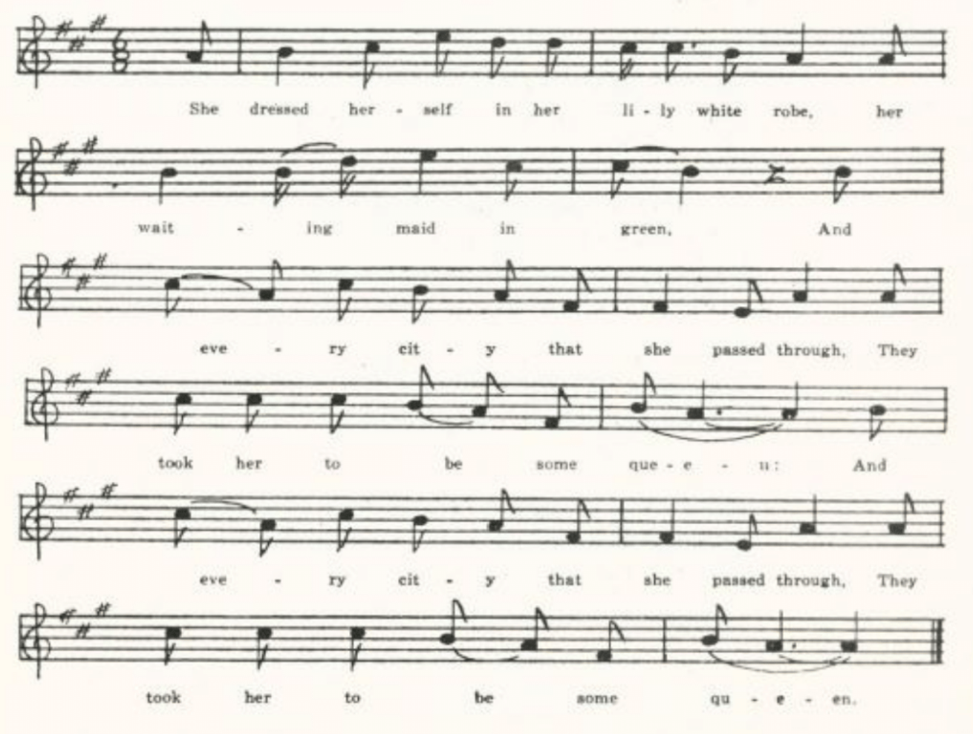
(46)
L
‘Lord Thomas and Fair Eleanor.’ Written down for Miss Lowry by Earl Cruickshank, one of her pupils in the Columbus (Kansas) High School in 1920. An exceptionally full text. Note the ballad repetition by which the description of Eleanor’s dress and its effect in the ninth stanza is anticipated in the description of Thomas in the fourth.

Lord Thomas was as fair a young man as ever
Kissed king’s daughter fair;
Fair Eleanor was a handsome lady,
Lord Thomas loved her dear.

‘Come riddle me, mother, come riddle,’ he cried,
Come riddle us both in one:
Shall I marry Fair Eleanor
OR bring the Brown girl home?’

‘The Brown girl, she has houses and land,
Fair Eleanor she has none;
So, if you take your mother’s advice,
Go bring the Brown girl home.’

He dressed himself in rich apparel,
His servants all in green,
And every village that he passed through
They took him to be some king.

Lord Thomas rode to fair Eleanor’s hall
And tingled all ’round the ring;
And none was so ready as fair Eleanor
To let Lord Thomas in.

‘What news have you, Lord Thomas?’ she cried,
‘What news have you today?’
‘I’ve come to ask you to my wedding.’
‘Oh, sorrowful news!’ cried she.

‘Come riddle me, mother, come riddle,’ she cried,
‘Come riddle us both in one;
Shall I to Lord Thomas’ wedding go,
OR stay with you at home?’

‘There’s many there may be your friend
And many may be your foe;
But if you take your mother’s advice
To Lord Thomas’ wedding don’t go.’

(47)
She dressed herself in rich apparel,
Her servants all in green,
And every village that she passed through
They took her to be some queen.

She rode and she rode to Lord Thomas’ hall
And tingled all ’round the ring;
And none was so ready as Lord Thomas
To let fair Eleanor in.

He took her by her lily-white hand
And capered all ’round the hall;
He took off his hat to every one,
And kissed her before them all.

‘Is this your bride, Lord Thomas?’ she cried;
‘I think she looks wonderfully brown.
You might have had as fair a bride
As ever the sun shone on.’

‘No sport of me,’ Lord Thomas then cried,
‘No sport of me today
’Twere better I love your little finger
Than the Brown girl’s whole body.’

The Brown girl had a little pen-knife
Which was both keen and sharp;
And sorrowful news I tell unto thee,
She pierced fair Elanor’s heart.

‘O what’s the matter?’ Lord Thomas then cried,
‘I think you look dreadfully pale.
You used to wear as fresh a color
As ever the rose did enhale.’

‘Oh, are you blind, Lord Thomas,’ she cried,
‘Or can you not very well see
The very last drop of my dearest heart’s blood
A-trinkling o’er your knee?’

Lord Thomas had a two-edged sword
Which was both keen and small;
He cut the Brown girl’s head from her body
And kicked it against the wall.

(48)
‘Go dig my grave,’ Lord Thomas then cried,
‘Dig it both wide and deep,
And bury fair Eleanor in my arms,
The Brown girl at my feet.’

He put the handle to the wall,
The point toward his heart,
Saying, ‘Here are three lovers very well met,
But sorrowfully they do part.’

Fair Margaret and Sweet William
(Child 74)

Child remarks that this is ‘a favorite of the stall,’ a fact which perhaps accounts in part for its frequency in American collection. He gives one text (V 293-4) from Massachusetts. Since the completion of his work it has been reported from tradition in Yorkshire (JFSS II 289-90) and Dorset (JFSS III 64-6), and on this side of the Atlantic from Newfoundland (FSN 94-8), Nova Scotia (BSSNS 25-6), Ontario (JAFL XXXI 74, a fragment), Maine (BBM 134-9), Vermont (VFSB 213-4), Virginia (TBV 221-39, SharpK I 139-40, 143-5, SCSM 103-5), West Virginia (FSS 65-77), Kentucky (JAFL XXIII 381-2, LT 94-9, FSKM 69-70, SharpK I 134-5, 142-3, besides a text introduced into a story by Julian Ralph in Harper’s Monthly for July 1903), Tennessee (SharpK I 132-4, 140-2), North Carolina (JAFL XXVIII 154-5, SharpK I 135-9, 145, FSSM 2-3), Mississippi (FSM 87-90), Ohio (JAFL XXXV 340-2), Indiana (JAFL XLVIII 301-3), Illinois (TSSI 141-2), the Ozarks (OASPS 181-3), and Missouri (JAFL XIX 281-2; whether the text printed by Kittredge in JAFL XXX 303-4 is to be assigned to Missouri or to Indiana is not clear). The rather puzzling opening scene in Child A and in many American texts is probably understood by singers of the ballad as an answer to some question asked by Margaret’s father; it is specifically so presented in FSS E. Several texts—perhaps feeling that this opening is not intelligible—have dropped it, beginning with Margaret looking out of her bower window and seeing William and his bride going by to church. Generally we are told that after this Margaret is seen no more, leaving it to be inferred that she dies of grief; but a good many texts imply, and some, e.g. the Missouri-Indiana text in JAFL XXX 303-4, directly say, that she commits suicide by throwing herself down from her high window. The visit of Margaret’s ghost, William’s report next morning of a dream that his bower was full of red (sometimes white) swine and his bride-bed full of blood, and the rose-and-briar ending are fairly persistent features of the story. The phrase ‘with the leave of my (wedded) lady’ of the Child versions has been expanded in some of the America texts to a formal asking of his lady’s permission to visit the dead Margaret.

(49)
A
‘Sweet William and Lady Margaret.’ Secured by Miss Williams in Clinton County in 1903. Printed in JAFL XIX 281-2.

Sweet William he rose one morning in June,
And dressed himself in blue:
‘Come tell me of that long love lay
Between Lady Margaret and you.’

‘I know nothing of that long love lay
Between Lady Margaret and me,
But tomorrow morning before eight o’clock
Lady Margaret my new bride shall see.’

Sweet William he rode to Lady Margaret’s hall
With his new bride all so gay,
And he saw Lady Margaret in the midst of her hall
A-combing of her hair.

She laid down her . . . comb,
She wrapped her hair in silk,
And out of the door went this lady gay
Never to return again.

When day was past and night came on
And all mankind was asleep,
Lady Margaret went to sweet William’s hall
And stood at his bed’s feet.

‘Oh how do you like your bed?’ said she,
‘And how do you like your sheet?
And how do you like that lady gay
That lies by your side asleep?’

‘Very well I like my bed,’ said he,
‘And well I like my sheet,
But better of all I like that lady gay
That stands at my bed’s feet.’

When night was passed and day came on
And all mankind was awake,
Sweet William said he was troubled in his head
Of the dreams he dreamt last night.

‘Such dreams, such dreams I do not lik,
Such dreams they are not good.
I dreamt my hall was full of white swine,
My bed was swimming in blood.’

O then he called his merry maids all,
By one, by two, by three,
And the last of them all he called his new bride:
‘Lady Margaret may I go and see?’

‘O if Lady Margaret you go and see,
Pray what will become of me?’
‘It’s first Lady Margaret I’ll go and see
And then I’ll return to thee.’

Sweet William he rose to Lady Margaret
Tingling full out to tell;
There was none so ready as her seven brothers
To rise and let him in.

‘O is Lady Margaret in her kitchen,
Or is she in her hall,
Or is she in her upper chamber,
Among her merry maids all?’

‘Lady Margaret is not in her kitchen,
Nor is she in her hall,
But yonder she lies in her cold coffin
Behind yonder wall.’

‘Fold back, fold back those flowing white sheets,
. . . . .me now decline;
For today they hand round Lady Margaret’s corpse
And tomorrow they shall hand around mine.’

(50)
Lady Margaret was buried in the new churchyard
Sweet William was buried by her;
And out of her heart there sprang a red rose,
And out of his a brier.

They grew and they grew by the old church wall
Till they could not grow any higher;
They lapped and they tied in a true lover’ knot,
The red rose and the brier.

B
‘Lady Margaret.’ Communicated in 1906 to C. H. Williams by J. G. Scott, who in turn got it from ‘a neighbor girl who learned it in the hill country of Bollinger and Perry Counties.’ The girl had ‘never seen it in print.’ As frequently in popular tradition, the story has been dramatized by transposing it to the first person except at the beginning and the end.

Lady Margaret was sitting in her high brown chair
A-combing back her hair;
Who did she spy but Sweet William and his bride
From the churchyard drawing nigh.

She first threw down her ivory comb,
And then threw back her hair;
Then she fell from her high brown chair—
Lady Margaret heard no more.

The day being gone, the night coming on
While all men were asleep,
Who did I spy but Lady Margaret’s ghost
A-standing by my bed-feet.

Saying, ‘How do you like your bed,
And how do you like your sheet,
And how do you like that new-wedded bride
That lies in your arms asleep?’

‘It’s very well that I like my bed,
And better I like my sheet;
But best of all’s that pretty fair maid
That stands at my bed-feet.’

The night being gone, the day coming on
While all men were awake,
Then I asked my wedded bride
If Lady Margaret I might see.

I went till I came to Lady Margaret’s door,
And loudly I tringled on the ring;
Who was there but Lady Margaret’s borther
To rise and let me in?

‘Oh, where is Lady Margaret?’ I said,
‘Is she in her kitchen or is she in her hall,
Or is she in her high brown chair
Among her wedding maids all?’

‘Neither she’s in her kitchen,
Nor neither she’s in her hall,
But she’s in her cold coffin,
Her face turned toward the lid.’

‘Go unfold those winding sheets
That are so nice and fine,
So I may kiss those lily-white lips
That often have kissed mine.’

First he kissed those lily-white lips;
The next he kissed was her hand;
Again he kissed those lily-white lips
And pierced his heart within.

They buried Lady Margaret in the churchyard,
They buried Sweet William in the choir.
From Lady Margaret’s breast there grew a red rose
And out of Sweet William’s a green brier.
. . . . . . .
. . . . . . .
They twingled and they twangled to the church tower top
For all true lovers to admire.

(51)
C
‘Lady Margarette.’ Communicated to Miss Hamilton by Nora Strickland of the West Plains High School in 1908 as ‘found among the papers of an aunt’ who took it down in 1877. The story is incomplete and confused.

Sweet William arose one May morning
And dressed himself in blue:
‘Come tell unto me that long, long love
That came between Lady Margarette and youn.’

‘I know nothing of Lady Margarette,
Lady Margarette knows nothing of me;
But tomorrow morning by eight o’clock
Lady Margarette my bride shall be.’

Lady Margarette was in her dressing room
A-combing back her hair
When she saw Sweet William with his own chosen bride;
TO the curch they were drawing near.

‘I’ll throw down my ivory comb,
I will just brush back my hair,
And I’ll go and make Sweet William bow,
And no more shall I go back there.’

She threw down her ivory comb,
She just brushed back her hair;
She went and she made Sweet William bow
And no more did she go back there.

D
No title. Another bit secured by Miss Hamiltonin West Plains, in 1910, from a Mrs. Bevier, who thought that it perhaps belonged to Barbara Allen—as in a sense it does, since the rose-and-briar ending is frequently attached to that ballad. But the names of William and Margaret, and the first three lines, show that it is a memory of Fair Margaret and Sweet William.

Sweet William rode forth one May morning
All dressed in silver gray,
. . . . . . .
. . . . . . .
Lady Margaret she died it seemed but today,
Sweet William he dies but tomorrow.
Lady Margaret she died of some pure love grief,
William, he died of sorrow.

And out of her bosom there grew a red rose,
And out of his a green brier.
And they linked together in a lover’s knot,
For only lovers to admire.

Lord Lovel
(Child 75)

Practically all the American texts belong to the tradition of Child H, a London broadside. It is not infrequent in stall print and in songbooks, and its popularity is evidenced by the fact that it was parodied for political purposes, on both sides, in the Civil War—see below. The rose and brier ending is an almost unfailing feature in modern texts, tho it is lacking in three of Child’s versions, C D G. The name of the church in the English broadside, St. Pancras, appears to have sounded strange in American ears, and has undergone various changes: St. Pancreas, St. Pancridge, St. Patrick, St. Pauthry, St. Varnie, St. Vincent, St. Rebecca, so that one may suspect a rather close relation to print where the original name is retained, as it is in Missouri D and two of the texts where the original name is retained, as it is in Missouri D and two of the texts in TBV. Texts have been reported since Child’s time from Aberdeenshire (LL 57-8), Wiltshire (FSUT 145-6), Essex (JEFDSS I 134), Kent (JFSS VI 31-2), and from Irish immigrants to America (BFSSNE I 4-5). On this side of the Atlantic I do not find it reported from Canadaor Newfoundland, but it is known in Maine (BBM 139-49, with valuable notes), Vermont (VFSB 215-6), Nantucket (JAFL XVIII 291-2, by way of New Jersey), Connecticut (JAFL XVIII 292, by way of New Jersey), Rhode Island (JAFL XVIIII 293), New York (SCSM 102, FLSH 203-4), Pennsylvania (JAFL XXXV 342, NPM 140-1), Maryland (SCSM 99-100), Virginia (TBV 240-58, SharpK I 146-7, 149, TNFS 55-6, SCSM 101-2, SFLQ II 70), South Carolina (SCB 121-4), Mississippi (FSM 90-1), the Ozarks (OMF 193-5), Ohio (JAFL XXXV 343), Indiana (JAFL XLVIII 303-5), Illinois (ABS 4-6, by way of Nebraska), Michigan (KNR 301), and Wyoming (ABS 6-7).
Six copies have come into the Missouri collection, but they are so nearly alike that it seems sufficient to give the text of one.

A
Secured by Miss Williams in Clinton County in 1903, and printed in JAFL XIX 283-4. No mention of church bells.

B
From the MS ballad-book of James Ashby of Mound City, Holt County, compiled in Civil War times or not long thereafter and secured for me by Miss Lois Welty in 1907. Printed in JAFL XIX 284-5. ‘St. Patrick’s bells.’

(53)
C
One of the many ballads secured thru Mr. C. H. Williams from his brother George of Bollinge County, in 1907. ‘St. Varnie’s bell.’

Lord Lovel he stood at his castle gaet,
A-combing his milk-white steed,
When along came Lady Nany Bell
A-wishing her lover good speed, speed, speed,
A-wishing her lover good speed.
(Repeat thus the last line of each stanza)

‘Oh, where are you going, Lord Lovel?’ she said,
‘Oh, where are you going?’ said she.
‘I’m going, my dear Lady Nancy Bell,
Strange countries for to see.’

‘Oh, when will you be back?’ she says,
‘Oh, when will you be back?’ says she.
‘In a year or two, or three at the most,
‘I’ll return to your fair body.’

He had not been gone but a year and a day
Strange countries for to see,
When languishing thoughts came into his head
Lady Nancy Bell he would see.

He rose, he rose upon his white steed
Till he came to London town;
And there he heard St. Varnie’s bell
And the people all mourning round.

‘Is anybody dead?’ Lord Lovel he said;
‘Is anybody dead?’ says he.
‘A lord’s daughter dead,’ a lady replied,
‘And some call her Lady Nancy.’

He ordered the grave to be opened forthwith
And the shroud to be folded down,
And there he kissed her clay-cold lips
Till the tears came trickling down.
Lady Nancy she died as it might be today,
Lord Lovel he died tomorrow.
And out of her bosom there grew a red rose
And out of Lord Lovel’s a briar.

They grew and they grew till the reached the church top,
And there they couldn’t grow any higher;
And there they entwined in a true lover knot,
Which true lovers always admire.

D
‘Lord Lovel.’ Secured by Mr. D. Stewart of Chillicothe in 1907 from G. B. Sherman of Grundy County. This text has ‘St. Pancras’ bell.’

E
‘Lord Lovel.’ Communicated in 1910 by Professor G. C. BRoadhead of Columbia as one of the songs he had known for more than fifty years. ‘St. Pancridge’s bells.’

F
‘Lord Lovel.’ Sent to me in 1912 by Miss Frances Yeater of Sedalia, Pettis County. ‘St. Vincent’s bell.’

G
The collection has two fragmentary texts of a Civil War parody of Lord Lovel satirizing Mansfield Lovell, the Confederate officer who failed to defend New Orleans against Farragut in 1862. It was printed in the New Orleans Delta at the time as ‘The

(54)
New Ballad of Lord Lovell.’ Cox lists it in FSS 78 but gives no text of it. In TBWV 28, however, he prints a text of two eight-line stanzas froma man in Pennsylvania who learned it in New Orleans. The ballad was parodied also to satirize Lincoln; see TBV 258-9.

(a)
Secured by Miss Hamilton in 1910 from Walter Haskell of the West Plains High School.

Lord Lovel he sat in St. Charles Hotel,
IN St. Charles Hotel sat he,
A-cutting as big a rebel swell
As ever you’d wish to see, see, see,
As ever you’d wish to see.

He had thirty thousand gallant men,
Thirty thousand men had he,
Who’d all sworn with him they’d never surrender
To any tarnation Yankee, kee, kee,
To any tarnation Yankee.

His thirty thousand gallant men
Dwindled down to a thousand and six,
And all of them then and there instanter
Commenced to cutting their sticks, sticks, sticks,
Commenced to cutting their sticks.

. . . . . . .
. . . . . . .
and gallant old Ben sailed in with his men
And captured their great citee-tee-tee,
And captured their great citee.

(b)
Communicated in 1931 by Mrs. Mary Paxton Keeley as sung by her ucle, C. A. Young of Kansas City, who heard it in Philadelphia not long after the Civil War. Mrs. Keeley did not remember all of it. The punning allusion to Admiral Porter’s mortar Fleet is apparent.

General Farragut. . . .
He sat in the St. Charles Hotel
. . . . . .
(News of the surrender comes)

‘I loved the drinks of St. Charles Hotel,
But I never could bear strong porter,
Especially served up in a shell
And mixed in an iron mortar.’

‘I rather think not,’ Sir Farragut said,
‘I rather think not,’ said he;
‘For if my porter would fly at your head
A terrible smash that would be.’

(55)
The Lass of Roch Royal
(Child 76)

This ballad has been reported but rarely in recent times. Keith (LL 59-63) has two texts from Aberdeenshire, both of them similar to Child’s D version; and in America two texts have been published (Cox, FSS 83-7; Combs, FSMEU 134-8), both from West Virginia, both going back to a text similar to Child’s D, and both, probably, ultimately from print. It is not in the Missouri collection. But a motive from it—at least one that appears, in Child’s work, only in this ballad—the shoe-and-glove motive—appears in a wide variety of contexts in the folk-lyric collected in America, and will be discussed later under that head in this volume: see The False True Lover.

The Wife of Usher’s Well
(Child 79)

This ballad has persisted better in America than in the old country. Child’s C is from Shropshire, ‘taken down…24th March, 1883, from the recitation of an elderly fisherman at Bridgworth;’ I have found no later record of it in the British Isles. Nor has it been reported from Canada or Newfoundland. In the United States many texts have been taken down in recent years, nearly all of them from the South. In Maine Barry found one person who recognixed nearly all of Cox’s West Virginia text A and another who knew several stanzas of Cox’s B and D; it has not otherwise been recorded from New England. Texts have been printed from Virginia (TBV 278-88, SharpK I 157-9, SCSM 168-9), West Virginia (FSS 88-93), Kentucky (JAFL XXX 308, FSKM 4, BSK 59-60, SharpK I 155-7), Tennessee (ETWVMB 121-2, SharpK I 152-3, 160, FSSH 71-2), North Carolina (Child V 294-5, JAFL XXX 306-7 (by way of California), SharpK I 150-2, 153-4, 159-60), Georgia (JAFL XLIV 63-4, FSSH 70-1), Mississippi (FSM 93-5), Nebraska (ABS 20-1), the Ozarks (OASPS 180-1), and Missouri. All of these American texts seem to belong to one version, distinguished from Child A B C by the following particulars:

- The revenants are children (most often ‘babes’) not the ‘stalwart sons’ of Child A.

- There is no cursing of the waters; but the mother often prays for the return of her babes.

- The children decline earthly food and drink because ‘yonder stands our Savior dear, to him we must resign.’ And commonly, too, the spendor of the golden spread the mother lays upon their bed is rebuked as evidence of worldly pride.

- The children are sent away at the beginning to ‘learn their grammarye’, a feature not found in Child A B C.

(56)
- The recall of ghost by cock-crow is either changed to the crowning of ‘chickens’ (except in BBM B, which is Irish)—this looks like a case of American bowdlerizing—or is omitted altogether, the children refusing the fine bed their mother has prepared for them or simply waking one another at the proper time.

- Use of the folk-belief that tears shed for the dead disturb their rest in the grave by wetting their winding-sheet. This is not unfailing but a very common feature of the American texts and does not appear in Child A B C.

The Shropshire version has in common with these America texts a strongly religious coloring, but has little resemblance to them in detail. One suspects some printed source as the explanation of the likeness in the American texts, but I find no mention of such.
I have in my file (it was printed in JAFL XXX 308-9) a text from Tennessee and also one printed in the Grapurchat, school paper of the East Radford (Va.) State Teachers College and sent to me by Professor Jean Taylor. The former was communicated to my by Professor A. R. Hohlfeld of the University of Wisconsin, who had it from Miss Mary Pierce of Nashville, In answer to a query of mine as to the provenience of the text Miss Pierce wrote to me: ‘I remember that the woman who gave me “The Wife of Usher’s Well” said that it was from a (ballad) book.’ Neither of these texts is from Missouri and they are therefore not given here.

A
‘The Lone Widow.’ Given to Miss Hamilton by Nita Stebbins of the West Plains (Howell County) High School, who had it ‘from a woman who used to live in the country. A song that her mother used to sing to her.’ Printed in JAFL XXIII 429.

There was a lady neat,
And children she had three;
She sent them away to far countrye
To learn their grammare.

They hadn’t been gone but a little while,
About three months, we’ll say,
Till death was abroad all over the land
And swept her babes away.

One winter night about Christmas time,
The night was dark and cold,
Her three little babes came running home
Into their mother’s room.

It was over the table she spread a cloth
And on it bread and wine,
Saying ‘Rise ye up, you three little ones,
And eat and drink of mine.’
‘I’ll eat none of your bread, mother,
I’ll drink none of your wine,
For yonder is our Savior dear
And with him we will join.

‘Cold clods lay over our heads, mother,
Green grass grows over our feet;
The tears you have shed, my mother dear,
Would wet our winding-sheet.’

(57)
B
‘Song Ballad.’ From the Civil War diary of Jacob Bess of Bollinger County, lent to me by his grandson, Professor Charles Bess of Flat River Junior College. There are two copies of it in the diary of which this is the second and fuller one. It belongs to the same tradition as A, but varies from it interestingly. The spelling and pointing have been standardized, but not the idiom.

There was a bride, a beautiful bride,
And three little babes had she.
She sent them away to the northern land
To learn the garmurre.*

They hadn’t been gone so very long,
About three week and a day,
When sixkness spread wide o’er the land
And swept them all away.

She prayed to God, if there be and God,
If there be any God on high,
To send her three little baes back home
That night or soon next day.

It being close to Christmas times,
When the nights was long and cool,
‘Come home, come home, my three little babes,
Come running home again.

‘Spread o’er the table bread and wine,
That my three little babes may dine.’
‘I can not eat none of your bread,
Neither can I drink your wine.

‘Tomorrow morn at eight o’clock
With my Savior I will dine.’
‘Spread o’er the bed the golden sheet,
That my three little babes may sleep.’

‘Take it off, take it off once more and again,
Take it off once more and again;
It hain’t been long since pride began.
Here stands my Savior word.†

‘Cold clods, cold clods at my head and feet,
Cold clods at my head and feet;
The teards that flowed from a mother’s eyes
Will wet a winding sheet.’

*So written in the diary. Possibly to be read as ‘grammar,’ but more probably, in view of the rime, as ‘grammarie.’
†So the line stands in the diary; and I do not know how to construe or amend it.

Little Musgrave and Lady Barnard
(Child 81)

There is a full and excellent discussion of this ballad, especially as found in America, in BBM 177-94. It has lived better on this side of the Atlantic than on the other. I have found no record of it in the old country since Child’s time (tho BBM H was learned in Scotland by the singer, who came to America ‘only about seventeen years ago’); but it has been reported from Nova Scotia (BSSNS 27-34, SBNS 11), New Brunswick (BBM 160-4, 173-6, 186-90), Quebec (BFSSNE III 6-8, by way of New Hampshire), and negroes in Jamaica (PMLA XXXIX 470-3), and in the United States from Maine (BBM 150-94, BFSNE VII 9-10), Virginia (TBV 289-301, SharpK I 182, SCSM 144-7; also in the Grapurchat, school paper of the East Radford State Teachers College, so in the Grapurchat, school paper of the East Radford State Teachers College, 25 August, 1932), West Virginia (FSS 94), Kentucky (JAFL XXX

(58)
309-14, FSS 94-5, TKMS 22-35, BKH 52-5, SharpK I 166-8, 170-82, BFSSNE IV 123), Tennessee (JAFL XLII 265-7, ETWVMB 50-4, SharpK I 164-6, 168, 172, FSSH 73-9), North Carolina (SharpK I 161-4, 168-70, 182, SSSA 65-8, SCSM 147-9; and JAFL XLII 265-7 is really from North Carolina), South Carolina (SCB 125-8), and Missouri.
Among the stigmata not used by the editors of BBM in distinguishing types of tradition in America is the opening scene (lost in many texts). In Child A of tradition in America is the opening scene (lost in many texts). In Child A C H and in most America texts from the South it is at church, or coming out of church, that the assignation is made. In the Northern texts this appears but once, BBM E; the Northern texts prefer ‘playing at the ball,’ as in Child D E J K L O, which is also the setting in not a few of the texts from the South as well. One trait of the Child texts does not appear in the America versions. In Child C E F H I J K L O and perhaps in D an attempt is made by the lady to corrupt or frighten the page. There is no hint to this effect in the America texts.

‘Little Matthy Gorves.’ Communicated in 1916 by Mrs. Case from her childhood memories in Harrison County. Printed in JAFL XXX 314-7, and again in BBM 177-80. The last line of each stanza is repeated by way of refrain.
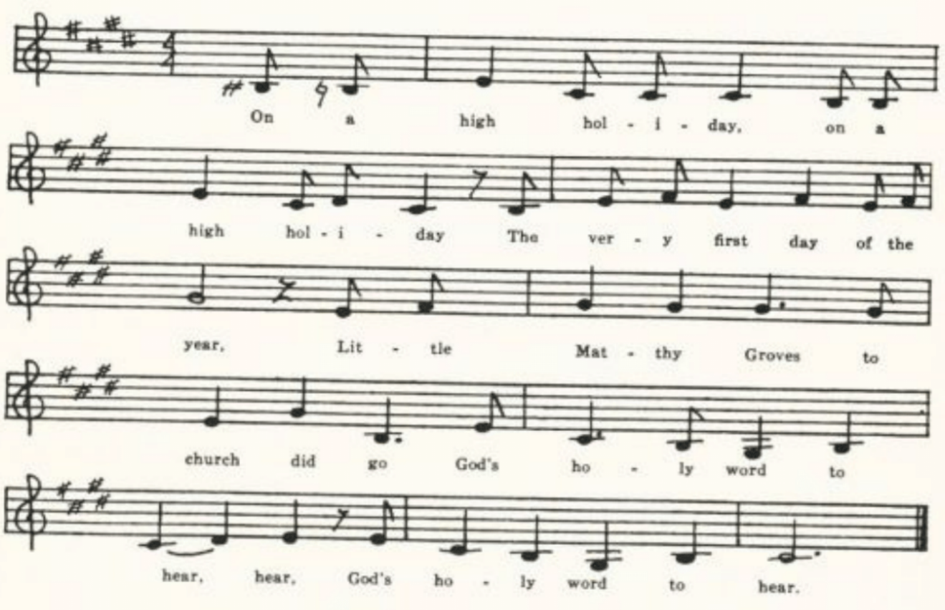
On a high holiday, on a high holiday,
The very first day of the year,
Little Matthy Groves to church did go
God’s holy word to hear, hear,
God’s holy word to hear.

The first that came in was a gay ladie,
And the next that came in was a girl;
And the next that came in was Lord Arnold’s wife,
The fairest of them all.

(59)
She steeped right up unto this one
And she made him this reply,
Saying, ‘You must go home with me tonight
All night with me for to lie.’

‘I cannot go with you tonight,
I cannot for my life;
For I know by the rings that are one your fingers
You are Lord Arnold’s wife.’

‘And if I am Lord Arnorld’s wife,
I know that Lord Arnold’s gone away.
He’s gone away to Old England
To see King Hen-e-ry.’

A little footpage was standing by,
And he took to his feet and run;
He run till he came to the waterside,
And he bent on his breast and swum.
What news, what news, my little footpage,
What news have your for me?
Are my castle walls all tor-en down,
Or are my castle three?’

‘Your castle walls are not tor-en down
Nor are your castles three
But little Matthy Groves is in your house
In bed with your gay ladie!’

He took his merry men by the hand
And placed them all in a row,
And he bade them not one words for to speak
And not one horn for to blow.

There was one man among them all
Who owed little Matthy some good will,
And he put his bugle horn to his mouth
And he blew both loud and shrill.

‘Hark, hark! Hark, hark!’ said little Matthy Groves,
‘I hear the bugle blow,
And every note it seems to say
“Arise, arise and go!”’

‘Lie down, lie down, little Matthy Groves,
And keep my back from the cold;
It is my father’s shepherd boys
A-blowing up the sheep from the fold.’

From that they fell to hugging and kissing
And from that they fell to sleep;
And next morning when they woke at the break of day
Lord Arnold stood at their feet.

‘And it’s how do you like my fine featherbed,
And it’s how do you like my sheet?
And it’s how do you like my gay ladie
That lies in your arms and sleeps?’

‘Very well do I like your fine feather-bed.
Very well do I like your sheets
But much better do I like your gay ladie
That lies in my arms and sleeps.’

‘Now, get you up, little Matthy Groves,
‘And all your clothes put on;
For it never shall be said in Old England
That I slew a naked man.’

‘I will get up,’ said little Matthy Groves,
‘And fight you for my life,
Though you’ve two bright swords hanging by your side
And me not a pocket knife.’

‘If I’ve two bright swords by my side,
They cost me deep in purse,
And you shall have the better of the two
And I will keep the worse.’

The very first lick that little Matthy struck
He wounded Lord Arnold sore.
But the very first lick that Lord Arnold struck
Little Matthy struck no more.

He took his lady by the hand
And he downed her on his knee,
Saying, ‘Which do you like the best, my dear,
Little Matthy Groves or me?’

(60)
‘Very well do I like your rosy cheeks,
Very well do I like your dimpled chin,
But better do I like little Matthy Groves
Than you and all your kin.’

He took his lady by the hand
And led her o’er the plain;
He took the borad sword from his side
And he split her head in ttwain.

‘Hark, hark, hark, doth the nightingale sing,
And the sparrows they do cry;
Today I’ve killed two true lovers,
And tomorrow I must die!’

Barbara Allen
(Child 84)

Whether originally a stage song (as might be conjectured from Pepys’s entry of January, 1666) or not, Barbara Allen has become, and remains, the most widely known and sung of all the ballads admitted by Child to his collection. Its persistence in print—broadside, stall, and songbook—down to the present might be looked upon as cause or as effect of its popularity; probably it is both. At least it is that most of the marks of its form in recent reports are due to printed versions. Child had a number of America texts but considered none of them worthy of mention. He knew too of versions in which the lovers makes bequests to Barbara, but considered them base matter, not fit for preservation. It might be convenient to list some of the features by which modern tests are distinguished. One is the time of year. In most texts, including Child B, a seventeenth century English broadside, it is the merry month of May, when green buds they are swelling, or an equivalent; in others it is Martinmas, when the leaves are falling (Child A, Ord, LL, one of the Maine and one of the Nova Scotia texts, and six from Southern states). The bequests, not found in any of the texts admitted to Child’s canon, appear in LL, Ord, texts from Oxfordshire, Somerset, and Newfoundland, but infrequently in the United States and not at all in Missouri. The taunt about leaving her our in the drinking of healths, found in Child A, Ord, and a Hampshire text, is almost unfailing in American copies; and so is the rose and briar ending, which does not appear in the Child versions. On the whole, however, the texts recently recorded are so much alike that it does not seem necessary to reproduce here all the copies in the Missouri collection. Six of them were printed in JAFL XIX 285-92.
The song has been reported since Child’s time fromAberdeeenshire (LL 67-70), Yorkshire (JFSS I 266), Norfolk (JFSS II 80), Lincolnshire (JFSS II 80, Oxfordshire (FSUT 206-7), Wiltshire (FSUT 204-5), Hampshire (JFSS I 267), Kent (JFSS I 265), Sussex (JFSS I 111—but the text here is confessedly from a broadside), and Somerset (JFSS II 15-6); and in America from Newfoundlands (BSSN 26-7), Nova Scotia (BSSNS 35-), Maine (BBM 195-200; one of these is from Irish tradition), Pennslyvania (NPM 122-4), Virginia (JAFL XXIX 161-2, TBV 302-45, SharpK I

(61)
191-195, SCSM 83-8, Grapurchat for 25 August, 1932), West Virginia (FSS 96-109), Kentucky (JAFL XX 250-1, XXII 63-4, LT 1-5, FSKM 39-44, BKH 47-8, MSHF 6-7, SharpK I 190-1, 192-5), Tennessee (JAFL XLII 268-70, SSSA 248, ETWVMB 66-8, 132-3, XLII 270-2, XLV 13-7, XLVI 28-9, ABS 10, SharpK I 187-8, 191-2, SCSM 89-96, SMFSB 12-3, FSSH 81-2, 84-7, SFLQ II 71), South Carolina (SCB 129-41), GErogia (JAFL XXIX 198, XLII 303-5, SharpK I 183-7), Mississippi (JAFL XXVIII 144-6, FSM 95-107), Texas (PFLST X 146-9), Ohio (JAFL XXXV 343, tune only), Indiana (JAFL XLVIII 310-1), Illinois (TSSI 137-9), Michigan (KNR 301), and Missouri (Ozark Life V No. 7, besides those from the Missouri collection printed in JAFL XIX). Shearin printed one from the Cumberland mountains in the Sewanee Review XIX 315. For further notation of its appearance in broadsides and songbooks as well as in further notation of its appearance in broadsides and songbooks as well as in collector’s reports see Kittredge’s very helpful bibliographical items in JAFL XXIX 160-1 and XXX 317.

A
No title. Secured by Miss Williams in 1903 from ;an old lady in Clinton County who sang it when she was a girl. It was then a common neighborhood song.’ Printed in JAFL XIX 288-90. Time, Martinmas. Sir James Grahm and Barbara Allen. She taunts him about the drinking of heaths in the tavern but he makes no defense. Rose and briar ending.

B
‘Barbara Allen’s Cruelty.’ Another text reported by Miss Williams in 1903 by W. S. Johnson from the singing of Tom Waters, local fiddler of Tuscumbia, Miller County. Season not mentioned. Sweet William and Barbara Allen. Begins as a narrative by the lover but passes after the first scene to the third person. Has the rose and briar ending and the charge about slighting Barbara when ;down yonder at the tavern you drank your wine with the ladies round’—for which a bystander offered, when this stanza was sung, the following local color substitute:

‘O Willie, O Willie, don’t you know,
When we’s down at the grocery drinkin’,
You drank the heath to the ladies all
And slighted Barbara Allen?’

Printed in JAFL XIX 285-6

D
‘Barbery Allen.’ Sent in by W. S. Johnson in 1903 as sung and written down by Stella Cotton of Tuscumbia. Time, early in the month of May. Little Jimmy Grooves

(62)
and Barbery Allen. When Barbery accuses Jimmy of slighting her in the drinking of healths he defends himself. Rose and briar ending. Printed in JAFL XIX 282-8.

E
‘Barbra Allen.’ A fragment of three stanzas, the rose and briar ending, contributed by Miss Lowry in 1905 as known by her aunt in Indiana. Printed in JAFL XIX 288.

F
'Barbra Allen, From a manuscript of about Civil War times, sent me in 1907 by D. W. Parsons of Sweet Springs, Saline County. Time, all in the merry month of May. Young Jemmy Grove and Barbra Allen. Four eight-line stanzas, stopping with Barbra's farewell to the dying man.
G
‘Barbara Allen.’ A tune, no text. Sent me by Mark Skidmore of Springfield, Missouri, in 1908, with the following note: ‘I was with a party of friends at Lakeside Park, near Carthage, one evening about three weeks ago. As we were rowing along one of the fellows began to sing “Barbara Allen.’ I had heard him sing it for me the next day and wrote it down. He said he had learned it when he was small from a family of Tennessee people who lived in his neighborhood.’
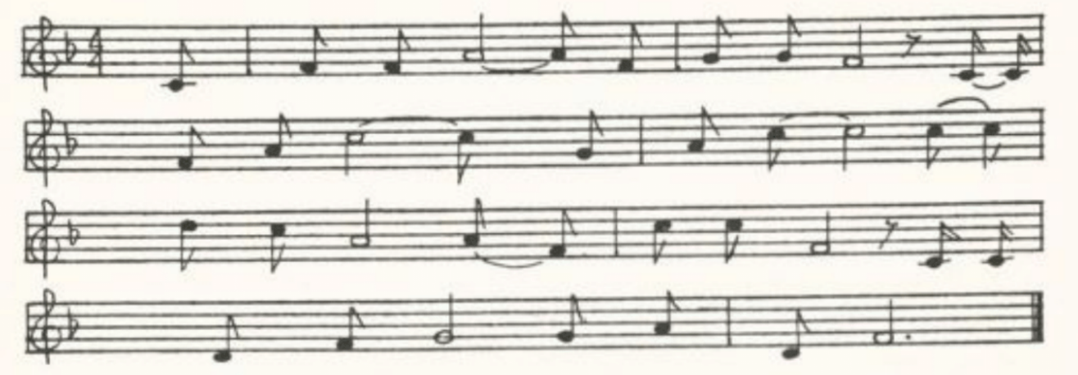
H
‘Barbara Allent.’ Sent me in 1909 by C. H. Williams as sung by his mother, in Bollinger County. Time, the merry month of May. Sweet William and Barbara Allen. Nothing about the drinking of healths. Rose and briar ending. Printed in JAFL XIX 291-2.

I
‘Barbara Allen.’ Secured b y Miss Hamilton in 1909 from Nellie Harper, one of her pupils in the West Plains High School. Time, the month of May. Sweet William and Barbara Allen. She rebukes him for slighting her at the wine-drinking and he defends himself. Rose and briar ending.

(63)
J
‘Barbara Allen.’ Secured by Miss Hamilton in 1911 from Agnes Shibley, one of her students at the Kirksville State Teachers College, as ‘sung by her grandmother,…who lived until she was grown in Vermont, Illinois, and moved to Putnam County in 1862.’ Season, ‘about the autumn’s time, When the green leaves were a-fallin’.’ Barbara Allen and Sir John Green. She charges him with slighting her at the health-drinking but he makes no defense. Ends with his dying words to her.

K
‘Barbara Ellen.’ Taken down by Miss Colquitt Newell from the singing of Mrs. — Chandler of Farmington, St. Francois County, in 1912. ‘She learned it as a child about fifty years ago from her mother, who in turn learned it as a child from an aunt. They havd never seen it in print,’ writes Miss Newell.
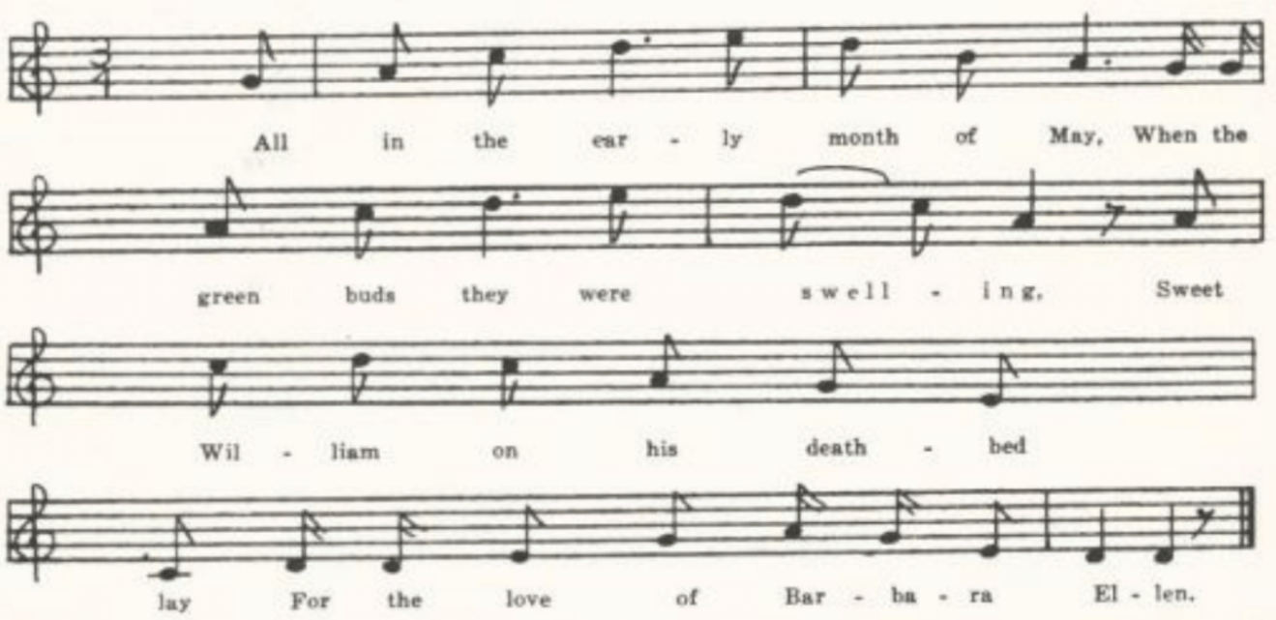
All in the early month of May,
When the green buds they were swelling,
Sweet William on his death-bed lay
For the love of Barbara Ellen.

He sent his servant to the town,
To the town where she was swelling:
‘My master’s sick and sent for you,
If your name be Barbara Ellen.’

Then slowly, slowly she rose up,
And she did come a-nigh him,
And all she said when she got there
Was, ‘Young man, I think you’re dying.’

‘It’s true I’m sick, and very sick,
And death lies in my dwelling;
And I do know that I will die
If I don’t get Barbara Ellen.’

‘It’s true you’re sick, and very sick,
And death lies in your dwelling;
But don’t you remember when the cup went round
And slighted Barbara Ellen?’

Then slowly, slowly she rose up
And slowly she did leave him;
She sighing said she could not stay
Since the breath of life had left him.

(64)
He turned his pale face to the wall,
And he began a-crying,–
‘And I do know that I will die
If I don’t get Barbara Ellen.’

Sweet William died on Saturday night,
And Barbara died on Sunday.
Her mother died for the love of both–
She died on Easter Monday.

Sweet William was buried in the high churchyard
And Barbara was buried in the squire;
And out of his heart there grew a red rose
And out of hers a briar.

They grew till they tied in a true love’s knot,
This red rose and this briar
They grew till they tied in a true love’s knot,
For all true lovers to admire.

L
‘Barbary Allen.’ A leaf torn from some cheap songbook and sent me by Miss Ruth Sedwick in 1912. A long text, in eight-line stanzas.

M
‘Barbara Allen.’ Sent to me in 1916 by Mrs. Case, with the tune, as known to her in her childhood in Harrison County. No mention of the season, or of a drinking of healths. I give the tune as she sent it. It might be mentioned that Sharp once told me he had taken down the tune of this ballad twenty-seven times and that it was always in 5-time.
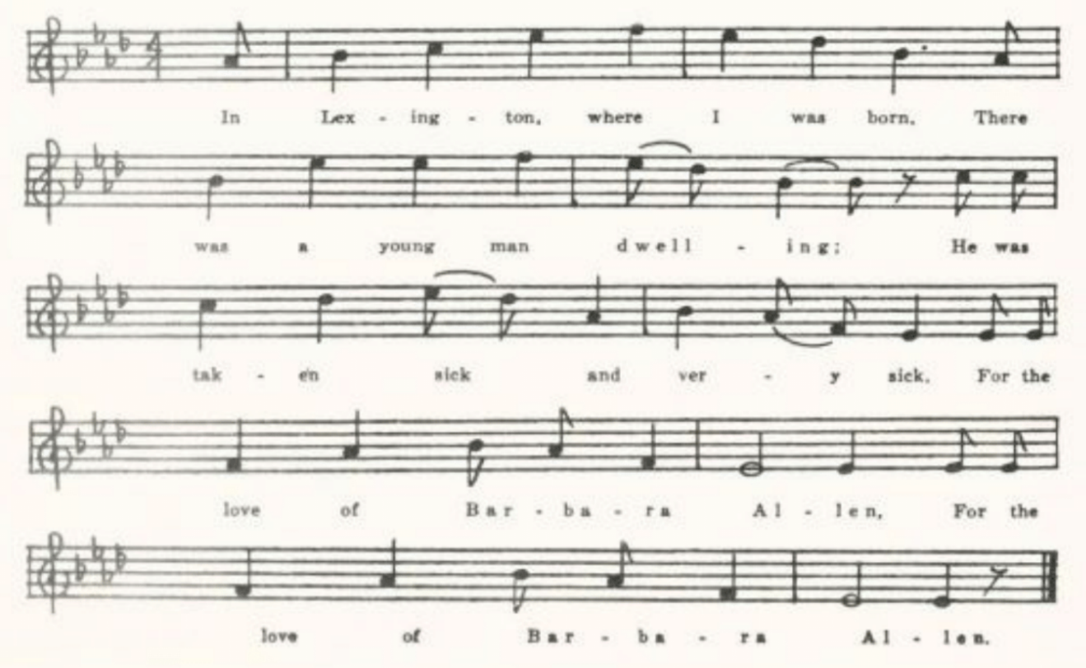
(65)
N
‘Barbara Allen.’ The tune as known to Mrs. L. D. Ames of Columbia, whose great-grandparents came from Virginia and Kentucky. Note that like Mrs. Case’s it is not in 5-time.
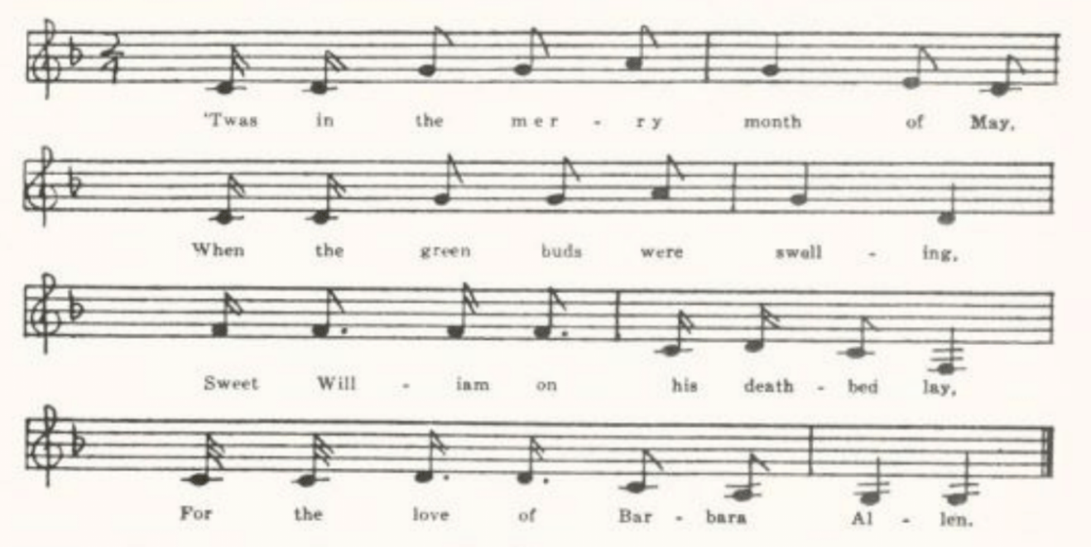
O
‘Barbary Allen.’ Taken down by Miss Grances Barbour of Washington University in 1917 from the singing of Minnie Dowyel of Arlington, Phelps County. Miss Barbour observed a ‘marked negro influence’ in the tune, but she did not write the tune down. She published the text in JAFL XLIX 207-8.

P
‘Bonny Barbara Allan.’ Contributed by Mrs. Jewell Grooms of Boone County in 1937 ‘as sung in this part of Missouri around seventy-five years ago.’ Time, the merry month of May. Taunt about the drinking of health in the tavern. Rose and briar ending.

There are also in the collection two texts not really from Missouri. One, contributed by Miss Leah R. C. Yoffie of St. Louis in 1917, was sent to her by a friend in Chicago who ‘heard it years ago in Port Colburn, Canada, on the Welland Canal.’ Mentions the health-drinking but has not the rose and briar ending. The other was given me in 1934 by Miss Beulah Wohlbeck, who had it from Miss Etta Sledge of Draper, North Carolina. Time, the early month of May. Sweet William and Barbara Allan. Barbara charges him with slighting her at the tavern (in the matter of dancing, apparently, rather than of drinking: ‘You gave your hand to the ladies all around’) and he defends himself. Rose and briar ending.

(66)
The Maid Freed From the Gallows
(Child 95)

For the range of this ballad in other languages (Romance, Germanic, Slavic, Magyar) and for the ‘golden ball’ form of the story see Child’s headnote; and for the later discussion and analysis and for its bearing on the question of ballad origins see Kittredge’s introduction to the one-volume Child xxv-xxvii, Miss Broadwood in JFSS V 231-8, H. Sager in MP XXVII 129-45, Reed Smith in SCB 80-97, Barry in BBM 210-3, and Davis in TBV 360-2. The story being essentially dramatic, it frequently takes the form of a folk-play, as in the Lancashire version given by Miss Broadwood (JFSS V 233-5) and the Florida negro version recorded by Miss Scarborough (TNFS 39-41). American versions, however, never show the ‘prickly bush’ refrain which prompted Miss Broadwood—rightly, no doubt—to connect this with the Seeds of Love song and to interpret the golden ball (silver cup, comb) as a symbol of virginity. In fact, the original conception of the story has been so far changed in many American versions that it is a man, not a woman, that is rescued from the gallows. This is the form of the story in the only text recorded from Missouri (if we except the negro folk-tale version given by Miss Owen in Old Rabbit the Voodoo).
It has been reported in recent times, as ballad, folk-play, or cante-fable, from Lancashire (JFSS V 233-4), Westmoreland (JFSS V 235), Oxfordshire (FSUT 282-3), Wiltshire (JFSS V 228-9, FUST 281-2), Dorsetshire (JFSS V 230-1), Somerset (FSSom No. 121); Neilson’s text in JAFL XVI 175 is from an Irish maid-servant in America; and it is known to the negroes of Jamaica (PMLA XXXIX 475-6, W. Jekyll’s Jamaican Song and Story 58-9; see also BBM 210-2) and of Andros Island (MAFLS XIII 152-4). In the United States it is widely known, having been recorded in Maine (BBM 206-213, 389-93), New York City (JAFL XXX 319-20), Virginia (TBV 360-80, TNFS 34-7, SharpK I 209-10, 212, 214, SCSM 199-200, FSSH 96-7, Grapurchat for 25 August, 1932), West Virginia (FSS 115-9), Kentucky (LT 44-8, BKH 113-4, DD 164-5, SharpK I 211-2), Tennessee (ASb 385, ETWVMB 15-6, SharpK I 208, SFLQ II 71), North Carolina (JAFL XXX 321, XLII 272, SharpK I 208-9, 213-4, BMFSB 18-9, FSSH 95-6, 98-9, SCSM 197-8), South Carolina (SCB 144-7), Mississippi (FSM 111-4, TNFS 39-41), Louisiana (TNFS 41-2), Oklahoma (JAFL KXII 272-3, by way of Jersey City), Indiana (JAFL XLVIII 312), and Missouri (Ozark Life VI No. 2). As noted above, it appears as a negro folk-tale from Missouri in Miss Owen’s Old Rabbit the Voodoo. There is a curious adaptation of it to the life of the western ‘bad man’ in CS 159-61.

‘The Hangman’s Tree.’ Contributed by E. E. Chiles in 1916 as known by his wife, who learned it from a housemaid, Elsie Ditch, in 1900, on a farm near Plattin, Jefferson County. Printed in JAFL XXX 320. Observe that it is here a man who is freed from the gallows.

(67)
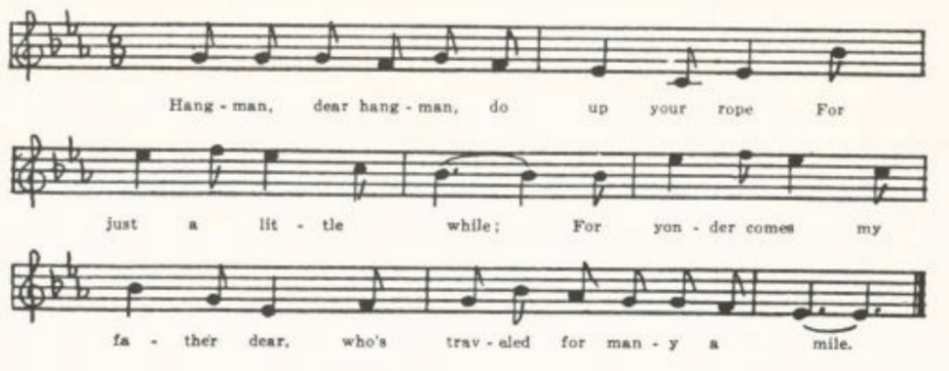
‘Hangman, dear hangman, do up your rope
For just a little while;
For yonder comes my father dear,
Who’s traveled for many a mile.

‘Father, dear father, fave you brought the gold?
Have you come to buy me free?
Or have you come to see me hung
Upon the gallows tree?’

‘Son, dear son, I’ve brought no gold,
Nor come to buy you free,
But I have come to see you hung
Upon the gallows tree.’

(Similarly, in sets of three stanzas each, for mother, sister, brother; then)

‘Hangman, dear hangman, do up your rope
For just a little while;
For yonder comes my sweetheart dear,
Who’s traveled many a mile.

‘Sweetheart, dear sweetheart, have you brought the gold?
Have you come to buy me free?
Or have you come to see me hung
Upon the gallows tree?’

‘Sweetheart, dear sweetheart, I’ve brought the gold,
I’ve come to buy you free;
I have not come to see you hung
Upon the gallows tree.’

(68)
The Baliff’s Daughter of Islington
(Child 105)

This is a seventeenth century broadside ballad. Child gives only one version, from a collection of broadside prints, tho he had an American text. It is one of the few ballads on the returned disguised lover theme (this time with the sexes reversed) which he admitted to his collection. It is still sung both in Great Britain and in America; probably more often than collectors’ records show, since it has held pretty closely to print and would therefore seem negligible to folklorists. Many of the reports listed below are of the tune only.
It has been reported since Child’s time from Aberdeenshire (LL 82-4), Oxfordshire (FSUT 174-5), Surrey (JFSS I 209), Sussex (JFSS I 125), Dorset (JFSS VII 34), and Somerset (JFSS VII 34-5); and from Maine (BBM 225-7), Vermont (GGMS 74-6, CSV 6-7), Virginia (TBV 383-4, 585), Kentucky (SharpK I 219-21), Mississippi (FSM 115-6), and Indiana (JAFL XXX 332). Kitteredge JAFL XXX 332 prints the tenth stanza of Mrs. Case’s version as an ‘amusing variation’, which it is; but it is by no means unique, the same or a similar stanza appearing in the Aberdeenshire and the two Kentucky texts.

‘The Baliff’s Daughter of Islington.’ Contributed by Mrs. Case as sung by her in her childhood in Harrison County.
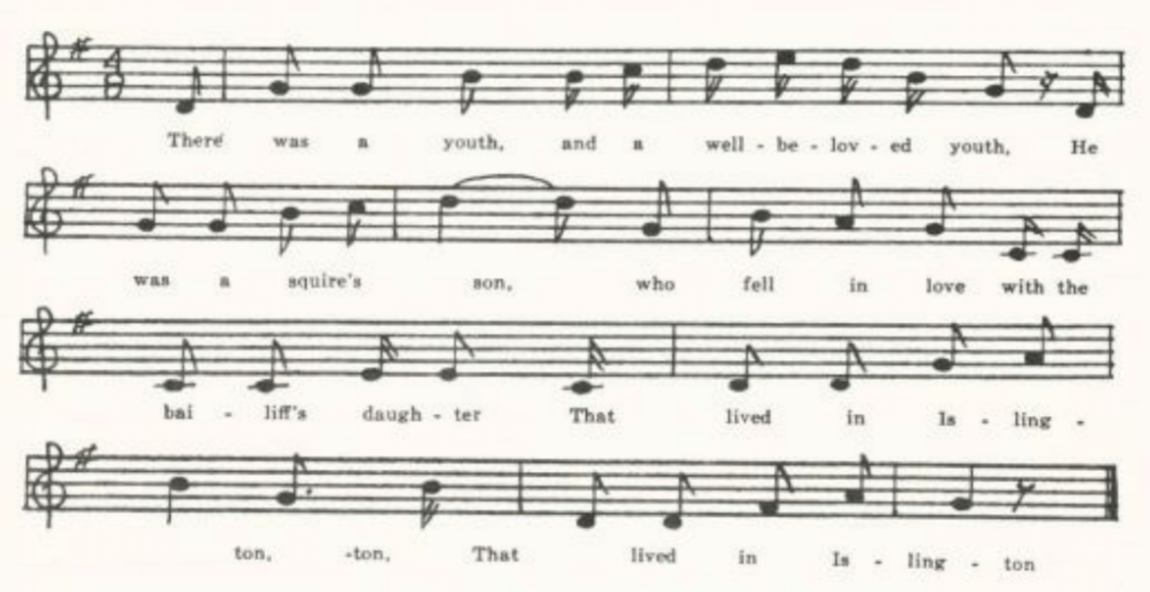
There was a youth, and a well-beloved youth,
He was a squire’s son,
Who fell in love with the bailiff’s daughter
That lived in Islington.

But when his friends did understand
His fond and foolish mind,
They sent him up to fair London
An apprentice for to bind.

And when he had been there seven long years
He longed his love for to se,
Saying, ‘Many fond tears have I shed for her
Who little has thought of me.’

(69)
Now all the maids of Islington
Went forth for to sport and play;
All but the bailiff’s daughter dear;
She secretly stole away.

Now she’s put off her gown so gay,
Put on her sober attire;
And she’s gone up to fair London
Her true-love to require.
And as she went along the road,
The weather being hot and dry,
There she saw her own true-love
At last come riding by.

She stepped right up unto his side,
Took him by the bridle-rein:
‘A penny, kind sire, oh give to me
For to ease me of my pain.’

‘I pray thee, sweetheart, tell to me
Where that thou wast born.’
‘At Islington, kind sir,’ said she,
‘Where I have had many a scorn.’

‘If you were born at Islington,
Pray tell me, dost thou know
The bailiff’s daughter of Islington?’
‘She’s dead, sir, a long time ago.’

‘If she be dead and I am a-living,
She’s lying there so low–
Oh, take from me my coal-black steed,
My fiddle and my bow!’

‘She is not dead, but she is a-living,
A-standing by your side;
She is not dead but she is a-living,
Ready for to be your bride.’

‘Oh, farewell grief and welcome joy,
Ten thousand times o’er and o’er,
For now I have seen my own true-love
That I thought I should see no more!’

Sir Hugh, or, The Jew’s Daughter
(Child 155)

It is somewhat surprising, in view of the vogue of the two themes combined in this ballad in medieval story, that child finds it in traditional balladry only in English. It is also remarkable that it has retained its popularity in America down to the present, as appears from the record of it listed below. The two themes are the miracle of Our Lady and the ritual murder of a Christian child by Jews. For the former see especially Professor Carleton Brown’s paper in the Chaucer Society Publications Series 2 No. 45 (1910).* The latter is dealt with at some length in Child’s headnote, and exhaustively by H. L. Strack, professor of theology at Berlin.† Belief in ritual murder is by no means extinct, as is shown by the excitement over an alleged case at Keif in 1913; nor is it held only in Slavic Europe. A charge of ritual murder was brought against the Jews of Massena, New York, as late as 1928. What has kept the ballad alive in America is probably not, however, racial or religious animosity but the simple pathos of the little schoolboy’s
*And more recently Dr. Woodburn Ross in MLN L 307-10.
†English translation with author’s revisions, The Jew and Human Sacrifice, London, 1909. For the possible connection of this medieval belief and so of our ballad with pre-Christian ritual in the Hellenic world see ‘“The Jew’s Daughter” and the Myth of Zagreus,’ MLN XXXIX 161-6

(70)
death. The miracle of Mary, which is the theme of Chaucer’s treatment of the story in the Prioress’s tale and which is still visible in some of the older versions of the ballad, Child A for instance, has almost entirely vanished from American versions; Our Lady’s drawwell has become simply a well or has disappeared completely, and the mother if she appears at all is merely a sorrowing (or sometimes a threatening) mother. Nor do any of the recent texts of the ballad show any clear idea that the murder has anything to do with religion. The enticer of the little boy is however regularly a Jew’s daughter (in the medieval miracle stories the boy is kidnapped or enticed, but never by a woman), and there is frequently a sort of formality about the killing—she lays him on a board and stabs him like a sheep; she carefully saves his blood in a basin; she withdraws to an inner room to do the deed, ‘where no one can hear him call’—which may well be a dim memory of the original motivation. Practically all the texts listed below, if they are not fragments, start with the boys playing ball and throwing their ball into the Jew’s garden, and most of them note that it was rainy weather. For conclusion many of them draw upon the formula found in most texts of The Two Brothers. An incongruous detail found in some of the Virginia texts—that when he is bought inside the Jew’s house he finds there his nurse (or mother, or sister) picking a chicken—is not an American invention, being found also in Child H K S and in one of the versions recorded by Sharp in Somerset.
The ballad has been recorded since Child’s time in Hampshire (JFSS I 264), Somerset (JFSS V 253-5), the Bahamas (JAFL XLI 470), and Nova Scotia (SBNS 16-7)l and in the United States in Vermont (BFSSNE V 6-7), Connecticut (JAFL XXIX 166), New York (JAFL XLIV 296-7), Pennsylvania (JAFL XXXIX 212-3, XLIV 65-7, FSSH 103-4, SCSM 174-5), Virginia (TBV 400-15, TNFS 53-4, SharpK I 227-8, JAFL XLVII 358-61, Grapurchat for 25 August, 1932), West Virginia (FSS 120-7), Kentucky (SharpK I 222, BMFSB 22-3, SCSM 123-4), South Carolina (SCB 148-50), Georgia (JAFL XLIV 64-5, FSSH 104-5), Alabama (ABS 15), Mississippi FSM 116-7), Ohio (JAFL XXXV 334-5), Indiana (JAFL XXIX 164, XLVIII 297-8), and Missouri. B. L. Jones (KNR 301) mentions it as known in Michigan but does not give a text.

A

‘The Jew’s Garden.’ Contributed in 1903 by Miss Williams, from Clinton County. Printed in JAFL XIX 293-4.

IT rained all night and it rained all day,
It rained all over the land.
The boys in our town went out to play
To toss their ball around –round –round,
To toss their ball around.
(Repeat thus the last line of each stanza)

(71)
Sometimes they tossed their ball too high,
And then again too low;
They tossed it into a Jew’s garden
Where no one would dare to go.

Out came the Jew’s daughter, out came the Jew’s daughter,
Out came the Jew’s daughter all dressed,
And said to the boy, ‘Little boy, come in,
And get your ball again.’

‘I won’t come in, I shan’t come in;
I’ve often heard it said
Whoever goes into a Jew’s garden
Will never come out again.

The first she offered was a yellow apple;
The next was a bright gold ring;
The third was something so cherry red,
Which enticed the little boy in.

She took him by the lily-white hand
And led him through a hall
Into a cellar so dark and dim
Where no one could hear him call.

She pinned a napkin round his neck,
She pinned it with a pin;
And then she called for a tin basin
To catch his life-blood in.

‘Go place my prayer-book at my head,
My Bible at my feet;
And if any of my playmates ask for me
Just tell them that I’m asleep.

‘Go place my Bible at my feet,
My prayer-book at my head;
And if any of my playmates ask for me
Just tell them that I am dead.’

B
Anotehr version secured by Miss Williams, with the notation that the contributor learned it years ago in Kentucky and did not know of it in print. Printed in JAFL XIX 294. In this there is no dialog between the Jew’s daughter and the boy, indeed there is no

(72)
woman, simply ‘they;’ the boy volunteers to climb the wall and bring back the ball; and the conclusion is

They dug his grave by a juniper tree,
They dug it wide and deep;
A marble slab at his head,
And his ball at his feet.

C

‘The Jew’s Garden.’ Secured by Miss Charlotte F. Corder in 1906 from Mrs. Mollie Lewis of Lafayette County, who learned it from her mother, a native of Virginia.

It rained all day, it rained all day,
It rained all over the town,
Till all the boys within our town
Went out to toss their ball, their ball,
Went out to toss their ball.
(Repeat thus the last line of each stanza)

At first they tossed their ball too high
And then again too low,
Till over into the Jew’s garden it went
Where no one dared to go.

Out came the Jew’s dauther all dressed, all dressed,
All dressed in riches gay:
‘Come in, come in, my little man,
You shall have your ball again.’

‘I won’t come in, I shan’t come in,
Unless my playmates do;
For I’ve often heard those who go in
Never come out again.’

She gave to him a cherry red,
And then a gay gold ring;
She gave to him a gay gold ring
To entice this little boy in.

She took him by his lily-white hand
And through a dark passage went,
Down into a cellar so dark and deep
Where no one could hear him lament.

(73)
. . . . . . .
‘Pray lay my Bible at my head,
My prayerbook at my feet;
If any of my playmates call for me,
Pray tell them I’m asleep.

‘Pray lay my Bible at my feet,
My prayerbook at my head;
If any of my playmates call for me,
Pray tell them I am dead.’

The Gypsy Laddie
(Child 200)
Of the twelve versions of this ballad recognized by Child (five Scotch and two from the north of Enland, one Irish, one from Shropshire, one from gypsies, one from Massachusetts, and one from New York) the northern broadside, G, is apparently the source of or at least the nearest akin to the American texts. It was also printed by catnach, and had sufficient popularity in this country to be burlesqued in DeWitt’s Forget-Me-Not Songster(New York, 1872, p. 223). Child gives no analogs from other languages; but since Child’s work was completed Olrik, in his continuation of Grundtvig’s work, has published (DgF No. 369) a Scandinavian ballad in which a proud girl who has refused princes and noblemen is fooled into marrying a roaming ‘skinner,’ the Danish equivalent of gypsy or tinker, and ends as a tinker’s trull. The jingling refrain commonly found in American versions (as in Miss Law’s text, below) I have not found in British texts. The compelling charm of gypsy music (regarding which see JEFDSS II 83-91) is fairly well retained in America, north and south, as are also the shoes (or boots) of Spanish leather; the latter derive from the English broadside. But what has apparently most pleased American singers is the contrast between domesticity, security, and luxury on the one hand and the homeless proverty of the wandering gypsies on the other. Few texts miss the comparison between the warm feather bed and the cold, cold ground.
Texts have been recorded from tradition since Child’s time in Aberdeenshire (LL 126-9; also in Ord), Oxfordshire (FSUT 122), Berkshire (FSUT 120), and Somerset (FSSom 18); and on this side of the water in Newfoundland (FSN 13-6, BSSN 38-9), Nova Scotia (JAFL XVIII 194), Nantucket (by way of New Jersey, JAFL XVIII 193), Pennsylvania (JAFL XXIV 346-7), Virginia (TBV 423-31, SharpK I 237-9, SCSM 218-21), West Virginia (FSS 130-6), Kentucky (FSKM 14-7, SharpK I 237-8), Tennessee (ETWVMB 59-60, SharpK I 233-4, 236, FSSH 110-2), North Carolina (SharpK I 234-6,

(74)
237, 239, FSSH 112, BMFSB 6-7, TBSSG, 4-5, SCSM 216-9), South Carolina (SCSM 221-3), Mississippi (FSM 117-9), Ohio (JAFL XXV 174-5), Illinois (JAFL XLVIII 385-6, TSSI 140-1, SCSM 223-4), Iowa (MAFLS XXIX 11), and Missouri. It is given without precise location in FSSM 4-5.

A
‘Black Jack Daley.’ Given me in 1905 by Finis Dean as known by his mother in Carroll County. Printed in JAFL XIX 294-5.

Black Jack Daley a-crossing the sea,
HE sang and he sang most beautifully;
He sang and he made the green woods ring,
And he charmed the heart of a lady,
And he charmed the heart of a lady.
(Repeat thus the last line of each stanza.)

‘Oh, will you leave your house and lands,
Oh, will you leave your baby,
Oh, will you leave your own true lover
And go with Black Jack Daley?’

‘Oh yes, I’ll leave my house and lands,
Oh yes, I’ll leave my baby,
Oh yes, I’ll leave my own true lover
And go with Black Jack Daley.’

(Own true lover find it out:)

Go saddle me my coal-black pony
And saddle her up in a hurry;
I’ll ride all night and I’ll ride all day
And I’ll overtake my lady.’

(He overtakes her:)

‘You take off those high-heeled shoes
Made of Spanish leather;
You put on these low-heeled shoes,
And we’ll walk the road together.

‘Last night you lay on a warm feather bed
By the side of me and the baby
Tonight you’ll lie on the cold damp ground
By the side of Black Jack Daley.’

B
‘Black Jack Davy.’ Written out for Miss Hamilton by David Hogan, one of her pupils in West Plains, in 1909. He got it ‘from an old lady.’ Printed JAFL XXV 174. IT is not always clear to whom the speeches are to be assigned.

‘Come go with me, my pretty little pink,
Come go with me, my honey,
Come go with me to a distant land
Where we never will need for money,
Where we never will need for money.
. . . . .
‘The river slow, the heather bright,
The sky is low and hazy;
But ere the morning dawns again
You’ll be gone with the Black Jack Davy,
You’ll be gone with the Black Jack Davy.’
. . . . .
‘Go bring me out my high-heel shoes
That’s made of Spanish leather,
And I will wear them out today
For flowers at the distant heather,
For flowers at the distant heather.’
. . . . .
‘Go bring me out my milk-white horse
Which rides so light and steadyl
I’ll ride all day and I’ll ride all night
Till I overtake my lady.’
. . . . .

C
‘The Gyptian Laddie.’ Contributed by Miss Lucy Laws of Christian College, Columbia, in 1911. Learned in her childhood in Kentucky from a Shakeress who was a nurse in the family. Miss Laws adds: ‘I heard portions of this ballad in Columbus, Indiana, in 1869. The tune was entirely different and the ballad altogether suggestive of conscious coarseness.

‘One there was a high-born lord,
He courted a high-borne lady;
He met with a false (or fault), a false so gay
Along of Gypsy Davy—O

Chorus:

Hoops now’s all the go,
Sets the darkies crazy;
This is the way we all shall go
Along o’Gypsy Davy (sometimes Davy—O)
. . . . . .
Last night she slept in a warm feather-bed
And in her arms her baby;
Tonight she sleeps the devil knows where
In the arms of Gypsy Davy.

‘…Probably I caught the words from children in the public school or on the street.’ Evidently from the Forget-Me-Not Songster burlesque, of which the chorus runs:

Elopments now are all the go,
They set the ladies crazy;
Now then, ladies all, beware,
And look out for Gypsy Davy,

and quite a different affair from the version she learned from the Shakeress. Printed in JAFL XXV 171-4.

‘O would you leave your house and home,
O would you leave your honey?
O would you leave your three little babes,
To go with the Gyptian laddie?’

Raddle-um-a-ding, a-ding, ding, ding,
Raddle-um-a-ding-a-dary,
Raddle-um-a-ding, a-ding, ding, ding,
Raddle-um-a-ding-a-dary (or She’s gone with the Gyptian laddie!)

‘O yes, I’d leave my house and home,
O yes, I’d leave my honey,
O yes, I’d leave my three little babes
To go with the Gyptian laddie.’

The old man came home that night
Inquiring for his honey;
The maid came tripping along the hall:
‘She’s gone with the Gyptian laddie.’

‘Go saddle for me my milk-white steed,
Go saddle for me my brownie;
I’ll ride all night and I’ll ride all day
Till I overtake my honey.

(76)
‘O come go back with me, my love,
Go back with me, my honey;
I’ll lock you up in a chamber so high
Where the Gyptian can’t come near you.’

‘I won’t go back with you, my love,
I won’t go back, my honey;
I’d rather have one kiss from the Gyptian’s lip
Than all your land and money.’

(Forgotten stanzas, in which he bids her strip off her finery—rings and diamonds, perhaps—and then the Gyptian casts her off).

‘Last night I slept in my fine feather-bed
And in my arms my dearie;
Tonight I sleep in an old . . .
And the Gyptian won’t come near me (or And the gypsies all around me).’

Geordie
(Child 209)

Child prints fourteen versions (some of them fragments), all from Scotland, the earliest that contributed by Burns to Johnson’s Museum, and as an appendix two broadside good-nights found in the Roxburghe and Pepys collections which contain something of the same matter and which he thought were derived from or colored by the Scotch ballad. Ebsworth, however (Roxburghe Ballads VII 67-73), thought that the broadsides (which go back to the seventeenth century) were the earlier form, dealing with a border reiver, and that the Scotch forms were adapted from these by folk-singers taking up local names and persons. IT was part of the stock of nineteenth century ballad printers in London, Pitts, Such, and Catnach, in a form fairly close to most America texts. In these the ransom motive is absent; George’s offense is stealing the king’s horses and selling them in Bohemia (or some perversion of that name); and George is hanged in a golden chain or a silken cord (once in a white silk robe). Child mentions no American texts. Since his time it has been frequently recorded on both sides of the Atlantic. It has been reported from Aberdeenshire (LL 130-3; also in two forms in Ord, 408-10, 456-7), Lincolnshire (JFSS III 191), Cambridgeshire (JFSS II 47-9), Norfolk (JFSS IV 89-90), Suffolk (JFSS IV 332), Surrey (JFSS IV 332), Sussex (JFSS I 164, II 208), Dorset (JFSS IV 332-3), and Somerset (JFSS II 27-8); from Newfoundland (BSSN 40); and in the United States from Vermont (VFSB 241-2), Pennsylvania (NPM 158-9), Virginia (TBV 435-8, SharpK I 242, SHF 12-3), West Virginia (FSS 135-6), North Carolina (SharpK I 2401-1, 243, MSNC 13-5, SCSM 214-5), the Ozarks (OMF 224-5), and Missouri. Cox has a serviceable bibliographical note on this ballad.

A
‘The Life of Georgia.’ From the MS ballad book of James Ashby, Holt County, sent to me in 1906 by Miss Lois Welty. Ashby was a veteran of the Civil War, and the books seems to have been compiled not long after the war. Printed JAFL XX 319-20.

(77)
As I was going over Muldars Bridge—
IT was in the morning early—
I heard a fair damsel lamenting and say,
‘Lord, spare me the life of Georgia.

‘Go bridle up my milk-white steed
And saddle him up so gayly,
That I may ride to the King’s castle town
And plead for the life of Georgia.’

She rode all day, she rode all night,
Until she was wet and weary;
And combing back her fine yellow hair,
Pleading for the life of Georgia.

Pulling out a purse of gold,
Saying unto the lawyers:
‘Lawyers, lawyers, fee yourselves
But spare me the life of Georgia.’

Says Georgia unto the lawyers:
‘I never murdered any;
But I stold sixteen of the King’s white steeds
And sold them in Bohema.’

Says the lawyers unto Georgia:
‘Lord, I feel sorry for you,
But your own confession has condemned you to die;
May the Lord have mercy on you.’

‘Georgia shall be hung with a golden chain,
If it cost ten thousand guineas,
Because he came of a royal race
And courted a virtuous lady.’

As he walked up and down the streets
And he bid farewell to many;
And he bid farewell to his own dear girl,
Which grieved him more than any.

‘I wish I was on London’s shore
Where work and money is plenty,
With a sword and pistol by my side
I would fight for the life of Georgia.’

B
No title. Give to Miss Hamilton by Mary van Wormser, one of her pupils in the West Plains High School, 1909, as ‘sung to her by her grandfather.’

‘Go saddle me my milk-white steeds
And bridle them so neat,
That I may ride down to Newcastle gate
And beg for the life of Georgie.’

‘George shall be hung in golden chains,
For he is more bolder than any;
He stole sixteen of the king’s milk-white steeds
And sold them to his Janie.’

C
‘Georgia.’ Given to Miss Hamilton at the Kirksville State Teachers College in 1911 by Agnes Shibley, who got it ‘from Mr. Finkens’s collection, Macon County’—doubtless a MS ballad book.

As I walked over the London bridge,
It was in the morning early,
It was there I spied the pretty fair maid
A-lamenting for her Georgia.

‘Saddle me my milk-white steed,
Bridle him most gaily,
And I will ride till break of day
Or save me the life of Georgia.’

(78)
She rode till she came to Naveville hall,
It was in the morning early;
It was there on her bended knees did fall
To plead for the life of Georgia.
The king looked over his right shoulder,
And seemed to be quite sorrow,
Saying, ‘Kind lady, you’ve come too late;
Georgia is condemned already.’

The False Lover Won Back
(Child 218)

Professor John Robert Moore published the following text in JAFL XXXIV 395-7, with the notation that it had not been elsewhere reported from America. It was given to him in 1921 by one of his students at Washington University, Miss Lillian Scott, who had received it from Miss Gladys Moore of Galena, Stone County, Missouri. Miss Moore had learned it fin childhood from the singing of her grandmother, a native of the northern pat of Cumberland, who was then living with Miss Moore’s family. The only other report of it in recent time that I have noted is from Aberdeenshire, LL 153-5.

‘The True Lover’
(Child 218)

A fair maid sat in her front door
Wringing her lily hands.
And by it came a sprightly youth
Fast stripping o’er the sands.

‘Where go you, young John?’ she says,
‘So early in the day?
It makes me think by your fast trip
Your journey’s far away.’

He turned about with an awful look
And said, ‘What’s that to you?
I’m going to see a lovely maid
More fairer far than you.’

‘Now have you played me thus false
In summer amid the flowers,
I will repay you back again
In winder amid the showers.

‘But never fear, dear love, for me
You may come back again.
But if you look at other girls
I’ll look at other men.’

But she took up her clothing fair
And after him went she.
But all he said was, ‘Go back again,
No farther go with me.’

The first town that they came to
He bought her a blazing ring;
And then he said, ‘Go back again
And go no more with me.’

The next town that they came to
He bought her a muff and gloves
And told her to go back again
And find some other love.

The next town that they came to
His heart it grew more warm,
And he was deep in love with her
And she was over again.

The next town that they came to
He bought her a wedding gown
And made her a lady of his own bowers
In sweet Berwick town.

(79)
James Harris (The Daemon Lover)
(Child 243)

All of Child’s versions from oral tradition are Scotch; A and B are from ballad print, A a Pepys broadside and B from a later garland. He gives no American texts except two stanzas of an American stall print that had appeared in a magazine. Since then Barry has printed the DeMarsan (New York) broadside, of about 1860, in JAFL XVIII 207-9—a text to which most of the American copies from oral tradition conform rather closely. The nearest to it of the Child versions is B, the garland print. There can be, I think, no question, in the case of this ballad, of the importance of print in spreading and perpetuating it. Yet if Child was right in believing that the seventeenth century broadside was the original or at least the ancestor of the traditional forms, we have here a fine instance of what Barry called communal recreation. Nothing could well be more prosaic and pedestrian than the James Harris of the Pepys collection; but tradition has transformed it into a pretty good ballad, and one that has maintained a strong hold on the affections of ballad singers. Where Child B and the DeMarsan print are the work of professional ballad-makers or merely record a text wrought out by folk singers it would not be easy to say; probably the latter. Child adduces no parallels from other languages. There is however a Danish ballad (DgF 39) of the treacherous merman which bears some resemblance to it in plot.
It has been reported in recent times from Aberdeenshire (LL 196-7) and Dorset (JFSS III 84) in the old country, and in the United States from Maine (BBM 304-10), Vermont (GGMS 80-2, BFSSNE VI 78, the latter Irish), Pennsylvania (JAFL XXV 274-5), Virginia (TBV 439-78, SharpK I 256, 257, SCSM 151-6, Grapurchat for 25 August , 1932), West Virginia (FSS 139-49), Kentucky (JAFL XX 257-8, TKMS 54-61, DD 172-3, SharpK I 246-8, 256, 257, 258, SCSM 158-9), Tennessee (JAFL XLII 274-6, SharpK I 249-50, 252-4, FSSH 116-8, SFLQ II 75), North Carolina (JAFL XLV 21-5, SharpK I 244-6, 248-9, 250-2, 254-6, 258, FSSH 113-6, SCSM 156-7), South Carolina (SCB 151-5), Mississippi (FSM 119-22), Texas (PFLST X 159-62), Ohio (JAFL XXXV 347-8), Indiana (JAFL XLVIII 295-6), Illinois (JAFL XXVI 360-1, by way of Nebraska, reprinted ABS 43-5), Iowa (MAFLS XXIX 11-3), Minnesota (Dean 55-6), and Missouri (Ozark Life V No. 8, JAFL XLIX 209-11). In SFLQ II 75-6 is a text, learned from a man in Kentucky, of ‘The Rocky Mountain Top’ which curiously combines stanzas from this ballad with others from Lady Isabel and the Elf-Knight.
In Missouri the texts are much alike, and all are close to the DeMarsan broadside. The title, where one is given, is ‘The House Carpenter’ (the English ‘ship carpenter’ is lost, except in version I). All except E and H, which lack the opening lines, begin with the man’s greeting to the woman, ‘Well met, well met, my own true love’ or the like. In all he replies to her question of how he is to maintain her by telling of his ships. In all he

(80)
promises to take her ‘where the grass grows green on the banks of the sweet Willee’ A B F G, ‘of the salt water sea’ C, ‘of the sweet Dundee’ D, ‘of Elmore’ E, ‘of liberty’ H—variations of DeMarsan’s ‘where the grass grows high, on the banks of old Tennessee.’ In all she kisses her baby goodbye and bids him keep his father company; and tells her lover, in reply to his question what she is weeping for, that she is weeping for her baby (in C for her husband and her baby). All except C and I have the curious incremental repetition in the statement of time (see the text of D, below). IN a ll the ship sinks (springs a leak in all except E) and disappears, with no intimation of supernatural agency. Two traits of the DeMarsan broadside, his boast that he might have married a king’s daughter and the closing curse on seamen, have been lost from about half of the Missouri texts, the former appearing only in C D G H I, the latter only in B D G. The hills of heaven and of hell, the only clear evidence of the supernatural in American texts, retained in several from Virginia, Kentucky, and other southern states, are not in the DeMarsan broadside nor in any of the Missouri copies.

A
‘The House Carpenter.’ Secured by Miss Williams in 1903 in Clinton Countty. Printed JAFL XIX 295-6.

B
No title. Contributed by W.S. Johnson from Miller County in 1904. Printed JAFL XIX 296-7.

C
‘House Carpenter.’ Secured by Miss Hamilton in 1909 from Julia Rickman of the West Plains High School, who described it as ‘written by an old lady who now lives in California but was formerly a resident of Missouri.’

‘Well met, well met, my own true love,
Well met, well met,’ said he;
‘I have just returned from the salt water sea
And it was all for the love of thee.

‘I could have married a King’s daughter fair,
And she would have married me,
But I refused a crown of gold—
It was all for the love of thee.’
‘If you could have married a King’s daughter fair,
And she would have married you,
I think you are much to blame;
For I have lately married a little house carpenter
And I think he’s a nice young man.’

(81)
‘O, will you forsake your house carpenter
And come along with me?
I will take you where the grass grows green
On the banks of the salt water sea.’

‘If I would leave my house carpenter
And go along with you,
What have you to maintain me upon
And to keep me from slavery?’

‘I have seven ships on the high, high sea,
All sailing for dry land;
One hundred and ten bold jolly young men
You can have at your command.’

She picked up her sweet little babe
And gave it kisses three,
Singing, ‘Stay at home, my sweet little babe,
Keep your father company.’

She dressed herself in rich attire,
Most costly to behold,
And as she marched the long highway
She shone like glittering gold.

She had not been on the sea three weeks,
I am sure it was not four,
Until fair Ellender began to weep,
And she wept most bitterly.

‘Oh, do you weep for your house carpenter,
Or do you weep for your gold,
Or do you weep for your sweet little babe
Whom you never will see any more?’

‘I neither weep for your gold,’ said she,
‘Neither do I weep for your store,
But I do weep for my house carpenter and sweet little babe
Whom I never will see any more.’

She had not been on sea three weeks,
I am sure it was not four,
Until the ship sprang a leak
And sank to rise no more.

(82)
D
‘The House Carpenter.’
Taken down by Miss Colquitt Newell in 1912 from the singing of T. B. Chandler of Farmington, St. Francois County. Mr. Chandler had learned it from his mother about the time of the Civil War. The mother was born in Tennessee but moved to Missouri in 1820.
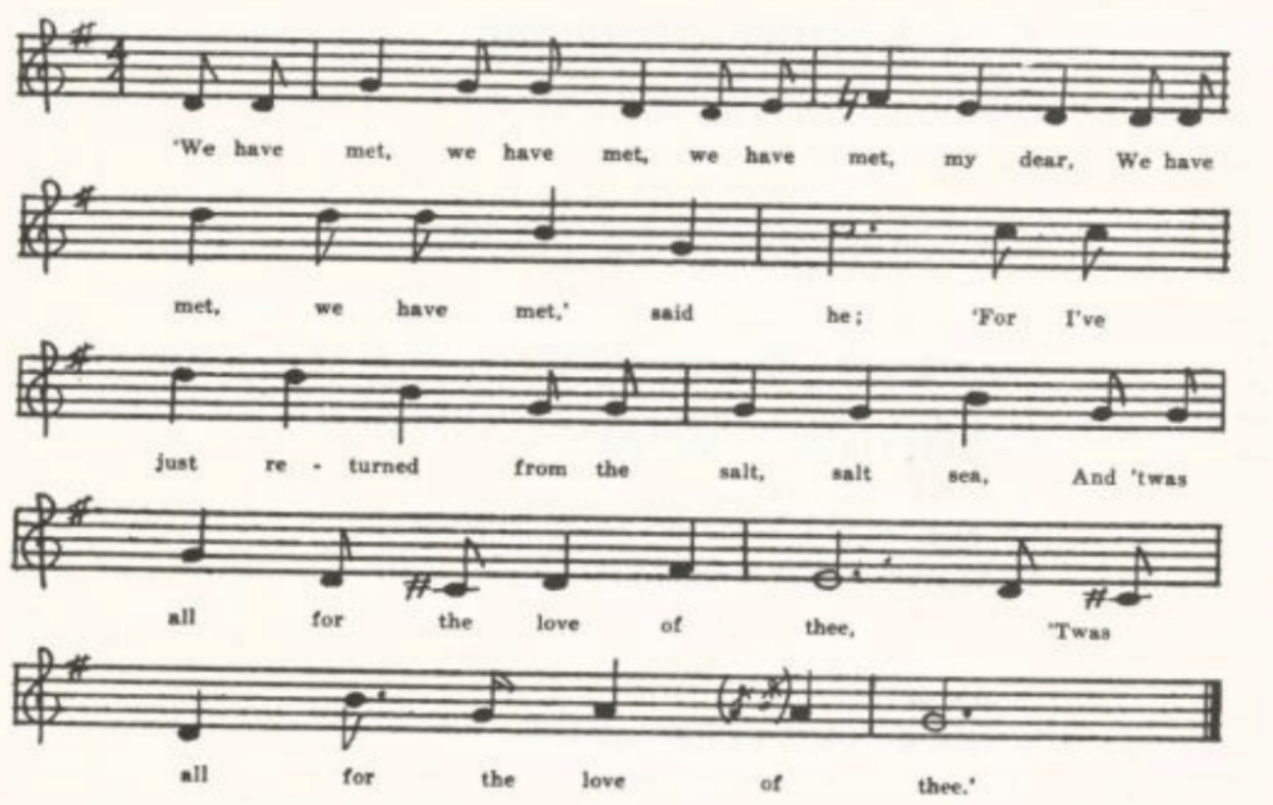
‘We have met, we have met, we have met, my dear,
WE have met, we have met,’ said he;
‘For I’ve just returned from the salt, salt sea,
And ‘twas all for the love of thee.

‘I once could have married the king’s daughter,
And she would have married me;
But I refused her crowns of gold,
And ‘twas all for the love of thee.’

‘If you could have married the king’s daughter
I’m sure you were to blame.
For I have married a house-carpenter,
And I think he’s a nice young man.’

‘If you will forsake your house-carpenter
And go along with me
I’ll take you to where the grass grows green
On the banks of the sweet Dundee.’

(83)
‘If I should forsake my house-carpenter
And go along with you,
What would you have to support me on
And keep me from slavery?’

‘I have seven ships on the high, high sea,
All sailing for dry land;
One hundred and ten bold jolly young men
You can have at your command.’

She picked up her sweet little babe
And gave it kisses three,
Singing, ‘Stay at home, my sweet little babe,
Keep your father company.’

She dressed herself in rich attire,
Most costly to behold,
And as she marched the longg highway
She shone like glittering gold.

She had not been on the sea three weeks,
I am sure it was not four,
Until fair Ellender began to weep,
And she wept most bitterly.

‘Oh, do you weep for your house carpenter,
Or do you weep for your gold,
Or do you weep for your sweet little babe
Whom you never will see any more?’

‘I neither weep for your gold,’ said she,
‘Neither do I weep for your store,
But I do weep for my house carpenter and sweet little babe
Whom I never will see any more.’

She had not been on sea three weeks,
I am sure it was not four,
Until the ship sprang a leak
And sank to rise no more.

(82)
D
‘The House Carpenter.’ Taken down by Miss Colquitt Newell in 1912 from the singing of T. B. Chandler of Farmington, St. Francois County. Mr. Chandler had learned it from his mother about the time of the Civil War. The mother was born in Tennessee but moved to Missouri in 1820.

‘We have met, we have met, we have met, my dear,
We have met, we have met,’ said he;
‘For I’ve just returned from the salt, salt sea,
And ‘twas all for the love of thee.’

‘If you could have married the king’s dauther
I’m sure you were to blame.
For I have married a house-carpenter
And I think he’s a nice young man.’

‘If you will forsake your house-carpenter
And go along with me
I’ll take you to where the grass grows green
On the banks of the sweet Dundee.’

(83)
‘If I should forsake my house-carpenter
And go along with you,
What would you have to support me on
And keep me from slavery?’

‘Seven hundred ships on yonder sea
All sailing for dry land,
Ten thousand and fifty jolly sea-boys—
They shall be at your command.’

Then she dressed her babe so neat and clean
And gave it kisses three,
Saying, ‘Lie still, lie still, my sweet little babe,
And keep your father company.’

Then she dressed herself so neat and clean (or in the finest silk)
And along with me did go,
And as she walked along the street
She looked like the glittering gold,

She hadn’t been gone more than two weeks,
I’m sure it was not three,
Until she sat herself down to weep
And she wept most bitterly.

‘What are you weeping for? My gold?
Or is it for my store?
Or is it fore your house-carpenter
That you never expect to see any more?”

‘I am not weeping for your gold
Nor neither for your store;
I am weeping for my sweet little babe
That I never expect to see any more.’

She hadn’t been gone more than three weeks,
I’m sure it was not four,
Until the ship she was on sprung a leak
And she sunk, for to rise no more.

‘A curse, a curse, a curse,’ said she,
‘A curse to all sea-men,
For they robbed me of my sweet little babe
That I never can see again.’

(84)
E
‘A House Carpenter.’ Contrubuted by Mrs. George H. Barnett of Columbia in 1913 as leaned from her mother.

F
‘The House Carpenter.’ Sent to me by Miss Vivian Bresnehen in 1916 as known by her father, who learned it from a hired man on a farm in Linn County about forty years before.

G
‘The House Carpenter.’ Contributed by Mrs. Case in 1916, from memories of her childhood in Harrison County.
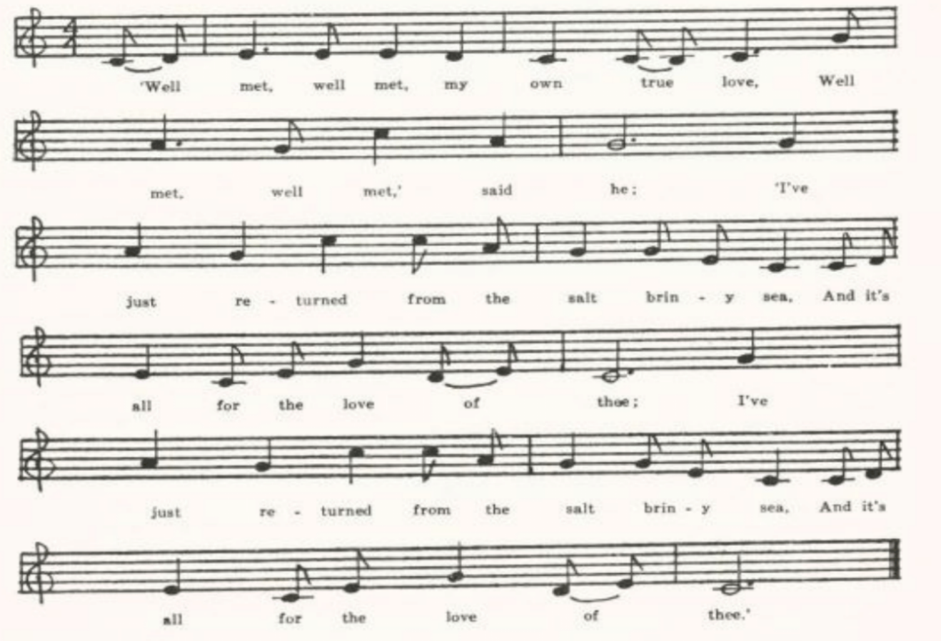
‘Well met, well met, my own true love,
Well met, well met,’ said he;
‘I’ve just returned from the salt briny sea
And it’s all for the love of thee.’

‘If you have returned from the salt briny sea
I’m sure you are to blame’
For I have married a house carpenter,
And I’m sure he’s a nice young man.’

(85)
‘Would you leave your house carpenter
And go along with me?
I’ll take you down yonder where the grass grows green
On the banks of the sweet Wilee.’

‘If I was to leave my house carpenter
And go along with thee,
What have you got to maintain me upon
Or to keep me from slavery?’

‘I’ve seven fine ships all on the sea
And seven on dry land,
And a hundred and ten of the finest young men,
And they are to wait on thee.’

She dressed her babe so neat and clean
And gave it kisses three,
Saying, ‘Lie you there, you sweet little babe,
And keep your father’s company.’

She dressed herself in scarlet red,
Her waiting maid in green;
Saying, ‘Lie you there, you sweet little babe,
And keep your father’s company.’

She dressed herself in scarlet red,
Her waiting maid in green;
And every city that they passed through
They took her to be some queen.

She had not been on board the ship
For weeks not more than three
Till this young damsel began to weep,
And she wept most bitterly.

‘What are you weeping about, my love?
Are you weeping about my fee?
Or are you weeping about your house-carpenter
That you left when you came upon the sea?’

‘It’s I’m not weeping about your love
Nor yet about my fee,
But it’s all for the love of my sweet little babe
That I left when I came upon the sea.’

This lady hadn’t been on board more than three weeks,
I’m sure it was not four,
Till in the bottom of the boat there sprang a leak
And her weeping was heard no more.

(86)
‘A curse, a curse to all sea boatmen,
A curse, a curse, said she;
‘You have taken me away from my sweet babe
And stole my life away.’

H
‘House Carpenter.’ Reported by Miss Frances Barbour of Washington University from the singing of Minnie Doyel of Arlington, Phelps County, in 1917. Some lines the singer could not recall. Published by Miss Barbour in JAFL XLIX 209-10.

I
‘The Ship Carpenter.’ Secured by Miss Lowry in 1920 from Earl Cruickshank of Columbus, Kansas. He got it from his mother, who grew up in Lewis County, Missouri, so that it may be considered a Missouri text. It is the only one in the collection that retains the figure of the ship carpenter. Mrs. Cruickshank said there should be another stanza telling about the woman’s throwing herself into the sea, but she could not remember it.

‘Well met, well met, my own true love,
Well met, well met,’ cried he.
‘I have just returned o’er the salt salty sea
And was all for the love of thee.
I have just returned o’er the salt salty sea
And was all for the love of thee.
(Repeat thus the last two lines of each stanza)

‘O, I could have married a king’s daughter fair,
I’m sure she’d a’married me,
But I forsook her houses and lands,
And was all for the love of thee.’

‘If you could have married a king’s daughter fair
I’m sure you’re much to blame,
For I have married a ship carpenter
And I think he’s a nice young man.’

‘If you will leave your ship carpenter
And come along with me
I’ll take you to where the grass grows green
On the banks of the sweet Dundee.’

She cuddled up her pretty little babe
And gave it kisses three
Saying, ‘Stay at home, my pretty little one,
Keep they father company.’

(87)
They had not sailed more than two weeks,
I’m sure it was not three,
Till this poor maid began for to weep
And she wept most bitterly.

‘What are you weeping for, my dear?
Is it for your houses in store,
Or is it for that ship carpenter
Whom you left on the distant shore?’

‘I’m not weeping for my ship carpenter
Nor for my houses in store,
But I’m weeping for that pretty little one
That I never shall see more.’

Henry Martin
(Child 250)
With some hesitation, I have entered the text given below under Child 250 instead of under Child 167, Sir Andrew Barton. Barry BBM 253-8 argues rather impressively that Henry Martin should be considered not a distinct ballad that has ‘sprung from the ashes’ of Sir Andrew Barton but simply as a variant of that ballad; and that the American versions, retaining the name Barton—variously modified—and substituting ‘Captain Charles Stuart’* for the Howard of Sir Andrew Barton (the challenger of the pirate is not named in British versions of Henry Martin), constitute a fuller and probably older intermediate stage. On the other hand, all the texts given by Child under the hero is called Bardun or Battam or Bodee or Martin—have a formal likeness that alone is enough to warrant classing them together as a distinct ballad: they all begin with three borthers of old Scotland casting lots to see which of them shall go robbing all on the salt sea to maintain the family. Most of them, too, represent the pirate as triumphing over his foes. But form is a more trustworthy mark of identity than particulars of plot.
Catnach and other ballad printers of the nineteenth century (see Kittredge’s bibliographical note JAFL XXX 327) printed Henry Martin as a stall ballad.
Two of tChild’s texts, D and E, are American. Since the completion of his work the ballad has been reported from tradition in Sussex (JFSS I 162-3, IV 301-2), Droset (JFSS IV 303), Glouchestershire (FSUT 78-9), Somerset (FSSom No. 30), and Devonshire (JFSS IV 92-3) in England, and in America from

*See upon this point Miss Poun’s comment in connection with her Nebraska text secured from a man who learned it in Ireland, in which the name appears as ‘Captain Joe Stuart’—SFLQ II 205-6.

(88)
Newfoundland (FSN 104-6), Nova Scotia (BSSNS 61), Maine (BBM 248-56), Vermont (CSV 8-9), West Virginia (FSS 150-1), South Carolina (SCB 156-8—the same as Child E), Kansas (Adventure for 20 November, 1924), Nebraska (SFLQ II 205-6), Minnesota (JAFL XVIII 135-6), and Missouri.

‘Andy Bardan.’ Communicated by Miss Lucy Laws of Christian College, Columbia, in 1911, as learned by her in her childhood in Mercer County, Kentucky, from Charlie Sims, son-in-law of a Shakeress who was a nurse in Miss Laws’s family. She writes: ‘He was a pensioner of the Civil War, brought up in Indiana, I think, but of the old Kentucky Sims family. He came to Mercer County, Kentucky, in the late sixties. . . . He introduced the ballad among the children of the neighborhood about that time.’ Printed in JAFL XXV 171-3, and again in BBM 252-3.

Three brothers in old Scotland did dwell,
Three loving brothers were they;
The youngest of the three,
For to maintain the other two
A-robbing around the salt sea.
He had not sailed very many long nights
Before a ship he did spy;
It sailed far off, it sailed far off,
And then it came sailing close by.

‘Who’s there, who’s there? Said Andy Bardan,
‘Who’s there that sails so nigh?’
‘We are the rich merchants from old England,
If no offense, let us pass by.’

‘Oh no! oh no!’ said Andy Bardan,
‘Oh no, that never can be!
Your ship and your cargo we’ll have, my boys,
And your bodies sink in the salt sea.’

The news came unto king Henry
(For it was him they crowned)
His ship and his cargo bother were lost
And all his merry men drowned.

‘Go build a ship both wide and deep (or long)
And build it safe and secure,
And if Andy Bardan you do not bring in
Your lives shall no longer endure.’

(89)
They had not sailed very many long nights
Before a ship they did spy;
It sailed far off, it saided far off,
And then it came sailing close by.

‘Who’s there? Who’s there?’ said Captain Charles Stewart,
‘Who’s there that sails so nigh?’
‘We are the bold robber from old Scotland;
If no offense, let us pass by.’

‘Oh no! oh no!’ said Captain Charles Stewart,
‘Oh no! that never can be;
Your ship and your cargo we’ll have, my boys,
And your bodies sink in the salt sea.’

‘Peel on! Peel on! Said Andy Bardan,
And loud the cannon did roar;
And Captain Charles Stewart took Andy Bardan,
He took him to fair England’s shore.

‘What now, what now?’ said Andy Bardan,
‘What now my fate it will be!
The gallows is ready for Andy Bardan,
The bold robber around the salt sea.

‘Go dig my grave both wide and deep,
And dig it close to the sea;
And tell my brothers as they pass by
I’ve done robbing around the salt sea.’

Our Goodman
(Child 274)

For the range of this piece of folk humor see Child’s headnote. He seems to have thought that the Gaelic, Flemish, and German forms of it were derived from the English, and the Scandinavian and Magyar from the German. Gaston Paris (Origines de la Poésie lyrinque en France 34) uses the French form of it in his argument for the origin of folk-song from the May-day rites of the middle ages. There are in English two forms of it, represented respectively by Child’s A (Which happens to be Scotch, but is the type followed by most recent texts in both Great Britain and America) and B (a London broadside, in which the woman has three lovers in the house at once, as is the case also in Williams’s Berkshire text and in one of the Virginia copies). It continues to hold the

(90)
interest of folk singers, and can be heard on the phonograph and the radio. It has been reported since Child’s time from Aberdeeenshire (LL 214-6) and Berkshire (FSUT 188-90), from the Bahamas (MAFLS XIII 162-3) and Nova Scotia (BSSNS 62-3), and in the United States from Maine (BBM 315-7), Massachusetts (JAFL XVIII 294-5), Virginia (TBV 485-94, SCSM 234-6), West Virginia (FSS 154-8), Kentucky (SharpK I 269-70), Tennessee (FSSH I 267-9, BMFSB 14-5, FSSH 119-21, 123-4, SCSM 232-3), South Carolina (SCB 159-61), Mississippi (FSM 122-3, SCSM 236), the Ozarks (OMF 225-7), Ohio (JAFL XXXV 348, text not given), Michigan (KNR 301), Iowa (MAFLS XXIX 13-4), and Kansas (JAFL XXIX 166, from Scotland).

A
No title. Sent to me in 1914 by H. A. Chapman, student at the School of Mines at Rolla, with the remark that there are some twenty verses of it, each one “rottener” than the one before. It is often sung by the older generation of miners.’

The old man came home last night
As drunk as he could be,
And on the rack he found a hat
Where his hat ought to be.
‘My dear wife, my loving wife,
My darling wife,’ says he,
‘What is this thing upon the rack
Where my hat ought to be?’
‘You old fool, you damn fool,
You son of a b……,’ says she,
‘Can’t you plainly see
That’s only a frying pan
That mother sent to me?’
‘I’ve traveled by land and sea
A thousand miles or more,
But never did I see a frying pan
With lining in it before.’

The old man came home last night
As drunk as he could be,
And in the bed he found a head
Where his head ought to be.
‘My dear wife, my loving wife,
My darling wife,’ says he,
‘What means this head within the bed
Where my head ought to be?’
‘You old fool, you damn fool,
You son of a b……’ says she,
‘Can’t you plainly see
That’s only a cabbage head
That mother sent to me?’
‘I’ve traveled o’er land and sea
A thousand miles or more,
But never did I see a cabbage head
With hair on it before.’

B
‘Our Good Man.’ Written our for Mr. Robert Geist in 193 by one of his students in a class in English literature, Mrs. Jewell Grooms, who notes: ‘Handed down by my grandmother, eighty-seven years old. She was born and raised in Maries County, near Meta and Vienna, Missouri.’

The old man came home, for his home he loved to be,
Found a horse in the stable where his own horse should be.
‘Ha, ha, my dearest dear, how comes this to be,
A horse in the stable where my own horse should be?’

(91)
‘You old fool, you blind fool, you surely cannot see,
’Tis nothing but a milk cow that mamie* sent to me.’
‘Miles I have traveled, ten thousand miles or more,
A saddle on a milk cow I never saw before.’

The old man came home, for his home he loved to be,
Found boots in the hall, where his own boots should be.
‘Ha, ha, my dearest dear, how comes this to be,
Boots in the hall, where my own boots should be?’
‘You old fool, you blind fool, you surely cannot see;
’Tis nothing but some pudding bags that mamie sent to me.’
‘Miles I have traveled, ten thousand miles or more,
Spurs on pudding bags I never saw before.’

The old man came home, for his home he loved to be,
Found a hat on the rack, where his own hat should be.
‘Ha, ha, my dearest dear, how comes this to be,
A hat on the rack where my hat should be?’
‘You old fool, you blind fool, you surely cannot see;
’Tis nothing but a dish pan that mamie sent to me.’
‘Miles have I traveled, ten thousand miles or more,
A dish pan with a brim I never saw before.’

The old man came home, for his home he loved to be,
Found a coat on the bed, where his own coat should be.
‘Ha, ha, my dearest dear, how comes this to be,
A coat on the bed where my own coat should be?’
‘You old fool, you blind fool, you surely cannot see;
’Tis nothing but a bed quilt that mamie sent to me.
‘Miles I have traveled, then thousand miles or more,
Button on a bed quilt I never saw before.’

The old man came home, for his home he loved to be,
Found a man in the room where he himself should be.
‘Ha, ha, my dearest dear, how comes this to be,
A man in the room where I myself should be?’
‘You old fool, you blind fool, you surely cannot see;
’Tis nothing but a baby that mamie sent to me.’
‘Miles I have traveled, ten thousand miles or more,
But whiskers on a baby I never saw before.’

*Whether ‘mamie’ for ‘mammy’ is intended for a phonetic spelling I do not know.

(92)
The Wife Wrapt in Wether’s Skin
(Child 277)
Child’s A-E are all Scotch; but in V 303-4 he adds a text from Massachusetts and one from Suffolk. No parallels are adduced from other languages. Since his time the song has been rather frequently recorded: from Aberdeenshire (LL 218-9), Lancashire (JFSS II 235), Somerset (JFSS V 260-1, also FSSom and IOOEFS), and from Maine (BBM 322-5), Vermont (VFSB 224-5, GGMS 84-6), Connecticut (VFSB 222-3, from Scotland), Virginia (TBV 497-500 and 597-8, SharpK I 271), West Virginia (FSS 59-63), Kentucky (SharpK I 271-4), Tennessee (FSSH 125), Mississippi (FSM 123), Indiana (JAFL XLVIII 309), and Bebraska (ABS 17-8). These texts may be grouped, roughly, by the refrains used. What may be called the ‘Cooper of Fife’ form appears in Child C D and also in Lancastershire and in the Connecticut text, which comes from Scotland; the ‘clish-a-ma-clingo’ form in Child’s Suffolk version and in one of the Virginia texts; Sharp’s ‘Iero’ form only in Somerset; and two forms only in America: the ‘Dandoo’ refrain, found in most of the Virginia texts and also in West Virginia, Kentucky, Mississippi, Missouri, Indiana, and Nebraska, and the ‘rosemary’ refrain (borrowed apparently from The Elfin Knight), which is the preferred New England form (Maine, Vermont, Massachusetts) but is known also in Kentucky and Missouri.

A
‘Dandoo.’ Recorded by W. S. Johnson in 1904 in Miller County. Printed in JAFL XIX 298.

There’s a little old man lives in the west
Dandoo, dandoo
There’s a little old man lives in the west
Town a town clingo
There’s a little old man lives in the west,
HE’s got an old woman that’s not for the best.
Town boy di wigel di digel di di do town clash town clingo

This little old man came in from his plow:
‘See, old woman, have you got dinner ready now?’

‘See, there’s a piece of cold corn bread hanging on the shelf;
If you want any better go bake it yourself.’

This little old man went out into his sheepfold,
Downed an old sheep with a big long pole.

He hung his old sheep on two little pins
And out of his skin he soon jerked him.

(93)
He hung his sheep skin on his old wife’s back
And two little hickories went whick-it-a-whack.

Says she, ‘I’ll tell my father and all his kin
You’s whippin’ your wife with an old sheep skin.’

Says he, ‘Tell your father and all of his kin
I’s only a-dressin’ the old sheep skin.’

B
‘The Wife Wrapped in a Wether’s Skin.’ Communicated by Mrs. Case in 1916, from her childhood memories in Harrison County. Printed in part in JAFL XXX 328-9.
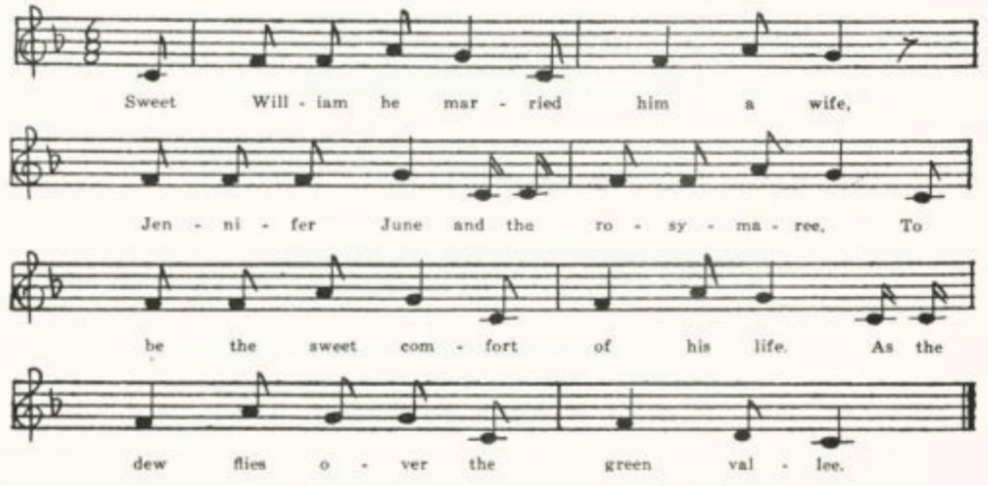
Sweet William he married him a wife,
Jennifer June and the rosymaree
To be the sweet comfort of his life.
As the dew flies over the green vallee.

It’s she couldn’t into the kitchen go
For fear of soiling her white-heeled shoes.

It’s she couldn’t wash and it’s she wouldn’t bake
For fear of soiling her white apron tape.

It’s she couldn’t card and it’s she wouldn’t spin
For fear of spoiling her delicate skin.

Sweet William came whistling in from the plow;
Says, ‘O my dear wife, is my dinner ready now?’

(94)
She called him a dirty paltry whelp:
‘If you want any dinner, go get it yourself.’

Sweet William went out unto the sheep-fold
And out a fat wether he did pull.

Upon his knees he did kneel down
And soon from it did strip the skin.

He laid the skin on his wife’s back
And he made his stick go whickety whack.

‘I’ll tell my father and all my kin
How you this quarrel did begin.’

‘You may tell your father and all my kin
How I have thrashed my fat wether’s skin.’

Sweet William came whistling in from the plow;
Says, ‘O my dear wife, is my dinner ready now?’

She drew her table and spread her board
And ‘twas ‘O my dear husband’ with every word.

And now they live free from all care and strife
And now she makes William a very good wife.

The Farmer’s Curst Wife
(Child 278)

Child prints two versions from oral tradition, one English and one Scotch, and mentions a broadside in the Roxburghe collection (Which, tho on the same and general theme, is quite distinct from the traditional ballad), but adduces no parallels from the balladry of other tongues. Nor does he appear to have received any texts fro mAmerican sources. Yet the song is something of a favorite in this country, as spears below. Related to it in theme is The Devil in Search of a Wife, part of the ballad stock of both Pitts and Such in the last century; and Pitts also printed the English traditional form of the ballad, under the title The Sussex Farmer. Most of the English texts noted since Child, and also one from Nova Scotia, one from Tennessee, and four recovered in Virginia, have a whistling chorus. In many texts the farmer expresses apprehension that the devil has come for his eldest son and is greatly relieved when he finds that it is his scolding wife that is demanded. Peculiar to America (found in Maine, Virginia, Tennessee, and Texas)

(95)
is the assertion that he yokes up his hogs or pigs to draw his plow. The devils or imps in hell appear dancing in chains or draggin chains; but only in Nova Scotia and Missouri do the little devils come ‘dancing on a wire’—an expression that suggest memories of the mystery plays. The stage directions of the Cornish Creation of the World, 1611, show that Lucifer goes down to hell ‘apareled fowle with fyre about hem’ and that the plain in which the play is acted is filled with ‘every degree of devylls of lether and spirytis on cordis.’*
The song has been reported from Aberdeenshire (LL 220, tune only), Sussex (JFSS II 184), Wiltshire (FSUT 211), and Dorsetshire (JFSS III 131-2); from Nova Scotia (SBNS 18-9, BSSNS 64); and from Maine (BBM 325-33), Vermont (VFSB 226-8), Massachusetts (JAFL XXIV 348-9, XXVI 68), Virginia (TBV 505-15, 598-601, SharpK I 276-7), West Virginia (FSS 164-5), Kentucky (SharpK I 277-8, 279-81), Tennessee (SharpK I 278-9, FSSH 125-6, SFLQ II 77-8), North Carolina (SharpF I 275-6; and a tune, SFLQ II 77), Mississippi (FSM 124-5), Texas (CS (1910 Ed.) 110-1, PFLST X 164-5), the Ozarks (OMF 227-31), Indiana (JAFL XLVIII 299-300), Nebraska (SFLQ II 77-8), and Missouri.

A
‘A Woman and the Devil.’ Contributed in 1906 by C. H. Williams from Bollinger County. Printed in JAFL XIX 298-9. The opening stanza he could not recall.

. . . . . . . . .
‘It’s neither you nor your oldest son,
Sing fall de rall de a
It’s neither you nor your oldest son
But your scolding wife, she is the one.’
Sing fall de rall, sing fall de rall,
Sing fall de rall de a.

‘O take her in welcome with all your heart;
I hope you’ll be happy and never part.’

He took her up all on his back
And off he went like a horse in a rack.

He set her down all for to rest;
She up with a stick and she hit him on her best.

He went on till he came to the gate.
He gave her a kick and said, ‘There’s your place.’

*Chambers, The Medieval Stage II 142.

(96)
Ten little devils come all on a wire;
She up with her foot and kicked nine in the fire.

Four little devils come rolling a ball:
‘Father, take us back or she’ll kill us all.’

The old man in the kitchen peeping out at the cracks:
‘Yonder comes the old devil a-wagging her back.’

And now you see what a woman can do;
She can out the old devil and her husband too.

B
The Old Woman and the Devil.’ Sent me by Mrs. Edward Schaaf, ST. Mary’s Ste. Genevieve County, in 1914. Printed in JAFL XXX 329-30.

The good old man went out to plow
Sing tory a loo, walked out to plow,
Up stepped the old devil, ‘How are you now?
Sing tory a loo, how are you now?

‘It’s one of your family I have come for,
. . . . . . .
‘It’s neither you nor your eldest son,
It’s your old scolding wife, she is the one.’

‘Take her and welcome, with all your heart.
I hope to my soul you will never part.’

He picked her up upon his back,
Like an old bald eagle went off in a rack.

He had not gotten more than half his road
Before he said, ‘Old woman, you are a hell of a load.’

He set her down all for to rest;
She up with a stick and hit him her best.

He picked her up upon his back,
Like an old bald eagle went off in a rack.

He traveled on until he came to his gate;
He gave her a kick, said, ‘There is your place.’

(97)
Ten little devils strung on a wire;
She up with her foot and kicked nine in the fire.

One little devil peeping over the wall
Sang, ‘Daddy, take her back, she’ll murder us all.’

The good old man was peeping out of a crack;
Here came the devil wagging her back.

‘Now, old man, see what a woman can do;
She can rout her husband and kill devils too.

‘Now, old woman. On earth you must dwell;
You are not fit for heaven, and they won’t have you in hell.’

The Golden Vanity
(Child 286)

I have chosen the alternative of Child’s two title, since The Sweet Trinity seldom appears as title in modern texts. In America, indeed, it is more commonly called The Merry Golden Tree or The Yellow Golden Tree. Child gives three versions: one from a seventeenth century broadside, which is in all probability the original form of the ballad; another from (chiefly) Scottish tradition; and a third from nineteenth century English stall print which has also become traditional. Most of the recent texts belong to his third form; tho the second, Child B (in which the cabin boy is rescued by his shipmates and the story ends happily), has left its mark in texts from Scotland and from Vermont and perhaps in those from Wiltshire, Nov Scotia, and one Maine text. He threatens to sink his own ship as he sank the enemy craft in Child B, in Aberdeenshire, Vermont, and Maine B, less distinctly in the Nova Scotia and one of the Virginia texts; but his gallant refraining from the execution of this threat out of regard for his shipmates(less often for the captain’s daughter) is found only in American texts from the southern and midwestern states (Virginia, West Virginia, Kentucky, Tennessee, North Carolina, Mississippi, Indiana, Illinois).
The ballad has been reported from Aberdeenshire (LL 228-9; also in Ord, 450-1), Lancashire (JFSS II 224), Wiltshire (FSUT 199-200), and Sussex (JFSS I 104-5); from Cornwall (SBW 136-7); from Newfoundland (BSSN 43) and Nova Scotia (SBNS 20-1); and in the United States from Maine (BBM 339-477, BFSSNE V 10-1), Vermont (JAFL XVIII 125-7, CSV 40-1, VFSB 230-1), Pennsylvania (NPM 126-8), Virginia (TBV 516-20 and 602, VFSB 230-1), West Virginia (FSS 169-71), Kentucky (LT 72-5, FSKM 96-102, SharpK I 285-8, 289), Tennessee (ETWVMB 93-4, SharpK I 289, JAFL XLV 25-8, FSSH 127-30, 131-3, SFLQ II 79), North Carolina (JAFL XLV 28-9, SharpK I 282-4,

(98)
FSSH 130-1), Mississippi (FSM 125-7), Indiana (JAFL XLVIII 312-4), Illinois (JAFL XLVIII 386-8, SCSM 187-9), Nebraska (ABS 24-6, learned in the Shetland Islands), the Ozarks (OASPS 177-80), and Missouri (Ozark Life VI No. 1, and texts from the Missouri collection mentioned below as printed in JAFL).

A
No title. Secured by Miss Hamilton in 1909 from Owen Davidson of the West Plains High School, whose father had learned it from a hire man. Printed in JAFL XXIII 429-30.

‘Oh Captain! Dear Captain! What will you give to me
If I sink that vessel called the Yellow Golden Tree
As she sails in the Lowlands low low
As she sails in the Lowlands low?’

‘One thousand pounds I’ll give to you and my dauther to by your bride
If you’ll sink that ship called the Yellow Golden Tree
As she sails’ etc.

He took him an auger well fitted for the use
And bored nine holes in the bottom of her sluice
As she sailed etc.

‘Oh Captain! Dear Captain! Come and take me up,

For I have sunk that vessel called the Yellow Golden Tree
As she sailed’ etc.

The Captain wrapped him up in an old rawhide*
And sunk him to the bottom with a fair wind and tide
As they sailed etc.

Nine months later his ghost did appear,
Which caused the wicked Captain great dread and fear
As he sailed etc.

B
‘The Lowlands.’ Contributed by Mrs. George H. Barnett in 1912, whose mother learned it ‘from a girl who came from Kansas to Missouri shortly after the close of the Civil War.’

*This feature of the story is from the nineteenth century broadside, and appears (generally as a hammock) in Wiltshire, Nova Scotia, Nebraska, (from the Shetland Islands), and one of the Virginia texts.

(99)
There came a ship from the northern countree
It sailed by the name of the Golden Willow Tree.
It was sailing on the Lowlands so lowly, oh, so low,
It was sailing on the Lowlands so low.

‘O captain, O captain, what will you give me
To overtake the Golden Willow Tree?
They will sink us in the Lowlands’ etc.

‘I have money, I have a fee,
Besides an only daughter your wedded wife shall be
If you’ll sink them in the Lowlands’ etc.

Then he smote his breast and away swam he
To overtake the Golden Willow Tree
They were sailing in the Lowlands etc.

Some were playing cards, while others playing dice,
And some were giving the very best advice,
For they’re sailing on the Lowlands etc.

He has an instrument all fitted for the use,
He bored nine holes in the bottom all at once,
Crying, ‘Oh, the Lowlands’ etc.

‘O captain, O captain, take me on board
And be unto me as good as your word,
For I’ve sunk them to the Lowlands’ etc.

‘Oh no,’ said he, ‘I’ll not take you on board,
Nor be unto you as good as my word;
For you’ve sunk them to the Lowlands’ etc.

Then he smote his breast and down sank he,
Bidding adieu to the yellow Golden Tree,
Crying, ‘Oh, the Lowlands so lowly, oh, so low,’
Crying, ‘Oh, the Lowlands so low.’

C
‘The Merry Golden Tree.’ Contributed by Mrs. Case in 1916, from memories of her childhood in Harrison County. Printed in JAFL XXX 331-2.

‘Oh Captain! dear Captain! what will you give to me
If I’ll sink for you that ship called the Merry Golden Tree
As she sails in the Lowlands lonesome low,
As she sails in the Lowlands low?’

(100)
‘It’s I will give you money and I will give you fee;
I have a lovely daugther I will marry unto thee
IF you’ll sink her in the Lowlands lonesome low,
If you’ll sink her in the Lowlands low.’

He bent upon his breast and out swam he;
He swam until he came to the Merry Golden Tree
As she sailed in the Lowlands lonesome low,
As she sailed in the Lowlands low.

He took with him an auger well fitted for the use
And he bored nine holes in the bottom of the sloop
As she sailed in the Lowlands lonesome low,
As she sailed in the Lowlands low.

He bent upon his breast and back swam he;
He swam until he came to the Turkish revelry
As she sailed in the Lowlands lonesome low,
As she sailed in the Lowlands low.

‘Captain, O Captain, take me up on board;
For if you don’t you’ve surely broke your word,
For I’ve sunk her in the Lowlands lonesome low,
I’ve sunk her in the Lowlands low.’

‘It’s I’ll neither give your money nor will I give you fee,
Nor yet my lovely daughter will I marry unto thee;
You may sink in the Lowlands lonesome low,
You may sink in the Lowlands low.’

He beat upon his breast and down sank he
Right alongside of the Turkish Revelry,
And he sank her in the Lowlands lonesome low,
And he sank her in the Lowlands low.

Down went the vessel and down went the crew,
And down to join the cabin boy went the captain too,
All sunk in the Lowlands lonesome low,
All sunk in the Lowlands low.

(101)
The Mermaid
(Child 289)
Despite the antiquity and range of the belief that the sight of a mermaid is an omen of shipwreck, this song has been traced no further back than the latter part of the eighteenth century and Child found no corresponding ballads in other tongues. Half of his texts are English, half Scotch; but the place names in the latter point rather to English than to Scotch origin. Its persistence in popular song is no doubt connected, as cause or effect or both, with the frequency of its appearance in broadsides and songbooks. See Kittredge’s bibliographical note in JAFL XXX 333. It is indeed not improbable that its familiarity in print has caused it to be overlooked sometimes by modern collectors. Yet even so it has been reported in recent years from a wide territory: from Scotland (Ord 333-4) , Oxforshire (FSUT 84), Hampshire (JFSS III 47-8), Chesire (JFSS III 49, tune only), Dorset (JFSS III 50-1), and Devonshire (JFSS III 139); from Prince Edward Island (BBM 364-5), Nova Scotia (BSSNS 65), and New Brunswick (BBM 365-6); from Maine (BBM 363-4), Vermont (JAFL XVIII 136, XXII 78), Massachusetts (JAFL XXVI 175-6), Virginia (TBV 521-8, SharpK I 293), West Virginia (FSS 172-3), Kentucky (FSKM 45-9, SharpK I 291-2), Tennessee (FSSH 133-4), North Carolina (SharpK I 293, SCSM 189-90), Mississippi (FSM 127), Texas (PFLST X 162-3), Iowa (MAFLS XXIX 14-5), Wyoming (ABS 26-7), and Missouri. For the sake of completeness I give here the text in the Missouri collection, altho it has already appeared in JAFL XXV 176-7.

‘Shipwreck.’ Secured by Miss Hamilton in 1911 from Agnes Shibley of the Kirksville State Teachers College, who learned it from her mother.

One Saturday night as we set sail,
Not being far from shore,
‘Twas then that I spied a pretty fair maid
With a glass and a comb in her hand, her hand,
With a glass and a comb in her hand.
The stormy wind did blow,
And the raging sea did roll,
And we poor sailors came leaping to the top
While the landsmen lay down below, below, below,
While the landsmen lay down below.

Then up came a boy of our gallant ship
And a noble-spoken boy was he,
Saying, ‘I’ve a mother in distant York town
This night is a-weeping for me.’

(102)
The up came a lad of our gallant ship
And a beautiful lad was he,
Saying, ‘I’ve a sweetheart in distant York town
This night is a-looking for me.’

Then up came the clerk of our gallant ship
And a noble-spoken man was he,
Saying, ‘I’ve a wife in distant York town
This night a widow will be.’

Then up came the captain of your gallant ship—
There is no braver man than he—
Saying, ‘For the want of a yawl-boat we’ll be drowned,
And we’ll sink to the bottom of the sea.’

Then three times round our gallant ship turned,
Three times round turned she;
Three times round our gallant ship turned,
Then she sank to the bottom of the sea.

Jesus and Joses
The following, a folk-legend, not a song, seems to be related in spirit and by its curse upon the willow tree, tho not in the motivation of the story, to the ballad of The Bitter Withy—for which see G. H. Gerould in PMLA XXIII 141-67 and Barry in JAFL XXVII 79-89. IT was sent to me in 1914 by H. A. Chapman of the Missouri School of Mines at Rolla.

‘I have known for some time that the mountain folk has a fear or prejudice against the willow tree; and some time back I heard an explaination that may be the reason. An old man who trapped south of Warrensburg [in Johnson County] gave it to me.
‘”When Jesus was a child he had a brother name Joses, who tho younger was much larger and stronger. Near where they lived were willows, and Joses would tell fibs about Jesus to Mary and then bring willow switches for her to punish him (Jesus) with (to be exact, he said ‘God rot it’). And the willow always brings bad luck, rots quicker than any tree and if a child is punished with it he will have much suffering and will die before he is old.”’

(103)
The Soilder’s Wooing

The likeness of the story here told to that of Erlinton, Child No. 8, has been noted by previous collectors. In its present form it goes back at least to the seventeenth century, when was ‘Printed for A. M. W. O. and Tho. Thackeray at the Angel in Duck Land’ the broadside ballad ‘The Master-piece of Love-songs’ (see Roxb. Ballads VI 229-31). Two marks appears here that persist in nineteenth century stall prints, Such’s for example, and in pretty nearly all texts derived from oral tradition. They must have made the success of the piece, for they are repeated in a sailor version, ‘The Seaman’s Renown in Winning his Fair Lady,’ also printed for Thackeray about the same time (Roxb. Ballads VII 559-61). These marks are the rimes prattle-rattle-battle and the bride’s adjuring her warrior lover (only a game-keeper in the seventeenth century ballad) not to stop fighting till her father has promised all his wealth as her dower. Texts have been recorded from oral tradition in Sussex (JFSS I 108), Berkshire (FSUT 115-6), Nova Scotia (SBNS 25-6), New Brunswick (BBM 381), Maine (BBM 377-9), Vermont (GGMS 60-2, VFSB 232-3), Massachusetts (?) (BBM 380-1), New Jersey (JAFL XXIII 447-9), Virginia (SharpK I 355-7, SCSM 201-3), West Virginia (FSS 375-6), Kentucky (SharpK I 334), Tennessee (SharpK I 334), North Carolina (SharpK I 333, 337, BTFLS II 1), Georgia (JAFL XLV 114-6, FSSH 185-7), and Louisiana (ABS 68-9). Tolman notes, JAFL XXIX 188, that he has a text from Canada, and, JAFL XXXV 414, give two tunes from Ohio, but does not print a text.

‘The Soilder.’ From the manuscript ballad-book of James Ashby of Holt County, compiled in the latter part of the last century and secured by Miss Welty in 1906. The pointing is mine, and I have bracketed a few places that were scarcely legible.

Oh, my handsome [soilder], just lately from the war,
He courted a fair damsel with riches and great store;
Her riches was so great that they scarcely could be told.
She said she loved a soldier because he was so bold.

‘Oh, my handsome soldier, how vain* I’d be your wife!
But my cruel parents would surely take my life.’
He drew his sword and pistol and hung them by his side
And swore he’d get married let what would be tried.†

They jumped on their horses and away they did ride.
They rode and they rode till they came to the lane,
And there she met her father and seven armed men.
‘Oh, flee!’ said the lady, ‘I fear we shall be slain.’

*Read, no doubt, ‘fain.’
†Probably should read ‘let what would betide.’

(104)
‘Fear nothing,’ said the soldier, the soldier again,
‘There’s no time for to talk nor no time for to prattle.’
The lady held the horses while the soldier fought the battle.
The first one he came to he run him to the man,

The next one he came to he pierced him through the brain.
‘Flee!’ said the rest, ‘I fear we shall be slain.
To fight a valiant soldier we find it’s all in vain.
Hold your hand, you valiant soldier, and don’t you be so [bold],
And you shall have my daughter and seven pounds of gold.’

‘Fight on, ye valiant soldier, your portion is too small;
Fight on, you valiant soldier, and you [will get it all].’
‘Come, stop,’ says the old man, ‘and do but spare my life,
And you shall have my daughter all for your wedded wife.’

They jumped on their horses and home they did ride
A fine wedding dinner her father did provide;
He called him his son and made him his heir.
It wasn’t out of good will but truly out of fear.

Come all ye young ladies, a warning take by me
And never slight a soldier because he’s sometimes poor.
If he is truly handsome he’s jolly, brave, and free,
And will fight for his wife and [is soon in liberty].’

Come all ye young ladies, a warning take by me
And never slight a soldier because he’s sometimes poor.
If he is truly handsome he’s jolly, brave, and free,
And will fight for his wife and [is soon in liberty].

The Greenland Whale Fishery

Altho not strictly a ballad found in Missouri, it seems worth while to record this text because of its infrequent appearance in America. Barrett, in GCS, where it is No. 26, calls it ‘a very old song.’ It was printed by Pitts, by Such, and by Catnach, all giving 1824 as the date of the occurrence. It has been found in oral circulation in Sussex (JFSS I 101), Lancashire (JFSS II 243), and Somerset (FSSom No. 74). Barrett’s text, which is not located, gives the date as 1794. The only American record of it that I have found is from Maine (MM 226-7), where the date is 1801.

‘The Whale Song.’ Communicated in 1910 to Miss Hamilton by Fred Wilkinson of the West Plains High School, who found it in ;an old MS collection made by his grandmother, Eliza Robbins, of Brownington, Vermont.’

One thousand eight hundred and twenty-four
And March the twenty-third,
We hoisted the colors of our masthead
And for Greenland bore our way, brave boys,
And for Greenland bore our way.
(Repeat thus the end of each stanza)

(105)
Our captain being on the mast so high
With a spy-glass in his hand,
‘Here’s a whale, here’s a whale, here’s a wild fish,’ he cried,
‘And she blows at every spang.’

Our boatswain being on the quarter-deck
And a merry good man was he:
‘Overhaul, overhaul, let your jib-sheet fall,
And launch your boat on the sea.’

Our boat being launched and the men all in,
And she flourishes with her tail;
Capsized our boat and lost five men—
Nor did we catch that whale.

The news unto the captain went,
‘We have lost your prentice boy;’
And hearing of this dreadful news
He down with the colors all.

In losing of this wild fish
It grieved his heard full sore;
But in losing of the five golly tars
It grieved him ten times more.

Oh, Greenland is a barren place,
Neither light nor day to be seen;
The ice and the snow, and the wild fish do play,
And the daylight seldom seen.

Now away* your anchors now, brave boys,
For the winter star I see.
It is time for to leave such a cold country
And for England bore† away.

*Originally, no doubt, ‘weigh.’
†Should apparently be ‘bear.”

(106)
The Babes in the Wood
For the bibliography of this nursery classic see Kittredge’s note in JAFL XXXV 349-50. It has been much reduced from the form given by Percey in the Reliques, which he says he printed from ‘two ancient copies, one of them in the first half of the fifteenth affording Wordsworth his illustration of the differences between true simplicity in poetry and the dulness of Dr. Johnson’s famous parody. IT has been reported from tradition in recent years in Oxfordshire (FSUT 217), Virginia (SharpK I 309), West Virginia (TBWV 73-4), Kentucky (FSKM 103-6), Mississippi (FSM 285), Louisiana (TNFS 57, a negro version) Iowa (JAFL XXXV 349), and Wyoming (ABS 233-4). No doubt it is much more widely known than this list would indicate, collectors ignoring it as something universally familiar.

A

‘The Babes in the Wood.’ Reported by mIs Mary Meek Atkeson from the singing of her cousin, Virginia Wheat Atkeson of Buler, Bates County, in 1892. She had learned it from her mother.

Oh, don’t you remember, a long time ago,
Two poor little babes, whose names I don’t know,

Were stolen away one bright summer’s day
And lost in the woods, I’ve heard people say.

And when it was night, the moon had gone down
And the stars gave no light . . . .

They sobbed and they sighed, and they bitterly cried;
Poor babes in the wood! They lay down and died.

And when they were dead, the robins so red
Brought strawberry leaves and over them spread,

And sang them a song, the whole day long:
‘Poor babes in the wood to heaven have gone.’

B

‘The Little Babes in the Woods.’ From the manuscript ballad-book of Mrs. Lida Jones of Dade County, secured for me by miss Lowry in 1906.

Oh, don’t you remember, a long time ago,
When two little babes, their names I don’t know,
Were stolen away one bright summer day
And lost in the woods, I’ve heard people say.

(107)
The moon went down and the stars gave no light
To those two little babes, so sad was their plight;
They sobbed and they sighed and they bitterly cried;
Poor babes in the wood, they lay down and die[d].

And after a while their mama came by.
She saw the poor babes and how she did cry!
She fainted and fell and by them she lay;
‘God bless that robin!’ was all she could say.

The Maid on the Shore

The recorded texts of this agree so closely that one infers a printed ballad as the source, but I have found no mention of such print. As will be seen from the list below, it has been reported (except for one stanza from Ireland, a version from California, and our Missouri text) only from northeastern America. Mackenzie associates it with Child 4 and 43; Barry (BFSSNE VII 13) traces it congeners in Scandinavia and the Latin countries of Europe, and thinks it is a development of the siren or bird-soul myth. Texts have been published from Ireland (OIFMS No. 327, one stanza), Newfoundland (FSM 30-8, BSSN 63-4), Nova Scotia (BSSNS 74-5), Maine (BFSSNE VII 12), and California (Adventure for 15 August, 1927, found by Gordon, which I have not seen).

‘The Maid on the Shore.’ Reported by Mrs. Case in 1916 as known by her in her childhood in Harrison County.
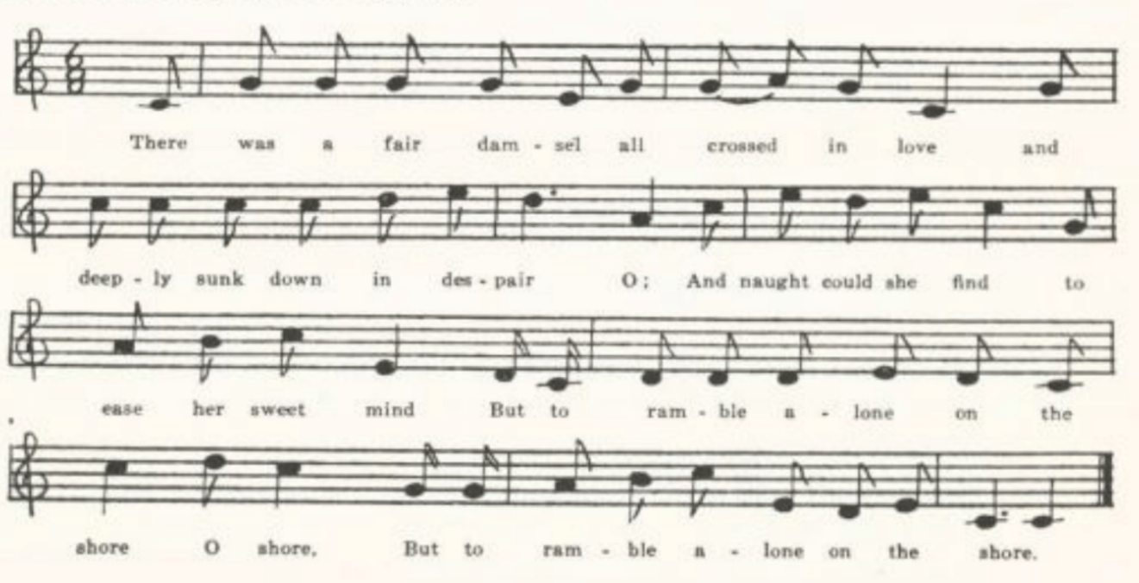
(108)
There was a fair damsel all crossed in love
And deeply sunk down in despair O;
And naught could she find to ease her sweet mind
But to ramble alone on the shore O shore,
But to ramble alone on the shore.
(Repeat thus the last line of each stanza)

There was a sea captain who sailed that way;
The wind it blew steady and fair O.
‘I shall die, I shall die!’ the sea captain did cry,
‘If I don’t win that maid on the shore.

‘It’s I have jewels, I have rings,
It’s I have costly ware O.
Oh! it’s what will I give to my jolly seamen
If they’ll bring me that maid on the shore!’

By many persuasions they got her on board;
The captain he set her a chair O.
He invited her down to the cabin below,
Saying, ‘Fare you well, sorrow and care!’

‘I’ll sing you a song if you don’t think it wrong.’
The captain upon her did stare O.
She sung it so sweet, so loud and complete,
She sung captain and seamen to sleep.

She robbed them of jewels, she robbed them of rings,
She robbed them of costly ware O;
The captain’s broadsword she took for an oar
And she paddled her boat to the shore.

Our men they were mad, our men they were sad,
And deeply sunk down, down in despair O
To see her go ‘way in her beauty so gay
To ramble alone on the shore.

Nor were our men mad, nor were our men sad,
Nor deeply sunk down in despair O
I eluded my men as well as myself
And I gained that sweet maid on the shore.

In the Maine and Nova Scotia texts the last two stanzas are (1) question by the captain and (2) answer by the maid—making the situation more intelligible:
‘O were my men sleeping, or were my men mad,
Or were my men sunk in despair, O,
That the lady so gay should thus run away,
When the captain he welcomed her there, O?’

(109)
‘No, your men were not sleeping, your men were not mad,
Your men were not sunk in despair, O;
I deluded your crew and likewise yourself too,
And again I’m a maid on the shore, O!’
(Barry’s text from Maine, BFSSNE VII 12)

The Bramble Briar

For a discussion of this ballad and its possible relation to Filomena’s story in the fourth day of the Decameron see ‘Baccaccio, Hans Sacs, and The Bramble Briar,’ PMLA XXXIII 327-95. A few other texts have been recorded since then, and it may be well here to set down all the reports of it that I have seen.* It has been found in tradition in Hertfordshire (JFSS V 126-7), Hampshire (Alice E. Gillington, Songs of the Open Road 10-1, from the singing of New Forest gypsies), and Somerset (JFSS II 42, V 126-7); in West Virginia (FSS 305-7, TBWV 57-9), Kentucky (JAFL XX 259-60, Sewanee Review XIX 321-2, SharpK 313-5), Tennessee (JAFL XLV 48-9, FSSH 161), North Carolina (JAFL XLVI 25-7, SharpK I 310-2), Texas (PFLST II 6-7), Ohio (JAFL XXIX 169, XXXIX 169, XXXV 359), and Missouri. Barry listed it in his Folk Songs of the North Atlantic States, but I do not find that he ever printed his version.

A
‘The Merchant’s Daughter.’ Secured by Miss Hamilton in 1910 from Carl Mayhew of the West Plains High School; sung by his mother, who learned it from her mother in Howell County.

In a seaport town there lived a merchant;
He had two sons and a daughter fair.
An apprentice bound boy from all danger
Courted this merchant’s daughter fair.

Five hundred pounds was made her portion.
She was a neat and cunning dame.
Her brothers were so hard and cruel—
All of this was to the same.

One evening they were silent, courting.
Her brothers chanced to overhear,
Saying, ‘Your courtship will soon be ended;
We will send him hither to his grave.’

Next morning early, breakfast over,
With them a-hunting he did go.
They went over hills and lofty mountains
And through some lonesome valleys too,
Until they came to a lonesome desert;
There they did him kill and throw.

When they returned back home that evening
Their sister asked for the servant man.
‘We lost him in the woods a-hunting
And never more we could him find.’

Next morning she was silent, weeping.
He came to her bedside and stood.

*And to correct an error in my PMLA article. I there wrote that ‘no printed copy of the ballad has been found,’ having overlooked the fact that Professor Kittredge had already (JAFL XXIX 168) noted a printed of Wehman’s in the Harvard College library. I know of no other ballad print of it.

(110)
All pale and wounded, ghastly looking,
Wallowed o’er in gores of blood,

Saying, ‘Why do you weep, my pretty fair one?
It is a folly you may pawn.
Go over hills and lofty mountains,
This lonesome place you may me find.’

She went over hills and lofty mountains
And through some lonesome valleys too,
Until she came to a lonesome desert,
And there she found him killed and thro[wn].

His handsome cheeks the blood was dyeing,
His lips were salt as any brine;
She kissed him o’er and o’er, crying,
‘This dear beloved friend of mine.’

Three days and nights she did stay by him,
‘Twas on her bended knees she stood;
All in the height of her great anger
She uttered forth such words as these:

‘My love, I thought I would stay by him
Until my heart should break with woe;
But I feel sharp hunger growing on me,
Which forces me back home to go.’

When she returned back home that evening
Her brothers asked her where she’d been.
‘You hard and cruel and unkind creatures!
For him alone you both shall swing.’

And then to avoid all shame and danger
Away to the sea they both did go.
The wind did blow and it was no wonder
The roaring sea proved both their graves.

B
‘The Bamboo Briars.’ Taken down by Miss Frances Barbour of Washington University in 1917 from the singing of Minnie Doyel of Arlington, Phelps County. Not all of it was remembered.

One night as they was sitting courting,
Two villains overheard,
Saying, ‘This courtship it shall be ended;
We’ll send him along to his grave.’

And to conclude this bloody murder
A-hunting these two villains did go.
. . . . . .
. . . . . .

They traveled over hills and hollows
And places too that was not known
Until they came to the bamboo briars,
And there they killed him—killed and thrown.

. . . . . .
It is ‘Dear brothers, where have you been?
The reason I ask you seems to whisper;*
Dear brothers, tell me if you can.’

One night as she was lying weeping
He came to her in gory blood
Saying, ‘What do you weep for, you harmless creature?
Your brothers killed me, killed and thrown.

. . . . . .
. . . . . .
And was by being both rash and cruel†
In such a place you can me find.’

* This part is confused in many texts; see PMLA XXXIII 340-2. It is most intelligible in Miss Broadwood’s Hertfordshire text:
I ask because I see you whisper.

†Shearin’s Kentucky text throws some light on this:
Your brothers being both rash and cruel

(111)
She traveled over hills and hollows
And places too that was not known
Until she came to the bamboo briars,
And there she found him killed and thrown.

. . . . . . .
. . . . . . .
She stayed three days, hunger came on her;
Then she returned back home again.

. . . . . . .
It is, ‘Dear sister, where have you been?
The reason we ask you seems to whisper.
Dear sister, tell use if you can.’

‘You are two hard-hearted, deceitful villains!
For him alone you both shall swing.’
And, dear friends, if you’ll believe me,
The raging sea provides their graves.

A Brave Irish Lady

This seems the most fitting title for America texts of this ballad, tho some collectors enter it as a form of Child 295, The Brown Girl. It is related, certainly, to that ballad, but is sufficiently distinct to be ranked as a separate song. In The Brown Girl it is the woman, not the man, that is hard-hearted; the story is put in her mouth; and there is no Irish lady. In fact the figure of the Irish lady is America; the British broadside (printed in BBM 422-3) know nothing of her. The man’s declaration that he will dance on her grave—which is probably what has most contributed to keep the song alive—goes back to Child’s two versions of 295, and his suggestion that she has called him in as a doctor is at least implied in Child B, tho not fully developed till later. The peculiarly flat statement, with its false rime, that

‘You can quit your intentions, and end your discourse,
For I will never have you unless I am forced.

Is apparently to be credited to the nineteenth century stall prints; it appears in both of them as printed in BBM, and maintains itself pretty well in American tradition. Only in American texts has the stanza from Death and the Lady (100EFS 52)

Now Sally is dead, lies cold in the clay,
Her rosy-red cheeks are all moldering away

Crept in; it is found in TBV B, SharpK F H, FSS C D, and all the Missouri texts.
The song has been reported since Child’s time from Scotland (Christie II 240-1) and Somerset (JFSS VIII 5-6), from Maine (BBM 418-25), Vermont (VFSB 244-6), Viriginia (TBV 537-43, SharpK I 297, 300-1, 303-4, SCSM 98), West Virginia (JAFL XXXII 502, FSS 366-70), Kentucky (SharpK I 295-7, 302-3), Georgia (SharpK I 298), Mississippi (FSM 128-30), and Kansas (JAFL XXVII 73-4). Tolman had a text from Indiana but did not print it because it was so much like that given by Barry in JAFL

(112)
XXVII 73-4. It is listed as recorded in Tennessee but the text not given in SFLQ II 79.

A
‘A Brave Irish Lady.’ Sent in by Miss Welty as secured by her from Mabel Hyder, one of her pupils in the Excelsior Springs High School, Clay County, in 1910. Mabel Hyder learned it from her grandmother, a native Missourian.

A brave Irish lady to London she came,
A beautiful damsel called Sallie by name.
A young squire earning five hundred a year
He courted pretty Sallie and loved her so dear.

Her beauty was great, her fortune so high
That upon this young squire she scarce cast an eye.
‘O Sallie! O Sallie! O Sallie!’ cried he,
‘I’m sorry that your love and mine can’t agree.’

‘No hatred to you nor no other man,
But to say that I love you is more than I can;
I wish you would retire and end your discourse,
For I never will love you unless I am forced.’

When eight weeks was over, when eight weeks went by,
Young Sallie fell sick and she knew not why.
She sent for young Jimmie to come back indeed,
She sent for her true love to come with full speed.

Young Jimmie came in, he came to her bedside.
‘Am I the doctor?’ young Jimmie replied.
‘Oh yes, you’re the one that can kill or can cure,
And without your assistance I’m ruined, I’m sure.’

‘Oh, where does the pain lie? Does it lie in your head?
Oh, where does the pain lie? Does it lie in your side?’
‘Oh no, loving Jimmie, that’s quite the wrong guess,
But the pain doth pierce me right through my breast.’

‘O Sallie! O Sallie! O Sallie!’ said he,
‘Don’t you remember when I courted thee?
You laughed at my courtship, you denied me to scorn,
And now I’ll reward the for what’s past and gone.’

‘For what’s past and gone, dear, forget and forgive,
And grant me a little longer to live.’
‘Oh no, I won’t, Sallie, while I draw breath,
But I’ll dance on your grave when you’re laid in the earth.’

(113)
She retch out her hands and gave him diamond rings three,
Saying, ‘Take these and wear them while you’re dancing o’er me.
Oh, farewell father! and farewell friends!
Farewell loving Jimmie, God maketh amends!

‘Oh, now I must be laid in a cold bed of clay,
Where my red, rosy cheeks will moulder away.
I’d freely forgive you, although you won’t me.
Ten thousand times over my folly I see.’

B
No title. Contributed by Myrtle Wright in 1914, who learned it from her mother, born and reared in Ray County.

There was a gay Irish young lady, from London who came,
Fine Sally, fine Sally indeed was her name.

There was a noble young squire, worth a thousand a year,
Who courted Miss Sally, who soon did appear.

‘No hatred to you, sir, nor to no other man,
But to say that I love you is more than I can.

‘So you can quit your intentions, and end your discourse,
For I never will have you unless I am forced.’

Before twenty-four hours had passed and gone,
This young lady began to take on.

She was tangled in love, but she knew not the reason why;
So she sent for this young man whom once she did deny.

‘Oh Sally, oh Sally, oh Sally,’ said he,
‘Do you remember when I first courted thee?

‘I asked you so kindly, and you denied me with scorn;
Now I’ll reward you for things that have passed and gone.’

Then pulling from her fingers full diamond rings three:
‘Go wear these while dancing on me.’

Now she is dead beneath the cold, cold clay,
And her red rosy cheeks are mouldering away.

. . . . and as we suppose,
To some other gay young lady she willed all of her fine clothes.

(114)
C
‘Sally Sailsworth.’ Sent in by Mrs. Case in 1916 as known to her in childhood in Harrison County. Note that the story begins as a first person narrative by the man; and that the lady is not Irish.
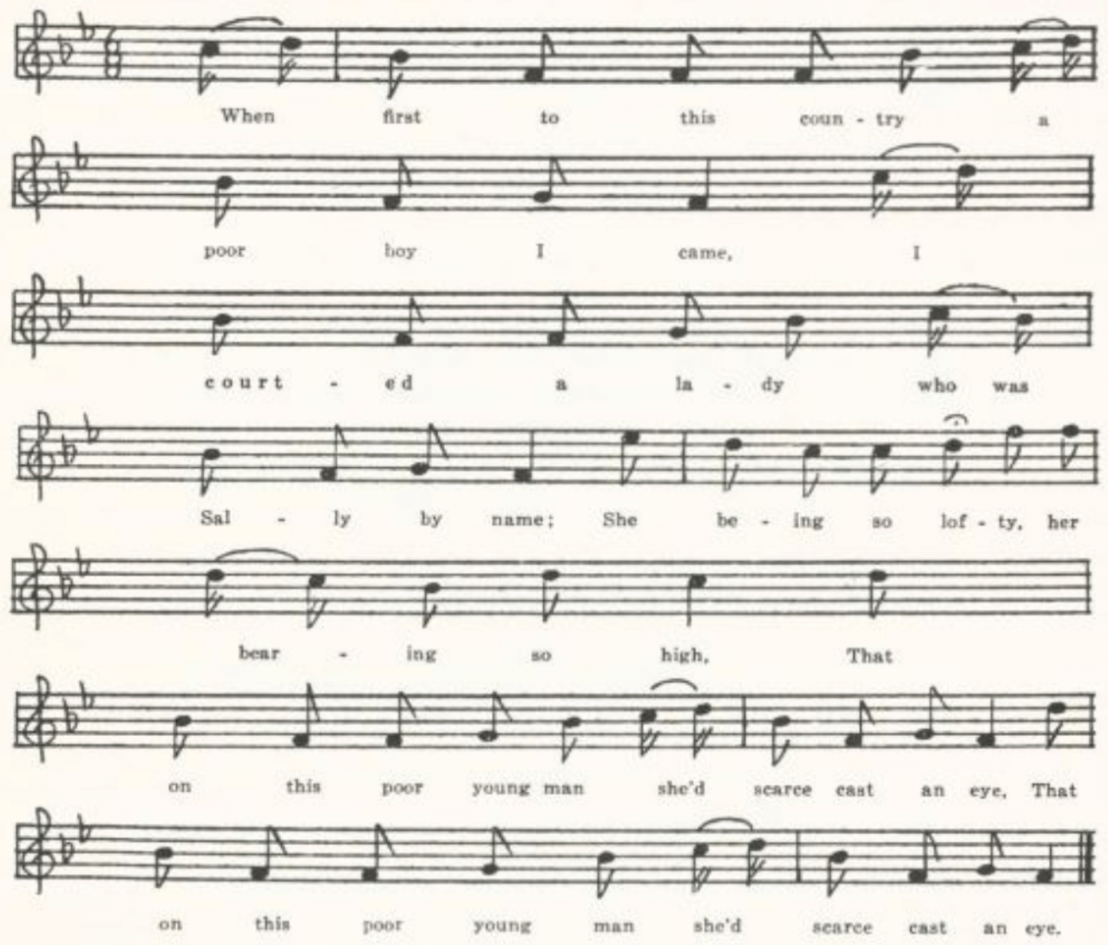
When first to this country a poor boy I came
I courted a lady who was Sally by name.
She being so lofty, her bearing so high,
That on this poor young man she’d scarce cast an eye.

‘Oh Sally, oh Sally, Sally Sailsworth,’ says he,
‘I’m afraid that our courtship will never agree.
Unless your hatred shall turn to true love,
We never can be married by the powers above.’

‘Oh no, I don’t hate you, nor no other man,
But to say that I love you is more than I can.’
‘So now I will leave you to dwell all alone;
Perhaps you will marry some other young man.’

(115)
He had not been gone but weeks two or three,
. . . . . . . .
Till Sally fell sick and she knew not for why,
And she sent for this young man she once did deny.

‘Oh, it’s am I the doctor, can kill or can cure,
Or am I the young man you once did deny?’
‘Oh yes, you’re the doctor, can cure or can kill;
But grant me some longer in this world to live.’

‘Oh Sally, oh Sally, Sally Sailworth,’ says he,
‘Oh, don’t you remember when I first courted thee?
You laughed at my courtship, denied me with scorn;
And now I’ll reward you for what’s past and gone.

‘For what’s past and gone, love, let’s forget and forgive,
But grant me some longer in this world to live.’
‘For what’s past and gone I shan’t forgive and forget,
But I’ll dance on your grave when you’re cold in the clay.’

She pulled diamonds off her fingers three,
Saying, ‘Wear these on your right hand when you’re dancing
on me.
And when you’re done dancing on Sally your queen,
Fly away to the West, love, no more to be seen.’

Now Sally is dead, you all may suppose
Some other young lady is a-wearing her clothes.
Now Sally is dead, lies cold in the clay,
Her rosy-red cheeks are all moldering away.

D
‘The Rich Irish Lady.’ Given to Miss Lowry by Earl Cruickshank of Columbus, Kansas, in 1920, as sung by his mother.
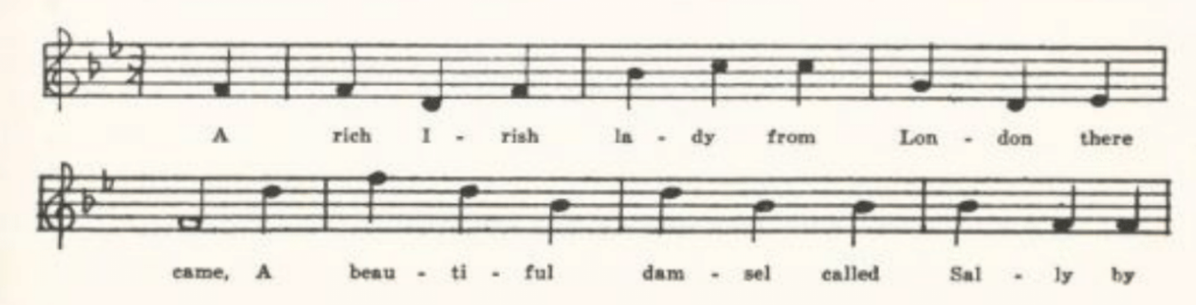
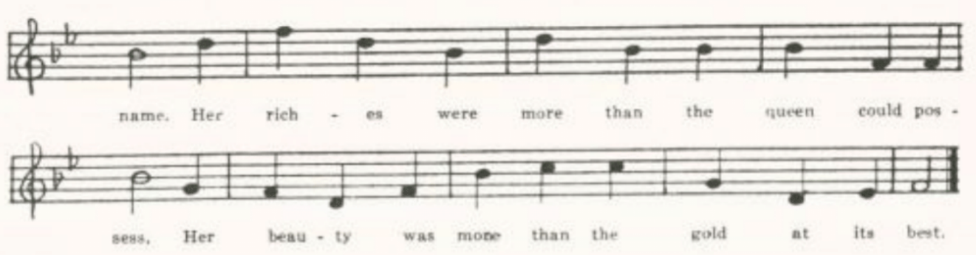
(116)
A rich Irish lady from London there came,
A beautiful damsel called Sally by name.
Her riches were more than the Queen could possess,
And her beauty was more than the gold at its best.

A rich merchant’s clerk comes a-courting to her,
Whose income was more than ten thousand per year.
She thought of her riches and prized them so high
That on this poor young man she scarce cast an eye.

‘O Sally, O Sally, O Sally,’ said he,
‘I’m afraid that your courtship and mine won’t agree;
Unless that your hatred should turn into love,
I’m afraid that your beauty my ruin will prove.’

‘I owe you no hatred, nor no other man,
But to say that I love you is more than I can;
So therefore I beg you leave off your discourse,
For I never shall have you unless I am forced.’

Now several long years have come and are past,
And the beautiful damsel fell sick at the last;
She was tangled in love and she could not tell why,
So she sent for the young man whom she once did deny.

‘Oh, am I the doctor you sent to come here,
Or am I the young man you love most sincere?’
‘Yes, you are the doctor, can kill or can cure;
And the pain I lie under is hard to endure.’

‘O Sally, O Sally, O Sally,’ said he,
‘Oh, don’t you remember when I courted thee
You laughed at my courtship and denied me with scorn?
And now I’ll reward you for what’s past and gone.’

‘For what’s past and gone, love, forget and forgive,
And grant me some long years yet for to live.’

(117)
‘No, that I won’t, Sally, not while I have breath,
But I’ll dance o’er your grave after your death.’

Then from off her fingers she pulled diamond rings three,
Saying, ‘Wear these, loving William, while you’re dancing o’er
me.
Ten thousand time over my folly I see.’

Now Sally is dead, as we may suppose,
She’s left all her lovers for other girls’ beaux;
She’s taken up her lodgings in the banks of cold clay,
And her red rosy cheeks are all mouldering away.

E
‘The Irish Lady.’ Contributed in 1924 by Beulah Pendergrass, student at the University of Missouri, who knew it in her childhood in northeastern Arkansas.

There was an Irish lady, from London she came,
A beautiful lady, and Molly by name;
Her riches was so great and her honors so high
That upon this young man she could scarce cast an eye.

‘Oh Molly! oh Molly! oh Molly!’ said he,
‘I wish that my love and yours could agree.
I’d marry you, Molly, by the powers above,
If I knew that your hatred would turn into love.’

‘Oh no, I don’t hate you nor no other man,
But to say that I love you is more than I can;
So drop your attentions and cease your discourse,
For I shall not marry you unless I am forced.’

On Friday this lady was taken down sick;
She sent for this young man to come and come quick.
He came to her bed, sat down by her side:
‘Is there a pain in your head, love, or a pain in your side?’

‘Oh no! oh no, love! You did not guess right;
The pain that torments me will soon take my life,
And you are the doctor, can kill or can cure,
And without your assistance I’ll die, I am sure.’

‘Oh Molly! oh Molly! oh Molly!’ said he,
‘Don’t you remember when you first slighted me?
I courted you with pleasure; you denied me with scorn;
And now I’ll reward you with what’s past and gone.

(118)
‘Of what’s past and gone, love, forget and forgive,
And grant me still longer while on earth to live.’
‘Oh no, I can’t, Molly, whatever I must,
But I’ll dance on your grave, love, when you’re laid in the dust.’

She drew from her fingers a diamond ring free,
Saying, ‘Take this, and remember, while dancing o’er me,
Ten thousand times over to your folly I’d flee,
And I would forgive you, but you won’t forgive me.

‘Farewell to my father, and all of my friends;
Farewell to young Johnny; God will make you repent.
I’m going, I’m going to my cold bed of clay,
Where these red rosy cheeks will moulder away.’

Bedroom Window (The Drowsy Sleeper)

For a study of the antiquity and range of this theme see C. R. Baskervill’s paper in PMLA XXXVI 565-614. The kernel of it is a dialog between a lover and his mistress at the latter’s window; characteristic lines are

Awake, awake, you drowsy sleeper
and
Who is that at my bedroom window?

He bids her ask first her father and then her mother to consent to their love; to both request she replies that it will be unavailing, adding in many texts what looks like an implication that he has been making love to another; and he departs disconsolate. That is the general plan; but it is subject to a great variety of modifications, and in America has rather frequently drawn upon The Silver Dagger for a conclusion. Pitts, Such, and Catnach all have nineteenth century stall prints of it. In the Such and Catnach prints it is developed into a ballad of the cruel father threatening impressments or transportation to the lover; the Pitts print is a seduction piece of a fairly familiar pattern in which the woman admits her lover and after he has had his will of her asks him to marry her and gets a jeering denial. Somewhat nearer to the American song is the Scotch I will put my ship in order (Christie I 224-5, Ord 318-9). In Christies’s text there is a father and a step-mother, and the latter seems to mislead the lover by speaking in the girl’s place, somewhat as in The Lass of Rock Royal, so that the lover departs—or, rather, starts to do so, for the girl calls him back and all ends happily. In Ord’s text the lover is really gone, and the girl drowns herself. (Ord 89 has another piece with a like setting and dialog but ending happily with the lover’s admission.) Earlier British broadside texts are printed and discussed by Ebsworth in Roxburghe Ballads VI 193-215.

(119)
Bedroom Window—in forms sufficiently close to the normal text to justify listing them here—has been reported from Surrey (JFSS VI 19), Sussex (JFSS I 269-70), Dorset (JFSS III 78-80), and Somerset (FSSom No. 99); from Newfoundland (BSSN 76); and from Virginia (SharpK I 361-4, SCSM 141), West Virginia (FSS 348-9), Kentucky (JAFL XX 260-1, XXX 340-1, SharpK I 364), North Carolina (JAFL XLV 55, XLVI 32, SharpK I 358-60, FSSH 190, a fragment, SCSM 140-1), Georgia (JAFL XXIX 200-1), Ohio (JAFL XXXV 356), Indiana (ABS 51-2, by way of Nebraska), and Missouri. Texts with the Silver Dagger tragic ending (as in Missouri G and H, below) have been reported from Newfoundland (BSSN 55-6), Nova Scotia (BSSNS 99), Vermont (SHV 30-1), West Virginia (FSS 349), North Carolina (SharpK I 360, SCSM 139-40, 142), Mississippi (FSM 161-2), Ohio (JAFL XXXV 357, mentioned but text not given), Michigan (JAFL XXX 341-2), and Nebraska (ABS 52-3, by way of Utah). Altho they are a good deal alike in the main and three of them have already been printed, the inherent interest of this song prompts me to give here all the texts in the Missouri collection. The assignment of speeches by quotation marks is editorial, and is by no means certain, especially in the latter part of C and D.

A
‘Bedroom Window.’ A fragment, secured by W. S. Johnson in 1903 from the fiddler Waters in Tuscumbia, Miller County. Printed in Archiv für das Studium der neueren Sprachen XCIX 430.

‘Open your door, your diamond window,
And listen to what I have to say;
How can you lie and sleep and slumber
When your true love is going away?’

‘Go ’way, go ’way, you wake my father,
Who lays on yonder bed to rest;
And in his hand he holds a dagger
To pierce the one who loves me best.’

B
‘Bedroom Window.’ Secured by Miss Gertrude Simmons in 1903 from Ethel Doxey of Carroll County, Arkansas. Printed in Archiv für das Studium der neueren Sprachen XCIX 430-1.

. . . . . . .
. . . . . . .
‘Who is this at my bedroom window,
Crying so loud and mournfully?’

‘’Tis I, ’tis I, your own true lover
That’s once more to bother thee.
Go, love, go, love, and ask your mother
If you this night my bride can be.’

‘I will not, will not go ask my mother
Nor let her know my love so dear.’
‘Go, love, go, love, and ask your father
If you this night my bride can be.’

‘I will not, will not ask my father,
For yonder he lies on his bed of rest,
And by his side he keeps a weapon
To slay the one my heart loves best.’

(120)
‘I’ll go, I’ll go to some lonesome valley,
There I’ll spend my weeks and years;
I’ll eat nothing but the willows,
I’ll drink nothing but my tears.’

‘Come back, come back, my own true lover!
Come back, come back once more to me;
I’ll forsake my father and mother
And go along and walk with thee.’

C
No title. From the manuscript ballad-book of James Ashby of Holt County, secured in 1906 by Miss Welty. Printed in Archiv für das Studium der neueren Sprachen XCIX 431.

‘Awake, awake, you drowsy sleeper;
Awake, awake, it is almost day.
How can you sleep, you felistian* creature,
When your true love is just gone* away?’

‘Go way, go way, you will wake my mother,
And that will be sad news to me.
You must go way and court some other,’
She whispered low, love, in my ear.

‘Go way, go way, you will wake my father;
He lies on yonders bed of rest,
And in his hands he holds a rapture†
To pierce the one whom I love best.’

‘Go fetch to me yonders pen and paper
That I may set down and write a while;
I will tell you of the grief and sorrow
That troubles me both day and night.

‘I wish I was a little swallow
Or else some lonesome trukle dove;
I would fly away over hills of sorrow
And light on some land of love.

‘In yonders field go stick an arrow.
I wish the same was in my heart;
Then I would bid adieu to sin and sorrow,
Then my poor soul would be at rest.

‘Go dig my grave in yonders meadow,
Place marble stones at head and feet,
And on my breast a turtle dove,
To testify I died for love.’
February 22 1874

*Presumably ‘felistian’ is for ‘Philistine’ and ‘gone’ for ‘going’.
†Rapier?

D
‘The Drowsy Sleeper.’ Contributed by Mrs. Case, in 1916, from her childhood memories in Harrison County.
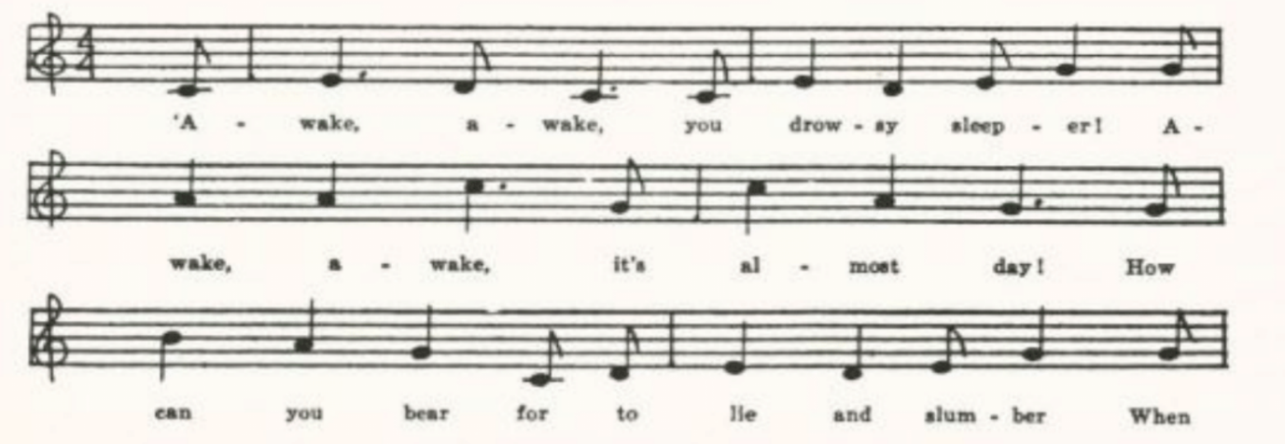
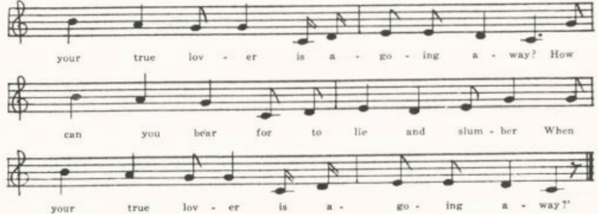
(121)
‘Awake, awake, you drowsy sleeper!
Awake, awake, it is almost day!
How can you bear for to lie and slumber
When your true lover is a-going away?’

‘Go ’way, go ’way! you’ll wake my mother,
And that will be sad news for me.
You must go ’way and court some other,
For she is all this world to me.

‘Go ’way, go ’way, you’ll wake my father:
He now lies on his bed of rest,
And in his hand he holds a dagger
For to kill the one that I love best.

‘Go fetch to me both pen and paper
That I may set me down and write;
I’ll tell you of the grief and sorrow
That trouble me both day and night.

‘I wish I were a little swallow,
Or else some lonesome turtle dove;
I’d fly away over hills of sorrow
And light upon some land of love.

‘In yonder field go stick an arrow;
I wish the same was in my breast.
I’d bid adieu to sin and sorrow,
And my poor soul would be at rest.

‘Go dig my grave in yonder meadow,
Place marble stones at my head and feet,
And on my breast a turtle dove
To show the world that I died for love.’

E
No title. Secured by Miss Lowry in 1920 from Earl Cruickshank of Columbus, Kansas, who knew it from his mother’s singing.

‘Awake, awake, ye drowsy sleeper,
Awake, awake, it’s almost day.
How can you bear to lie in slumber
When your true lover’s going away?’

‘Who’s that, who’s that all at my window,
Who calls my name so speedily?’
‘It is, it is your own dear Willie
Who wants to have a talk with you.’

‘Go way, go way, you’ll wake my mother;
No tales of love she wants to hear.
Go way, go way and court some other,’
She softly whispered in his ear.

‘My pretty little miss, be not offended
At what I say—I mean no harm.
I only mean to steal you away from your mother
That you may lodge in your true lover’s arms.’

(122)
‘Go way, go way, you’ll wake my father;
He’s now a-taking up his rest.
In his right hand he holds a weapon
To slay the one that I love best.’

‘In yonder wood there grows an arrow,
I wish I had it through my breast;
‘Twould put an end to all my sorrow,
And my poor souls should be at rest.’

F
A single stanza, sent to me by Mrs. J. T. Duncan of Excelsior Springs, Missouri, as the beginning of a song that used to be very popular ‘in the rural districts of Northern Texas.’

‘Awake, arise, ye drowsy sleeper,
Awake, arise, ‘tis almost day.
Why will ye lie and sleep and slumber
While your own true lover goes away?’

G
‘Death of William and Nancy.’ Sent in by C. H. Williams in 1909, who had it from J. G. Scott, who learned it from a girl who in turn had learned it ‘in the hill country of Bollinger and Perry Counties.’ One of the Missouri texts that have adopted the Silver Dagger ending.

‘Who is that at my bed window?
Who is there I do not know?’
‘’Tis I, ’tis I, your own true lover.
Oh, come, oh, come and pity me.’

She raised her head from her pure white pillow
And out of the window she looked to see;
Who did she spy but her own true lover
Sitting beneath the willow tree,

Saying, ‘Nancy, go and ask your mother
If you my wedded bride may be;
If she says no, return and tell me
And I no more will trouble thee.’

‘It’s of no use to ask my mother,
For I’m the only girl she’s got.
In her right hand she holds a letter
To show me the man I should love best.’

‘Oh, Nancy, go and ask your father
If you my wedded wife may be;
If he says no, return and tell me
And I no more will trouble thee.’

‘It’s of no use to ask my father,
For he is on his bed of rest;
And by his side there lies a dagger
To kill the man that I love best.’

William took up the shining dagger,
Pierced in his aching heart:
‘Adieu, adieu, my own dear Nancy,
Adieu, adieu! We both must part.’

Then Nancy took up the bloody dagger,
Pierced it in her pure white breast:
‘Adieu, adieu, my own dear William,
Adieu, adieu! We’re both at rest.’

(123)
H
No title. Contributed by Myrtle Wright, 1914; from her mother, who was born and lived in Ray County and had ‘a store of ballads.’ Another with the Silver Dagger ending.

‘Awake, awake, you drowsy sleeper,
Awake and listen unto me!
For here beside your bedroom window
I am weeping almost* bitterly.

‘Oh, Mary dear, go ask your mother
If you my wedded bride may be;
If she says no, return and tell me
And I’ll no longer trouble thee.’

‘Oh, Willie dear, I dare not ask her,
For she has tried to set me free;
Oh, go your way and court another,
And stay no longer here with me.’

‘Oh, Mary dear, go ask your father
If you my wedded bride may be;
If he says no, return and tell me
And I’ll no longer trouble thee.’

‘Oh, Willie dear, I dare not ask him,
For he is on his bed of rest,
And by his side lies a sliver dagger
To pierce the one that I love best.’

‘Oh, I could climb the tallest tree-top,
Or I could rob the richest nest,
Or I could court the fairest lady,
But not the one that I love best.’

Then Willie drew forth a sliver dagger
And pierced it through his aching heart:
‘Farewell, farewell to you, dear Mary,
You and I now must part.’

Then Mary picked up the blood-stained dagger
And pierced it through her snow-white breast:
‘Farewell, farewell to you, dear parents;
Willie and I have gone to rest.’

*‘Almost’ should perhaps be ‘all most.’

The Silver Dagger

Altho from its style and content this seems clearly to be a product of the professional ballad-maker, I know of no ballad print of it either British or American (except No. 518 in Wehman’s series of ballad prints, where it is combined with The Drowsy Sleeper); it is recorded only from traditional singing, and that only from the South and the West. That its conclusion has been incorporated in texts of Bedroom Window has already been noted. As an independent and quite distinct ballad it has been reported from Virginia (SharpK II 230), West Virginia (FSS 350-2), Kentucky (JAFL XX 267, BKH 71-2, DD 110-1, SharpK II 229-30), Tennessee (JAFL XLVI 45-6), Mississippi (JAFL XXXIX 129-32), Arkansas (Ozark Life V Nos. 5-6), Ohio (JAFL XXXV 374, tune only), Illinois (ABS 123-4, TSSI 162), Wyoming (ABS 121-2), and Missouri (JAFL XLIX 211-3). The Missouri texts agree so closely that not all are printed here.

(124)
A
No title. Secured by Miss Gertrude Simmons in 1904 from Ethel Dozey of Carroll County, Arkansas.

Come all young maidens, pay attention
To these few lines I’m going to write;
They are as true as ever was mentioned,
Concerning a young and a beautiful bride.

He courted her to be her lover;
He loved her as he loved his life.
He ofttimes vowed that he would make her
His lawful and his wedded wife.

And when his parents came to know this
They strove to part them day and night,
Saying, ‘Son, oh son, don’t you have her,
Fr she’s a poor girl,’ they ofttimes say.

Down on his bended knees a-pleading,
Crying, ‘Father, father, pity me!
She is my own, my own dear jewel;
What’s this world without her to me?’

And when this maiden came to know this
She soon resign* what she would do;
She rambled forth and left the city
No more her loving groms* to view.

She rambled down the clear flowing river,
And there she did its death prepare,
Saying, ‘Here I land my youthful warning.
Must I sink in deep despair?’

And out she drew her silver dagger,
She pierced through her lily-white breast;
Forth she reeled and then she staggered,
Crying, ‘True love, I’m going to rest.’

Her lover being near where he could hear her
And knowing well her female voice,
He ran, he ran like one distracted,
Crying, ‘True love, I fear you’re lost!’

And up he picked this bloody body,
HE rolled it o’er within his arms,
Saying, ‘Now no gold nor friend can save you.
Must you die, and all your charms?’

Her coal-black eyes like stars she opened,
Crying, ‘True love, you have come too late;
Prepare to meet me on Mount Zion,
Where all our joys will be complete.’

And up he picked this bloody weapon,
He pierced it through his own tender heart,
Saying, ‘Let this be a woeful warning
To all true lover who has to part!’

*Lines 2 and 4 of this stanza seem corrupt. For line 2 other texts have:
B She wondered quick what she might do
C She quickly resolved what she would do
F G She soon resolved what she would do
And for line 4:
B No more its pleasant scenes to view
C No more would its pleasures glow to you
F In the pleasant groves no more to roam
G No more its pleasures she would view
The stanza does not occur in D and E, which are incomplete texts.

B
‘The Silver Dagger.’ Secured by C. H. Williams in 1906 from Mary Cross, who found it in Ralls County. An incomplete text, lacking stanzas 4, 8, 9, 10, and 11 of A.

(125)
C
‘The Silver Dagger.’ From the manuscript ballad book of Ada Belle Cowden, compiled about 1909 and secured for me by Miss Laws off Christian College. Miss Cowden lived at Woodlandville, Boone County. Lack stanza 4 of A and has telescoped stanzas 2 and 3 into one stanza.

D
‘Old Song.’ Secured by Miss Hamilton in 1912 from Luther Crookshank of the Kirksville Teachers College. ‘This song was popular at “parties” and other such social gatherings about thirty or forty years ago, in the rural sections of North Missouri. The writer secured it from his mother, who was reared in Linn County, Missouri’—L.C.’s note. An abbreviated version, four stanzas.

Young men and maids, pray lend attention
To these few lines I am going to write,
And when a lonely youth I mention
Who courted a gair and handsome bride.

But when her parents came t oknow it,
They strove to part them day and night;
To rob her of her precious jewel
In whom she took such great delight.

Down by the side of yonder river,
Beneath the shade of a tall green tree,
She sat and sighed, ‘Oh, shall I ever,
Shall I ever again my true love see?’

She then picked up a silver dagger
And pierced it through her tender heart,
Saying, ‘Let this cruel deed be warning
To all true lovers whom they part.’

E
No title. Secured by Miss Hamilton in 1912 from Agnes Shibley of the Kirksville Teachers College. The latter part of the song only, beginning ‘She wandered fields and meadows over.’

F
‘The Silver Dagger.’ Contributed in 1916 by Mrs. Case, who knew it in her childhood in Harrison County. Text corresponds to A except that it lacks stanza 4 of that text. Printed in JAFL XXX 362-3.
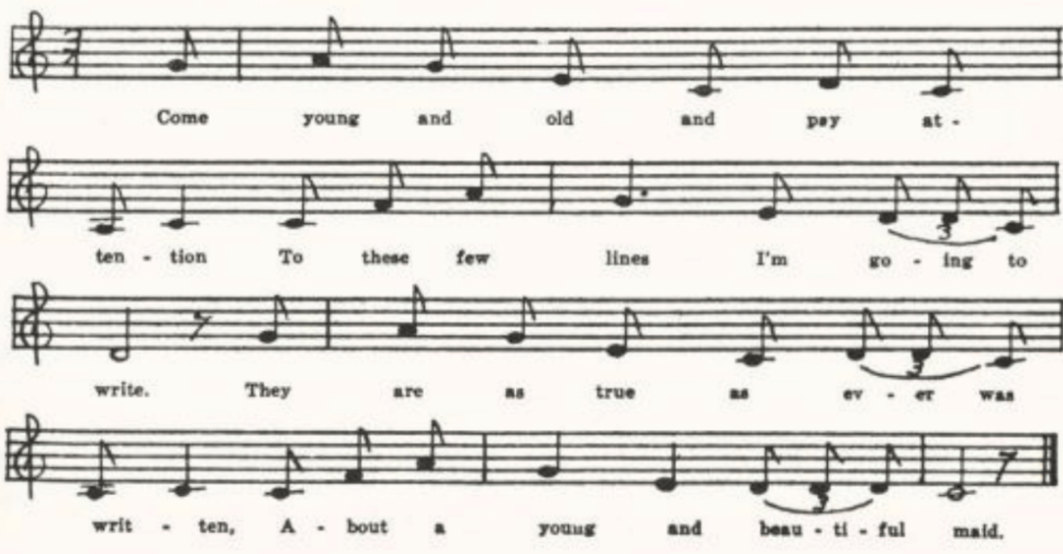
(126)
G
No title. Sent by Miss Frances Barbour of Washington University in 1917 as sung by Minnie Doyel of Arlington, Phelps County. Miss Barbour has since printed it (JAFL XLIX 211-3) among her instances of fusion of two or more ballads; but it has no definite traces of The Drowsy Sleeper, and does not differ significantly from A.

H
‘Silver Dagger.’ Secured in 1920 by Miss Lowry from Earl Cruickshank of Columbus, Kansas. Lacks the first stanza, but otherwise corresponds to A except that the closing stanzas are differently ordered: stanzas 9, 10, 11 of A are stanzas 9, 8, 10 in H.

Mary in the Silvery Tide

As Mackenzie remarks, this stall ballad, frequently issued by the English ballad press, is little known in America. In fact, his Nova Scotia text (BSSNS 147) and one printed by R. W. Gordon in Adventure from a Michigan correspondent are the only reports of it from this side of the Atlantic. It is known in Scotland (Ord 472-3), Sussex (JFSS I 216-7), and Somerset (FSSom No. 112). The texts secured from folk singers do not differ greatly from the stall copies.

‘Pretty Mary.’ From the manuscript ballad-book of Mrs. Lida Jones of Dade County, compiled probably in the 80s and secured by Miss Lowry in 1906.

’Twas of this fair young creature
Who dwelt down by the sea,
Of her lovely form and feature—
They called her pretty Mary.

All in young Henry’s absence
A nobleman there came
A-courting of pretty Mary;
But she refused just the same.

‘My vows are vain all o’er the main,’
So eagerly she cried,
‘So now be gone! I love but one,
And he is on the silvery tide.’

‘Now,’ cried this artful villain,
‘Consent to be my bride
Or I’ll cause your separation—
I’ll take away your life.’

With trembling hands cried Mary:
‘My vows I never will break.
’Tis Henry I love dearly
And I’ll die for his sweet sake.’

He tied her hand[s] with his handkerchief
And plunged her into the tide;
A-shrieking she went floating
Along with the silvery tide.

In a few days afterwards
Young Henry he returned
Expecting to get married;
Had fixed his wedding clothes.

‘We fear your true love’s murdered,’
His eager parents cried;
‘She cause[d] her own destruction
Down in the silvery tide.’

(127)
Young Henry on his pillow lay,
He could not [get] any rest,
For the thought of his pretty Mary
Disturbed his wounded breast.

At midnight dawn young Henry rose
And yonder alone walked he
In search of his pretty Mary
Who had died on the silvery tide.

At daybreak in the morning
Young Mary’s corpse he spied;
He knew it was his Mary
Who had died on the silvery tide.

He knew it was his Mary
By his own ring on her hand.
He untied the handkerchief,
Which put him to a stand.

The name of her base murderer
In letters full he spied.
He knew then how his Mary
Had died on the silvery tide.

This murderer was take,
The gallows was his doom
For the ending of pretty Mary
Who had scarce reacher her prime.

Young Henry so rejected*,
He vowed the ocean he’d ride
Broken-hearted for pretty Mary
Who had die on the silvery tide.
Lucy Clary

*Such, and Ord, have here more properly ‘dejected.’—The name at the end, a not infrequent phenomenon in manuscript ballad-books, may be assumed to be that of the person who supplied the text.

Edwin in the Lowlands Low

For the vogue of this among the ballad printers see Kittredge’s note JAFL XXXV 422-3 and the headnote to Mackenzie’s Nova Scotia text. It has been found in oral currency in Scotland and in Ireland (See notes in SharpK), and in Sussex (JFSS I 124), Hampshire (FSE II 38-40, JFSS III 266-7), Nova Scotia (BSSNS 92-3), Ontario (JFSS VIII 227-8), Vermont (VFSB 106-7), West Virginia (FSS 345), Kentucky (JAFL XX 274-5, TKMS 42-5, JAFL XXXV 421-2, SharpK I 355-7), Tennessee (JAFL XXV 153, SharpK I 351-2), North Carolina (SharpK I 351-2, 353-4, 356-7, JAFL XLV 40-1, FSSH 164-6), Georgia (SharpK I 352-3), and Ohio (JAFL XLIX 230-1, by way of Kentucky).
‘The Driver Boy.’ Secured in 1909 by Miss Hamilton from Emma Bond of the West Plains High School.

Young Emelye was a lady;
She loved her driver boy
Who drove all over the ocean
To gather lots of gold.

‘My name is young Edward.
Let no one know,
For I am the driver boy
Who drove in the lowlands low.’

‘My father keeps a public house
Down by the river side.
IF you will stop and stay a while
I am sure you’ll meet your bride.’

(128)
Young William his* father said,
‘His money will make a show.
We’ll sent his body floating
Down in the lowlands low.’

Young Emelye went to bed that night.
She had a frightful dream;
She thought she saw her true lover’s blood
Flowing down the stream.

She rose up early next morning
And to her father did say,
‘Father, dear father, you’ll die a public show,
For the murder of my driver boy
Who drove in the lowlands low.’

‘His body is in the ocean,
The ships sail over his breast;
His body is in the ocean;
I hope his soul is at rest.

‘And when I go to the river,
The willows bending to and fro,
It reminds me of my driver boy
Who drove in the lowlands low.’

*Should apparently be ‘her,’ not ‘his.’ The ‘young William’ can hardly be the driver boy, for his name, he has just told us, is Edward; and if Emelye’s father is meant, why ‘young?’ The assignment of speeches is editorial, the MS having no quotation marks; and I am by no means sure that it is all cases right.

The Flying Cloud

The Flying Cloud, built by Donald McKay of Boston and sailed by Captain Josiah P. Creesy of Marblehead, made in 1851 the passage to San Francisco in 89 days, which appears to have been the record up to that time (J. R. Spears, The Story of the America Merchant Marine (New York, 1910) p. 231). In 1871 (Professor H. E. Rollins of Harvard tells me) R. M. De Witt, 33 Rose Street, New York, published The Flying Cloud. A Romance of New York Bay. By Professor J. H. Ingraham, in which the ship is said to have been built for Mexico by order of President Santa Anna, but, not being paid for, to have been sold to one Fordwell, and adventurer. I have not seen Ingraham’s book, which may be based upon fact or may be simply a romanticizing of the story of our ballad. The name is the one that may well have been given to more than one vessel in the palmy days of American shipping. The ballad appears in Joanna Colcord’s Roll and Go 73-5, and in the Boston Transcript for 30 December, 1916. It has been reported by collectors from Newfoundland (BSSN 349-53), Nova Scotia (BSSNS 283-5, SBNS 126-30), Maine (MM 214-6), Missouri (ABFS 504-7), Minnesota (JAFL XXXV 370-2, Dean 1-2), and North Dakota (BSSB 145-9). It is known also in New Hampshire (JAFL XLVIII 351), The editor of Adventure received in 1919 a text from Michigan. It is included, without note of its provenience, in Finger’s Frontier Ballads. The text in the Missouri collection is not really from Missuori but from Michigan by way of Wisconsin, but it seems worth while to give it here.

‘Edward Hollander.’ Tune and text secured by Miss Colquitt Newell in 1913 from A. F. Nelson of Madison, Wisconsin, who had learned it as a boy some twenty years before from neighboring farm boys in Dane County, Michigan.

(129)
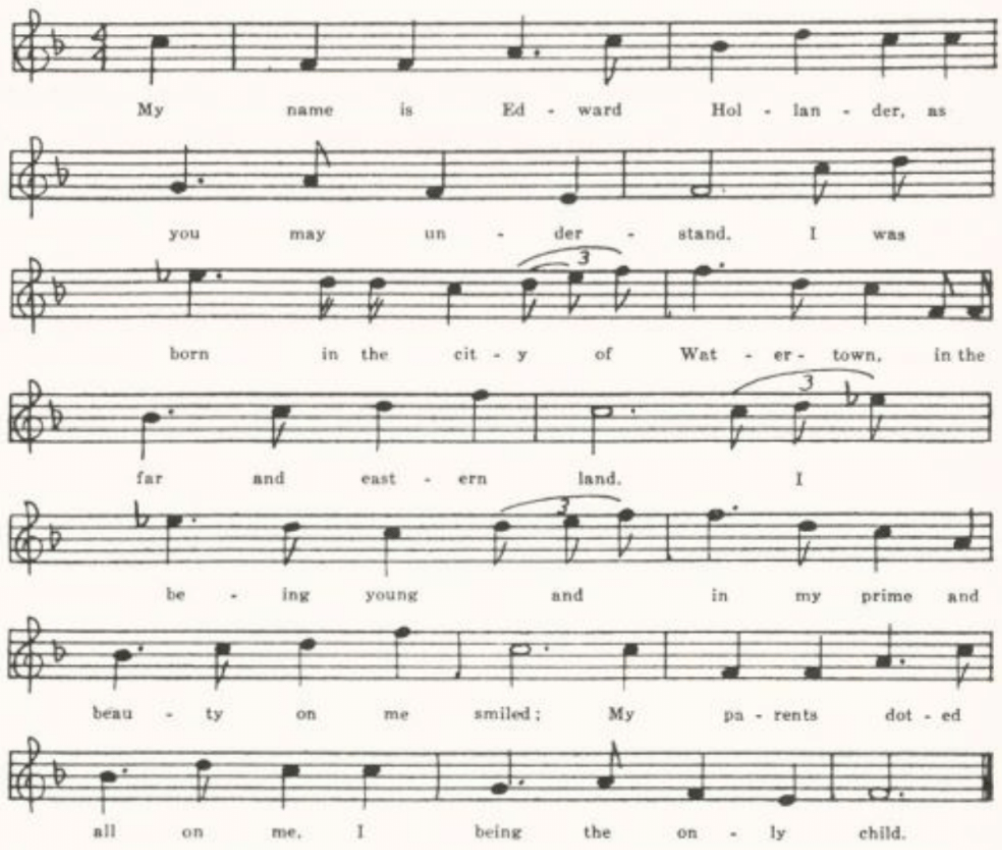
My name is Edward Hollander, as you may understand;
I was born in the city of Watertown, in the far and eastern land.
I being young and in my prime, and beauty on my smiled;
My parents doted all on me, I being the only child.

My father bound me to a trade, it was in Trenton town;
He bound me to a cooper there by the name of William Brown.
I served my master faithfully for eighteen months or more,
Then I shipped on board of the Ocean Queen bent for Belfrazer shore.

And when I struck Belfrazer shore I met with Captain Moore,
The commander of the Flying Cloud belonging to Baltimore.
He cordially invited me a slavery voyage to go
To the burning shore of Affarie, where the sugar cane does grow.

The Flying Cloud was a clipper built, four hundred tons or more.
She could easily sail around any ship that sailed from Baltimore.
Her sails were as white as the driven snow and on them not one speck;
She had thirty-two brass guns, my boys, she carried upon her deck.

(130)
And in a short time after we had struck the African shore
Eighteen hundred of those poor souls on board with us we bore.
We made them walk out on our planks as we stored them down below;
Scarce eighteen inches to the an was all that she would go.

The very next day we set to sea with our cargo of slaves.
It would have been better for them poor souls had they been kept in their graves.
For the plagued fever came on board and swept one half away;
We drew their bodies up on deck and hove them in the sea.

And in a short time after we struck the Cubian shores.
We sold them to the planters there to be slaves for ever more,
To hoe in the rice and coffee fields beneath the burning sun,
To worry out a wretched life till their career was done.

Our money soon being spent and gone, we set to sea again,
When Captain Moore came out on deck and spoke to all his men:
‘There is gold and silver to be had if you’ll with me remain;
We will hoist aloft our pirate flag and scour the Spanish Main.’

We all agreed but five young men, who told us them to land.
Two of them were Boston boys and two from the New Foundland
And one of them was a young Irish lad belonging to Trymoor.
I would to God I would have joined those men and went with them on shore.

We robbed and plundered many a ship while on the Spanish Main,
We caused many a mother’s heart an orphan to remain;
We made them walk out on our planks and take a watery grave,
For the saying of our captain was, ‘A dead man tells no tales.’

We were often chased by many a ship, both frigate and liner too.
It was all in vain across the main as at our stern they flew;
It was all across the … with their cannons thundering loud,
They could not catch the Ocean Queen, they dreaded the Flying Cloud.

It was all in vain of them catching us, till the Dreadnaught came in view.
She fired a shot across our deck, a signal to heave to.
We gave her no answer, but sailed before the wind,
When a chance shot struck our mizzenmast; it was then we fell behind.

We cleared our deck for action then, as she hove along our side.
And first across our quarterdeck there flowed a crimson tide.
We fought till Captain Moore was killed and eighty of his men;
Then a bombshell set our ship on fire—we had to surrender then.

(131)
They took us down to Rulawarp* bound down in iron chains
For the robbing and plundering of ships at sea while on the Spanish Main.
It was whiskey and bad company that made a wreck of me;
So, boys, beware of my sad plight and curse all piracy.

Now I will bid adieu to the shady grove and the girl that I love dear,
Her voice like music soft and sweet I never more shall hear;
I never shall kiss those ruby lips or stroke the lily-white hand,
But die a sad and scornful death down in this foreign land.

*The Michigan text mentioned above has ‘to Newgate,’ which suggests an English stall print as the original form. I am at a loss to explain ‘Rulawarp.’

The Sheffield Apprentice

This story of the serving man whose mistress falls in love with him and, when he refuses to abandon his true-love Polly, her maid, ‘frames’ him as a thief and has him brought to trial and execution, reminiscent as it is of Joseph Andrews and Lady Booby, was a favorite of the nineteenth century ballad press. Harvard Library has prints of it by Such, Pitts, and Catnach. It is also in Turner and Fisher’s Forget-Me-Not Songster, Philadelphia and New York, about 1840. It has been reported from oral tradition in Scotland (Christie II 67, Ord 421-2), Norfolk (JFSS II 169), Surrey (JFSS I 200-1), Vermont (VFSB 94-6), West Virginia (FSS 294-5), Kentucky (Sewanee Review XIX 320), Tennessee (JAFL XLV 51-3, FSSH 283-4, ETWVMB 80-1, SharpK II 67-8), North Carolina (JAFL XXVIII 164, SharpK II 66-9), and Minnesota (Dean 18-9).

No title. Written down for Miss Hamilton in 1911 by Shirley Hunt of the Kirksville Teachers College as sung by her mother.

In Sheffield I was bred and born all of a high degree.
My parents doted on me; they had no child but me.
I roamed about in freedom just where my fancy led
Till I was bound apprentice; then all my joys were fled.

I did not like my master; he did not use me well.
I formed a resolution not long with him to dwell.
Unknown to my poor parents, from him I ran away.
I steered my course for London—and cursed be that day!

A beautiful young lady from Holland was there.
She offered me great wages to serve her for a year.
After a long persuasion with her I did agree
To go and live in Holland; it proved my destiny.

(132)
I had not been in Holland more years than two or three
Until my pretty mistress became quite fond of me.
She said her gold and silver, her houses and rich land,
If I’d consent to marry her they were at my command.

I said, ‘Dear honored ladies, I cannot wed you both,
For I have lately promised and took a solemn oath
To wed to none but Polly, your pretty chambermaid.
Excuse me, my dear mistress, she has my heart betrayed.’

Then in an angry humor away from me she ran.
She had resolved within her mind that she would be revenged.
Her being perplexed she would not be my wife,
Then she must seek some project to take away my life.

One day while we were walking all in the garden gay,
The flowers they were blooming most beautiful in May,
A gold ring from her finger, just as she passed me by,
She dropped it in my pocket—and for it I must die.

My friends, who stand around me my wretched fate to see,
Oh, don’t mourn for my downfall, but oh! Do pity me.
A long while I’ve proved innocent, still death has sentenced me.
Oh, farewell, pretty Polly! I’ll die a-loving thee.

The Lily of the West

A favorite with the ballad press. There are seven stall prints of it in the Harvard Library, Wrigley printed it in New York, and it is included in Uncle Sam’s Army Songster (Indianapolis, 1862). I find it recorded from tradition in Nova Scotia (SBNS 84-6), Kentucky (SharpK II 199), and Ohio (JAFL XXXV 368-9). The name is generally Flora; but in the Kentucky and Missouri texts she is Mary, and comes from Michigan (Cruickshank enters both names, from which I infer that he knew it both ways).

A
‘The Lily of the West.’ Secured by Miss Frances Miller in 1912 from Mrs. Charles Opel of Jefferson City, who learned it from her mother.

I just came down from Louisville
Some pleasure for to find,
A handsome girl from Michigan,
So pleasing to my mind.

Her rosy cheeks and roving eyes
Like arrows pierced my breast;
They called her Handsome Mary,
The Lily of the West.

(133)
I courted her for many a day,
I thought her love to gain.
Too soon, too soon she slighted me,
Which caused me grief and pain.
She robbed me of my liberty,
Deprived me of my rest;
But still I loved my Mary,
The Lily of the West.

As I walked out one evening
Down in yon shady grove,
I saw a lord of high degree
Conversing with my love.
He sang, he sang so merrily,
While I was sore distressed;
He sang for handsome Mary,
The Lily of the West.

I rushed up to my rival
A dagger in my hand,
I caught him by the collar
And boldly bade him stand.
Being mad to desperation,
My dagger pierced his breast.
I was betrayed by Mary,
The Lily of the West.

And now my trial has come off
And sentenced soon I’ll be.
They put me in the criminal box
And there convicted me.
She so deceived the jury,
So modestly did dress,
She far outshone bright Venus,
The Lily of the West.

Since then I’ve gained my liberty,
I’ll roam the country through,
I’ll travel the cities over
To find my loved one true.
Through she robbed me of my liberty,
Deprived me of my rest,
But still I love my Mary,
The Lily of the West.

B
‘The Lily of the West.’ Written out by Earl Cruickshank of the Columbus (Kansas) High School in 1920 for Miss Lowry. As noted above, he writes ‘Mary’ as an alternate reading for ‘Flora’ throughout. Does not differ significantly from A.

The Oxford Girl
The story of the girl murdered by the man who has seduced her takes many forms in street balladry, as it has done, no doubt, in our social history. The earliest that I have come upon is that in the Pepys collection, The Bloody Miller (Rollins III 118-22), a piece of ballad journalism on the murder of Anne Nicols on the 10th of February, 1684. The murderer here is a miller, but the place is Hocstow near Shrewsbury, not Oxford or Wexford, and there is no fence stake and no drowning. Bleeding figures, but it is at the trial, not on his return from the murder. The nearer antecedent of the American ballad is the English broadside of The Berkshire Tragedy; or, The Wittam Miller, found in the Douce and Roxburge collections (Roxburghe Ballads VIII 629-31, where Ebsworth says it is ‘originally of date circa 1700’) and printed in the nineteenth century by Pitts, Such, Catnach, Birt, and no doubt by others. Here the scene is at Wittam near Oxford (sometimes Wexford, and in one print preserved in the British Museum it is at maidstone

(134)
in Kent), the man is a miller or a miller’s apprentice, the girl is beaten with a stick pulled from a hedge and then thrown in the water to drown, and the man explains (either to his master or his mother or his servant) the blood on his clothes as due to nose-bleed. These features persist, for the most part, in the versions from tradition listed below and also (with a change of place-name) in the early nineteenth century Boston broadside of The Lexington Miller (for which see JAFL XLII 249-50). For distinct American pieces on the same theme see Oma Wise and Florella, later in the present volume.
The Oxford Girl, under various names, has been reported from tradition in Norfolk (JFSS VII 23), Dorset (JFSSS VII 44-5), Newfoundland (BSSN 119), SCSM 161-2), West Virginia (FSS 311-3), Kentucky (SharpK I 407-9), Tennessee (JAFL XLV 125-30, SCSM 160-1, 162-4, FSSH 219), Mississippi (JAFL XXXIX 125-9, FSM 141-3), Illinois (TSSI 150), and Texas (PFLST VI 213-4). Probably derived from this, tho lacking the special features listed above as diagnostic, are two texts, one (The Old Shawnee) from Nebraska and the other (On the Banks of the Old Pedee) from Wyoming, in ABS 108-9.

A
No title. From a manuscript collection lent me in 1904 by harry fore of the University of Missouri. Compiled in Gentry County, apparently in the 70s.

When I was a little prentice boy
About sixteen years of age,
My father bound me to a miller
That I might learn the trade.

I fell in love with an Irish girl
With a dark and rolling eye,
And she said she would marry me
If I would not her deny.

My father he persuaded me
To take her for a wife;
And the devil he persuaded me
To take away her life.

I went to her father’s house
At nine o’clock [at night];
And but little did this damsel know
That I owed her any spite.

I asked her to take a walk with me
Across the fields so gay
That we might take a pleasant chat
And set the wedding day.

We had not gone but a little ways—
Turned her round and round,
Pulled up a fence stake
And straightway knock[ed] her down.

Upon her bended knees
For mercy she did cry,
Saying, ‘Dear, don’t murder me,
For I’m not fit to die.’

But I caught her by her yellow hair
And turned her round and round
And pulled her to the millers pond
And plunged her in to drownd.

(135)
When I got back to the miller’s house,
About ten o’clock last night,
And but little did this miller know
What I had been about.

He look[ed] at me quite earnestly,
Saying, ‘What bloodied up your clothes?’
I only made him this reply:
‘It was bleeding at the nose.’

About five days and afterwards
This damsel she was found
Floating by her sister[’s] house
That lived in Oxford town.

Now all ye young ladies
Take warning by me
And never trust a young man
To any high degree.

B
‘The Oxford Girl.’ Written out in the summer of 1913 for Miss Jennie F. Chase of St. Louis by Addie McClard of French Mills, Madison County, whom Miss Chase heard sing it there. I have made the line and stanza divisions and have indicated what I take to be gaps.

‘Twas in the town of Vago
Where I did live and dwell,
‘Twas in the town of Oxford
I owned a flowery mill.

I fell in love with an Oxford girl;
She had dark rolling eyes.
I promised her I would marry her
If me she didn’t deny.

I went into her sister’s house
At eight o’clock one night.
. . . . . .
. . . . . .
I asked that fair one to walk with me
And view the meadows so gay,
That we might have some pleasant talk
And point the wedding day.

We walked along, we talked along,
Till we came to level ground;
I picked a piece of edgewood up
And knocked that fair one down.

She fell upon her bended knees:
‘O Lord, have mercy!’ she cried;
‘O, Willie dear, don’t murder me here,
For I’m unprepared to die.’

I paid no heed to her dying calls;
I beat her more and more,
Till the ground all around and around
Was covered with her bloody gore.
I picked her up by her long yellow hair
And slung her round and round,
I slung her in the river
That flows through Oxford town.

‘Lie there, lie there, you Oxford girl;
To me you never be tied;
Lie there, lie there, you Oxford girl;
You’ll never be my bride.’

I went into my father’s house,
It being late at night;
My mother woke in an awful fright
Of being weary at night.

‘My son, my son, what have you done
To bloody your clothes and hands?’*
The answer I gave her
Were bleeding at the nose.

I asked her for a candle
To light my way to bed.
No candle did they give me
To light my way to bed.

*Should evidently be ‘hands and clothes,’ to rime with the last line.

(136)
For the murdering of my own true love
Was rushing through my head.
No one to entertain me,
No one to go my bail.

I rolled, I tumbled,
No comfort could I find,
For the gates of hell was open wide
And in my eyes did shine.

The Rambling Boy

A form of a rather indeterminate, at least not easily identifiable, highwayman’s goodnight, probably of Irish provenience, variously known as The Flash Lad, In Newry Town, The Robber, The Rambling Boy, and Adieu, adieu, hard was my fate. Generally (but not in the Missouri text) the hero turns to robbery to support a wife. And directions for his funeral frequently terminate the song, in language suggestive of The Unfortunate Rake (see pp. 392-7 below). Pitts, and doubtless others, issued it as a stall ballad. It has been reported from the mouths of singers in Sussex (JFSS I 114-5), Hampshire (JFSS III 284), Worcestershire (JFSS VIII 190-1), Somerset (FSSom No. 120), and, rather vaguely, Devonshire and Cornwall (GCS No. XVII); and in this country in Kentucky (BDKH 63-4) and Tennessee (ETWVMB 43).

‘The Rambling Boy.’ Communicated in 1912 by Mrs. George H. Barnett of Columbia, as learned and sung by her mother, Mrs. J. T. Cooper, of Johnson County, before the Civil War.

I robbed Lord Mansfield, I do declare,
I robbed him at St. James’s Fair.
I robbed him here, I bade him goodnight,
All in my bloom I took my flight.

To Dublin city I bore away,
My face it was fair blooming gay;
Five hundred men did they* pursue,
And I was caught by the valiant crew.

Now I’m caught, condemned to die,
A many a fair maid will for me cry.
No weeps nor sighs can set me free
Or save me from the gallows tree.

Now I’m going to my grave,
A funeral preached pray let me have;
Six fair maids to bear me on
And six jolly fellows to bear me home.

* Should apparently be reversed, ‘they did.’

(137)
Give them gold rings, pink ribbons on,
Give them bright swords, and likewise guns,
So they may fire, with hearts of joy,
Saying, ‘Here goes the last of the Rambling Boy.’

The Banks of Dundee

A favorite with ballad printers in both the Old World and the New, and therefore presumably with the printers’ public. Professional balladists even wrote extensions of it by which the story is linked up with the returned lover theme. See Kittredge’s bibliographical note in JAFL XXXV 355-6. Traditional texts have been reported from Scotland (Ord 406-7) and from Berkshire (ECS 117); and in America it has been found in Nova Scotia (BSSNS 84-5), West Virginia (FSS 379-81), Kentucky (SharpK I 399-400), Tennessee (SharpK I 401), and Ohio (JAFL XXXV 354-5).

A
‘On the Banks of A-Dundee.’ Secured by Miss Hamilton from Helen Rode of West Plains in 1910. Miss Rode says it was ‘known by her mother when a child’—presumably in Howell County.

Oh, Willie was a plowboy
Whom Mary loved full well;
Down in her uncle’s garden
The story of love to tell.
There was a wealthy squire
Who often came to see;
But Mary loved the plowboy
ON the banks of a-Dundee.

Oh, the uncle and squire were a-riding,
Out riding one day,
And the uncle to the squire
These bold words did say:
‘Young William is her favorite.
We’ll tie him to a tree,
Unless in private we kill him
On the banks of a-Dundee.’

They taken William a prisoner
Upon a certain day.
He boldly fought for liberty,
But there was three to one.
The blood was flowing freely;
‘Pray kill me not,’ said he,
‘But I’ll die for the love of Mary
On the banks of a-Dundee.’

Oh, Mary was one day walking,
Lamenting her lost love.
She met the wealthy squire
Down in her uncle’s grove.
He threw his arms around her
And loving words did say;
But she fired and killed the squire
On the banks of a-Dundee.

Her uncle, hearing a noise,
Did hasten to the grove,
Saying, ‘Since you have killed the squire
I’ll give you your death wound.’
‘Stand back, stand back with vengeance,’ she cried,
Then the trigger she drew
And her uncle she slew*
On the banks of a-Dundee.

*One suspect that ‘Then the trigger she drew and her uncle she slew’ constitute one line with interior rime, and that another line has been lost here.

(138)
B
‘The Sweet Dundee.’ Contributed by Mrs. Case in 1916 from her childhood memories in Harrison County.

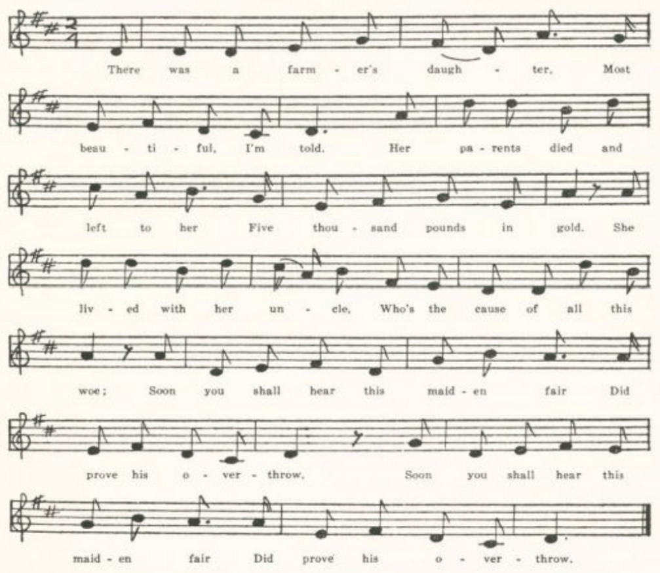
There was a farmer’s daughter,
Most beautiful, I’m told;
Her parents died and left her
Five thousand pounds in gold.
She lived with her uncle,
Who’s the cause of all this woe.
Soon you shall hear this maiden fair
Did prove his overthrow.

Her uncle had a plowboy
Whom Mary loved full well;
Down in her uncle’s garden
They tales of love did tell.
There was a wealthy squire
Ofttimes came her to see,
But still she loved her plowboy
On the banks of the sweet Dundee.

Her uncle and the squire
Rode out one summer’s day.
But William was her favorite,
As plainly you may see.
Said her uncle to the squire:
‘We’ll tie him to a tree,
Or else we’ll bribe the press-gang
On the banks of the sweet Dundee.’

(139)
The press-gang came to William
Where he was all alone.
He bravely fought for liberty,
But they were six to one.
The blood flowed red in torrents.
’Pray kill me now,’ says he,
‘I’d rather die for Mary
On the banks of the sweet Dundee.’

Next morning very early
She was walking through the grove.
She met this wealthy squire
Dressed in his morning robe.
She seized his two weapons,
Which he had used so free,
Then she fired and killed the squire
On the banks of the sweet Dundee.

Her uncle hearing the noise,
He hastened to the ground.
“Since you have killed the squire,
I’ll give you your death-wound.’
‘Stand off, stand off!’ young Mary cried,
‘Undaunted I will be!’
She the pistol drew and her uncle slew
On the banks of the sweet Dundee.

Her uncle sent for a doctor,
A man of noted skill,
Likewise a wealthy lawyer
To write and sign his will;
He willed his gold to Mary
Who had fought so manfully—
Then he closed his eyes no more to rise
On the banks of the sweet Dundee.

Fair Fannie Moore

Undoubtedly a production of the ballad press, but I have not found any stall print of it. Nor have I found that it is known in the British Isles. It has been reported from Vermont (VFSB 58-9), Pennsylvania (NPM 68-9), West Virginia (FSS 441), Montana (ABS 206-7), and, presumably, Minnesota (Dean 85-6), and it is given in CS 219-21.

A
‘Fair Fannie Moore.’ Found by Miss Williams in Clinton County in 1903.

Go look in yonder cottage all dark and alone,
Where was once a gravel walk, all green and overgrown;
Go look and you will see some dark spot on the floor.
Alas! It is the blood of the fair Fannie Moore.

This Fannie all blooming, two lovers had she,
They offered their love and their riches besides.
Their love and their riches they failed to allure
The love-burning bosom of the fair Fannie Moore.

The first was young Randal, all haughty with pride.
He offered his love and his riches besides.
Their love and their riches they failed to allure
The love-burning bosom of the fair Fannie Moore.

The first was young Randal, all haughty with pride.
He offered his love and his riches besides.
But his love and his riches failed to allure
The love-burning bosom of the fair Fannie Moore.

(140)
The next was young Edward of lowly degree.
He offered his love and enraptured was he;
And quick to the altar he went to secure
The hand and the heart of the fair Fannie Moore.

This Fannie all blooming in her cottage one day
When business had called her fond husband away,
Young Randal all haughty he opened the door,
And clasped to his bosom the fair Fannie Moore.

‘O Fannie, lovely Fannie, beware of your fate,
Accept of my offer before it’s too late.
For one thing is certain, I came to secure
The love or the life of the fair Fannie Moore.’

‘O spare me, O spare me, for mercy’s sake,’ she cried,
‘O spare me, O spare me, for mercy’s sake,’ she cried.
‘Go ye, go ye to the land of the blest!’
And he buried a dagger in her snowy white breast.

This Fannie all blooming and blood-stained she died.
Young Randal the haughty was taken and tried
And hung in chains on a tree beside the door
For taking the life of the fair Fannie Moore.

Young Edward he wandered distracted and wild;
He roamed for a while on his own native isle,
Till quickly he was taken from his own cottage door
And laid by the side of the fair Fannie Moore.

B
‘Fannie Moore.’ Secured by Miss Hamilton in 1911 from Shirley Hunt of the Kirksville Teachers College. Miss Hunt came from Scotland County. A somewhat better preserved text than A.

Yonder stands a cottage all dark and alone,
Where once there were graveled streets but now are overgrown.
Go into the parlor, there’s a dark spot upon the floor;
But alas! ‘tis the blood of the fair Fannie Moore.

To Fannie so blooming two lovers there came.
One offered young Fannie his wealth and his fame;
But neither his money nor pride could secure
A place in the heart of the fair Fannie Moore.

(141)
The next was young Henry of lowest degree.
He won her fond love, and enraptured was he;
And then at the altar he quick did secure
The hand with the heart of the fair Fannie Moore.

As she was alone in her cottage one day,
When business had called her fond husband away,
Young Randolph the haughty came in at the door
And clasped in his arms the young fair Fannie Moore.

‘Fannie, oh Fannie! reflect on your fate.
Accept of my offer before ‘tis too late,
For one thing tonight I’m bound to secure
Is the love or the life of the fair Fannie Moore.’

‘Spare me! oh, spare me!’ the fair Fannie cries,
While the tears swiftly flow from her beautiful eyes.
‘Oh, no!’ says young Randolph, ‘Go home to your rest!’
And he buried his knife in her snowy white breast.

So Fannie all blooming in her bright beauty died.
Young Randolph the haughty was taken and tried
Till at length he was hanged on a tree at the door
For shedding the blood of the fair Fannie Moore.

Young Henry the shepherd, distracted and wild,
Who wandered away from his own native isle
Till at length claimed by death he was brought to the shore
And placed by the side of his young fair Fannie Moore.

The Fatal Wedding

Mrs. Greenleaf, who notes that this was recited by a lady of St. John’s, Newfoundland (BSSN 368), but does not give the text because it is ‘familiar and accessible,’ says that it was published, ‘Words by Wm. M. Windom. Music by Gussie L. Davis,’ by Spaulding, Kornder & Co. with a copyright date of 1893; also by Spaulding & Gray, New York. It has been reported also from Mississippi (FSM 195-7), Illinois (TSSI 163-4), and Nebraska (ABS 140-2), and a text is given by Spaeth, Read ‘em and Weep 172-4.

A
‘The Fatal Wedding.’ From the manuscript ballad-book of Ada Belle Cowden of Woodlandville, Boone County, compiled about 1909 and secured for me by Miss Lucy Laws of Christian College, Columbia.

(142)
The wedding bells were ringing on a moonlit winter’s night,
The church was decorated, all within was gay and bright.
A mother with her boy came and saw the lights aglow.
She thought of how the same bells chimed for her three years ago.

Chorus:

While the wedding bells were ringing, while the bride and groom
Were marching up the aisle together as the organ pealed on air,*
Telling tales of fond affection, vowing never more to part;
Just another fatal wedding, just another broken heart.

‘I’d like to be admitted, sir,’ she said to the sexton old,
‘Just for the sake of baby, to protect him from the cold.’
But he told her that the wedding was but for the rich and grand,
And with the eager crowd outside she would have to stand.

She begged the sexton once again to let her step inside.
‘For your baby’s sake you may come in,’ the gray-haired man replied.
‘If anyone knows a reason why this couple should not wed,
Speak now or hold your peace forever,’ the preacher said.

‘I must object,’ a woman cried, her voice so meek and mild.
‘The bridegroom is my husband, sir, and this our little child.’
‘What, pray,† have you?’ the preacher cried. ‘My baby, sir,’ she said,
And knelt to pray to God in heaven. The little one was dead.

The parents of the bride took the outcast by the arm.
‘We’ll care for you through life,’ they said; ‘you’ve saved our child from harm.’
The parents, bride, and outcast wife in a carriage rolled away.
The bridegroom died by his own hand before the break of day.

No wedding feast was spread that night. Two graves were made next day,
In one the little babe and in one the father lay.
The story has been ofttimes told by firesides warm and bright
Of parents, bride, and outcast’s‡ wife and the fatal wedding night.

*Mattie White’s copy shows how the first two lines should run:
While the wedding bells were ringing, while the bride and groom were there,
Marching up the aisle together as the organ pealed an air,
†Read, ‘What proof have you?’
‡Read, ‘outcast.’

B
‘The Fatal Wedding.’ Communicated by Miss Colquitt Newell in 1912; the tune from the singing of Mr. T. B. Chandler of Farmington, St. Francois County, the text from

(143)
‘a book of ballads and songs,…bought by him from a blind man selling them thru that town about ten years ago.’ The text does not differ significantly from A, except that it has no chorus. Chandler’s tune:
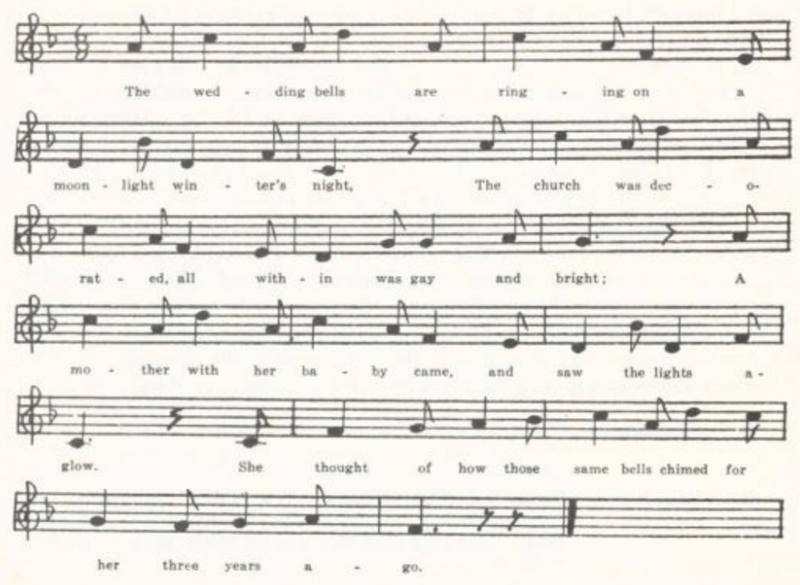

C
‘The Fatal Wedding.’ Manuscript of Mattie White, of Rucker, Boone County, 1906. The text does not differ essentially from A except that it indicates that the chorus is sung after eight-line, not four-line, stanzas.

Little Mohea

The relation of this American song—a great favorite, but found, so far as I know, only in America—to the British stall ballad of The Indian Lass is touched on by Kitted in JAFL XXXV 408 and is dealt with at length by Barry in BFSSNE VI 16-7. Kittredge suggests that it is a chastened American remaking of the British ballad. Barry argues ingeniously if not quite convincingly that the relation runs the other way: that the ballad ‘was originally a landsman’s song’ of the love of an (American) Indian girl for a pioneer (the English stall print has American localization: ‘She was born and brought up in a place near Orleans,’ and the name Maumee or Momee is a form of the Indian tribal name Miami) and that it has been ‘re-created by and for seamen’; that the English form has developed from an American original. The name Mohea, Mohee he allows, with the

(144)
editors of MM, is a form of Maui, the name of one of the Sandwich Islands; and he thinks the original song was remade or adapted in the days of the whaling industry to the experiences of sailors in that trade. However that may be, there is no question that the song as we have it in American tradition is a song of sailors and that the ‘Indian lass’ is a denizen not of America but of the South seas. The British ballad has been recorded from tradition in Yorkshire (JFSS II 262) and Nova Scotia (BSSNS 154, SBNS 103-5). The America song has been found in Maine (MM 230-3, BFSSNE VI 16), New Hampshire (JAFL XLVIII 351, but text not given), Vermont (BFSSNE VI 15-6), Virginia (SCSM 337-42), West Virginia (FSS 372-4), Kentucky (LT 52-4, DD 98-9, BKH 84, SHF 2-3, FSSH 290), Tennessee (ETWVMB 62-3, JAFL XLV 97-9, FSSH 286-7, 289-90), North Carolina (JAFL XLII 283, XLV 76-7, MSNC 16-23, BMFSB 30-1, FSSH 287-9, SCSM 342-5), Alabama (JAFL XLII 284-5, FSSH 285-6, BFSSNE VI 18), Mississippi (FSM 162-4), Illinois (TSSI 173-5), Minnesota (Dean 17-8), Iowa (MAFLS XXIX 33-7), and Montana (ABS 197-8); and Tolman mentions (JAFL XXXV 408) but does not print a text from Iowa. The seven texts in the Missouri collection are closely alike—mostly, as it happens, from the northern part of the state:

A ‘Little Momee’ From a manuscript collection compiled apparently in the 70’s
in Gentry County and lent to me by Harry Fore in 1904.
B ‘Little Mohea’ Brought to Miss Josephine Norville of Chillicothe, Livingston
County, in 1907 by one of her pupils in the school there, who
said that her grandmother sang it while a child at school.
C ‘Maumee’ Reported by George Williams in 1909 from the singing of Ode
Shrum, a lead miner, at Flat River, St. Francois County.
D ‘The Pretty Mohea’ Communicated to Miss Hamilton in 1912 by Shirley Hunt
of the Kirksville Teachers College, as sung by her mother, who was reared in Scotland County
E ‘The Little Mohea’ Secured in 1913 by Miss Welty from a girl in the Oregon
High School, Minnie Stout of Forbes, Holt County.
F ‘The Lass of Mohee’ Contributed by Emma Boundy of Barton County in 1913,
as sung by her mother’s mother in Illinois.
G ‘Little Mohee’ From manuscript songs in the ledger of A. E. Allenbrand of
Gentry County, brought to Miss Hamilton in 1923 by Allenbrand’s daughter Elizabeth, one of her students at Palmer College, Albany.

I give only D, which is one of the fuller texts.

As I went out walking for pleasure one day
In sweet recreation to while time away,
As I sat amusing my self on the grass
Oh, who should come near me but a fair Indian lass.

(145)
She sat down beside me, took hold of my hand,
Said, ‘You look like a stranger and in a strange land;
But if you will follow, you’re welcome to come
And dwell in a cottage that I call my own.’

The sun was fast sinking far o’er the blue sea
When I wandered alone with my pretty Mohea.
Together we wandered, together we rove,
Till we came to the cot in the cocoanut grove.

Then this kind expression she made unto me:
‘If you will consent, sir, to stay here with me
And go no more roving upon the salt sea,
I’ll teach you the language of the little Mohea.’

‘O no, my fair maiden, that never can be,
For I have a true love in my own country,
And I’ll never forsake her, for I know she won’t me,
And her heart is as true as the little Mohea.’

‘Twas early one morning, a morning in May,
That to this fair maiden these words I did say:
‘I’m going to leave, so farewell, my dear;
My ship’s sails are spreading and home we must steer.’

The last time I saw her she stood on the strand
And as my boat passed her she waved me her hand
Saying, ‘When you get home to the girl that you love,
Think of little Mohea in the cocoanut grove.’

And then when I landed on my own native shore,
With friends and relations around me once more,
I gazed all about me—no one could I see
That was fit to compare with my pretty Mohea.

And the girl that I trusted proved untrue to me.
So I’ll turn my course backward, far o’er the deep sea;
I’ll turn my course backward, from this land I’ll flee,
I’ll go spend my days with my pretty Mohea.

(146)
The Isle of St. Helena

For the occurrence of this lament for fallen greatness in broadside and songbook print see Kittredge’s note JAFL XXXV 359. It has been recorded from tradition in Ireland (JFSS II 89), Sussex (JFSS II 89), Newfoundland (BSSN 198-9), Vermont (VFSB 111-2), Massachusetts (JAFL XIV 140), Kentucky (SharpK II 245), and Tolman (JAFL XXXV 359) reports a text from Ohio but does not give it. Jackson, WSSU 182, points out that it was printed in The Social Harp, a song book compiled by J. G. McCurry of Georgia and published in Philadelphia in 1855.

A
‘The Isle of St. Helena.’ Entered under date ‘February 1st 1873’ in the MS ballad-book of James Ashby of Holt County, secured in 1906 by Miss Welty.

He is gone, he is gone from the wars of all fighting,
He is gone to the place that he never took delight in;
No more will he sit down and tell of scenes he hath seen of,
But he mourns when he thinks on the isle of St. Helena.

Louisa doth mourn of her loved on departed,
She dreams when she sleeps and awakes broken-hearted;
Not a friend to console her, those who might be with her,
She mourns when she thinks on the isle of St. Helena.

The rude rushing waves all around the shores are washing
And the great billows heave and the wild rocks are dashing.
He may look to the moon on the great Mount Diana
With his eyes on the waves that surround St. Helena.

All ye that have wives, pray beware of ambition;
‘Tis a decree in fate that might change your condition.
BE ye steadfast in time, for what is to come ye know not,
For fear you might be changed like he on St. Helena.

No more in St. Cloud shall he be seen in such splendor
Or go on with his crown like the great Alexander;
For the young king of Rome and the prince of Igana*
Say they will bring their father back from the isle of St. Helena.

*The Newfoundland text has here ‘the young king of France and the prince of Guiana.’ The former is of course the ‘king of Rome,’ Napoleon’s son by Maria Louisa; the latter I am not able to identify.

(147)
B
No title. Communicated to me by Professor Raymond Weeks of the University of Missouri, who had it in 1906 from J. F. Treasure, Superintendent of Schools at Cameron, Clinton County. It is incomplete, being stanzas 1, 2, and 4 of A. Treasure writes: ‘The following is a copy of that ballad as dictated to me by my mother… My mother told me she never saw the ballad in print, but learned it from an older sister.’

Wilkins and Dinah

Kittredge (JAFL XXIX 190 and XXXV 419) points out that there are two forms of this, the tragic ballad of William and Diana and the parody of it so popular on the variety stage and in songbooks, Villikens and his Dinah. The former was printed by Catnach and others and has been reported from tradition in Nova Scotia (SBNS 34-5), New Brunswick (JAFL XXXV 419, text not given), New York (JAFL XXXV 419-20, FLSH 209-10), Ohio (JAFL XXXV 418-9), and perhaps Kentucky (BKH 90) and North Carolina (BMFSB 42-3); it is not clear whether the last two belong to the serious or to the comic version. The parody, originating apparently about the middle of the last century, was widely known and sung, and has been reported from tradition in Nova Scotia (SBNS 36-7), Jamaica (PMLA XXXIX 479-82), Vermont (VFSB 49), West Virginia (FSS 344), and Mississippi (FSM 146-7). A ‘Dutch’ form, in which Katrina chokes to death on a sausage, is reported from Iowa (MAFLS XXIX 54-5). The Kentucky version mentioned by Shearin in Sewanee Review XIX and that from Louisiana mentioned by Tolman in JAFL XXIX 190 are presumably the comic form. So are all the Missouri texts; and they follow the printed form so closely that I shall not give them in extenso here. One of them amusingly illustrates the way of the folk with what they hear but do not understand. In the following text the second line of the fourth stanza is for ‘in gorgeous array’ and the third line of the eighth stanza is for ‘the billy dux (i.e. the billet-doux) stated.’ There are four texts in the collection.

‘Villikings and Dinah.’ Written out for Miss Hamilton in 1909 by Julia Rickman of the West Plains High School.

There was a rich merchant
In London did dwell,
He had but one daughter,
Of whom I will tell.

She had a rich fortune
Of silver and gold.
Her name was Dinah,
So I have been told.

As Dinah was walking
The garden one day
Her father came to her
And thus he did say:

‘Go dress yourself, Dinah,
And guard your surrey;
I’ll bring thee a husband
Both gallant and gay.’

(148)
‘Oh, father, my large fortune
I’ll gladly give o’er
If you’ll let me live single
One year or two more.’

She dressed herself neatly
And guarded her surrey.
He brought her a husband
Both gallant and gay.

As Villikings was walking
The garden around
He spied his dear Dinah
Lying dead on the ground.
A cup of cold poison
Lay by her side
From which Villikings docstated
By poison she died.

He drank of the poison
Like a lover so brave;
And he and his Dinah
Were laid in one grave.

A Sweetheart in the Army

The return of the soldier or sailor lover, one of the oldest and most widespread themes of popular song (See W. Splettstösser, Der heimkehrende Gatte und sein Weib, Berlin, 1899), is represented in the Missouri collection by several distinguishable pieces. For the first of these I have chosen of the multifarious title by which it is known that used by Wyman and Brockway in LT. It opens almost unfailingly with ‘a pretty fair maid down in the garden’ and a soldier (or sailor) passing by; American traditional texts (but not the British stall prints) have commonly the Patient Grissel test; and the returning lover identifies himself by matching the parts of a broken ring. Such printed it, and so did another printer (Harvard Library 25242.5.7, p. 78) who did not set his name to it. Christie has two forms of it, one (I 264-5) from Aberdeenshire and one (II 201-2) from Banffshire, and Ord also has it. And Irish version is recorded in JFSS VI 272. In England it is reported as sung in Herefordshire, Surrey, Sussex, and Dorset (JFSS IV 128-9, tunes, not texts), in Hampshire (JFSS IV 127-8), and Somerset (FSSom No. 25; but the text here is from Such’s print). On this side of the water texts have been reported from Nova Scotia (SBNS 56-7, BSSNS 168-71), Massachusetts (JAFL XXII 379, from Boston Irish), Virginia (SharpF II 73, SCSM 260-3), West Virginia (FSS 316-8), Kentucky (JAFL XXII 67-8, LT 88-9, BKH 77-8), Tennessee (ETWVMB 64-5, FSSH 202l I have also a text of six stanzas from Tennessee given me by Mr. P. G. Perrin in 1920), North Carolina (SharpK II 70-2, FSSH 201, SCSM 264), South Carolina (SCB 162-3), Georgia (JAFL XXIX 201-2, FSSH 203), Mississippi (FSM 150-1), and Texas (PFLST VI 194-5, X 155-6, the former a cowboy version).

A
‘The Solider Boy.’ Given me in 1905 by Miss Charlotte Corder as ‘contributed by Mrs. Corrin’ of Corder, Lafayette County, ‘who learned it from her father, a native of Virginia.’ Printed in Archiv für das Studium der neuren Sprachen CXX 64-5.

(140)
A young lady standing in her garden,
A soldier boy came riding by.
He rode up to the fence side by her,
Saying, ‘Pretty miss, will you marry me?’

‘Oh no, oh no,’ she quickly answered;
‘How can you impose on a girl like me?
I have a lover in the army
Who has been gone four years and past.’

‘Perhaps your lover he is drowned,
Perhaps he is in some battle slain;
Perhaps he’s gone with some fair girl and married,
To never return again.’

‘If he is drown-ed I hope he is happy,
Or if he is in some battle slain;
Or if he is gone with some girl and married,
I love the girl that married him.’

He ran his hand down in his pocket,
His fingers being so white and small;
He drew a plain gold ring between them
Which caused this miss at his feet to fall.

He picked her up in his arms so fondly
And kisses gave her one, two, three,
Saying, ‘Now, pretty miss, will you marry a soldier
Who has come so far to marry thee?’

‘Oh yes, oh yes,’ she quickly answered;
‘My love, have you got back at last?
I thought you had almost forgot me;
You have been gone four years and past.’

B
No title. Written down for Miss Lowry by a Mrs. Bowman of Everton, Dade County, in 1906, with the comment: ‘This is well known here.’ Printed in Archiv für das Studium der neuren Sprachen CXX 65.

A pretty fair mad down in the garden,
A fair young sailor passing by.
He stepped up to her and thus he greeted her:
‘O pretty fair maid, will you be my bride?’

‘Oh no, O no, you man of honor—
A man of honor you must be
To press upon a fair young lady
Not willing for your bride to be.

‘I have a lover on the ocean;
Yes, seven long years he’s been at sea;
And if he be gone seven years longer,
No other man shall marry me.’

‘Suppose your lover’s in the ocean;
Suppose he’s in some battle slain;
Or else he’s to some pretty girl married
And never will come to you again?’

‘Well, if he’s drowned I hope he’s happy,
Or if he’s in a battle slain;
And if he’s to some pretty girl married
I love the girl who married him.’

He put his hand into his pocket,
His fingers being white and slim,
And gave to her a pretty gold ring,
And by this ring she knew ‘twas him.

‘O no, my lover is not drowned,
O no, my lover is not slain,
But unto me he has proved faithful;
He’s come to be with me again.’

C
‘Sailor Song.’ Secured by George Williams in 1909 from Mrs. J. Thomas of Buchanan, Bollinger County. Practically identical with B.

(150)
‘The Sailor’s Return.’ Contributed by Mrs. Case in 1916, from her childhood recollections in Harrison County.
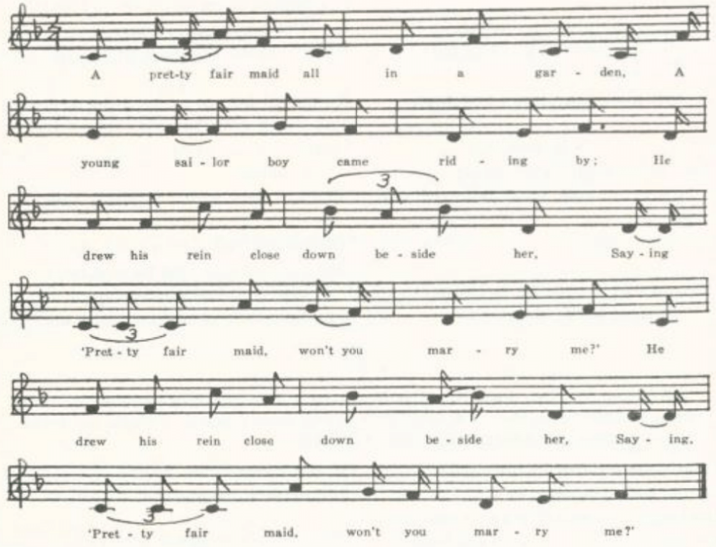
A pretty fair maid all in a garden,
A young sailor boy came riding by;
He drew his rein close down beside her,
Saying, ‘Pretty fair maid, won’t you marry me?’

‘A man, a man, a man of riches,
A man of honor you must be;
Don’t call upon a poor young maiden
Not worthy for your bride to be.

‘I have a true love on the ocean,
And there for seven long years is he;
But if he’s there for seven years longer,
No man on earth shall marry me.’

‘Suppose your true love he is drownded?
Suppose he’s in some battle slain?
Suppose he’s to some fair girl marri-ed
And never to you returns again?’

‘Oh, if he’s drowned I hope he’s happy,
Or if he’s in some battle slain;
And if he’s to some fair girl marri-ed,
Oh, I’ll love the girl that’s married him!’

‘Oh no, your true love he’s not drownded
Nor neither is he in some battle slain;
Nor is he to some fair girl marri-ed,
But he is at your side again!’

He picked her up into his ar-rums
And gave her kisses one, two, three,
Saying, ‘Can’t you marry a poor single sailor
Who has come so far for the love of thee?’

(151)
E
No title. Secured by Miss Beulah Wohlbeck in 1934 from Veda Frye of Dexter, Stoddard County, who learned it from her mother. The Lover is ‘a gay young soldier,’ and she calls him ‘a man of wonder;’ she tells him that her true-love has been gone two years in the army. Otherwise a regular text.

The Mantle of Green

This fits the theme to the Napoleonic wars, in particular to the battle of Waterloo. Such and others printed it in England, and Wehman in this country. Ord reports it for Scotland, and American traditional texts have been reported from Newfoundland (BSSN 175-7; compare also 172-3, 178-9) and Nova Scotia (BSSNS 182-4, SBNS 60-1).

‘One Morning in June.’ Secured in 1914 by Miss Antoinette Taylor of Bartold, St. Louis County, from a Mrs. Edwards, of whom Miss Taylor writes: ‘Her son is a fiddler—calls the old figures and all that sort of thing. They are from the Ozark Mountains.’ Mrs. Edwards’s manuscript is subscribed: ‘Written by Mrs. Edwards learned to me by Mrs. Betsie Matlock 1868 Phelps Co. Mo. This Mrs. Matlock was born in Baltimore Md. 1791.’ The omissions indicated are not marked as such in the MS.

One morning, one morning, one morning in June
. . . . . . .
I met a fair lady, she appeared like a queen
With her costly fine robes and her mantle so green.

I stood in amazement, I was struck with surprise;
She appeared like an angel had fell from the skies.
Her eyes like two diamonds, her cheeks like the rose,
She’s one of the fairest that nature composed.

I said, ‘My fair maid, if you’ll go along with me,
I’ll join you in wedlock, and married we’ll be.
I’ll dress you in riches, you’ll appear like a queen
With your costly fine robes and your mantles so green.’

‘Oh, now, my young man, you must be refused,
As I’ll wed with no man you must be excused;
To the green hills I’ll wander to shun all men’s views,
For the man I love dearly is in vain* Waterloo.

. . . . . . . .
‘Draw near to my garments and there you’ll behold
His name and his surname in letters of gold.’

*Other texts show that this is a mishearing of ‘famed.’

(152)
On raising her mantle there I did behold
His name and his surname in letters of gold.
‘Willie O’Riley fell to my view;
He was my chief comrade in vain Waterloo.

. . . . . . . .
‘It was on the field of Normand,* where true love doeth lie,
He fought very victoriously until the fourth afternoon;
He received his death summons on the eighteenth of June.

‘Now, my young lady, it was I won your heart,
In your father’s garden, the day we did part.
. . . . . . . . . . . . . and to prove this true,
Here is the ring which I gave to you.’

This couple got married, I heard people say.
They had nobles attend them on their wedding day.
‘Now peace is proclaimed, the war is all over,
You are welcome to my arms, loving Nancy, once more.’

*Wehman has here ‘Norvon;’ but I am at a loss to explain either word.

Mary and Willie
This was printed as a stall ballad by Such and Catnach and Evans in London and by Jackson in Birmingham, and Barrett has a text in his English Folksongs parts of which are from singers in Bedfordshire and Cheshire. In America texts have been recorded in Vermont (VFSB 150-1), Tennessee (JAFL XLV 102-3, FSSH 172-3), Mississippi (FSM 153-4), and Montana (ABS 200-2), and Jones has what looks like a first stanza of it from Michigan (KNR 299). A song with the same story but not the same song is recorded in JFSS III 95 from Dorset.

A
‘Mary and Willie.’ From the manuscript ballad-book of Mrs. Lida Jones of Dade County, secured for me by Miss Lowry in 1906. Printed in Archiv für das Studium der neueren Sprachen CXX67-8. In the MS no attention is paid to verse-lines; and I have supplied most of the punctuation.

Mary and Willie sit by the sea shore
Their last farewell to take.
Says Mary to Willie: ‘You’re now going to sea;
I fear that my fond heart will break.’

‘Oh, don’t be despairing,’ young Willie then said,
And pressed his fair maid to his side;
‘My absence don’t mourn, for when I return
I’ll make little Mary my bride.’

(153)
Three years having passed without any news,
As Mary stands by her own door
A beggar came by with a patch on his eyes
And did for her pity implore.

‘Fair lady,’ cried he, ‘your charity bestow,
And I’ll tell your fortune besides:
The lad whom you mourn will never return
To make little Mary his bride.’

‘Oh, if it be true you tell unto me,
My Willie, my hero still lives!
Oh! if it be true, straightway unto you
All the money I have I will give.’

‘He is living,’ quoth he, ‘all in poverty;
HE has been shipwrecked besides.
He’ll return no more, because he is poor,
To make little Mary his bride.’

‘May the heavens above know the joy that I feel,
And for his misfortune I’ll mourn.
He’s welcome to me all in poverty,
With his blue jacket tattered and torn.’

The beggar threw by the patch from his eye,
Likewise the crutch from his side;
Blue jacket and trousers and cheeks like a rose,
Young Willie stood by Mary’s side.

‘Forgive me, fair lady, forgive me,’ he cried,
‘It was only your love that I tried.
The church we’ll away before close of day
To make little Mary my bride!

I’ve money in plenty and riches untold,
I never was shipwrecked beside;
In coaches we’ll roll all covered with gold
When I make little Mary my bride!’

B
‘Mary and Willie.’ Secured by Miss Hamilton in 1909 from Georgia Green of the West plains High School. Does not differ significantly from A.

(154)
The Banks of Claudy
For the vogue in print of this Irish adaptation of the returned lover theme see Kittredge’s bibliographical note in JAFL XXXV 352-4. To the recordings there mentioned may now be added: Scotland (Ord 130), Nova Scotia (BSSNS 185), Virginia (SCSM 266-7), West Virginia (FSS 321-2), and Mississippi (FSM 152).

‘The Banks of Claudy.’ From the manuscript ballad-book of James Ashby of Holt County, secured by Miss Welty in 1906. Printed (with the misreading ‘Clandy’ for ‘Claudy’) in Archiv für das Studium der neueren Sprachen CXX 66-7. Ashby dated his entry ‘January 30th 1874.’ I have supplied a few words where the MS was defective or illegible.

As I walked out one evening
In the pleasant month of May,
Down by yon flowery [meadow]

So carelessly did stray,
I overheard a damsel
Most grievously complain,
Saying, ‘On the banks of Claudy
My darling doth remain.’

I gently stepped up to her,
Which took her in surprise;
I own she did not know me,
Me being in disguise.
‘How far do you mean to travel
This dark and dreary night?
. . . . . .
. . . . . .

‘Kind sire, the way to Claudy
Will you me please to show?
Oh, pity a distressed girl,
For there’s where I mean to go.
For I am in search of young man,
And Johnny is his name.
I am told on the banks of Claudy
That he doth yet remain.’

‘This is the banks of Claudy,
Fair maid, on which you stand.
And do not trust to Johnny,
For he is a false young man.
For Johnny doth deceive you
And doth not meet you here.
Tarry with me in these green woods;
No dangers need you fear.’

‘If Johnny was here this night, sir,
He would keep me from all harm,
But he is in the field of battle
All in his uniform;
He is in the field of battle,
His foes he will destroy;
Like a ruling king of honor
He has fought in the wars of Troy.

‘It’s been six weeks or over
Since Johnny left the shore.
He is cruising the wide ocean
Where the thunder and cannons roar,
He is cruising the wide ocean
For honor and for fame.’
‘The ship was wrecked, as I’ve been told,
Nigh on the coast of Spain.’

On hearing of this dreadful news
She fell into despair,
To wringing of her hands
And tearing of her hair:
‘Since Johnny’s gone and left me
No man on earth I’ll take;
Through woods and lonesome valleys
I’ll wander for his sake.’

(155)
On seeing of her royalty
He could no longer stand
But fell into her arms
Saying, ‘Betsy, I’m the man.
O Betsy, I am that young man
That’s been the cause of all your pain;
Since we have met on the banks [of Claudy]
We ne’er shall part again.’

Johnny German

This seems to be an American treatment of the returned lover theme. At least I have found only American records of it. It is printed together with The Lexington Miller in a Boston broadside in the Harvard Library which dates from about 1840. It has been reported from tradition in Nova Scotia (BSSNS 173-4), West Virginia (FSS 328-9), Kentucky (SharpK II 256-7), and Texas (PFLST X 156-7). But the ‘London’ of the Missouri text suggests that it is really British.

‘Johnny German.’ Contributed by Miss Williams in 1903 from Clinton County. Printed in Archiv für das Studium der neueren Sprachen CXX 63-4. The story here is told in the first person by Johnny German himself—a sort of dramatization not uncommon in traditional ballad-singing.

As I returned to London I heard the happy news.
I will relate it over, if you will not refuse.
‘Twas of a jolly sailor boy, a jovial-hearted lad,
Who met with a fair damsel whose countenance looked sad.

‘Perhaps, kind miss, I saw him when I as last at sea,
And now I will describe him, if you will answer me.
And if I do describe him right and if he is the man,
You must agree to marry me if he ne’er comes back again.

‘He’s handsome in every feature, in courage he does not lack;
Just like the darting sparrows . . . . .
. . . . . . . . .
And if Johnny German be his name, he died five years ago.’

She wrung her lily-white hands, while the tears rolled down her cheek,
Grieving and lamenting, not a word could she speak,
But straight went to her bed-chamber and there alone did lie,
Grieving and lamenting and wishing for to die.

I turned my back upon her and straightway I did go
To see how well she loved me, and I served her so ill;
Bid farewell to the Rainbow, since Polly stole my heart;
I never shall cease to lover her until death do us part.

(156)
I dressed myself in scarlet and back in haste I came,
With a joyful resolution to comfort her again.
‘Come, rise you up, my Polly, and leave all tears behind.
Leave off your sobs lamenting; some comfort you will find.’

She arose all to oblige him, all in amaze was she;
Oh, who but Johnny German could this young sailor be?
‘O Johnny, why did you grieve me, why did you serve me so?’
‘Oh, never mind that, Polly; I’ll serve you so no more.

‘I only did it to try your love, to see if you were true.
I never saw a turtle-dove that ever exceeded you.
You are truer than a turtle-dove, you are sweeter than a rose,
You remind me of some flow’ret, where love and beauty grows.’

William Hall

This appears to be another American reshaping of the familiar theme. I know of no ballad print of it and only American texts from oral tradition. None the less it has all the air of British stall balladry. Texts have been recorded from Virginia (SharpK II 239-40, 242, SCSM 269-70), West Virginia (FSS 326-7), Kentucky (LT 100-2, DD 84-5, SharpK II 241-2), Tennessee (SharpK II 242;; described also by Shearin, Sewanee Review XIX 322-3, but text not given), North Carolina (SharpK II 240-1, SCSM 265-6), Georgia (FSSH 180-1), Mississippi (FSM 154-5), and Indiana (ABS 71-2, by way of Nebraska).

A
‘William Hall.’ From the manuscript ballad-book of James Ashby of Holt County, secured by Miss Welty in 1906. Printed in Archiv für das Studium der neueren Sprachen CXX 65-6. The shift from first person to third person and back again in the narrative is a frequent phenomenon in folk-singing.

True love is sweet and true love is pleasant
To a young man’s view;
For once I was parted, broken-hearted—
Oh, dear me, what shall I do?

As soon as his parents came to know this,
That he loved this young lady so,
They sent him away across the ocean
That he might see her face no more.

He sailed the ocean over and over
Until he came to his own country shore,
Saying, ‘If Molly is alive and I can find her,
I’ll make her my lawful bride.’

(157)
As I was walking, as I was talking,
As I was walking up the street
Cold drops of rain fell just as it happened
My true love I chanced to meet.

I stepped up to her side so boldly,
Saying, ‘Pretty miss, do you fancy me?’
‘No, I have placed my affections on a brisk young farmer
Who has lately gone to sea.’

. . . . . . .
. . . . . . .
. . . . . . .
‘Describe him, describe him unto me.’

‘He was tall, he was neat, he was pretty, he was handsome,
Pretty blue eyes with them all;
He wore jet-black hair and he wore it curled,
And his name was William Hall.’

‘Oh yes, oh yes, I knew him quite well
And his name was William Hall;
And I saw a French cannon-ball go through him
And in death’s cold arms he did fall.’

The screams, the screams that she did hallo!
She screamed until she was forced to fall;
And it was all for the sake of her own true lover,
And his name was William Hall.

‘Cheer up, cheer up, my pretty little damsel,,
Cheer up, cheer up unto me;
Since I have been the cause of all this trouble,
Here is the ring you gave to me.’

This young couple joined hands together
And to church did straightway go;
And this young couple they got married
Whether their parents was willing or no.

Copyed the 17 of Mar. 1875

(158)
B
‘William Hall.’ Secured by Miss Hamilton in 1909 from Julia Rickman of the West Plains High School. The opening stanza she could not recall.

I rode, I rode this country o’er,
I rode it o’er and o’er again.
If Miss Molly is alive and I can find her
I’ll make her my lawfully wedded bride.

‘Twas one morning very early
I was walking down the street,
Cold drops of rain fell just as it happened
My true love I chanced to meet.

‘Good morning, good morning, my pretty fair lady.
Do you think you would fancy me?’
‘No, my fancy is on a brisk young farmer
Who has lately crossed the sea.’

. . . . . . .
‘Describe him, oh, describe him to me.
Perhaps I saw him and knew him,
For I’ve lately crossed the sea.’

‘He was tall and neat and handsome
. . . . . . .
He had black hair and wore it curly,
But oh! those pretty blue eyes were all.’

‘Yes, I saw him, and I knew him.
His name was William Hall.
I saw a cannon-ball go through him;
Dead, oh, dead I saw him fall.’

Oh, the screams of the fair lady—
‘Oh, goodness, what shall I do?
We were parted, broken-hearted;
My poor heart will break in two.’

‘Cheer up, cheer up, my pretty fair lady,
For that man it might be me!
To convince you of my story,
Here’s the gold ring you gave me.’

(159)
They joined their hands together,
To the churchhouse they did go;
This lovely couple were lawfully wedded,
Whether their parents were willing or no.’

C
No title. Secured by Miss Frances Barbour of Washington University in 1917 from the singing of Minnie Doyel of Arlington, Phelps County.

. . . . . .
. . . . . .
I courted a fair and charming lady,
In Jasper town she did dwell.

But when our parents came to know this
They said they’d send her across the sea,
They said they’d send her across the ocean
Where her face I’d never see.

But I roamed the ocean over and over
Until I came to her native side,
Saying, ‘If Mary’s alive and I can find her,
Oh, I’ll make her, make her my lawful bride.’

. . . . . . .
As I was walking up the street,
The cold rain drops were just a-falling,
There is my true love by change to meet.*

‘How do you do, my fair pretty lady,
And it’s how do you think you could fancy me?’
‘My fancy’s all on a brisk young farmer
Who has lately crossed the sea.’

. . . . . . .
‘Describe him, describe him unto me;
For perhaps I’ve seen him and have known him,
As I’ve lately crossed the sea.’

‘He is fine in all his features,
He is handsome and he’s tall,
He has light hair and wears it curly,
And the prettiest blue eyes of all.’

*Miswritten for ‘There my true love I chanced to meet.’

(160)
‘Yes, I’ve seen him and have known him
And he went by the name of William Hall.
I saw a French cannon-ball go through him;
In death I saw him fall.’

The screams, the screams of this fair pretty lady!
‘I’m at a loss, what shall I do?
At last we’re parted, broken-hearted.
Oh, good land, what shall I do?’

‘Cheer up, cheer up, my fair pretty lady,
For it’s perhaps that I am he;
And to convince you of this story
Here’s the ring you gave to me.’

They clasped their loving hands together
And to the church they did go,
And this young couple they got married
In spite of all their parents could do.

Green Beds
For information about the various songs setting forth the sailor’s resentment of the treatment received at the hands of grasping landladies and tavern keepers, many of which were issued by the ballad press, consult Mackenzie’s headnote, BSSNS 245-6. Green Beds, the only one of them in the Missouri collection, has been reported from tradition in Hampshire (JFSS III 281-2), ‘rewritten,’ appears as No. 91 of Baring-Gould’s Songs of the West); in Nova Scotia )BSSNS 245-50); and in Virginia (SharpK I 368), West Virginia (FSS 390-1), Kentucky (SharpK I 366-7, FSSH 170-2), Tennessee (JAFL XLII 290-2, FSSH 168-70), North Carolina (JAFL XXVIII 156, SharpK I 365-6), Mississippi (FSM 156-8), the Ozarks (OASPS 189-91), and Ohio (JAFL XXXV 373-4). Sandburg, ASb 430-1, has a text which he says he got from Rickaby and which may therefore represent tradition among the lumbermen of the north woods.

A
‘Young Johnie.’ Communicated in 1905 by Mrs. Carrie Phelps of West Plains, Howell County. Printed in Archiv für das Studium der neueren Sprachen CXX 68.

Young Johnie he’s on sea,
Young Johnie he’s on shore,
Young Johnie’s gone to Polly’s house
Where he’s often been before.

‘You as well come home,* young Johnie,
You as well come home* from sea,
For Polly’s been dreaming
So long about thee.

*Miswritten, no doubt, for ‘You are welcome home.’

(161)
‘What luck have you, young Johnie,
What luck have you on sea?’
‘My luck is quite indifferent,’
Young Johnie said he;

‘Call down your daughter Polly
And sit her down by me;
We’ll drown all melancholy,
And married we will be.’

‘My daughter Polly’s very rich,
Young Johnie; you are poor.
If Polly comes home
She will turn you out of doors.’

Young Johnie being weary,
He hung his head;
He called for a candle
To light him to bed.

‘My beds are full of foreigners,
And their fortune it is of more;
My beds are full of foreigners—
Young Johnie, you are poor.’

Young Johnie walked out.
‘Twas in the hall
He made a loud fuss
And reckon he did call.*

‘Here is fifty guineas of the new
And forty of the old.’
Young Johnie pulled out
Both his hands full of gold.

Down come pretty Polly
With a smile upon her face,
She hugged him, she kissed him,
So kindly embraced:

‘My green beds are empty,
Young Johnie shall lie there;
My green beds are empty,
Young Johnie shall lie there.’

‘I would rather lie within the street
Than lie within your door.
For when I had no money
My lodging was to seek;

‘But now I have got money
I’ll make the taverns roar
With hol,† wine, and cider,
And brandy galore.’

Come all you valiant sailors
That plows the raging main
And gains all your money
In the cold storm and rain,

I’ll have you take care of it
And lay it up in store,
Or else your companion
Will turn you out of doors.

*That is, he called for his reckoning.
†‘Hollands’ is intended, presumably.

B
‘Young Johnny.’ From the manuscript ballad-book of James Ashby of Holt County, secured by Miss Welty in 1906. Printed in Archiv für das Studium der neueren Sprachen CXX 69. Ashby has dated his entry ‘March 21sst 1875.’

Young Johnny been on sea
And young Johnny been on shore,
And young Johnny been to Ireland
Where young Johnny been before.

‘You are welcome home, young Johnny,
You are welcome home from sea;
For last night daughter Molly
Lay dreaming of thee.

(‘Oh, what for luck had you, young Johnny,
Oh what for luck had you on sea?’
‘I lost my ship and cargo
All on the roaring sea.

‘Go bring your daughter Molly
And set her down by me,
And we will drownd the melancholy
And married we will be.’

‘Molly is not at home, Johnny,
nor hasn’t been this day;
And I am sure if she was, Johnny,
She would not let you stay.

‘Molly is very rich, Johnny,
. . . . . .
. . . . . .
. . . . . .’

Young Johnny feeling drowsy,
He hung down his head
And called for a candle
To light him to bed.

‘The green beds they are full, Johnny,
And have been for this week;
And now for your lodging,
Poor Johnny, you must seek.’

He looked upon the people,
He looked upon them all;
He looked upon the landlord,
And loudly he did call,

Saying, ‘How much do I owe you?
I am ready for a call.’
‘Its twenty for the new score
And forty for the old.’

Then young Johnny he pulled out
His two hands full of gold,
. . . . . .
. . . . . .

‘I didn’t speak in earnest,
Neither was I just,
For without any exception
She loves you the best.’

Then Molly came a-running down,
Gave him kisses one, two, and three,
Saying, ‘The great bed is empty,
And you may lie with me.’

‘Before I would lie within your green bed
I would lie within the street;
For when I had no money
My lodging I might seek.

‘Now I have money plenty, boys,
We will make the taverns herl;*
A bottle of good brandy
And a better looking girl.’

*The Ohio text has ‘hurl,’ that from Mississippi ‘whirl,’ and that from Tennessee has ‘hurl’ interpreted by the editor as ‘whirl.’ This final stanza is a sort of commonplace of street balladry of a bacchanalian temper.

C
‘Song Ballad-Young Johnny.’ From a miscellany of penciled MSS brought to Miss Lowry by one of her pupils in Columbus, Kansas, and written by, or for, William Dresia about 1875-80. It does not differ significantly from B.

(162)
Early, Early in the Spring

Here the returning lover finds that his sweetheart has married another ‘for riches’ sake’ and thereupon curses all gold and silver too and vows he will sail the sea till the day he dies. Most texts have in some form the idea that the lovers’ correspondence has been tampered with—most often by her parents. It goes back at least as far as the seventeenth century, when was ‘printed for Charles Baker’ the blackletter broadside of The Seaman’s Complaint (Brit. Mus. C. 22. f. 14, p. 175), and there are later stall prints of it. It is No. 70 in FSSom. In the United States it has been reported from Virginia (SSSA 144-6, by way of Tennessee, FSSH 233-4, SCSM 328-31), West Virginia (FSS 358-61, TBWV 64-5), Tennessee (ETWVMB 65-6), North Carolina (SharpK II 151-4), Georgia (JAFL XLIV 78-9, FSSH 234-5), Mississippi (FSM 155-6), and Texas (PFLST VII 151-3)—in this last, as in Missouri B and Lomax’s CS text, transposed from sailors to cowboys.

A
No title. Secured by W. S. Johnson from the fiddler Waters in Miller County in 1903. Printed in Archiv für das Studium der neueren Sprachen CXX 69-70.

Early, early in the spring
I shipped on board to serve my king;
I left my dearest dear behind,
Who ofttimes said her heart was mine.

And when I clasped her in my arms
I thought she had ten thousand charms,
With features fair and kisses sweet,
Saying, ‘We’ll get married next time we meet.’

So seven long years I served my king;
In seven long years I returned again,
Saying, ‘Where is the darling of my life
Who’s ofttimes said she’d be my wife?’

I rode up to her father’s hall
And there I gave a loudly call,
Saying, ‘Where’s the darling of my life
Who’s ofttimes said she’d be my wife?’

Says he, ‘Young man, you’ve come too late;
My daughter has married for riches’ sake.’
So curse all gold and silver too
And curse all girls that don’t prove true.

. . . . . . .
. . . . . . .
Who will their own precious promise break
And marry another for riches’ sake.

Now that girl is married that I adore,
I’ll stay no more on Scotland’s shore.
I’ll cut my way where the bullets fly
And I’ll sail on sea till the day I die.

Dark and drizzly was the day
Our ship set sail for America.
With music sweet and trumpet sound
For America our ship was bound.

As I walked up fair Columbus street
A letter I shoved from beneath my feet;
And on each line, without a blot:
‘So soon sailed away, so soon forgot.’

(164)
B
No title. Received in 1913 from J. F. Jones, student at the University of Missouri, who wrote: ‘I learned it from my room-mate, Locksley Graham, who heard it on a ranch in Montana.’

‘Twas early in the spring of 83
That J. J. Simpson hired me.
Says he, ‘Young man, you’ll suit the time,
You like wild life so very fine.’

‘Twas late in the fall of that same year
He started me down the trail with a bunch of steers.
‘Twas a long and tiresome go
As the herd moved on toward New Mexico.

. . . . . .
. . . . . .
And the music sweet of the cowboy’s song,
As I hit those steers, and trailed ‘em along.

Before I reached my native home
I longed for my dear, but I couldn’t go.
. . . . . . .
. . . . . . .

I wrote a letter to my dear,
And not a word from her did I hear.
But when I reached my native home
I asked, ‘Where is my sweetheart gone?’

They said she had married a richer life,
Therefore, cowboy, seek another wife.
Oh! I cursed all gold and silver too,
Also the girls who don’t prove true.

‘Dear brother, dear brother, stay at home
And don’t forever be on the roam;
For there are much better girls than she.
So come, dear brother, and go with me.’

. . . . . . .
. . . . . . .
I’ll go right back where the bullets fly
And work on the trail until I die.

Charming Beauty Bright

The return is not always happy. In the piece for which the above phrase from the opening line may serve as a title the lover finds that the lady has died for love of him during his absence. I have not found it in ballad print, and the only British record of it is a tune and a ferment of text from Lincolnshire in JFSS II 81. In America it has been reported from Vermont (SHV 22-5), Massachusetts (JAFL XXVI 176-7), Virginia (SharpK II 105, 107, SCSM 312), West Virginia (FSS 342), Kentucky (JAFL XXX 334-5, SharpK II 106-7), Tennessee (SharpK II 104), North Carolina (SharpK II 103-4, 105, 105-6, 108), Mississippi (JAFL XXVIII 147), Texas (PFLST X 158), Ohio (JAFL XXXV 388-9), and Indiana (JAFL XXIX 184-5).

‘Lover’s Lament.’ Contributed thru Miss Lowry in 1920 by Earl Cruickshank of Columbus, Kansas.

I courted a lady, a handsome beauty bright,
And on her I fixed my whole heart’s delight;
I courted her for love and her love I did obtain.
Do you think I’d any reason at all to complain?
(Repeat last two lines of each stanza)

(165)
When her parents came for to know
That me and my true love together did go
They locked her in her chamber and kept her there sever.
I never, never after got sight of my dear.

Now to her chamber I mean for to go
To see whether she will prove loyal or no.
But when I got there she answered me and cried,
Saying she always would prove loyal until the day she died.

Now to the army I mean for to go
To see whether I can forget her or no.
But when I got there with my armor shining bright
I never could forget her, she was my whole heart’s delight.

Seven long years I served to the king,
Hoping to return to my lover’s again;
With my heart so full of woe and my eyes so full of tears,
How happy would I be if my true love was here.

Back to her father’s I mean for to go
To see whether she is alive yet or no.
When her mother saw me coming she [w]rang her hands and cried,
Saying, ‘My daughter loved you dearly and for your sake she died.’

Then I did struggle like a man that was slain,
Scarce could be brought to my senses again;
Still crying out with woe, ‘This grief I cannot bear.
My true love’s in her grave and I wish she wasn’t there.’

When I came to my sense again
I picked up my hat and wrote down with a pen:
‘Come all of you in love, come pity, pity me,
Come pity my misfortune and sad misery.’

The Faultless Bride

In this the girl, forced into marriage with another, yet dies faithful to her lover. Pitt’s stall print The Plymouth Tragedy tells a like story but has little resemblance in detail to the traditional ballad. For the relation between the traditional song and the comic All Round My Hat popular in music-halls a hundred years ago see Miss Gilchrist’s notes in JFSS VIII 203-5. Johnny Doyle (BSSNS 106-7, JAFL XLIV 93-4, FSSH 162-3,
(166)
SCSM 249-50) is another ballad on the same theme. The Faultless Bride has been reported from tradition in Scotland (Grieg I art. 24, Ord 132-3), Ireland (OIFMS No. 413), Somerset (JFSS VIII 4-5), Dorset* (JFSS VIII 202-3), Newfoundland (BSSN 155-6, FSN 135-9), Maine (JAFL XXIV 339-40), and Georgia (SharpK II 83).

*So I assume. There are many Miltons in England; but Hammond, who reports it as taken down in ‘West Milton,’ did his collecting mostly in Dorset.

‘The Faultless Bride.’ From the manuscript ballad-book of James Ashby of Holt Country, secured in 1906 by Miss Welty. Printed in Archiv für das Studium der neueren Sprachen CXX 70-1.

I was of late at a noble wedding,
The wedding of one that proved unkind
To him that loved her but was forsaken,
And now the thoughts of him filled her mind.

Gay was the guest at that noble wedding
And bright the beauty assembled there,
As lovely as the stars of evening
Or moonlight through the summer’s air.

And there was also her slighted lover,
That day returned from the fields of war
With love thoughts filling his constant bosom
And his mind relieved from the dim† afar.

The wedding supper was now passed over
And every guest was to sing a song;
And the first that sung was the slighted lover,
And the words to the false bride did belong.

‘How can you lie on a stranger’s pillow,
You that was my love so late,
And leave me here to wear the willows
In sorrow pining for your sake?

‘But if I wear this woeful willow
It will only be for a week or two;
It’ll lay aside this woeful willow
And change the old love for the new.

‘Here is a piece of gold that was broken;
I kept it safe in this golden chain.
You gave it me as a true love token;
No longer with me it shall remain.’

The bride she sat at the head of the table;
Each word he sung she marked it well.
To bear it longer she was unable;
Down at the bridegroom’s feet she fell.

‘A small request I have to offer,
And this request I make of you:
That I tonight may sleep with mother.
Tomorrow night I’ll sleep by you.’

This request at last was granted.
Sighing and sobbing she went to bed.
When they woke next morning early
There they found the young bride dead.

Now all young maidens that hear this story,
To your vows be firm and true,
And don’t be led by lands or money
To change the old love for the new.

†Perhaps miswritten for ‘din.’

(167)
The Lover’s Lament for her Sailor

I have found this recorded from traditional song only once, by Henry in FSSH 204, from Tennessee by way of Georgia. He refers to various recordings of John Reilly, which is not the same song. The song in the Missouri collection was, however, a favorite of the ballad press—there are four stall prints of it in the Harvard Library collection of broadsides—and it was parodied by Sam Cowell, music-hall singer, about a hundred years ago. See Roxburghe Ballads IV 397, where the editor describes it as a modern reproduction of The Sorrowful Lady’s Complaint, a broadside in the Roxburghe collection.

A
No title. Communicated in 1906 by Supt. W. J. Weese of Bowling Green, Pike County, who wrote: ‘This ballad was sung to my mother over forty years ago by a girl playmate of hers, who came from Illinois to Gentry County, Mo., about that time.’

As I was walking down by the seashore
I spied a fair damsel lamenting and mourn.

Chorus:
Crying, ‘Oh, my love is gone, he’s the one I adore,
And he’s gone where I’ll never see him any more.’

She was dressed like a damsel, she looked like a queen,
She was the prettiest maiden that ever I’d seen.

I asked her if she’d marry myself.
The answer she gave me was ‘My lover’s on sea.

‘I never will marry, nor by any man’s wife.
I’d rather live single the rest of my life.

‘A woman may prove true and do all she can,
But there is nothing in this wide world so false as a man.

I’ll bury myself in this wide, deep sea
For the blue waves to roll over me.’

She plunged her fair body in the wide, deep sea
For the blue waves to roll over her pretty blue eyes.

B
No title. Secured by Miss Hamilton in 1910 from Grace Clemmons of the West Plains High School, who had it from a Mrs. Atherton, formerly of Green Bay, Wisconsin.

(168)
As I was walking along the seashore
I met a fair creature I never met before.
She looked like a goddess and dressed like a queen;
She was the fairest creature I ever had seen.
Chorus:
She was crying ‘Oh! my love he’s gone,
He’s the lad that I adore;
He’s gone where I never
Can see him any more.’

‘My love was a sailor, he ran number eight;
But now he is drowned and I am desolate.’

I asked her to marry me if she pleased
But oh, she kept sighing and solemnly refused:
‘Oh no; I’ll not marry, I’ll be no man’s wife.
I expect to live single the rest of my life.

‘The shells of the ocean shall be my death-bed,
And the fish of the waters shall swim o’er my head.’

She plunged her gay body in the ocean so deep,
And there closed her blue eyes in the water to sleep.
The shells of the ocean were her death-bed,
And the fish of the water did swim o’er her head.

Locks and Bolts

Known in Scotland (Grieg I art. 8, Christie I 37), Kentucky (SharpK II 19, JAFL XLIX 236-7—the latter an especially full and delightful text), Tennessee (JAFL XLV 100-2, FSSH 254-5), North Carolina (SharpK II 17-9), Georgia (FSSH 253), and Iowa (ASb 149). Mr. Paul G. Brewster, who has a yet unpublished text from Indiana, points out to me that it is probably descended from or at least is related to the Pepys broadside of A Constant Wife (Rollins II 201-6). Our fragment gives little idea of the ballad, which tells a stirring story of a lover’s rescue of his sweetheart from opposing relatives; but it undoubtedly belongs to the ballad.*

No title. Reported to Miss Hamilton in 1909 by Hunter Jones of the West Plains High School as ‘sung by his mother’s hired girl.’

Last night I dreamed of my true love;
All in my arms I had her.
When I awoke she was not there,
I was left alone without her.

*See Appendix, note 1.

(169)
He long yellow hair like strings of gold
Came dazzling o’er my pillow.
That pretty little girl I love so well,
She’s gone from me forever.

Pretty Peggy O

The notes in SharpK show that this is found in Greig, Christie, and Ford, and in a Pitts broadside entitled Pretty Peggy of Derby; Ord also has it (304-5), with the title The Bonny Lass o’Fyvie. In this country it has been reported from Kentucky (Sewanee Review XIX 326, SharpK II 59, 60-1), North Carolina (SharpK II 59-60), Mississippi (FSM 165-6), and Indiana (JAFL XLIX 256-7, changed into a children’s game song). The ‘brother John’ of the Missouri text I have not found in other versions.

No title. Written down for Miss Hamilton in 1909 by Hunter Jones of the West Plains High School as ‘sung by his mother’s hired girl.’

‘Come and go along with me, my pretty Peggy O;
Come and go along with me, my pretty Peggy O;
On the coaches you shall ride
With your true love by your side,
And your name shall be called pretty Peggy O.’

‘It’s I never can agree, my pretty Willie O,
It’s I never can agree, my pretty Willie O;
It’s I never can agree
For to go so far with thee
And leave my mamma behind me O.’

‘Come a-tripping down the stairs, my pretty Peggy O,
Come a-tripping down the stairs, my pretty Peggy O,
Come a-tripping down the stairs
And let’s brush your curly hairs;
Take a long farewell from your Johnny Jinkle Joe.’

Up stepped her brother John so very angry O,
Up stepped her brother John so very angry O,
‘If she can’t agree
There are others you may see,
The fairest of the land of Savery O.’

(170)
King David Had a Pleasant Dream

The only other record of this that I have found is in SharpK II 247, from Tennessee. Content and manner suggest, however, that it is English and goes back as far as the eighteenth century.

‘The Soldier.’ Secured in 1905 thru Jesse Williams from Gen. W. A. Roby of Hamburg, Arkansas, who writes: ‘The songs sent you were composed before, during and immediately after the Revolutionary War…The authors are entirely unknown to me. I learned them when a wee bit of a boy, sitting on my grandfather’s knee, who did service in the war of 1812. . . . I have never seen any of the songs sent you in print.’ Roby’s text is in considerably better English than that in SharpK, but the last two lines are hard to construe.

A soldier and a comely maid, as they walked forth one day,
Many a handsome compliment he unto her did say:
‘And shall I kiss your ruby lips? ‘Twould make me somewhat bolder.’
But ‘O no, sir; my mamma says I must not kiss a soldier.’

The soldier being a forward youth, he took her by the hand
And says, ‘My dear, the soldier has the world at his command.
Besides, he is the pillow* strong, he is the land’s upholder;
And he’s to blame, and she’s the same, that speaks against a soldier.

‘King David dreamed a pleasant dream as he lay on the ground;
He dreamed he had become a king and wore a golden crown.
He threw off his shepherd cloak that hung about his shoulder,
Picked up his sword, that by him laid, and so became a soldier.

‘He slew Goliath with a stone that proved his overthrow,
And took his head to Jerusalem in spite of friend or foe;
There he was proclaimed a king, he was the land’s upholder,
With a golden crown upon his head he was both king and soldier.’

These words they pierced the fair maid’s breast, that caused her thus to say:
‘I always shall a soldier love until my dying day.
A soldier looks so neat and trim, with his gun fixed on his shoulder!
In spite of all my mamma says I’ll kiss the handsome soldier.

‘Long may he live and reign,’ she says, ‘and be forever blessed;
And when his days are at an end may he see eternal rest.’
But she of whom her love was true was worth a mint of money;
But he of whom his love was false wasn’t worth a single penny.

*Read ‘pillar.’

(171)
Jack Munro

The figure of the Maiden Warrior (as she is called in one of the English broadsides of the seventeenth century) has appealed to the human imagination from the days of Theseus and Hippolyta in the Mediterranean countries and of Alf and Alfhind in the Baltic,* down thru the Britomart and the Mary Ambree of Elizabethan England, to our own time. Permutation and combination of a few simple elements have produced almost innumerable stall ballads on this theme in the last three centuries. See Bagford Ballads I 250-3, 311-5, 323-9, 471-4, Roxburghe Ballads VIII 146-8, IX cxxviii*-cxxxix.* Some of these have passed definitely into oral tradition—or possibly from tradition into print. Of these three have sufficient coherence or integrity to be considered here, being represented in the Missouri collection. I have chosen to name them Jack Munro, Lisbon, and The Lady Leroy. Others—Polly Oliver, William Taylor—have some threads of connection with this theme but are not primarily derived from it.
The story of Jack Munro is of a girl in love with a man in the navy who defies her parents, disguises herself as a man, enlists and follows her lover, finds him wounded on the field of battle, rescues him, gets a doctor to ‘cure up his wounds,’ reveals her sex, marries him, and returns triumphant. His name is Jacky Fraizer (often simply Jack, or Jack the sailor), and the name she gives herself when she enlists is Jack Munro (often reduced in tradition to Jackaro). Most of the texts recovered from American tradition have the waist-and-fingers dialog found in the Missouri texts given blow; but this does not appear in the broadsides. The broadsides do, however, have the sarcastic naming of the girl as ‘Mrs. Frazier’ by her angry parents found in Missouri B and D, which appears also in West Virginia, Kentucky, North Carolina, and Texas.
I have seen four British ballad prints of Jack Munro, three in the British Museum and one in the Harvard College library, all northern; it is printed also in The American Sailor’s Songster (New York, n. d.) 172-3. Songs akin to it, but not the same, have been reported from oral tradition in Scotland (Ord 233-4, 298), Somerset (JFSS VIII 9-10), Kentucky (SCSM 372-3), and North Carolina (JAFL XXVIII 160). Jack Munro has been found in Virginia (SharpK I 389-90, 392-4, 395, SCSM 203-10), West Virginia (FSS 330-3), Kentucky (JAFL XX 269-73, LT 38-43, SharpK I 386-7, 391), Tennessee (SharpK I 390, JAFL XLV 74-6, XLVI 48-9, FSSH 206), North Carolina (JAFL XII 249, XLV 76, XLVI 38, FSSH 208, SharpK I 385, 394, 395), Georgia (SharpK I 388-9), Mississippi (FSM 147-8), Texas (PFLST X 150-4), and Ohio (JAFL XXXV 377-8).

*Saxo Grammaticus Bk. VII—pp. 274ff. of Elton’s translation.

A
‘Young Jack the Farmer.’ Reported by Finis Dean in 1905 from the singing of his mother, who was reared in Carroll County.

(172)
There was a wealthy merchant,
In London he did dwell.
He had an only daughter,
If I the truth can tell.
And sing low, and sing low,
And sing low le low low lay.

She got sweethearts a plenty
To court both day and night;
But in one, young Jack the farmer,
She placed her heart’s delight.

The old man flew in a passion
And straightway he did go,
He went unto an officer
To prove Jack’s overthrow.

(‘Old man has Jack drafted into the army for Santa Fe’)

It’s first unto a tailor
To dress in men’s array,
And next unto an officer
To carry her away.

. . . . .

The cannon did loudly roar
And the fife did sweetly play;
Into the field of battle
So bravely marched away.

The cannon did loudly roar
And the balls did swiftly fly,
And a bullet from the Spaniards
Cut her darling down to lie.

She picked him up in her arms
And she carried him to town;
She carried him to a doctor
Who soon cured up his wound.

. . . . .

B
‘The Wealthy Merchant.’ From the manuscript balladbook of James Ashby of Holt County, secured by Miss Welty in 1906. Ashby has dated the entry ‘January 26th 1873.’

There was a wealthy merchant
In Louisville did dwell,
He had and only daughter,
To you the truth I tell;

She has sweethearts in plenty
To court both day and night,
But on young Jack the farmer
She placed her whole delight.

But in came the waiting maid
The old man for to know
To send for an officer
To prove Jack’s overthrow.

He sent for his daughter Mollie
And straightway home she came:
‘Good evening, Mrs. Frazier,
Be that your true love’s name.’

‘Oh! Father, you have got me,
My body you may bind;
But there’s none but Jack the farmer
That will ever suit my mind.

‘And now young jack is gone, sir,
With a sore and troubled mind
For leaving of his country
And his darling girl behind;

‘Now young Jack is gone, sir,
His face I never shall see;
He has landed in New Mexico
In the wars in Santa Fe.’

(173)
. . . . . .
‘Oh, here is twenty guineas,
I’ll place them in your hand,
To place young Jack the farmer
All in his native land.’

Oh, daughter Mollie is at liberty
And money at her command;
She formed a resolution
To view a foreign land.

She harnessed up a mule team
And a wagon she set sail.
She landed in New Mexico
On a swift and pleasant gale.

‘Your fingers are too slender,
Your body is too small,
Your cheeks they are too rosy red
To face a cannon ball.’

‘I know my fingers are slender,
My body is but small,
Although I never will tremble
To face a cannon ball.’

(Here Ashby repeats the date noted above, and adds ‘Sunday.’ Perhaps he was interrupted, perhaps he did not then have the rest of the text at hand; at any rate he did not complete it till more than a year later. See final date, below.)

‘Now we are going to travel,
Your name I’d like to know,
She answered with a smile,
‘You may call me Jack Munroe.’

Where the drums did loudly beat
And the cannon balls did fly
A bullet from a Spaniard
Caused her true love on the ground to lie.

She picked him up . . .
And ran with him to town
And there she got a doctor
That soon cured up Jack’s wounds.

Then as too* they got married
Amongst the jolly crew;
They value not their parents
Nor nothing they could do.

February 23/74

*Perhaps for ‘these two.’

C
‘Jack the Sailor.’ From a manuscript balladbook compiled by Mrs. Lida Jones in Dade County and secured for me in 1906 by Miss Welty.

There was a wealthy merchant,
In London he did dwell;
He had a lovely daughter,
And the truth to you I’ll tell.
Lo la lo lo la lo lo la la.

She was courted by a young man,
A man of high degree;
But she loved young Jack the sailor
Who plowed the rolling sea.

Her waiting maid mistrusted,
And she proved Jack’s overthrow;
She went to Mollie’s parents
And the secret let them know.

Her parents flew in passion
And straightway in did come:
‘Good morning to you, Miss Mollie,
Since Jack is your true love’s name.’*

*The singer has forgotten the sailor’s name but remembers that the girl is mockingly addressed here; hence the pointlessness of these last two lines.

(174)
‘Good morning to you, dear parents.
My body you have combined.*
But none but Jack the sailor
Can satisfy my mind.’

Her parents flew in passion
And straightway out did go,
They went to an enlisting officer
To prove Jack’s overthrow.

‘Here is five thousand gilders
Which I will give to thee
If you’ll press young Jack the sailor
To the wars of Germany.’

Now Jack has gone a-sailing,
His face you’ll see no more.
He is landed in old England
On a desert sandy shore.

Yes, Jack has gone a-sailing
With a sad and troubled mind;
He has left his native country
And his darling girl behind.

Now Mollie’s set at liberty,
She has money at her command;
She has formed a resolution
To see some foreign land.

She went unto a tailor,
And dressed in men’s array;
Then went to a sea-captain
To carry her far away.

‘Your waist is slim and slender,
Your fingers they are small,
Your cheeks are red and rosy
To face a cannon ball.’

‘I know my waist is slender,
My fingers they are small;
But I have a heart within me
To face a cannon ball.’

‘Since you have gone a-sailing
Your name I’d like to know.’
She answered with a smiled and said,
‘You may call me Jack Monroe.’

Then they drew up anchor,
Made ready to set sail,
And they landed in old England
From a briskant pleasant gale.

She rose early next morning.
A battle was to be,
And in the ranks a-standing
Her darling boy did see.

She marched straight up to him,
But her he did not know
Till a smile lit up her countenance:
‘You’re an English boy, I know.

‘If you will be my partner
And with me abide,
I will be your true companion
And stand up by your side.’

The drums did loudly beat
And the fife did loudly sound,
And they marched into the battle field
All round and around and round.

They had not fired but a few rounds
Till Jack fell to the ground.
Mollie quickly sprang beside him
And bore him off to town.

The first she found a doctor
Who quick healed up his wound,
And the next they found a parson
And in marriage they were bound.

Then they drew up anchor,
Made ready to set sail,
And they landed in French London
From a briskant gale.

(175)
She went unto her parents
All dressed in men’s array:
‘Good morning to you, dear parents,
And I’ve come home to stay.’

‘Is this my daughter Mollie
Who sailed across to Spain?’
‘I have married Jack the sailor and brought him back again.’

Now this young couple’s married
And living at their ease.
Kind people, let your children
Get married when they please.

D
‘Jack Munroe.’ Contributed by C. H. Williams in 1907 as sung by Mrs. Scott of Higdon, Madison County. ‘Several slightly different versions are known in the same neighborhood,’ Mr. Williams noted.

There was a rich old merchant,
In London he did dwell;
He had an only daughter
And he didn’t treat her well,
Oh, he did not treat her well.

(Repeat thus the last line of each stanza)

She had sweethearts a plenty
To court her day and night,
But upon Jack Frasier
She had placed her heart’s delight.

He came to see her one morning.
Her father he stopped in:
‘Good morning, Mr. Frasier;
Is that your sweetheart’s name?*

‘My daughter, oh my daughter,
I’ll advise you’d better mind;
I’ll lock you in a dungeon
And your body I’ll confine.’

‘You may lock me in the dungeon,
My body you may confine,
There’s no one but Jack Frasier
That would ever suit my mind.’

Now Jack he went a-sailing
With trouble on his mind.
He left his native country
And his darling girl behind.

Now Mary being at liberty,
With money at her command,
She set a resolution
To sail to the foreign land.

She went into a clothing shop,
Like a man dressed hastily.
‘Oh, now I’m going to the war
In the old Germany.’

‘Before you get on board
Your name we’ll have to know.’
She smiled up in his countenance:
‘You may call me Jack Munroe.’

‘Your fingers they are slender,
Your body is quite small;
I fear that you would tremble
To face a cannon ball.’

‘My fingers they are slender,
My body is quite small,
But I would never tremble
To face a cannon ball.’

She went into the battle,
So boldly she did ride;
Among the dead and wounded
Her true love there she spied.

*Here again the lines are misremembered and the point lost.

(176)
Up in her arms she took him,
The sweat wiped from his brow,
Saying, ‘Come along, dear Jackey,
And we’ll get married now.’

They both being at liberty
With money at their command,
They set a resolution
To sail to their native land.

Her father saw them coming.
He [w]rung his hands and raved,
Saying, ‘Here’s my portion, take it;
My children’s all I crave.’

E
‘Jack the Sailor.’ Contributed thru Miss Lowry in 1920 by Earl Cruickshank of the Columbus (Kansas) High School. This is appreciably nearer than the preceding texts to the English broadside, especially toward the end, but still differs from it a good deal.

There was a wealthy merchant
In London he did dwell;
He had an only daughter,
The truth to you I’ll tell,
O the truth to you I’ll tell.
(Repeat thus the last line of each stanza)

She was courted by lords and dukes
And men of high degree,
But she loved on Jack the sailor
Just from the raging sea.

The old man flew in a passion
And swore it should not be;
So he pressed young Jack the sailor
To the wars of Germany.

Now Jackie is on board ship
With a sore and troubled mind;
He’s taking of his leaving
And his darling far behind.

Now Polly, being at liberty,
Has money at her command,
And she’s taken another notion
To view some foreign land.

She went into a tailor shop
And dressed in men’s array
And waited for an officer
To carry her away.

‘Your face is not familiar;
Your name I do not know.’
She answered in a low sweet voice:
‘They call me Jack Monroe.’

‘Your waist is too slender,
Your fingers are too small,
Your face it is too delicate
To face a cannon ball.’

‘I know my waist is slender,
And my fingers they are small,
But cheeks as red as roses
Can face a cannon ball.’

‘An officer’s commission
On you I’ll bestow.
Now push and make your fortune,
My darling Jack Monroe.’

She fought in many a battle,
She fought courageously;
Both privates and officers
Down by her side did die.

She walked along the ranks
And among the wounded men,
And there she found her own true love;
She thought he had been slain.

(177)
She drew out her handkerchief*
Some private marks to show,
Saying, ‘Jackie, won’t you marry me?
Oh, Jackie, don’t you know?’

The priest he then was sent for,
The marriage knot was tied;
And many a highly officer
Begrudged Jack his bride.
They were going down Dover Street,
The people they did see
Saying, ‘Here comes the tars of war
From the wars of Germany.’

Then up stepped her father
And unto her did say:
‘You look just like our daughter
Who from us ran away.

“I do not like your clothing,
I do not like your walk,
Nor do I like that vagabond,
That by your side doth walk.’

‘Oh, I am from the Highlands.’
‘Your name I do not know.’†
She answered in a low sweet voice,
‘They call me Jack Monroe.’

Then up stepped her mother
And unto her did say:
‘You look just like our daughter
Who from us ran away.’

‘I am your daughter Polly
As you may understand,
And this young Jack the sailor,
That you see at my right hand.’

She fought in many a battle,
She fought courageously
Until young Jack the sailor
Down by her side did die.

She drew out her broadsword
And bid this world adieu,
Saying, ‘There’s an end of Jack the sailor,
Likewise of Jack Monroe.’

*The broadside has:
‘She stripped down her snow-white breast some private marks to show.’
This avoidance of immodesty is characteristic of American tradition.

†Or ‘I am not your daughter
Who from you long did go’

‘My mother knows the song both ways’—E. C.’s note.

Lisbon

This song lacks the full story interest of Jack Munro, being essentially a dialog between a soldier-sailor and his sweetheart in which she urges him to marry her and take her with him and he finally consents. But it is akin to that piece by virtue of her declaration that she is not afraid of battle. . .

The cannons loudly roaring, the bullets they do fly,
The drums and trumpet sounding, to drown they deadly cries,

as the broadside The Youthful Damsel has it. Half of the traditional texts have also the waist-and-fingers element. The two broadsides and most of the complete traditional texts have however an element that does not appear at all in Jack Munro: as an extreme test of the girl’s devotion the man asks what she will do if he finds some other love while they are abroad and she replies:

‘I’d step aside, sweet William, while she does pleasure you,’

which melts his resistance and he says he will marry her and take her along. This which melts his resistance and he says he will marry her and take her along. This Patient Grissel touch may be considered the high pint of the song, even tho it does not appear in all the texts. The name Lisbon, which appears in all the English traditional texts listed below and in some American texts but not in the two broadsides, suggests that the song was worked over under the influence of the Peninsular campaign of 1808; and even the Molly and William broadside, with its ‘To meet the French we’re bound,’ points to the same period.
Two broadsides in the British Museum, The Youthful Damsel (1871. f. 13, p. 51, no printer’s name) and Molly and William (1876. e. 3. p. 252, Butler, Worcester), may be considered the source or basis of the traditional song. Traditional texts have been reported from Surrey (JFSS VI 17-8), Sussex (JFSS II 191-2), Dorset (JFSS VII 50-1), and Somerset (JFSS II 22-3); from Nova Scotia (BSSNS 109-10); and from Virginia (SharpK II 140-1), Kentucky (SharpK II 141, BKH 67-8), and Georgia (JAFL XLIV 99-100, FSSH 167-8). Stout (MAFLS XXIX 47) reports a fragment of it from Iowa; Dean in The Flying Cloud has a fragmentary text presumably from Wisconsin or Minnesota; and Mrs. Parsons in JAFL XLI 467 reports a fragment of negro song from the Bahamas which contains the Patient Grissel motive. Akin to it is The Banks of the Nile, a stall ballad of frequent occurrence but not in the Missouri collection. For this and for further bibliographical information see Mackenzie’s headnote, BSSNS 108-9.

A
‘It was on one Monday morning.’ Written down for Miss Lowry in 1904 by L. W. Lee, formerly of Howard County, Missouri, as ‘one of the ballads that we California miners used to sing with a vim in the 50s.’

It was on one Monday morning
All in the month of May,
Our ship she slipped her cable
As we were bound for sea.
The wind blew from the southwest;
To Lisbond we were bound.
The hills and the vales were garnished
With pretty fair maids all round.

There was a young man among the rest
All in the bloom of years
Who went to see his Polly
With bitter sighs and tears;
Who went to see his Polly
To let her understand
That he was going to leave her
To view some foreign land.

‘Don’t say so, dear William,
Those words have gained my heart;
Come, let us go and marry
Before that we do part;
For I can love no other,
No other one but thee;
So stay at home, dear William,
Be kind and marry me.’

(179)
‘If I were to stay at home, love,
Some other would take my place;
It would be a disappointment,
Besides a sad disgrace.
Our captain has commanded us
And I for one will go;
And for my very life, love,
I dare not answer no.’

‘My yellow hair then I’ll cut off,
Men’s clothing I’ll put on,
I’ll go ‘long with you, William,
I’ll be your waiting-man;
I’ll fear no storm or battle,
Let them be e’er so great,
Like true and faithful servant
Upon you I will wait.’

‘Your waist it is too slender, love,
Your fingers are too small;
I’m afraid you would not answer
If I should on you call
Where the cannon loudly rattle
And the blazing bullets fly
And the silver trumpets sounding
To drownd the deadly cry.’

‘My waist is not too slender, love
My fingers not too small;
I’m sure I would not tremble
To face the cannon ball
Where the guns are loudly rattling
And the blazing bullets fly
And the silver trumpets sounding
To drownd the deadly cry.’

‘Supposing I were to meet with some fair maid
And she were pleased with me;
If I should meet with some fair maid
What would my Polly say?’
‘What would I say, dear William?
Why, I should love her too,
And stand aside like a sailor
While she might talk with you.’

‘Now don’t say so, dear Polly;
Those words have gained my heart.
Come, let us go and marry
Before that we do part.’
This couple then got married
And are sailing round the main;
May great success attend them
Till they return again.

B
No title. Secured by Miss Frances Miller in 1912 from Mrs. Charles Opel of Jefferson City, who was brought up in Missouri and ‘learned many of the ballads from her mother.’

‘I’ll go with you, dear William,
And as the waiting one
. . . . .
. . . . .
I’ll fear no toil or danger
Let them be e’er so great;
And like a gallant soldier
On you, my love, I’ll wait.’

‘Your waist it is too slender,
Your fingers are too small;
I fear you would not answer
If I on you should call.
The cannons they are roaring
And the blazing bullets fly
And the silver bugle’s calling
To drown the deathless cry.’

Of the multitude of other songs put forth by the ballad press from the seventeenth century onward representing the parting between a sailor or a soldier and his sweetheart one has left the following trace in Missouri:

(179)
‘Johnnie.’ Given to Miss Hamilton in 1909 by Nora Strickland of the West Plains High School as known to her mother.

The war is now raging and Johnnie must go.
‘May I go with you?’ ‘Oh no, my love, no.’

‘O Johnnie! O Johnnie! I think you are unkind
For you to go away and leave me behind.

‘You’ll stand out on picket these cold rainy days;
Those red, rosy cheeks will soon fade away.

‘I go to your captain and fall down on my knees
And ten thousand guineas I’ll give to your release.

‘O Johnnie! O Johnnie! I love you much better than tongue can express.
May I go with you?’ ‘Yes, my love, yes.’

‘Farewell to all sweethearts, farewell to all beaux!
I’ll go with my Johnnie wherever he goes.’

The Lady Leroy

Altho this is presumably an Irish stall ballad, I have found no ballad print of it Irish or other. It has been recorded from tradition, with rather widely varying texts, in Newfoundland (BSSN 220-1), Ontario (JFSSS VIII 218-9), Vermont (VFSB 137-8), Pennsylvania (NPM 70-1), West Virginia (FSS 377-8), Kentucky (SharpK II 210), Chicago (JAFL XXIX 180-1), Iowa (MAFLS XXIX 32-3), and Minnesota (Dean 33-4). IN these the scene is commonly Ireland, not England as in the Missouri version.

‘The Sailor Boy.’ From the manuscript ballad-book of Allen F. Wade, made apparently in Daviess County in the eighties of the last century and lent to me by his daughter in 1923.

The sun had just risen and shone o’re the plain,
The birds they were singing; it was early one spring.
I spied a fair couple on the old England shore
A-viewing the ocean where the billows do roar.

The one was a lady so young and so fair,
The other was a captain persuading his dear,
Persuading his true-love for to sail the seas o’er,
For to cross the wide ocean where the billows do roar.

(181)
‘Your father he is great, he is angry with me;
For to stay in old England he’ll be the death of me.
For to leave thee behind me ‘twould grieve my heart sore
For to cross the wide ocean where the billows do roar,’

The maiden being grieved she hung down her head;
But again taking courage she this to him said:
‘I am bound to go with you, you brave sailor boy;
The ship may come unto called the Lady Leroy.’*

She dressed herself up in a suit of men’s clothes
And to her old father straightway she did go.
She purchased a vessel and paid the demand,
And little did he know of his own daughter’s hand.

She wrote a letter to her lover straightway
Saying, ‘All things are ready; now make no delay.’
They hoisted their topsails and their colors let fly,
And across the wide ocean sailed the Lady Leroy.

Her father, just hearing of what was at hand,
He swore he would be the death of that handsome young man,
For Polly his daughter should ne’re be his wife;
For such false disobedience he would end her sweet life.

He wrote a short note to the captain straightway,
Saying, ‘All things are ready; now make no delay.’
They hoisted their topsails, their colors let fly,
And across the wide ocean where the billows do roar.

They had not been out but a week or ten days
Till the wind from the east blew a fair pleasant gale.
They spied a fair vessel and hailed it with joy,
And found it to be the Lady Leroy.

They ordered her back to the old England shore
Or volleys of grapeshot broadside they would pour;
But Polly’s own true-love he made this reply:
“We’ll take all your grapeshot; we’ll conquer or die.’

So volley after volley of grapeshot did pour,
Till the cannons on both sides like thunder did roar.
But Polly’s own true-love he gained the victory,
And shouted the sweet sounds of sweet liberty.

*I have no interpretation to offer of this line.

(182)
These two gallant vessels they sailed into Spain,
Those two gallant vessels I’ll tell you their names;
The one was Lord Essie and the other Leroy;
And it’s luck to pretty Polly and the brave sailor boy.*

*In most of the other texts the port they make is Boston. ‘The Lady Leroy’ appears to be the name both of the heroine and of the ship; the name of the other ship is the ‘Essex’ in the Pennsylvania text.

William Taylor

‘A favorite song with folk-singers all over England,’ says Sharp; printed by Such, Catnach, and others, and in Ashton’s Modern Street Ballads. For further bibliographical information see JFSS V 162. In the British and some of the American texts the story is given a cheerful turn at the end: the captain is so impressed by the summary vengeance wreaked by the heroine upon her faithless lover that he makes her commander or at least lieutenant of a ship and in some texts marries her to boot; but in West Virginia she is tried for murder and declares ‘I am lost for the shooting of my dear,’ in the Pennsylvania, Missouri, and one of the Kentucky texts she is filled with remorse and jumps overboard, and in three—one from Kentucky and two from North Carolina—she does not even kill Taylor but drowns herself instead. The song is reported from tradition in Scotland (Ord 315-6, Christie II 208-9, and Greig II art. 101), Yorkshire (JFSS I 254-5, tune only), , Lincolnshire (JFSS III 214-20, V 69), Hertfordshire (JFSS V 161-2), Sussex (JFSS V 162, tune only), and Somerset (FSSom Nos. 118 and 119); in Newfoundland (BSSN 132-4, FSN 125-9) and Nova Scotia (BSSNS 132-4); in Massachusetts (JAFL XXII 380-2, Irish), Pennsylvania (JAFL XXII 381), Virginia (FLJ VII 30-1), West Virginia (FSS 382-3), Kentucky (SharpK I 373-6), North Carolina (JAFL XXVIII 162-3, SharpK I 373), and Missouri (Ozark Life VI No. 1).

‘William Taylor.’ Secured by Miss Hamilton in 1911 from Flora Wright of the Kirksville State Teachers College, ‘as sung to her by Miss Stout, of Kirksville.’

William Taylor and his true love
Was full of love and full of care;
And just before they was to get married
He was pressed and sent to war.
O raddle-addle-ingdum-ty-raldy-a
O raddle-addle-ingdum-ty-raldy-a

She dressed herself in man’s attire,
And went by the name of Richard Carr,
And with her long and slim white fingers
Covered o’er with pitch and tar.

One day as they was fighting in a bloody battle,
Her among all the rest,
A silver button flew off her waistcoat
And there they saw her snowy white breast.

This caused the captain to inquire,
‘What misfortune brought you here?’
‘I’m on the hunt of William Taylor
Whom you pressed the other year.’

(183)
‘If you’ll get up right early in the morning,
Just about the break of day,
There you’ll spy young William Taylor
Walking with his lady gay.’

She got up right early in the morning,
Just about the break of day,
And there she spied young William Taylor
Walking with his lady gay.

‘O Willie, Willie, long I’ve loved you,
For your sake I’ve risked my life;
Them that has you shan’t enjoy you;
For your sin I’ll end your life.’

Then she called for a brace of pistols.
All was given at her command,
And there she shot young William Taylor
As she held him by the hand.

She got on board the waiting vessel,
Headed for her native land;
But her grief soon overcame her
And she jumped into the deep.

So Willie got shot and Molly got drownded,
And this put an end to both their lives.
So now, young men, come, all take warning
How you talk to your intended wives.

Polly Oliver

Connected in some degree, by its story, with the female soldier theme, this song has been a favorite of the ballad press (printed by Pitts, Such, Catnach, and others) and has had considerable traditional currency. She Cox’s headnote, FSS 387. In America it has been reported from Newfoundland (BSSN 51-2), Nova Scotia (BSSNS 151), Massachusetts (JAFL XXIV 337-8, from Boston Irish), New York (FLSH 205-6), Pennsylvania (NPM 180-1), Virginia (SharpK 387-8), Kentucky (SharpK I 344-6), North Carolina (JAFL XII 248, SharpK I 344), and Iowa (MAFLS XXIX 22, a fragment). The expression ‘a comical notion came into her head’ became something of a street-ballad commonplace; Ebsworth, Roxb. Ballads VII 739, finding what looks like a parody of it in a ballad satirizing the Pretender, argues that Polly Oliver must be as old as 1717. Whether the lines telling how she became drowsy, hung down her head, and asked for a candle to light her to bed belong originally to this or to Green Beds, in which also they occur, I do not know. The ‘Jew’ of Missouri A I have not found in other texts; perhaps it is a mishearing of ‘duke,’ which occurs in the West Virginia version: “Duke William, pretty Polly’s true love.’

A
‘Pretty Polly.’ From the manuscript ballad-book of James Ashby of Holt County, secured by Miss Welty in 1906.

Away down in the lowlands pretty Polly did dwell.
She was courted by a captain who loved her full well.
It was her cruel old parents who caused her to false prove,
And they separated pretty Polly and her royal true love.

(184)
One night as pretty Polly lay musing in bed
A comical notion came into her head:
‘Neither father nor mother shall make me false prove,
For I will dress like a soldier and follow my love.’

Early next morning pretty Polly arose
And dressed herself up in a suit of men’s clothes.
She went to the stable and viewed the stalls round;
At length she came to a horse that could travel the ground.

She rode till she came to the town of renown
And there she put up at the sign on the ground.*
The first that came in was an old English Jew,
An the next was the captain, pretty Polly[‘s] royal true love.

She handed him a letter in hand,
Say[ing,] ‘This is a letter from Polly, your friend.’
He turned himself round and he thanked the young man
For car[ry]ing him a letter from Polly, his friend.

Now Polly was weary, she hung down her head
And called for a candle to light her to bed.
Says the captain, ‘I have a bed at ease,
And you may lodge with me, kind sir, if you please.’

‘To lodge with the captain is [a] delicate thing.
I am a new listed soldier and I will fight for my king;
I’ll fight for my king on sea or on land,
And if you are my captain I am at your command.’

So early next morning pretty Polly she arose
And dressed herself up in her own proper clothes.
The captain he viewed her from the top to the toe
And fell into her arms, saying, ‘Love, is this you?’
February 1st, 1874, James Ashby

*The stall prints have ‘at the sign of the Crown.’

B
‘Young William.’ Communicated thru Professor W. C. Etheridge in 1921 by Professor R. T. Kirkpatrick, from his kinsfolk in the Ozarks.

As Polly was lying on some down-soft bed
A frolicsome notion came into her head,
Saying, ‘Neither father nor mother can make me false prove.
I’ll dress like a soldier and follow my love.’

(185)
So early next morning pretty Polly arose.
She dressed herself in a suit of men’s clothes.
With her long yellow hair like bright gold did shine
In every degree she looked just like a man.

She walked to the stables to view the stalls [round],
And at length she found one that could travel the ground.
A brace of brass pistols with a sword by her side,
Little Polly, pretty Polly like a true bird did ride.

She rode and she rode till she came to the Hall;
And there she put up, by the leave of them all.
The first one that entered was a bravingish* lord,
And the next one that entered was Polly’s true love.

‘Here’s a letter from Polly, from Polly O dear.
Take, read it with pleasure and keep it in care.
And under the sealing there’s a guinea to be found,
So you and your soldiers may drink your wealth† round.’

He opened the letter, to read it full slow,
The tears from his eyes like a fountain did flow;
And after he read it he brought a deep sigh,
Saying, ‘Wherever I see Polly I’ll make her my bride.’

Now Polly being sleepy she hung down her head
And called for a candle to light her to bed.
‘A bed,’ says the captain, ‘a bed at your ease.
Come, go lie with me, kind sir, if you please.’

‘To lie with a soldier, it’s a dangerous thing.
Although I’m a soldier, I’ll fight for my king;
I’m a soldier on sea, I’m a soldier on shore.
Pretty Polly, pretty Polly is a girl I adore.’

So early next morning pretty Polly arose.
She dressed herself up in a suit of her clothes,
Came tripping down stairs, saying, ‘How valiant I’ve proved!
Oh, here is pretty Polly, young William, your love!’

Now Polly is married, she lives at her ease;
She goes when she wants to, and comes when she please.
Left father and mother to weep and to mourn,
Saying, ‘Welcome, dear strangers, I’m a long way from home.’

*Doubtless miswritten for ‘brave English.’
†Should be ‘drink her health.’ Is the custom, or the phrase, unknown in the Ozarks?

(186)
The Sailor Boy

This song is a general favorite on both side of the water. The core of it is that the girl asks her father to build her a boat that she may go in search of her sailor lover; that, meeting ships, she inquires for him and is told that he was drowned (or simply ‘lost’) at an island (commonly ‘Rocky Island’); and that she then runs her boat upon a rock or throws herself overboard. Very often the conclusion is borrowed from The Butcher Boy: she calls for pen, ink, and paper and writes a letter directing that her grave be dug long and deep and a turtle dove be placed on her breast to show that she died for love. The Lincolnshire text shows a pretty complete contamination of the two: she hangs herself, and her father comes home, cuts her down, and finds the letter. Stall texts were printed by Catnach and Such, and one by Pitts is allied to it in story tho not in language. It is recorded from tradition in Scotland (Christie I 249), Ireland (JFSS VIII 213), Lincolnshire (JFSS II 293-4), Sussex (JFSS I 99), Worcestershire (ECS 74-5), Dorset (JFSS VIII 212), Somerset (NSS IV 2-3); in Newfoundland (FSN 59-62), Nova Scotia (SBNS 89-91), Quebec (JAFL XXXI 170-1), Ottawa (JAFL XXXI 162); in Virginia (SharpK II 87-8, SCSM 319-20), West Virginia (FSS 353-7), Kentucky (SharpK II 87), Tennessee (JAFL XXX 363-4, XLV 79-80, FSSH 188-9, SharpK II 86-7), North Carolina (JAFL XLV 80-1, SSSA 177-8, FSSH 189-90, SharpK II 84-6, 88-9), Georgia (JAFL XXIX 199), Ohio (JAFL XXXV 410-1), and Wisconsin (BSSB 85-6, adapted to the life of raftsmen). ‘Careless Love,’ reported by Henry from North Carolina (BMFSB 24-5), and ‘A Soldier’s Life,’ reported by Cox from West Virginia (FSWV 29-30), use parts of it. I have not found it reported from the North Atlantic states.

A
‘The Sailor Boy.’ Reported by Miss Williams in 1903 from Clinton County, where it was ‘a neighborhood song when the singer was young.’
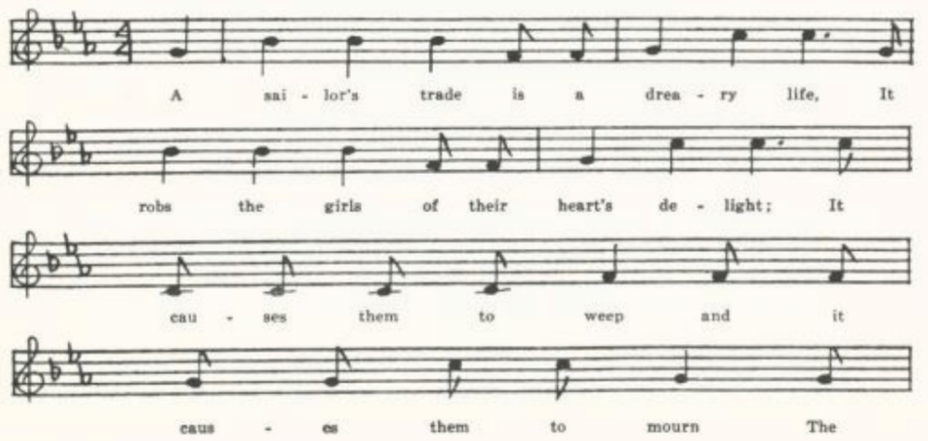
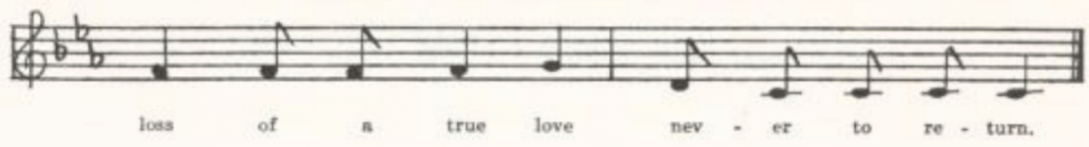
(187)
A sailor’s trade is a dreary life,
It robs the girls of their hearts’ delight;
IT causes them to weep and it causes them to mourn
The loss of a true love never to return.
(Repeat the last two lines of each stanza)

‘O Father, O Father, come build me a boat
That over the ocean I may float,
And every ship that I pass by
There I’ll inquire for my sweet sailor boy.’

As she was sailing all over Maine,*
She met three ships just out from Spain;
She hailed each captain as she passed by
And then she inquired for her sweet sailor boy.

‘O Captain, Captain, tell me true,
Did my sweet William sail with you?’
‘No, kind miss, he is not here;
Your love got drownded in the Gulf, my dear.

‘Down yonder by that rocky isle
We left him lie as we passed by.’
She wrung her hands and she tore her hair
Just like some lady in despair.

‘Go bring me a chair to sit upon,
Pen, ink, and paper to write it down.’
At the end of every line she dropped a tear,
At the end of every verse cried ‘Oh, my dear!’

‘Go dig my grave both wide and deep,
A marble stone at my head and fee,
And on my breast place a sweet turtle-dove
To let the world know that I died for love.’

*Should read ‘over the main.’

B
‘The Sailor Boy.’ From the manuscript balladbook of Ada Belle Cowden of Woodlandville, Boone County, compiled about 1909 and secured for me by Miss Laws.

(188)
‘Brown was the color of my true love’s hair,
His cheek resembled a lily fair.
Oh! If he would return and give me joy,
None would I have but my sweet Willie boy.

‘Father! Father! build me a boat,
That all over this world’s ocean I may float.
And I’ll hail each captain as he passes by
And there inquire of my sweet Willie boy.

‘Captain! Captain! do tell me true,
Does my sweet Willie sail with you?
Speak! Oh do! and give me joy,
For none will I have but my sweet Willie boy.’

‘Dear honorable lady! he’s not here.
He got drowned in the wide gulf near.
The Rocky isle as we passed by,
There we left your sweet Willie boy.’

She wrung her hands, she tore her hair,
Just like a lady in despair.
She called for a chair to sit her down,
With pen and ink for to write it down.

On every line she dropped a tear,
In ever line was ‘O! Willie my dear.’

C
‘The Sailor’s Trade.’ Secured by Miss Hamilton in 1909 from Mary Van Wormser of the West Plains High School, who wrote it down ‘as sung to her by her grandfather.’

The sailor’s trade is a dreary life,
It causes poor girls to lose their heart’s delight;
It causes them for to weep and mourn
The loss of their true love, never to return.

‘Brown was the color of my true love’s hair,
His cheeks resembled a lily’s fair.
If ever he returns it will give me joy,
For none can I wed but my sweet sailor boy.

‘Father, father, go build me a boat,
That I may on the river float;
I’ll hail each captain as I pass by,
And there I’ll inquire for my sweet Willie boy.

(189)
‘Captain, Captain, tell me true,
Does my dear Willie sail with you?
Tell me quick, for ‘twill give me joy;
For none can I wed but my sweet sailor boy.’

‘No, kind madam, he is not here,
He’s drowned in the gulf and we left him there;
All on the rocky island as we passed by,
There we let your true lover lie.’

She wrung her hands and she tore her hair
Just like some lady in despair:
‘All on the rocky island, as they passed by,
There they let my true lover lie.

‘Hand me a chair till I sit down,
A pen and ink for to write it down.’
At the end of every line she shed a tear,
At the end of every verse cried ‘Willie, my dear.’

‘Go dig my grave both wide and deep,
A marble stone at my head and feet;
And on my breast a sweet turtle-dove,
To let the world know I died for my love.’

D
‘California Boy.’ Contributed by Miss Celestine McDonald in 1914 from Vernon County. An adaptation, apparently, to the time of the Forty-niners.

Going to California is a dreary life,
It robs sweet girls of their heart’s delight,
Causes them to weep and mourn
The loss of a true love never to return.

‘Oh! Captain, Captain, bring me a boat
That I may on the ocean float;
I’ll hail each vessel passing by
And there I’ll enquire for my California boy.

‘Brown is the color of my true love’s hair,
His cheeks resemble the roses fair.
If he’ll come back and give me joy,
None will I have but my California boy.’

She called for a chair to sit upon,
Pen and paper to write in down;
At the end of every line she dropped a tear,
At the end of every verse cried ‘Oh, my dear!’

(190)
‘Dig my grave both wide and deep,
Put marble stones at my head and feet;
And on my breast a turtle dove
To show to the world that I died in love.’

E
‘Sailor Boy.’ Secured by Miss Lowry in 1920 from Earl Cruickshank of Columbus, Kansas.

‘Father, O father, build me a boat,
That on the ocean I may float;
I’ll hail the ships as they pass by
And inquire for my sailor boy.
I’ll hail the ships as they pass by
And inquire for my sailor boy.’
(Repeat thus the last two lines of each stanza)

She had not sailed far o’er the main
Till she spied three ships just out from Spain.
She hailed the captain as they drew nigh
And inquired for her sailor boy.

‘Captain, O captain, tell me true,
Does sweet Willie sail with you?
Tell me quick and give me joy;
Say, do you know my sailor boy?’

‘No, pretty miss, he is not here;
He’s drownded in the gulf, my dear.
At Rocky Isle as we passed by
We lost a fine young sailor boy.’

‘Place me a chair to sit upon,
A pen and ink to write it down.
At the end of every line she dropped a tear,
At the end of every verse cried ‘O my dear!’

‘Go dig my grave both wide and deep,
Place a marble stone at my head and feet;
Upon my breast a snow-white dove
To tell the world I died of love.’

F
‘True Sailor Boy.’ Contributed by Miss Beulah Wohlbeck in 1934 as known to her uncle in Morgan County.

(191)
. . . . . .
‘Captain, O Captain, come tell me true,
Does my Sweet William sail with you?
Tell me quick and give me joy,
For I’m inquiring for my true sailor boy.’

As she went sailing down the main
She met three ships all out from Spain;
And every ship that she passed by
She’d inquire for her true sailor boy.

She rammed her boat against a rock.
I thought to my soul her heart had broke;
She wrung her hands and tore her hair
Just like a lady in despair.

The Rambling Beauty

Known in Scotland (Christie II 7, Ord 176-7), Maine (BFSSNE I 7), Virginia (SharpK II 226-7), and Kentucky (SharpK II 227). I have not found it recorded elsewhere.

A
No title. From a manuscript sent to me in 1905 of which I unfortunately failed to record the provenience.

Once on a time with boyish fancy,
When life was fair and I was young,
I loved a girl whose name was Nancy;
I loved her more than the common run.

. . . . . .
My love she scorned for the sake of another,
Whose manly form and winning smile
Seemed sure that he would win her over
And mostly did her time beguile.

Full many a day I pined in sorrow
To see my Nancy, once so gay.
They were to wed on the coming morrow.
OH, must I see their wedding day?

Ah, could there be a trial harder?
‘Tis nearing now the month of May.
Her husband don’t in the least regard her,
For he took to gambling night and day.

(192)
Come all ye girls and lads, take warning,
When life is young and fair as May;
For many a bright and sunshiny morning
Turns out a dark and gloomy day.

B
‘Come all you girls of a rambling.’ From the manuscript ballad-book of James Ashby of Holt County, secured by Miss Welty in 1906.

Come all you girls of a rambling nature
And listen to my doleful song.
Once I knew a girl above my station;
I loved her more than the common run.

One night as we sat lovely talking
I offered her a wedding ring.
So haughty did she refuse it, saying,
I never thought of such a thing!

‘Oh, get you gone, you wild deluded,
And come no more to bother me.
Put on this robe of thy green willow,
For your true love I never will be.’

I turned around before I left her
And gently made her this reply:
‘Should ever you by chance to get married,
I hope you will see trouble as well as I.’

So now she is married to the dubolrago.*
A rambling boy goes through the town.
She says he don’t in the least regard her.
Her haughty pride he will soon bring down.

*So Ashby’s manuscript seems to read, and I have no interpretation to offer. In a text privately communicated to me by Professor C. A. Williams of the University of Illinois as learned by his mother many years ago in Western Pennsylvania the girl says ‘now I’m married to the Duke of Swago;’ in Ord’s text she is married to ‘Prince Orai;’ in Barry’s (from Maine) to ‘one of the blackguards of the town.’

C
‘My Sad Story.’ From the manuscript ballad-book of Allen F. Wade of Daviess County, compiled apparently in the 80s, and lent to me by his daughter in 1923.

Come all young men of youth and beauty,
Come listen to my mournful song.
I have courted more than my duty,
I have courted more than the common run.

(193)
I went to see a widow’s daughter
Who dressed in silk and satin fine.
To her I took one of the greatest fancies
That ever I did on the womankind.

As we were in the parlor so sweetly talking,
I offered her a marriage ring.
So scornfully she did refuse me,
Saying, ‘I never had a thought of any such a thing.’

That night as I arose up for to leave her
I gently made her this reply:
‘If ever you should chance a young man for to marry
I hope you’ll see trouble until you die.’

Now she is married to some other,
Nothing but a poor boy a-wandering town.
He says he don’t in the least regard her
And her haughtiest spirit he’ll bring down.

As I passed by my true-love’s window
I heard a low voice but sweetly say:
‘My husband don’t in the least regard me,
He follows gambling both night and day.

‘I wish I were a little swallow,
OR I wish I were some other flying bird;
After my true-love I would follow;
If he ever courted a girl there I’d be nigh.

‘But I am none of those little swallows,
Nor I’m none of those other flying birds;
But here I’ll live in grief and sorrow,
In grief and sorrow here I’ll die.’

The concluding lines of A and of C belong to that floating body of love-lyric which is dealt with below, pages 473-94.

(194)
Last Friday Evening

This seems to be the somewhat maudlin complaint of a rejected lover who has drowned his woes in liquor. I have not come upon it elsewhere, tho the glorification of the bottle and the imagery of the last four lines belong to that common stock of folk-lyric of which more will be said later (p. 489). The text is from the repertory of Waters, the Miller County fiddler, taken down by W. S. Johnson in 1904. No title was given, nor any stanza division; and without the tune I shall not attempt to provide the deficiency.

Last Friday evening as I rambled aye*
Hard was my fortune and hard was my fate.
I went to Molly’s window, thinking to get in;
Instead of finding pleasure, my sorrow did begin.
I waited there an hour as patiently as Job;
I found that my name wasn’t written on the cord.
I found another man enjoying of her room,
The room by the roadside by the light of the moon.
I put out, not knowing of the way,
The bottle in my pocket as jolly as the day.
I’ll dress up in a higher degree,
I’ll slightly pass by Polly as she dare by me.
Down yander in the meader beneath the shady grove,
Drinking of my liquor and thinking of my love,
Last Monday morning Polly came riding by,
With the red, rosy cheek and a dark, rolling eye—
Her hair is dark as charcoal, her eyes is just the same—
Saying, ‘Oh, my lovely Polly, did you ever feel a pain?’
I wish I was a fisherman by yonder water’s side
And Polly was a salmon come swimming down the tide;
I’d cast my net around her, I’d bring her to the shore;
I’d have my loving Polly, and I’d weep for her no more.

*Apparently ‘aye’ has been miswritten for ‘late.’

I’m Despised for Being Poor

Tho the general theme of this is not infrequent in the output of the ballad press, I have found this particular piece as traditional song only in Virginia (FLJ VII 32-3). It is one of Wehman’s prints—No. 890, I Was Despised because I Was Poor. The following text is from a manuscript collection of songs made in Gentry County in the 70s of the last century and lent to me by one of my students, Harry Fore, in 1904.

(195)
Farewell, false girls,* I leave you
In sorrow and in pain.
My absence cannot grieve you;
Soon you’ll bear a stranger’s name.
I’m forsaken for another,
One with gold in store.
Then farewell, father and mother—
I’m despised for being poor.

We have lived and loved from childhood
And vowed we ne’er would part,
Spend many hours in the wildwood—
But she’s nearly broke my heart.
There came a wealthy stranger
Just from a foreign shore;
He wooed, and soon he gained her
From me, for I was poor.

Then wed the bells† were chiming
And the carriage it passed by.
The lads and the lasses were smiling,
But a tear bedimmed her eye.
Farewell, vain girl, the ocean
Will part us evermore;
I’ve loved you with devotion
But was scorned for being poor.

Farewell, vain girl, I leave you
In sorrow and in pain;
I’ve enlisted for a soldier,
To die on the battle plain.
May sorrow ne’er distress her
But happiness in store.
And yet loving I will bless her
Though despised for being poor.

*Miswritten, apparently, for ‘girl.’
†Read ‘The wedding bells.’

The Lonesome Scenes of Winter

Another song of the rejected lover, which I have found only in the United States. I has been reported from Kentucky (JAFL XX 273, TKMS 94-7), Tennessee (JAFL XLV 11-2, SSA 136-7, FSSH 298-9), Georgia (JAFL XXIX 200, FSSH 299-300), and Minnesota (Dean 108-9). A Newfoundland song, Proud Nancy (FSN 47-51), has a like theme but little verbal resemblance.

No title. Taken down in 1904 by W. S. Johnson from the singing of Tom Waters, fiddler, in Tuscumbia, Miller County.

Lonesome seems the winter,
The chilling frost and snow;
Dark clouds around me hover;
The wind has ceased to blow.

I went the other evening
My true love for to see.
I asked her if she’d marry me;
She would not answer me.

The little birds sing sweetly
Among every bush and vine.
My joys they would be doubled
If only you were mine.

The chickens are a-crowing,
It’s almost break of day.
I’m waiting for an answer;
Kind love, what will you say?

‘If it’s you that I must answer,
I choose a single life;
For I never thought it suited
For me to be your wife.

‘So take this for an answer,
And for yourself provide.
For I have found a new sweetheart
And you are cast aside.’

(196)
About six weeks or more,
This lady’s mind did change;
She wrote to me a letter,
Saying, ‘Kind sir, I feel ashamed.

‘I feel that I’ve forsaken you;
I cannot bear in mind.
So here’s my heart, come take it
And claim it as your own.’

I wrote her back an answer,
I sent it off in speed:
‘I loved you once, my darling,
I loved you once indeed;

‘But since you proved false-hearted
I’ve learned to love again.
I’ve found a new sweetheart
And you may do the same.’

Wounded Spirit

Given to Miss Hamilton in 1911 by Shirley Hunt of the Kirksville State Teachers College as ‘the last verse of Wounded Spirit’—a song of which I know nothing further. It seems to be of the same temper as several of the pieces of folk lyric that will be dealt with later in the present work.

It is true when I read your first letter
That I blotter your name with a tear.
I was young then, but now I know better,
And I’ll say so whenever you’re near.
Oh dear, how you fret and you worry,
Repeating your vows to be true!
If I said so I told you a story;
For now I love another, not you.

Courting Too Slow

This title (being that of the Scotch song in Logan’s Pedler’s Pack 364 from which our American song is probably derived—see Kittredge’s note in JAFL XX 273) is chosen as carrying the central idea of the song, tho it is not used as the title of any of the American texts nor does the phrase occur in the Missouri text. It has been reported fro Virginia (SCSM 317-8), Kentucky (JAFL XX 273-4, XLIX 225-7, DD 96-7, SharpK II 20).
No title. Reported by W. S. Johnson as sung by Tom Waters, fiddler, of Tuscumbia, Miller County, in 1904.

I’se well educated, brought up in good use,
And in all of ladies’ company I was well introduced.

I wrote my love a letter, it was sent in great haste,
And the one who carried the letter had no time to waste.

(197)
In reading the letter filled her heart full of grief,
Saying, ‘I’ll arise and go to William and grant him relief.’

When William saw her coming unto his bedside,
Saying, ‘Yonder comes a lady; must she be my sweet bride?’

‘O William, dear William, ‘tis you I adore.
If I’d ’a’ got your first letter I would ask for no more.

‘Now we’re lovely* married, I will die for your sake.’
As she threw her arms around him she felt his heart break.

‘Now he is dead, and I hope he is at rest.’
As she hugged him and kissed him and died on his breast.

*Read ‘lawfully’?

Time Enough Yet

Evidently a parlor song, but I do not know its history. A text from Mississippi is reported in JAFL XXXIX 182-3.

A
‘Time Enough Yet.’ Secured by Jesse Williams in 1905 from General W. A. Roby of Hamburg, Arkansas, who writes: ‘The songs sent you were composed before, during, and immediately after the Revolutionary War . . . The authors are entirely unknown to me. I learned them when a wee bit of a boy, sitting on my grandfather’s knee, who did service in the war of 1812. I have never seen any of the songs sent you in print.’

In terms full as long as the siege of old Troy
To win a handsome girl I my time did employ;
I oftentimes urged her the wedding-day to set,
But she always would answer me, ‘It’s time enough yet.’
Chorus:
Time enough yet, time enough yet
She always would answer me, ‘It’s time enough yet.’

At last I told her her answer was wrong
And more than I dared to be trifled with so long.
She then burst out to laughing at seeing of me fret,
And she hummed out a tune, ‘It’s time enough yet.’

I determined now by her to be laughed at no more;
I flew from her presence and bounced out at the door,
Resolving of such usage the better to get
Or on her my eyes again never to set.

(198)
The next morning early he maid came in haste
To beg that for God’s sake I would forget what had passed;
Relating her young mistress did little else but fret.
And I sent hr back an answer: ‘It is time enough yet.’

The next came a letter as long as my arm
Declaring from her soul that she had intended no harm,
That all her past conduct she did very much regret.
And I wrote her back an answer: ‘It is time enough yet.’

Now this was scarce gone before a messenger I sent
To show her in my heart that I began to relent.
I asked of her and together we met;
We kissed and made friends again and so we are yet.

B
‘Time Enough Yet.’ Secured by Miss Hamilton in 910 from Grace Clemmons of the West Plain High School, who learned it from a Mrs. Autherson of Green Bay, Wisconsin. It does not differ significantly from A except in its closing stanza, which runs:

Come all you young ladies with beaus so plenty,
Be sure you get married before your are twenty;
For if you don’t you’ll always regret
The very first time you said ‘time enough yet.’

Peggy Walker

For this I have adopted the title given in LT, although the name does not occur in the Missouri texts. It is a derivative of, or at least owes it temper-giving line to, The Girl I Left behind Me, since the eighteenth century the favorite farewell song of British soldiers and sailors, frequently issued by the ballad press and discussed in Helen K. Johnson’s Familiar Songs (ed. of 1896) 503 and S. J. A. Fitz-Gerald’s Stories of Famous Songs 360ff. The Girl I Left behind Me, either the whole song or bits of it or merely the refrain line, is widely known in America (see JAFL XLVIII 351, NPM 150-1, JAFL XXVI 133, FSM 229-30, ABFS 280-3, JAFL XXVII 297, XXVIII 286, XXXIII 99-100, CS 58-60), but appears in the Missouri collection only in this derivative form. The British stall ballad which gives us the American Peggy Walker was printed by Such as The Lover’s Lament; or, The Girl I Left behind Me; also by Bebbington, and by Walker of Durham. It has been recorded from Scotland (Ord 45-7) and from Norfolk (JFSS VIII 262), and in this country from West Virginia (FSS 300-1), Kentucky (LT 76-8, SharpK II 64-5), Tennessee (ETWVMB 47-9, JAFL XLV 150-2, FSSH 354-8), and North Carolina (JAFL XXVIII 161-2, SharpK II 62-3).

(199)
A
No tile. Communicated in 1905 by Finis Dean, as sung by his mother, who was reared in Carroll County.

There was a wealthy old farmer
Lived in our country nigh.
HE had an only daughter;
To her I cast my eye.

I asked her one day if it made her any difference
Should I go cross the plains.
She said it made no difference
If I’d come back again.

So I went into that country
And settled close to a village nigh,
Where work and money was plenty
Myself to satisfy.

But as I was walking up the street one day
The post-boy met me there.
He handed me a letter
Which gave me to understand
The girl I’d left in old Missouri
Had married another man.*

So turning myself around about,
Not knowing what to do,
My mind was bent on rambling,
And gambling I will do.

B
‘The False-hearted Lover.’ From Ashby’s manuscript ballad-book, compiled in Holt County and secured for me by Miss Welty in 1906.

My parents reared me tenderly,
Having no child but me.
My mind was bent on roving;
With them I couldn’t agree.

So I became a rover,
Which grieved my heart full sore;
I left my aged parents
Never to see them more.

There was a wealthy merchant
Lived in a town close by.
He had an only daughter
On whom I cast my eye.

She was so handsome and tall,
So beautiful and fair,
There was no other in that country
To her I could compare.

I asked her if it made any difference
If I crossed over the plains.
She said it made no difference
So I returned again.
She said she would prove true
Till death did prove unkind.
WE kissed, shook hands, and parted;
I left my girl behind.

When first I left old Iowa
To Kansas I was bound;
And when I got to that country
I roved the country all round.

There work and money was plenty,
To me the girls was kind;
But the only object of my mind
Was the girl I left behind.

*Presumably these six lines are the result of telescoping two stanzas.

(200)
I took a walk one evening
Down by the public square;
The mail-coach had arrived,
And I met the driver there.

He handed me a letter
Which soon gave me to understand
The girl I left behind me
Had wed another man.

I advanced a few steps further
To see if it was true;
I turned myself around about
Not knowing what to do.

My trade I will give over,
Bad company I’ll resign;
I’ll roam all round from town to town
For the girl I left behind.

C
No title. From some pages of old manuscript communicated in 1911 to Miss Hamilton by Agnes Shibley of the Kirksville Teachers College. The manuscript was written by a man who was born in 1831 in Tennessee and come to Macon County, Missouri, in 1835; written probably sixty or seventy years ago. The opening stanzas were not recorded.

I asked her if it would make any difference
If I should cross the plain.
She said it would make no difference
If I would return again;

That she would prove true unto me
Till death would prove unkind.
So we kissed, shook hands, and parted,
And I left my girl behind.

And when I left old Iowa
For Missouri I was bound.
I arrived in Allen City
And viewed the place around.

Where trade and work was plenty
And the gents to me was kind.
The only, the only thing that grieved me
Was the girl I left behind.

One evening as I took a walk
Around the public square
The mail-coach had just come in town;
The post-boy met me there.

He handed me a letter
Which gave to madness*
The girl I left in Iowa
Had married another man.

I walked on a little farther.
I found the news quite true.
I turned myself around,
For I knew not what to do.

My trade I’ll now give over,
Bad company resign,
I’ll travel this world over
For the girl I left behind.

*Read, ‘gave me to understand.’

(201)
The Maid of Prairie Du Chien

Presumably a song of the fur-traders or, later, of lumbermen, but I have not come across it in print. Prairie du Chien is at the junction of the Wisconsin and Mississippi Rivers in southwest Wisconsin.

‘The Maid of Prairie du Chien.’ Sent in in 1903 by Miss Williams, with the notation: ‘Sung by an old man in Clinton County. He says it was a popular neighborhood song when he was a boy. Does not know of it in print.’

Farewell, my friends, I will bid you adieu.
My heart’s full of sorrow for this leaving you.
There’s nothing doth my footsteps detain
But the beautiful maid of Prairie du Chien.
(Repeat the last line of each stanza)

I paid my addresses unto her one day.
I was merely a-jesting to see what she’d say.
She kindly received me and not with disdain,
The beautiful maid of Prairie du Chien.

I proffered her marriage, believing her true;
She made no denial, but sadly withdrew.
She’s rejected my offer again and again,
The beautiful maid of Prairie du Chien.

When lovers get scarce, which will soon be the case,
Perhaps she’ll think she’s once seen my face.
She shall never have the chance to deny me again.
This beautiful maid of Prairie du Chien.

I wish I could wander to some distant shore,
Where wild battles conflict, and the cannon doth roar:
But were I a slave bound into my chain
I’d still love the maid of Prairie du Chien.

The Butcher Boy

For evidence of the popularity of this ballad in stall and songbook print see Kittredge’s notes in JAFL XXIX 170 and XXV 361. He suggests that it is ‘an amalgamation of The Cruel Father, or Deceived Maid and There is an Alehouse in Yonder Town,’ both English. The combination, however, seems to be rather definitely an American product. In its ‘regular’ form, as printed by De Marsan, Partridge, Wehman, and in many songbooks, a girl, who lives in Jersey City, tells how she loves a butcher

(202)
boy, who has transferred his amours to another girl ‘because she has more gold than I;’ foretells that he will cease to love this other girl when her gold is gone; goes upstairs to make her bed, lamenting to her mother and bidding her bring a chair, pen, ink, and paper; then (with a sudden shift to third person narration) her father comes home, breaks open her door, finds her handing in a rope, cuts her down, and in her bosom finds a letter giving directions for her burial, including the placing on her breast of a turtle dove ‘to show the worlds I died for love.’ Most of the elements of the story are to be found in more than one British ballad. The location in Jersey City is, of course, American (the ‘in Jessie’s city’ of the Essex text in JFSS II 159 looks as if this text had traveled back from America to England)l but it is ‘in London city’ in texts from Nova Scotia, Vermont, Virginia, and Tennessee, ‘in Dublin city’ in Ontario and one text from Nova Scotia, ‘in New York City’ in one of the West Virginia and one of the Iowa texts, ‘in Jefferson City’ in two Illinois texts, ‘in yonder city’ in Georgia, and ‘down in a village’ in Mississippi. The location is Sheffield Park in Pitts’s broadside of that title, which comes closest of all British stall prints to the American ballad and is current also orally in Hampshire (Gillington, Eight Hampshire Folk Songs NO. 7). A Dorset text has ‘in Yorkshire Park.’ The ‘butcher boy’ is only American, but is remarkably constant in American texts; in English analogs he is ‘a brisk young lad,’ ‘a sailor lad,’ ‘a rambling boy.’ And the like (in the Essex text mentioned above he is ‘a postman boy’). The tavern (inn, alehouse) is English; American texts of The Butcher Boy have either no localization of the young man’s second amours or a vague ‘town’ or ‘house’ (exceptions are Nova Scotia A, Ontario, Iowa A B H, and the Nebraska text in ABS 62—this last not strictly a text of The Butcher Boy). The girl’s suicide by handing appears in The Rambling Boy (Pitts), The Cruel Father (Harvard Library, no imprint), and in oral tradition in Lincolnshire (JFSS II 293-4, a version of Early, Early in the Spring), Essex (JAFSS II 159-600, In Jessie’s City), and Dorset (JFSS VII 46-7). The concluding stanza in which the girl gives directions for her burial is likely to appear in almost any ballad ending in a death. Missouri C has in its third stanza (see below) an item which I have found in only two other traditional texts of The Butcher Boy but which is of frequent occurrence elsewhere: in Dorset (JFSS V 188-9, There was Three Worms on Yonder Hill, fairly close in story to The Butcher Boy), perhaps in Lancashire (JFSS I 252-3, a text of There is an Alehouse in Yonder Town in which Kidson has editorially filled in the places with other words) in Spaeth’s text in Weep Some More, My Lady 128-9, in North Carolina (SharpK II 268, Every Night when the Sun Goes in), in the Appalachians (AMS 50, Careless Love), and in negro songs (JAFL XXIV 286, PFLST VII 99, ANFS 326-7, NS 194-5, and elsewhere). It is a riddling metonymy of a sort that the folk are fond of, like the sheath and knife figure in the Child ballad named therefrom. One other feature, frequent in English ballads

(203)
having a similar story but not found in any text* of The Butcher Boy, should be mentioned. In two seventeenth century broadsides, The Deceased Maiden Lover and The Constant Lady and False-hearted Squire (Roxburghe Ballads I 260-2 and VIII 635-6), in Sheffield Park (Pitts; also in oral tradition in Hampshire, see above), in Lancashire and Hertfordshire texts of A Brisk Young Sailor (JFSS V 183-9), in the Dorset There was Three Worms on Yonder Hill, in an Essex text of Died for Love (JFSS II 158-9)—all having a story something like that of The Butcher Boy—the girl does not hang herself but, like Ophelia, goes in search of flowers to cure the wounds of love,† makes a bed of them, and dies thereon (or, sometimes, dies and is covered with flowers and grass by her loving mistress). This element appears also in an otherwise unrelated song from North Carolina, Dearest Billie (MSNC 7).
The Butcher Boy, as distinct from other renderings of the same general situation, has been recorded from tradition in Essex (JFSS II 159), Nova Scotia (BSSNS 157-60, SBNS 33-4), Ontario (JAFL XXXI 73), Vermont (VFSB 115-6), New Jersey (JAFL XLIV 76-7, XLV 73, FSSH 197-9), Pennsylvania (JAFL XXII 78, FSSH 196-7), North Carolina (BMFSB 36-7, SCSM 287-8), Georgia (SharpK II 76-8, JAFL XLV 72-3, FSSH 195-6), Mississippi (FSM 160), Missouri (Ozark Life V No. 9), Ohio (JAFL XXIX 169, XXXV 360-1), Indiana (FSSH 199), Illinois (TSSI 146-9), Iowa (MAFLS XXIX 37-41), and Wyoming (ABS 60-2). Shearin’s list shows that it is known also in Kentucky; and it is probable that it is current in many other parts of the country but has not been thought worthy of record. Spaeth (Weep Some More, My Lady 128-9) and Sandburg (ASb 324) give it without localization.

A
‘The Butcher Boy.’ Secured by Miss Williams in 1903 from Eva Packard, of Clinton County, who learned it ‘from a hired girl.’

*Rather, in any printed text. In two text privately communicated to me by Barry in 1917, one from Harrisburg, Pennsylvania, and one from Deerfield, Massachusetts, the girl runs thru the meadows gather flowers, for
There is a flower that I’ve heard say
‘Tis called hearts-ease both night and day,
And if that flower I could find,
‘Twould ease my heart and please my mind.
The former of these has also the ‘apron high’ motif.
†The folk-lore of flowers and herbs is too complex and too vague to be dealt with here; see PMLA XXXIII 359-67. As de Gubernatis points out (Mythologie des Plantes I 131), Ovid knew that there were no simples that could cure these wounds:
Me miseram, quod amor non est medicabilis herbis
Heroid. V 149
Ei mihi, quod nullis amor est sanabilis herbis
Metam. I 523

(204)
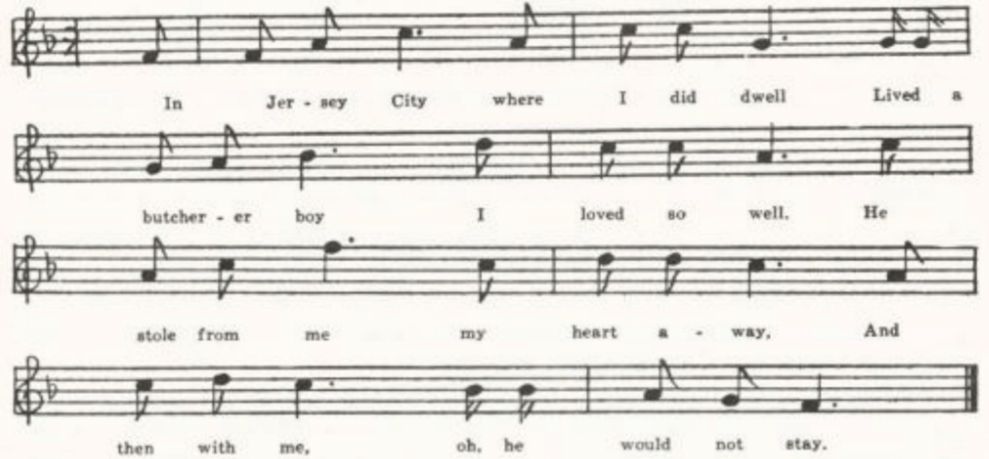
In Jersey city where I did dwell
Lived a butcher boy I loved so well.
He stole from me my heart away,
And then with me, oh! he would not stay.

There lives a girl in that same town
Where my lover goes there and sits down;
He takes a strange girl on his knee,
And he tells to her what he once told me.

I went upstairs to make my bed
And nothing to my mother said;
But she followed me right up for fear
Saying, ‘What is the matter, daughter dear?’

‘O mother dear, you cannot know
What pain and sorrow, grief and woe,
What pain and sorrow, grief and woe
To be in love with a butcher boy.’

My father, when he came home that night,
Said, ‘Where has my dear daughter gone?’
He went upstairs and broke the door
And found her hanging by a rope.

He took a knife and cut her down,
And in her bosom this letter he found.
He called her mother up the stairs
And read these words through his tear:

‘Go dig my grave, go dig it deep,
Place a marble stone at my head and feet,
And on my breast place a sweet turtle-dove
To let the world know that I died for love.’

B
‘The Butcher Boy.’ Secured in 1903 by W. S. Johnson from Mr. Vaughan, principal of the high school in Tuscumbia, Miller County.
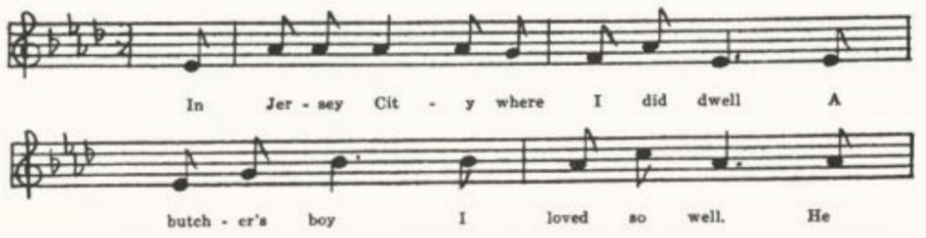
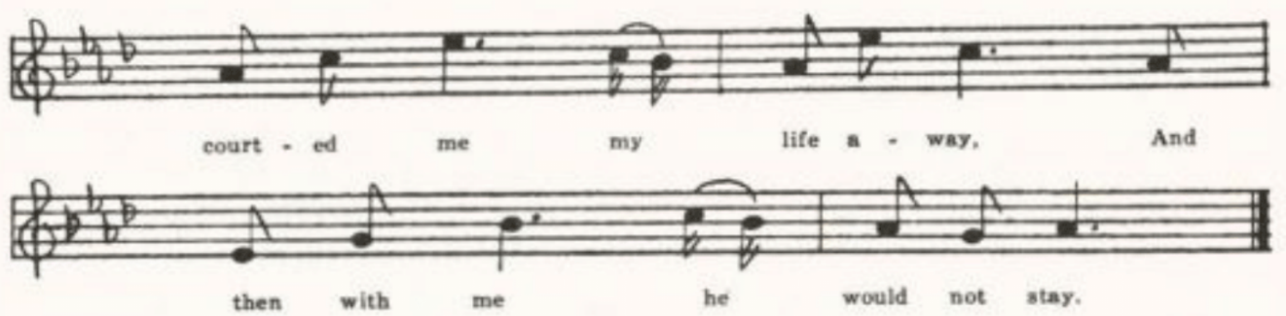
(205)
In Jersey City where I did dwell
A butcher’s boy I loved so well.
Her courted me my life away,
And then with me he would not stay.

There is a house in yonder town
Where my love goes and sits around;
He takes strange girls upon his knee
And tells them that he don’t love me.

But I can tell you the reason why:
They have more gold and silver than I.
Their gold it will melt, their silver fly;
In time of need they’re poor as I.

I went upstairs to make my bed,
With nothing to do, my mother said.
She came upstairs and said to me,
‘What can [be] the matter, my daughter, with thee?’

‘Oh, mamma dear, you do not know
What pain and sorrow I have know.
Go get a chair and sit me down.
A pen and ink for to write it down.’

With ever line she dropped a tear
For calling back her Willie dear.
Her father came home and looking round
Says he, ‘Where can my daughter be found?’

He went upstairs, and the door he broke.
He found her hanging on a rope.
He took his knife and cut her down
And in her hands these words he found:

‘Go dig my grave, go dig it deep;
Place a marble stone at head and feet,
And upon my heart a turtle dove,
To show this world I died for love.’

C
‘Butcher Boy.’ Secured by Miss Charlotte F. Corder in 1906 from Nellie Martin of Corder, Lafayette County, who learned it from her father, who knew it as a boy in South Carolina.

In Jersey City where I did dwell
A butcher boy I loved so well.
He courted me my heart away
And then with me he would not stay.
‘Tis grief, oh! grief ‘tis hard to tell
Of a butcher’s boy I loved so well.

I think I know the reason why;
It’s because she has more gold than I.
Her gold will melt, her silver will fly,
And then she’ll be as poor as I.
‘Tis grief, oh! grief ‘tis hard to tell
Of a butcher’s boy I loved so well.

And when I wore my aprons low
He would not let me through the snow;
But now I wear them to my chin
And when he passes he never comes in.
For he has courted me my heart away
And now with me he will not stay.

(206)
I went upstairs to make my bed
And to myself this is what I said:
‘She’ll never live to see the day
That she will take my lover away.’
And so within a few short days
I heard of the death of Katie McGays.

Her father came home saying one eve,
‘Oh where, oh where had my daughter gone?’
Upstairs he went
And there he found her on the rope.
He took his knife and cut her down,
And on her breast these lines were found:

‘Oh father dear, go dig my grave,
And dig it so both deep and long,
And at my head place a willow tree
To show the world I’ve died for thee;
And on my breast place a snow-white dove
To show the world I died for love.’

‘The Butcher’s Boy.’ From Ada Belle Cowden’s manuscript ballad-book, compiled in Boone County about 1909. The place is ‘in London city.’ The letter found on the girl’s boy begins with two lines not found in most of the other Missouri texts:

‘Oh, what a foolish, foolish girl,
To kill myself for a butcher’s boy!’

E
‘The Butcher Boy.’ Secured in 1912 by Miss Frances H. Miller from Mrs. Charles Opel of Jefferson City, who ‘was brought up in Missouri, and … learned many of the ballads from her mother.’ A somewhat abbreviated text, with no distinctive features.

F
‘The Turtle Dove, or The Butcher Boy.’ Not strictly a Missouri text, since it was secured by Miss Colquitt Newell in Madison, Wisconsin, in 1913 from Mr. A. F. Nelson of that town. He was of Scandinavian descent. The tune to which he sang it was reported as follows by Miss Newell:
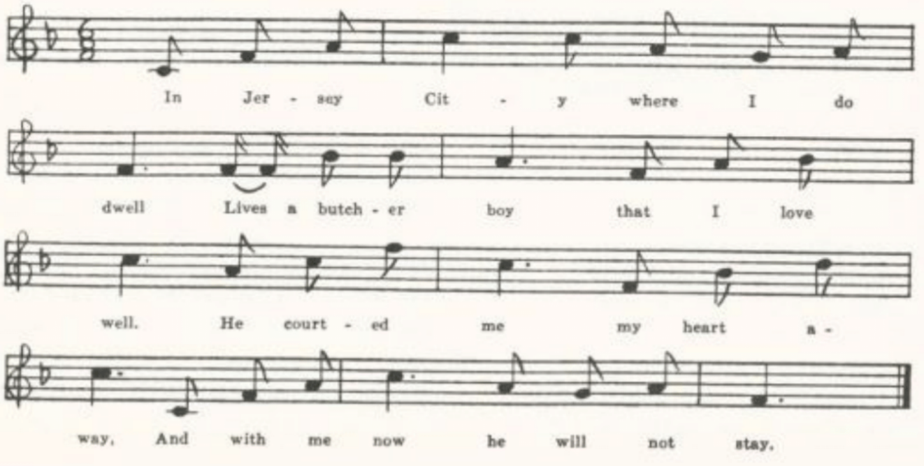
(207)
G
‘The Butcher’s Boy.’ Communicated in 1921 by Professor John Robert Moore, then at Washington University, as sent in a letter to one of his students, Lillian Scott, by Mrs. Charles Dillard of Crane, Stone County. Has the same preliminary to the funeral directions as D.

H
‘Butcher Boy.’ Secured by Miss Beulah Wohlbeck in 1934 from Miss Vera Frye, who learned it from her mother in Dexter, Stoddard County. The Place is ‘in Boston city.’ A somewhat abbreviated text.

Mary of the Wild Moor

For the frequency of this general favorite in stall and songbook print see Kittredge’s notes in JAFL XXIX 185 and XXXV 389. Helen K Johnson’s Our Familiar Songs 303 calls it ‘a combination of old English words and music,’ and says its popularity was due to the uniting of the words and the air by Joseph W. Turner, about the middle of the last century. Unfortunately I have not the tune of any of the Missouri texts; but it may be noted that the tune recorded by Barrett from Sussex is not that given in Our Familiar Songs. Naturally, in view of its frequency in print, the texts taken down from singing do not vary greatly. It has been recorded from tradition in Sussex (EFS No. 44), Glouchestershire (FSUT 213-4), Nova Scotia (BSSNS 164-5), Vermont (SHV 36-9), Pennsylvania (NPM 110-1), Virginia (SCSM 335-6), West Virginia (FSS 437-8), North Carolina (JAFL XLV 69-70, FSSH 372-3), Ohio (JAFL XXIX 185, besides tunes XXXV 389-90), Indiana (ASb 466), Illinois (TSSI 149), Iowa (MAFLS XXIX 28-30), Nebraska (ABS 81-2), and California (TBWV 87); and it is also in Barry’s and Shearin’s lists. There are six copies in the Missouri collection:
A from the fiddler Waters, Miller County.
B from Ethel Doxey of Carroll County, Arkansas, secured by Miss Simmons.
C from C. H. Williams, Bollinger County.
D from James G. Hommell, Kansas City.
E from the MSS of William Dresia, Columbus, Kansas.
F from Helen Rode, Howell County, secured by Miss Hamilton.
Since they differ but slightly—chiefly by omissions—it will be sufficient to give one here.

F
‘Mary of the Wild Moor.’ Written out for Miss Hamilton in 1910 by Helen Rode of the West Plains High School, as known by her mother when a child.

‘Twas on one cold winter’s night
When the wind blew across the wild moor,
When Mary came wandering home with her child
Till she came to her own father’s door.

(208)
‘O father, dear father,’ she cried,
‘Come down and open the door,
For the child in my arms will perish and die
By the winds that blow ‘cross the wild moor.

The old man was deaf to her cries;
Not a sound of her voice reached his ears;
And the watch-dog did howl, and the village bell tolled,
And the wind it blew ‘cross the wild moor.
‘Oh, why did I leave this dear spot,
Where once I was happy and free?
But now I am doomed to roam without friends or home
And no one to take pity on me.’
Oh, how must the old man have felt
When he came to the door in the morn!
Poor Mary was dead, but the child was alive
And asleep in its dead mother’s arms
Half frantic he tore his gray hair
And the tears down his cheeks they did pour,
Saying, ‘This cold winter’s night she has perished and died
By the winds that blow ‘cross the wild moor.

The old man in grief find the way.*
The child to its mother went soon.
The cabin, not a soul has lived there to this day
And the cabin to ruin has gone.
The villagers point to the spot
Where the willow droops o’er the door,
Saying, ‘There Mary died, once a gay village bride,
By the winds that blow ‘cross the wild moor.’

*Misheard, of course, for ‘pined away.’

All on Account of a Bold Lover Gay

Altho the general theme of this is familiar, I have not found this form of it elsewhere.

‘All on account of a Bold Lover Gay.’ Contributed by Miss Hamilton as known by Mary van Wormser of West Plains High School, 1909.

Ho, ho, you pretty lassy, ho, ho, you sweet little dear,
Come sit you on my lap and do not fear.
Why those rosy blushes, why those blushes, I say?
All on account of a bold lover gay!

(209)
Leave your father and mother and come along with me,
And I will carry you to my home across the sea.
Oh, oh, thou pretty lassy, oh, oh, thou sweet little May!
All on account of a bold lover gay.
No hard work for you there, I say,
But silk and satin dresses, May!
And all the day we’ll laugh and play.
Oh, you false young lover gay!

Heigh-ho, thou pretty lassy, heigh-ho, thou sweet young May,
Why do you look back at your old home so much
As you go with him on the way?
All on account of a bold lover gay.

Heigh-ho, thou pretty lassy, heigh-ho, thou sweet young maid,
You’ll wish you at home had stayed, stayed,
Nor left your old father and mother that day
To go away with your bold lover gay.

Heigh-ho, thou poor pale May, heigh-ho, thou poor young dear,
‘Tis well nigh a year since you left here!
And where are your silks and satins, May?
And what is that under your cloak, I say?
All on account of a bold lover gay!

Fond Affection

This is reported, with rather widely different texts, from Kentucky (ASb 323), Tennessee (JAFL XLV 70-1, FSSH 250-1), North Carolina (BMFSB 52-3), and Arkansas (Ozark Life V Nos. 10-11). Spaeth’s ‘Go Now and Leave Me if You Wish’ (Weep Some More, My Lady 44-5) has only its first stanza in common with this song.

From the manuscript ballad-book of Ada belle Cowden of Woodlandville, Boone County, compiled about 1909 and secured for me by Miss Lucy Laws of Christian College.

Once did I love with fond affection,
I thought your love was all for me,
Until that dark-eyed girl persuaded;
I found you cared no more for me.
Chorus:
There’s but three things I ask for, love,
‘Tis my coffin, shroud, and grave.
When I’m dead, love, come and see me
And kiss the girl you have betrayed.

(210)
Many are the nights with you I’ve rambled,
Many are the nights with you I’ve strayed.
Thinking your love was mine forever.
Now I find it all displayed.

Many are the hours while you are sleeping,
Dreaming and sleeping in sweet repose,
While I, poor girl, lie broken-hearted,
Listening to the wind that blows.

Oh! you may love her if you want to,
But I love no other but thee;
While in you heart you love another—
While in my grave I’d rather be.

Birdie Darling
This varies little from the print in Wehman’s ballad series, No. 248. It has been reported as traditional song from Illinois (TSSI 254-7).

‘Birdie Darling.’ Secured in 1913 by Mrs. Geo H. Barnett from Mrs. Sarah Henry, who learned it in Saline County about 1865-70.

Fly across the ocean, birdie,
Fly across the deep blue sea,
There you’ll find an untrue lover,
Untrue, yes, untrue to me.

Chorus:
Birdie, birdie, darling, birdie,
Do not tarry on the way,
And when you hear the ocean murmur,
Birdie darling, fly away.

Oh, tell him, birdie, to remember
In my window by my side,
When he told me that he loved me,
When he asked me to be his bride.

Oh, tell him, birdie, to remember
When our hearts were light and free,
When he pledged hisself forever
Unto me as unto me.

Take to him these glossy ringlets,
Place them on his bosom bare;
Ask him, birdie, to remember
How my curls have nestled there.

Fly away now, birdie darling,
Stay no longer by my side;
Now God bless, God bless you, birdie!
Carry my message o’er the tide.

(211)
Thou Hast Learned to Love Another

This song is credited to Charles Slade in Ditson’s Home Melodist (1859) 38, and is No. 272 in Partridge’s series of broadsides.

No title. Written our for Miss Hamilton in 1912 by Shirley Hunt of the Kirksville Teachers College. Miss Hunt had it from her mother, who was reared in Scotland County.

Thou hast leaned to love another,
Thou hast broken every vow.
We are parted from each other,
And my heart is lonely now.
I have taught my looks to shun thee
When coldly we have met,
For another’s smile has won thee
And thy voice I must forget.
Oh, is it well to sever
This heart from thine forever?
Can I forget thee? Never.
Farewell, farewell forever.

We have met in scene of pleasure,
We have met in halls of pride.
I have seen thy new-found treasure,
I have gazed upon thy bride.
I have marked the timid luster
Of her downcast, happy eye;

I have seen thee gaze upon her,
Forgetting I was nigh.
Oh, would I never met thee;
Fain, fain would I forget thee;
‘Tis folly to regret thee.
Farewell, farewell forever.

We have met and we have parted,
And you scarcely spoke one word.
Like some guilty thing I started
When your well-known voice I heard.
Thy looks were stern and altered,
Thy words ran cold and high;
How my traitor courage faltered
When I dared to meet thine eye!
Oh! Woman’s love will deceive her
And woman’s pride will leave her;
Life is fled when love deceives her.
Farewell, farewell forever!

Ella Lea

This and the following song probably owe their origin to Slade’s ‘Thou Hast Learned to Love Another,’ to be found in Ditson’s Home Melodist and also among Partridge’s stall prints (No. 272 in Partridge’s list). Textually, however, there is little beyond that title line common to the three.

From the Dreisa MSS secured by Miss Lowry in Columbus, Kansas, in 1909. I have corrected only the pointing.

If you will listen to me I will sing you the song
Of the unfortunate Ella Lea.
The girl that I love is hansom and fair
And I called her my sweet Ella Lea.

(212)
‘To whom my thoughts are known,
Oh, calm these trembling fears;
Oh, turn away thy words’ cold frown
And dry my falling tears.
Won’t you love once more as you did long ago
And call me your sweet Ella Lea?

‘Life without thee is lonely;
Thou fills my heart with glee.
Give me that smile of gladness
And call me your sweet Ella Lea.

‘Thou has learned to love another,
Most dearer than me.
Thou has forsaken
This lonely Ella Lea.’

The Broken Engagement

The same song, tho with rather wide differences in the text, is reported from Kentucky (JAFL XLIX 219-20) and from the Appalachians (SSSA 165-6).

Secured by W. S. Johnson in 1903 from Waters, the Miller County fiddler, Johnson notes that the ‘o in folly has a long sound something like awe.’

You may go and win another,
Go and win her for your bride;
For my bleeding heart has sevred*
More than love can conquer pride.

Chorus:
For I love you, dearly love you,
More than all this world can know;
But you’ve broke the trust you’ve plighted.
Go, I say, forever go.

Oh, when you heave won another,
Please do cast one thought on me—
The one who has often prayed in secret,
Who would have died for the love of thee.

*The SSSA text has
Then this bleeding heart will smother;
Love can never conquer pride.
Perhaps, however, ‘sevred’ is for ‘suffered.’

(213)
Soon we’ll part to meet as strangers,
Plucking flowers from the ile-stream of love;
And from o’er the graves the dear ones
We once all have loved so well.

Yes, I’ll give you back your letters
And your picture I love so well,
And we’ll part to meet as strangers.
Still I cannot say farewell.

How I wish I never had met you,
Though ‘tis folly to regret;
We have parted now forever.
Still I love my darling yet!

The Finished Letter

Altho this is pretty certainly a piece of parlor sentiment and first circulated either in song books or as sheet music, I have not seen it in print except in Neely’s collection of songs traditional in southern Illinois (TSSI 231-3), where the editor remarks: ‘This song seems to have enjoyed some little popularity with the young people forty years or more ago. Today it is rarely sung. This particular version was copied from a manuscript written many years ago.’ The variations in the two Missouri texts show that it has passed by word of mouth.

A

‘The Jealous Lover.’ Secured by W. S. Johnson in 1903 from Waters, the Miller County fiddler. Stanza 6 is unintelligible as it stands.

I have written him a letter
Telling him that he is free.
From this moment and forever
He is nothing more to me.

I will teach him that in courting
He should never court but one.
But this heart is light and gayer
Since the letter it was done.

Everybody in the village
Knows that he’s been courting me;
But this morning he was riding
With a saucy Annie Lee.

And they say he smiled upon her
As she scantled by his side;
And no doubt but what he’s promised
To make Annie Lee his bride.

He can have her if he wants her,
If he loves her more than me,
But I want him to remember
He is nothing more to me.

I was riding our this morning
With my cousin by my side;
She was telling her intention
To soon become my bride.

(214)
I’ll declare, out in the twilight
There is someone coming there.
And it is his figure,
Just as sure as I am here.

He is coming through the gateway!
I will meet him at the door
And I will tell him that I love him
If he’ll court Miss Lee no more.

‘Madam, I received your letter
Telling me that I am free.
From this moment and forever
You are nothing more to me.’

‘Forgive me, oh, forgive me!
I’ll repent of what I’ve done.’
‘I’ll forgive you? Oh, no, never.
I’ll go choose another one.

‘Goodby, Rosa, goodby, darling,
For whatever you choose to be;
For I want you to remember
This all came through jealousy.’

E
‘It is Finished.’ Form the manuscript ballad-book of James Ashby of Holt County, secured for me in 1906 by Miss Welty.

It is finished, the letter
Telling him that he is free,
That this moment and forever
He is nothing more to me.
But my heart is lighter, gayer,
Since at last the deed is done;
And I’ll teach him that when courting
He should never court but one.

Every lady in the village
Knows that he has been courting me;
And this morning he was riding
With that saucy Annie Lee.
And they said he smiled upon her
As he capered by her side,
And I’ll warrant you that he’s promised
For to make her soon his bride.

It is twilight, and the evening
That he said he’s visit me,
And no doubt he is now with Annie Lee.
He can stay there, too, for me.
He can stay there if he wants to,
If he loves her more than me.
And if I thought it was but flirting
It is more than I could hear.

It is time that he should be coming,
And I wonder if he will.
If he does, I will act so coolly—
What’s that shadow on the hill?
I declare, out in the twilight
There is someone coming near.
And I Wonder if it’s his shadow--
Just as sure as I am here!

Now I see him through the gateway,
And I’ll meet him at the door.
And I’ll tell him that I love him
If he’ll court Miss Lee no more.
I regret that I sent the letter
Telling him that he is free
And this moment and forever
He is nothing more to me.
February 3d 1873
James Ashby

(215)
Katie’s Secret

This is the title of the song in Wehman’s 1000 Songs, where it is No. 27. It is given also in Wehman’s Irish Song Book No. 4, p. 74. It is reported by collectors from Virginia (WSSU 271), Louisiana (ABS 199-200), Iowa (MAFLS XXIX 69-70), and Nebraska (ABS 198-9). The two copies in the Missouri collection do not differ much from each other or from Wehman’s printed text; in fact only by the loss, in A, of the second stanza.

A
‘Weeping Kate.’ Communicated in 1913 by Miss Bertha Earnest of Springfield, Greene County.

B
‘Katie and Willie.’ Communicated in 1937 to Mr. F. P. Batdorf by one of his students, Miss Selma Nelson, who learned it from her grandmother in Maries County.

Last night I was weeping, dear mother,
Last night I was weeping alone;
The night was so dark and so dreary
My heart it grew heavy as stone.

I thought of the lonely and loveless,
For lonely and loveless was I.
I scarcely could see how ‘twas, mother,
But oh! I was wishing to die.

And Willie came out in the moonlight
Down by the old garden gate
And whispered, ‘Come out in the moonlight;
I’ve something to say to you, Kate.’

And out in the moonlight we wandered
Down by the old hawthorn tree.
And, mother, I wonder if any
Were ever so happy as we.

And now I will gather the roses
And twine them in my long golden hair,
And Willie will come in the evening
And smile when he sees me so fair.

Now, mother, to him I am dearer
Than all this wide world besides.
He told me so out in the moonlight;
He called me his darling, his bride.

(216)
Faded Flowers

Another bit of parlor sentiment. It has nothing but the title in common with no. 405 of Wehman’s series of ballad prints (‘Copyright, 1851, by G. P. Reed & Co.’), a song that appears also in Russell and Tolman’s Rosalie the Prairie Flower Melodist (Boston, copyr. 1859), where it is credited to ‘Powers.’

‘Faded Flowers.’ Communicated to Miss Hamilton in 1910 by Grace Clemmons of the West Plains High School, who had it from a Mrs. Autherson, formerly of Green Bay, Wisconsin.

I’ve been gathering wild flowers on the hillside
To wreathe upon your brow.
But so long you’ve kept me waiting
They are dead and faded now.

Will you never come again?
With your bright and merry smile,
Will you never come again
Through the lonely hours to beguile?

HE will never love no other.
He loves no one but me.
Yet I only answered fondly,
‘Remember you are free.’

He turned away in his sorrow
With his firm and roaming brow.
I thought I heard him murmur,
“Life is nothing to me now.’

I am free, so free again,
I am free, so free at last.
Though I may sometimes be haunted
By visions of the past.

Will my heart forget its sorrow?
‘Tis deeply wounded now.
I saw him in the twilight
With another by his side.

His arms were all around her,
She whispered low to him.
I saw them from my window
In the twilight gray and dim.

(217)
I will never love another
Unless I know he is true.
And if he may be flattering,
Oh, yes, I know him too.

The Dying Girl’s Message

This is No. 761 in Wehman’s series of ballad prints, where it is copyrighted under date 1885, but I have not found it recorded in any collection of folk-song—probably because it is so patently a piece of ‘literary’ sentiment. One wonders whether it was suggested by Tennyson’s May Queen, or whether some earlier form of it prompted Tennyson. The meter is the same.

A
‘The Dying Message.’ Communicated by G. W. Ridgway in 1906, who had it from Mattie White of Rucker, Boone County.

Raise the window, mother darling, it can never harm me now,
Let the breeze blow in upon me and relieve my aching brow.
Death will soon relieve my sorrow, soon relieve this aching heart;
But there is a dying message I must breath before we part.

There is one—you know him, mother, but never speak his name—
How in loving words he sought me, how in loving words he came,
How he won my young affection, speaking in love’s gentle tone;
How he would forever guide me, when my heart was all his own.

Take this ring from off my finger, here he placed it long ago,
Give it to him with a blessing, and these dying words I breathe;
Tell him it is a token, mother, of forgiveness and of pride;
Tell him I forgive him, and wish him joy with her so soon his bride.

I am cold now; close the window. IT will do no good, I fear.
While I breathe just one more sentence on your fond and loving ear.
Hark! I hear a footstep coming. No, ‘tis but a restless breeze.
Strange that my disordered fancy caught a step among the trees!

Now I am dying, mother, dying. See the death-dew on my brow.
Soon this body will be lying in the grave so low and cold.
Weep not for your dying daughter, she has been but trouble here;
I am going, going, going to the land of joy and rest.

(218)
B
‘Raise the Window.’ Communicated by Miss Bertha Earnest of Springfield, Greene County, in 1913.

Raise the window, mother darling,
For no air can harm me now.
Let the wind blow in upon me;
Perhaps ‘twill cool my fevered brow.

But I have a dying message
And must speak before we part.
Take this ring from off my finger;
Give it to him with a blessing.

Tell him ‘tis a pledge, dear mother,
Of forgiveness and of love.
Hark, I hear a burst of music!
One more kiss and then goodbye.

The Dying Nun

A sentimental parlor song which achieved sufficient popularity to be printed as No. 535 in Wehman’s series of stall ballads but has not (for that reason, probably) been admitted to any of the collections of traditional song that I have examined. I have not been able to trace its history or authorship.

A
‘The Dying Nun.’ Sent to me in 1912 by Miss Colquitt Newell from Farmington, St. Francois County, the tune from the singing of Mr. T. B. Chandler of that town, the text from a ‘book of ballads and songs, some new, some old, … bought by him from a blind man selling them through that town about ten years ago. He learned several tunes for different songs in the book from this blind man, who would sing them from the street corners.’
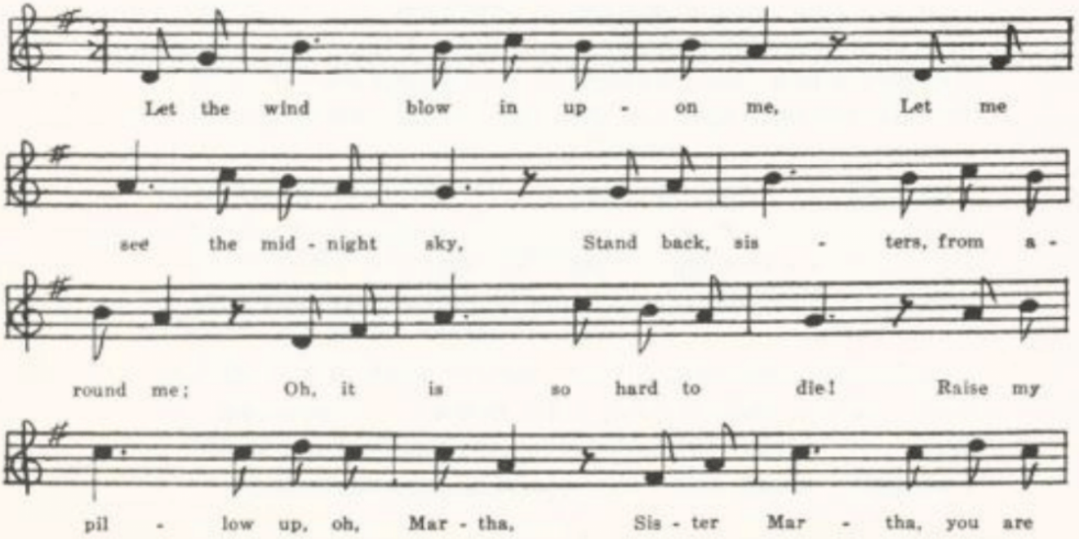
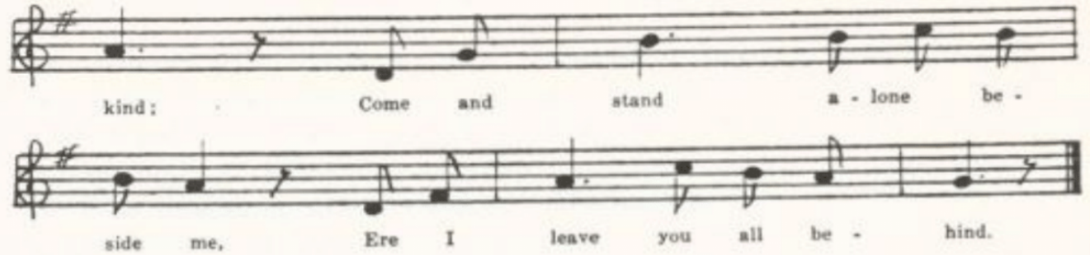
Let the wind blow in upon me,
Let me see the midnight sky,
Stand back, sisters, from around me;
Oh, it is so hard to die!
Raise my pillow up, oh Martha,
Sister Martha, you are kind;
Come and stand alone beside me,
Ere I leave you all behind.*

Oh, this hand so cold and frozen,
Once it was so soft and white;
Little ring they thought so worthless
That they let me keep it there,
Just a plain and golden circlet
With a lock of Douglas’ hair.

Sweet Martha, are you near me?
You are kinder than the rest.
Lift my head and let me lean it,
While I live, upon thy breast.
I was thinking of some music
That I heard long, long ago.
Oh, how sweet the nuns are singing
In the chapel down below.

Oh, my father, oh, my mother!
Will you not forget the the past,
When you hear some stranger tell you
How your stray lamb died at last?
But of all who used to love me,
Who will weep when I am dead,
Only you, O sister Martha,
Keep the last watch over my bed.

Sister Martha, Sister Martha,
Has the moon gone down so soon?
For myself† seems dark as winter,
Tho’ I know it is but June.
Sister in your white bed lying,
Dreaming in the June moonlight,
In your dreams comes there no message?
‘Clara dies alone tonight.’

Hark, a strain of heavenly music
Fills the holy midnight dim;
Lo, I hear the wild waltz pealing,
And I float away with him;
I am coming, Douglas, Douglas,
Where you are I’ll soon be there;
Freed at last I come, my dearest,
Death gives back your little Clare.

*The printed text directs that the last two lines of each stanza be repeated; but, as Miss Newell observed, this would not fit the tune to which Chandler sang the song.
†This seems to be a misprint from mishearing. Allenbrand’s text has, correctly, ‘my cell.’

B
‘The Dying Nun.’ Copied by Miss Hamilton, 1923, from the MS balladbook of A. E. Allenbrand of Gentry County. The text differs little from A, but the last two stanzas are transposed.

(220)
Little Rosewood Casket

Clearly a piece of ‘literary’ sentiment, like several of the preceding items, this song has ‘found its final home,’ as Mrs. Richardson notes, among folk singers. I have seen it in print (outside of the collections listed below) only once—on a stall sheet without printer’s name but numbered 972 and marked ‘Copyright 1870, by White & Goullaud,’ formerly in the possession of T. B. Chandler of Farmington, St. Francois County, sent to me by Miss Newell in 1912. It is reported as traditional song from Kentucky (DD 100-1), Tennessee (JAFL XLV 90-4, FSSH 244-7), North Carolina (JAFL XXVIII 172-3, XLII 295, XLV 95-6, SSSA 182-3, BMFSB 32-3, MSNC 24, FSSH 247-50), Alabama (JAFL XLII 293-5, FSSH 243-4), Arkansas (Ozark Life V Nos. 5-6), Texas (PFLST VI 291-2), Illinois (TSSI 230-1), and Iowa (MAFLS XXIX 83-5), and in Mrs. Richardson’s AMS 54 without exact location. It is listed also in Miss Pound’s Nebraska syllabus. No two texts are quite the same, tho the variations are generally slight, due to failure of memory. Sometimes, however, as in the North Carolina text reported by Henry in SSSA and that from Illinois in TSSI, there is what looks like conscious reconstruction: the dying girl speaks to her brother, not to her sister, and she is jealous of another girl. Besides the text given below and Chandler’s ballad sheet, it was one of the items in Ada Belle Cowden’s MS ballad-book, but I failed to take a copy of it.

‘Little Rosewood Casket.’ From the MS ballad-book of A. E. Allenbrand of Gentry County, copied out for me by Miss Hamilton in Gentry County, copied out for me by Miss Hamilton in 1923.

In the little rosewood casket
Resting there upon the stand
Is a package of old letters
Written by a lover’s hand.

You may go and bring them, sister,
And set down here upon my bed
And take gently to your bosom
My poor aching, throbbing head.

You have brought them? Thank you, sister.
You may read them o’er to me.
I have often tried to read them,
But for tears I could not see.

When I’m resting in my coffin
And my shroud around me’s wound
And my narrow bed is ready
In the pleasant churchyard ground,

Take this package of old letters;
Strew them all around my heart.
But this little ring he gave me
From my finger never part.

I must say farewell, dear sister;
Place my hands upon my breast.
I am dying. Kiss me, sister.
I am going home to rest.

(221)
The Old Elm Tree

Barry JAFL XXVII 69 prints a text from Kansas and a tune from Massachusetts, and Dean (27-8) a text presumably from Minnesota.*

‘The Old Elm Tree.’ Written down by Mattie White of Rucker, Boone County, in 1906, and communicated to me by G. W. Ridgway.

There’s a lonely path by the old deserted mill,
And the stream by the old bridge broken still,
Where the golden willows are bending low
O’er the green mossy banks where the violets grow.
The birds are singing their same sad lay.
It charms me to dream of the dear old days
Where Lolla my beautiful sat with me
On the green mossy banks 'neath the old elm tree.

It was there where the bright blue skies above,
I told her the tale of her heart’s true love;
It was there the blossoms of summer died,
She whispered the promise she’d be my bride.
Though now came the pain of the parting sore,
Little did we dream we would meet no more.
The day I returned from the deep blue sea
They laid her to rest 'neat the old elm tree.

Cruel and false were the tales they told
That my vows were false and my old love cold,
An untrue heart held another fair,
Forgetting the vows that was whispered there.
Her cheeks grew pale with the cross heart’s pain,
Her beautiful lips ne’er smiled again,
And that she wept so bitterly
For the past 'neat the old elm tree.

She died, and they parted her sunny hair
From the pale cold brow death left so fair;
They laid her to rest where the bright summer flowers
Could bloom on her grave in the long summer hours.
Oh! Lolla, dear Lolla, my long-lost love,
I hope we’ll meet in heaven above;
Earth holds no treasure so dear to me
Ass the lonely grave 'neat the old elm tree.

*See Appendix, note 2

(222)
Lorena

Miss Pound ABS xxiii notes that this song, written by H. D. L. Webster, is one of the ‘many sentimental songs from the middle decades of the nineteenth century’ that are still current; S. J. A. FitzGerald, Stories of Famous Songs 105, notes that it was ‘an immense favourite in the sixties.’ It is No. 829 in Partridge’s series of ballad prints. It has been reported as traditional song from Pennsylvania (NPM 189-90) and Kentucky (JAFL XLIX 228-9).

‘Lorena.’ Reported by Jesse Williams from Hamburg, Arkansas, where he was teaching school in 1905. The ‘dew’ of the second line is ‘snow’ in the original text.

The years creep slowly by, Lorena,
The dew is on the grass again;
The sun’s low down the sky, Lorena,
The frost gleams where the flowers have been.

. . . . . .

A hundred months have passed, Lorena,
Since last I held your hand in mine
And felt your pulse beat fast, Lorena,
Tho’ mine beat faster, far, than thine.

A hundred months;–‘twas flowery May
As up the grassy slopes we’d climb
And watch the dying of the day
And listen to the church-bells chime.

Annie of the Vale

This is No. 522 in Partridge’s ballad series, and No. 793 in Wehman’s. It was sufficiently popular to provoke a parody, Annie with the Veil, No. 1130 in Wrigley’s series of ballad prints. I have not found it reported by collectors of traditional song.

No title. From the Dresia MSS, written about 1880 and secured by Miss Lowry at Columbus, Kansas, in 1909.

I’m lonely and weary,
Without thee I’m dreary,
Sighing for thy sweet melting voice;
I love thee so fondly,
Without thee I’m lonely,
For in this world thou art my only choice.

(223)
Come, come, come, love, come,
Come where the night proaches pale.*
Arise in thy duty, thou marvel of beauty†
Dear Anna, sweet Anna of the vale.

I’ll go forth to battle
‘Mid the . . . and rattle
Of musketry and cannon roar;
They cannot defeat us,
For the Lord will assist us;
We conquer or we welter in our gore.

If then, love, I’m lying
Wounded and dying,
Upon the field of battle I’m slain,
The spirit of thy lover
Around me‡ will hover;
In heaven I hope to meet thee, love, again.

*Partridge has
Come ere the night torch is pale,
And Wehman
Come ere the night torches pale.
†Partridge and Wehman have here
Oh, come in thy beauty, thou marvel of duty
‡Apparently should be ‘thee.’

Lovana

This is in Dean’s Flying Cloud, page 3. I have not found it elsewhere.

No title. From the manuscript songs of William Dresia of Columbus, Kansas, secured by Miss Lowry in 1909.

I once knew a cot, it was humble as could be,
And it stood on the banks of the river . . .*
The wild flowers bloomed and the mocking-birds did sing;
There lived my darling Lovana.

Chorus:
She’s as mild as the eve, as fair as the dawn,
As graceful as the flowing Susquehanna;
She is my idea of angel on the earth,
The idle of my Lovana.†

*MS illegible here. Dean’s text has
It stands on the banks of the Susquehanna.
†Dean’s text runs here:
She is my ideal, an Angel of the earth,
The idol of my heart is Luluanna.

(224)
She bathes her brow in the morning dew
And the pleasant streams are her mirror,
And the pebbles are the jewels she wears in her hair,
And her parhed‡ is a boat on the river.

I wish I were a fish, I would swim by her side
As she floats down the broad Susquehanna;
And if I were the wind I would whirl through her sails
And play with the curls of Lovana.

And if I were anything else but myself
I’d be nowhere else but beside her;
I would sing of her by day and dream of her by night
Till I won the loving heart of Lovana.

‡So written, for once quite clearly, in the MS. Possibly for ‘parlor?’

The Derby Ram

This is an exercise in the humor of exaggeration—something like Paul Bunyan’s Blue Ox. It is still sung in England, in Northumberland (ECS 45-6), Yorkshire (ECS 47), Derbyshire (see JAFL XVIII 54), and Berkshire (FSUT 48-9), is known to Jamaica negroes (PMLA XXXIX 478), and has been reported in this country from Vermont (JAFL XVIII 53, VFSB 100-1, GGMS 24-6), Massachusetts (JAFL XVIII 51-2, one of the Allen Family Songs), New Jersey (FSSH 177-8), Virginia (SharpK II 186-7), Kentucky (JAFL XXVI 377, BKH 58, SharpK II 185-6), Tennessee (SharpK II 184-5, FSSH 175-7), and Mississippi (FSM 273-4).

No title. Secured by Miss Leah R. C. Yoffie at St. Charles in 1914 as ‘sung by Jeff Whitlock, slave of Capt. John Whitlock.’ The forth line of each stanza is repeated after the burden.

As I was coming from Dobbin on a market day,
I saw the fattest ram, sir, that ever fed upon hay.
He had four feet before, sir, he had four feet behind,
Every foot that ram had covered an acre of land.
Chorus:
Sing fal-a-ral-a-ray, boys, fal-a-ral-a-ray,
Every foot that ram had covered an acre of land.

The wool between his horns, sir, big as any twine,
Made a suit of broadcloth, called it superfine.
The wool on his back, sir, growed to the sky,
The eagle built his nest, and I heard the young uns cry.
(225)
The man that killed that ram, sir, was in danger of his life,
Had to send to Cincinnati to get a longer knife.
The man that stuck that ram, sir, drownded in the blood,
The man that held the basin was washed away in the flood.

Father Grumble

Of the various Old World ballads on the theme of the farmer turned housewife (for which see Kittredge’s note, JAFL XXVI 364-5) it is clearly the Scotch John Grumlie that lies behind the American texts—tho the name appears but once in the Missouri versions, and then somewhat disguised (see version D, below). The Wife of Auchtermuchty in Ramsay’s Ever Green, The Woman to the Plow of Roxb. Ballads VII 185-7, the modern English stall ballad of The Churlish Husband, St. John Honeywood’s Darby and Joan all tell a similar story, but tell it differently. Our ballad has been reported from tradition in Ireland (JIFSS I 43-4), Norfolk (JIFF I 44), and on this side of the water in Vermont (FFMS 50-1, VFSB 104-5), Virginia (JAFL XXIX 173-4), West Virginia (FSS 455-63), Kentucky (SharpK II 266-7, JAFL XLIX 237-8), North Carolina (SharpK II 265-6, SCSM 243-4), Mississippi (FSM 175-6), Indiana (JAFL XXIX 174-7), Ohio (JAFL XXXV 366, tune only), belong to one tradition, but differ interestingly in the omission and retention of items in the goodman’s series of misfortunes.

A
No title. A fragment, secured by W. S. Johnson in 1903 from the singing of the fiddler Waters in Tuscumbia, Miller County.

Hicker knocker swore by the green leaves
On the trees, trees,
That he could do more work in a day
Than Phoebe could do in three, three,
That he could do more work in a day
Than Phoebe could do in three.

Little phoebe standing by—
‘You can try it now, now.
You go do the work in the house
And I’ll go follow the plow, plow;
You go do the work in the house
And I’ll go follow the plow.’

B
No title. From Mrs. Carrie Phelps, of West Plains, in 1906.

There was an old man lived under the hill,
As you may plainly see, see.
He said he could do more work in a day
Than his wife could do in three, three,
He said he could do more work in a day
Than his wife could do in three.
(Repeat thus the last word in the second line
and the third and fourth lines of each stanza)

(226)
‘Be it so, then,’ the old lady replied,
‘But this you must allow,
That you go work in the house today
And I’ll go follow the plow.

‘But you must milk the Teeny cow,
For fear that she goes dry.
And you must feed the little pigs
That live in yonder sty.

‘You must watch the speckled hen
For fear she lays away.
And you must wind the hank of yarn
Your wife spun yesterday.

‘You must go to the dining-room
And scour up all the plates;
But don’t forget the curly dog,
Or he’ll eat all of the cakes.

‘You must wash the dirty clothes
That hang upon the wall;
But don’t forget the crooked stairs
Or you’ll get an awful fall.

‘You must churn the crock of cream
That stands upon the frame;
But don’t forget the fat in the pot
Or ‘twill all go up in a flame.’

So the old woman she took the whip in her hand
To go and follow the plow,
And the old man he took the pail on his arm
To go and milk the cow.

But Teeny she hooked, and Teeny she crooked, And Teeny turned up her nose;
And then she gave the old man such a kick
That the blood ran down to his toes.

He went to watch the speckled hen
For fear she’d lay away;
But he forgot to wind the yarn
His wife spun yesterday.

He then went to the dining-room
To scour up all the plates;
But he forgot the curly dog,
And he ate all the cakes.

He went to wash the dirty clothes
That hung upon the wall;
But he forgot the crooked stairs,
And he got an awful fall.

He went to churn the crock of cream
That stood upon the frame;
But he forgot the fat in the pot,
And it all went up in a flame.

That night he swore by the light of the moon
And all the stars in heaven
His wife could do more work in a day
Than he could do in seven.

C
No title. From C. E. Humphery of Jefferson City, in 1913, who describes it as ‘an old ballad which has stuck in my memory ever since childhood. I don’t know anything about it except that someone who stayed with us for a short time used to sing it.’

And old man and old woman lived under the hill;
And this you’ll plainly see—
He said he could do more work in one day
Than she could do in three.

‘Be it so,’ the old woman cried;
‘And this we will allow:
You stay in the house and work today
While I go follow the plow.

(227)
‘And you must milk the old Sooky cow
For fear she will go dry;
And you must feed the little pigs
That live in yonder sty.

‘And you must watch old speckled hen
For fear she’ll go astray;
And you must wind the spool of thread
That I spun yesterday.’

The old woman took the whip in her hand
And went to follow the plow.
The old man took the pail in his hand
And went to milk the cow.

‘Sa, Teeny! sa, Teeny!
My good little cow, stand still;
For if ever I come to milk you again
It will be against my will.’

Teeny hooked, and Teeny crooked,
And Teeny turned up her nose.
She gave the old man such a kick on the shin
That the blood ran down to his toes.

He went to feed the little pigs
That live in yonder sty,
And the old sow give him such a bite on the leg
That he feel right down in the mire.

He went to watch old speckled hen
For fear she’d go astray,
And forgot to wind the spool of thread
That his wife spun yesterday.

Then the old man swore by the point of his nose
And all the stars in heaven
That his wife could do more work in one day
Than he could do in seven.

D
‘Old Crumbly Crust.’ Communicated by Mrs. Case in 1916 as known to her in her childhood in Harrison County.

Old Crumbly, old Crumbly, old Crumbly Crust
Old Crumbelly he swore, swore,
He swore by the green leaves on the tree
That he could do more work in one day
Than his wife could do in three, thee,
Than his wife could do in three.

‘It’s I will take the whip, whip,
And I’ll go follow the plow, plow;
It’s you may take the pail, pail,
And go and milk the cow, cow,
And go and milk the cow.

‘It’s you must churn the milk
That stands within the frame, frame;
And you must watch the fat
That it doesn’t go into a flame, flame,
That it doesn’t go into a flame.
‘It’s you must reel the yarn, yarn,
That your wife spun yesterday, day,
It’s you must watch old speckledy hen
That she doesn’t run away, way,
That she doesn’t run away.’

Old Mrs. Crumbly took the whip
And she went to follow the plow, plow.
Old Crumbly took the pail
And he went to milk to cow, cow,
And he went to milk the cow.

Old Muley saw him coming,
She snorted and she blowed, blowed;
She gave him a kick right on the shin
Till the blood ran to his toes, toes,
Till the blood ran to his toes.

(228)
He went to churn the milk, milk,
That stood within the frame,
And he forgot the fat,
And it all went into a flame, flame,
And it all went into a flame.

He went to reel the yarn, yarn,
That his wife spun yesterday, day,
And he forgot old speckledy hen
And she ran clear away, way,
And she ran clear away.

He went out and he looked to the east
And he looked to the west, west,
And he thought to his soul ‘twas a long, long day
And his wife would never come, come,
And his wife would never come.

E
‘The Old Man Who Lived in the Wood.’ Reported by Miss Jane D. Johns of St. Charles in 1917 as known to her uncle, Douglas Voss Martin, who learned it as a boy in Virginia.

There was an old man who lived in the wood
As you can plainly see.
He said he could do more work in a day
Than his wife could do in three.

‘Be it so,’ the old woman said,
‘And that I will allow,
That you may stay at home today
While I go follow the plough.

‘You must milk the Teeny cow
For fear she will go dry,
And you must feed the little pigs
That live in yonder sty;

‘And you must watch the speckled hen
For fear she’ll lay astray;
And you must wind the bobbin of yarn
That I spun yesterday.’

The old woman took the staff in her hand
And went to follow the plough,
And the old man took the pail in his hand
And went to milk the cow.

Teenie winced and Teenie flinched
And Teenie turned up her nose;
She gave the old man such a rap with her tail
That the blood trickled down to his toes.

‘Whoa, Teenie, and so, Teenie,
My good little cow, stand still.
If ever I do milk Teenie again
‘Twill be against my will.’

The old man took the tray in his hands
To give the pigs their hire;
The old sow ran between his legs
And pitched him into the mire.

He went to watch the speckled hen
For fear she’d lay astray,
But forgot to wind the bobbin of yarn
His wife spun yesterday.

The old man swore by the sun and the moon
And the green leaves on the tree
That his wife could do more work in a day
Than he could do in three.

(229)
Dog and Gun (The Golden Glove)

For the frequency of this ballad in print and in tradition see Kittredge’s note in JAFL XXIX 171-2. Bell, Ancient Poems, Ballads, and Songs of the Peasantry of England 70, says that it is sung ‘in every part of England’; Christie II 114 says that it has been ‘long a favourite in Aberdeenshire.’ It has been recorded from tradition in Shropshire (Burne, Shropshire Folk-Lore 552-3), Kent (JFSS VI 29-30, where Miss Gilchrist notes that she has tunes for it from Westmoreland and Sussex), Nova Scotia (BSSNS 80-1), Vermont (VFSB 117-8), Pennsylvania (JAFL XXIX 171-3, by way of Kansas), Virginia (SharpK I 378, SCSM 228), West Virginia (FSS 384-6), Kentucky (LT 49-51, DD 170-1, SCSM 229-30), North Carolina (SharpK I 377-8), Mississippi (FSM 158-9), and California (TBWV 68-9). Since the Missouri texts differ chiefly by omissions here and there, not all of them are given here.

A
‘The Dog and Gun.’ Reported by Miss Williams in 1903 from Clinton County.
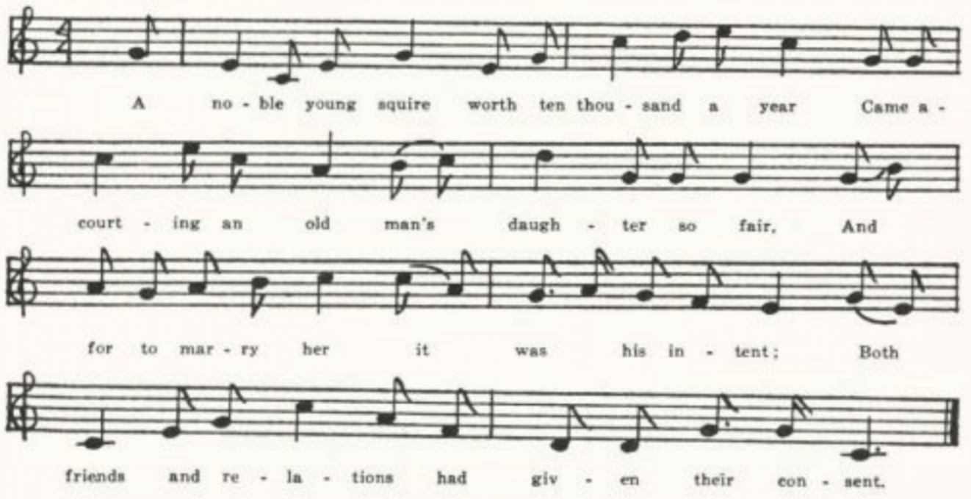
A noble young squire worth ten thousand a year
Came a-courting an old man’s daughter so fair,
And for to marry her it was his intent;
Both friends and relations had given their consent.

The wedding was appointed, the marriage day came off,
A jolly brisk young farmer the waiter to be.
But as soon as e’er she spied him so inflamed her heart,
‘O my heart!’ then she cried, ‘O my heart!’ then she cried.
(230)
Instead of being married she went unto her bed,
The thoughts of the farmer ran so in her head.
And a way for to join him she quickly did find,
And a way for to join him she quickly did find.

A vest, coat, and breeches then she put on
And a-hunting she went with her dog and her gun.
She hunted all around where the farmer did dwell;
‘Twas only because that she loved him so well.

It’s oft-times she fired and nothing she did kill,
Till at length this young farmer came into the field.
And for discourse with him it was her intent,
With her dog and her gun to meet him she went.

‘Why wasn’t you at the wedding the other day,
To wait upon the squire and give him his bride?’
‘O no,’ said the farmer, ‘if truth I must tell,
I’ll not give her away, for I love her too well.’

This honored young lady was pleased to hear him so bold,
She gave him her glove that was flowered with gold,
Saying, ‘I picked it up out yonder as I came along
A-hunting with my dog and gun.’

O then she started home with her heart full of love.
She put out a speech she had losted her glove:
‘And the man that will find it and bring it unto me,
I do vow and declare his sweet bride I will be.’

This honored young man was pleased to hear of this news.
Straightway to this lady then he goes,
Saying, ‘Here, honored lady, I picked up your glove;
With this you’ll be pleased to grant me your love.’

‘’Tis already granted, sir,’ she replied;
‘I love the sweet breath of the farmer,’ she cried;
‘I’ll be mistress of your dairy and the milking of your cows,
While my jolly brisk young farmer goes whistling to his plows.’

Then after they were married she laughed and told of her fun,
How she hunted the farmer with dog and with gun.
Now she’s mistress of his dairies and the milking of his cows,
While her jolly brisk young farmer goes whistling to his plows.

(231)
B
‘The Nobleman’s Daughter.’ Sent me by D. W. Parsons of Sweet Springs, Saline County, in 1907, with the comment that it ‘was very popular here fifty years ago’ and that he did not know it in print. Nine stanzas. Differs from A chiefly by lacking the last stanza and by combining stanzas 2 and 3 into the following:

The time was appointed for their wedding day.
A farmer was chosen to give her away;
But the farmer refused, if the truth I must tell,
Because in his heart he did love her so well.

C
‘Hunting with a Dog and Gun.’ Secured by Miss Hamilton in 1909 from Julia Hickman of the West Plains High School. Eight stanzas, two of them defective. Lacks the opening two stanzas of A.

D
No title. Communicated in 1911 by Paul J. Manes of Camden County as known in his family. He had not seen it in print. Begin:
In Yorkshire, in Yorkshire a lady did dwell.
Ten stanzas, combing stanzas 2 and 3 of A into this:

The day was appointed the wedding to be,
A nice brisk young farmer the waiter you see.
But instead of getting married, this lady went and hid;
The thoughts of a farmer had entered her head.

E
‘As I was out hunting with my dog and gun.’ Written out for Miss Antoinette Taylor of Bartold, St. Louis County, in 1913 by a Mrs. Edwards who was working for her at the time. Mrs. Edwards describes it as a ‘song ballad, . . . learned to me by Mr. and Mrs. Isaac Perry in 1869 in Phelps County.’ A somewhat confused text, but offering no significant variations.

Kate and her Horns

For the history of this song in ballad and song-book print see Mackenzie’s headnote, BSSNS 325. It has been recorded from tradition in Nova Scotia (BSSNS 325-7) and Kentucky (FSMEU 157-8, SharpK I 405-Є), and it is in Shearin’s list.

‘Young Kate.’ Contributed in 1903 by Miss Hamilton, from her grandfather, who knew it in his early days in Clinton County.

(232)
Come all you young rover and listen to me.
Trol lol tiddle lidium
A story I’ll relate of my tragedy.
Trol lol liddle tidium
It was of a young lady of Cold Chester,
And a young lawyer courted her.
Sing tedium todium trum tiddle lodium
Trol lol tiddle lidium.

He courted her for many a day,
But still young Kate she answered nay.
At length he gained young Kate’s consent—
At straight unto another went.

Kate never told to friend or foe
Nor did she let her parents know,
But went unto [the] Tannery
And with the Tanner did agree.

She borrowed an old cowhide,
The horns on it both long and wide;
And when she rolled herself therein,
And now in truth she did begin.

She went unto a lonesome place,
She expected young Clothier down that way;
When after him she did pursue
He cried, ‘Good God, what shall I do?’

Kate quickly seized him by the coat
With a sad and doleful note:
‘You have left young Kate, so I do hear,
To court a lawyer’s daughter dear.’

‘Pray, master devil, spare me now,’
And I’ll perform my former vow.’
‘I’ll see you do,’ young Kate replied,
And smiled within her old cowhide.

Kate never told it to friend or foe
Nor did she let young Clothier know
Till three long years had married been
She told it at a house therein.

It pleased the people to the heart,
They said young Kate well played her part;
Young Clothier laughed as well as they—
It was a jovial merry day.

(233)
Love in the Tub

Evidently the work of a professional ballad-maker, this is included here because I have not elsewhere found it recorded from tradition. There is a broadside of it in the Harvard Library collection (No. 1976).

‘Love in the Tub.’ Secured by Miss Hamilton in 1910 from Fred Bingaman of the West Plains High School. His mother knew it.

Come all ye young people and listen awhile;
I’ll sing you a ditty, it will cause you to smile.
It’s witty, it’s pretty, diverting and new.
Although it is witty I’m sure it is true.

In the city of London a lady did dwell;
A very rich merchant was known very well.
He had but one daughter, a beauty so bright,
And on her he placed his chief joy and delight.

There was a young vender who that lived near,
Had dealt with this merchant some four or five year;
And being invited to supper one night
Oh! there he spied this beauty so bright.

Instead of his stomach he feasted his eyes
On the charms of her beauty, which did him suffice.
And that very night fortune proved so kind
That unto this lady he opened his mind.

‘Dear sir,’ said she, ‘how can you say so
When thousands of pounds to my father you owe?
And I am a lady of noble estate;
How dare you presume to talk at such rate?’

‘Dear miss, if I had ten thousand a year
I’d part with it all for the sake of my dear.
Don’t let true love be despised for gold;
It’s not to be bought, it cannot be sold.’

She granted his love; and then she replied:
‘My dear, I would have you now well satisfied.
But [if] without the consent of my father I wed,
Not a farthing of portion there is to be had.

(234)
‘There’s a comical fancy that runs through my head
And when you do hear it, I fear not,’ she said,
‘And when you do hear it, I fear not,’ said she,
That unto my project you’ll quickly agree.

‘You know in the vault of my father’s wine stand
There’s some empty pipes all on the right hand.
I’ll send for a cooper; I’ll trust him,’ says she,
‘I’ll give him ten guineas in gold for a fee.’

They both liked the project, they both did agree.
They sent for the cooper, he come in all speed.
He took up this lady without more delay
And into a hogshead he placed her away.

He headed it up, secured it nice.
Then in came the vender all in a trice
And says to her father, ‘Sir, at this time
I stand in great need of a hogshead of wine.’

Then to the wine-cellar they both did repair
To taste of the liquor. But when they got there,
Him knowing the hogshead, he made this reply:
‘Since all is for sale, then this will I buy.’

The bargain was made and the money was paid.
Then the vendor turned round to [the] merchant and said:
‘Now all that I buy in this hogshead is mine
But the hoops and the staves, and they are all thine.’

He picked up the pierce and pierced the same.
Not one single drop from the hogshead there came.
‘Well, well,’ said the vender, ‘what a bargain is this?
Not one single drop in the hogshead there is.’

‘Oh, yes,’ said the old man, ‘the bargain is good,
For you bought the hogshead just as it stood.’
He knocked off the head and the lady came forth;
The old man stood staring and ripped out an oath.

‘It’s folly, I know, to fly in a rage;
I find that youth is too cunning for age.
I sold her, you bought her, now love her,’ says he;
‘Ten thousand pounds portion I’ll surely give thee.’

(235)
This vendor he loved her as dear as his life;
It was reported she proved a good wife.
They follow their calling by drawing of bungs,
Therefore you may know there was love in the tub.

The Gray Mare

Tolman JAFL XXXV 372 notes that this is found in Baring-Gould’s Songs of the West and in Kidson’s Traditional Tunes, and Kittredge lists a number of English stall prints of it, an Irish version from Michigan among the Child MSSS, and one stanza from Scotland in Greig’s Folk-Song of the Northeast. It has been reported from tradition in Newfoundland (BSSN 59-60), Vermont (VFSB 62-4), Massachusetts (JAFL XII 251-2), Nebraska (ABS 80), and Ohio (JAFL XXXV 372, tune only); it is in Barry’s list, and it is one of the Allen Family songs.

A
‘Young Jimmy the Miller.’ From the manuscript of William Dresia of Columbus, Kansas, compiled in the 70s of the last century and secured by Miss Lowry in 1909.

Young Jimmy the miller he courted of late
A farmer’s fair daughter called beautiful Kate.
She had for her portion fine jewels and rings,
Gay gold and silver, and many fine things.
She had for her portion
She had for her portion full fifty fine things.

Her glittering money and beauty likewise
Both tickled his fancy and dazzled his eyes,
So that he was obliged for to tell her his mind
That he would prove to her comfort and kind,
That no other woman should be his sweet bride.
She was a jewel
For she was a jewel and comfort, he cried.

The day was appointed, the money paid down;
It was a full portion of five hundred pound.
The preacher was sent for, this couple was dressed.
Says Jimmy to the father, ‘I have one more request;
Although your daughter is comely and fair,
I won’t have your daughter,
I won’t have your daughter without the gray mare.’

The old man he angered, he angered in speed.
‘I thought you had married my daughter indeed;
But since it’s no better I’m glad it’s no worse.
Bo more of my money you shall have from my purse;
You shan’t have my daughter, I vow and declare,
You shan’t have my daughter
You shan’t have my daughter, neither the gray mare.’

Young Jimmy was turned straightway out of door
And charged for to never come back any more.
Young Jimmy he tore down his long yellow hair
And wished that he never
And wished that he never stood for the gray mare.

In a year or two or somewhere about
He chanced for to meet with Miss Katy his love.
Says he, ‘Miss Katy, it’s don’t you know me?’
‘I have saw someone of your likeness, if I han’t mistaking,’ said she,
‘A man of your likeness with long yellow hair
That once came a-courting
That once came a-courting my father’s gray mare.’

‘’Twas not the gray mare a-courting I came,
It was Miss Katy, to call her by name;
But little did I think that your father would doubt
Of giving his daughter and gray mare to boot
For the sake of such a fine beautiful son.
But now I am sorrow,
But now I am sorrow for what I have done.’

‘I care nothing for your sorrow, I value them not;
There is young men enough in this world to be got.
I think a young man would be in despair
To marry a wife for the sake of a mare.
The price of a mare is not so great.
So fare you well, Jimmy,
So fare you well, Jimmy, go mourn for your Kate.’

B

‘Rogger the Miller.’ Secured by Miss Hamilton in 1910 from David Hogan of the West plains High School. Does not differ significantly from a, but lacks the last stanza.

(237)
Johnny Sands

This story exists in two forms. In one, which might be called the vulgate form (S. Foster Damon in his Series of Old American Songs reproduces a sheet music print of it which he dates 1842 and adds that it was composed ‘by John Sinclair, who . . . began his American career about 1830, singing in operas and concerts for some twenty years’), the husband has his wife tie his hands so that he shall be helpless when she pushes him into the water; then he slips aside and lets her go rushing in and, when she calls for help, tells her he cannot help her because she has tied his hands. Kittredge in his bibliographical note JAFL XXIX 179 remarks that, tho founded on a folktale, ‘it is its extraordinary currency (he lists many song-books containing it) is due to its having been sung by the Hutchinsons and other singing ‘troupes’ of that time. The Harvard library has an Irish broadside of it and at least two British ballad prints. He adds that he has a manuscript text of it from Massachusetts and that B. L. Jones had one from Michigan. Tolman had one from Indiana (JAFL XXIX 179) but did not print it. Texts have been published from Massachusetts (ABS 114-5), Kentucky (JAFL XLIX 235-6), Texas (PFLST VI 223-4), Illinois (TSSI 175-6), Iowa (MAFLS XXIX 65-8), and Wyoming (ABS 115-6).
In the other form (known in Scotland as The Wily Auld Carle or The Wife of Kelso, see Kittredge’s note above referred to, and to Tolman as The Old Woman of Slapsadam) the wife has her husband eat marrowbones, which makes him blind—or so at least she believes—and he professes to be unable to help her when she (not he) rushes into the water. Instead, he gets a pole and pushes her away from the bank. In this form it has been reported from West Virginia (FSS 264), Kentucky (JAFL XLIX 235-6; listed also by Shearin and Combs), Texas (PFLST X 165-6), Ohio (JAFL XXIX 179-80), and Illinois (TSSI 151-2). A text recently reported from Virginia (SCSM 239-40) seems to be a blend of the two forms of the story; there are no marrowbones, but his hands are not tied and when she cried out he says ‘I am so blind I can’t see at all.’ The Missouri collection has five texts of the first form of the story and one of the second. Those of the first form, with one exception, keep close to the printed text. They are:

A From George Williams, Bollinger County, 1906, as he heard it sung by his
uncle, Henry Tallent, who ‘learned it many years ago in this county.’
B Also from George Williams, communicated two years later. A full regular
text.
C Sent me in 1907 by James G. Hommell of Kansas City, whose earlier home
was in eastern New York. Regular text.
D From a letter sent by Mrs. W. J. Whipple of Winona, Minnesota, to Miss Grace
Lusk of St. Louis and forwarded to me by Miss Leah Yoffie in 1915.
Regular text. Mrs. W. says: ‘As I used to sing it, the last line of each
verse was repeated, and this last line sung three times.’

(238)
E From Mrs. Mary Paxton Keeley of Columbia, as sung by her uncle C. A.
Young of Kansas City, who heard it in the early sixties in Berks County,
Pennsylvania. Lacks one stanza.

A
‘Johnny Sands.’ The variations from the printed text are presumably to be explained as due to failure of memory either in the singer or in the reporter.

There was a man named Johnny Sands;
He married Betsy Yay.
But John and Betsy a quarrel had
All on their wedding day.

Said John, ‘I’ll go and drown myself,
I’ll go and take my life.’
‘I do not care. I wish you would;
Agreed,’ replied his wife.

‘For fear that I should courage take
And try to save my life,
Oh, tie my hands behind my back.’
‘I will,’ replied his wife.

‘For fear that I should courage take
And not jump in the sea,
Oh, dear, run down from yonder hill
And push me in, quickly.’

The lovely bride came running down,
A-running with all her force;
And Johnny he did step aside,
And in she went, of course.

She sploshed, she dashed just like a fish.
‘Oh, save me, Johnny Sands!’
‘I would do much, I wish I could;
But see, you’ve tied my hands.’

Of the second of ‘marrowbones’ form the Missouri collection has but one text, communicated by Miss Lowry in 1906 as sung and written down for her by T. A. Scott of Everton, Dade County. No title.

There was an old woman,
In Garland she did dwell;
She loved her old man dearly
But some other twice as well.
Sing tu re iful tu re a,
Sing tu re iful tu re o.

She went unto the doctor
To see if she could find
Some remedy at all
To make her old man blind.

The doctor told her to get seven marrow bones
And have him suck the marrow from them all.
Then he cried out, ‘My loved wife,
I cannot see at all.’

He swore if he was to the rive
He’d jump in and drown.
Says she, ‘I’ll go along,
[For] fear lest you run astray.’

They came upon the bank;
They stood upon the shore.
He swore he would not go in
Unless she’d push him o’er.

She went upon the hill,
Came running for to splunge him in.
He stepped aside
And she went headlong in.

(239)
. . . . . .
Oh, she kicked, she screamed, she squalled.
But he cried out, ‘My loved wife,
I cannot see at all.’

Nimble, being of good nature
And thinking she could swim,
Cut him a great long pee paw pole
And pushed her further in.

The Nightingale

The wit, if that is the name for it—the double entendre which is the core—of this song is an ancient if not venerable poetic theme. The spirit of it, tho not the specific equivoque, is present in Theocritus’ twenty-seventh idyll, the oaristys or lover’s talk. Marie de France turns it into tender romance in her lay of the Nighingale; Boccaccio, two centuries later, restores it to its proper atmosphere of popular humor in the fourth story of the fifth day of the Decameron. In English balladry it is as old at least as the seventeenth century, when was printed ‘The Nightingale’s Song; or, The Soldier’s rare Musick, and Maid’s Recreation’ (Roxb. Ballads IX clxx*-clxxi*), which is the earliest form I have found of our ballad. many others of a like character, with the pastourelle opening ‘as I was walking’ tho not with the particular figure of the nightingale, issued from the ballad press well down into the nineteenth century. Tho Miss Karpeles’ note upon it in SharpK II says it ‘is well known to traditional singers in England, and several versions appear in Cecil Sharp’s manuscript collection,’ I have not found it often in the reports of collectors in England; in fact, only once, from Dorset (JAFF VIII 194-51).* In America it has been reported from Virginia (SCSM 310-1), West Virginia (TBWV 78-9), Tennessee (ETWVMB 92, SharpK II 192, FSSH 200), Texas (CS 183-5, TBWV 80-1, by way of California), and Missouri (Ozark Life V No. 9), and by Sandburg in ASb 136-7.

A
No title. Secured by W. S. Johnson in 1903 from the principal of the Tuscumbia High School (Miller County).

One morning, one morning, one morning in May
I spied a fair couple a-making their way;
The one was a soldier, a gay volunteer,
The other a maiden with bright golden hair.

‘Where are you going, my pretty fair maid?
Where are you going?’ the soldier he said.
‘I’m going down to the brooks of Moline
To hear the birds warble and the nightingale sing.’

*A fragment of it is reported from Ireland, OIFMS No. 78. The texts given in ECS 125, from Surrey, and in Songs of the West No. 15 (traced back to Arne’s opera Thomas and Sally, 1760), have lost, either in folk tradition or at the hands of the editors, the double-entendre element. So too the Surrey text, JFSS VI 5-6.

(240)
A-walking and talking they rambled so low
Till they came to the place where the primroses grow.
And they seated them down by the slippering stream
For to hear the birds warble and the nightingale sing.

They hadn’t been there more’n an hour or two
Till out of his knapsack a fiddle he drew.
He played a sweet tune to the wild woods along;
‘Hark, hark,’ says the maid, ‘’tis the nightingale’s cry.’

Come all ye fair maidens take warning by me,
Never place your affections upon a soldier so free;
. . . . . . . .
For he’ll run away and leave you to rock the cradle.

B
‘The Nightingale.’ From Will J. Carrington of Jefferson City, who had it in 1904 from Ben Morrow, one of the janitors in the Capitol building. Five stanzas, one incomplete. The soldier is ‘a brave man of war.’ The lady says she is going ‘to the banks of New Orleans.’ At the close the soldier refuses to marry her:

‘I have a wife in London and children twice three.
One woman’s a plenty, too many for me.

‘I’ll go back to London and stay there one year,
Instead of cold water I’ll drink wine and beer,

And if ever I return it will be in the spring,
To see the gliding waters and hear the nightingale sing.’

C
‘Song—One Morning in May.’ Form the Dresia MSS, secured by Miss Lowry in 1909 at Columbus, Kansas. The lady tells the soldier that she is going ‘down yonder to the banks of old liss.’ There ‘he played her a tune called the valley to ring,’ and later ‘he tuned up his fiddle on a still higher key, and he played her a tune called the valley to ring,’ whereupon ‘hark, hark, said the lady, hear the nightingale sing.’ Conclusion as in B.

(241)
D
‘One Morning in May.’ Taken down by Miss Colquitt Newell in 1912 from the singing of a Mrs. Turley of Farmington, St. Francois County, who learned it as a child at Flat River in that county.
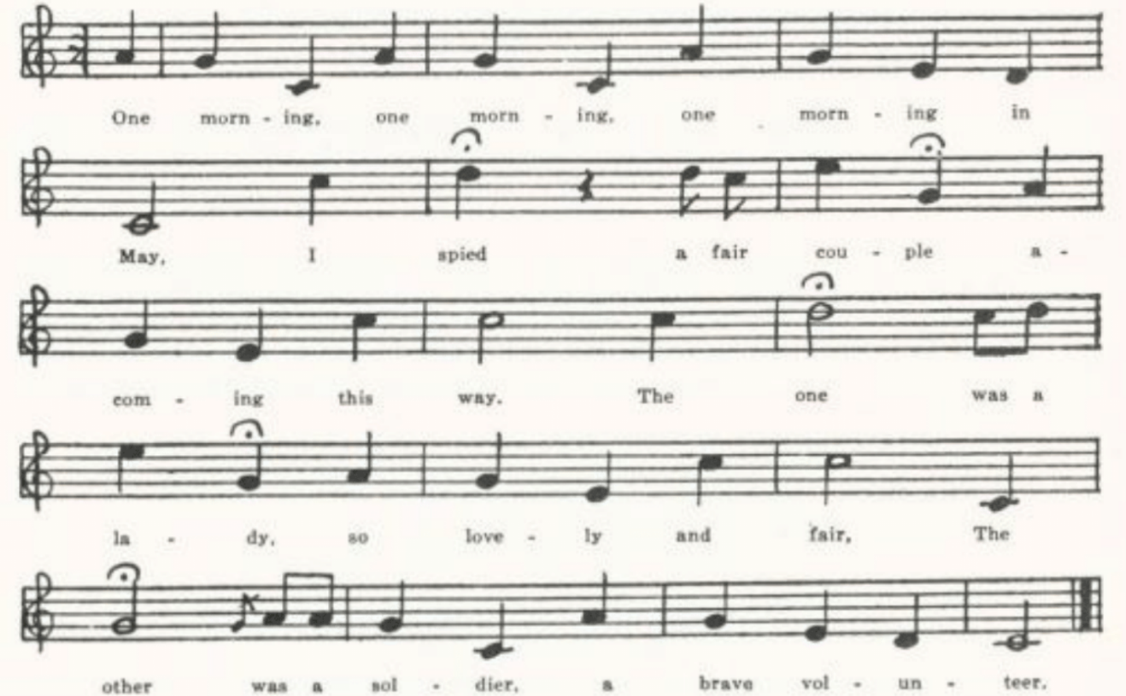
One morning, one morning, one morning in May
I spied a fair couple a-coming this way.
The one was a lady so lovely and fair,
The other was a soldier, a brave volunteer.

‘Good morning, good morning, good morning,’ says he.
‘Oh, where are you going, my pretty ladie?’
‘I’m going,’ says the lady, ‘to the banks of Zenoring
To see the waters gliding, hear the nightingale sing.’

They had not been there more than an hour or two
When out of a satchel a fiddle he drew.
He played her a tune of an Oxoring.
‘Hark, hark!’ says the lady, ‘hear the nightingale sing.’

‘’Tis time for to go, my pretty lady,’ says he.
‘Oh, no,’ says the lady, ‘play one more tune for me.
I’d rather hear your fiddle, or the tune of one string,
Than to see the waters gliding, hear the nightingale sing.
(242)
‘Pretty soldier, pretty soldier, won’t you marry me?’
‘Oh no,’ says the soldier, ‘that never can be.
I’ve a wife in Missouri and children twice three.
One wife is a plenty—too many for me.

‘I’ll go back to Missouri and stay there one year,
Where all is merry, drink ale, wine, and beer;
And if I come back, ‘twill be late in the spring
To see the waters gliding, hear the nightingale sing.’

E
‘One Morning in May.’ Written down at the request of Miss Antoinette Taylor of Bartold, St. Louis County, in 1911, by a Mrs. Edwards who was then in the employ of Miss Taylor and who says it was ‘learned to me by Mother Lydia Matlock in 1869 in Phelps Co. Mo.’ They go simply ‘to the springs.’ Two passages, coming after the first and second stanzas respectively and marked ‘Chorus,’ run:

‘Oh, my handsome soldier, won’t you play me one tune?’
He tuned up his fiddle in a very high key
And played her a tune called the Valley Story.
and
‘Oh, my handsome soldier, won’t you play me one tune more?’
He tuned up his fiddle on a very high string,
And he played that same tune over and over again.

When he refused to marry her he says that he will ‘go home to old Flanders and stay one whole year, and drink of cold water instead of strong beer,’ and that if he ever comes back ‘it will be in the spring, to see the waters a-gliding and hear the nightingale sing.’

F
‘The Nightingale.’ Text and tune from Mrs. Case, 1916, who knew it in her childhood in Harrison County. The fullest and most regular of the Missouri texts.
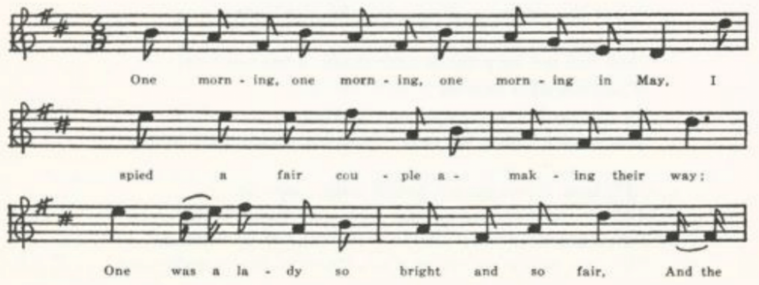
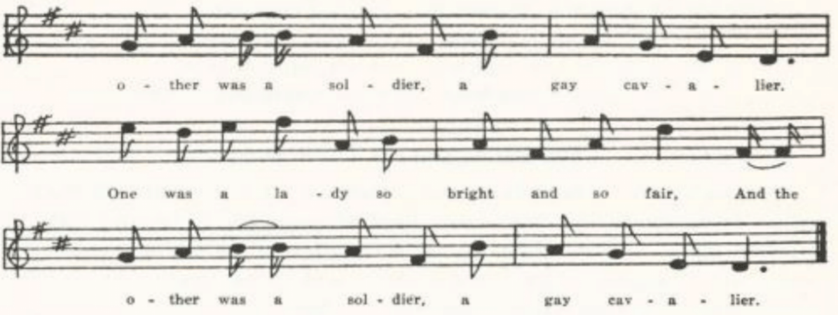
(243)

One morning, one morning, one morning in May
I spied a fair couple a-making their way.
One was a lady so bright and so fair,
And the other was a soldier, a gay cavalier.

‘Oh, where are you going, my pretty fair maid?
Oh, where are you going, sweet lady?’ he said.
‘I’m going,’ said she, ‘to the banks of the stream,
To see the waters gliding, hear the nightingales sing.’

They had not been there but an hour or two
Till out of his satchel a fiddle he drew.
He played her a love-song caused the valleys to ring.
‘Hark, hark!’ says the lady, ‘hear the nightingales sing!’

‘Oh, now,’ says the soldier, ‘’tis time to give o’er.’
‘Oh no,’ says the lady, ‘just play one tune more;
I’ve a wife in Low Flanders, with children twice thee;
And two and the army’s too many for me!

‘I’ll go home to Flanders and stay there one year.
In place of pure water I’ll drink wine and beer.
And if ever I return, ‘twill be in the spring
When the waters are gliding and the nightingales sing.’

Come all ye fair damsels, take warning from me.
Never place your affections on a green willow tree;
For the leaves they will wither like flowers in the spring
While the waters are a-gliding and the nightingales sing.
(244)
Come all ye fair damsels, take warning from me,
Never place your affections on a soldier so free.
For he’ll love you and leave you without any ring
To rock your young baby, hear the nightingales sing!

The Miller and his Three Sons

Since Chaucer’s time at least, and probably much longer, the dishonesty of millers in taking toll has been the subject of quips among country folk. In Greene’s James the Fourth a character is described as the son of a miller ‘that could shift for a pecke of grist in a bushell;’ and a seventeenth century broadside in praise of seamen (Bagford Ballads 291) has

With a thievish Miller I never will deal,
Because out of a bushel a peck he will steal.

The earliest appearance of our ballad that I have found is a broadside in the Roxburghe and Douce collections (Roxburghe Ballads VIII 611-2) dated by Ebsworth ‘c. 1730,’ from which the traditional texts gathered in the last century do not greatly vary. For bibliography see Tolman JAFL XXXV 390 and Kittredge’s addenda ibid. 391. Traditional texts have been reported from Wiltshire (FSUT 192-3), Devonshire (SBW No. 12), Nova Scotia (SBNS 203-4), and in this country from New Hampshire (that is, from the Isles of Shoals, in Celia Thaxter’s book of that title—see JAFL XXIX 215), West Virginia (FSS 450-4), Kentucky (SharpK II 161-2, DD 80-1), Tennessee (FSSH 194-5), North Carolina (SharpK II 162-3, JAFL XLVI 30-1, FSSH 192-3, SCSM 242, FSSM 12-3), Ohio (JAFL XXXV 390-1), and Nebraska (JAFL XLVIII 392-3, TBSSG 3), and Kittredge has also texts from New York and from Michigan. It is included in Bell’s Ancient Poems, Ballads, and Songs of the Peasantry of England and in Newell’s Songs and Games of American Children. And it is doubtless even more widely known than this list would indicate. The location of the mill is generally not given, but in the Nova Scotia text it is in Derbyshire and in one of the West Virginia texts it is ‘on Dundee.’ The variations are mostly in the names given to the three sons, devised to rime, for the first two, with ‘peck’ and ‘half,’ and for the third with ‘sack’ or ‘all;’ tho in the broadside and n most of the traditional texts the third son is not named at all.

A
‘The miller’s Will.’ Communicated in 1907 by D. W. parsons, Sweet Springs, Saline County.

There was an old man once who owned a mill,
And when he was dying he made his will.
And all were present to his oldest son,
And these were the words that fell from his tongue.

He called unto his eldest son,
Saying, ‘Son, my glass is almost run;
If I my mill to you do leave,
What toll do you intend to have?’

(245)
‘Father,’ he says, ‘my name is Jack;
Out of a bushel I’ll take a peck,
And if your mill to me should leave,
I am sure a good living I will have.

He called unto him his second son,
Saying, ‘My glass is almost run;
If I my mill to you do leave,
What toll do you intend to have?’

‘Father,’ he says, ‘my name is Ralph;
Out of a bushel I’ll take a half,
And if your mill to me should leave,
I am sure a good living I will have.’

He called unto him his youngest son,
Saying, ‘Son, my glass is almost run;
If I my mill to you do leave,
What toll do you intend to have?’

‘Father,’ he says, ‘I am your boy;
And as taking of toll is all my joy,
I’ll neither do like Ralph or Jack,
But I’ll take all their corn and give them the sack.’

‘You are my boy,’ the old man cried,
‘My favorite son,’ he sadly sighed,
‘And I my mill to you will leave.
I am sure a good living you will have.’

B
No title. Communicated to miss Hamilton in 1909 by Dorys Hollenbeck of the West Plains High School.

There was an old man who lived all alone;
He had three songs who fully were grown.
His only possession was a mill,
On which he was to make his will.
Sing fol-dinkey-day, sing fol-dinkey-day

He called to him his eldest son:
‘Son, O son, my race is run;
If you’ll be the miller I will make,
Tell to me the toll you’d take.’

‘Father, O father, my name is heck.
Out of a bushel I’d take a peck.’
‘Fool, O fool,’ the old man cries,
‘Out of this no man can rise.’

He called to him his second son:
‘Son, O son, my race is run;
If you’ll be the miller I will make,
Tell to me the toll you’d take.’

‘Father, O father, my name’s Ralph.
Out of a bushel I’d take half.’
‘Fool, O fool,’ the old man cries,
Out of this no man can rise.’

He called to him his youngest son:
‘Son, O son, my race is run;
If you’ll be the miller I will make,
Tell to me the toll you’d take.’

‘Father, O father, my name is Jack.
I’ll steal all the corn and swear to the sack.’
‘Glory hallelujah!’ the old man cried,
Then he shut his eyes and died.

C
‘Willing the Mill.’ Another version secured by Miss Hamilton at the West Plains High School—from David Hogan, in 1910.

A little old man was making his will,
And all he had was a little old mill.
He had three sons almost men grown,
And to these he would make his wishes known.

He called up his eldest son:
‘Son, oh, son, I am almost gone.
Now to you my mill will I make;
Come tell me the toll you intend to take.’

(246)
‘Dad, oh, dad, I’m your oldest son,
And out of four pecks I will have one.
And now to me your mill you make,
That is the toll I intend to take.’

He next called up his second son:
‘Son, oh, son, I am almost gone.
Now to you my mill will I make;
Come tell me the toll you intend to take.’

‘Dad, oh, daddy, my name it is Ralph,
And out of four peck I will take half.
Now if to me the mill you make,
This is the toll I intend to take.’

He next called up his youngest son:
‘Son, oh, son, I am almost gone.
Now to you my mill will I make;
Come tell me the toll you intend to take.’

‘Dad, oh, daddy, my name it is Heck,
And out of a bushel I’ll leave but a peck;
Then if I can’t make a fortune at that,
Then I’ll take all the corn and swear to the sack.’

‘Son, oh, son, you’re my darling boy!
Taking toll is your only joy.’
‘Glory hallelujah!’ the old woman cried;
The old man straightened out his arms and died.

Three Jolly Welshmen

I have adopted this as the title because what look like less fragmentary forms, both English and American, have that phrase, Sometimes, however, the three hunters are not Welsh but an Englishman, a Scot, and an Irishman; (or ‘I’ and ‘the others’ carry on the dialog. All are sequence pieces. Most of them consist of absurd identifications of the things the hunters found. The list varies widely in the different texts; a broken plow-stock is identified as a wooden horse and then as a windmill with the vanes blown away, a ship in full sail is declared to be a washtub with the clothes hung out to dry, a haystack is explained by Paddy the Irishman as a protestant church with its steeple blown away, and so on. Fairly persistent is the indentification of an owl found which I have ventured to consider forms of this song because of their structure are adaptations to the fox-hunt. The stanza- and refrain-forms of the various songs show that they were sung to a wide variety of tunes. The refrain of the Missouri text, ‘Lookee there!’ links it with that from Nova Scotia, the first-listed Vermont text, and that from West Virginia.
The song has been reported from Wiltshire (FSUT 179-80), Nova Scotia (SBNS 201-3), Vermont (FFMS 28-9, VFSB 125-6), Massachusetts (JAFL II 242-3, XXVII 71-2 ‘Reynard’), Virginia (TNFS 57-8, a negro version), West Virginia (FSS 478-9), Kentucky (BKH 183-4), Tennessee (JAFL XLIX 233-4, by way of Kentucky), Alabama (JAFL XXVII 72, a negro text), Texas (PFLST VI 225-6 ‘Reynard’), and Illinois (Adventure for 10 September, 1925; JISHS XXXI 213-4). Damon in his Series of Old

(247)
American Songs reproduces under the title ‘Cap Ann’ an 1843 sheet music print of it as sung by J. J. Hutchison of the famous singing family.

No title. Contributed in 1911 by G. C. Broadhead, who first heart it ‘about 1840.’
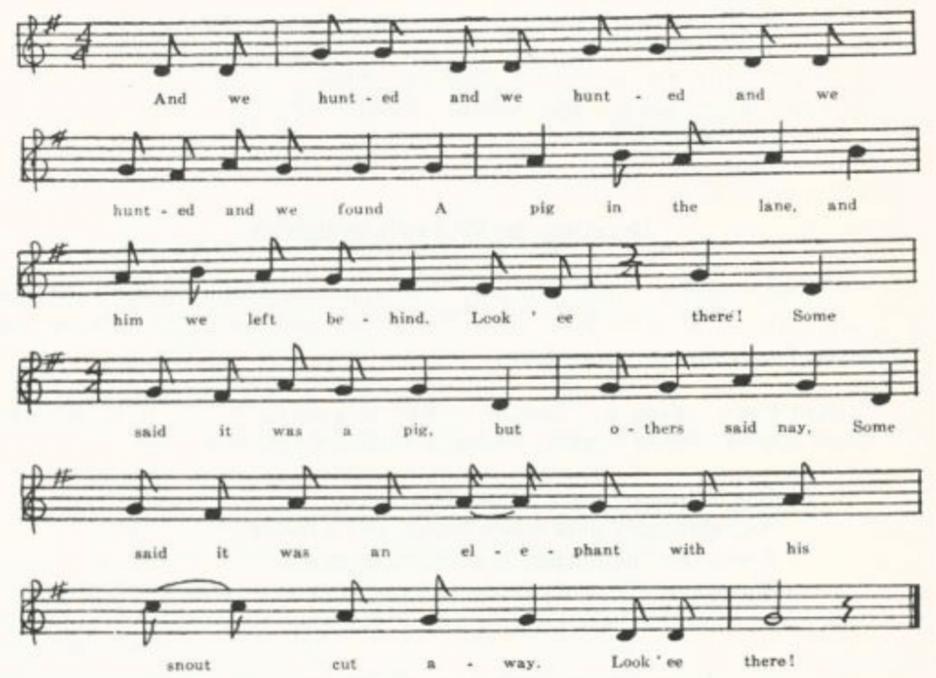
And we hunted and we hunted and we hunted and we found
A pig in the lane, and him we left behind—
Look’ee there!
Some said it was a pig but other said nay,
Some said it was an elephant with his snout shot away—
Look’ee there!

And we hunted and we hunted and we hunted and we found
A man in the road, and him we left behind—
Look’ee there!
Some said it was a man, but others said nay,
Some said it was a monkey with his tail cut away—
Look’ee there!

And we hunted and we hunted and we hunted and we found
A frog in the well, and him we left behind—
Look’ee there!
(248)
Some said it was a frog, but others said nay,
Some said it was a canary bird with his feathers washed away—
Look’ee there!

And we hunted and we hunted and we hunted and we found
An owl in an ivy bush, and it we left behind—
Look’ee there!
Some said it was an owl, but others said nay,
Some said it was the devil and we all ran away—
Look’ee there!

Courting the Widow’s Daughter

Probably from the variety theater, and apparently built on the tune and refrain of the social satire Song of the Times, for which see p. 433. I have not, however, found this song elsewhere.

‘Hard Times.’ From a miscellany of MSS sent me in 1907 by D. W. Parsons of Sweet Springs, Saline County. Probably written down about 1870.

One Saturday night I went to a house,
And through a dark entry I crept like a mouse;
I went for the purpose my true love to see.
She opened the door; I entered straightway,
And it’s hard times.

Such laughing and chatting as we did keep,
We waked the old lady right out of her sleep.
In a very few moments she thus addressed me:
‘What an impudent fellow before me I see!’
And it’s hard times.

‘Old lady, old lady, pray give me your hand
And cease from your passions till you know who I am.
I am Billy the miller and go by that name.
For the purpose of courting your daughter I came.’
And it’s hard times.

‘My daughter, my daughter, my daughter!’ said she,
‘To think that my daughter would go before me!
When I am so old and she is so young,
For her to get and I to get none—
O it’s hard times!’
(249)
‘Old lady, old lady, you speak with alarm;
You are but a widow and have but few charms.’
‘A widow I am and go by that name,’
So up with the broomstick and at me she came.
O it was hard times!

Such fighting and scuffling! At length I got free.
I mounted my horse and the way I did flee,
The blood running down my cheeks in full bloom,
For there was never a poor fellow so broomsticked before.
And it’s hard times.

So now, young men, take warning by me
And never a widow’s daughter go see;
For it you do you’ll meet with your doom,
For they fight like the devil and beat with the broom.
And it’s hard times.

The Monkey Turned Barber

This English stall-ballad goes back to about the beginning of the last century. The British Museum has a Durham print of it from the period 1780-1820, and there are in Harvard College Library prints by Forth, Catnach, Walker of Newcastle, and Cadman of Manchester. For its possible connection with Poe’s Murders in the Rue Morgue and a like story in Sue’s Mysteries of Paris, see Sewanee Review XIX 236-9. That it does not appear in any of the collections of traditional song in America that I have examined is due, presumably, to its quality as street balladry, not to a lack of currency among American ballad singers.

A
‘The Monkey Turned Barber.’ Communicated by Professor J. D. Elliff in 1916 as known to him years ago in Macdonald County.

In Dublin’s fair city one grand spark did dwell.
When he went to Liverpool he wasn’t well. (bis)
He went into a barber shop for to get shaved,
When a great ugly beast unto him did behave.
Chorus:
Fol de la, fol de lai do, fol de lol, lai o day,
Fol de la, fol de lai do, fol de lol, lai o day.
(250)
‘Can you shave a wild Irishman, just from the Sod?’
He looked into Pat’s face, gave a wink and a nod. (bis)
He picked up the wobbling box right in his paw,
He walloped the soap, and he lathered Pat’s jaw.

But when he came his trusty razor to use,
The very first stroke he took a piece of Pat’s nose. (bis)
He cut him, he scarred him, he bled him full sore;
Like a bull in the slaughter pen Pat he did roar.

The barber came in all trembling with fear
To hear the wild Irishman cursing and swear. (bis)
‘Pray tell unto me what the matter may be.’
‘Why, don’t you see what your old father has just done to me?’

‘Why, that’s not my father, my father’s dead.’
‘That was your grandfather’s ugly gray head; (bis)
He’s gone up the chimney and he daresn’t come down,
For by the hold St. Patrick I’ll crack his old crown.’

With cursing and swearing Pat ran through the street;
With one of his comrades he chanced for to meet. (bis)
‘Pray tell unto me what the matter may be?’
‘Why, he was dressed like me, but he was a monkey.’

B (1)
No title. Communicated by Homer Coffman, 1933, as he had heard it recited by his grandfather, J. N. Welch, of Rolla, Phelps County, who had learned it about seventy-five years before from a clown in a circus.

There was a bold Irishman,
From Liverpool he came;
He stepped into a barber shop,
Saying, ‘Can you crop me mane?’
Chorus:
To my ri fol de rol,
To my ri fol de re.

The barber was not to home
Nor the lady not within;
There set a big monkey,
He looked so very grim.

‘Can you shave an Irishman
Just from the sod?’
The monkey turned around,
Gave a wink and a nod.

He first took up the lather box
In his paw,
And so very ingeniously
He lathered Paddy’s jaw.

He next took up the razor
And very much up-posed;
And the very first swipe
Off came Paddy’s nose!
(251)
The barber coming home,
He was very much scared
To hear Paddy’s story,
For he raved and he sweared.

‘O Paddy, what’s the matter?
What’s the matter?’ says he.
‘Your danged ugly son
Has maimed me, don’t you see?’

Mr. Coffman gave me also another text from his grandfather’s recitation; it is noticeably different from the first, so that one or the other probably includes some of the grandfather’s own elaborations of the theme. Observe that the monkey has disappeared entirely.

B (2)

A barber kept a razor
Full of notches and rust
To shave the poor devils
Who came there for trust.

It happened a poor Irishman
Was passing that way,
Whose beard has been growing
For many a day.

He looked at the barber
And then lay down his hod,
Saying, ‘Can you trust me a shave
For the love-sake of God?’

He picked up the razor
Full of notches and rust
He kept to shave the poor devils
Who came there for trust.

‘Ouch, murther,’ says Pat,
‘Now leave off with your tricks
And don’t shave any more.’
And Paddy he bolted
Straight out of the door!

Saying, ‘You may lather and shave
Your friends till you’re sick,
But, be-jabers, I’d rather
Be shaved with a brick.’

A few days after, as Paddy
Was passing the door,
When a jackass he kicked up
A terrible roar.

‘Ouch, murther,’ says Pat,
‘Just listen to the knave,
He’s giving some other poor devil
A love-of-God shave!’

Billy Grimes

Presumably a stage song, but I have note been able to find its origin. So far as I know it is only American. Texts have been reported from Pennsylvania (NPM 61-2), Virginia (SharpK II 248), Mississippi (JAFL XXXVIII 173), and Michigan (ABS 205-6, by way of Nebraska). A variant in which the dialog is between daughter and father, not mother, is reported from Mississippi (FSM 281-2).

‘Billy Grimes.’ Communicated to Miss Hamilton in 1910 by Fred Wilkinson of the West Plains High School from ‘an old manuscript collection made by his grandmother, Eliza Robbins, of Brownington, Vermont.’ So that it should really be credited rather to Vermont than to Missouri.

(252)
‘Tomorrow morning I am sweet sixteen,
And Billy Grimes, the rover,*
Has popped the question to me, Mama;
He wants to be my lover.
Tomorrow morn, he says, Mama,
He’s coming here quite early
To take a pleasant walk with me
Across the fields of barley.’

‘No, daughter dear, I will not hear,
So there’s no use your talking.
You shall not go with Billy Grimes
Across the fields a-walking.
To think of this presumption,
The dirty, ugly rover!
I wonder where your pride has gone
To think of such a lover.’

‘Old Grimes is dead, you know, Mama,
And Billy the only surviving heir
To Grimes’s ‘state, to which, they say,
Is nearly a cool six thousand dollars, Mama,
And about six hundred yearly.’

‘Oh, daughter dear, I did not hear
You last remark quite clearly.
Young William is a clever lad.
No doubt he loves you dearly.
Remember well tomorrow morn
And be up bright and early
To take a pleasant walk with him
Across the fields of barley.’

*Mrs. Robbins, as other texts show, misheard—or misread—this line. Billy is a drover.

Looking for Poppies

A stage or parlor song, no doubt, and for that reason not reported by collectors of folk-song. Stanzas 3 and 4 suggest that it may have had some connection, in its genesis, with The Nightingale (see pp. 239-44). The even0numbered stanzas function as a varying refrain, tho in Miss Chase’s manuscript the repeat line in stanza 4 is not given—doubtless by oversight.

(253)
‘Looking for Poppies.’ Communicated by Miss Jennie F. Chase of St. Louis in 1913 with the note: ‘Sung by my father, Edward Chase, in his boyhood in New England, where he was born, at Swansea, Massachusetts, in 1824.’

‘Why are you wandering here, fair maid?’
And old man asked a maid one day.
‘Looking for poppies, so bright and red,
Father,’ said she, ‘I hither am led.’

‘Fie! fie!’ she heard him cry,
‘Poppies, as known to all who rove,
Grow in the field and not in the grove,
Grow in the field, grow in the field,
Grow in the field and not in the grove.’

‘Tell me again,’ the old man said,
‘Why are you wandering here, fair maid?’
‘The nightingale’s song, so sweet and clear,
Father,’ said she, ‘I come to hear.’

‘Fie! fie!’ she heard him cry,
‘Nightingales also, people say,
Warble by night and not by day,
Warble by night, and not by day.’

The sage looked grave, the maiden shy—
When Reuben jumped over the stile hard by.
The sage looked graver, the maid more glum;
Reuben he twiddled his finger and thumb.

‘Fie! fie!’ they heard him cry.
‘Poppies like these I own are rare,
And of such nightingales’ songs beware,
Nightingales’ songs, nightingales’ songs,
And of such nightingales’ songs beware.’

Billy Barlow

This once popular song of the variety stage Professor Broadhead told me he had heard sung by the clown in a circus as long ago as 1842; and two years before that Poe, writing to his friend Thomas in St. Louis, speaks of his ex0employer the actor-publisher Burton as ‘Billy Barlow.’ There is a print by Bebbington of Manchester with the same title and temper, tho a more homely and childish text, in the Harvard College Library. And Wehman (No. 373) has a parody of it satirizing ‘President Pierce’ and there fore of date about 1855. Broadhead’s tune, as written down for me in 1910, runs as follows; but I have not attempted to fit it to the text.

(254)
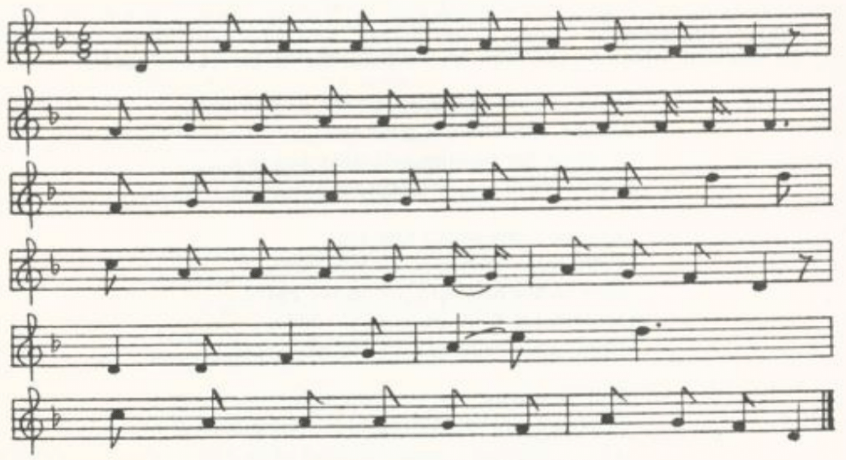
Now, gentlemen, ladies, how do you do?
Here I come before you with one boot and one show.
I don’t know how ‘tis, but somehow ‘tis so.
Now ain’t this a hard case on Billy Barlow?
Oh, oh, alackaday oh,
Now ain’t this a hard case on Mr. Barlow?

As I was going down the street 'tother day
I met two young ladies; I heard one of them say
That ‘that chap, he’s not so slow.’
‘Guess not,’ says the other, ‘that’s Billy Barlow.’

I went out to the race-course 'tother day
And the man at the gate he asked me to pay.
‘Pay for what?’ says I, and I looked at him so.
‘Pass on, stranger, you are Mr. Barlow.’

I went 'tother day to a caravan show
Where there was lions and monkeys and porcupines too,
But the man that shows them loses, I know,
For they can’t cage such a beat as young Billy Barlow.*

The tailors in town are running after me,
They want the cut of my coat, that’s very plain to see.
But before they get it I’ll teach them to know
They must shell out the cast to young Mr. Barlow.†

*In the repeat ‘beat’ is changed to ‘bird.’
†‘Cash’ becomes ‘rhino’ in the repeat.

(255)
Alack and alas, I am tired of this life
And I’ve got in the notion to get me a wife.
So if any young lady is in want of a beau
She must let it be known to William Barlow.

What’s the Matter Now?

Of this song I know only that it is to be found in the New Musical and Vocal Cabinet, published in London about 1820, and was apparently an old song then, since no author’s name is affixed as is generally done in that publication. The following text was secured by Miss Hamilton in 1903 as ‘sung in Ray or Clinton County as much as fifty years ago.’

My seventeenth year scarce over,
Blithe Damon wooing came,
A young and tender lover,
He owned his ardent flame.
Such a piteous tale he told me
Of his poor wounded hear:
It was heaven to behold me
But death if we must part.
Oh dear! oh dear! oh dear!
At length his patience failing,
He proudly swore he’d go;
‘Not yet,’ said I, half smiling,
With ‘What’s the matter now?’

He slyly seized that moment
To press me to be his,
And how it was I know not,
I thoughtless answered yes.
Oh, then when first we married
How easily I reigned!
If checked, my point I carried
With sobs and tears well feigned.
Oh dear! oh dear! oh dear!
The poor good soul was melted,
Not proof against my woe,
And coaxingly consented
With ‘What’s the matter now?’

Alas, those times are over,
And I have had my day.
No more a doting lover,
He swears he’ll have his way;
To all entreaties callous,
Whole days from me he’ll roam,
Get tipsy at the alehouse
And then come staggering home.
Oh dear! oh dear! oh dear!
Then if I weep or chide him
With consequential brow
He sits, his arm beside him,
With ‘What’s the matter now?’

Old Rosin the Beau

One does not know whether to write ‘beau’ or ‘bow.’ Most texts do not show the subject to be a fiddler but rather a toper who was something of a gay dog with the ladies. S. Foster Damon in his facsimile Series of Old American Songs reproduces a Ditson print of it, without date, in which it is called a ‘favorite Southern ballad,’ and notes that ‘Mr. Martyn sang it in New York in the late thirties,’ but says its origin is ‘lost in the mists of

(256)
antiquity.’ Spaeth (Read ‘Em and Weep 41-2) says the tune was used for ‘no less than four political songs between 1840 and 1875.’ It was printed as a stall ballad by Ryles of Seven Dials, and Joyce has a tune so called (OIFMS No. 352) from Limerick but without words. It is No. 53 in Barrett’s English Folk Songs. Williams (FSUT 93-4) reports it from singing in Wiltshire, with the spelling ‘beau.’ All agree that it is old but do not know whether it is English, Scotch, or Irish in origin. Just possibly it goes back to a refrain quoted by Moros in Wager’s The Longer Thou Livest the More Fool Thou Art, which is dated by Furnivall ‘ca. 1658’:

Robin lende to me thy Bowe, the Bowe,
Robin the bow, Robin lende to me thy bow a.

If so, ‘bow’ is the original form, and the use of resin on fiddle bows has transformed Robin into Rosin. The song is reported from tradition in Pennsylvania (NPM 115-6, ‘beau’), Mississippi (FSM 203-5, ‘bow’), and Montana (ABS 209-11, ‘bow’). Lomax gives it (CS 278-9, ‘beau’).

‘Old Rosin the Bow.’ Professor G. C. Broadhead gave me two versions in 1910, the younger of which he said he had heard ‘as long ago as 1839.’ His ‘older version’ (A below) is perhaps copied from print. Note that it used the spelling ‘beau.’

A
I live for the good of the nation,
And my sons are all growing low;
But I hope that my next generation
Will resemble old Rosin the beau.
I’ve traveled this country all over,
And now to the next I will go,
For I know that good quarters await me
To welcome old Rosin the beau.

In the gay round of pleasure I’ve traveled,
Nor will I behind leave a foe;
And when my companions are jovial
They will drink to old Rosin the beau.
But my life is now drawn to a closing,
And all at last will be so.
So we’ll take a good bumper at parting
To the name of old Rosin the beau.

When I’m dead and laid out on the counter,
The people all making a show,
Just sprinkle plain whiskey and water
On the corpse of old Rosin the beau.
(257)
I’ll have to be buried, I reckon,
And the ladies will all want to know,
And they’ll life up the lid of my coffin,
Saying ‘Here lies old Rosin the beau.’

Oh! When to my grave I am going
The children will all want to know;
They’ll run to the doors and the windows,
Saying ‘There goes old Rosin the beau.’
Then pick me up six trusty fellows
And let them all stand in a row
And dig a big hole in a circle
And in it toss Rosin the beau.

Then shape me out two little donochs,*
Place one at my head and my toe,
And do not forget to scratch on it
The name of old Rosin the beau.
Then let those six trusty good fellows,
Oh, let them all stand in a row
And take down that big-bellied bottle
And drink to old Rosin the beau.

*Variant of ‘dornick,’ a word of uncertain origin meaning a stone or boulder.

B

Come, fellows, and pledge me a bumper
And drink me one toast ere we go;
Fill high, let the wine cup now sparkle,
And drink to old Rosin the Bow.
Chorus:
And drink to old Rosin the Bow,
And drink to old Rosin the Bow,
Fill high, let the wine cup now sparkle,
And drink to old Rosin the Bow.

A fiddler he was of renown,
Who traveled through sunshine and snow;
And slowly and dull went the town
When absent old Rosin the Bow.
(258)
Soft eyes, soft speeches and glances
Belong to a lover, you know,
But nothing its pleasure enhances
Like the notes of old Rosin the Bow,
Like the notes of old Rosin the Bow.

At the Sign of the Apple

I know nothing of this song, or fragment of a song, except that it was communicated to me in 1916 by Professor J. D. Elliff as known to him from his early years. It seems to have been of the nature of a tavern catch—the kind of thing that Sir Toby loved to troll.

‘The Tavern.’ Communicated in 1916 by J. D. Elliff, who grew up in Macdonald County.

Once on a time I visited I asked my host to name my bill;
A house most neat and splendor, He smiled, and then said, ‘nay, sir.’
A golden apple was the sign, That house I’ll always patronize
Hung by a twig so tender. Whene’er I go that way, sir.

Chorus:
Do la la la, la la, la la,
Do la la la, la la, la la,
Hung by a twig so tender.

Old Grimes is Dead

This humorous song, written by Albert Gorton Green of Rhode Island in 1820,* has had considerable currency as traditional song. It is to be found in Trifet’s Multum in Parvo Songster (Boston, n. d. but not far from 1900) and Ogilvie’s Two Hundred Old-Time Songs (n. d. but late), and Spaeth prints it in Weep Some More, My Lady. It is hardly ever found in collections made by students of the ballad, probably because of its somewhat sophisticated quality and its known authorship. In West Virginia the opening stanza of it is used in a nonsense song (FSS 490) that has no further connection with Greene’s poem. In Trifet and Ogilvie it is set to the tune of Auld Lang Syne. Cox does

*According to DAB, which says that Greene wrote it when he was eighteen (Greene’s dates are 1802-68). Greene did not think enough of his verses ever to publish a collection of them; but this piece, along with others of his, was published in The Rhode Island Book in 1841. Damon, who reproduces an undated print of it in his Series of Old American Songs, says it was first published anonymously in the Providence Gazette for 16 January, 1822, that Greene ‘acknowledged the authorship of all but the first stanza in a letter to the Manufacturers’ and Farmers’ Journal in 1833, and that the version in The Rhode Island Book was a revision.

(259)
not give the tune of the West Virginia song, but the repeated last line of each stanza makes it probably that it is sung to a tune similar to that recorded by Broadhead. Neely reports it from tradition in Illinois (TSSI 217-9).

‘Old Grimes is Dead.’ One of the songs of early days remembered by Professor G. C. Broadhead of Columbia and written down for me in 1910. he wrote out only the four stanzas here given but noted: ‘In all, 12 verses; I have the others.’ I neglected at the time to secure the other stanzas, and Broadhead died not long thereafter. All the other texts known to me—Trifet’s, Oglivie’s, Spaeth’s—have ten stanzas, not twelve.
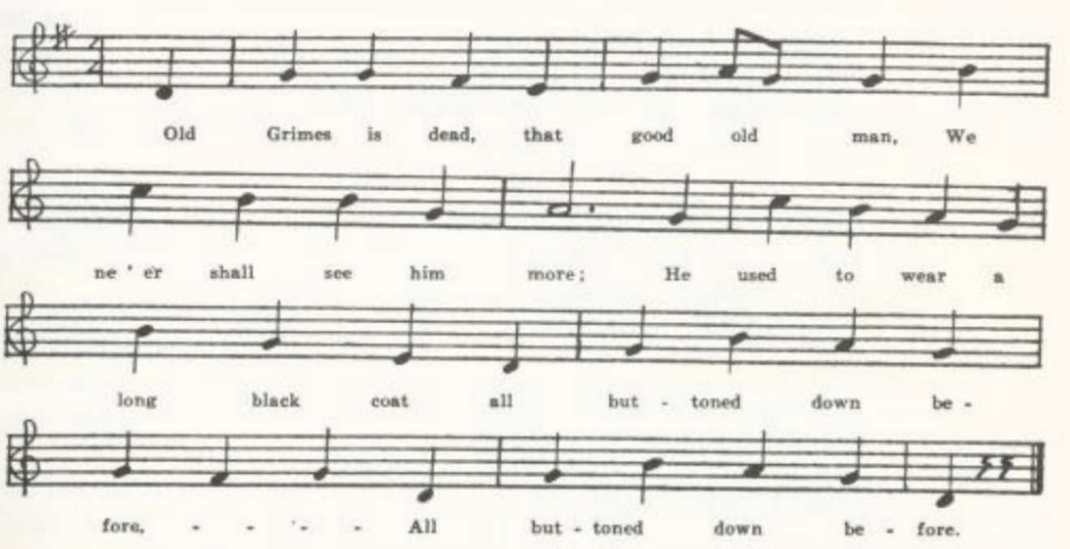
Old Grimes is dead, that good old man,
We ne’er shall see him more;
He used to wear a long black coat
All buttoned down before.

His heart was open as the day,
His feelings all were true;
His hair was some inclined to gray;
He wore it in a queue.

Whene’er he heard that voice of pain
His breast with pity burned.
The large round head upon his cane
From ivory was turned.

King words he ever had for all;
He knew no base design.
His eyes were dark and rather small;
His nose was aquiline.

Prentice’s Drinking Song

This is the American representative of an English song as old as the eighteenth century, given in Roxburghe Ballads VI 245 with the title ‘The Good Fellow.’ The piece has been reported from Georgia in SharpK II 79, and it is also in WSSU.

No title. Secured by W. S. Johnson in 1903 from Mr. Vaughan, principal of the high school at Tuscumbia, Miller County.

(260)
Seven long years I’ve served my trade,
One more and I’ll be free;
For I belong to a jovial band
And there’s no one cares for me.
Chorus:
I’ll ramble and I’ll rove and I’ll call for my boat,
Let them all say what they will,
For it’s all I am and as long as I live
I’ll be a gay fellow still.

I had a good old father at home,
I’ve cost him many a pound;
And to make him lament* for them all
I’ll travel this wide world round.

I had a good old mother at home,
I’ve cost her many a tear;
And to make her a lament* for them all
I’ll travel far and near.

I had a good little sister at home,
She gave me some good advice;
She told me to quite my rambling ways,
Hunt me some loving wife.

My sweetheart gave me a round piece of gold,
I loved it wondrous well;
But ‘twill neither buy me a house nor a home
Nor save my soul from hell.

But it will buy me a full flowing bowl,
That my friends may drink their fill;
. . . . . .
I’ll buy it, yes I will.

*Possibly a mishearing of ‘amends.’

(261)
The Little Brown Jug

The tune of this very popular bacchanal is the work of R. A. Eastburn; of the authorship of the words I know nothing except that Professor Broadhead told me it was written by J. E. Winner and that ‘100,00 copies were sold the first year’—but, alas! I failed to ask what year that was. It is in many song-books. It is No. 255 in Wehman’s series of stall ballads. It is reported as traditional song in Wiltshire (FSUT 212), Kentucky (SFLQ II 161), and Iowa (MAFLS XXIX 124-5), and without localization in ABFS 176-7 and Read ‘Em and Weep 58-9. Miss Hamilton (JAFL XXVII 296-7) reports a use of the words—or rather an adaptation from them, and evidently to a different tune—as a play-party song in Missouri. It is reported as a play-party song also in Michigan (JAFL XXXIII 109-10) and Texas (Owens, Swing and Turn 35-6).

A
‘The Little Brown Jug.’ Communicated by George Williams, Bollinger County, in 1906, with the remark: ‘Everybody knows this; it is often played at dances.’

My wife and I lived all alone
In a little log hut we called our own;
She loved gin and I loved rum,
I tell you what we had lots of fun

Chorus:
Ha, ha, ha, you and me,
Little brown jug, don’t I love thee!
Ha ha, ha, you and me,
Little brown jug, don’t I love thee!

‘Tis you who makes my friends my foes,
‘Tis you who makes me wear old clothes.
Here you are, so near my nose,
So tip her up, and down she goes!

When I go toiling to my farm
I take little brown jug under my arm;
Place it under a shady tree—
Little brown jug, ‘tis you and me!

If all the folks in Adam’s race
Were gathered together in one place,
Then I’d prepare to shed [a tear]
Before I’d part from you, my dear.

If I’d a cow that gave such milk
I’d clothe her in the finest silk,
I’d feed her on the choicest hay
And milk her forty times a day.

The rose is red, my nose is, to,
The violet blue, and so are you;
And yet I guess, before I stop,
We’d better take another drop.

B
‘Little Brown Jug.’ Part of a collection of play-party songs made by Miss Hamilton from her students at the Kirksville Teachers College 1912. it is quite distinct from the adaptation mentioned in the headnote above, being the same as A except for the last stanza, which runs:
As I went down the railroad track
I took my brown jug on my back.
I stubbed my toe and I went down
And broke my brown jug on the ground.
The entire text is given in Miss Hamilton’s article JAFL XXVII 301.

(262)
I Wouldn’t Marry . . . .

This theme takes three forms: a) that in which a man speaks, b) that in which a woman speaks, and c) a composite (or perhaps antiphonal) form in which now a man speaks and now a woman. The first is reported from Kentucky (JAFL XXXVI 379), Tennessee (BTFLS II 4), Mississippi (JAFL XXVIII 136-7, a negro version), and Texas (PFLST I 33, as part of an otherwise quite unrelated play-party song). It is not represented in the Missouri collection. The second form is reported from Kentucky (BKH 91-2, SSSA 26), the Cumberland Mountains (FSSH 310), Missouri (Springfield News and Leader for 11 September, 1938, a Stone County text furnished by Mrs. May Kennedy McCord), and Montana (ABS 208-9), and is represented in the Missouri collection by

‘Shabby De-Rue.’ Secured by Mrs. George H. Barnett in 1913 from Mrs. Sarah Henry, who learned it in Saline County about 1865-70.

I won’t marry a man too rich,
Shabby de-rue de-rue
He’ll keep me whipping from stitch to stitch,
Shabby de-rue de-rue
Shabby de-rue to-little to-little to too
Shabby de-rue de-rue.

I won’t marry a man too poor,
He’ll keep me begging from door to door.

I won’t marry a man too old,
His face grows wrinkled, his love grows cold.

I won’t marry a man too young,
His wavering mind, his perlathering tongue.

I won’t marry a man at all;
I’ll stay at home and keep maiden’s hall.

The saddle and bridle are on the fence,
If you want any more you can sing it yourself.

The composite or antiphonal form is reported from Kentucky, Tennessee, North Carolina, and Mississippi (JAFL XXVIII 175-7; also, for North Carolina, The North Carolina Booklet XI No. I pp. 32-3, FSSH 309, and for North Carolina negroes JAFL XLIV 428-9), and is represented in the Missouri collection by

No title. Contributed in 1918 by Miss Pauline Pfeiffer as written down for her by one of the school children of Piggott, Arkansas.

(263)
I wouldn’t have an old maid; I wouldn’t have a preacher;
I’ll tell you the reason why: I’ll tell you the reason why:
She’s always in the kitchen He’s always in the pulpit
A-bakin’ chicken pie. A-preachin’ chicken pie.

I wouldn’t have an old maid; I wouldn’t have a lawyer;
I’ll tell you the reason why: I’ll tell you the reason why:
Her neck’s so long and stringy He’s always in the courthouse
I’m afraid she’d never die. Swearin’ many a lie.

The Old Bachelor

This has been found in West Virginia (FSS 468), and Barry found it in New Jersey. Professor L. W. Payne (PFLST VI 234-5) reports a song on the same theme from Texas, but it is not the same piece.

No title. Communicated by J. H. Craig of Bowling Green, Pike County, in 1905.

I heard an old bachelor makin’ mighty noise,
A-mourning o’er his true love’s voice:
‘Yet I can’t tell the reason can be,
Since there’s none that’ll marry me.

‘I’ve been to the rich and I’ve been to the poor,
And I’ve been kicked from every door.
Yet I can’t tell the reason can be,
Since there’s none that’ll marry me.

‘I rode twelve horses nigh to death,
Six of them they hadn’t any breath;
Yet I can’t tell the reason can be,
Since there’s none that’ll marry me.

‘I rode my saddle back to a tree
To find a pretty girl that’ll marry me;
Yet I can’t tell the reason can be,
Since there’s none that’ll marry me.

'Throwed myself across my bed,
Tore every hair out of my old head;
Yet I can’t tell the reason can be,
Since there’s none that’ll marry me.’

(264)
The Old Man’s Courtship

The theme is old. It appears in The Shirburn Ballads (lxvi), in Christie II 96-7, and ‘An Old Man Came to See Me’ reported by Tolman from Indiana in JAFL XXIX 188 is a form of it. In the form represented by the Missouri text given below it goes back at least to 1730, when was published in London The Musical Miscellany volume III, on page 110 of which it is found, in Scottish or northern dialect, with the characteristic burden ‘and his beard new shav’n.’ According to an article in the Westminster Review LV 50 it was printed also (in English, not Scotch) in The Robin, London, 1749. It is found in Bell’s Ancient Poems, Ballads, and Songs of the Peasantry of England 237. In recent times it has been recorded from tradition in Worcestershire (FL X 193-4), Wiltshire (FSUT 73), Virginia (SharpK II 93-4), West Virginia (FSS 489), Kentucky (JAFL XXVIII 158, SharpK II 94-5), North Carolina (SharpK II 93-4, BMFSB 8-9, FSSH 301-2), Georgia (FSSH 302), Iowa (MAFLS XXIX 30), and without exact location in the Ozarks (Ozark Life VI No. 3) and in the southern Appalachians (SSSA 9-10). A fragment of it from Louisiana is reported in American Speech I 502.

‘The Old Man.’ Communicated by Miss Jane D. Johns, St. Charles, Missouri, as known to her uncle, Douglas Voss Martin, who learned it in his youth in Virginia. Lines 2 and 4 of stanza 1 are the refrain, repeated so in each stanza.

There was an old man came over the lea,
Ha ha ha but I won’t have him
Came over the lea a-courting me
With his old grey beard newly shaven.

My mother she told me to open the door.
I opened the door and he bowed to the floor.

My mother she told me to give him a stool.
I gave him a stool and he sat like a fool.

My mother she told me to give him some pie.
I gave him some pie and he made the crust fly.

My mother she told me to light him to bed.
I lit him to bed and he asked me to wed.

My mother she told me to lead him to church.
I led him to church and I left him in the lurch.
(265)
The Quaker’s Wooing

This of course is akin to Paper of Pins, for which see pp. 507-9. The Missouri text is close to that from Iowa given in ABS 223-4.

‘Quaker Wooing.’ Contributed in 1917 by Miss Frances Barbour as sung by Flora Gunnerson of St. Louis. ‘She learned it from her mother, who sang it as a girl; doesn’t know where she picked it up—somewhere near Paragould, Arkansas.’

‘Maiden, I have come a-courting,
Hey hum hey hum hey he
Not for pleasure nor for sporting,
Hey hum hey hum hey he.’

‘Then you may sit and stir the fire,
Ding tum a ding tum a dey dy oh
For I think that I’ll retire,
Ding tum a ding tum a day dy oh.’

‘I’ve a ring and forty shilling,
And you shall have them if you’re willing.’

‘What care I for rings or money?
I want a man that’ll call me honey.’

‘Must I give up my religion
And become a Presbyterian?’

‘You go home and tell your daddy
That you did not find me ready.’

‘Must I go without one token?
Must I go with my heart broken?’

‘Cheer up, cheer up, loving brother,
If you don’t catch one fish, catch another.’

Hard of Hearing

I knew this in my boyhood in Connecticut. There is a text and tune from North Carolina in SharpK II 252. Miss Hamilton notes that she saw it also in Huldah, by Alice McGowan and Grace McGowan Cooke, 1904. It is probably so familiar that collectors have not thought it worth setting down.

No title. Written down for Miss Hamilton in 1909 by Nellie Harper of the West Plains High School. The second line of each couplet is repeated.

‘Old woman, old woman, won’t you do my washing?’
‘Speak a little louder, sir; I’m very heard of hearing.’

‘Old woman, old woman, won’t you do my ironing?’
‘Speak a little louder, sir; I’m very hard of hearing.’

‘Old woman, old woman, won’t you do my darning?’
‘Speak a little louder, sir; I’m very hard of hearing.’

‘Old woman, old woman, may I come a-courting?’
‘Speak a little louder, sir; I almost heard you.’

‘Old woman, old woman, will you marry me?’
‘O God bless you! O God bless you! That’s the time I heard you!’

(266)
Mother and Daughter

The ancient theme of the girl determined to get married, frequent in early French poetry (see Jeanroy, Origines de la Poésie lyrique en France au Moyen Age 15-206) and still current in French-Canadian folk-song (JAFL XXXII 53-4), is not very fully represented in English and American tradition. Ord has two Scotch songs on the subject, pp. 148-50, and Sharp, FSSom No. 62, an English form. The oldest record of it in this country that I have noted is that found in Irving’s MS notes made, presumably, during his southwestern tour in 1832 and published by Leisy and Williams in Southwest Review XIX 449-54 under the title ‘Polly Holman’s Wedding.’ Here it is art of the repertory of a Kentucky ballad singer. It is reported also from Virginia (SharpK II 159), and from Mississippi (FSM 280-1).

No title. Written down for Miss Hamilton in 1910 by George Sessen of the West Plains High School.

As I went out one morning
To get the morning air,
I saw a mother talking
To her daughter fair.
Lol-i-trudam-trudam-i-dey

‘Oh, hush up, my daughter,
And hold your civil tongue.
You talk of getting married,
You know you are too young.
Supposing I were willing,
Where’d you get your man?’
‘Law law, ma’am, I can
Get my handsome Sam.’
Lol-i-trudam-trudam-i-dey

‘Supposing he was to slight you,
As he has done before?’
‘Law law, ma’am, I,
I can get a man more.
There’s tinkers, and tailors,
And boys that hold that plow.
They all want to marry,
And why not marry now?’
Lol-i-trudam-trudam-i-dey

I Won’t Be a Nun

This is an ancient theme; see Jeanroy, Origines de la Poésie lyrique en France au Moyen Age 189ff., and Bartsch, Altfranzösische Romanzen und Pastourellen 28-30. The text as known in Missouri is identical with that printed by Cadman of Manchester (and doubtless by other ballad printers), tho quite different from that printed by Catnach. For purposes of identification I give below a text sent me by D. W. Parsons of Sweet Springs in 1907. In the same year Miss Josephine Norville of Chillicothe sent me the same text, with the notation that it was from a printed collection, Songs of the People, Boston, 1893, but ‘was sung in Virginia, Ohio, and Missouri as early as ’49, to my knowledge.’ G. F. Broadhead wrote out for me in 1910 the tune as he knew it:
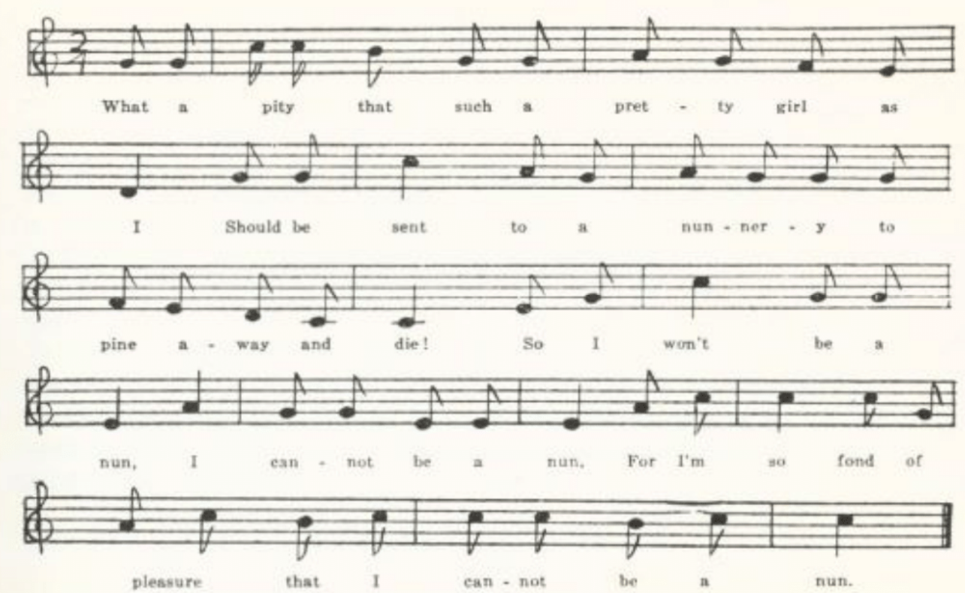
(267)
The text sent me by Parsons is a leaf from a MS song book, in a neat hand of, I should judge, fifty or seventy-five years ago. The name at the end is presumably that of the person who supplied the text.

Now it is not a pity such a pretty girl as I
Should be sent to a nunnery to pine away and die?
But I won’t be a nun—no, I won’t be a nun—
I’m so fond of pleasure that I cannot be a nun.

I’m sure I cannot tell what’s the mischief I have done,
But my mother oft tells me that I must be a nun.
But I won’t be a nun—no, I won’t be a nun—
I’m so fond of pleasure that I cannot be a nun.

I could not bear confinement, it would not do for me.
I like to go a-shopping and to see what I can see.
So I won’t be a nun—no, I won’t be a nun—
I’m so fond of pleasure that I cannot be a nun.

I love to hear men flattering, love fashionable clothes,
I love music and dancing and chatting with the beaux.
But I won’t be a nun—no, I won’t be a nun—
I’m so fond of pleasure that I cannot be a nun.

O mother, don’t be angry now, But let your daughter be,
For the nuns would not like to have a novice wild as me.
And I can’t be a nun—no, I won’t be a nun—
I’m so fond of pleasure that I cannot be a nun.

M.L. Greer

(268)
The Three Rogues

See Kittredge’s bibliographical notes upon this JAFL XXIX 167, XXX 348-9, XXXV 350-1. Originally, in England, sung of the time ‘when Arthur ruled this land,’ it was changed in America to ‘in good old colony times.’ Texts have been reported from traditional singing in Lancashire (ECS 20-1), Wiltshire (FSUT 194), and Somerset (NSS III 10-1), and in this country in Vermont (VFSB 103), West Virginia (FSS 480-1), Kentucky (JAFL XXIX 167-8), Georgia (JAFL XLV 47, FSSH 191), Illinois (TSSI 190), and Nebraska (ABS 234-5). It is probably much more generally know and sung in this country than these citations would indicated. A text given me by F. G. Perrin in 1920 from family tradition in Vermont shows that it was performed in much the same way as the Old Woman All Skin and Bone (see pp. 502-3); it is directed to be sung ‘very slow and dramatic till the third line’ of the last stanza, and the last two lines to be repeated ‘as fast and as wildly as possible, to frighten’ to auditors.

A
‘The Three Rogues.’ From Miss Jane D. Johns, of St. Charles, 1917, as sung by her uncle, Douglas Voss Martin, who learned it as a boy in Virginia.

. . . . . . . .
. . . . . . . .
There were three rogues who were drummed out of town
Because they could not sing.

The first he was a weaver,
And the second he was a miller,
And the third he was a little tailor—
Three great rogues together.

The miller he stole corn,
And the weaver he stole yarn,
And the little tailor stole broadcloth enough
To keep these three rogues warm.

The miller was drowned in a dam,
And the weaver was hung with his yarn,
And the de’il ran away with the little tailor
With his broadcloth under his arm.

B
No title. Reported by Miss Leah R. C. Yoffie of St. Louis in 1915 from Mrs. W. J. Whipple of Winona, Minnesota.

(269)
The miller he stole corn,
And the weaver he stole yarn,
And the little tailor he stole broadcloth enough
To keep the three rogues warm.

The miller got caught in his wheel,
And the weaver got hung in his yarn,
And the devil he got the little tailor
With the broadcloth under his arm!

C
‘In Good Old Colony Times.’ Given to Miss Lowry in 1920 by earl Cruickshank of Columbus, Kansas, from the singing of his mother, who was reared in Lewis County, Missouri.

In good old colony times
When we lived under the king,
Three roguish chaps fell in a mishaps
Because they could not sing.
Because they could not sing,
Because hey could not sing,
Three roguish chaps fell in a mishaps
Because they could not sing.
(Repeat thus the last two lines of each stanza)

The first he was a miller,
The second he was a weaver,
The third he was a little tailor boy—
Three roguish chaps together.

The miller he stole corn,
The weaver he stole yarn,
The little tailor boy stole broadcloth for
To keep these three rogues warm.

The miller got drowned in his den,*
The weaver got hanged in his yarn,
The jailor clasped his hands on the little tailor boy
With the broadcloth under his arm.

*Misheard, no doubt, for ‘dam.’

(270)
The Carrion Crow

Widely known as a nursery song in England. Bell, Ancient Poems, Ballads, and Songs of the Peasantry of England 202-3, has an elaborate exegesis of it as a political satire on the Romanizing tendencies of the Restoration court. Halliwell-Phillips, however, in his Nursery Rhymes of England (5th edition, 1853) 116, traces it still further back, giving a version from a manuscript of Charles I’s time. It is one of Pitts’s stall prints (Harv. Libr. 25242.2, p. 110). It is reported as traditional song from Gloucestershire (JEFDSS I 136-7), Berkshire (FSUT 227), and the west of England (GCS No. XLVI), from Nova Scotia (BSSNS 375-6), Kentucky (SHF 18-9), North Carolina (SharpK II 324-5), and Texas (PFLST VI 230-1). Mackenzie reprints two English texts, one from Rimbault’s Collection of Old Nursery Rhymes and one from a Pitts stall print, in BSSNS 372-8.

A
‘Kimonaro.’ Sent to me in 1906 by Elizabeth Bedford of Christian County. No tune is given, but the refrain shows that it was sung to one of the tunes of The Frog’s Courtship.

There was an old man, and he lived on a hill,
Tim-a-linny-danny, finny-danny, kimo
And if he’s not moved he’s living there still,
Tim-a-linny-danny, finny-danny, kimo
Kimonaro nelton karo kimo
A-hum-a-jum a-fum-a-jum a-fike-ta-ma-ling-dum
Dilly-lally-lingdum, kimo.

He called to his wife for his arrow and bow,
That he might shoot that carrion crow.

He set his arrow straight to the mark
And shot their fat hog right through the heart.

‘Old woman, old woman, some brandy in a spoon
Or our fat hog will die very soon.’

‘If our old hog dies we’ll haul him to the house
And we’ll have pudding and chitlings and souse.’

B
‘Carrion Crow.’ Secured by Miss Hamilton at Kirksville in 1912 from a Mrs. Ballard of La Plata, Vernon County, who learned it from her parents. Note that it has not the ‘kimonaro’ refrain.

Carrion crow a-sittin’ on an oak,
Lala diddle lala diddle l idol lo
Carrion crow a-sittin’ on an oak,
Spyin’ a tailor a-cuttin’ out a coat,
Sing heigh ho! carrion crow!
Lala diddle lala diddle li dol lo

‘Wife, O wife, fetch my arrow and my bow
Till I take a shot at the carrion crow.’

He fired away and he missed his mark
And shot his old sow through the heart.

‘Wife, O wife, bring some brandy in a spoon,
For my old sow’s in a devil of a tune.’

The Jolly Miller

This does not appear to have been recorded as traditional song by collectors either in America or in the old country—probably because it is so universally known as a school and children’s song. S. J. A. Fitz-Gerald in his Stories of Famous Songs 220 says: ‘Originally there were only two verses, but two more have been added, perhaps by Isaac Bickerstaff, who introduced it into his comic opera “Love in a Village,” Covent Garden Theatre, 1762, . . . and “There was a Jolly Miller” was marked “old tune” even then,’ and adds that ‘it is still sung in our [British] public schools.’

‘There was a jolly miller.’ From George Williams, Bollinger County, 1906, who notes: ‘This was sung by James Cook, a neighbor boy, who I think learned it from print (1 have seen it printed), through he learned the tune in this county.’

There was a jolly miller once,
Lived on the river Dee,
He worked and sung from morn till night,
No lark more blithe than he;
And this the burden of this song
Forever used to be:
‘I care for nobody, no, not I,
If nobody cares for me.

‘I live by the mill, she is to me
Like parent, child and wife;
I would not change my station
For any other in life;
No lawyer, surgeon, or doctor
E’er had a groat from me,
And I care for nobody, no, not I,
If nobody cares for me.’

(272)
A Farmer’s Boy

This was thought by Robert Bell (Ancient Poems, Ballads, and Songs of the Peasantry of England 148-9) to date from the early eighteenth century. It is ‘popular all over England,’ he says. It was frequently printed as a stall ballad—by Pitts, Such, and Catnach in England and by Wehman and Wrigley in this country. It is in Trifet’s Multum in Parvo Songster 151 and in Marsh’s Star Song Book 65. It has been recorded from tradition in Berkshire (ECS Derbyshire, Hampshire, and Devonshire’), and in this country in Vermont (VFSB 118-9), Ohio (JAFL LI 38-9), Iowa (MAFLS XXIX 27-8), and Wyoming (ABS 68-71, where it is described by the contributor as learned from her father, who said it was brought over from Newcastle, England, as early as 1870).

‘A Farmer’s Boy.’ Contributed by Miss Josephine Norville of Chillicothe, Livingston County, in 1907, with the note that she got it ‘last summer in Kenosha, Wisconsin. It was sung at an “Old Folks’ Concert” by Mr. Fred Perkins, who says that his father and grandfather both used to sing it.’

The sung had sunk behind yon hill
Across yon dreary moor,
When wet and cold there came a boy
Up to a farmer’s door.
‘Can you tell me,’ said he, ‘if any there be
Who will give me employ
For to plow and to sow and to reap and to mow
And to be a farmer’s boy, boy,
And to be a farmer’s boy?
(Repeat these last three lines at the end of each stanza)

‘My father’s dead and my mother left,
And with three children small;
And what is worse for my mother still,
I’m the oldest of them all.
But as little as I am I will do what I can
All for to seek employ.’

‘Oh, yes,’ cried the wife, ‘let us try the lad;
Let him not further seek!’
‘Oh, yes,’ the daughter she replied,
While a tear ran down her cheek,
‘It is hard for those who seek for work
And wander for employ.’
(273)
The boy he stayed till he grew a man
And the good old farmer died.
He left the lad with all he had
And his daughter for his bride.
But the lad that now a farmer is,
He oft times smiles with joy
When he thinks of the day that he came this way
All for to seek employ,
For to plow and to sow and to reap and to mow
And to be a farmer’s boy, boy,
And to be a farmer’s boy.

A Soldier’s Poor Little Boy

Perhaps made to be sung by beggar boys at street corners, perhaps merely a piece of parlor sentiment. Cox, FSS 275, notes that in a Philadelphia broadside it is ascribed to Charles Bender—of whom I know nothing. It was printed by Such, Pitts, and Ryle and in this country by Wehman and DeMarsan. See Cox’s headnote. It has been recorded from tradition in Newfoundland (BSSN 201-2), Pennsylvania (NPM 71-2), West Virginia (FSS 275-6), Iowa (MAFLS XXIX 117-8), and California (TBWV 88). I have not found it in British collections from traditional singing.

A
No title. From a manuscript collection made apparently in Gentry County in the seventies of the last century and lent to me in 1904 by Harry Fore.

The snow is fastly falling
And the winds did loudly roar
When a poor little boy, quite frozen,
Came up to a rich lady’s door;
And seeing her in her window so high
It filled his heart with joy,
Crying, ‘Oh, for mercy’s sake some pity on me take,
I’m a soldier poor little boy.

‘My mother died when I was young,
My father’s gone to war;
He has fought on many battlefield
And is covered with wounds and sore.
But on his knapsack
He has carried me with joy;
But now I’m left quite parentless,
A soldier poor little boy.

‘The snow is fastly falling
And the night is coming on,
And if you don’t protect me now
I’ll perish before it is morn.
And then ‘twill grieve your cheerful heart,
Your peaceful mind destroy
To find me next lying dead at your door,
A soldier poor little boy.’

The lady arose from her window so high
And opened the door to him,
Saying, ‘Come in, ye poor unfortunate man,
And never roam any [more].
My only son in the battle was slain;
You’re my only hope and joy.
Then as long as I live sweet comfort I’ll give
To a soldier poor little boy.’

(274)
B
‘A Soldier’s Homeless Boy.’ Taken down by George Williams of Bollinger County from the singing of his sister Hattie, in 1909.

The snow was fast a-falling
And the howling winds did roar,
When a homeless child, near frozen,
Came up to a lady’s door.
HE saw her at the window,
And it filled his heart with joy.
‘Take pity on me, lady,
A soldier’s homeless boy.

‘The snow is fast a-falling,
I perish ere the morn.
Pray shelter me, dear lady,
From this impending storm.
Deny me not, I pray you;
It would rob you of all joy
To find me in the morning
A lifeless little boy.

‘My mother died last summer;
My father has gone to war,
He has fought in many a battle,
All covered with wounds and scars.
My likeness in his knapsack*
He carries it with joy.
Take pity on me, lady,
A soldier’s homeless boy.’

The lady left the window
And opened wide the door.
‘Come in, you little stranger,
And never wander more.
My only son has fallen,
My only hope and joy;
Long as I live I’ll shelter
A soldier’s homeless boy.’

*This looks like an attempt to improve the reading of A and C. Cox’s two West Virginia texts, however, agree here with A and C.

C
‘The Soldier’s Boy.’ Secured in 1912 by Miss Colquitt Newell from the singing of Mrs. Turley of Farmington, St. Francois County. Mrs. Turley learned it as a child in Flat River in the same county, and had never seen it in print.
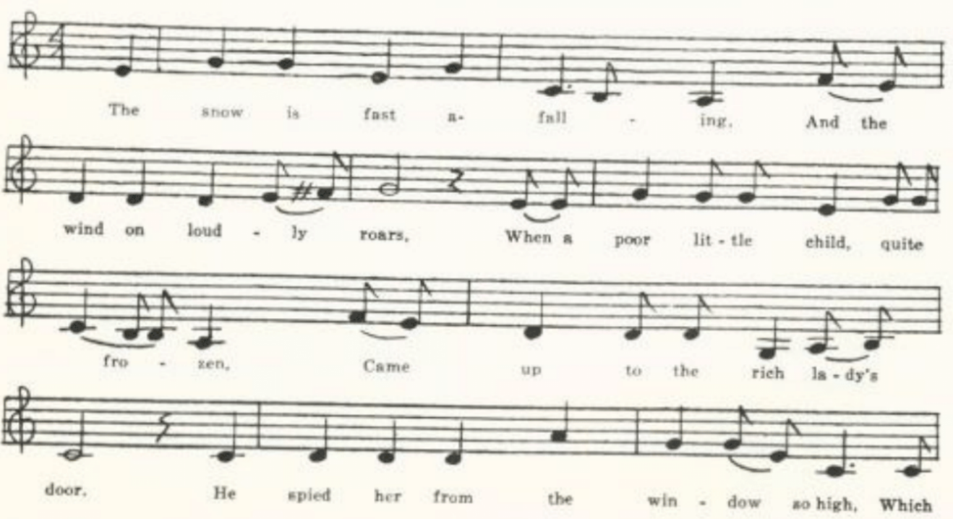
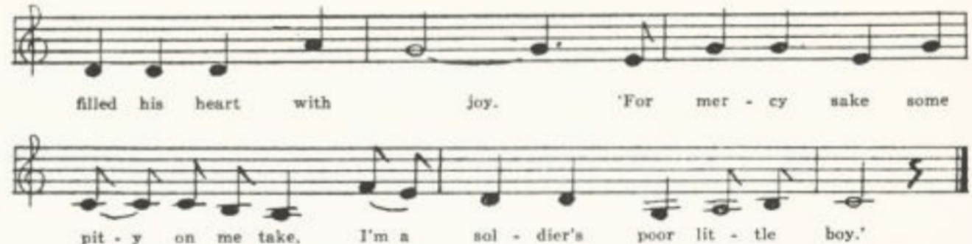(275)
The snow is fast a-falling,
And the wind on loudly roars,
When a poor little child, quite frozen,
Came up to the rich lady’s door.
He spied her from the window so high,
Which filled his heart with joy:
‘For mercy sake, some pity on me take;
I’m a soldier’s poor little boy.

‘My mother died when I was young,
My father went to the war;
And many a battle so brave he has fought,
Always covered with wounds and scars.
Many a mile on his knapsack
He carried me with joy.
But now I’m left quite parentless—
I’m a soldier’s poor little boy.

‘The snow is fast a-falling,
The night is coming on,
And if you don’t protect me
I shall perish before the morn.’*

She rose up from the window so high
And opened the door to him:
‘Come in, you young unfortunate child;
Thou shalt never wander again.
My only son in the war was slain,
My pride, my all, my joy;
And as long as I live, some shelter will I give
To a soldier’s poor little boy.’

*The stanza stands thus incomplete in Miss N.’s MS.

The Blind Child

Whatever valuation one may place upon this effort to tear the heart-strings, it is clear that the author did not miscalculate. Without any help from ballad or songbook print that I have been able to find (tho of course it circulated originally in print), it has lodged in the memory of a good many singer. IT has been reported as traditional song from Kentucky (JAFL XXVIII 171, BKH 146), North Carolina (JAFL XXVIII 170-1, SSSA 128-9), Alabama (JAFL XLV 75-6, FSSH 371-2), Arkansas (Ozark Life V No. 5-6), Illinois (TSSI 247-9), and Iowa (MAFLS XXIX 79-80). There are five copies of it in the Missouri collection, no two precisely alike but not differing sufficiently to warrant printing more than one of them here. The five are

A ‘The Blind Girl.’ From the manuscript ballad-book of Mrs. Lida Jones of
Everton, Dade County, compiled about the end of the last century and
secured by Miss Lowry in 1906.
B ‘The Blind Girl.’ From the manuscript songbook of Mrs. John Singleton of
Jacksonville, Randolph County, compiled in the nineties of the last
century and lent to me by her son, Dr. Ralph Singleton.

(276)
C ‘The Blind Girl.’ Communicated in 1913 by Mrs. George H. Barnett of
Columbia as known by Mrs. Sarah Henry, who learned it as a child in
Saline County shortly after the Civil War.
D ‘The Blind Girl.’ From George Williams, Bollinger Country, in 1906. Given
below.
E ‘The Blind Child.’ Secured by Mr. F. P. Batdorf from one of his students in the
summer session of the University in 1937, Selma Elizabeth Nelson, who
learned it from her grandmother in Maries County.

D
‘The Blind Girl.’ G. W. writes: ‘This song is generally known here. I cannot remember the first time I heard it. I feel sure it was not brought in in print, as it is best known among unlearned people.

‘They tell me, father, that tonight
You wed another bride,
And that you’ll clasp her in your arms
Where my poor mother died.

‘They say her name is Mary, too,
The name my mother bore.
Oh, tell me, is she kind and true
As the one you loved before?

‘And is her step so soft and low,
Her voice so sweet and mild,
And do you think that she will love
Your blind and only child?

‘Please, father do not bid me come
To greet your loving bride.
I could not meet her in the room
Where my poor mother died.

‘Her picture’s hanging on the wall,
Her books are lying near;
And there’s the harp her fingers touched;
And there’s her vacant chair—

‘The chair whereby I’ve often knelt
To say my evening prayer.
Oh! father, it would break my heart,
I could not meet her there.

‘I love you, but I long to go
To yon bright world so fair
Where God is true, and I am sure
There’ll be no blind ones there.

‘Now let me kneel down by your side
And to our Savior pray
That God’s right hand may shield you both
Through life’s long dreary way.

‘My prayers are ended now, dear pa,
I’m tired now,’ she said.
He picked her up all in his arms
And laid her on the bed.

And as he turned to leave the room
A joyful cry was given.
He heard, and caught the last sweet smile—
His blind child was in heaven.

They laid her by her mother’s side
And raised a marble fair,
And but engraved these simple words:
‘There’ll be no blind ones there.’

(277)
The Orphan Girl

Jackson SFSEA 48 prints a text and tune from the 1902 (Alabama) edition of The Sacred Harp, in which the tune is credited to ‘Eld. C. G. Keith, Nov. 1, 1906’ (so Jackson quotes the book, although he gives its date of publication as 1902); but he believes the ascription to indicate merely the source of the copy provided for the compiler or the printer. The song has been recorded from tradition in Virginia (SCSM 364-6), West Virginia (FSS 446-7), Kentucky (BKH 106-7), Tennessee (ETWVMB 26-7, JAFL XLVI 49, FSSH 374-6), North Carolina (JAFL XXVIII 170, XLV 66-8, SSSA 124-5, FSSH 373-4), and Iowa (MAFLS XXIX 61, ASb 319—the latter a fragment. Sandburg prints also a full text but does not say where he got it).

A
No title. Reported in 1906 by C. H. Williams of Bollinger County, from his mother, who learned it as a child in Illinois.

‘A home, a home,’ plead a little girl
At the door of a princely hall
As she trembling stood on the polished steps
And leant on the marble wall.

‘My father, alas, I never knew,’
As the tears dimmed her eyes so bright,
‘My mother sleeps in a new-made grave;
‘Tis an orphan begs tonight.’

Her clothes were thin and her feet were bare
And the snow had covered her head.
‘Oh, give me a home!’ she feebly said,
‘A home and a piece of bread.’

‘Twas cold and dark and the snow fell fast,
But the rich man shut his door,
And his proud lips curled as he rudely said,
‘No home, no bread for the poor.’

‘I must freeze,’ she said, ‘alas!’ as she sank
On the steps of the rich man’s door
And strove to wrap her feet in her tattered dress,
All covered with sleet and snow.

The hours passed by, and the midnight bell
Tolled out like a funeral knell,
And the earth seemed wrapped in a winding sheet,
And the drifting snow still fell.
(278)
The rich man lay on his velvet couch
And dreamed of his silver and gold;
And the little girl on her bed of snow
And murmured ‘So cold—so cold.’

The morning came, and the little girl
Still lay at the rich man’s door;
But her soul had fled to a home above,
Where there’s room and bread for the poor.

B
‘The Orphan Girl.’ Copied out by Miss Newell in 1912 from a manuscript of Mrs. Chandler of Farmington, St. Francois County, who had learned it as a child and had never seen it in print. Differs from A only by the transposition of stanzas 6 and 7. Mrs. Chandler’s tune is here recorded.
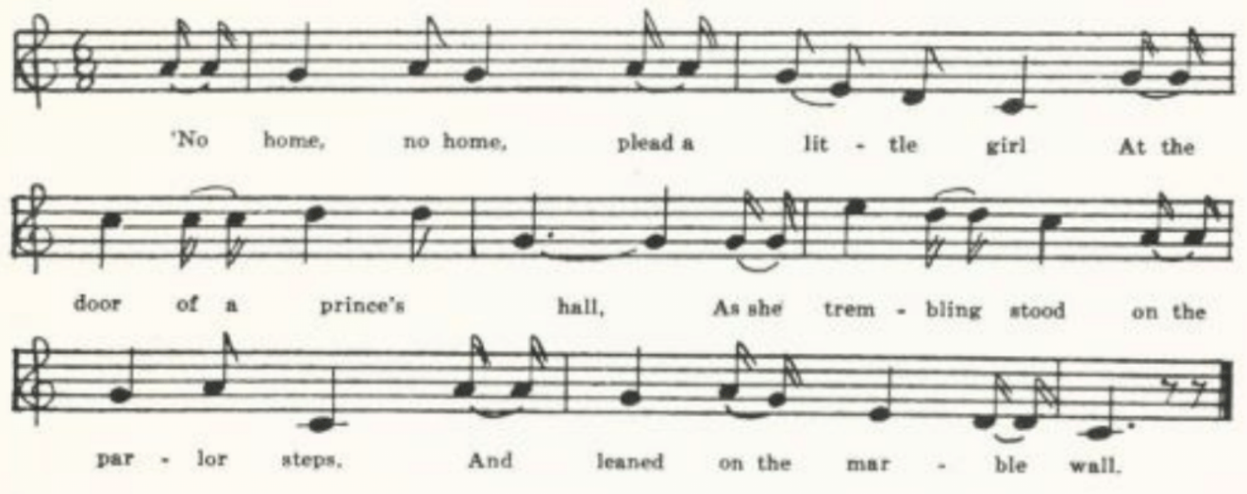
The Orphan

This, like the preceding, no doubt derives from print, but I have found it only as a collector’s item. It is reported from Kentucky (BKH 147) and from North Carolina (JAFL XLV 68-9, FSSH 377).

A
‘The Orphan.’ Sent in in 1909 by George Williams from the singing of Newton E. Tallent of Glen Allen, Bollinger County.

Will you listen to my lonely story
Of my friends who are dead and gone?
Father, no, nor no more mother;
I am an orphan left alone.

Mother said when she was dying,
When her breath was almost gone,
‘Dearest darling, trust in Jesus
While an orphan left alone.

(379)
‘Take this bible to your bosom,
Read and pray both night and morn.
Ofttimes you may think of mother
While an orphan left alone.’

Brothers, sisters have I neither,
I am left to weep and mourn;
I am a cast-out among strangers,
A poor orphan left alone.

I ofttimes walk the lonely graveyard,
Thinking of the time to come,
When by mother I’ll be buried
And no more be left alone.

B
‘The Orphan Girl.’ Secured by Mrs. George H. Barnett in 1913 from Mrs. Sarah Henry, who learned it in Saline County about 1870.

Will you hear my mournful story?
All my friends are dead and gone,
Father is no more, nor mother;
I’m an orphan left alone.

Brother I have none nor sisters,
I have neither friends nor home;
In this dreary world of sorrow
I’m an orphan left alone.

Mother said to me when dying,
And her voice was nearly gone:
‘Dearest daughter, you will soon be
A poor orphan left alone.

‘Take the Bible from the closet.
Read and pray both night and day.
Seek protection in our Saviour
While an orphan left alone.’

Then her eyes in death were closed
And her corpse lie in the tomb.
I have no one to care for me now;
I’m an orphan left alone.

Oft I’ve walked the lonely graveyard,
Praying for the time to come
When by mother I’ll be buried
And no more be left alone.

Put Me in My Little Bed

Spaeth Read ‘Em and Weep 99 remarks that this has been ‘the seed for a whole harvest of baby songs.’ It is No. 457 in Wehman’s ballad series, and I found a stall print of it, without printer’s name, in the British Museum. I have not learned who wrote it. It is probably too familiar to catch the attention of collectors; at least I have found it recorded as traditional song only once, in Iowa (MAFLS XXIX 53).

‘O Birdie.’ Written down for Miss Josephine Norville of Chillicothe, Livingston County, in 1907, by one of her pupils in the school there who learned it from her grandmother.

O birdie, I am tired now, I do not care to hear you sing.
You sang your happy songs all day, now put your head beneath your wing.
Now sing to me your last good-night, for I my evening prayer have said;
I’m tired now and sleepy too; come put me in my little bed.

(280)
Chorus:
Come, sister, come kiss me good-night, for I my evening prayer have said,
I’m tired now and sleepy too; come put me in my little bed.

O birdie, what did mother say, when she was called to heaven away?
She told me always to be good and never, never go astray.
I can’t forget the night she died. She placed her hand upon my head
Whispered softly, ‘Keep my child;’ and then they told me she was dead.

Over the Hills at the Poorhouse

Altho this bears almost exactly the same title as Will Carleton’s well-known poem, and two of the sons have the same names in both, it is by no means a mere memory of Carleton’s piece. Nor is it the same piece as ‘Over the Hills to the Poorhouse’ in Dean’s The Flying Cloud (121-2), which is No. 182 of Wehman’s 1000 Songs and in which the father, not the mother, upbraids undutiful children. Quite possibly the song here given suggested the subject to Carleton.

Over the hills at the poorhouse
In the twilight so dim and so gray
A woman is quietly lying
Breathing her life away.
All alone in the sick ward,
With nobody near to wait
And no one to care but our Father,
Who heareth the prayers . . . .

‘God bless you, my heartless children,
I did just the best that I could.
I know that I raised you all healthy,
And I tried hard to raise you all good.
But children will never listen
To half that a mother says;
And may be I whipped you too seldom
Or gave you too ready praise

‘Farewell to my dearest children!
You can’t help but feel remorse
When you see the shroud and white winding
To cover my stiffened corse.
(281)
There will some of you come to my funeral,
My Charlie and his pretty wife,
And you’ll wish, as you surround my coffin,
That I would come back to life.’

The last fond excuses were spoken,
And still was the wintry air,
But the spirit had left that poor body
And only a corse lay there.
The poormaster sent the message
To each of the children five
That somehow their mother right lately
Had been grumpy and did not thrive.

And so she had died that morning,
Would be buried the following eve,
And any might come to the funeral
Who could most conveniently leave.
Charley and his wife were traveling,
While Thomas was ashamed to go
And said that he never could stand
To be among folks so low.

Shule Aroon

For bibliography of this favorite Irish song (assigned by Joyce, OIFMS No. 425, to the period after James’s defeat at the Boyne, when Irishmen went as volunteers into the French army) see Kittredge’s note to Tolman’s Ohio texts, JAFL XXXV 404-5. Lancashire texts (JFSS V 180, also a stall print by Summerside of Liverpool) and one from Hampshire (JFSS III 29) introduce an alien line in the refrain: ‘Sweet William a-mourning among the rush.’ It has been recorded in this country in Virginia (SharpK II 50), Mississippi (FSM 275-6), and Ohio (JAFL XXXV 202-4).

No title. Communicated in 1907 by Miss Josephine Norville of Chillicothe, Livingston County, as written out for her by a friend who ‘used to hear some school-mates sing it’ but had ‘no idea what it means.’

I’ll dye my dress, I’ll dye it red,
And o’er this wide world make my bed,
Although my parents think me dead—
Come bibble-un-a-boose said Lora.
(282)
Shule, shule, shule-a mac-a-me,
Shule-a mac-a-rac-stack Sally Bobby cue
Shule-a mac-a-rac-stack, Sally Bobby Lee
Come bibble un-a-boose, said Lora.*

I’ll sell my frock, I’ll sell my wheel
To buy my lover a sword of steel,
So in that battle he may wield—
Come bibble-un-a-boose etc.

*‘Shule’ (siubhal) in Gaelic means ‘walk’ or ‘come;’ but I am not prepared to guess from what the other syllables in this refrain may be perverted. Barry, JAFL XXII 15, gives a form of the refrain in Gaelic:
Siubhal, siubhal, siubhal a run,
Siubhal go sochair, agus siubhal go cun,
Siubhal go den duras, agus eligh liom,
Is go de tu, mo muirnin slan,
and translates: ‘Walk, walk, walk, my love, walk quietly and walk boldly, walk to the door and flee with me! Here’s a health to you, my darling!’

Erin’s Green Shore

Cox FSS 442 notes that his is common in English broadsides, listing several of them. It has been reported from tradition in Newfoundland (BSSN 142-3), Nova Scotia (SBNS 171-2), West Virginia (FSS 442-4), and Kentucky (DD 176-8).

‘Erin’s Green Shore.’ Text secured in 1920 by Miss Lowry from Earl Cruickshank of Columbus, Kansas, who notes: ‘My mother said that her folks learned this song from a family of Lillards who came from Kentucky to North Missouri.’

One evening so late as I rambled
On the banks of a sweet purling stream,
I sat myself down ‘mid primroses
And so gently I fell into dream.

I dreamed that I met a fair lady
Whose like I had ne’er seen before;
And she sighed o’er the ruins of her country
As she rambled o’er Erin’s green shore.

She was dressed in the richest apparel*
And green was the mantle she wore,
Bound round with the rose and the shamrock
Which grew on sweet Erin’s green shore.

*’She resembled the goddess of liberty’ was remembered as an alternative to this line.

(283)
I stepped up to this beautiful damsel
And so modestly asked her name:
‘My reasons for asking this question,
I knew you were a stranger just came.’

‘I’m the daughter of Daniel O’Connell
From England just lately sailed o’er;
I’ve come to awaken my countrymen
Who slumber on Erin’s green shore.’

Transported with joy I awakened,
And alas, it all proved a sad dream.
The beautiful damsel fled from me,
And I longed to be dreaming again.

May the heavens above be her guardian!
For I know I shall see her no more;
May the true sons of freedom shine round her
As she rambles on Erin’s green shore!

The Croppy Boy

This tragic ballad of the Irish rebellion of 1798 was printed by Catnach and others in England and by Partridge and Wehman in America. It is recorded from tradition in Nova Scotia (SBNS 183-4) and (presumably) in Minnesota (Dean 45-6).

‘The Croppy Boy.’ Written down for Miss Hamilton in 1909 by Nannie Shuttee of the West Plains High School as ;known by her mother.’ There is confusion in stanzas 6-7; in Dean’s text the betrayer is ‘my cousin Nancy’ and ‘my sister Mary’ is faithful and tries to buy his freedom.

It was early in the spring;
The small birds whistling sweet did sing,
Changing their notes from tree to tree;
The song they sang was ‘Old Ireland free.’

It was early last Thursday night
The yeoman cavalry gave me a fright;
The yeoman cavalry was my downfall
When I was taken before Lord Cornwall.

It was in his guardhouse where I was laid
And in his parlor where I was tried,
My sentence passed and my spirits low
When to New Guinea I was forced to go.

When I was marching through the street
The drums and fifes did play so sweet,
The drums and fifes did so sweetly play
As we were marching so far away.

When I was marching past my father’s door,
My brother William stood on the floor,
My aged father did grieve full sore,
My tender mother her hair she tore.

(284)
When my sister Mary heard the express
She ran downstairs in her morning dress
Saying, ‘Five hundred guineas I would lay down
To see you marching through Wexford town.’

As I was marching through Wexford street
My sister Mary I chanced to meet.
This false young woman did me betray,
And for one guineas she swore my life away.

And when I am dead and taken to my grave,
A decent funeral pray let me have
And over my head plant a laurel tree
In sweet remembrance, In remembrance of me.

When I was marching o’er Wexford Hill,
Oh, who could blame me to cry my fill?
I looked behind, I looked before,
But my tender mother I ne’er saw more.

I chose the dark and I chose the blue,
I chose the pink, and the orange, too;
I forsook all those and did them deny,
I wore the green, and for it I’d die.

When I was mounted on the gallows high,
My aged father was standing by;
My aged father did me deny,
And the name he gave me was the Croppy Boy.

It was in old Ireland this young man died
And in old Ireland this boy’s laid.
All the people that do pass by
Say, ‘The Lord have mercy on the Croppy Boy.’

Brennan on the Moor

The highwayman William Brennan, who operated in County Cork and ended his career on the gallows in 1804, is the hero of the following ballad, which has something of the temper of the Robin Hood cycle and was frequently printed in the ballad press—by Such and Bebbington in England and by Partridge and Wehman in this country. Joyce (OIFMS No. 379) says in 1909 that he has ‘some copies in sheets printed by Haly of Cork sixty years ago.’ Sharp reported it from Somerset (FSSom No. XXVI). Mackenzie found it in Nova Scotia (BSSNS 309-10) and Virginia (SharpK II 170-1), and that it was known in Maine is shown by the refrain of Bracey on the Shore (MM 332-4).*

A
‘Brennan on the Moor.’ Written down for Miss Lowry in 1920 by Earl Cruickshank of Columbus, Kansas. The Kilworth Mountains of County Cork (‘Lilvart’ in Such’s print), unknown to the American singer, have become the Cumberland Mountains, and Cashel has been heard as ‘Cortial.’ Turpin has become ‘Durban.’

*A piece of local personal satire, which owes to our ballad nothing except its refrain:
Bracey on the shore, Bracey on the shore,
Bold and undaunted stood Lew Bracey on the shore.

(285)
‘Tis of a fearless Irishman
The store I will tell;
His name was Willie Brennan,
In Ireland he did dwell.
‘Twas in the Cumberland Mountains
He commenced his wild career,
And many a wealthy nobleman
Before him shook with fear.
Chorus:
And it’s Brennan on the moor, Brennan on the moor,
Bold, gay, undaunted stood young Brennan on the moor.

A brace of loaded pistols
He carried night and day;
He never robbed a poor man
Upon the king’s highway,
But when he’d taken from the rich
Like Durban and Black Bess,
He always divided
With the widow in distress.

Now Willie met with a packman
By the name of Julius Bunn.
They traveled on together
Till day began to dawn.
When Julius found his money gone,
Likewise his watch and chain,
He encountered Billy Brennan
And he robbed him back again.

Now Willie finding the packman
As good a man as he,
He took him on the king’s highway
A companion for to be.
Then Julius threw his pack away
Without any more delay
And proved a faithful comrade
Unto his dying day.

One day upon the king’s highway
As Willie sat him down,
HE met the mayor of Cortial
One mile outside of town.
The mayor knew his features,
And ‘I think, young man,’ said he,
‘Your name is Billy Brennan.
You must come along with me.’

New Willie’s wife she being in town
Provisions for to buy,
When she saw her Willie
She began to weep and cry.
You ought of seen the token—
As soon as Willie spoke
She handed him a blunderbuss
From underneath her cloak.

Now of this loaded blunderbuss
The truth I’ll unfold;
He made the mayor to tremble
And robbed him of his gold.
A hundred pounds were offered
For his apprehension there.
His horse, saddle, and bridle
To the mountains he did tear.

Now Willie being an outlaw
Upon the mountain high,
With infantry and cavalry
To catch him they did try.
He laughed at them, he scoffed at them
Till at last he has to say
‘A false-hearted young girl
Did beastly me betray.’

‘Twas in the town of Tipperary,
The county of Claymore,*
That Willie and his comrade
Were made to suffer sore;
They lay out in the briers
That grew up in an open field,
And they received twelve wounds
Before it’s they would yield.

*Such has ‘In the county of Tipperary, in a place they call Clonmore,’ which would be geographically satisfactory if Clonmel were substituted for Clonmore. I do not find Clonmore on the maps. Certainly there is no County Claymore in Ireland.

(286)
Now Willie he as taken,
With strong irons he was bound,
They took him to the Commeral† jail
Where strong walls did him surround.
The jury found him guilty
And the judge made this reply:
‘For robbing on the king’s highway
You are condemned to die.’

‘Here’s to my wife and children,
Who long may mourn for me;
Here’s to my aged father,
Who has shed tears for me;
Here’s to my aged mother,
Who tore her locks and cried,
Saying, “’Twere better, Billie Brennan,
In your cradle you had died.”’

†Presumably should be ‘Clonmel.’

B
‘Young Brinnon on the Moor.’ A fragment of two stanzas, stanzas 7 and 10 of A, recalled by Finis Dean in 1905 from the singing of his mother, in Carroll County.

Rinordine

In its main outline, and in particular in the demand for the name of the man, this piece seems to belong with the ballads of wayside seduction that have come down from the old French pastourelle tradition, like The Bonny Hind, The Knight and the Shepherd’s Daughter, and Crow and Pie (Nos. 50, 110, and 111 in the Child collection). But the statement that he was ‘brought up in Venus’ train,’ that his castle is ‘written in ancient history,’ and that he lives variously as Rinordine, Rinor, Randordine, Randall Rine, and Reynard Dine. A. P. Graves in response to a query of mine suggested that it might mean ‘a small high point of land’ (‘the mountains high’ occurs in practically all texts), or simply ‘the little bold fox.’ J. S. Crone, Notes and Queries Ser. 10 IX 12, thinks it represents a love affair between Whig and Tory (English planter’s daughter and Irish outlaw) in the early seventeenth century. Whatever lies back of it, it carries a delightful air of mystery. Joyce knew no more of it than appears in his Ancient Irish Music p. 21, one stanza, with tune. It has prompted—at least furnished theme and some phrases for—other pieces: The Shannon Side, printed by Such and by Batchelor and recorded from tradition by Ord (200-2), and Burnwell, recorded by Christie (II 77) and more recently from Berkshire by Williams (FSUT 158-9). It was a stock piece with the nineteenth century ballad press—printed by Such, Catnach, Pitts, and others. Sigerson’s The Mountains of Pomeroy (Graves, The Irish Song Book (New York, 1895) 104-5) is a literary and romanticized reshaping of it.
Rinordine has been reported from tradition in Ireland (Joyce, as above), Sussex (JFSS I 271-2), Nova Scotia (BSSNS 102-3), West Virginia (FSMEU 165-6), and Kentucky (DD 108-9). It was one of the songs sung by the Kentucky frontiersman in Irving’s MS notes published by Leisy and Williams in Southwest Review XIX 449-54—showing that it was known there before 1832.

(287)
A
No title. Sent to me in 1906 by G. Taggart of Olathe, Kansas, who writes: ‘Fifty years ago, this was a popular song. I write it as I heard it sung in the long ago . . . . As a boy of ten I memorized these words from hearing them sung. Never saw the song in print.’ It hold fairly close, however, to the stall prints—even to the absurdity of putting the last two stanzas into the mouth of Rinordine.

One evening as I rambled
Two miles below Pomroy
I met a farmer’s handsome daughter
All on the mountains high.

I said, ‘My pretty fair maid,
Your beauty shines most clear;
And upon these lonely mountains
I am glad to meet you here.’

She said, ‘Young man, be civil,
My company forsake.
‘Tis my greatest of opinion
I fear you are a rake.’

‘I am no rake, my dear;
Brought up in Venus’ train,
Looking for concealment
All in the judges’ name.

‘Your beauty has enchained me,
I cannot pass you by;
So with my gun I’ll guard you
All on the mountain high.’

This pretty little thing
She fell into amaze;
With her eyes as bright as amber
Upon me she did gaze.

Her cherry cheeks and ruby lips
Had lost their former dye,
And she fell into my arms
All on the mountain high..

I had not kissed her once or twice
Till she came to again.
Then modestly she asked me,
‘Pray, sir, what is your name?’

‘If you go to yonder forest
My castle you will find,
Written in ancient history;
My name is Rinordine.

‘Perhaps when you come to see
Perhaps you will not find;
But I will be in my castle.
Just call for Rinordine.’

Come, all you fair maids,
A warning take by me.
Quit night walking
And shun bad company.

For if you don’t you will surely rue
Until the day you die.
And beware of meeting Rinordine
All on the mountain high.

B
No title. Sent to me in 1906 by Miss Belle Strong of Kansas City, with the notation: ‘I first remember the old song sixty years ago. My father, John Strong, brought the song book from England, 1834. I don’t know what became of it after his death. I learned it when I was a very little girl.’

(288)
One evening as I rambled two miles beyond Ponmore
I met a farmer’s daughter upon the mountains high.
She says, ‘Young man, be civil, my company forsake,
For to my great opinion I fear you are a rake.
And if my parents should it know my life they would destroy
For keeping of your company upon the mountains high.’

This pretty little things she fell in to a maze.
Her eyes as bright as ambers, upon me she did gaze.
Her cherry cheeks, her ruby lips, they lost heir former dye,
And then she fell into my arms upon the mountains high.

I had not kissed her once or twice until she came to again.
She modestly then asked me, ‘Pray, sir, what is your name?’

‘If you go to yonder forest my castle you will find,
Wrote in an ancient history, the name of Rinordine.
But when you come to look for me perhaps you will not me find,
But I will be in my castle; you call for Rinordine.

Now all you pretty maidens, a warning take by me,
Beware your midnight walkings and shun bad company;
For if you don’t you will rue it until the day you die;
Beware of meeting Rinor upon the mountains high.

C
‘Rinordine.’ Sent to me in 1906 by Jacob De Cou of Chanute, Kansas, who says he learned it ‘at Simoce, Ontario, before September, 1849, from an aunt.’ He notes further: ‘A number of years ago I picked up an old song-book (none of the music in it) in a second-hand book store in K. C., entitled “The Songs Our Grandparents Sung”—songs of love, murder, shipwrecks, etc.—and among them I notice the songs of Ranordine.’ He gives only a few of the lines, for the most part telling the story in his own words; but parts of his text are interesting. When the girl questions him Ranordine says

‘Oh no, my dear, I am no rake, I was brought up in Venus’ train,
And am searching for Council men all in the Judge’s name.’

And after telling his name he adds

‘And I have men at my command all on this mountain high.’

These suggest rather an outlaw than a supernatural lover.

(289)
Frequently printed as a stall ballad and in song-books this is also well and widely known as traditional song. It appears as part of the repertory of a Kentucky frontiersman not later than 1832 in some MS notes made by Washington Irving on his trip to the southwest in the year.* More recently it has been recorded in Dorset (JFSS III 133), Jamaica (PMLA XXXIX 476-7, a negro cante-fable version), Newfoundland (BSSN 184-6), Nova Scotia (SBNS 152-62), West Virginia (FSS 336-8), Kentucky (DD 166), North Carolina (SharpK II 82), Georgia (SharpK II 81-2), and Indiana (ABS 86-9, by way of Nebraska). Mackenzie’s Mary Riley (BSSNS 120-1) and Gray’s Mary Aclon (SBML 82-4) seem to be another ballad made on the same situation.

‘William Riley.’ From the MS ballad-book of James Ashby of Holt County, secured for me in 1906 by Miss Lois Welty.

‘Oh rise up, Williams Riley, and come away with me,
For I do mean to go with you and leave this country,
To leave my father’s dwellings, his houses and free lands;’
And away goes Willie Riley with his dear Mary Ann.

Over hills and lofty mountains, along the lonesome plain,
Through shady groves and valleys, her presence to obtain.
Her father followed after her, and with an armed band
Soon taken was poor Riley and his fair Colleen Bawn.

Then home she was brought and in her chamber bound,
And arrested was poor Riley and laid in Sligo jail
To answer at the bar and before the judge must stand
For nothing else but stealing the fair Colleen Bawn.

Then in the cold damp prison his hands and feet was bound,
Confined like a murderer, and tied down to the ground.
‘All this toil and slavery I am willing for to stand,
Expecting to be saved by my dear Colleen Bawn.’

In went the jailer’s son and to Riley he did say:
‘Do rise up, Willie, Riley, you must appear this day
The great squire Railland’s anger and justice for to stand.
I fear you’ll suffer sorely for your dear Colleen Bawn.

‘This is the news, Riley, last night I heard of thee:
The lady’s oath will hang you or else will set you free.’
‘If that be true,’ said Riley, ‘my trial I will stand,
Still hoping to be saved by my dear Mary Ann.’

*See E. E. Leisy and Stanley Williams, “Polly Holman’s Wedding,’ Southwest Review XIX (July, 1934) 454.

(290)
The lady is sensible though in her tender youth.
If Riley has deluded her she would declare the truth.
Now like a moving angel bright before them she did stand:
‘You’re welcome here, my heart’s delight, my Colleen Bawn.’

Her father said to the jury, ‘Take pity now on me.
This villain came amongst us to disgrace our family.
This impudence of this inferior I’m not able for to stand.
If I don’t get satisfaction I’ll leave this Irish land.’

Then out spoke the noble Fox as at the table he stood by:
‘Gentlemen of the jury, look on this extremity.
To hang a man for love, it is a murder, don’t you see.
Let us save the life of Riley and banished let him be.’

Then out spoke the lady fair with a tear in her eye:
‘The fault is none of Riley’s, the blame does on me lie.
I made him for to leave the place and go alone with me.
I love him out of measure; such was my destiny.’

Then said the noble judge: ‘We may let the prisoner go;
The lady she has cleared him, the jury well may know.
She has released her true love and renewed her own name,
That her honor great may raise his state and gain his aim.’

‘But, good my lord, he sold from her her jewels and her rings,
Gold watch and silver buckles, with many other things;
They cost me in bright guineas the sum of four hundred pounds.
I will have the life of Riley should it cost ten thousand pounds.’

‘’Tis true, my lord, I gave them in token of true love.
And when we are a-parting I’ll have them all removed.
Have you got them, Riley? Pray bring them back to me.’
‘I will, my lovely lady, with many thanks to thee.’

‘There is a ring among them I’ll allow yourself to wear
With thirty shining diamonds well set in silver clear.
As a true lover’s token wear it on your right hand,
That you may think of me when in a foreign land.’

February 22, 1874

(291)
Joe Jimmy Murphy

Possibly a game-song, but certainly originally a song about a hanging, and evidently Irish. I have not come across it in collections of traditional song.

‘Joe Jimmy Murphy.’ Communicated in 1911 to Miss Hamilton by Agnes Shibley of the Kirksville Teachers College, who had it from her cousin, Sylvia Husted, of Worthington, Putnam County, who learned it from an old man who came from Tennessee.

On the banks of Killcany
Where a great row is resin*
Is Joe Jimmy Murphy
Who is lost and forsaken.

Chorus:
Then rall-a-boney lass now
From the east to Dan Pathrow’s
To entice poor Jimmy Murphy
From the green mossy banks of the
Jam-spooder-fudle-ram-jam-fa-de-riddle-die-do,
Fa-da-riddle-die-do, tie-yi-ya.

Oh, tomorrow he will ride,
He will ride through the city
With his hands pinned behind him,
All ladies to pity.

Oh, tomorrow he will hang;
But it’s not for sheep-stealing
But for courting a pretty girl
By the name of Moll Figen.

Now he is dead
And his troubles are over,
And the ladies and lasses
Will hold him in clover.

*Perhaps ‘raising;’ or ‘raging.’ And ‘Killcany’ is possibly for Kilkenny.

(292)
The Irish Girl

There are stall prints of this by Forth of Pocklington and Ryle of Seven Dials in the Harvard Library, and it is in Turner and Fisher’s Forget-Me-No Songster. Like other pieces of folk-lyric it varies considerably in text, taking up and dropping familiar motives. Frequently the lover wishes he were a bird or a butterfly, as in the Forget-Me-Not Songster and in texts from Ireland, Surrey, Sussex, Hampshire, Nova Scotia, and Newfoundland; sometimes he would console himself with drink, as in one of the Missouri and one of the Virginia versions; in the Turner and Fisher text and in those from Surrey, Nova Scotia, and Newfoundland both motives are employed. The song has been recorded from tradition in Ireland (OIFMS No. 382), Surrey (JFSS I 190), Sussex (JFSS I 25), Hampshire (FSE III 6-8), Nova Scotia (SBNS 175-7), Newfoundland (BSSN 198-9), Virginia (TBV 274-5, SharpK II 254), and North Carolina (SharpK II 255).

A
‘The Irish Girl.’ Taken down in 1904 by Will J. Carrington of Jefferson City from the singing of Ben Morrow, janitor in the Capitol building. Carrington writes: ‘Nearly always he has a song which he mumbles to himself as he does his work, but when anyone is around he refuses flatly to sing. The other day . . . he got pretty full, and that was my chance. He sang for nearly two hours, but unfortunately most of his efforts would not look well in print.’

As I walked out one morning
Along the river side,
I cast my eyes around me,
An Irish girl I spied.

Her rosy cheeks, her golden hair,
How yellow was that hair!
So costly were the jewels
This Irish girl did wear.

Her shoes were made of Spanish,
All bound with fangles* high;
Her tears rolled down her crystal cheeks
As she begin to cry:

‘Alas, oh, and alas,
And alas beyond degree,
How can you go and leave me,
And leave your dear Mollie?’

*This is ‘spangles’ in the Turner and Fisher text.

B
‘The Irish Girl.’ Give n to Miss Hamilton in 1909 by Nora Strickland of the West plains High School, who had found it among some old papers of an aunt bearing the date of 1877.

Last Monday morning as I walked out
Down by the river side,
Cast my eyes around me,
The Irish girl I spied.

So red and rosy was her cheeks,
So curly was her hair,
And costly were those jewels
The Irish girl did wear.

(293)
The tears came trinkling down her cheeks
As she began to cry,
Saying, ‘My love is in old Ireland
And quite forsaken am I.

‘I wish I was in Ireland,
A-sitting in a chair,
In my hand a glass of wine
And by my side my love.

‘I’d call for rum, for brandy and wine,
And pay it as I’d go;
I’d sail the deepest ocean,
Let the wind blow high or low.’*

*I have put the last two stanza as part of the Irish girl’s speech because they seem to be part o the lament begun in the third stanza. Really they are the utterance of the rejected lover, the man. Ballad singers dramatize readily but they do not maintain the dramatization; the singer is now one, now another of the person making up the situation.

C
‘The Irish Wash-Woman.’ Communicated in 1911 to Miss Hamilton by Agnes Shibley of the Kirksville Teachers College, who learned it from her mother.

As I walked out one May morning
Down by yon river side,
I gazed all around me
And an Irish girl I spied.

So costly was the yellowish robe
That Irish girl did wear,
I wished I had my Molly dear
Back side that yonder rock.
A better man that I might be,
That we might sit and talk.
The bells do ring, the birds do sing,
Likewise the trumpets, too;
Perhaps, my love, I’ll merrily return
In the winds that’s fair to you.

Paddy Darry

I know nothing of this beyond the fragment here given; and I neglected to secure the tune when I might have done so. It was given to me some years ago by Mrs. W. B. VerSteeg of St. Louis, ‘Just as I remember it as a child,’ she wrote, adding that the ‘tune is enchanting.’ I should be very glad to know more of it.

Paddy Darry lived in Clarry,
Had a girl in Biddy Town.
Her tongue was slit with the sierel larry,
But she sang to Paddy a golden rune.
Hey eye for the sierel-larry
Hey for the sierel sierel lay,
Oh, what’s the use of going fast?
He’s sure to meet me on the way.
(294)
Uncle Tahiah

Possibly from a school reader, more likely a parlor song originally; but I have not found it in print and do not know its author. A somewhat reduced text from Iowa is given in ABS 124-5; and Miss Pound has also a fragment from Nebraska.

No title. Secured in 1907 by Miss Norville from Miss Carrie Brant of Chillicothe, Livingston County, who knew it as a child and whose mother used to sing it.

Away in the depths of the forest,
Where men like beasts are wild,
A white man built a cabin
And dwelt with his wife and child.

The smoke from the nearest wigwam
Rose up just over the hill;
‘Twas hung by the skin of a panther,
The proof of a hunter’s skill.

‘Twas the home of a lonely Indian
With painted face and trim,
Who could boast a score of battles,
A scar on every limb.

The white man one morning early
To a distant town had gone,
Leaving his wife and Ida
At home in the woods alone.

When suddenly a dark brown shadow
Fell in at the open door.
‘Twas the form of a dusky Indian
Across the sandy floor.

The mother grew pale, and pressing
Her darling babe to her breast,
And smiled Tahiah good morning,
She list to his strange request.

Speaking with extended gestures
HE made her to know his will
Was to take the prattling Ida
To his home beyond the hill.

The mother grew pale and paler,
Her heart was deathly cold,
But she dared not rouse the anger
Of the red man stern and bold.

So, kissing her precious darling,
She tied on its hat like snow
And gave to the arms of Tahiah;
And Ida was pleased to go.

All day with prayer and weeping
She wandered from place to place,
Awaiting her husband’s returning
And longing for Ida’s face.

The sung had sank down in the westward,
The mother was almost wild,
When with joy she saw at a distance
Tahiah bringing her child.

As nearer they came, and pointed
The baby’s finger uprose,
‘Mama!’ cried the little one gaily,
‘See, Ida has pretty shoes!’

The thankful mother espied them
As she hasted her child to meet,
A pair of moccasins gaily
Just fitting her tiny feet.

She patted the dark scarred bosom
As if it had a thousand charms,
And calling him Uncle Tahiah
She sprang from his yielding arms.

(295)
Full many a day thereafter,
As Ida had older grown,
The Indian sat in his wigwam
On the hillside, not alone.

He taught the child to tie baskets
Of gold and azure hue;
She taught him to read his bible
And pray to the God that’s true.

War Song of the Revolution

Not strictly of Missouri, since my only knowledge of it is that it is one of the songs collected in 1905 by Jesse Williams from Gen. W. A. Roby, U. C. V., of Hamburg, Arkansas, who writes: ‘The songs sent you were composed before, during, and immediately after the Revolutionary War. . . . Most of them had been written nearly a century at the commencement of the Civil War. The authors are entirely unknown to me. I learned them when a wee bit of a boy, sitting on my grandfather’s knee, who did service in the War of 1812. . . . I have never seen any of the songs sent you in print.’ It is rather a homiletic than a war song, and if it really goes back to Revolutionary times represents rather Tory than Revolutionary feeling.

Come ye Americans and tremble
Here before your mighty God
. . . . . .
Through our lands disperse abroad;
Hear what cries, what bitter wailing,
Mothers for their murdered songs,
Widows with their helpless offspring,
Husbands slain and then undone.

See our corn destroyed by tempest,
Hurricanes of wind and rain;
Mark our wheat before the harvest;
Rust and mildew spoils the grain.
Hear the thundering cannons roaring,
Spreading death all o’er our plain,
Populous town in flames are burning
And our fields covered with slain.

And if we will not take warning
By the judgment on us come,
And will still go on in sinning
Sodom’s lot will be our doom.
Therefore turn, O guilty nation,
Turn from sin and serve the Lord;
Plead for pardon and salvation
Through the merits of his word.

Then he’ll send us peace and plenty
And our land will fruitful grow,
All good men will be contented;
God grant this may soon be so.
And when time shall be no longer
All God’s children shall remain*
Glory unto God forever
And to Christ the dying lamb.

*Misremembered, probably, for ‘proclaim.’

James Bird

For the history of this song see Tolman’s headnote JAFL XXXV 380, and for its occurrence in song-books and the like Kittredge’s note thereto, ibid. 382-3. It was written by Charles Miner and printed in his paper, The Gleaner, at Wilkesbarre, Pennsylvania, in 1814. It has been reported from tradition in New York (by way of Nebraska, ABS 93-7), Pennsylvania (NPM 159-61), West Virginia (FSS 261), Ohio (JAFL XXXV 380-2), Texas (mentioned but text not given, PFLST VI 215), and Wisconsin (BSSB 139), and it is in Barry’s list. The text given below is close to that of the original print.

‘James Bird.’ Reported by Miss Williams in 1904 as sung by her aunt.

Sons of freedom, listen to me,
And ye daughters, too, give ear.
You a sad and mournful story
As was ever told shall hear.

Hull, you know, his troops surrendered
And defenceless left the west.
Then our forces quick assembled
The invader to resist.

Among the troops that marched to Erie
Were the Kingston volunteers,
Captain Thomas, their commander,
To protect our west frontiers.

Tender were the scenes of parting,
Mothers wrung their hands and cried,
Maidens wept their swains in secret,
Fathers strove their hearts to hide.

But there’s one among the number,
Tall and graceful is his mien,
Firm his step, his look undaunted,
Scarce a nobler youth is seen.

One sweet kiss he snatched from Mary,
Craved his mother’s prayer once more,
Pressed his father’s hand, and left them
For Lake Erie’s distant shore.

Soon they came where noble Perry
Had assembled all his fleet.
There the gallant Bird enlisted,
Hoping soon the foe to meet.

Where is Bird? The battle rages.
Is he in the strife or no?
Now the cannons roar tremendous,
Dare he meet the hostile foe?

Aye, behold him, see him, Perry!
In the self-same ship they fight.
Though his messmates fall around him,
Nothing can his soul affright.

Ah, behold! a ball has struck him!
See the crimson current flow!
‘Leave the deck!’ exclaimed brave Perry.
‘No,’ cried Bird, ‘I will not go!

‘Here on deck I took my station.
Ne’er will Bird his colors fly.
I’ll stand by you, gallant captain,
Till we conquer or we die.’

Still they fought, though faint and bleeding,
Till the stars and stripes arose,
Victory having crowned our efforts,
All triumphant o’er our foes.

And did Bird receive a pension?
Was he to his friends restored?
No, he never to his bosom
Clasped the maid his heart adored.

(297)
Soon there came most dismal tidings
From Lake Erie’s distant shore.
Better, better had Bird perished
‘Mid the battle’s awful roar!

‘Read this latter, brother, sister;
‘Tis the last you’ll hear from me.
I must suffer for deserting
from the brig Niagara.

‘Dearest parents,’ said the letter,
‘This will bring sad news to you.
Do not mourn your first beloved,
Though this brings his last adieu.’

Lo! he fought so brave at Erie,
Freely bled and nobly dared.
Let his courage plead for mercy
Let his precious life be spared!

See, he kneels upon his coffin.
Sure his death can do no good!
Spare him! Hark! Oh, now they’ve shot him!
See, his bosom streams with blood!

Farewell, Bird! Farewell forever!
Home and friends he’ll see no more.
But his mangled corpse lies buried
On Lake Erie’s distant shore.

Andrew Jackson’s Raid

Another of the old songs known to General Roby of Hamburg, Arkansas, from his grandfather’s singing and sent to me in 1905. It celebrates Jackson’s campaign against the Creek Indians in 1813-4. The Fort Stratton of the first stanza should probably be Fort Strother, which was the base from which Jackson set out for the battle of the Horseshoe on the Tallapoosa River, the fight that definitely broke the power of the Creeks. The song may well enough have been one of the many that circulated in ballad and song-book print in glorification of Jackson, but I have not found it in print.

When forces were marched, four thousand brave men,
On the fourteenth of march to Fort Stratton again.
When Jackson reviewed us and marched us on,
We had plenty of cannon and tories* not one.

In six days we came to Fort William below,
Established a station and manned it also.
Oh the twenty-fourth day we marched away
To storm the stronghold on the Tallapoosa.

At first we attempted by the cannon ball
To shatter the breastwork and beat down the wall.
But vengeance and carnage it did grow so warm,
We charged on the stronghold and took it by storm.

Here is health to the congress with an army so strong,
Here is health to the poet that composed the song;
Here is health to the brave boys who fought on the plain,
And a double to those who will try it again.

*I am not sure of the reading of the MS here.

(298)
The Hunters of Kentucky

Samuel Woodworth’s song on the battle of New Orleans had a great stage success as sung by the comedian Noah Ludlow in this theater in New Orleans, was printed in Melodies, Duets, Trios, Songs, and Ballads, New York, 1826, and frequently thereafter in song-books, and has lasted here and there in popular memory, from which it has been reported in Tennessee (SSSA 93-4) and Wisconsin (BSSB 141). In Missouri it has been combined with another piece on the same subject but of different stanza structure, which I know only by A and the last stanza of C, below. Probably this should have been entered as a separate item under the title ‘Packenham.’

A
‘Packing Ham.’ Sent me in 1905 by Gen. W. A. Roby of Hamburg, Arkansas, as one of the song he learned from his grandfather.

Jackson, put the kettle on,
Coffee,* blow the fire strong,
Carroll,* hand the cups around;
The strangers must have tea.

We will sweeten it with sugar of leads
. . . . . .
Perhaps it might get in their heads
And spoil their taste for tea.

Come, Packingham,† and take a cup,
Perhaps the last you will ever sup’
We will send you back all pickled up
Like pork from Tennessee.

B
‘Packenham.’ A fragment reported by George Williams of Bollinger County in 1906 as remembered by his mother, whose family was from Tennessee.

Old Packenham he made his brags,
If he in fight was lucky,
He’d have the girls in cotton bags
In spite of old Kentucky.

‘Old Packingham.’ Secured by Miss Newell in 1912 from the singing of Mr. T. B. Chandler of Farmington, St. Francois County.
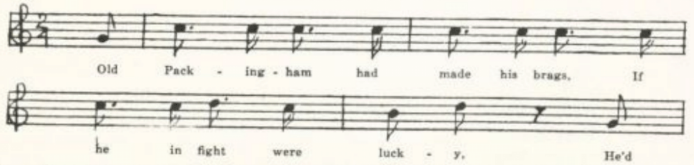
*Generals Coffee and Carroll were Jackson’s fellow officers at the battle of New Orleans
†Major General Sir Edward Pakenham was in command of the British at the battle.

(299)
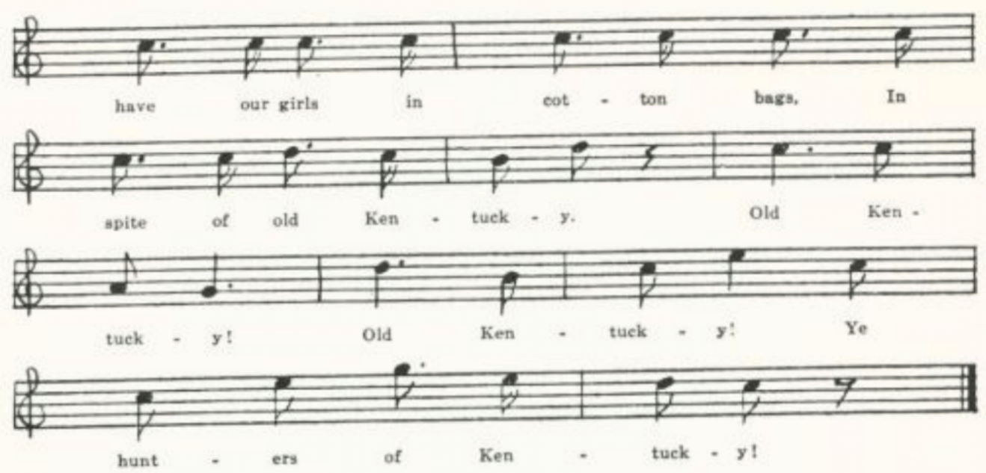
Old Packingham had made his brags,
If he in fight were lucky,
He’d have our girls in cotton bags,
In spite of old Kentucky.
Old Kentucky! Old Kentucky!
Ye hunters of Kentucky!

But General Jackson was wide awake
And wasn’t scared at trifles,
For well he knew what aim we take
With our Kentucky rifles.

He led us into cypress swamps,
Where the ground was low and mucky.
There stood John Bull in martial pomp;
And here stands old Kentucky.

Old Packingham, come take a cup,
Perhaps the last you’ll ever sup.*
We’ll send you home well pickled up,
Like hogs from old Kentucky.

*Pakenham was killed in the battle.

Springfield Mountain

This has been very thoroly studied in its various forms by Barry in BFSSNE II, III, V, VII, VIII, X, XI, XII. Altho the event on which it is based is of the eighteenth century (the death from snake-bite of Timothy Myrick of Springfield Mountain, Massachusetts, in 1761), he finds ‘no evidence that the ballad is of earlier date than the second quarter of the last century.’ It is known in tradition , for the most part in one or another of the comic forms in which it appeared on the variety stage in the thirties and forties, in perhaps all of the older states, north and south, and west as far as Texas and Montana. Two of the texts in the Missouri collection are printed in ABS 98-9.

A
No title. Secured by Miss Hamilton in 1909 from Marie Walt of the West Plains High School, as sung to her in childhood by her mother. The place is ‘near Woodville

(300)
Mound;’ the victim is ‘Deacon Jones’ oldest son;’ the girl’s name is Sal; and it is wheat, not hay, that is mowed. Printed in ABS 98-9.

B
‘The Mower.’ Secured by Miss Hamilton in 1909 from Dave Hogan of the West Plains High School. A somewhat reduced text.

‘Oh, Mollie dear, do come and see
What a venomous viper did bit me.’
With a bumble bumble dick a rid um
Able de dinctum day

‘Oh, Johnnie dear, why did you go
Away down yonder in the field to mow?’

‘Oh, Mollie dear, I thought you knowed
’Twas daddy’s hay and it had to be mowed.’

C
‘In Springfield Mountain.’ Communicated by Miss Hamilton in 1911 as known to one of her students at the Kirksville Teachers College. The man is Billie, the girl Mary. As he mowed, ‘a garter-snake gathered him by the toe,’ then ‘a rattlesnake gathered him by the heel,’ whereupon ‘he stepped back, as he thought best, right into a yaller-jackets’ nest.’ Printed in ABS 99.

The Waggoner

Böckel, Psychologie der Volksdichtung 82 says that Fuhrleute—the ‘freighters’ of our westward migration—were the Aristokraten der Landstrasse and were great singers. In England, too, carters have been purveyors of folksong. Again and again items in JFSS are traced to some carter. The following song, one of the those secured by Jesse Williams from Gen. Roby of Hamburg, Arkansas, appears to be a relic from the days of what Winston Churchill calls the Crossing. The Yadkin river affords one of the passages up the Appalachians toward the West. I have not found this song in other collections.

‘The Waggoners.’ One of the songs secured in 1905 by Jesse Williams from Gen. Roby of Hamburg, Arkansas.

September last, on the seventh day,
I geared my team to start away,
To the South Yadkin tried the road,
In order to cross the shallow ford.
Chorus:
Li ding dong daddle, lala ding dong day.
(301)
The South Yadkin was the first in course,
The Catawba was the next I crossed.
I crossed them all without delay,
But the next night’s work caused me for to slay.*

The frost it was so cold and white,
And I stripped of bothe† naked quite.
It was a night of infinite love,
And I waded up to my middle and above.

The hills they were so tall and steep,
‘Twas enough to make a tender-hearted person weep
To see the horses fall and slip
And the waggoner cursing and cracking his whip.

But now my journey is at an end.
I landed the people at their friends’
And took a horse to ride about
And view the country full out.

*This should perhaps be ‘stay.’
†So the MS. Perhaps for ‘off, bathed.’

The Wagoners

This, tho dealing with wagoners, is a quite different matter from the preceding. It is an adaptation of the English street ballad of The Jacket So Blue.

‘Song Ballad. The Wagoners’. Sent to me by Miss Simmons as written down for her in 1907 by Mrs. S. H. Doxey of Berryville, Carroll County, Arkansas. It is somewhat incoherent, and apparently defective in some places.

There is a company of wagoners I will . . . . . to
From old East Tennessee to Colorado did go.
There is one in that company I wish I’d never knew.
He is a jolly wagoner with a jacket so blue.

One morning I rose from my bed,
And our pretty Polly, my own waiting maid,
I called on her to dress me as a true one could do
For I had to take a trip with the jacket so blue.

Early one morning I rose from my bed,
Walked down to the wagon-yard to hear what was said.
My true lover sailed by me and away he did go.
My heart went with the jacket so blue.

There was a rich lady that always proved true and sweet.
Shall I put a stain on that jacket so blue?
(302)
Fuller and Warren

The killing of Palmer Warren by Amasa Fuller at Lawrenceburg, Dearborn County, Indiana, in January, 1820, aroused great interest not only in that pioneer community but even in the East, as appears from items at the time in newspapers in Massachusetts and Vermont quoted by Barry in his very informing discussion of this ballad (BFSSNE VIII 12-3, IX 14-7). Fuller was tried and convicted in march, the sentence to be carried out on the 31st of that month; according to a Massachusetts newspaper quoted by Barry he was reprieved by the governor, Jennings, until the 14th of August, ‘when it is supposed he then will be pardoned;’ the case was appealed to the supreme court of the state; but Fuller was finally hanged. The accounts differ as to the public feeling about Fuller. O. H. Smith, Early Indiana Trials and Sketches (Cincinnati, 1858) pp. 8-9, says that ‘these young men were highly respected in Lawrenceburg, especially Fuller, who was a great favorite,’ and that ‘the people in Dearborn almost in mass signed a petition to the Governor for the pardon of Fuller.’ Smith was Warren’s fellowboarder in Lawrenceburg at the time. Eastern newspaper accounts at the time, however, were hostile to Fuller; the Vermont Intelligencer news item calls him ‘the villain’ and describes Warren in much the same language that Smith applies to Fuller, and a dispatch from Cincinnati to the Franklin Herald of Greenfield, Massachusetts, just after the reprieve had been granted, noted that ‘public indignation ran high’ that Fuller should have been reprieved, and that ‘the guards at the jail, upon hearing the news, discharged their pieces and refused to serve any longer.’ The balladist’s sympathies are pretty clearly with Fuller, as one would expect. There is a tradition in Indiana that the author was one Moses Whitecotton, riming justice of the peace in Indiana in the early days. But Mrs. Kate Milner Rabb of the Indianapolis Star, who gave me this information in 1929, discredits the tradition, pointing out that Whitecotton’s piece on this affair is quite another matter. Whether the charge made in various texts of the ballad that Warren had told the girl that Fuller was already married to another came out in the testimony at the trial I do not know, nor whether there was any basis in fact for the jeer at the two doctors who, when the rope broke, hanged Fuller ‘by main strength of hand’ but were none the less baulked of their ‘prey’ because the body was duly buried instead of going to the anatomist’s table. This item appears in texts as far apart as Maine, Texas, and Missouri. I have not found Fuller and Warren in ballad print, although it must have circulated in printed form (possibly in the ‘poet’s corner’ of newspapers). It has been reported from tradition in New Brunswick (by way of Maine, BFSSNE IX 14), Maine (BFSSNE IX 15), West Virginia (FSS 217), Mississippi (FSM 191-3), Texas (CS 205-9), Arkansas (Ozark Life V No. 10-11), Michigan (Adventure for 10 March 1924), and Nebraska (ABS 116-8), and Finger has it in his Frontier Ballads.

(303)
A
‘Fuller and Warren.’ Given me in 1905 by Finis Dean as known to his mother in Carroll County. Imperfectly remembered.

Oh, ye sons of Columbia, your attention I do crave
While a sorrowful ditty I will tell
That has happened here of late in the Indiana state
To a hero that few can excel.

. . . . . . .

A gold ring he gave her in token of his love,
And on that jewel was the image of a dove;
And they mutually agreed they’d be married with speed—
They were promised by the powers above.

But this fickle-minded maid had promised to wed
With Warren, another of the place;
And she struck the fatal blow that caused her overthrow
And added to her sorrow and disgrace.

When Fuller came to know he was deprived of his love
He had sworn by the powers to wed,
With a heart full of woe unto Warren he did go,
And this unto Warren he said:

‘Oh, Warren, you have wronged me to gratify your cause
By reporting I had left a promised wife.
Oh, Warren, acknowledge before I break the law;
Oh, Warren, I’ll deprive you of your life.’

Then Warren replied: ‘Your request must be denied,
For my heart to your girl is ever bound.
And further, I can say this is my wedding day
In spite of all the heroes in town.’

Then Fuller, in a passion of anguish and love
That has caused so many hearts to cry,
With one fatal shot he killed Warren on the spot,
Then smiling said: ‘I’m ready now to die.’

Young Fuller was condemned by the honorable court
Of Warrensburg and Leavenport to die,
To die that shameful death, to hang above the earth
Like Haman on the gallows so high.

(304)
When the morning drew near on which Fuller was to die
With a smile he bade the audience adieu.
Oh, how proudly he did stand! For he was a handsome man;
On his breast he wore a ribbon of blue.

. . . . . . .
And the guards dropped a tear from each eye,
Saying, ‘Cursed may she be who has caused this misery!
Would to God that in his stead she had to die.’

By the ancient history we do understand
And by the Bible we’re bound to believe
That woman has ever been the downfall of man,
As Adam was beguiled by Eve.

B
‘Sons of Columbia.’ Sent me in 1905 by Miss Lowry; sent to her by a correspondent in Baxter County, Arkansas, with a note: ‘This is a song one of the neighbors wrote for you. . . . It certainly is old.’ Closely similar to A, but has this stanza:

This freckled minded maid stood by Fuller’s side,
Her arms she pressed upon his breast,
Crying, ‘Cursed be the day that Warren came this way
For to cause only sorry and death.’

C
‘Warren and Fuller.’ Taken down in 1912 by Miss Newell from the singing of W. T. Street of Farmington, St. Francois County. He had learned it about twenty-five years before from his father, and had never seen it in print. This has matter not in A and B.
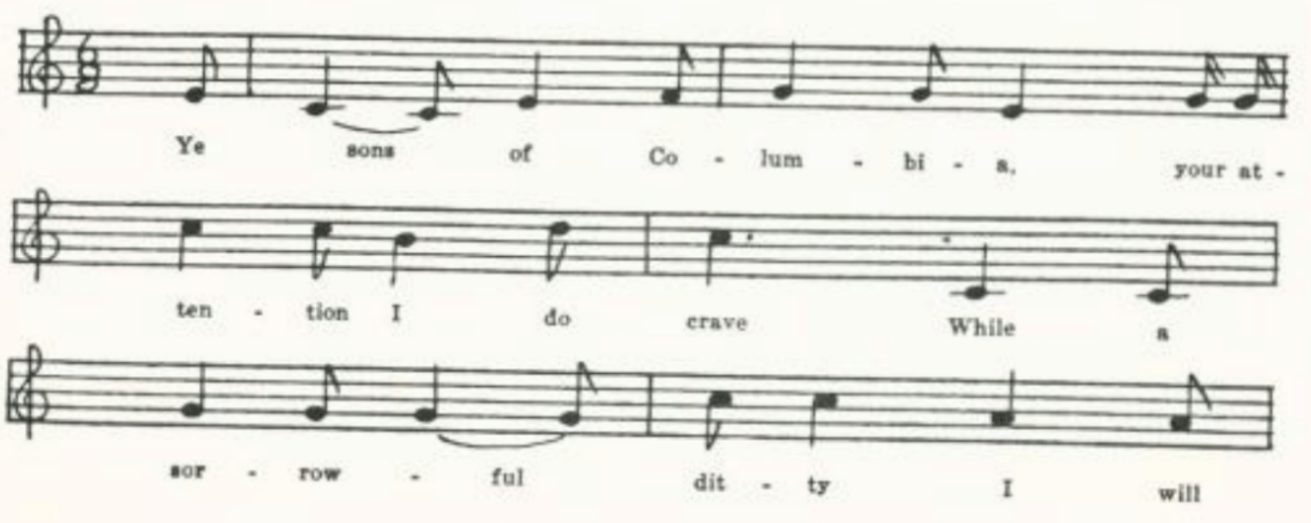
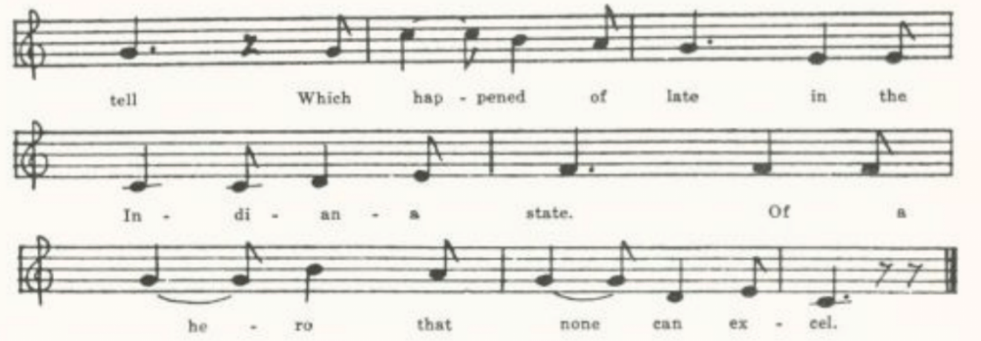
(305)
Ye sons of Columbia, your attention I do crave
While a sorrowful ditty I will tell
Which happened of late in the Indiana state
Of a hero that none could excel.

Like Samson he courted the choice of the fair
And intended to make her his wife,
When like Delilah fair she his heart did ensnare
And it cost him his honor and his life.

A gold ring he gave her as a token of true love,
And the flower was the image of a dove.
They mutually agreed to be married in speed,
And were promised by the powers above.

But this fickle-minded maid had promised to wed
Young Warren, a liver in the place.
With hearts full of woe and with sad overthrow
It ended in shame and disgrace.

When Fuller came to know he was deprived of his dear
Which he’d promised by the powers to wed,
With his heart full of woe straight to Warren he did go
And smiling unto Warren he said:

‘Oh, Warren, you have injured me to gratify your cause
By reporting that I’d lost a legal wife.
Now acknowledge that you’ve wronged me, before I break the law,
Or I will deprive you of your life.’

Then Warren said to Fuller: ‘Your request must be denied;
For my heart to your true love is bound.
Oh! Fuller, I can say this is my wedding day
In spite of all your heroes in town.’

(306)
Then Fuller, in a passion of love and anger bound,
Which at length caused many for to sigh,
With one fatal shot he killed Warren on the spot,
And smiling said: ‘I’m ready now to die.’

Then Fuller was condemned by the honorable court
Of Laurence burgeneers* for to die,
The ignominious death to hang above the earth
Like Haman on the gallows so high.

When the morning came that brave Fuller was to die,
He smiled and bid the world adieu.
Like an angel he did stand, for he was a handsome man;
On his breast he wore a ribbon of blue.

Then thousand spectators then smote upon their breasts,
And the guards dropped a tear from their eye,
Saying: ‘Cursed be she who has caused this miseree;
In his stead she had ought for to die.’

But the mighty God of love looked in anger from above,
And the rope flew asunder as the sands.
Two doctors for their prey they did murder, we might say,
For they hung him by the main strength of hand.

But his body was buried, and the doctors lost their prey,
And the lady deprived of her beau.
And his spirit it exalted above the starry skies,
While they silently lament their doom.

Of all the ancient history that I can understand,
Which we’re bound by the scripture to believe,
Bad women are essentially the downfall of man,
As Adam was beguiled by Eve.

So, young men, beware, be cautious and be wise
Of such women when you’re courting for wives.
Look in Genesis, and Judges, and in Samuel, Kings, and Job,
And the truth of the doctrine you’ll find.

For marriage is a lottery and few gain the prize
That’s both pleasing to the heart and to the eye.
So those who never marry may well be called wise.
So, gentlemen, excuse me; goodbye.

*Lawrenceburg is the county seat of Dearborn County; what the other two syllables stand for I am at a loss to say.

(307)
D
‘Warren and Fuller.’ Secured by Miss Lowry in 1920 from Earl Cruickshank of Columbus, Kansas. Of the same type as C, but more specific in certain points. Fuller says Warren has injured him ‘By reporting that I left a prudent wife.’ The balladist moralizes:

Since Satan through the hands of a woman lady’s* snare
To deprive these two heroes of their lives,
Now, young men, be cautious, be wise and beware
Of those vows when you’re courting for your wives.

And the closing stanzas—after the doctors have ‘strung him by the main strength of hand’—run:

His body it was buried and the doctors lost their prey,
And the lady was deprived of a groom.
His spirits exalting above the starry sky,
They silently lament his sad doom.

One pleasing consolation may yet remembered be;
While the rope it hung o’er his head
He believed and was baptized and from sing he was set free,
And his spirit unto glory it fled.

‘Tis not by a railing spirit nor a vicious desire,
It solemnly is not my design;
Look in Genesis and Judges, in Samuel, Kings and Job,
And the truth of the doctrine there you’ll find.

In all the ancient history that I can understand
We are bound by the Scriptures to believe
That women are essentially the downfall of man
As Adam was beguiled by Eve.

Now you who have wives that are lovely and kind,
Pray crown them with honor and love;
For ‘tis my firm opinion they are hard to find;
They’re a blessing from the powers above.

Since marriage is a lottery and few that gain the prize
That’s both pleasing to the heart and to the eye,
So they that never marry may well be called wise.
So, gentlemen, excuse me; goodbye.

*So E. C.’s copy. Read ‘laid a.’

(308)
Young Charlotte

Perhaps the most widely known and best loved of native American folk-songs. For folk-song it is, inasmuch as it is sung by the ‘folk,’ has traveled and is transmitted by oral tradition, and is to its singers as authorless, as much theirs, as any of the ballads in Child. It is not, however, in the ‘traditional ballad’ style; and its authorship is now known. Back in 1912 Barry, who had for some time been interested in it and had collected nineteen texts ranging from Maine to South Dakota, attributed it to William Lorenzo Carter, son of a Baptist preacher of Benson, Vermont, who became a Mormon and went with the Mormons to Ohio and later to Missouri, where he died. For the whole argument see JAFL XXV 156-68. It was reasonable and fairly convincing; but it has since been shown to be wrong, and that by Barry himself, who, shortly before his death in 1937, discovered that this ballad was the work of Seba Smith, the Maine-born New York journalist who under the pen-name of ‘Major Jack Downing’ satirized Jacksonian Democracy in the thirties. Smith published it in The Rovers II No. 15 p. 225, in December, 1843. See BFSSNE XII 26. Altho Barry, in the paper in which he attributed it to Carter, used the different texts in illustration of his argument fro ‘communal recreation’ of ballads, it is really surprising how little the texts, wherever found, differ—the more surprising because it does not appear to have circulated in print.* It is also somewhat surprising to find it traditionally known in Georgia and Mississippi, where sleighs, let alone freezing to death on a sleigh-ride, must be unknown. The ballad has been reported from tradition in Newfoundland (BSSN 347-8), Nova Scotia (BSSNS 161-3, SBNS 328-31), Maine (BFSSNE VIII 17-9), Vermont (FFMS 10-4, VFSB 35-8), New York (JAFL XLVIII 379-81†), Pennsylvania (JAFL XXII 367-70, NPM 72-5), West Virginia (FSS 286-91, FSWV 16-7), Tennessee (JAFL XXII 367-70, NOM 72-5), Georgia (Asb 58-9), Mississippi (FSM 182-4), Texas (PFST VI 215), Missouri (Ozark Life VI no. 1), Ohio (JAFL XXV 159-62, XXXV 421), Michigan (BSSB 135-8), Minnesota (Dean 57-8), Iowa (MAFLS XXIX 51-3), Kansas (ABS 103-7, by way of Montana), and California (FSWV 15). Barry had texts also from Massachusetts, Wisconsin, and South Dakota. It is to be found in CS, FB, and Weep Some More, My Lady. Since the texts in the Missouri collection are so nearly alike, I shall give only selections. I have not had access to

*One of the Missouri texts is said by the informant to be from ‘a printed copy.’ I have never seen it in print myself except as a collector’s item; nor apparently had Barry, at least up to the time of his JAFL article above cited, in which he says that it ‘never fell into the maw of the ballad press.’
†Doubtless many persons have bee frozen to death on a sleigh-ride. Smith was prompted to write his poem by a newspaper item of such a case in 1840. Barry’s Ohio text in JAFL XXV is said to be derived from ‘a native of Vermont who ‘knew that the story was as it is related, taking place on New Year’s Eve, and . . . either knew the people spoken of, or those who knew them”’ fern Bishop, who reports the New York text, had it from her grandmother, who professed to remember the night when the tragedy happened, presumably in Jefferson County, where she lived. And Miss Eddy, Tolman’s collaborator, was informed that the song was written ‘about Charlotte Dills, who was frozen to death at Auburn, Indiana, in 1862.’

(309)
Smith’s original text, and can only presume that the text secured from Rosa Grabel, which she said she got ‘from a printed copy,’ represents it. If so, the last three stanzas of A and like matter in other Missouri texts are accretions.

‘Young Charlotte.’ As written down for miss Williams in 1903 by W. l. Howard of Greene County.

A
Young Charlotte lived by the mountain side
In a wild and dreary spot
With no other dwelling for miles around
Except her father’s cot.

On many a cold and wintry night
Young swains would gather there;
Her father kept a social board,
And she was young and fair.

‘Twas Christmas Eve and the sun gone down.
Still she sets with a restless eye,
A-gazing upon the frosty panes
As the merry sleighs went by.

All of fifteen miles away
There’s a merry dance to-night.
The air is chilly and cold without
Yet her heart was warm and light.

Still restless beams her longing eyes ,
Till his well-known voice was heard
When dashing up to the cottage door
Young Charles in his sleigh appeared.

‘Oh, daughter dear,’ the mother said,
‘Take this blanket, around you fold;
The air is chilly and cold without;
You’ll catch your death of cold.’

‘Oh, no, no,’ the daughter said,
And she laughed like a gypsy queen,
‘To ride in blankets all muffled up
I never will be seen.

‘You know I have a silken cloak
That is lined all throughout;
Besides, I have a silken shawl
To tie my neck about.’

Her bonnet and her gloves were on,
And she jumped into the sleigh,
And away they went round the mountain side
And o’er the hills away.

‘There is music in the sound of bells
As o’er the hills we go.’
‘What a creaking noise these runners make
As they glide o’er the frozen snow!’

‘Such a night as this I never seen;
The reins I scarce can hold.’
When Charlotte said in these few words:
‘I am exceeding cold.’

He cracked his whip, he urged his team
Much faster than before,
Until five long and weary miles
In silence were passed o’er.

‘How fast,’ said Charles, ‘the driving snow
Is gathering on my brow!’
When Charlotte said in these few words:
‘I’m growing warmer now.’

It was out in the frosty air
And in the dim starlight
Till at length the village inn
And the ballroom came in sight.

(310)
Driving up to the door
He gave his hand to her:
‘Why sit you there like a monument
That hath no power to stir?’

He asked her once, he asked her twice,
Still she answered not one word;
He asked her for her hand again,
And still she never stirred.

He took her hand in his—O God!
It was cold and stiff as stone.
He moved the robe from off her brow
And the cold stars o’er her shone.

He threw his arms around her neck,
He kissed her marble brow;
His thoughts went back to where she said;
‘I’m growing warmer now.’

And, setting down by her side,
How the gushing tears did flow!
‘Alas, my young and blooming bride,
You ne’er shall know me more.’
He bore her out into the sleigh
And with her he drove home;
And when he reached the cottage door
Oh, how her parent mourned!

They mourned the loss of a daughter dear,
And Charles mourned o’er his doom,
He mourned until his heart did break—
They slumber in one tomb.

B
‘Young Charlotte.’ From Mrs. Lida Jones’s MS ballad-book, compiled in Dade County in the last quarter of the last century and secured for me in 1906 by Miss Lowry. A leaf had been torn out, leaving only the first five and a half stanzas, which show hardly any variations from the corresponding stanzas of A.

C
‘Young Charlotte.’ Written out for Miss Josephine Norville in 1907 by one of her pupils in school at Chillicothe, Livingston County. Numerous slight variations from A. in place of stanza 10 of A it has only

With muffled faces, silently
The first five miles they passed.

And it has lost the significant ‘I’m growing warmer now.’

D
‘The Frozen Girl.’ Sent to me in 1907 by J. G. Hommell of Kansas City, with the notation that he learned it at his home in the Katskill Mountain region of New York from his sister, who in turn had learned it from a cousin ‘about forty years ago.’ The tune I secured later from the sister, Mrs. S. M. Gray of Saugerties, N. Y. This text was printed by Barry JAFL XXV 162-4 as part of his argument for ‘communal recreation’ in this ballad. In no other text, so far as I know, is the breed of Charles’s team mentioned. Since this text varies in several details from others in the collection I print it here.
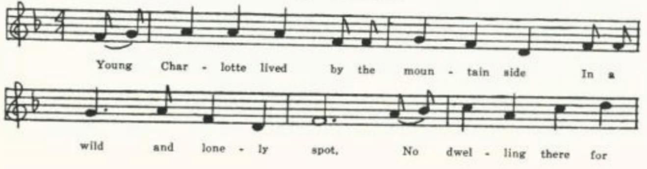
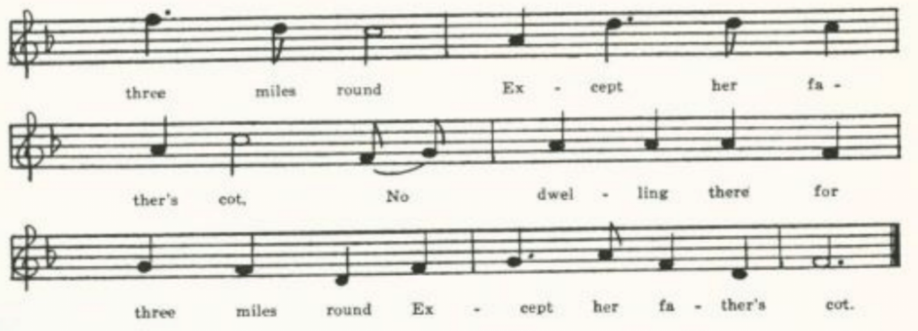
(311)
Young Charlotte lived by the mountain side
In a wild and lonely spot;
No dwelling there for three miles round
Except her father’s cot.
(Repeat the last two lines of each stanza)

At evening when their work was o’er
Young swains would gather there;
For her father kept a social board,
And she was very fair.

At the close of a cold and stormy day,
With beaming, anxious eye
Young Charlotte by the window stood
To see the sleighs go by.

The snow had fallen all day long,
The wind to westward veered—
And dashing up to the cottage door
Young Charlie’s sleigh appeared.

Charles drove a pair of Morgan blacks
That were his special pride.
His cutter had just space enough
For Lottie at his side.

‘At a village inn fifteen miles off
There’s a merry ball tonight.’
The air is freezing cold as death
But her heart is warm and light.

Her father just then coming in
It took not long to gain
Consent from him and his good wife
For Charles, their favorite swain.

Her mother said, ‘My daughter dear,
This blanket round you fold,
For it is a dreadful night abroad;
You’ll take your death of cold.’

‘Oh no! oh no!’ young Charlotte cried,
For she felt like a Gypsy Queen,
‘To ride in blankets muffled up
I never can be seen

‘You know I have a satin cloak
You know it’s lined throughout;
Besides I have a silken shawl
To tie my neck about.’

Five miles along the mountain roads
Charles drove his blacks with pride.
He was as proud as any king
With Lottie at his side.

Said Charles, ‘Such a night I never saw—
The reins I scarce can hold,’
When Charlotte said in a feeble voice,
‘I am exceeding cold.’

He swung his arms, chirped to his team,
Dashed frost from beard and brow;
When Charlotte said in a voice quite low,
‘I’m growing warmer now.’

(312)
He dashed up to the ball room door
And gave his hand to her.
‘Why sit you there like a monument
That has no power to stir?’

He took her hand in his—O God!
‘Twas cold and hard as a stone.
He took the cloak from off her breast
While the stars bright on her shone.

Young Charlotte was a frozen corpse
And never spoke no more.

E
Tune only. Secured in 1908 by Miss Helen Sewall at Hardin College, Mexico, Missouri, from a friend of hers, a Miss Acres from Texas, who had a copy of the words which she wrote when she was about twelve years old, and who set down the tune from memory.
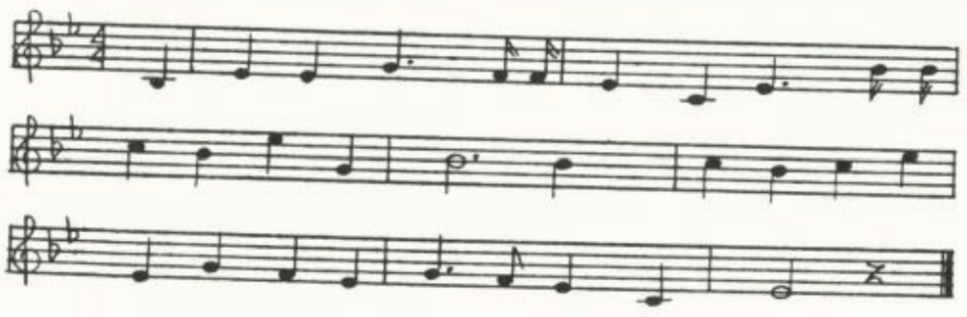
F
Another notation of the tune. Set down by Miss Mary Davis of Carthage, Jasper County.
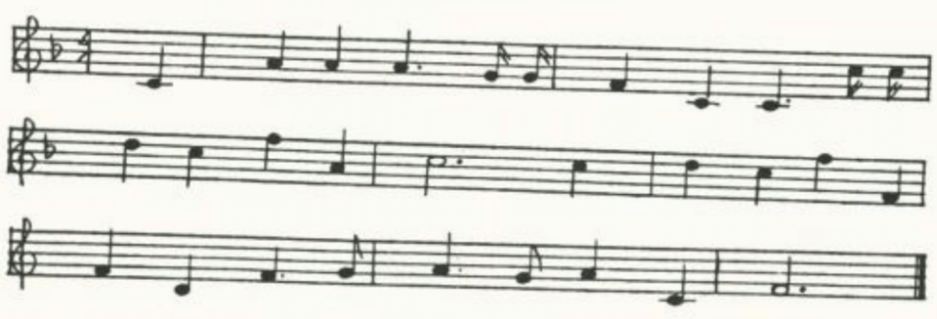
G
‘Young Charlotte.’ As remembered by Captain Joseph Frazier of the United States Army in 1909, taught to him in his childhood by his sister in Randolph County. Eighteen stanzas. Charlotte’s father ‘kept a public house;’ when her mother advised her to wrap herself in a blanket she ‘hopped like a gypsy queen.’ Has the line ‘I’m growing warmer now’ and Charles’s recollection of those ominous words after he finds she is frozen to death. Closes:

(313)
He twined his arms around her neck,
He kissed her marble brow,
And his thought went back to where she said
‘I’m growing warmer now.’

‘Twas there into the lighted hall
A lifeless corpse they bore—
Young Charlotte was the lifeless corpse;
She never spoke any more.

H
‘Ballad.’ Given me in 1909 by Byron Cosby, from a manuscript in his family, which he says ‘was probably copied by a child from memory.’ He heard it ‘sung years ago in Eastern Illinois, and also in Missouri.’ Twenty-one stanzas. The text is much like that of A, but has as its third stanza:

Her father loved to see her dress
As gay as a city belle,
For she was the only child he had
And he loved his daughter well.

The last two stanzas are:

And young Charley wrung his hands,
And as his hair he tore,
He kissed her and cried, ‘My blooming bride,
You will never be no more.’

And he threw his arms around her neck,
And kissed her marble brow,
And the thought came back to him when she said,
‘I am growing warmer now.’

I
‘Fair Charlotte.’ Given me in 1909 by Eva Ware, whose mother had learned it in Ralls County about thirty years before. Shows loss by failure of memory, and not a little verbal variation.

Fair Charlotte lived by the mountain side
In a wild and lonely spot;
There was no dwelling for three miles round
Except her father’s cot.

Fifteen miles off to the village inn
There’s a merry ball tonight.
Through piercing winds as cold as death,
Yet her heart was warm and light.

It was Christmas eve as the sun went down.
She gazed with a steady eye
All on those frosty window panes,
As the merry sleighs go by.

(314)
With rosy cheeks and sparkling eyes,
A well known voice she heard
And rushing to the cottage door
Her Charley’s sleigh appeared.

‘Oh daughter dear,’ her mother said,
‘Those blankets around you fold
For it is such a dreadful night abroad,
You’ll take your death of cold.’

‘Oh no, oh no,’ fair Charlotte said,
As she laughed like a gypsy queen,
‘To ride in blankets all muffled up
I never will be seen.’

Her father liked to see her dressed as gay
As any city belle,
For she was the only child he had,
And he loved his daughter well.

Her bonnet and her gloves went on
As she stepped into the sleigh,
And swiftly gliding by the mountain side
And o’er the hills away.

‘Such a night, such a night I never saw,
My lines I can scarcely hold.’
Fair Charlotte spoke in a trembling voice,
‘I am exceeding cold.’

Alas! alas! to the village inn
The ball room was in sight
And driving up to the tavern door,
A-thinking all was right.

He took her by the hand; oh God!
She was hard and cold like stone.
He took the mantle from her brow
And on her cold stars shone.

He took her up the lighted hall,
Her feeble form he bore;
Fair Charlotte she was cold and stiff
And never spoke no more.

Come all young girls a warning take
And always dress aright,
Never venture out so thinly dressed
On such a dreadful night.

J
‘Young Charlotte.’ Secured by miss Hamilton in 1909 from Rosa Grabeel of the West Plains High School, who said it was from a ‘printed copy.’ As such it seems worth giving here as probably the form in which it circulated in Missouri.

Young Charlotte lived on a mountain side,
In a wide and lonely spot.
There were no dwellings for three miles wide
Except her father’s cot;
And yet on many a winter’s night
Young swains were gathered there;
For her father kept a social board,
And she was very fair.

One New Year’s eve, as the sun went down,
Far looked her wishful eye
Out from the frosty window-pane,
As the merry sleighs dashed by.
At the village fifteen miles away
Was to be a ball that night;
And though the air was piercing cold
Her heart was warm and light.

How brightly beamed her laughing eye,
As a well known voice she heard;
And dashed up [to] the cottage door
Her lover’s sleigh appeared.
‘O daughter dear!’ the mother cried,
‘This blanket round you fold;
For ‘tis a dreadful night abroad,
You will get your death of cold.’

(315)
‘Oh nay! Oh, nay!’ young Charlotte cried,
As she laughed like a Gipsy queen;
‘To ride in a blanket muffled up
I never would be seen.
My silken cloak is quite enough,
You know ‘tis lined throughout;
And there is my silken scarf to twine
My head and neck about.’

Her bonnet and her gloves were on,
She jumped into the sleigh,
And swiftly they sped down the mountain side
And over the hills away.
With muffins* beat so slightly
Five miles at length were passed,
When Charles, with few and shivering words,
The silence broke at last.

‘Such a dreadful night I never saw;
My reins I scarce can hold.’
Young Charlotte faintly then replied,
‘I am exceeding cold.’
He cracked his whip, he urged his steed
Much faster than before;
And thus five other dreadful miles
In silence were passed o’er.

Spoke Charles ‘How fast the freezing ice
Is gathering on my brow!’
And Charlotte still more faintly said,
‘I’m growing warmer now.’

Thus on they rose through the frosty air
And the glittering cold starlight
Until at last the village lamps
And the ball room came in sight

They reached the door and Charles sprang out,
And held his hands to her;
‘Why sit you like a monument
That hath no power to stir?’
He called her once, he called her twice,
She answered not a word;
He asked her for her hand again,
But still she never stirred.

He took her hand in his; ‘twas cold
And hard as any stone!
He tore the mantle from her face,
And the cold stars o’er it shone.
Then quickly to the lighted hall
Her lifeless form he bore;
Young Charlotte’s eyes had closed for aye,
Her voice was heard no more.

And there he sat down by her side,
While bitter tears did flow,
And cried, ‘My own, my charming bride,
You never shall know.’
He twined his arms around her neck
He kissed her marble brow,
And his thoughts fell back to where she said
‘I’m growing warmer now.’

*Miswritten, apparently, for ‘muffled.’

K
‘Young Charlotte.’ Secured by miss Hamilton in 1909 from Mabel Davis of the West Plains High School, who knew it from the singing of her mother and her grandmother. ‘They brought it from Michigan about twenty-five years ago,’ Miss Hamilton learned. Eighteen stanzas, ending

Then quickly to the lighted hall
Her lifeless form he bore.
Young Charlotte was a stiffening corpse
And words were never spoken more.
(316)
He twined his arms about her neck
And kissed her marble brow;
And his thoughts ran back to the place where she said
‘I’m getting warmer now.’

L
‘Charollet.’ Contributed thru Miss Hamilton in 1909 by Harry Shuttee of the West plains High School, who said it was given to him by an old lady, a Mrs. Humrickshasen. Only fourteen four-lines stanzas, yet it has all the essentials of the story, including the remembering of her words, ‘I am a little warmer now,’ by Charles after he finds that she is frozen to death. The last two stanzas are:

He picked he up and he carried he out;
With her he rode alone,
Until he came to the cottage door.
O! how her parents mourn!

They mourn the love of a daughter dear
While he mourns on in gloom
Until he quite heart-broken got.
They slumber in one tomb.

M
‘Young Charlotte.’ Secured by Miss Hamilton in 1910 from Helen Rode of the West Plains High School, whose mother knew it when a child. Somewhat imperfectly remembered; Charlotte’s second response is missing, but that it was originally there is evident from the conclusion:

His mind went back to the spot where she said,
‘I am growing warmer now.’

N
‘Fair Charlotte.’ Contributed in 1912 by Arretta Watts from Lincoln County. Seventeen stanzas. Has Charlotte’s second response, but not Charles’s recalling of it after he finds that she is dead.
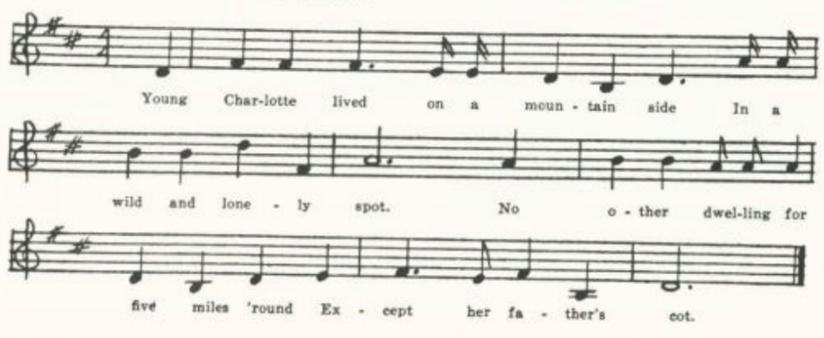
(317)
O
‘Fair Charlotte.’ A fragment of two stanzas, MS of J. M. Sommers.

P
‘Young Charlotte.’ Secured in 1920 by Miss Lowry from Earl Cruickshank of Columbus, Kansas, who got it from a Mrs. Carver there. ‘my mother knew this song once,’ Cruickshank reported, ‘but she had forgotten most of it, although she still knows the tune.’ A pretty regular text, nineteen stanzas, ending

He twined his arms around her neck
And he kissed her marble brow,
And this thoughts went back to where she said
‘I’m growing warmer now.’

Q
‘Fair Charlotte.’ Secured by Miss Beulah Wohlbeck in 1934 from Vera Frye of Dexter, Stoddard County. Eight and a half eight-line stanzas. Ends:

He kissed her once, he kissed her tweice,
He kissed her marble brow,
His thoughts ran back to where she said,
‘I am growing warmer now.’
‘Twas there into that lighted room
Her lifeless form they bore;
Fair Charlotte was a frozen corpse
Who never knew no more.

McAfee’s Confession

A goodnight, spread no doubt by print, although the only ballad print of it that I have found is that of Missouri D. The texts vary not widely but sufficiently to show that it has traveled also by word of mouth. It is known in Virginia (SharpK II 15-6), West Virginia (FSS 194-6, FSWV 21-2), North Carolina (SharpK II 15-6), Indiana (JAFL XXIX 185-7), Illinois (FSS 192-4), Iowa (MAFLS XXIX 107-9, ABS 153-4), the Ozarks (OASPS 199-201), Texas (CS 201-3), and is included in Shearin’s list and in Finger (FB 40-3). Cox had, but did not print, a text from Kentucky. So far as I know, the authenticity of the story has not hitherto been examined. The contributor of Tolman’s Indiana text, it is true, told him that ‘her mother knew Hettie Stout well;’ and one of the texts in Cox’s collection was reputed to tell of a case in Magoffin County, Kentucky. But under the title in the Missouri printed text (D) is the notation: ‘(Hanged at Dayton Ohio).’ I accordingly wrote to the Ohio Historical Society at Columbus, and received from its secretary and

(318)
librarian, Mr. Harlow Lindly, the following information: ‘The trial of John McAfee for the murder of his wife lasted two days, March 2 and 3, 1825. he was found guilty and sentenced by Judge Joseph H. Crane to be hanged March 28. Monday morning, march 28, 1825, crowds began to come in from the country. At ten o’clock in the morning, McAfee was taken from the jail and seated in a carriage, attended by the Rev. Father hill, a Catholic priest from Cincinnati, who had visited the prisoner on two previous occasions. Guarded by the militia, McAfee was conveyed to the gallows erected west of Dayton, near the Miami River. He made a confession of his crime, and was hanged at 3:00 P. M.’ The crowd from the country, and the militia guard, suggest that the case had aroused a lively interest in that frontier community, much as the case of Fuller and Warren (see p. 302) had done a few ears before in Indiana. In Sharp’s versions, which are only fragments, the name of the man does not appear and ‘Miss Hattie Stout’ has become ‘Miss Harry Gray;’ but the song is known as ‘Macafee’s Confession.’ I print here only two of the texts in the Missouri collection.

A
‘The Murdered Wife.’ Secured by Miss Williams in 1903 in Clinton County. Seventeen stanzas. The man’s name does not appear; left an orphan ‘before I reched my fifth year,’ he is brought up by an uncle; but he takes to bad courses, runs away, marries, falls in love with ‘Miss Hattie Stout,’ poisons his wife, and is now at the gallows.

B
‘McAfee’s Confession.’ Reported by Miss Lowry in 1905 as secured from an aunt, who learned it (and set it down in her ballad-book, apparently) in Indiana. Since this is an early and a full text I give it entire.

Draw near, young men, and learn of me
The sad and mournful history,
That you may never forgetful be
Of all this day I tell to thee.
I scarce had reached my fifth year
When father and my mother dear
Were both laid in their silent grave
By him who did their being gave.

No more a mother’s voice I heard,
No more a mother’s love I shared,
No more was I a father’s joy;
I was a helpless orphan boy.
But Providence, the orphan’s friend,
A kind relief did quickly send
And snatched from want and poverty
Poor little orphan McAfee.

Beneath my uncle’s friendly roof
From want and danger far aloof
Nine years was I kindly reared
And oft his good advice I heard.
But I was thoughtless, young, and gay
And often broke the Sabbath day;
In wickedness I took delight
And often done what was not right.

And when my uncle would me chide
I’d turn from him dissatisfied
And join again my wickedness
And Satan serve with eagerness.
At length arrived the fatal day
When from my home I ran away,
And to my sorrow now in life
I took unto myself a wife.

(319)
And she was kind and true to me
As any woman need to be;
And now alive would be, no doubt,
Had I ne’er seen Miss Hettie Shoup.
As well I mind the very day
When Hettie stole my heart away.
‘Twas love for her controlled my will
And counseled me my wife to kill.

‘Twas on one pleasant summer night
When al was still, the stars shone bright;
My wife was lying on her bed
When I to her approached and said:
‘Dear wife, here’s medicine I’ve brought
Which I this day for you have bought.
My dear, I’m sure it will cure you
Of those vile fits; pray take it, do.’

She gave to me a tender look,
Then in her mouth the poison took;
Then with her baby on her bed
Down to her last long sleep she laid.
And, fearing she was not yet dead,
Upon her throat my hands I laid.
And, fearing she was not yet dead,
Upon her throat my hands I laid
And they such deep impression made
Her soul soon from her body fled.

Then was my heart filled full of woe;
I cried, ‘Oh, whither shall I go?
How shall I quit this lonesome place,
The world again how shall I face?
I’d feely give up all my store,
If I’d a thousand pounds or more,
If I could bring again to life
My dear, my darling murdered wife.’

Her body’s now beneath the sod,
Her soul, I hope, is with its God;
And soon into eternity
My guilty soul shall also be.
Young men, young men, be warned by me;
Pray shun all evil company,
Walk in the ways of righteousness,
And God your soul shall surely bless.

The moments now are drawing nigh
When from this world my soul shall fly
To meet Jehovah at his bar
And there my final sentence hear.
Dear friends, I bid you all adieu,
No more on earth shall I see you;
But on heaven’s bright and flowery plain
I hope to meet you all again.

January 20 1863

C
‘McAfee’s Confession.’ From the MS ballad-book of Mrs. Lida Jones of Everton, Dade County, compiled in the last quarter of the last century and secured for me by Miss Lowry in 1906. Fourteen stanzas. No uncle mentioned. The other woman is ‘Miss Hettie Stout.’

D
‘McInfee’s Confession on the Gallows.’ Under the title is printed ‘(Hanged at Dayton Ohio).’ Secured in 1912 by Miss Newell in Farmington, St. Francois County; the tune from the singing of Mr. T. B. Chandler, the text from ‘a book of ballads and songs . . . . bought by him from blind man selling them through that town about ten years ago. He learned several tunes for different corners.’ Altho it differs little from B, I reproduce the text here as being the only printed ballad text of the piece that I have found.

(320)
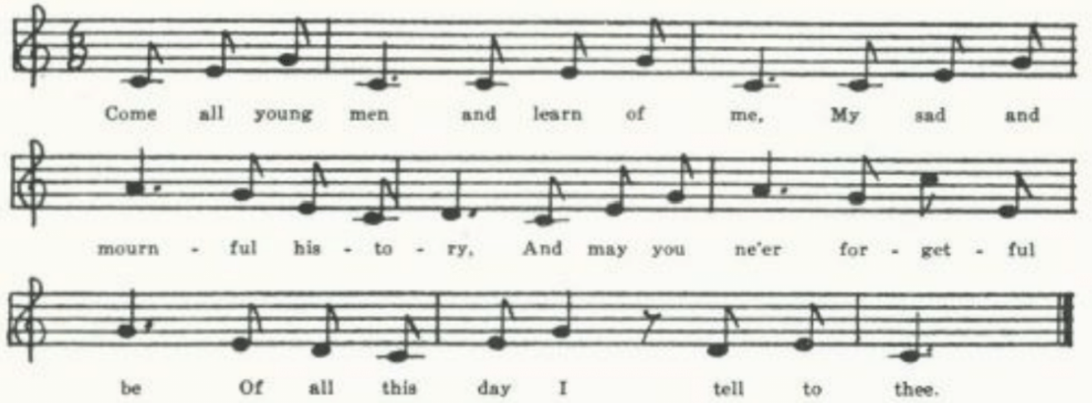
Come all young men and learn of me,
My sad and mournful history,
And may you ne’er forgetful be,
Of all this day I tell to thee.

I scarce had reached to my sixth year,
Before my father and mother dear,
Were both laid in their silent grave,
By him who did their beings give.

No more of father’s voice I heard,
No more of mother’s love I shared;
No more was I a parents joy
But left a helpless orphan boy.

But Providence, the orphan’s friend,
Did kind relations quickly send,
Snatch me from all temerity,
Poor little orphan McInfee.

Under my uncle’s kindly roof,
From toil and shame I was aloof,
For nine long years most highly reared
And often good advice I heard.

At length there came a fatal day,
When from my home I ran away,
It proved the saddest sin of life
I took unto myself a wife.

She was as good and kind to me,
As any woman need to be;
And I’d have loved her I’ve no doubt,
Had it not been for Hettie Stout.

There came another fatal day,
When Hettie stole my heart away.
‘Twas love for her controlled my will,
And caused me my poor wife to kill.

‘Twas on one pleasant summer night,
When all was still the stars shone bright
My wife was lying on her bed,
When I approached her thus and said:

Said I, ‘Here’s medicine I’ve brought,
Which for you this day I’ve bought.
My dear, I know it will cure you
Of those vile fits, pray take it, do.’

She gave to me a tender look,
Then in her mouth the poison took,
And by her babe, upon the bed,
Down to her last, long sleep she laid.

But fearing she was not dead,
M hand upon her throat I laid,
And there such deep impression made
Her soul it from her body fled.

Then was my life filled full of woe,
I cried, ‘o, whither shall I go?
How can I quit this mournful place,
This world again how can I face?’

(321)
Her body’s now beneath the sod,
Her soul, I trust, is with it’s God,
And shortly in eternity,
My guilty soul will surely be.

Young men, young men, he warned by me
And shun all evil company,
Walk in the way of righteousness
And God your soul will surely bless.

I’d freely give up all my store,
Had I a thousand world or more.
If that would only bring to life,
My dear, my darling murdered wife.

But now the moment is drawing nigh,
When from this earth my soul must fly,
To meet Jehovah at his door,
And there my fatal doom to hear.

Young men, I bid you all adieu,
No more on earth shall I see you,
But there on Heaven’s bright golden plain
I hope to meet you all again.

E
‘The Drunkard’s Confession.’ Secured by Miss Hamilton in 1912 at the Kirksville State Teachers College from J. W. Waugh, who had learned it in Buckhannon, West Virginia. Eight stanzas; imperfectly remembered.

F
‘McAfee’s Confession.’ From the MS ballad-book of A. E. Allenbrand of Gentry County, compiled about the beginning of the century. Copied out by Miss Hamilton in 1923. Seventeen stanzas, normal text.
______________________

Not the same piece, tho telling a similar story, is the following, contributed by Professor John Robert Moore, then an instructor at Washington University, St. Louis, in 1922. It came to him thru one of his students as a fragment remembered by Mrs. Charles Dillard of Crane, Stone County.

Henry Green

Come listen to my tragedy both people young and old,
And I’ll tell to you a story that will make your blood run cold.
‘Tis of a fair young damsel, Miss White was her name,
Who was poisoned by her husband and he hung for the same.

They hadn’t been married scarcely three weeks when she was taken ill.
Great doctors they were sent for to try their power and skill,
Great doctors they were sent for to try her life to save,
But it was pronounced by many she must go to her grave.

Her brother a-hearing of these strange new straightways to her did go
Saying, ‘Sister dear, you’re dying, the doctors tell me so,’
Crying, ‘Sister dear, you’re dying, your life is at an end.
And have you not been poisoned by him you call your friend?’
(322)

Oma Wise

This is on the same theme as The Oxford Girl (see pp. 133-6) and Florella (see pp. 324-30). It lacks, however, the fence stake as the instrument of murder and the bleed at the nose as the means of detection which are diagnostic of The Oxford Girl. The persistence of the names Oma (Omie, Ommie, etc.) Wise for the girl and John Lewis (Luther in one Kentucky text) for the man suggest that it may have had a historical event as its origin. They go off riding double in practically all texts, not afoot as in Florella. Sometimes he beats her first, but most often he simply throws her in the river to drown. The crime is revealed by the discovery of the body, often by her brother while he is fishing; and sometimes the man is denounced by the girl’s mother. The scene of the crime is in most texts ‘Adam’s Spring.’ All things considered, it has the appearance of having been made, like Pearl Bryan, by some local balladist upon an actual event. Mr. Lunsford, in a note on his text in FSSM, says that ‘Jonathan Lewis drowned his sweetheart, Naomi Wise, in 1808, in Deep River,’ North Carolina. Texts have been recorded, so far as I can learn, only in the south: Virginia (FSSH 228-9), Kentucky (JAFL XLII 281-2, XLV 135-7, ETWVMB 30-1, FSSH 221-3, 227), North Carolina (SharpK II 145-7), SSSA 73-4, FSSH 223-7, FSSM 28-9), Mississippi (FSM 187-8), and the Ozarks (OASPS 201-3). On the Banks of the Ohio, reported by Henry from North Carolina (SSSA 76, BMFSB 44-5, FSSH 220-1), tells very much the same story but with different names.

A
‘Pretty Oma.’ Secured by W. S. Johnson in 1903 from Mr. Vaughan, principal of the high school at Tuscumbia, Miller County. Imperfectly remembered.

‘Come jump up behind me and away we will ride
Till we come to Squire Gardner’s, and I’ll make you my bride.’

She jumped up behind him and away they did ride
Till they came to deep waters by the river’s divide.

‘Oh Oma, oh Oma, I’ll tell you my mind;
My mind is to drownd you and leave you behind.’

He kicked her and he cuffed her till she could hardly stand,
And he drowned pretty Oma just below the mill dam.

They were hunting and searching, but it was all in vain,
When up steed Oma’s mother—she wrung her hands and cried:

‘Joe Black drowned Oma and fled to some far off land,
And was there put in prison for murdering a man.’
(323)
He made his confession that he was the very man
That drowned pretty Oma just below the mill dam.

‘Go hang me, go hang me I pray. . . . .
. . . . . . . . .

‘. . . . . . for I’m the very man
That drowned pretty Oma just below the mill dam.’

B
‘Omie Wise.’ Written down for Miss Lowry in 1920 by Earl Cruickshank of Columbus, Kansas. Stanzas 4 and 5 seem to contain memories of Florella. Cruickshank adds an interesting note: ‘This song was handed down to my mother through her grandfather, who came from Virginia. He moved from Virginia to Indiana. My mother says that he was acquainted with Omie Wise and had danced with her and went in the same circle with her. He described her as being a small light-complexioned girl. One time when he sang this song at a literary meeting or singing school in Indiana, there was a stranger at the meeting who got up and left the meeting and skipped the country. Many people thought perhaps this man might have been Lewis in the song.’ If this is to be relied on, it seems to locate the occurrence in Indiana, which is definitely the scene of Fuller and Warren (see pp. 302-7).

Come all you young people, I pray you draw near,
A sorrowful ditty you quickly shall hear.
The truth I will tell you about Omie Wise,
How Omie was deceived by Lewis’s lies.

Come al ye pretty fair maids take warning from me,
. . . . . . . .
Let this be a warning to all who pass by
That you be not deceived by Lewis’s lie.

He promised to wed her at Adam’s springs.
Some money he’d give her and other fine things.
Neither of them he gave her but flattered the case,
Saying, ‘W will be married; will be no disgrace.’

He said he’s go with her right straight to the town,
There they would be married, in union be bound.
He took her on behind him and away they did go
Till they came to the banks where the river did flow.

‘Now, Omie, poor Omie, I’ll tell you my mind;
I intend for to drown you and leave you behind.’
‘Have mercy, have mercy!’ poor Omie did cry,
Saying, ‘I’m a poor rebel and not fit to die.’

He said he’d go with her right straight to the town,
There they would be married, in union be bound.
He took her on behind him and away they did go
Till they came to the banks where the river did flow.

‘Now, Omie, poor Omie, I’ll tell you my mind;
I intend for to drown you and leave you behind.’
‘Have mercy, have mercy!’ poor Omie did cry,
Saying, ‘I’m a poor rebel and not fit to die.’
(324)
‘No mercy I’ll have,’ this hero did cry,
‘In the bottom of the river your body shall lie.’
‘Have mercy, have mercy, and spare me my life!
Let me go rejected and not be your wife.’

This hero did choke her, as we understand,
And threw her in the river below the mill dam.
Some count this high treason; but oh! what a crime
To murder poor Omie and leave her behind!

Now Omie is missing, as we all do know,
And down to the river a-hunting they go.
They found her a-floating on the water so deep,
Which caused many people to sigh and to weep.

The people they gathered to behold a great sight.
They left her on the shores all that dark stormy night.
The next day a-following the inquest was held.
No doubt but the jury their minds they could tell.

Florella (The Jealous Lover)

Similar in theme to The Oxford Girl and Oma Wise, this is none the less a distinct piece. In those, the man kills the girl to get rid of her; in this, the motive (avowed in most texts, and perhaps to be inferred in the others) is jealousy. The girl is stabbed, not drowned.* Persistent features of Florella are the rimes bloom and tomb, dew and flew (or drew), heart and part, her asking to be taken home, is plunging the fatal knife into her snow-white bosom, and her forgiving him as she dies. Common, too, is the opening ‘down Florilla, Floretta, Flora Ella, Flo Ella, Lorella, Lorilla, Louella, Lena, Emma, Emily, Alice, and (in Missouri) Nellie, Lillie, Willie, Nina, Lemo, Abbie, Abbie Summers; Edward, Edwin, Edmund, William, Willie, Henry, and (in Missouri) Elmer. See Kittredge JAFL XXX 344 and Barry AS III 441-7. Just what relation our song bears to T. H. Bayly’s ‘She never blamed him,’ which was sufficiently in vogue in Civil War times to be copied into a manuscript ballad-book in Arkansas, in not clear.† In Bayly’s song the girl is not murdered, apparently, but pines away; but the cruder imagination of ballad singers may not so have understood it At any rate one of Bayly’s stanzas,

*In Pretty Polly (or The Cruel Ship’s Carpenter), common in both England and America but not represented in the Missouri collection, the murderer has dug her grave the night before. There is no trace of this in Florella.
†Barry in the article above cited says the lines from Bayly’s song do not appear in
texts of Florella from New England and the British provinces.

(325)
She sighed when he caressed her
For she knew that they must part;
She spoke not when he pressed her
To his young and panting heart,

Appears, variously modified, in most of the Missouri texts, and another,

The banners waved around her
And she heard the bugle sound.
They passed and strangers found her
Cold and lifeless on the ground,

appears (sometimes with ‘bound’ for ‘found’) in Pennsylvania (NPM 58), West Virginia (FSS 199, 200, FSMEU 203-4), Nebraska (ABS 101), in Mrs. Richardson’s collection (AMS 31), and in Missouri D.
Florella seems to be known only on this side of the Atlantic, and only by word of mouth—at least I have found no ballad or songbook print of it. It has been reported from tradition in Newfoundland (BSSN 365-6), Nova Scotia (SBNS 320-1), Ontario (Adventure for 30 May, 1925), New Hampshire (JAFL XXII 370-2), Vermont (VFSB 59-60), Massachusetts (AS III 442-3), Pennsylvania (NPM 57-8 and 201-2), West Virginia (FSS 198-200, FSMEU 203-4, SFLQ III 19, FSWV 18-9), Kentucky (JAFL XX 264-5, BKH 65-6), Tennessee (SSSA 251, JAFL XLV 131, XLVI 39, FSSH 211-2), North Carolina (JAFL XLVI 38-9, BMFSB 26-7), Georgia (FSSH 213-4), Mississippi (FSM 185-7), Arkansas (Ozark Life V Nos. 5-6), Missouri (Ozark Life V No. 7), Illinois (TSSI 158-60), Michigan (KNR 299), Iowa (MAFLS XXIX 50), Nebraska (ABS 101-2), and Wyoming (ABS 102-3), and without exact location in AMS 30-1 and 56, SSSA 51-2, and FB 81 (one stanza only). Pearl Bryan and Leo Frank and Mary Phagan, late adaptations of it to specific crimes the former of which is rather widely known, are not represented in the Missouri collection.
Of the eighteen texts in the Missouri collection no two are just alike, but they do not differ sufficiently to justify printing all of them.

A
‘The Jealous Lover.’ Secured in 1903 by W. S. Johnson from the fiddler Waters in Tuscumbia, Miller County.

One evening when the moon shone brightly
There fell a gently dew,
When out of a cottage
A jealous lover drew.

Says he to fair young Ellen:
‘Down on the sparkling brook
We’ll wait and watch and wonder
Upon our wedding day.’

‘O Edward, I am weary,
I do not wish to roam,
For roaming seems so dreary;
Please, Edward, take me home.

(326)
‘Hard-hearted cruel monster,
Don’t draw that knife on me,
For you know not half the danger
May happen unto thee.’

But as she knelt before him
She begged him spare her life;
But in this fair young bosom
He splunged a daggered knife.

‘O Edward, I’ll forgive thee,
Though this be my last breath.
I never was deceiving,
Though I close my eyes in death.’

He smiled not when he pressed her
To his hard and cruel heart;
He smiled not when he kissed her—
‘But you and I must part.’

She died not broken-hearted,
Sickness, pain, nor woe;
But soon in death she parted
From all she loved below.

Down yander beneath the valley,
Where the violets are in bloom,
There sleeps a fair young damsel,
All silent in the tomb.

B
‘Abbie Summers.’ Communicated by J. H. Craig from pike County in 1905. he was told that it celebrated an actual occurrence in the neighboring town of Ashley, but date and particulars were not obtainable. Much the same as A, except that the girl’s name is given in full, Abbie Summers.

C
‘Down by the Weeping Willows.’ From Miss Charlotte F. Corder of Corder, Lafayette County, in 1906, who obtained it from Nellie Martin, ‘who learned it from her father, a man about fifty years old, native of North Carolina.’ The names are Lena and Edward.

D
‘Down by a Drooping willow.’ From the MS ballad-book of Mrs. Lida Jones, compiled in Dade County in the latter part of the last century and secured for me by Miss Lowry in 1906. Only a fragment, despite the transcriber’s ‘all’ at the end.

Down by a drooping willow
Where the violets fades in bloom
There lies my own true Nellie
In a dark and silent tomb.

The banners wave upon her
And shrill was bugle sound,
Till strangers came and found her
Cold, lifeless on the ground.

She died not broken-hearted
Nor sickness caused her death,
But in one moment parted
From the one she loved so well.
all

E
‘Emma.’ Sent to me by C. H. Williams from Bollinger County in 1907 as secured from ‘a schoolgirl who learned the song in the rural community in which she lives. She

(327)
knows nothing of it in print. I have heard it frequently, but with a different title and with considerable change in the wording.’ The names are Emma and Edward.

F
‘The Jealous lover.’ Sent to me in 1909 by George Williams of Bollinger County, who got it from the singing of a fiddler at Glen Allen in that county. The names are Nellie and Elmer.

G
‘The Drooping Willow.’ From the MS ballad-book of Ada Belle Cowden of Woodlandville, Boone County, secured for me by Miss Lucy Laws. The ballad-book was compiled in the first decade of this century, apparently. It is a confused text, in which the girl, whose name is Willie, seems to be the narrator part of the time, tho the opening stanza runs:

Down by the drooping willow,
Where the lovely violets grow,
There lies my innocent Willie,
So sweet and so true.

The following lines are marked ‘Chorus:’

One night in last September,
When the moon shone bright and clear,
Up stepped a jealous lover,
Up to her cabin door.

H
‘The Jealous Lover.’ Secured by Miss Hamilton in 1911 from Irma Novinger of the Kirksville Teachers College, who learned it from ‘a hired girl in Adair County.’ The names are Lillie and Edwin.

I
‘The Jealous Lover.’ Contributed in 1909 by Eva Ware as learned from a little girl at Linneus, Linn County. Eight stanzas. The names are Annie and Edwin.

J
‘Florilla.’ Secured by Miss Hamilton in 1911 from Shirley Hunt of the Kirksville Teachers College, who said that it was known by her ‘and other young people of the neighborhood’ in Scotland County. The man’s name is Edmund. It has an unusual final stanza:

And now this jealous lover
Has fled to parts unknown:
And Florilla is sleeping
So silent in the tomb.

(328)
K
No title. Another copy secured by Miss Hamilton at Kirksville, this time from a Mrs. Ballard, in 1912. Mrs. Ballard had it form her mother, Mrs. J. W. Waugh of La Plata, Macon County, ‘who learned it in Western Illinois, near Quincy.’ A normal text. The man’s name is Edmund; the girl is not named.

L
‘The Jealous Lover.’ Secured by Miss Newell in 1912 from the singing of Mrs. Chandler of Farmington, St. Francois County, who had never seen it in print. The names are Nina and Edward.
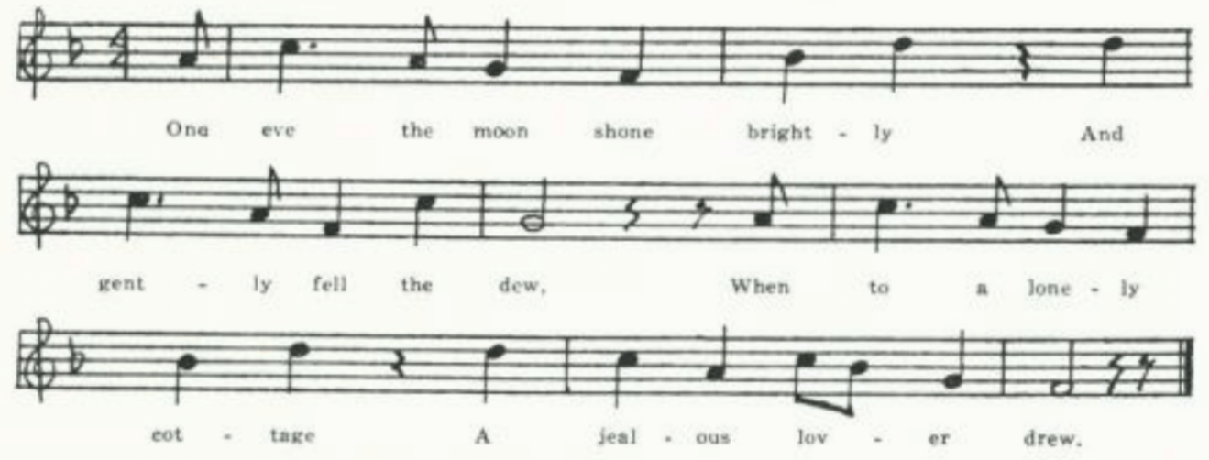

M
‘The Jealous Lover.’ Contributed by Arretta Watts, a student at the University of Missouri in 1912, as known in Lincoln County. The names are Abbie and Edwin.
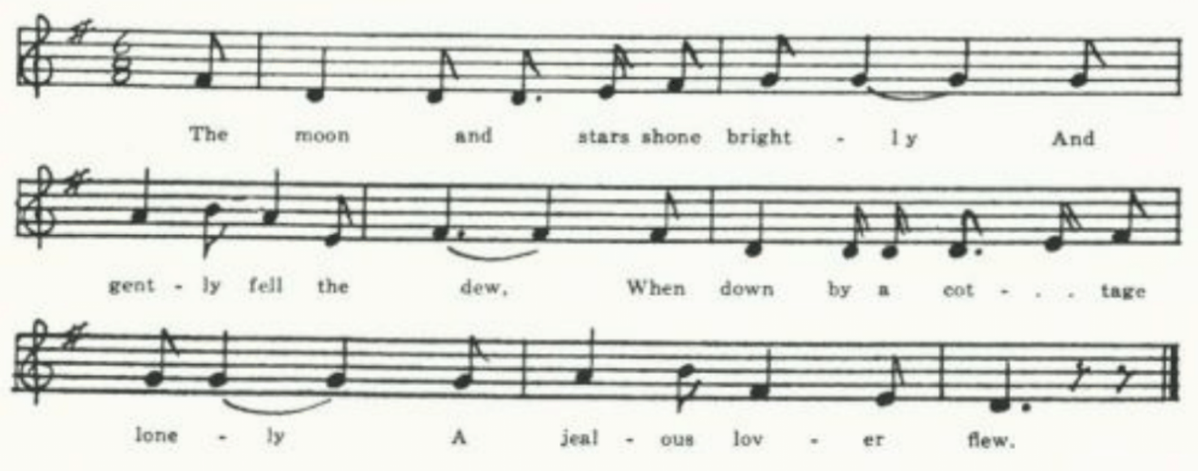
N
‘Jealous Lover.’ Communicated by Miss Hamilton, in 1912; from the sister of one of her students in the Kirksville Teachers College. The names are Emma and Edwin. A normal text of nine stanzas.

(329)
O
‘The Jealous Lover.’ Communicated in 1913 by Miss Bertha Earnest of Springfield, Greene County. The names are Lena and Edward. A normal text.

P
‘Under the Weeping Willow.’ Another text communicated by Miss Earnest. The names are Ella and Edward. The last three stanzas are not quite the usual ending:

‘Oh, farewell to my kind parents,
To parents, friend and home.
I leave you now forever,
But think of me as near.

‘I forgive you, dearest Edward,
With my last and dying breath,
But I never have deceived you.’
And she closed her eyes in death.

She knew that she was dying,
But she dreaded not her doom,
But left his world forever
With her life just at its bloom.

Q
‘Sweet Larilla.’ Communicated in 1918 by Miss Pauline Pfeiffer as learned from her pupils in a school at Piggott, Arkansas. The man is not named. Ends:

Next morn they found her body
And laid it in the grave
Down beneath the weeping willow
Where the dark green branches wave.
There sweetly sleeps Larilla
All silent in the grave.

R
‘Lemo.’ Communicated to Miss Lowry in 1920 by Earl Cruickshank, Columbus, Kansas.

Down in the lonely valley,
Where the violets used to bloom
There sleeps one gentle Lemo
Now silent in the tomb.

She died not broken-hearted,
Nor of sickness did she fall,
But in a moment parted
From the one who was dearer than all.

‘Twas on a summer’s evening,
As gently fell the dew,
Down to a lonely cottage
A jealous lover flew.

‘Come, Lemo, let us wander
Down by the meadows gay;
Come, Lemo, let us ponder
Upon our wedding day.’

‘O Edward, I am tired,
I do not wish to roam;
For roaming is so dreary.
I pray you, take me home.’

(330)
Up stepped this jealous lover
And made one solemn vow:
‘No hand on earth can save you,
For I shall slay you now.’

Down on her knees before him
She humbly begged for life.
But into her snowy bosom
He plunged the fatal knife.

‘Oh, Edward, I forgive you,
Although this be my last breath.
For I never have deceived you,’
Then she closed her eyes in death.

He sighed not when he pressed her
To his young but cruel heart.
He sighed not when he kissed her,
Though he knew that they must part.

Frankie and Albert

The origin and history of this, one of the most widely known and sung of native American ballads, has never clearly been made out. Thomas Beer, The Mauve Decade 120, says it ‘was known on the Mississippi in the ’50’s and was chanted by Federal troops besieging Vicksburg in 1863; a copy of twelve stanzas was made by a young officer and is preserved.’ And a footnote adds: ‘Mr. Emerson Hough dated this song from a murder at Natchez in the ’40’s.’ I have not been able to get any documentation of these claims. Sandburg, ASb 75, says it ‘was common along the Mississippi river and among railroad men of the middle west as early as 1888.’ John Huston, who made the story into a play (Frankie and Johnny, New York, 1930), believed it to have sprung from the killing of Allen Britt by Frankie Baker, figures in the negro underworld of St. Louis, in 1899, and declares that ‘the song has not been traced to any Frankie before her.’ Barry, BFSSNE X 24, reviewing Henry’s SSSA, suggests that it was based on the killing of Charles Silver by his wife Frankie at Toe River, North Carolina, in 1831, on the same provocation that led to the original ballad has been ‘readapted, probably more than once, to modern instances of underworld life.’ This is inherently probable (see the like phenomenon in the case of Florella and Pearl Bryan, P. 325), and would account for its appearance in the various regions and decades indicated above. It is commonly held to be of negro origin, and it is certainly well known among that race; but it is also sung by whites, from hill folk to college students, and has been an important item in the folk-song causeries of Carl Sandburg—who better than most as recognized the dramatic power of its bare narrative and the force of its refrain. It has been reported as folk-song from Connecticut (ABFS 106-10), West Virginia (FSS 216-20), Kentucky (JAFL XLII 285-6, FSSH 341-2), Tennessee (JAFL XXIV 366-7, XLII 287-9, ETWBMB 5-8, NS 228-30, ABFS 106-10), Louisiana (Lomax’s Negro Folk Songs as sung by Lead Belly), Texas (TNFS 80-5, ABFS 103-5), Arkansas (Ozark Life VI No. 2), and Illinois (ABFS 106-10);

(331)
without definite location in ASb 75-86, AMS 28-9, Read ‘em and Weep 34-9. R. W. Gordon printed a text from ‘a student in a New York college’ in Adventure for 20 August, 1923, and another learned by his informant in the Philippines in the same magazine for 10 May, 1925; he has collected something like a hundred texts. The Living Age for 29 January, 1921, quotes from the London Spectator a version secured from one of the ‘Y girls’ of the A. E. F. who ‘had learned it at one of their conferences in the middle West.’ It was parodied in the airmen’s songs of the World War; O’Neill puts it into the mouth of a New York Gangster in All God’s Chillun Got Wings; and there are divers phonograph records of it. The text in the Missouri collection is a composite.

‘Frances She Shot Albert.’ Sent to me in 1914 by H. A. Chapman of the School of Mines at Rolla, Missouri, with a letter giving some interesting details about his informants. They include, besides his mother, who knew the opening stanzas only, a wide variety: E. H., of Warrensburg, who ‘could read and write some; father was a fiddler;’ P. W., of Monserrat, Johnson County, who could sing her name, and ‘worked out;’ B. D., a negro in the poorhouse, who came from West Virginia; P.R., a cripple, fiddler, and horse-trader who ‘followed fairs;’ ‘Boar hog John, horse swipe, negro, ex-convict,’ from near Joplin; R. G., graduate of the Warrensburg Normal School, who had it from his grandmother, who came from Kentucky; a street-walker in Champaign, Illinois, ‘drunk, in Salvation Army hall;’ vagrants, ‘work-hunters . . . from hills south of Warrensburg;’ and tramps. Gordon, in 1926, wrote to me that the stanzas about waking up the minister and about the meeting at church looked to him ‘suspicious; . . . like a local addition.’ In printing the text I have included (in quotation marks) parts of Chapman’s comments.

Chorus:

He’s her man, but he done-a-her wrong,
He’s her man, but he done-a-her wrong.

‘This chorus is repeated after each verse. Sometimes only once, sometimes twice. . . . That is, four lines are sung.’ ‘The chorus is adapted to each verse. That is, if the woman is talking she says “He’s my man” etc.

Frances was a good girl,
She always went to school.
The only fault that Frances had
Was that she was a fool.

Albert as a bad man,
He always liked to sin.
The only fault that Albert had
Was drinking too much gin.

‘Another verse goes:’

Albert was a bad boy,
He never did do right.
The only thing that Albert did
Was gamble, drink and fight.

Frances was so gentle;
She always liked to cook.
The boys, they didn’t like her much
‘Cause she had that Romy look.

Chapman suggests that this may be for ‘romany’ i.e. gypsy. ‘I have heard at least seven different persons sing it Romny.’
‘Some twenty or thirty stanzas give a description of their youth; usually one verse about Frances and then one about Albert. This first part is the least often heard. It however is known southeast of Warrensburg, and yesterday a tramp was singing it. He

(332)
said he heard it in a saloon in Little Rock, Arkansas.

‘Then follows that story of the courtship.’
Frances she met Albert,
‘Twas at a shooting match.
She smiled at Albert sweetly,
His eye she tried to catch.

He looked at Frankie once,
He looked at Frankie twice.
The third time he looked at Frankie
Says, ‘She looks passing nice.’

He saw her in the church one night;
He’d peeked in through the door.
But when he saw a man with her
He walked away and swore.

Albert he kissed Frankie
Outside her mother’s gate.
‘oh, please don’t do that, Albert.
I’d have you know I’m straight.’

Albert he hugged Frankie
As they were walking’ slow.
‘Please don’t do that, Albert,
For ‘twill make my honor go.’

‘Then Albert proposes and she accepts. Then her mother hears of it and objects.’

Then right at once poor Frankie
To her little mother ran.
‘Mother, I love Albert.
I want him for my man.’

That mother, she did know best,
As only mothers can.
Pleaded with her daughter
Never to marry a gambling man.

‘Listen, oh my daughter,
To little mother dear.
Please don’t marry Albert,
For he’s a gamble-eer.’

‘Several more verses about the objections. One version has it that they were married at her home:’

The wedding took place early,
At early candle light;
‘Twas in her mother’s cottage,*
That little house so tight.

‘Then follows a long description of the wedding. Another version has it that they eloped and found a parson:’

They found a person sleeping,
They found him taking rest.
They made that parson get up
And marry them, undressed.

The parson was an old man,
His hair was awful white,
His beard it covered all his chest
When he married them that night.

‘Then they go to the city, and for a while all is lovely. But Albert gets “onery” and don’t work and spends money on other women. I’ve heard about thirty verses about this but cannot recall any of them verbatim.’

Frankie, she shot Albert,
And I’ll tell the reason why.
Ever’ dollar bill she give Albert,
He’d give it to Alice Blye.†

She went down Fourth Street
With a long knife in her hand.
Says, ‘Stand aside, your drunks and bums,
I’m lookin’ for my man.’

*Sometimes ‘cabin.’
†Sometimes ‘Alice Frye.’

(333)
She went into a hop joint,
And she didn’t go for fun.
For under her apron
She carried a forty-four gun.

She went into a hop joint
And ordered a bottle of beer.
Says to the bartender,
‘Have you seen my Albert here?

‘Now don’t tell me no story,
Now don’t tell me no lie;
If Albert’s got that girl in here
He’s shorely got to die.’

‘I won’t tell you no story,
I won’t tell you no lie;
Albert left here a while ago
With little Alice Blye.’

‘Alice sees her while they are dancing.’

‘Look a-here now, Albert,
I’m fearin’ for my life.
That woman standin’ in the door
She is your gentle wife.’

Frankie shot* at Albert once,
She shot at Albert twice;
Third time she shot at Albert
She took poor Albert’s life.

They took him to a hospital,
His life they tried to save;
But they didn’t do him any good,
For now he’s in his grave.

‘Turn me over, Frankie,
Turn me over slow;
Because them leaden bullets*
They did hurt me so.’

‘Albert forgives Frankie, but his mother does not:’

‘No! I can’t forgive you, Frankie,
No! woman, I never can.
He was your only husband,
Tho he was a naughty man.’

‘Finally he dies. . . . Then the funeral is described at much length:’

For miles around came people,
Yes to that funeral came.
They kept their faces covered
So no one knew their name.

They took him to that cemet’ry
In a rubber-tired hack,
They took him to that cemet’ry
But they did not bring him back.

‘Then Frankie is tried for murder. In this portion, the names of semi-famous local officials of a generation ago are often used.’

The judge says to the jury,
‘Now listen here to me.
This woman shot her husband
But I’m goin’ to set her free.’

‘I have given the verses exactly as I have heard them. Many of them have variations, but I have given those that I am most familiar with.’

*Sometimes ‘stabbed’ is sung for ‘shot’ and ‘cruel knife wounds’ for ‘leaded bullets.’

(334)

Root Hog or Die

This patriotic ditty, probably a variety stage production originally, was printed in The Dime Song Book (Boston, 1859) along with extensions or parodies of it in the nigger minstrel lingo, and there is a British stall print of it (without imprint) in the Harvard Library. The following text was secured by Miss Hamilton in 1909 from Edna Letsom of the West Plains High School, who found it in the Civil War notebook of Jas. L. McAnaly, Company D, Twelfth Iowa regiment.

I’ll tell you a story that happened long ago,
When the English came to America, I’m sure you all do know
They could not whip the Yankees; I’ll tell you the reason why:
The Yankee boys made ‘em sing ‘Root hog or die.’

John Bull sent to Boston, as you shall plainly see,
Forty large ships loaded up with tea.
The Yankees wouldn’t pay the tax; I’ll tell you the reason why:
The Yankee boys made ‘em sing ‘Root hog or die.’

They first met the enemy on the top of Bunker hill.
When it came to fighting I guess they got their fill.
The Yankee boys chased them off; I’ll tell you the reason why:
General Washington made them sing ‘Root hog or die.’

Then they met our Washington at Yorktown.
Then the Yankees mowed them down like grass from the ground.
Old Cornwallis gave up his sword; I’ll tell you the reason why:
General Washington made ‘em sing ‘Root hog or die.’

Then they came to Baltimore forty years ago.*
They tried to take North Point, but found it wouldn’t go.
The Baltimorians chased them off; I’ll tell you the reason why:
The Yankee boys made them sing ‘Root hog or die.’

Then they marched their army down to New Orleans.
That was the place, I think, old Jackson gave them beans.
They couldn’t take our cotton bales; I’ll tell you the reason why:
General Jackson made them sing ‘Root hog or die.’

*Observe that this line dates the piece. The attack on Baltimore was made in 1814.

(335)

Harrison Campaign Song

The exciting ‘Log cabin and Hard Cider’ campaign of 1840 produced many songs, some of which lingered long in the memory of the people. One such is the following. The ‘farmer,’ of course, is Harrison, the hero of the battle of Tippecanoe and the Whig candidate. Of the advisers of Van Buren, Amos clearly is Amos Kendall, his postmaster general and political handy-man; Levi is Levi Woodbury of New Hampshire, his secretary of the treasury; Joel is presumably Joel R. Poinsett of South Carolina, secretary of war; and john may stand for John Forsyth, of Georgia, who was secretary of state. I am not able to identify Jim.

No title. Brought to Miss Hamilton in 1912 by one of her students at the Kirksville Teachers College, a Miss McWilliams, as remembered by her father, who was then ninety-two years old.

A farmer there was
Who lived at North Bend,
Esteemed by his neighbors
And he’d many a friend.

You’ll see on a time,
If you follow my ditty,
How he took a short walk
Up to Washington City.

He’d a tidy log cabin
He left with regret,
And he put up a sign
It would be for to let.

But whate’er sights
The White House might display,
He found none so strange
As he’d seen in his day.

The farmer walked on
And arrived at the door;
And he gave such a thump
As he’d ne’er thumped before.

Run, John and run, Levi;
Run, Joel and Jim,’
Said Van, ‘but leave Amos,
I cannot spare him.

‘There’s only one living
Dares make such a to-do
As that sturdy old fellow
Called Tippecanoe.’

. . . . . .
Said Amos to Van,
‘I know how to work
This old farmer man.

‘We will ask him politely
To come up and dine,
And then we will muddle
His wits with the wine.’

. . . . . .
. . . . . .
. . . but says Tip,
‘I see what you’re at.

‘But a mug of hard cider
Will answer my turn.
It’s getting in fashion
Up here, as I learn.’

So Amos and Van
Searched the table all round.
Not a drop of hard cider
Was there to be found.

The farmer advised them
To lay in a store
By the fourth of next March,
If they did not before.

(336)
When This Old Hat Was New

Another relic of the same campaign, and from the same source as the preceding.

When this old hat was new, my boys,
The people used to say
The best among the Democrats
Was Harrison and Clay.
The locos now assume that name,
The title most untrue
And most unlike their party’s fame
When this old hat was new.

When this old hat was new, my boys,
Van Buren was a Fed,
An enemy to ever man
That labored for his bread;
And if the people of New York
Have got their records true,
He voted against the poor man’s rights
When this old hat was new.

When this old hat was new, my boys,
Sam Cushman did declare
That should a soldier cross the line
He hoped he’d perish there
And leave his bones in Canada
For enemies to view.
So much for his Democracy
When this old hat was new.

The Texas Rangers

This function of this famous organization was originally, as the song shows, to protect the settlers from Indians; later they dealt with the local ‘bad men,’ and in this capacity came to occupy in the public imagination something of the place now given to the FBI. The song retains some elements from British stall balladry. The captain’s warning before the fight appears in Nancy of Yarmouth (Catnach) and in Sea Storm (Birt), and ‘my feelings at that moment no human tongue can tell’ seems an echo of lines in President Parker (Christie II 102-3): ‘The grief I suffered at this moment, No heart can paint nor tongue can tell.’ The song is No. 748 in Wehman’s series of ballad prints, with the Limestone County, Texas.’ It has been reported from tradition in Vermont (CSV 30-1), Pennsylvania (NPM 88-9), West Virginia (FSS 262), Kentucky (BKH 191-2, where however San Antonio has become St. Sussanah and the Rio Grande ‘Ohio grand’), Tennessee (JAFL XLVI 48), North Carolina (JAFL XLII 281, FSSH 350-1, SharpK II 253, transferred in the latter text to the Civil War), Georgia (JAFL XLIV 85-7, FSSH 349-50), Mississippi (FSM 227-8), Ohio (JAFL XXXV 417-8), Michigan (KNR 300), Iowa (MAFLS XXIX 106), North Dakota (JAFL XXCI 186), and Washington (ABS 103-4, derived however from Missouri). Lomax prints a text in CS 359-61. The Missouri texts are too much alike to be given in their entirety. They are

A
‘Texas Rangers.’ From a manuscript lent to me in 1904 by Harry Fore, compiled in Gentry County in the seventies of the last century. Ten stanzas.

(337)
B
‘Texas Rangers.’ Sent to me in 1903 by Miss Simmons, secured by her from a correspondent in Carroll County, Arkansas. Seven stanzas.

C
‘Texican Ranger.’ From the MS ballad-book of James Ashby of Holt County, secured for me in 1906 by Miss Welty. Nine stanzas.

D
‘The Texas Ranger.’ Reported by C. H. Williams from Bollinger County in 1906 as sung by a country boy there about fifteen years before. ‘Not in print that I know of’—C. H. W.

About the age of sixteen
I joined a jolly band
And marched through Western Texas
Unto the Rio Grande.

Our captain he informed us,
Perhaps he thought it right:
‘Before we reach the station,
Brave boys, we’ll have to fight.’

I saw the Indians coming,
I heard them give a yell.
My feelings at that moment
No human tongue can tell.

Our bugle it was sounded,
Our captain gave command.
‘To arms, to arms!’ he shouted,
‘And by your horses stand.’

I saw the dust arising;
It seemed to touch the sky.
My feelings at that moment:
‘Oh, now’s my time to die.’

I saw the glittering sabers,
The arrows round us flew,
And all my strength it left me
And all my courage too.

We fought them full nine hours;
And when the strike was o’er
The like of dead and wounded
I never saw before.

And two as good old captains
As ever ranged the West
Were lying side by side
With arrows in their breasts.

E
‘Texas Rangers.’ Given me in 1912 by Miss Arretta Watts of Elsberry, Lincoln County, as sung by her father, who came to Missouri when a young man from Virginia.
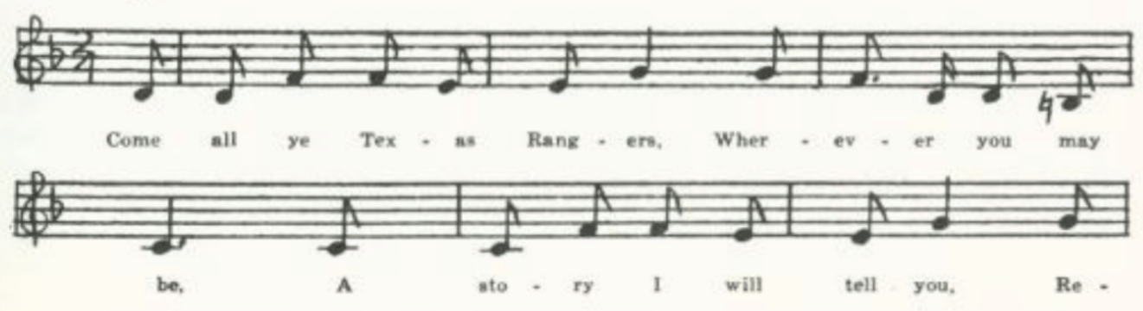
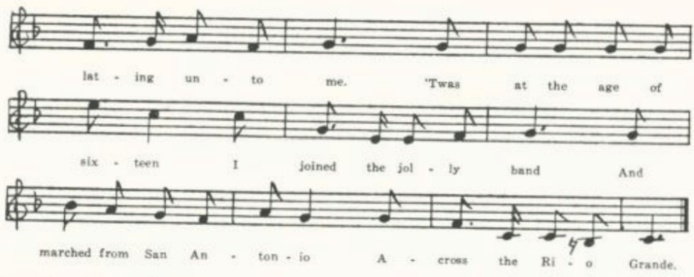
(338)
Come all ye Texas Rangers,
Wherever you may be,
A story I will tell you
Relating unto me.

‘Twas at the age of sixteen
I joined the jolly band
And marched from San Antonio
Across the Rio Grande.
Our captain he informed us,
Perhaps he thought ‘twas right,
‘Before you reach the station,
See, boys, you’ll have to fight.’

I saw the Indians coming,
I heard them give their yell;
My feelings at that moment
No human tongue can tell.

I saw the smoke ascending,
The bullets round me hailed.
My heart it sank within me,
My courage almost failed,

When some as noble Rangers
As ever trod the West
Fell mangled with their comrades.
Sweet peace may be their rest!

I thought of my old mother;
In tears she said to me:
‘Come all ye Texas Rangers
And stay at home with me.’

I thought her old childish,
The best she did not know;
My mind was bent on roaming
And I was forced to go.

Perhaps you have a mother,
Likewise a sister too,
And also a loving sweetheart
To weep and mourn for you.

If this be your condition,
Although you’re bound to roam,
I tell you from experience
You’d better stay at home.

F
No title. Given me by T. D. Glaze in 1912, from the MS of L. D. Cochrane of Harrison County, whose father came to Missouri from Ohio. The MS is dated ‘May 29, 1880.’ Similar to E, but has fourteen stanzas where that has ten. After stanza 1 of E it has

(339)
My name ‘tis nothing extra,
I’m sure I will not tell;
I am a Texas Ranger—
I’m sure I wish you well.

And in place of stanzas 4-6 of E it has

We saw the Indians coming.
Our captain gave command:
‘To arms, to arms!’ he shouted,
‘And by your horses stand!’

We saw their glittering lances,
The arrows round us hail.
My heart did sink within me,
My courage almost fail.

We saw the Indians coming,
We heard them give the yell.
My feelings at that moment
No human tongue could tell.

We saw the smoke ascended,
It almost reached the sky;
My feelings at that moment—
My time had come to die.

We fought for ten long hours
Before the strife was over.
The like of dead and wounded
I never had seen before.

Nine hundred noble rangers
As ever trod the West
Lie buried ‘side their comrades
With arrows in their breast.
or
Sweet peace may be their rest.

G
‘Texas Rangers Ballad.’ Contributed in 1912 by Helen J. Sommers of Nevada, Vernon County, whose father ‘learned it thirty years ago in Illinois.’ Five eight-line stanzas.

H
‘Texas Rangers.’ Sent to me by Miss Pound as taken down by Mrs. Eliza E. Shelman in Pickering, Nodaway County, Missouri. Fourteen stanzas. Agrees, barring some transpositions and a few slight verbal differences, with F.

Davy Crockett

This is a fragmentary memory of the negro minstrel piece described by Cox FSS 499. I have not found it recorded from tradition except in West Virginia.

‘Davy Crockett.’ Secured by C. H. Williams in 1906 from his brother George, Bollinger County, who writes: ‘I head this song several years ago but can’t remember who sang it. I know only what I give above.’

Don’t you want to hear about Davy Crockett,
Half horse, half man, and half sky-rocket?
He went out one night when the folks were all asleep.
The stars were lying on the ground about knee-deep.
(340)

Plains of Mexico

An adaptation to our war with Mexico of the various English stall ballads describing the parting of soldier-lover and his sweetheart. I have not found it recorded elsewhere.

‘Plains of Mexico.’ Secured by Miss Lowry in 1904 from L. W. Lee of Valley View, Texas, formerly of Howard County, Missouri, who learned it from a friend ‘after he returned from the Mexican War.’

‘Oh, Nancy, dearest Nancy,
Our ships they are all moored,
The signals they are flying
For us to be on board;
Tomorrow is our sailing day,
And we must haste to go
To display our country’s standards
On the plains of Mexico.’

‘Oh, Williams, dearest William,
Why leave me here alone?
You know your life to me, love,
Is more precious than my own.
Besides there’s thousand other men
Who are anxious for to go
To display our country’s standard
On the plains of Mexico.’

‘Why, would you have me stay, love,
While honor calls me now?
The mechanic leaves his workshop,
The farmer leaves his plow,
And freedom’s sons are all in arms
To show their haughty foe
That we value not their armies
On the plains of Mexico.’

‘Since you must go, dear William,
May heaven be your guide,
And when you meet your enemy
May God fight on your side;
And when you meet your enemy
And prove his overthrow,
You are welcome, my hero,
From the plains of Mexico.’

Buena Vista

Tolman JAFL XXXV 360 gives two stanzas of a form of this, ‘written down by a relative’ of his collaborator Miss Eddy, presumably in Ohio, in 1856; and Kittredge adds that the original poem, by one Col. Henry Petriken, was published in 1848 in Albert G. Emerick’s Songs for the People, Philadelphia. Lomax’s has a text of seven eight-line stanzas in CS (1910) 34-6. The following fragments do not correspond exactly with either Lomax’s print of Tolman’s, tho clearly from the same original. Emerick’s print I have not been able to consult.

‘Buena Vista.’ Communicated in 1905 by Finis Dean, from the singing of his mother, who was reared in Carroll County.

On Buena Vista’s bloody field
A wounded soldier lay.
His thoughts were on his happy home,
Some thousand miles away.

‘Oh, comrades, now,’ he said to them,
You make my last cold bed;
For ere tomorrow’s sun doth shine
I shall be number dead.

(341)
‘Oh, when you see my mother dear,
Be careful how speak.
The cords of life might snap too soon,
Her heart might cease to beat.

. . . . . .
She’s gentle as a fawn,
She lives beside a murmuring stream
Behind a sloping lawn.’
. . . . . .

The Campaign of 1856

The following fragments of campaign songs from the first election in which a candidate of the new Republican party figured, that of 1856, Miss Lowry secured from an aunt, who knew them in Indiana. J. C. Fremont, western explorer, had married the daughter of the famous senator Benton of Missouri. The Democratic candidates were James Buchanan of Pennsylvania and John C. Breckenridge of Kentucky. Whether the two stanzas belonged to the same song I do not know.

No title. Given me in 1905 by Miss Lowry, who had them from an aunt, who knew them in Indiana.

Old Benton had a daughter,
Fair Jessie was her name.
The Rocky Mountain ranger,
A-courting her he came.

Buck and Breck, neck and neck,
A yoke of oxen true,
Pulling to the Kansas log—
Gee, whoa, haw!

Joe Bowers

This is probably the best-known relic of the gold fever of ’49. Its authorship, like that of Jesse James, has been much discussed but never clearly made out. H. C. Merwin in his Life of Bret Harte (1911) 60-1 gives a detailed but quite undocumented account of its having been written by one Frank Swift, member of a band of two hundred Argonauts from Pike County, Missouri, in 1849, concerning another member of the band whose name was Joe Bowers, and sung by the band around their campfire and then passing into the repertory of Johnson’s Minstrels in San Francisco. A few years earlier W. E. Connelly in his Doniphan’s Expedition (1907) 5-14, after going over various attributions, concludes that the account given by Judge Thomas J. C. Fagg of Louisiana, Missouri, is probably right: that it was the work of one John Woodward, who was ‘connected with Johnson’s Minstrels in 1849 and the early fifties,’ and that ‘Joe Bowers’ is merely a typical figure of the forty-niners, not a real person. It is of course possible that Woodward merely picked up a song that he had heard sung by miners; but its origin in the minstrel company is inherently more probable. See Miss Pound’s discussion of the matter in

(342)
SFLQ II 131-3. Whatever its authorship, it is clearly an adaptation to American humor and the circumstances of the forty-niners of the world-old theme of ‘the girl I let behind me.’ It was printed by Partridge (No. 718), Wehman (no. 455), and DeMarsan, and frequently in song-books. Collectors of traditional balladry have found it in West Virginia (FSS 234-5), Mississippi (FSM 197-8), Illinois (TSSI 185-7), Minnesota (Dean 98-9), Nebraska (ABS 186-8), and Idaho (JAFL XXVIII 5-7), and it has served as a model or base for a lumberman’s song in Pennsylvania (NPM 46). Lomax (JAFL XXVIII 5) says he has found that it was ‘one of the popular songs among the Confederate soldiers of the Civil War’ and that he has ‘run upon men who knew it in Wyoming, in California, in Arizona, in Oklahoma, and in other States.’ It is given in ABFS 421-4 and in CS 375-7. ‘The Rambling Cowboy’ (CS 192-4, Thorp’s Songs of the Cowboys 134-5) and ‘Lackey Bill’ (CS 187-8) are adaptations of it to the life of the cowboy. There are four texts in the Missouri collection, but as they differ chiefly by omissions I give but one. The texts are:

A From Finis Dean, in 1905, as sung by his mother in Carrroll County.
B From George Williams ,Bollinger County, 1906, as sung by his uncle, who
learned it there.
C Secured by Miss Hamilton in 1910 from David Hogan of the West Plains High
School.
D From Homer Coffman, 1933, as sung by his grandfather in Phelps County, who
learned it in a mining camp in California or Nevada ‘in an early day.’

B
My name is Joe Bowers;
I’ve got a bother Ike;
I came from old Missouri,
All the way from Pike.
I’ll tell you why I left thar
And why I came to roam
And leave my poor old mammy
So far away from home.

I used to court a gal thar,
Her name was Sally Black.
I axed her if she’d marry me;
She said it was a whack.
Says she to me, ‘Joe Bowers,
Before hitch for life,
You ought to get a little home
To keep your little wife.’

‘Oh, Sally, dearest Sally,
Oh, Sally, for your sake
I’ll go to California
And try to raise a stake.’
Says she to me, ‘Joe Bowers,
You are the man to win;
Here’s a kiss to bind the bargain,’
And she hove a dozen in.

When I got in that country
I hadn’t nary red,
I had such wolfish feelings
I wished myself ‘most dead;
But the thought of my dear Sally
Soon made them feelings git,
And I whispered hopes to Bowers—
I wished I had ‘em yit.

(343)
At length I went to mining,
Put in my biggest licks,
Came down upon the boulders
Just like a thousand bricks!
I worked both late and early,
In rain, in sun, in snow—
I was working for my Sally;
It was all the same to Joe.

At length I got a letter
From my dear brother Ike,
It came from old Missouri,
All the way from Pike;
It brought to me the darndest news
That ever you did hear.
My heart is almost burstin’,
So pray excuse this tear.

It said that Sal was false to me,
Her love for me had fled,
She’d got married to a butcher—
The butcher’s hair was red.
And more than that, the letter said—
It’s enough to make me swear—
That Sally had a baby;
The baby had red hair.

Now I’ve told you all
About this said affair,
‘Bout Sally marrying a butcher,
That butch with red hair.
But whether ‘twas boy or gal child
The letter never said;
It only said the baby’s hair
Was inclined to be red.

The tune of Druns as follows:
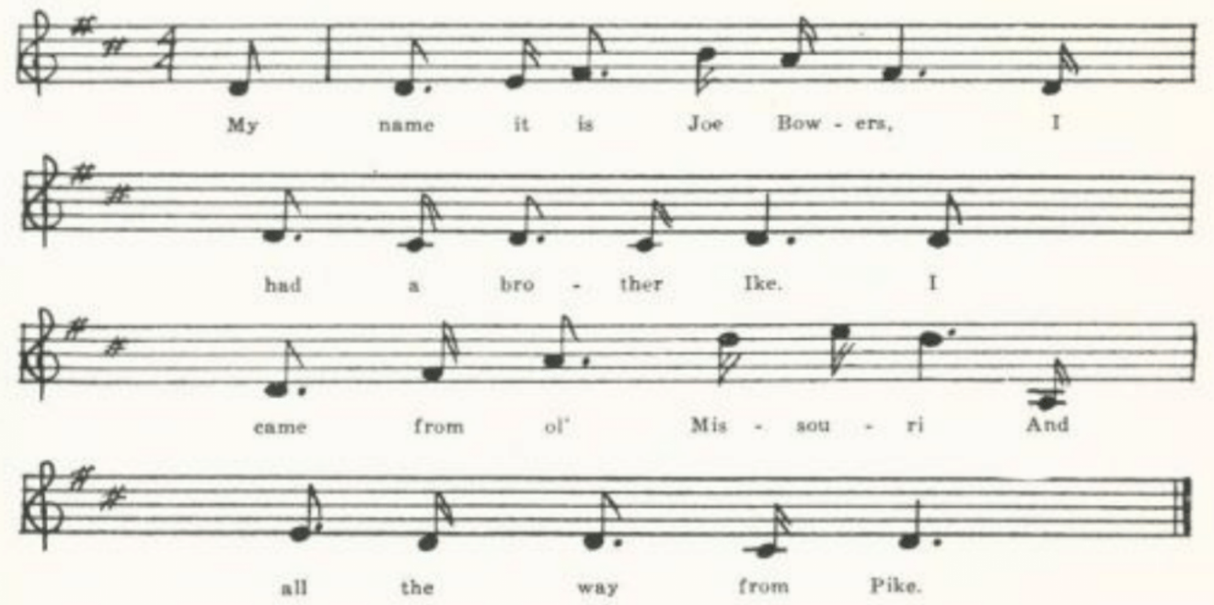

Betsy from Pike

A companion piece, in a rather broader vein of humor, to Joe Bowers. I know nothing of its history. It has been reported from Kentucky (DD 123-6), Iowa (MAFLS XXIX 106), and California (Mo. Hist. Rev. XXII 362-4, by a former Missourian), and is given without note of its provenience in ASb 108-9, CS 388-91, and ABFS 424-6. It is in Put’s Golden Songster (San Francisco, copyr. 1858) and no doubt in other song-books.

‘Betsy from Pike.’ Written down in 1904 for Miss Lowry by L. W. Lee of valley View, Texas, formerly Howard County, Missouri, who writes that it is one of the ‘ballads that we California miners used to sing with a vim in the ’50’s.’

(344)
Oh, don’t you remember sweet Betsy from Pike,
Who crossed the big mountains with her lover Ike,
With two yoke of oxen, a large yellow dog,
A tall shanghai rooster and one spotted hog?
Eli compoly compoli copelia
Eli compoly com copleria
Eli compoly com petheria
Eli compoly com petheria.

One evening quite early they camped on the Platte,
Close by the roadside on a green shady flat,
Where Betsy sore-footed lay down to repose.
With wonder she gazed on his Pike County rose.

The shanghai ran off and the cattle all died;
The last piece of bacon that morning was fried.
Poor Ike was discouraged, and Betsy was mad;
The dog wagged his tail and looked wonderfully sad.

At length the old wagon came down with a crash
And out on the prairie rolled all kinds of trash;
A few little baby-clothes done up with great care
Looked rather suspicious, though all on the square.

They went by Salt Lake to enquire the way,
When Brigham declared sweet Betsy should stay.
Betsy got frightened and ran like a deer
And Brigham stood pawing the ground like a steer.

They next reached the desert, where Betsy gave out
And down in the sand she lay rolling about.
Poor Ike, half discouraged, looked on with surprise,
Saying, ‘Betsy, get up; you will git sand in your eyes.’

At length they arrived on a very high hill,
With wonder looked down upon old Placerville.
Ike sighed, and he said, when he cast his eyes down,
‘Betsy, my darling, we’ve got to Hangtown.’

This Pike County couple attended a dance,
And Ike wore a pair of his Pike County pants;
Betsy was dressed up with ribbons and rings;
Says Ike, ‘You’re an angel, but where is your wings?’
(345)
A miner says, ‘Betsy, won’t you dance with me?’
‘I will that, old hoss, if you don’t make too free.
Don’t dance me too hard; if you want to know why,
Doggone you, I’m chockfull of strong alkali.’

This Pike County couple got married, of course,
And Ike became jealous, obtained a divorce.
Betsy, well satisfied, cried with a shout,
‘Goodby, you big lummix, I’m glad you backed out.’

I’ve Just Got in Across the Plains

A humorous recital of the difficulties of the crossing. Very likely from some song-book, many of which were printed but are not accessible to me. The text below was communicated to miss Hamilton in 1912 by one of her students at the Kirksville State Teachers College, a Miss McWilliams, from the repertory of her father, who was then ninety-two years old. On a corner of the MS was written: ‘Written on the California Trail about 1850 by Enuel Davis.’ The readings are uncertain in places, and I have indicated what seem to be omissions, tho they are not so marked in the MS. The title is simply ‘Miner’s Song.’

I’ve just got in across the plains.
I’m poorer than a snail.
My mules all died but poor old Clip
I pulled in by the tail.

I fed him last at Chimney Rock;
There’s where the grass gave out.
I’m proud to tell we stood it well
Along the trucky* route.

. . . . now poor and lean,
Tho I started plump and fat.
I wish I had the gold machine
I left back on the Platte.

And a pair of bed-tick pants
My Sally made for me
To wear when digging gold
. . . . . .

I had needles, pins and thread,
Which my mammy did prescribe,
But I left them all on Goose Creek
Where I freely did imbibe.

. . . . . .
. . . . . .
The flintlock musket loaded full
To shoot the Diggers wild.

I joined in with a train from Like
At Independence Rock.
The Indians they came in that night
And stampeded all out stock.

They laughed at me to [go] on foot;
But soon they stopped their fun
When my old mule was left behind
So poor he couldn’t run.

*Mrs. Sidney H. Robertson (who is making a detailed study of California songs) tells me that this should be ‘Truckee,’ an important point in the overland route to the gold fields—named after an Indian guide who led the Donner party there in 1844.

(346)
I packed my fancy nag,
For the rest I couldn’t wait,
And traveled up Sweet Water
Till I came to Devil’s Gate.

When my mule gave out, in sight
Of where I started in the morn,
I’d given all my boots and shoes
If I never had been born.

. . . . . .
. . . . . .
But I’d rather stripped at New Orleans
To swim around the Horn.

I arrived at Salt Lake City
On the 18th of July.
Old Brigham Young was on a bust;
He said he’d never die.

I went to see the Jordan
With a lady, God forgive her.
She took me to the water’s edge
And shoved me in the river.

I scrabbled out and started on
And managed very well
Until I struck the Humboldt,
Which I thought was nearly Hell.

I traveled till I struck the Sink,
Whose outlet can’t be found;
The Lord got through late Saturday night,
So he run it in the ground.

The Piutes stole what grub I had,
They left me not a bite;
And now the devil was to pay—
The day it was a sight.

And as the people passed along
They said to me, ‘You fool!
You never will get there in the world
Unless you leave that mule.’

I pulled, I pushed and coaxed.
At last I made a start.
His bones discreet did rattle so
I thought he’d fall apart.

I killed a buzzard now and then,
Gave Clip the legs and head.
I crossed the summit, too the trail
That to Nevada led.

There I fobbed* the town with lice
And robbed a China of his rice;
I robbed a nigger of a dollar,
Bought angwentin to grease my collar.*

I tried a pint and not one had gone.
It beat the world how I daubed it on.
. . . . . .
. . . . . .

When I got to Sacramento
I got a little tike.
I lodged about the prison brig
A half a day and a night.

I vamoosed when I got ashore,
Went to the northern mines;
Then found the saying very true
All is not gold that shines.

At home they think we ought to have
Gold on our cabin’s selves,
Wear high-heeled boots, well blacked, instead
Of rubber number twelves;
But let them come and try it
To satisfy themselves.

*This use of the verb ‘fod’ is strange to me. ‘China’ of course is for ‘Chinaman.’ ‘Angwentin’ probably stands for ‘unguentine,’ which, tho I do not find it in dictionaries, may well enough have been a trade name for an ointment used to remove lice.

(347)

When I Left the States for Gold

Another of the songs of the forty-niners secured by Miss Hamilton from Miss McWilliams in 1912. I find no other record of it. It is entitled in the MS simply ‘A Miner’s Song . . . ’49.’

When I left the states for gold,
Everything I had I sold:
A stove, a bed, and a fat old sow,
Sixteen chickens, and a cow.

Refrain:
Oh, leave, ye miners, leave;
Take my advice, kill off the lice,
Or go up into the mountains.
Oh, no, we’ve lots of dust,
Going to the city to get on a bust.

Off I started, Yankee-like,
And I soon fell in with a lot from Pike.
It first was ‘Back, gee!’ then ‘Whoa! haw!’
A ‘right smart chance’ from Arkansas.

On the Platte we couldn’t agree
Because I had the diarrhea;
We had a split-up, and I made a break
With one old mule for the Great Salt Lake.

The Mormon girls were fat as hogs,
The chief production, cats and dogs.
Some had ten wives, others none;
Thirty-six had Brigham young.

Gold

Another of the songs of the forty-niners secured by Miss Hamilton from Miss McWilliams in 1912 and not known to me form other sources. The MS is marked ‘Sung to the tune of “Lily Dale.” Composed by Enuel Davis.’

When the gold fever raged I was doing very well,
With my friend all around, young and old;
‘Twas a long time ago I bade them farewell
And embarked for the land of gold.

(348)
Refrain:
O miners, poor miners, hungry and cold,
Tho poor, I’ll return to my home far away.
Then farewell to the land of gold.

‘Twas a hard thing to part with the little ones so gay
As they played in the yard round the door,
And my wife sobbed aloud as I started away,
Saying, ‘Farewell, I’ll see you no more.’

I dreamed I was home in the old orchard tread*
With the loved ones around, it did seem;
But as I reached for the apples that hung round my head,
Disappointed I awoke from my dream.

Cold, wet, and hungry I slept on the found
While visions of happiness came;
But sad and disappointed I awoke at the sound
Of the screech-owl that lit on my claim.

*So the MS seemed to read. I am at a loss to interpret it.

Come All Ye Poor Men of the North

Another song of the gold fever, hortatory and optimistic instead of humorous. Written down for Miss Lowry in 1904 by L. W. Lee, formerly of Howard County, Missouri, as one of the ‘ballads that we California miners used to sing with a vim in the 50’s.’ No title is given. I do not know it elsewhere.

Come all ye poor men of the north who are working for your lives
For to support your families, your children and your wives:
There is easier ways of gaining wealth than toiling night and day;
Go and dig the gold that lies in California!

The fairest of all countries that lies beneath the sun,
Where lofty trees grow towering high and noble river run;
Beneath the sparkling waters as they glide to the sea
It is often there we will dig the gold that lies in California.

On ever lofty mountain, on every sunny plain,
The gold dust lies glittering like dewdrops after rain.
Beneath the shade of every tree, among the flowers so gay,
It is there we’ll dig the gold that lies in California.
(349)
What haughty, proud aristocrat can say that this is mine?
It’s for the poor as well as rich those costly treasures find.*
Why should you be engaged in work when your labors don’t repay?
Then go and dig the gold that lies in California.

Why should this noble country by Indians be run o’er,
While many of them are starving and many more are poor?
Go, rise, and with new energy and without more delay,
And go and dig the gold that lies in California.

There is many a loafer in that land, a low and shiftless race,
They do theirselves no manner of good, their country they disgrace.
Whenever I meet with one of them I unto them will say:
‘You had better be a-digging gold in California.’

*‘Find’ is presumably miswritten for ‘shine.’

The Dreary Black Hills

The gold strike in the Black Hills of Wyoming came nearly two decades after ’49, and has left but one song that is widely remembered. It has been reported from Pennsylvania (NPM 174-5) and Wyoming (ABS 185-6); texts are given without note of their provenience in CS 372-4, ASb 264-5, ABFS 384-40, and in Margaret Larkins’ The Singing Cowboy 87-90. There are two texts in the Missouri collection, differing only by slight variations. A is from the Dresia MSS secured by Miss Lowry at Columbus, Kansas, in 1909; and B was secured by Miss Newell in 1913 from Miss Ethyl Chandler of Farmington, St. Francois County.

B

Now if you listen to the tale I will tell,
I’m an object that’s needy and looking quite well,
I left off my practice selling patent right pills,*
To go digging for gold in the dreary Black Hills.
Chorus:
Don’t go there, I pray, stay away if you can,
Far away from that city that they call Cheyenne;
If Looking-glass* don’t, why, Cheyenne Bill
Will take off your scalp on the dreary Black Hills.

When I arrived in the Black Hills no gold could I find.
Then I thought of that free lunch that I’d left behind.
With mud, rain, and snowstorms froze up to my gills,
They call me the orphan boy in the Black Hills.

The round house in Cheyenne is filled every night
With people of every description and plight;
No coats on their backs, in their pockets no bills,
But still they keep striking out for the Black Hills.

Now, if you have listened to the tales I have told,
Don’t go to the Black Hills a-looking for gold;
For the railroad speculators their pockets will fill
If you go digging for gold in those dreary Black Hills.

*’Patent right’ should no doubt be ‘Wright’s patent.’ A has ‘Ayres patent pills.’ And for ‘Looking-glass’ and ‘Cheyenne Bill’ it has ‘big Wollipy’ and ‘Comanche Bill.’

(350)

The Dying Californian

For the history of this song see Kittredge’s notes JAFL XXXV 365 and XXXIX 139. It has been reported as traditional song from Newfoundland (BSSN 359-60), New York (JAFL XLVIII 381-2), West Virginia (FSS 232-3), Mississippi (FSM 221-2), and Iowa (ABS 191-3); Tolman prints two tunes for it found in Ohio (JAFL XXXV 364-5); he had the texts, but does not print them); it is in Miss Pound’s Nebraska collection; and Jackson (SFSEA 37-8) prints a text and tune from The Original Sacred Harp (Atlanta, 1911), noting that ‘it made its first appearance in fasola circles in the l859 edition of the Sacred Harp, where it is attributed to Ball and Drinkard.’ The passage of California by water, whether around the Horn or across the Isthmus, was fraught with danger, especially of disease. The Missouri text does not differ greatly from others that have been reported, but is given here for comparison.

‘The Dying Brother.’ Secured by Miss Hamilton in 1912 from Shirley Hunt of the Kirksville Teachers College.

Lie up nearer, brother nearer,
For my form is growing cold
And thy presence seemeth dearer
As thy arms around me fold.
I am dying, brother, dying;
Soon you’ll miss me from your berth,
For my form will soon be lying
‘Neath the ocean’s briny surf.

Hearken to me, brother, hearken;
There is something I would say
Ere the vale my vision darken
And I pass from earth away.
I am going, brothers, going;
But my faith in God is strong.
I am dying, brother, dying;
Yet he doeth nothing wrong.

Tell my father, when you see him,
That in death I prayed for him,
Prayed that I might one day meet him
In a world’s that free from sin.
Tell my mother—God protect her,
Now that she is growing old—
That her child would glad have kissed her
When his lips grew pale and cold.

Listen, brother, catch each whisper;
‘Tis my wife I’d speak to now.
Tell, ah, tell her how I missed her,
When the fever burned my brow.
Tell her I never reached the haven
Where I sought the precious dust,
But I’ve gained a port called heaven,
Where the gold can never rust.

(351)
Tell her she must kiss my children
Like the kiss I last impressed,
Hold them as when I last held them
Folded closely to my breast;
Give them early to their maker,
Putting all their trust in God,
And he never will forsake them,
For so he saith in his word.

Ah, my children! Heaven bless them,
They recall my life to me.
Would I could once more caress them
Ere I sink beneath the sea.
‘Twas for them I crossed the ocean.
What my hopes were I’ll not tell,
But they’ve gained an orphan’s portion—
Yet he doeth all things well.

Urge upon them to secure an entrance,
For they’ll find their father there.
Faith in Jesus and repentance
Will secure for each a share.
Hark, I hear my savior calling!
‘Tis his voice, I know full well.
When I’m gone, oh, don’t be weeping.
Brother, here’s my last farewell.

The Rolling Stone

This relic of the westward movement is interesting as an American specimen of the débat—not amatory, but prudential. It is reported from Massachusetts (CSV 32-3), Kentucky (BKH 100), and Ohio (JAFL XXXV 408-10), and was known to Hamlin Garland in his youth (A Son of the Middle Border 43-5, 446). In the Massachusetts and Ohio texts the husband proposes to go to Wisconsin; in both the Missouri texts the migration proposed is to California. The antiphonal refrain is, I believe, unique in American folk-song. Presumably it circulated in song-book or slip-ballad print, but I have not been able to trace it in that field.

A
No title. One of the songs written down in 1904 for Miss Lowry by L. W. Lee of Texas, formerly of Howard County, Missouri, as ‘ballads that we California miners used to sing with a vim in the 50’s.’

‘Since times are so hard, I’ll tell you, my wife,
I’ve a mind for to shake off this trouble and strife
And to California my journey pursue
To double my fortune as other men do;
For here we may labor each day in the field
And the winters consume all that summers do yield.’

‘Dear husband, I’ve noticed with a sorrowful heart
You’ve lately neglected your plow and your cart;
Your horses, sheep, cattle disorderly run,
And your new Sunday waistcoat goes every day on.
Now stick to your farming; you’ll suffer no loss,
For the stone that keeps rolling can gather no moss.’

(352)
‘Dear wife, let us go, and don’t let us wait.
I long to be doing, I long to be great,
And you some great lady, and who knows but I
Some great Governor before we do die.
For here we may’ etc.

‘Dear husband, remember your land is to clear;
It will cost you the labor of many a year.
Your horses, sheep, cattle will all be to buy,
And before you have got them you are ready to die.
So stick to your farming’ etc.

‘Dear wife, let us go and don’t let us stand.
We’ll buy us a farm all ready at hand,
And horses, sheep, cattle are not very dear;
And we’ll feast on fat buffalo more than half of the year.
While here we’ etc.

‘Dear husband, remember your land of delight
Is surrounded by Indians that murder at night;
Your house will be plundered and burned to the ground
And your wife and children lay mangled around.
So stick to your farming’ etc.

‘Dear wife, you’ve convinced me. I’ll argue no more.
I never once thought of your dying before.
My dear little children, although they are small,
And you, my dear wife, more precious than all.
So we’ll stick to our farming, and suffer no loss;
For the stone that keeps rolling can gather no moss.’

B
‘California Song.’ Brought to Miss Hamilton in 1909 by Allie Elliott of the West Plains High School, who had from J. L. McAnally, a Civil War veteran (Company D, 10th Iowa). Probably from McA.’s Civil War notebook or diary. It is a fragmentary and disordered text, but otherwise does not differ essentially from A.

(353)

The Call of Quantrell

The camp song (FB 64, ABFS 132-3, CS 142) about William Clarke Quantrill, the famous freebooter (also schoolteacher, and reputedly gambler and horse thief) who sacked and burned Lawrence, Kansas, in 1863 and was fatally wounded in a fight with Federal troops in Kentucky in 1865* is not in the Missouri collection. Instead it has the following romantic and ‘literary,’ composition, which appeared in print in Immortelles: A Tribute to ‘‘The Old South,” compiled by Sarah Robinson Reid and published at Little Rock, Arkansas, in 1896.

‘Call of Quantrell.’ Communicated thru Miss Hamilton in 1912 by M. F. Beach of the Kirksville Teachers College from the manuscript collection of George E. Sexton of Fayette, Howard County—presumably a Confederate veteran.

Up! Up! Comrades, up! The moon’s in the west,
And we must be gone ere the dawning of the morn;
The hounds of old Penick† will find out our next,
But the Quantrell they seek shall be far, far away.
Their toils after us shall ever be vain,
Let them scout through the brush and scour the plain;
We’ll pass through their midst in the dead of the night,
We are lions in combat and eagles in flight.
Chorus:
Rouse, my brave boys, up, up and away,
Press hard on the foe ere the dawning of the day;
Look well to your steeds so gallant and‡ chase,
That they may never give o’er till they win in the race.

When old Penick is weary and the chase given o’er,
We’ll come as a thunderbolt comes from the cloud;
We’ll pass through their midst and bathe in their gore,
We’ll smite the oppressor and humble the proud.
Few shall escape us and few shall be spared,
For keen is our saber, in vengeance ‘tis bared;
For none are so strong, so mighty in fight,
As the warrior who battles for our Southern right.

Though the bush is our home, the green sod our bed,
Our drink from the river, roots for our bread;
We pine not for more, we bow not the head,
For freedom is ever within the green wood;
Tyrants shan’t conquest, fetters shan’t bind,
For true are our rifles, our steeds like the wind;
We’ll sheathe not the sword, we’ll draw not the rein,
Till Penick is banished from valley and plain.

*According to a story in the Baltimore Sun for 10 August, 1907, he ws at that date still alive and working in a lumber camp in British Columbia under the name of John Sharp. But the DAB (quite properly, no doubt) disregards the story.
†W. R. Penick of St. Joseph, successively major, colonel, and brigadier general of the Missouri militia and active against the bushwhackers.
‡Miswritten, apparently, for ‘in.’

(354)
Blackfoot Rangers

Another of the songs from the MSS of George E. Sexton of Fayette, Howard County, secured by Miss Hamilton in 1912 thru M. F. Beach of the Kirksville Teachers College. Tho probably of newspaper or songbook origin, it is perhaps a local product. Blackfoot is the name locally given to a region in Boone County north of Columbia. Centralia in Boone County was the scene of a famous encounter between bushwhackers and Federal troops. Fayette is the county seat of the adjoining county of Howard. I have not found the song in print.

Mount! Mount! And away o’er the greenwood so wide,
The sword is our sceptre, the fleet steed our pride;
Up! Up with our flag, let its right folds gleam out,
Mount, mount and away on the wild Blackfoot scout!
Chorus:
Then mount and away, give the fleet steed the rein,
The Ranger’s at home in Blackfoot again;
Spur! Spur! In the chase dash on to the fight,
Cry vengeance for Blackfoot and God speed the right!

We heed not the danger, we heed not the foe,
When* our fleet steeds will bear us right onward we go;
For God smiles on Blackfoot and He speeds the right,
And never as cowards will we fly from the fight.

The might of the Federal gathers thick on the way,
They hear our wild shouts as we rush to the fray.
What to us is the fear of the death-stricken plain?
We’ve braved it before and we’ll brave it again.

Hurrah! my brave boys, you may fare as you please,
No Federal banner now waves on the breeze;
‘Tis the flag of the bushwhack that waves o’er each height,
While on its proud folds our star sheds its light.

*Presumably miswritten for ‘while,’ or perhaps for ‘where.’

(355)
Sterling Price

General Sterling Price, 1809-67, born in Virginia, came to Missouri in 1831 and in the Civil War was the chief figure in Missouri on the Confederate side. He and General Ben McCullough commanded the Confederate forces at the first important engagement in Missouri, the fight at Wilson’s Creek in August 1861, in which the Federal commander Captain Nathaniel Lyon, was killed. The following fragment is probably of local origin. I do not know it elsewhere.

No title. Heard by William J. Carrington of Jefferson City in 1904, sung by an old janitor of the Capitol.

Sterling Price he was a brave man,
He will clean out Dixie Land.
. . . . . . . . . .
Sterling Price he marched to Lexington
And there he took old Mulligan.*
. . . . . . . . . .
Sterling Price he wheeled his men about
And cut the Dutch into sauerkraut.
. . . . . . . . . .
Refrain:
Rinktum-polle-rodel-day

*Col. James A. Mulligan was in command of the Federal troops, 3000 of them, at Lexington, Missouri. Here he was besieged and defeated, and surrendered to Price, 20 September, 186l.

Kelley’s Irish Brigade

Partridge has two broadsides so entitled, Nos. 543 and 668, voicing Union sentiment. In the text following it has been made over for Missouri and the Confederacy.

‘Kelly’s Irish Brigade.’ One of the pieces from the MSS of George E. Sexton of Fayette, Howard County, secured by Miss Hamilton in 1912 thru M. F. Beach of the Kirksville Teachers College.

Come all you that hold communion
With southern Confederates bold,
While I tell you of some men who for the Union
In the northern ranks were enrolled;
Who came to Missouri in their “glory,”
And thought by their power we’d be dismayed;
But we soon made them tell a different story
When they met Kelley’s Irish Brigade.
Chorus:
Three cheers for the Irish Brigade,
Three cheers for the Irish Brigade;
And all true-hearted Hibernians
In the ranks of Kelley’s Irish Brigade!

(356)
You call us rebels and traitors,
But you have thrown off the name of late.
You were called it by the English invaders
At home in seventeen and ninety-eight.
The name to us we never will degrade,
And all true-hearted Hibernians
In the ranks of Kelley’s Irish Brigade.

You dare not call us invaders,
‘Tis but state rights and liberties we ask;
And Missouri, we will ever defend her,
No matter how hard be the task.
Then let true Irishmen assemble,
Let the voice of Missouri be obeyed;
And northern fanatics may tremble
When they meet Kelley’s Irish Brigade.

Old Honest Abe

This is a somewhat distorted copy of an anonymous Southern satire on Lincoln printed in Songs of the South, Richmond, 1863, of which Miss E. P. Ellinger kindly sent me a copy. The printed text has thirteen four-line stanzas, but does not indicate the repetition of the last line of the stanza. I have not found the piece reported by collectors of traditional balladry; and it is quite possible that it lasted only a little while. But the repeat at the end of the stanzas indicates that it was sung.

‘Old Honest Abe.’ Secured by Miss Simmons in 1903 from Ethel Doxey of Berryville, Carroll County, Arkansas. ‘Scot and Wool’ are, of course, General Winfield Scott and General John E. Wool, the senior officers of the United States Army when the war broke out. Scott was a native of Virginia, which accounts for line 20 of the following text. Since the MS does not make it clear whether the tune covers eight lines or only four, I have followed it I making the stanza lengths irregular.

Old honest Abe, you are a babe,
A milintary glory,*
An iron fool, a party tool,
A traitor, and a tory.
You are a boss, a mighty hoss,
A-standin in the stable,
A race or two,* and a kangaroo,
So whup us if you’re able,
So whup us if you’re able.

Dick Tater now is in a row
A-pullin of the trigger
Them that is on the South with the foamin mouth
Decoying of the nigger,
Decoying of the nigger.†

*Songs of the South has as line 2
In military glory
as line 3
An arrant fool, --a party tool—
as lines 5-8—but constituting stanza 7—
But you are boss, a mighty hoss,
A snortin’ in the stable—
A racer too, a kangaroo—
So whip us if you’re able.
†Songs of the South has as lines 3-4 of this stanza
At all the South, with foaming mouth
Decoying off the nigger.

(357)
Scot and Wool they will pull
Across the country level;
We’ll meet you there and fight you fair
And we’ll thrash you like the devil.
Wool will fly and Scot will die
Before he whups his mother.
But you will fail and tuck your tail
You everlastin villain,
You everlastin villain.*

Oh Mr. Link, what do you think
About the Southern cattle
That horns you so wherever you go
And whups you every battle,
And whups you every battle?†

*Stanzas 10 and 11 in Songs of the South run
If Scott and Wool should at us pull
Across the country level,
We’ll meet them there and fight them fair,
And trash them like the devil.

For Wool and Scott will never squat,
But one thing you’ll discover,
“That wool will fly,” and Scott will die,
Before he whips his mother.

†This is stanza 9 in Songs of the South.

The Bonny Blue Flag

S. J. A. Fitz-Gerald Stories of Famous Songs 106 says this was written in 1862 by Annie Chambers Ketchum to an Irish air adapted or composed by Henry McCarthy. Miss Ellinger in some notes she kindly sent me assigns it to McCarthy, 1862, and quotes Mildred L. Rutherford, The South in History and Literature (Athens, Georgia, 1906) to the effect that it was first sung at the Academy of Music in New Orleans in September, 1861, and that it so incensed Gen. Butler that he issued an order ‘that any man, woman, or child that sang that song, whistled or played it, should be fined twenty-five dollars.’ It is number 836 in Partridge’s and number 607 in Wehman’s ballad series. The text in the Missouri collection differs in many details of expression from that in Confederate Scrap-Book (Richmond, 1893), and still more widely from that in G. C. Eggleston’s American War Ballads I 189.

‘Bonny Blue Flag.’ Communicated by Miss Simmons in 1904 from a scrap-book belonging to her mother and compiled at Carrollton, Carroll County, Arkansas, in the early sixties of the last century.

We are a band of brothers, native to the soil,
Fighting for our property we gained by honest toil;
And when our rights were threatened, the cry rose far and near:
Hurrah for the Bonny Blue Flag, that bears a single star!
Chorus:
Hurrah, hurrah for Southern rights! Hurrah!
Hurrah for the Bonny Blue Flag that bears a single star!

(358)
As long as the Union was faithful to its trust,
Like friends and like brothers, kind were we and just;
But now that Northern treachery attempts our rights to mar
We’ll hoist on high our Bonny Blue Flag that bears a single star.

Come all you men of valor, now rally the banner of our right,
For Texas and fair Louisiana will join us in the fight;
With Davis our loved President, and Stevens, a statesman rate,
Now rally round our Bonny Blue Flag that bears a single star.

Now here’s to brave Virginia, the Old Dominion State
With the young Confederacy at last has linked her fate.
Impelled by her example, now other States prepare
To hoist on high the Bonny Blue Flag that bears a single star.

And here’s to our Confederacy! Strong are we and brave;
Like patriots of old, we’ll fight our heritage to save,
And, rather than submit to shame, to die we would prefer;
So cheer for the Bonny Blue Flag that bears a single star!

Then cheer, boys, [cheer,] and raise the joyful shout,
For Arkansas and North Carolina have both now gone out.
Then let another rousing cheer for Tennessee be given,
For the single star of the Bonny Blue Flag has grown to be eleven.

We cast our eyes far northward and lo! Missouri comes
With roar of dread artillery and sound of martial drums;
Through fire and smoke with martyr tread she braves the god of war,
So hoist on high the Bonny Blue Flag that bears a single star!

Then cheer, boys, cheer, for the dark and bloody ground
Awaking from her lethargy has caught the inspiring sound;
For noble old Kentucky shouts from her vales so green:
Make room upon the Bonny Blue Flag—Kentucky makes thirteen!

Maryland looks southward with supplicating eye
And listens with breathless haste to catch the battle cry.
When Beauregard shall tread her soil all panoplied in war
She’ll hoist on high the Bonny Blue Flag that bears a single star.

Maryland, we’ll think of thee, we’ll heed thy suppliants’ calls
As mournfully they float from out McKenny’s dungeon walls;

(359)
One corner shall be kept for thee through all the blaze of war
Upon our noble Bonny Blue Flag that bears a single star!*

Carrollton Arkansas Becca Oliver
May 24th 1863

*According to the plates of flags in the International Dictionary the Confederate flag was never the flag of a single star. In 1861 it had seven, in the corner on a blue ground; in 1863 thirteen, set in a cross in the upper left-hand corner. Several of the state flags have a single star, among them those of Texas (the ‘lone star state’) and North Carolina.

The Southern Oath

This appears, Miss Ellinger says, in Emily V. Mason’s Southern Poems of the War (Baltimore, 1867) as the work of Rosa Vertner Jeffry, with the date July 22, 1862, and the title ‘Confederate Oath’ but without date or authorship, in Allan’s Lone Star Ballads (Galveston, 1874). Numerous small variants in Taggart’s text from that given by Miss Mason (Miss Ellinger was kind enough to collate the two for me) show that the former is from memory rather than directly from print. Just when the cross appeared on the Confederate flag I do not know. According to the plates of flags in the second edition of the International Dictionary the original Confederate flag had no cross, but its ‘battle flag’ and the flag of 1863 had thirteen white stars on bands of blue arranged as a St. Andrew’s cross against a red background. Quite possibly the cross was suggested by the ‘Southern Cross’ of the constellation Centaurus, familiar to sailors but not visible from the southern states.

‘The Southern Oath.’ Sent to me by G. Taggart of Olathe, Kansas, in 1906, with the notation: ‘There are eight lines more, which I have forgotten.’

By the cross upon our banner,
Glory to our Southern skies,
We have sworn, a band of brothers,
Free to live or free to die.
We have sworn as freemen never
Swear who live to break their vows;
Northmen, by the right denied us,
You will never rule us now.

By the brave ones lost in battle,
Best and gentlest of our land,
Fighting with your Northern hirelings
Face to face and hand to hand,
By a sacrifice so priceless,
By the spirit of the slain,
Swear we now our Southern heroes
Shall not thus have died in vain.

Think you we will brook the insults
Of your fierce and ruffian chief
Heaped upon our fair-haired daughters,
Stricken down and pale with grief?
Think you, whilst astounded nations
Curse such malice, we shall bear
Foulest wrongs, with God to call on,
Hands to do and hearts to dare?

(360)
When we prayed in peace to leave you
Answering came the battle cry;
When we swore that oath which freemen
Never swear who fear to die.
Northmen, come and you shall find us
Face to face and hand to hand,
Shouting to the God of battle
‘Freedom, and our native land!’

The Homespun Dress

Miss Ellinger wrote to me that this is to be found in Miss Mason’s Southern Poems of the War (Baltimore, 1867) and in Confederate Scrap-Book (Richmond, 1893), and that it was written by Carrie Bell Sinclair in 1863. Hudson, who gives a Mississippi text and tune of it (FSM 265-6), has a different account—that it ‘was written by Lieutenant Harrington, an Alabamian belonging to Forrest’s cavalry.’ It was widely known in the South.

‘Southern Girl’s Song.’ Sent to me by Miss Simmons in 1904, from her mother’s scrap-book compiled in Carroll County, Arkansas, during the Civil War, where it is directed to be sung to the tune of ‘Bonnie Blue Flag.’

Oh, yes, I am a Southern girl,
I glory in the name
And boast it with far greater pride
Than glittering wealth or fame.
I envy not the Northern girl
Her robe of beauty rare,
Though diamonds grace her snowy neck
And pearls bedeck her hair.
Chorus:
Hurrah, hurrah,
For the sunny South so dear;
Three cheers for the homespun dress
That Southern ladies wear!

This homespun dress is plain, I know;
My hat’s quite common, too.
But then it shows what Southern girls
For Southern rights will do;
We’ve sent the bravest of our land
To battle with the foe,
And we would lend a helping hand—
We love the South, you know.

The Southern land’s a glorious land
And hers a glorious cause.
Then here’s three cheers for Southern rights
And for the Southern boys!
We’ve sent our sweethearts to the war,
But, dear girls, never mind;
Your soldier love will not forget
The girls he left behind.

A soldier lad is the lad for me,
A brave heart I adore;
And when the sunny South is free
And fighting is no more
I’ll choose me then a lover brave
From out that gallant band;
The soldier lad I love the best
Shall have my heart and hand.

And now, young men, a word to you,
If you would win the fair.
Go to the fields where honor calls
And win your lady there;
Remember that our brightest smiles
Are for the true and brave,
And that our tears fall for the one
Who fills a soldier’s grave.

Chorus:
Hurrah, hurrah
For the sunny South so dear,
Three cheers for the uniforms
That Southern soldiers wear!

Carrollton, Arkansas Transcribed by Becca
May 24th 1863

(361)
Root, Abe, or Die

‘Root, hog, or die’ was a popular song on the minstrel stage in the fifties, was turned to the purposes of national patriotism (see p. 334), and was printed by Partridge (numbers 373-373). It is here adapted to the recounting of Confederate triumphs in Missouri and to scorn of the German element in the Union army.

‘Root, Abe, or Die.’ From Rebecca Oliver’s Civil War scrapbook, sent to me by Miss Simmons in 1904.

The Dutch came to Missouri, as well you all do know,
To subjugate the rebel boys but couldn’t make it go.
They can’t whip the rebel boys, and I’ll tell you the reason why:
The Southern boys made them run—Root hot or die.

Colonel Seigle* came to Carthage to whip the rebel crew,
To feed us to the buzzards, and hang Claib Jackson* too.
But they couldn’t make the rifle; and I’ll tell you the reason why:
The Southern boys made them get—Root hog or die.

Then Lyon† came to Springfield to take another stand,
He said he’d whip us this time and drive us from our land.
He found us down on Wilson’s Creek, to whale us he did try;
But the Southern boys made them get—Root hog or die.

‘Twas on the tenth of August we heard the Lyon roar,
The grape-shot and minnie balls around like hail did pour.
But our shotguns did the work for them, and I’ll tell you the reason why:
The Southern boys made them get—Root hog or die.

“Twas there Lyon bit the dust and Seigle ran away,
Just as he did at Carthage upon a former day.
They left their wounded on the field, and I’ll tell you the reason why:
The Southern boys were after them, root hog or die.

It’s now we’ve cleared the Dutchmen, and to Jefferson we’ll go
To reinstate our government and let old Abram know
That when he wants to thrash us he gets the chance to try,
And the Southern boys will learn them how to Root hog or die!
May 25th 1862 Becca Oliver
Carrollton, Arkansas

*General Franz Sigel, a German by birth, came to this country as a prescribed revolutionary after 1848, and taught in a college in St. Louis. Having had a military training in his native country, he rose rapidly in the Union army in the Civil War. In the fight at Carthage, 5 July, 1861, he was engaged by a considerably greater number of men under Gov. Jackson and General Raines, and was not successful, but managed to withdraw his men with no great loss.
†Captain Nathaniel Lyon, energetic young officer in command of such Federal troops as there wee in Missouri at the outbreak of the Civil War and with Frank P. Blair chiefly responsible for saving Missouri to the Union in that conflict, was killed at the battle of Wilson’s Creek, 10 August, 1861.

(362)
Joe Slinsworth

A satire on the German element in the Union army—‘Dutch’ being a common name for Germans in English, and the author very likely not knowing that Holland is a distinct country. The German element was strong in St. Louis, especially after the Revolution of 1848; and these revolutionaries would naturally be opposed to slavery and would range themselves on the Union side. Presumably a camp song of the Confederates in Missouri. I have not found it elsewhere.

No title. From a scrap-book compiled in Carroll County, Arkansas, in Civil War times, and sent to me by the compiler’s daughter, Miss Emma Gertrude Simmons, in 1904. Apparently an incomplete copy, and the handwriting in some places hardly legible.

My name it is Joe Slinsworth,
I came from Amsterdam,
I am a full-blood Dutchman,
Of that there is no sham.

I comes off to this country;
They say the land is free.
And then I makes much money.
This is the land for me.

When I lands off the ship
The politicians say
Must vote for negro freedom.
Myself upon this way.

Do I makes myself Republican
And do as they do tell.
I walks up like a sovrin
And that does mighty well.

One day as I was drinking
Mine class of lager beer—
I thought there was no danger
In this great country here—

They all cry out ‘disunion’
And ‘union,’ very loud;
They make us walk together
In one very big Dutch crowd;

They say that some must now*
This Union for to save;
My God in heaven, did I think
Such a country I should find!

The first thing we did
Was to take old General Frost,†
And kill women in our way
To Camp Jackson which we crossed.

*So the MS seems to read.
†Brig. Gen. Daniel M. Frost was in command of the Missouri Militia at Camp Jackson, St. Louis, which surrendered to Captain Lyon 10 May, 1861. In the excitement on that occasion some shooting occurred, and a few of the bystanders were killed.

(363)
And next we came to Raly.*
Oh, how the Secesh run!
We made them get on every side;
It was such glorious fun!

And then we came to Springfield,
And there we stopped and stayed
Till our General Lyons
Got his plans well laid.

We heard that Price got . . .
Most all of his Secesh
Was camped away on Crain Creek
And was in a pretty mess.

So we go down there,
Till within about four miles;
And now we thinks we’ve got them,
We’ll eat them upon good old German style.

But Price he was too strong for us.
And then we run right back,
But not until he showed us
How nice the rifle cracked!

We made no stop, we hurried
Right into Springfield town,
Ad we fined† ourselves good
Mid† cannon all around.

Old Price and Ben‡ they came along
And stopped on Wilson Creek.
Now we thinks we have got ‘em,
We’ll whip ‘em mighty quick.

So we goes gown in the night time
And lays till break of day;
And then our guns did shoot
And our battries did play—

The entry in the scrap-book breaks off here. The original no doubt continued with a satirical account of the battle of Wilson’s Creek, the death of Lyon, and Sigel’s retreat to Rolla.

*Rolla, Phelps County, at that time the terminus of the west branch of the Pacific Railroad, and the place to which Sigel retreated after the battle of Wilson’s creek.
†’Fined’ is perhaps for ‘found,’ perhaps for ‘fixed’; and ‘mid’ is no doubt meant for German ‘mit.’
‡General Ben McCullough, a hero of the Mexican War, was with Price at the battle of Wilson’s Creek in the summer of 1861 and was killed the next spring in the fight at Elkhorn Tavern, Arkansas.

Happy Land of Canaan

Evidently a minstrel-stage song remade to catch the favor of Confederate sympathisers; tho the refrain suggests that it was made on the basis of some hymn or religious song—a ‘spiritual,’ perhaps. I have not found it elsewhere, unless the ‘Ha, ha, ha,’ reported by Sharp from Kentucky (SharpK II 201) is a form of it. The Kentucky fragment has a like refrain (‘the happy land of money’) and a like spirit, but is conceived from the Union point of view.

‘Over the Happy Land of Canaan.’ Sent to me in 1916 by T. C. Wright of Tuscumbia, Miller County, as sung by his father. I have no explanation to offer of the fourth word in the first line.

At Harper’s Ferry decessions they had an insurrection;
Old Brown thought the niggers would sustain him;
But old Governor Wise* put the spectacles on his eyes
And sent them over to the happy land of Canaan.

(364)
Chorus:
Hah, hah, hah! La, la, la!
The time of our glory is a-coming;
For we yet will see the time when all of us will shine,
For we’ll drive the Dutch from the happy land of Canaan.

There were some Japanese came here to raise a breeze,
And they brought little Tommy to entrain them;
But he fell in love with a pretty little dove,
And they sent him over the happy land of Canaan.

The ladies nowadays promenade Broadway,
The size of their hoops am a-gaining;
If they stop to have a talk they cover up the whole sidewalk,
Till there is no room in the happy land of Canaan.

*Henry A. Wise as governor of Virginia signed the death warrant of John Brown in 1859.

The Southern Wagon

R. B. Buckley’s song Wait for the Wagon was immensely popular in the dozen years or so before the outbreak of the Civil War, and lasted well down into my own time. It was parodied to express political feeling on both sides in that contest. A traditional version of the Southern for from Mississippi is given by Hudson, FSM 262. The form in the Missouri collection satirizes the Confederacy.

‘The Southern Wagon.’ Brought to Miss Hamilton in 1909 by Edna Letsom of the West Plains High School, who had it from Jas. L. McAnally, formerly of Company D, 10th Iowa.

Jeff Davis built a wagon and on it put his name,
And Beauregard was made the driver of secession’s ugly frame.
The horse he would get hungry, as most of horse do;
They had to keep the collar tight to keep from pulling through.
Chorus:
Bully for the wagon,
The new secession wagon;
Beaury holds the horse in
While you all take a ride.

The axles needed greasing, the body wasn’t wide;
North Carolina jumped into it, Mississippi by her side.
Virginia took a cushioned seat, and Louisiana next;
South Carolina got to scrouging, and Florida got vexed.

(365)
They asked Kentucky to take a ride; she said the horse was blind.
She shook her head at seeing Tennessee jump on behind,
But Jeff assured her all was right, the wagon it was new.
Missouri winked at Beauregard and said it wouldn’t do.

Old Scott brought out his wagon, one that had run for many years;
They caught old Union, hitched him up, and greased the running gears.
Said Scott to McClellan, ‘You’re the boy I want to fill my place,
So take rhe reins, and get the folks, and give Secesh a race!’

New York and Pennsylvania with a host of Yankee boys
Got up into the wagon and called for Illinois
And old Ohio she jumped in. Missouri tried her luck,
And Indiana threw her arms around old Kentuck.

Old Union threw his head back; he traveled rather slow
Until they reached Manassas; they hollered ‘Let him go!’
Their cheers for the Union made him put new mettle in his heel
As he ran into Secession, tore the spokes out of a wheel.

They took the broken wagon back and put in all new spokes.
Secesh went down towards Kentuck to tell it to the folks.
Old Union started after, and he made the welkin ring
When he ran into Secession at a little place, Mill Spring

Secesh got scared and ran away, the like was never seen.
Old Union threw his heels back and sailed through Bowing Green.
Secesh ran to Cumberland and couldn’t get across;
He broke the reins that guided him and trusted his hoss.

Old Union got his dander up and passed him under way;
He ran into Fort Donelson, but didn’t go to stay.
Tennessee fell out the wagon, and the balance of them cried
And asked McClellan as he passed, “Say, mister, let us ride!’

They went from there to Nashville, and they changed the scene;
They greased the axle and turned old Union’s head toward N’Orleans.
They’ll stop at Memphis, feed the horse, and then they’ll let him go
To drag Secesh’s rotten frame to the Gulf of Mexico.

Now Buckner has gone up the spout and played he’s seen the sight,
And all the boys that went away with Buckner for their right.
Ah, boys, you’ve seen the elephant; I hope it won’t be long
Till you’ll be singing out with joy, ‘The Union, right or wrong!’

(366)
Chorus:
Bully for the wagon,
The old Union wagon!
Oh! Grant holds the horses in
While we all take a ride!

The War in Missouri in ’61

The following is a rimed chronicle or camp ballad of the chief military activities in Missouri in the first yer of the Civil War. I have not seen it elsewhere. Rather more credence, I suspect, is t be given to the assertion of authorship in the last stanza than to ‘Billy Gashade’s’ claim to have composed Jesse James (see p. 402).

No title. Sent to me in 1916 by T. C. Wright of Tuscumbia, Miller County, as written down by his father. On the back of the MS is the following account of Lock, the professed author: ‘Lock was shot and killed in a fight with Jim and Bill Mathews and one or two others some 5 miles from his home in Miller County in the Saline hills etween Tuscumbia and Mount Pleasant, shortly after the war. The Matthews boys were in hiding with some stolen horses, when Lock with a posse of men led by Capt. William Franklin sought their arrest.’

Come all my jolly Union boys, to you the truth I’ll tell
About old Claybourn Jacks* of whom you know so well.
He undertook a project, and he didn’t quite succeed:
It was the forcing of Missouri from the Union to secede.

There was a man in Congress whose name was Tom Price.†
He talked to the governor and gave him good advice;
He told him the line of policy in which he was pursuing
That sooner or later the state he would ruin.

The next step of the governor, I don’t think it very wise,
It was the violation of the Harney‡ compromise.
If you don’t know how he did it, I can tell you on the square
It was by raising on large scales the means of warfare.

*Claiborne F. Jackson was Governor of Missouri in 1861, and worked with Sterling price to align Missouri with the Southern states.
†Thomas Lawson Price, a 1809-70, business man and promoter, especially of railroads; elected to Congress as War Democrat in 1861; opposed Governor Jackson’s efforts to align Missouri with the seceding states.
‡Gen. William S. Harney was in command of the U.S. troops at St. Louis in the spring of ’61, and issued ‘the Harney compromise; s a settlement of the dispute as to the status of the U.S. troops and the Missouri Militia at that time. Suspected of complicity with Price and Jackson in their attempts to steer Missouri into the Confederacy, he was superseded in the command of the troops by Lyon.

(367)
He sent his boys to St. Louis, I suppose for to drill.
They hadn’t been there long before they got their fill.
They were under a commander, I suppose his name was Frost,*
When Lyon came and took them, and not a man was lost.

When the governor found he was beat at this he swore he’d cut a dash,
He went up to the treasury and wagged off with the cash.
And then he went to Boonville to finish out his swell,
And in his proclamation a lie he did tell.

The Lion also pursued him, he traveled night and day
Hoping to get to Boonville before he ran away.
When they saw the Lion coming, with Frank Blair by his side,
Said one unto another, ‘Boys, it’s time for us to slide.’

So they opened up their batteries and they thought they’d have some fun,
But the third time the Lion roared the Dixie boys run.
The next fight was at Carthage. The Rebs thought they’d have their fun
Where they surrounded Sigel—and wished they’d ne’er begun;
For in a little creek bottom about 300 yards around
Thirteen hundred boasting Dixie boys lay dead upon the ground.

Says Parson† to old Price, ‘I think we’d better give it o’er,
I don’t think it will pay us to fight him any more.
He can’t be beat for skill, and he don’t lack for wit,
For he can whip the devil and all the time retreat.’

Old Parson met McCullough; a sad story he did tell:
‘Thirteen hundred of our bravest boys this day bid us farewell.
By the roar of Totten’s battery and the wielding of their blades
All of our one-horse generals lie back in the shade.’

Then again at Springfield they herd the Lion roar;
Grape-shot and minnie balls like hail around did pour.
The Lion received a shot that sent him to his den,
And the bursting of a bomb did the work for old Ben.‡

And now, my jolly Union boys, don’t make fun of my grammar.
I’m sure I’ve made my living with my plow and my hammer.
I’m going to tell you my name, whether you want to know it or not;
I live in Miller County and my name is B. F. Lock.

*Brigadier General Daniel M. Frost was in command of the Missouri Militia at Camp Jackson when Lyon demanded and received their surrender, 10 May, 1861.
†Possibly Lewis Baldwin Parsons, 1818-1907, a lawyer, born in New York state, settled in St. Louis in 1854. In the war he did notable service in organizing the land and water transport of he army, at first in the Department of the Mississippi and afterwards the whole country. But I do not find that he was ever a confidant of Price.
‡Gen. Lyon was killed at the battle of Wilson’s creek, near Springfield. Gen. McCullough took part in the battle, and may have been wounded there; but he was killed at the battle of Elkhorn Tavern, in Arkansas, in 1862.

(368)
The Battle of Elkhorn Tavern

Another rimed chronicle or camp ballad. Partridge printed (number 788) a broadside on the Battle of Pea Ridge (which is another name for the same engagement), but it is quite distinct from the song here given. Early in 1862 Price withdrew from Springfield into northwest Arkansas, where, at Sugar Creek, an engagement took place 20 February, 1862, between him and the Federal forces under Gen. S. R. Curtis in which Price was defeated. About two weeks later, 6-8 March, 1862, the much more important battle of Pea Ridge, or Ekhorn Tavern, was fought. Van Dorn was in command of the Confederate forces and McCullough, Price, Mackintosh, and Rain held commands under him. Curtis commanded the Union forces. It was a desultory but bloody fight, lasting some three days, and ended in a Federal victory. Gen. McCullough was killed in this battle. I have not found this song in print, tho no doubt it circulated in that form.

No title. Secured by Miss Simmons in 1903 from Ethel Doxey of Carroll County, Arkansas.

My name is Daniel Martin,
I’se borned in Arkansas;
I fled from those base rebels
Who fear not God or law.

I left my aged father
And my beloved wife;
I’se forced to go to Rollie*
For to try to save my life.

I jined in Phillips’s regiment—
I’m not ashamed to tell—
My colonel and my officer
They treated me mighty well.

I served four months at Rollie
Through sleet, snow, and ice,
And next received my orders:
Go meet old Sterling Price.

That old secession traitor
He didn’t like the fun;
He gathered up his rebel band,
To Arkansaw he run.

*Rolla, Phelps County, Missouri, was, as already noted, an important Federal military post in the Civil War.

We were close pursuing them
By night and by day,
And a many of those base rebels
We killed upon the way.

We followed through to Pea Ridge,
And there we stopped our chase;
But that poor frightened rebel band
Rolled on in mighty haste.

They joined old Ben McCullough,
Old Mackintosh and Rain,
And they mustered eighty thousand,
And here they come again.

They marched through pomp and splendor,
Led on by brave Van Dorn,
And there they found us waiting
At a tavern called Elkhorn.

They threw themselves around us
In the dark shade of night
And planted out their batteries
And waited till daylight.

(369)
We opened up our batteries,
Which made the mountain roar,
And on the ground in many a place
Was red with human gore;

We shot old Ben McCullough,
Old Slack* and Mackintush,
And shot old Sterling in the arm
And sent him in a rush.

Reckon what secesh will think
When we tell ‘em of our rhyme
About old Sterling Price—
He’s a-gettin on quick time.

Segal’s after him
In a mighty purty gait;
He wants to whip the old secesh
And drive him from our State.

*William Yarnel Slack, a lawyer at Chillicothe, Livingston County, had been a captain in the Mexican War, was commissioned a brigadier-general in the Missouri State Guard by Gov. Jackson, and served in the Confederate army until he was mortally wounded at the battle of Elkhorn Tavern, 7 March, 1862.

Victorious March

Another rimed chronicle, this time not so closely associated with Missouri, being an account of the siege of Vicksburg in 1863. I have not seen it in print, tho it is altogether likely that it circulated in that form and that McAnally copied it into his diary from print.

‘Victorious March.’ Secured for Miss Hamilton in 1909 by Edna Letsom of the West Plains High School from Jas. L. McAnally, formerly of Company D, 10th Iowa, who copied it into his notebook with the date ‘Huntsville, Alabama, March 15, 1864.’

In the early part of May,
So the books of record say,
General Grant, with his army of the Union,
Notwithstanding Rebels’ blows
Determined when to go
And stroke on the head of Rebellion.
Chorus:
Ho, ho, ho, ha, ha, ha,
There stood the terror of Rebellion;
General Grant knew it, too,
And had nothing else to do
But to lead on his army of the Union.

At Grand Gulf we met hem first,
And there they got the worst;
They withdrew from the field in confusion.
We captured several guns
And caused them all to run
And surrender to the army of the Union.

At Raymond next we came,
And there it was the same,
They trembled when they saw us advancing;
And when the charge was made
They preferred some other shade
And retreated in their own style of marching.

We left our prisoners there
And to Jackson did repair.
There we met the seniors of Rebellion.
Palmetto always did boast
Of their relentless host,
But acknowledged that for once we repelled them.

We whipped them all around;
Though well they stood their ground,
They knew not the foe they were fighting.
They stood well at Champion Hill,
But soon they got their fill,
And at Black River all went a-kiting.

(370)
Thus much at our command,
We at Vicksburg took our stand
And requested General Pem* to surrender.
His answer being nay,
We command without delay
To charge on this hopeful defender.

General † led the way
With his men in bright array
But found it too hard an undertaking;
Then a general charge was made
(By Grant the plan was laid)
Which resulted in a murderous raking.

It now [w] as clearly seen,
Though the fact we tried to screen,
That the works were hard to be taken;
And yet we knew full well
That another charge would tell.
But the plan was at once forsaken.

The plan that Grant had laid
Now upon their bacon preyed,
For they now drew but quarter ration;
Then hay was getting scant,
And they cursed out General Grant
And called him the imp of creation.

Our shelling now increased,
And our doubts were all released;
General Grant said they must soon come under.
We approached them every day,
And often heard them say
That Vicksburg must soon go to thunder.

*General John C. Pemberton, in command of the Confederate forces at Vicksburg in 1863.
†There is a gap here in the MS. Presumably McAnally’s memory failed him as to the name of the officer who led the charge. If so, he was writing the song down from memory, not from print.

(371)
General Logan played a trump
Which made the Rebels hump;
He well understood his position.
He made them up and git
And knew not where they lit,
As for this we had made no provision.

Their works he undermined;
An explosion he designed,
And, though the charge worked not its mission,
It hoisted two or three
And blew a darkie free
From the Rebs to the side of the Union.

Their heads they soon withdrew,
Four our riflemen were true;
Bullets filled the air in profusion.
If a Rebel showed his pate
He was sure to be too late,
For we sent him to the land of seclusion.

Their leaders they abused,
And for this they are excused,
For their rations were past being numbered
And all hope of Johnson’s aid
Was beginning now to fade,
For Grant had every source encumbered.

They endured it long and well,
For their sufferings none can tell;
And, demanding their Generals’ surrender,
They threatened to desert
And give up Jeff Davis’s works
And submit it to stubborn dependence.

We threw them over brick
And their bayonets did unfix;
We whispered to them, ‘Reby, come to supper.’
They asked of us hard tack,
And grenades we threw them back
Which whistled them the tune of Dan Tucker.

‘Twas on the third of July
That their General did reply;
A flag on the line he presented,
And on that very day
Faithful histories always say
That the grip of Rebellion relented.
The terms first proposed
They were publicly disclosed,
And Grant just as publicly declining;
But at last they came to terms
Which you all have doubtless heard
And save us the need of repenning.

‘Twas on the Fourth of July,
And the Rebels don’t deny
That our flag resumed its position.
And through ages may it wave
O’er a land of free and brave,
The pride of our hope and ambition.

Late Battle in the West

Another ballad on the Vicksburg campaign secured for Miss Hamilton by Edna Letsom of the West Plains High School in 1909 from Jas. L. McAnally of Company D, 10th Iowa. I have not seen it in print.

O bully for our chief, the two Mes* and Logan,
All the boys, their command, my song shall be concerning.
Oh, they are bully boys to whip out foul Secession
And raise aloft Red, White, and Blue, the emblem of our nation.
Chorus:
Old Jeff is getting scared, Grant getting bolder;
O Jeffy, you’ll go up before you get much older.

Oh, ‘twas on the first of May, on the top of Thompson Hill, sir,
The Rebs met us for the fray, but I guess they got their fill, sir.
McClellan commenced, supported by McPherson,
And ere we saw the light, see their heels a-working!

They skedaddled from Grand Gulf, and our boys took possession;
It was a stronghold too strong for secession.
We march to Big Black; they said, ‘The Yanks are coming.’
Our boys got on their track, and it’s fun to see them running.

Hard tack was getting scarce and our boys they needed recruits,†
So we watched for our train and our powder we were testing.
Then we changed our courses and took the road to Jackson,
And when we came near Raymond we heard the guns cracking.

(372)
McPherson found his line, the ball began to open;
On all sides you could see the fire and smoke a-rolling.
Our boys fixed another steal by order of Mc and Logan:
Forward double quick—and ‘twas fun to see them moving.

Then they broke to Jackson with all the force their heels could take them.
We get there a little too late, and Johnson saved his bacon.
But we whaled their little squad, of their town took possession,
Over their capitol we waved the emblem of our nation.

Oh, then we changed our course, Vicksburg our destination.
But we met Pemberton with his force, Champion Hill was his station.
Our boys fought with a will and full determination,
And soon the Rebels broke for Black River fortification.

We drove them from their forts and sent them to Vicksburg howling;
And every day since then we have given the Rebs a calling.
And now on Vicksburg’s spires floats our nation’s glorious banner.
Hurrah! Three cheers for Grant, and the Union forever!

*The ‘two Macs’ are presumably McClellan and McPherson, metnioned in the next stanza.
†Perhaps miswritten for ‘resting,’ which would meet the requirements of the rime.

The Goose Hangs High

This is not of Missouri or the west, but of Lee’s invasion of Pennsylvania and the battle of Gettysburg. It perhaps should not be included at all, since it is from print and I do not know that it was sung at the time it came into the collection. I have two copies of it; one through Miss Hamilton, in 1909, from Inez Leathers of the West Plains High School, who copied it from ‘the pamphlet sold by blind Jasper Kinder, fiddler, and his wife;’ the other through Miss Newell, in 1912 ‘copied from an old book of ballads and songs, some new, some old, owned by Mr. T. B. Chandler, Farmington, Missouri. The book was bought by him from a blind man selling them through that town about ten years ago.’ Altho West Plains, Howell County, is something like a hundred miles from Farmington, St. Francois County, the ‘blind man’ and the ‘blind fiddler’ are very probably the same person. The texts are so closely alike that I give only the first.

In June of sixty-three, I suppose you all know,
General Lee he had a plan into Washington to go;
For Lincoln’s men are going home, and then, my boys, we’ll try,
While everything is lovely and the goose hangs high.

They started on the road, my boys, with Stuart in the ban,
For forage it was getting low, poor rations had his men;
But our Union boys had seen the game, and here’s the reason why:
They had watched the rebel tactics while the goose hung high.

(373)
They Stuart whipped with heavy loss, his F. F. V’s so brave,
And back to old Virginia his command now flew to save;
And as they did not get this goose, you ask the reason why?
They don’t like Yankee cooking, and the goose was up too high.

But Lee he was not satisfied to leave this goose alone.
He said, ‘My boys, we’ll fix them yet; to Pennsylvania come,
Across Potamac’s fords advance; let us these Yankees show,
And in site of Hooker’s army into Washington we’ll go.’

Brave General Meade than took command of the true Union sons,
And soon they found their veteran boys were serving Yankee guns.
At Gettysburg we routed them; Lee says, ‘To Richmond go;
We’ve missed the route to Washington, for they’ve hung our goose low.’

Jeff Davis now as getting scared, and sent for Lee to come,
As Richard* was in danger now instead of Washington;
But Meade he followed up so close, and made the Rebels fly;
They left ten thousand prisoners, while the goose hung high.

Now, Davis, light your pipe with us, our Yankee boys have won,
Lee has not got to Harrisburg nor into Washington;
Now Grant has taken Vicksburg, you never need to try,
You cannot whip the Yankee boys while the goose hangs high.

*Miswritten, evidently, for ‘Richmond.’

Give the Dutch Room

Another evidence of the importance of the German element in the Union army, this time from the Union point of view. I have not seen the piece elsewhere.

‘Give the Dutch Room.’ Sent to me in 1916 by T. C. Wright of Tuscumbia, Miller County, as sung by his father.

Stand back, boys, and give the Dutch room,
I think by tomorrow night we’ll take Cahound.*
Chorus:
The Union won’t give it up, you see yourself,
And the Dutch won’t give it up at all;
The Union won’t give it up, you see yourself,
And the Dutch won’t give it up at all.

(374)
Riding along, every man by name,
We fell in hands with† Montgomery and Lane.

We met them and fought them five to one,
And not a man of ours did run.

We run them through the bottom and crossed on a drift;
And the very next day we took Fort Smith.

*So the MS seems to read. Possibly for Cane Hill, a little south of Ft. Smith, Arkansas, where there was a sharp engagement 5 December, 1862, between Confederate forces under Marmaduke and Shelby and Union forces under Blunt. The Confederates were defeated.
†Apparently should read ‘fell in with hands of.’ James H. Lane was brigadier general and James Montgomery was colonel of ‘jayhawk’ troops operating in southwester Missouri and northern Arkansas.

The Guerrilla Boy

‘The Roving Journeyman,’ probably of Irish origin, is frequent in British stall print—by Catnach, Such, Bebbington, and others—and Baring-Gould recorded it from Devonshire tradition in his Songs of the West. In it the hourneyman brags of his success with the girls and tells of the dispute between his girl and her mother. Undoubtedly a derivative of this, tho I have not found it in ballad print* and know it only as reported by American ballad collectors, is ‘The Gambling Man’ (occasionally a soldier, as in FSM 258-9, FSS 279, SharpK II 212-5—tho these are rather far removed textually from the normal form—and once a shanty-boy, BSSB 81). The mother-daughter dialog is fairly persistent in this, and so are the lines

She asked me in her parlor
And she cooled me with her fan.

‘The Gambling Man,’ under various titles and with differing accessories, has been recorded in Kentucky (BKH 131), Georgia (JAFL XXIV 379-80), Alabama (ANFS 338, negro), Mississippi (JAFL XXVIII 137, XXIX 134), and (presumably) Utah (ABFS 150-1), and is given without definite location in Asb 312-3, NS 258-9, and SSSA 98-9. Texts in which the man is not a gambler but a soldier—‘poor soldier,’ ‘rebel soldier’—are of a more elegiac temper, but the love element in them connects them, sometimes quite definitely, with ‘The Gambling Man.’ Such texts have been reported from Virginia (SharpK II 213-5), West Virginia (FSS 279), Kentucky (SharpK II 215), and Mississippi (FSM 258-9). Into both have crept—since liquor is the solace of the soldier as well as of the gambler—certain stanzas in which the man declares ‘I’ll eat when I’m hungry, and drink when I’m dry’† or the like or accuses ‘rye whiskey, rye whiskey’ of being the source of his woes. Such stanzas have been reported from Maine (MM 61), Virginia (SharpK II 213), West Virginia (FSS 279), Kentucky (BKH 159, DD 128-9), Tennessee (JAFL XXVIII 129, XLII 293), Mississippi (JAFL XXVIII 181-2, FSM 258-9), Texas (PFLST V 169, VI 157, VII 153-4), Michigan (KNR 299), and Iowa (MAFLS XXIX 140), and without precise location in ASb 133, 307, ABFS 170-3, and CS 163-6. The adaptation of ‘The Gambling Man’ specifically to the guerrilla of the Civil War I have found recorded elsewhere only by Randolph, Ozark Life VI No. 2, from Arkansas.

*Sandburg, however, gives (Asb 313) a text from Delaney’s Songbook Mo. 23.
†This goes back at least to the eighteenth century, occurring in an English broadside of 1737 given in Roxburghe Ballads VIII 613:
He eats when he’s hungry, and drinks when he’s dry.

(375)
A
‘The Guerrilla Boy.’ From the manuscript ballad-book of James Ashby of Holt County, secured in 1906 by Miss Welty.

I am a roving guerrilla,
I rove from town to town,
And whenever I spy a pretty little girl
So willingly I get down.
(Repeat the last line of each stanza)

I rode on my journey
Till I came to Bloomfield* town,
And there I spied a pretty little girl;
So willingly I got down.

I had not been in Bloomfield
More days than two or three
Till I fell in love with a pretty little girl
And she fell in love with me.

She asked me in her parlor,
She cooled me with her fan;
She whispered in her mothers’ ear,
‘I love the guerrilla man.’

‘Oh, daughter, dearest daughter,
How can you serve me so,
To leave your kind old mother
And with the guerrilla go?’

‘Oh, mother, dearest mother,
I know I love you well;
But the love I have for the guerrilla man
No human tongue can tell.

‘I’ll bundle up my clothing
With my true love by my side
And I’ll rove this wide world over
And I’ll be a guerrilla’s bride.

‘And when I see him coming
I’ll clap my hands for joy
And say to my old mother,
“There comes my guerrilla boy!”

‘With his pockets lined with silver,
A navy in each hand,
A long life and full success
To the roving guerrilla man!’

And now this war is over,
I’ll lay my navy down.
To be a roving guerrilla
I wear the starry crown.

*Bloomfield is the county seat of Stoddard County, in southeast Missouri.

(376)
B
‘A Roving Soldier.’ Taken down by Miss Newell in 1912 from the singing of Ethel Chandler of Farmington, St. Francois County, who had learned it about ten years before from an old man who used to visit the Chandler family. She had never known of the piece in print, and could not remember all of it. It is interesting to find that the guerrilla in this case appears to be on the Union side.
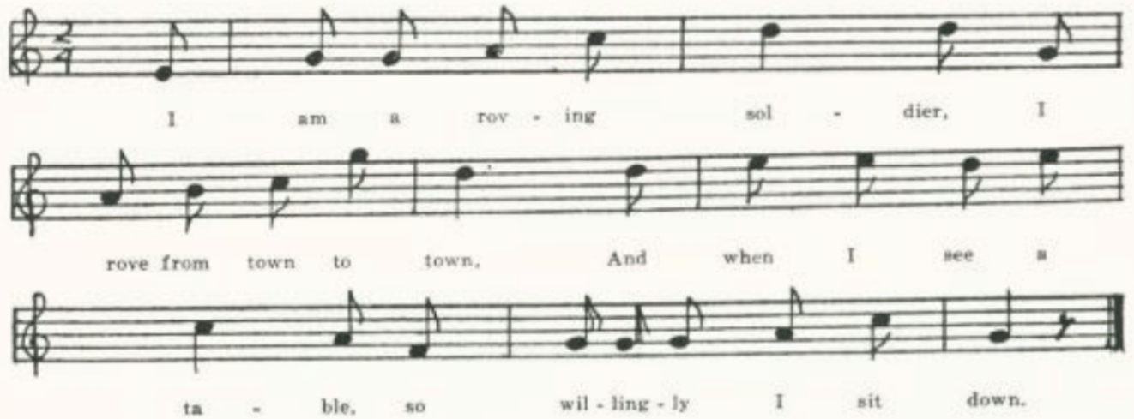
I am a roving soldier,
I rove from town to town,
And when I see a table
So willingly I sit down.

I eat when I get hungry,
I drink when I get dry,
And if the Rebels don’t kill me
I’ll live until I die.

‘Oh, daughter! oh, daughter!
What makes you treat me so?
To leave your native country
With a roving soldier boy?’

‘Oh, mother, oh, mother!
You know I love you well,
But the love I have for that Union man
No mortal tongue can tell.

‘His pockets lined with greenbacks,
His musket in his hand,
. . . . . . . . . . . . . . . .
The men at his command.

‘And when they hear him coming
They’ll wring their hands with joy,
And one will say to the other,
“There comes the soldier boy.”’

C
The following stanzas were written out for mw by Mason Vaugh of Flat River, St. Francois County, in 1914, as sung by his father.

I’ll eat when I’m hungry,
And I’ll drink when I’m dry,
And if a limb don’t fall on me
I’ll live till I die.

Rye whiskey, rye whiskey,
You’re no friend of mine,
You killed my poor old daddy
And injured my mind.

Rye whiskey, rye whiskey,
I wish you no harm,
But I’d like to have a drink
As long as my arm.

(377)
Here may be inserted a variant in which the gambler has become not a soldier but a railroad man.

‘The Railroader.’ Secured by Miss Hamilton in 1910 from Grace Clemmons of the West Plains High School, who had it from a Mrs. Autherson, formerly of Wisonsin.

I took a trip to Cornersville,
Some pleasure for to see.
I fell in love with the railroader
And he fell in love with me.

Chorus:
The railroader, the railroader,
The railroader is for me.
If ever I marry in all my live
The railroader’s bride I’ll be.

I took him in my little parlor
And cooled him with my fan.
I whispered in my mother’s ear,
‘I love the railroad man.’

I would not marry the farmer,
He’s always in the dirt;
I’d rather marry the railroader
Who wears the striped shirt.

I would not marry the blacksmith;
He’s always in the black.
I’d rather marry the railroader
Who pulls the triumphant back.

I wouldn’t marry the merchant;
He’s always sure to die.
I’d rather marry the railroader
Who has the pretty blue eyes.

I would not marry the gambler;
He’s always drinking wine.
I’d rather marry the railroader
Who pulls the number nine.*

*For other songs comparing callings see The Farmer and the Shanty Boy, pp. 443-5, and I Wouldn’t Marry . . . ., p. 263.

Brother Green

Of this pious and patriotic song, which has been reported from Virginia (number 6714 of J. Fischer & Bro.’s Choral Compositions, 1933), West Virginia (FSS 273-4), Kentucky (LT 18-21, BKH 195-6), Tennessee (ETWVMB 13-4, FSSH 364-5) North Carolina (SSSA 212-3), and Illinois (JISHS XXXI 303-10),* the Missouri collection has but one stanza, recalled by Mark Skidmore of Springfield, Greene County, in 1908 as sung to the tune of Barbara Allen:

O brother Green, do come to me,
For I am shot and dying,
The Southern foe has laid me low
On this cold ground to suffer.

*This Illinois text is said by the contributor to have been ‘composed by Rev. L. J. Simpson, late chaplain in the army…on the death of a brother who was killed at Fort Donelson, February, 1862.’

(378)
The Husband’s Departure

This debate between a husband who is about to volunteer and his prudent but in the end patriotic wife seems to be an adaptation to Civil War times of The Rolling Stone (see pp. 351-2). No doubt originally a printed ballad, but I have not found it in print.

‘The Husband Departure.’ Transcribed by Miss Welty in 1906 from ‘a loose sheet of letter paper’ in the Civil War diary of E. J. Sims, I suppose of Linn County, where Miss Welty was then teaching. I have normalized the spelling and pointing, but not the idiom.

‘This country is in danger, I’ll tell you, dear wife,
I am bound to go, at the risk of my life.
Though I would have you caused a soldier to be*
And fight the hard battles my country to free.
Chorus:
For this is a duty to my country I owe;
But if I am slaughtered, down South I will go.’

‘Dear husband, you are hasty; don’t talk to me so.
There is plenty young men to the army can go.
I you are in the army the cannons, I fear,
Will be the death of my husband so dear.

Chorus:
I ask you to stay; you love me, I know,
Yet I think strange when you talk to me so.

‘Dear husband, believe me, my heart it will break
If you join in the army yours to forsake.
Don’t go, I beseech you, and leave me to pine.
There is plenty without you to fill up the lines.’

(379)
‘Dear wife, I must go, as I told you before.
If I were a coward you would love me no more.
A man that will shrink from his own country’s call
Deserves not to have a companion at all.’

‘Oh, yes, my dear husband, disgrace it may be
If you were not to aid your country to free.
But worse than all, my dear, I fear
Orphans it would make of our children so dear.’

‘Dear wife, if our children it orphans would make,
My wife and children may all be at stake;
To slight my own country would be slighting of you,
Disgrace to my children; this never will do.’

‘Dear husband, your logic it not without weight.
Go join in the army though death be your fate;
And while you are fighting the hard battles, you know,
I will pray for my husband to conquer the foe.

‘And when the battles are over and the country is free
With pride I will welcome my husband to me.’
‘Alas, I must go! Adieu, dear wife,
Come kiss me, dear children, the pride of my life.’

*So line 3 reads in the MS. Perhaps lines 3-4 should be assigned to the wife; but even so I am at a loss to construe them.

The Yankee Man of War

The parting between the sailor and his sweetheart, favorite theme of British street balladry, is here made over to fit the American Civil War. Partridge printed it (No. 788); but as the Missouri text is much fuller it seems worth while to give it here.

‘The Yankee Man of War.’ From the MS ballad-book of James Ashby of Holt County, secured for me in 1906 by Miss Welty. Ashby dated this entry ‘May the 7, 1876.’

It’s down in yonders meadow where I carelessly did stray,
There I beheld a lady fair with some young sailor gay.
Says he, ‘My lovely Susan, I soon shall leave the shore
For to cross the briny ocean on the Yankee man of war.’

Young Susan she fell weeping. “Young sailor,’ she did say,
‘How can you be so venturesome and throw yourself away?
For by the time I’m twenty-one I shall receive my store;
So, Willie, do not venture on the Yankee man of war.’

(380)
‘Oh, Susan, lovely Susan, the truth to you I’ll tell;
The south she has insulted us, the North she knows it well.
I may be crowned with laurels just like some jolly tar;
And I’ll face the forts of the rebels on the Yankee man of war.’

‘How can you be so venturesome for to face the southern foes?
For when they are far in battle, love, they never take a man,
And by some bloody weapon you might receive a scar.
So, Willie, do not venture on the Yankee man of war.’

‘Oh, Susan, lovely Susan, the time will quickly pass.
Let’s go down to the ferry house and take the parting glass.
My shipmates they are waiting for to row me from the shore,
And it’s for America’s glory on the Yankee man of war.’

The sailor took his handkerchief and tore it into two,
Saying, ‘Susan, you may keep one half, the other I’ll keep for you.
When bullets may surround you and the rebel cannon roar,
I’ll fight for lovely Susan on the Yankee man of war.’

Then a few more words together; then she let go his hand.
The jolly crew surrounded him a rowed him from the land.
The sailor waved his handkerchief when far away from shore,
And Susan blessed her sailor love on the Yankee man of war.

Fare You Well, My Darling

Here a familiar situation of street balladry and recurrent elements of folk lyric have been adapted to the conditions of the American Civil War. No doubt from print, but I have not found it printed.
No title. One of the songs secured for Miss Hamilton in 1909 by Edna Letsom of the West Plains High School from Jas. L. McAnally of the 10th Iowa.

Oh, fare you well, my darling,
Oh, fare you well, my dear,
Don’t grieve for my long absence
While I am a volunteer.

Since it’s been my misfortune
S soldier for to be,
Content yourself, my darling,
And don’t grieve after me.

I am going to Pensacola
To tarry for a while
Away from my darling,
Yes, about five hundred mile.

When the cannon loudly roar
And the bullets swiftly fly,
The drums and fifes are a-beating
To drown their deadly cry.

On, see how she wrings her lily-white hands,
How mournfully she doth cry:
‘You’ll go and join the army
And in the war you’ll die.

‘You’ll be placed in the center,
It’s there to be slain.
It will burst by heart asunder
If I never see you again.

‘You have now joined the army
And enlisted for the war.
I hope the Lord will spare you
And bring you home again.

‘When the cannon roar like thunder
And the bullets are flying around,
I hope they all will miss you
And leave you safe and sound.

(381)
‘Then you can mount your battery
And turn the wheels around
And shout out our victory
All over the Southern land.

‘I will stay at home contented
And true* a single life
And long to see the time to come
To be a soldier’s wife.’

*Miswritten, presumably, for ‘lead.’

When This Cruel War is Over

This song by Charles C. Sawyer seems to have expressed a feeling about the war common both North and South. It was printed in song-books both of the North and the South (in the latter case with a few necessary alterations); Partridge printed three distinct parodies of it, Nos. 840, 858, and 862 of his single-leaf series; it even crossed the water and was printed by Such under the title ‘Weeping Sad and Lonely.’ I have not found it as a collector’s item; probably because of its familiarity and known authorship. The following is from the copy of it made by James Ashby of Holt County in his MS ballad-book, secured in 1906 by Miss. Welty. Ashby may have copied it from print, or may simply have known it from hearing it sung.

Dearest love, do you remember,
When we last did meet,
How you told me that you love me,
Kneeling at my feet?
Oh, how proud you stood before me
In you suit of blue,
When you vowed to me and country
Ever to be true!

Chorus:
Weeping sad and lonely,
Hopes and tears are vain.
When this cruel war is over,
Praying that we meet again.

When the summer breeze is sighing
Mournfully along,
Or when autumn leaves are falling,
Sadly breathes the song.
Oft in dreams I see thee lying
On the battle plain,
Sorely wounded, even dying,
Calling, but in vain.

If amid the din of battle
Nobly you should fall,
Away from those who love you,
None to hear you call,
Who would whisper sounds of comfort,
Who would soothe your pain?
Oh, the many cruel fancies
Ever in my brain!

But your country calls you, darling.
Angels cheer your way;
While our nation’s sons are fighting
We can only pray.
Nobly strike for God and liberty;
Let all nations see
How we love the starry banner,
The emblem of the free!

(382)
The Flag with the Thirty-Four Stars

This patriotic effusion is evidently an answer to the Southern ‘Bonnie Blue Flag’ (see p. 357). Presumably from print, but I have not come across it anywhere except in McAnally’s contribution.

‘The Flag with the Thirty-four Stars.’ Secured for Miss Hamilton in 1909 by Edna Letsom of the West Plains High School from Jas. L. McAnally, formerly of Co. D, 10th Iowa regiment.

The Rebels sing the Bonny Blue Flag
But we the Stripes and Stars;
Our Union flag we love so true
Will conquer stars and have their Secesh airs,
Their Maryland, as contraband of war.
Our cause is just; the flag for fight
Is one with thirty-four stars.

Chorus:
Hurrah, hurrah, for equal rights,
Hurrah, hurrah, for the dear old flag
With every Stripe and Star!

Our song is for the Union;
And triumph sure we must,
The cause so just will prosper
When in God we place our trust.
Our flag, our pride, victorious
Behold it near and far!
We have at last Red, White, and Blue
With every Stripe and Star.

Protection we extend to all;
The exile finds a home
In Columbia’s glorious happy land,
The stranger’s welcome home.
There with us heart and hand unite
To crush the Rebel war
And fight for our Red, White, and Blue
With every Stripe and Star.

Relations of the Union,
Stand loyal, ever true,
United with the border states
The Rebel horde pursue
With Maryland of Southern clime—
How dear her bright fame was!
That by our flag, our own true flag
With every Stripe and Star.*

Hurrah for brave McClellan
Of bold Antietam fame,
Victory crowns his battle flags,
A charm is in his name;
And Hooker, Sigel, Kenly too,
Who each can show a star.
. . . . . . . . . .
. . . . . . . . . .
With Foote, Dupont, Rosecrans,
Fine heroes of the West,
And Halleck, Burnside, Butler too,
Whose valor all attest;
And those who fought in Maryland
By old South Mountain side,
Drove Lee and Jackson from our soil
Across Potomac tide.

All honor to the men who fought,
Tears for their noble dead,
Our country mourns her soldiers brave
Whose blood for us was shed;
And every patriot volunteer
Enlisted for the war.
God bless them battling for our flag
With every Stripe and Star!

*The last two lines of the stanza are evidently disordered, but I do not know how to set them right.

(383)
The Last Fierce Charge

Patently ‘literary’ and widely known as this song is, I have not been able to find its authorship, nor have I seen it in print except as a collector’s item. It is variously entitled ‘The Charge at Fredericksburg,’ ‘The Battle of Fredericksburg,’ ‘The Battle of Gettysburg,’ ‘The Last Fierce Charge,’ ‘Custer’s Last Fight,’ ‘The Soldier Boy with the Curly Hair,’ and even (in Missouri) ‘The Fight at Bunker Hill.’ Texts have been reported from traditional singing in Nova Scotia (BSSNS 298-300) , Kentucky (BKH 94-5), Georgia (JAFL XLV 161-2, FSSH 363-4), Texas (PFLST VI 132-4), and Minnesota (Dean 14-6); it is in the lists of Miss Pound and of Shearin and Combs; Barry had a text from Massachusetts, and prints the tune of it (JAFL XXVII 70), noting that a text was printed in ‘Everybody’s Column’ of the Boston Globe for 18 August, 1912. The three texts in the Missouri collection do not vary greatly.

A
‘Fight at Bunker Hill.’ Reported by Miss Williams in 1903 from Clinton County.

‘Twas just before the last fierce charge.
Two soldiers drew their reins
With a parting word and a touch of the hands—
They might never meet again.
One had blue eyes and curly hair,
Nineteen but a month ago,
With red on his cheek and down on his chin—
He was only a boy, you know.

The other was tall and dark and slim,
And his faith in the world was dim.
He only cared the more for those
Who were all the world to him.
Now they looked into each other’s face
With a terrible, ghastly glance,
And the first to speak was the tall, dark man,
Saying, ‘Charlie, my hour has come.

‘We’ll ride together up yonder hill,
But you’ll ride back alone.
I want you a little trouble to take
For me when I am gone.
I have a face upon my breast—
I shall wear it in the fight—
With soft blue eyes and clustering curls
As soft as the morning light.

(384)
‘As soft as the morning light to me,
For she has gladdened a lonely life.
Oh, little cared I for the frowns of fate
When she promised to become my wife.
Write to her, Charley, when I am gone,
Send back her fair young face.
Oh, tell her tenderly how I died
And where is my resting place.

‘Tell her my soul shall wait for her
In the border land between
The heaven and earth, until she comes.
It won’t be long, I ween.’
Tears filled the blue eyes of the boy,
His voice grew weak with pain.
‘I’ll do your bidding, comrade mine,
If I ride back again.

But if I am dead and you ride back,
It’s do as much for me.
My mother at home must hear the news;
Write to her tenderly.
She has prayed at home like a waiting saint,
Her fond face white with woe.
Her heart will be broken when I am gone;
I shall see her soon, I know.

‘One after another of those she loved
She has buried, a husband and son.
I being the last, at my country’s call
She cheered me and sent me on.’
Just then the order came to charge.
For an instant hand touched hand,
Then they answered, and on they went,
That brave, devoted band.

Right on the crest of the hill they stood,
While the enemy with shot and shell
Poured drafts of death in their toiling ranks
And jeered them as they fell.
Then with a dying yell they turned
From the fight they could not gain
The blue-eyed boy and the tall, dark man
Were found among the slain.

(385)
B
‘The Soldier Boys.’ Coped by Miss Newell in 1912 from a MS belonging to Ethel Chandler, Farmington, St. Francois County, and the tune noted from her singing. A friend from the same county had written out the song for Miss Chandler’s sister some years before. She had never seen it in print. The differences between this text and A illustrate the effect of oral tradition.
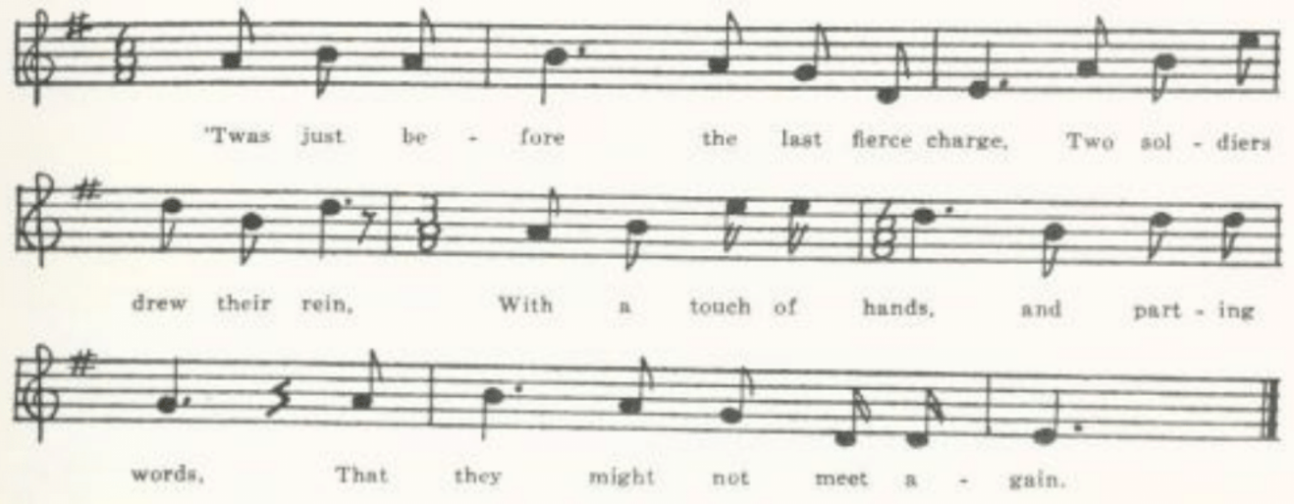

‘Twas just before the last fierce charge
Two soldiers drew their rein
With a touch of hands, and parting words
That they might not meet again.

One had mild blue eyes and curly hair,
Just nineteen years, you know,
With rosy cheeks and childish brow;
He was only a boy, you know.

The other was tall, daring, and proud,
Whose faith in this world was dim.
He only trusted most in them
Who were all the world to him.

They’d rode together for many a day
And marched for many a mile.
But ne’er until now had they met a foe
With a peaceful common smile.

They looked in each other’s eye
In the face of an awful doom.
And the tall, dark man was the first to speak,
Saying, ‘Charlie, my time has come.

(386)
‘We’ll ride together into the fight,
But you’ll ride back alone.
Then promise a little more trouble to take
When I am dead and gone.
‘I have a face upon my breast,
I’ll wear it into the fight,
With deep blue eyes and golden hair,
A face like morning light.

‘Like morning light ‘twas love to me
To brighten my lonely life;
And little I’ve cared for the flowers of this world
Since she promised to be my wife.

‘Write to her, Charlie, when I’m gone.
Send back this fair young face.
Write and tell her how I died
And where is my resting place.

‘Tell her I will meet her on the border line
Of earth and heaven between.
I know she’ll meet me over there,
And it won’t be long, I ween.’

There were tears in the eyes of the blue-eyed boy,
His voice was filled with pain.
‘I’ll do my comrade’s parting wish
If I ride home again.

‘But if you ride back and I am left,
Will you do as much for me?
For I have a mother to hear the news.
Write to her tenderly.

‘One after another she has lost.
She has buried all her husband’s sons.
And I was the last to my country’s call,
But she cheeredly sent me on.

‘She is waiting at home like a praying saint,
Her fair face filled with pain.
‘Twill break her hearts when she hears I’m dead;
I’ll meet her soon, I know.’

(387)
Just then there came an order to charge
An instant hands touched hands;
Eyes answered eyes, and away they dashed
To that bold devouring band.

They rode together to the brow of the hill,
Where the soldiers were stationed well,
Past clouds and drifts of burning shots
That cheered them as they fell.

But they had to turn from the awful fight;
That fight they could not gain.
And all those whom death had spared
Rode quietly back again.

But among those dying upon the field
Lay the boy with the curly hair,
And the tall, dark man that rode by his side
Lay dying by him there.

There is no one to write to that blue-eyed girl
Those words her lover said,
And the mother that’s waiting at home for her son
Will learn that he is dead.

She ne’er will know his last found words
To cheer her in her pain,
Until she crosses the river of death
And stands by his side again.

C
‘The Last Fearful Foe.’ Contributed by Ruth Sedwick in 1912 with the notation that it was ‘learned twenty-seven years ago in the Taney County hills.’ It is the least literate of the three, but does not differ significantly from A.

The Lone Prairie

Of the many cowboy songs collected by Lomax and others two are especially popular, and not only among cowboys. One of these is The Lone Prairie. It is an adaptation to the life of the cowboy of ‘The Ocean Burial,’ a song written by Captain William H. Saunders and sung, to a tune composed by G. N. Allen, by Ossian Euclid Dodge, who was for a while a rival of the Hutchinsons as a popular entertainer.* The

(388)
cowboy form of it is credited by N. H. Thorp, Songs of the Cowboys 62, to H. Clemons of Deadwood, South Dakota, in 1872. It has been reported from West Virginia (FSS 247-9, FSWV 27), Kentucky (SharpK II 236), North Carolina (SharpK II 236-7, JAFL XLV 152-3, FSSH 360 by way of New Jersey), Mississippi (FSM 222-3), Texas (JAFL XIV 186, PFLST VI 173-85), Nebraska (JAFL XXVI 357-8), South Dakota (Asb 20), and Montana (ABS 171-3), and it is given in CS and in Larkin’s Singing Cowboy, without definite location.

*Barry was, I believe, the first to point out the relation of The Lone Prairie to ‘The Ocean Burial’ (JAFL XXV 278-80). He notes the ascription of the latter to Saunders, but adds that ‘another tradition ascribes the authorship to Rev. E. N. Chapin.’ In support of this latter ascription he wrote to Professor E. E. Leisy (MLN XLVI 469-70): ‘I have in a volume of his sermons a “Discourse of the Burning of the Lexington,” a famous marine disaster, which contains passages repeated with little change in “The Ocean Burial.” ‘ The tune is ascribed to Allen in a Ditson print (says J. Frank Dobie, PFLST VI 174) with a copyright date of 1850. It is Barry (BFSSNE VII 17) that calls ‘The Ocean Burial’ one of Ossian E. Dodge’s songs’—by which I suppose is meant that Dodge sang it, not that he composed the tune. Leisy (MLN XLVI 469-70) has called attention to a song, ‘Oh, bury me not,’ by W. F. Wightman published in the Southern Literary Messenger for July, 1857, which may have been suggested by ‘The Ocean Burial, tho the meter is different and the thought confused—the singer asks first not to be buried ‘in the dark old woods’ but ‘by the bright blue sea’ and then not ‘by the rolling sea’ but ‘in the grand old woods.’ Nearer a good deal to ‘The Ocean Burial’ is “The Ocean Dead’ by M. Beck, which can be found on page 179 of George F. Morris’s American Melodies, published in 1841. This is earlier than Saunder’s song, if the headnote in Fulton and Trueblood’s Choice Readings p. 169 is to be strictly construed. There, under date ‘June 26th, ’83,’ Saunders is reported by his brother to have written ‘The Ocean Burial’ ‘nearly forty years ago.’ Since Morris’s book is not easily accessible it may be worth while to give Beck’s verses here:

How calmly they sleep on the ocean floor
By the sparkling gem and the gilded ore,
The shining sand and the glittering stone,
With the wealth of the ocean deep gone down.
Youth and beauty, and age and care,
Have lain them down in chambers there;
And the opening bud and spreading flower
Bloom side by side in the coral bower.

And what to them is the angry roar
As the surges lash the pebbly shore—
Or the sea-bird’s shriek o’er the troubled deep,
There they sleep on in their dreamless sleep!
Sleep on, sleep on, in your lowly graves,
Beneath the swell of the curling waves,
And the tempest and wind shall the requiem be
Of the sleepers who rest in the deep, deep sea.

A
‘The Dying Cowboy.’ Written down for me by Finis Dean in 1905 s sung by his mother, who was reared in Carroll County. A somewhat disordered text, especially in stanza 6.

‘Oh, bury me not on the lone prairie’—
These words came low but manfully
From the pallid lips of a youth who lay
On his dying couch at the close of day.

(389)
He had wasted his life till o’er his brow
Death’s shadows were closely a-gathering now;
And he thought of his home and his dear friends nigh
As the cowboys gathered to see him die.

‘Oh, bury me not on the lone prairie,
Where the wild coyote will howl o’er me,
But in a grave dug six by three
Oh, bury me not on the lone prairie!

‘I’ve ofttimes wished that when I died
I’d be laid in the churchyard neath the green hillside;
By the bones of my father, oh, let my grave be,
But bury me not on the lone prairie!

‘And thee is one who tears will shed
For him who dies on a prairie bed;
But little it pays me to think of her now.
She has curled these locks and pressed this brow.

‘This brow she has pressed with a cold, grave kiss,
These locks she has curled with a rattlesnake hiss.
For the sake of those who weep o’er me,
Oh, bury me not on the lone prairie!

‘Where the golden wings of the butterfly rest
And the wild flowers bloom on the prairie’s crest,
Where the coyote howls and the wind blows free,
Oh, bury me not on the lone prairie!’

B
‘The Dying Cowboy.’ From Mrs. Lids Jones’s MS ballad-book compiled in Dade County and secured for me in 1906 by Miss Lowry.

‘O bury me not on the lone prairie;--
These words came slow and mournfully
From the pale young face of a youth who lay
On his dying bed at the close of day.

‘O bury me not on the lone prairie,
Where the wild kiotes will howl o’er me;
In a narrow grave just six by three
O bury me not on the lone prairie!’

(390)
He worried in pain till o’er his brow
The shades of death are gathering now;
As he talked of his home and his loved ones so nigh,
The cowboys gathered to see him die.

‘O! it matters not, I’ve oft been told,
Where the body lies when the heart grows cold.
Yet grant, O, grant my wish to me;
Oh! Bury me not on the lone prairie.

‘I’ve always wished to be laid when I died
In the little churchyard on the geen hillside.
By my father’s grave there let me be;
O bury me not on the lone prairie.

‘Oh! Bury me not’—and his voice failed there.
But they gave no heed to his dying prayer:
‘In a narrow grave just six by three
Oh! Bur me not on the lone prairie!’

Oh, we buried him there on the lone prairie
Where the wild rose blooms and the winds blow free,
Oh, his pale young face nevermore to see,
For we buried him there on the lone prairie.

C
‘The Dying Cowboy.’ Secured by C. H. Williams in 1906 from his brother George, who heard it sung by a girl who lived in Bollinger County.

‘O bury me not on the lone prairie’—
These words came slow and mournfully
From the pallid lips of a youth who lay
On his cold, damp bed at the close of day.
Chorus:
O bury me not on the lone prairie,
Where the wild coyote will how o’er me,
Where the wild winds sweep and the grasses wave;
No sunbeams rest on a prairie grave.

He has wasted and pined till o’er his brow
Death’s shades are slowly gathering now.
He thought of his home with his loved ones nigh,
As the cowboys gathered to see him die.

(391)
‘I’ve ever wished that when I died
My grave might be on the old hillside.
Let there the place of my last rest be;
O bury me not on the lone prairie!

‘In my dreams I saw’—but his breath failed there.
They gave no heed to his dying prayer.
In a narrow grave just six by three
They buried him there on the lone prairie.

May the light-winged butterfly pause to rest
O’er him who sleeps on the prairie’s crest;
May the Texas rose in the breezes wave
O’er him who sleeps in a prairie grave.

And the cowboys now as they roam the plain—
For they marked the spot where his bones have lain—
Fling a handful of roses o’er his grave
With a prayer to him who his soul will save.

D
No title. Given me in 1913 by M. E. Crane of Dallas, Texas.

‘Oh, bury me not on the lone prairie,
In a narrow grave just six by three,
Where the buzzard beats and the winds blow free,
Oh, bury me not on the lone prairie!

‘Oh, bury me not on the lone prairie,
Where the wild coyotes will how o’er me,
Where the buffalo paws o’er a prairie sea,
Oh, bury me not on the lone prairie!’

But they buried him there on the lone prairie,
In a narrow grave just six by three.
Where the buzzard beats and the winds blow free,
They buried him there on the lone prairie.

E
‘Oh, Bury Me Not.’ Communicated to me by Mis Pound as ‘taken down in Pickering, Missouri, by Mrs. Eliza E. Shelman.’ Pickering is in Nodaway County.

‘Oh, bury me not on the lone prairie’—
These words came low and mournfully
From the pale lips of a youth who lay
On his dying couch at the close of day.

(392)
‘It matters not, so I’ve been told,
Where the body lies when the heart grows cold;
But grant, oh, grant this boon to me,
And bury me not on the lone prairie.

‘Oh, bury me not on the lone prairie,
Where the coyote and the crows sport free,
In a narrow grave just six by three,
Oh, bury me not on the lone prairie.

‘Oh, bury me where a mother’s prayer
Or a sister’s tears might mingle, there
Where my friends might come and weep o’er me;
Oh, bury me not on the lone prairie.

‘Oh, bury me not’—but his voice failed there,
Yet they gave no heed to his dying prayer.
In a narrow grave just six by three
They buried him there on the lone prairie.

The Unfortunate Rake

This is an adaptation to the cattle range of a British stall ballad on the death and burial of a soldier ‘disordered’ by a woman. Such printed it as ‘The Unfortunate Lad,’ whose comrades find him ‘down by Lock Hospital’* ‘wrapp’d in flannel, so hard is his fate.’ He states the situation adequately:

Had she but told me when she disordered me,
Had she but told me of it in time,
I might have got salts and pills of white mercury,
But now I’m cut down in the height of my prime,

and proceeds to order his funeral:

Muffle your drums, play your pipes merrily,
Play the dead march as you go along,
And fire your guns right over my coffin,
There goes an unfortunate lad to his home.

(393)
It is reported as traditional song from Yorkshire (JFSS I 254) and Somerset (JFSS IV 326). It is perhaps originally Irish; Joyce (OIFMS No. 442) gives a tune and one stanza as ‘sung in Cork about the year 1790.’ More frequently recorded is a form in which the sexes are reversed, ‘The Young Girl Cut Down in her Prime.’ This has been reported from traditional singing in Hertfordshire (JFSS V 193-4), Oxfordshire (JFSS IV 326), Hampshire (JFSS IV 325-6).† and on this side of the water in Nova Scotia (SBNS 219-20, BSSNS 301, JAFL XXV 277) and Maine (BFSSNE XI 18). The cowboy adaptation is widely known. It is No. 952 in Wehman’s series of single-sheet ballads. Texts have been reported from Nova Scotia 9BSSNS 302), Maine 9BFSSNE VIII 16-7), Massachusetts (JAFL XXV 277, BFSSNE VII 16—from Kansas), Pennsylvania 9NPM 196-7, REMADE FOR LUMBERJACKS), Virginia (SharpK II l64-5, SCSM 354-6, 358), West Virginia 9JAFL XXV 154, FSS 242-6, FSWV 24-6), Kentucky (FSMEU 209-10), North Carolina (SCSM 356-8), FSSH 360), Mississippi (JAFL XXV 153-4), Illinois (ABS 170-1, by way of Wyoming, TSSI 181-4), Iowa (MAFLS XXIX 103-5), Nebraska (Thorp’s Songs of the Cowboys41-4, where a headnote says: “Authorship credited to Troy Hale, Battle Creek, Nebraska’), North Dakota (JAFL XXII 258-9), and Montana (Margaret Larkin’s Singing Cowboy 14-5, where drum and fife are replaced by rope and spurs). ‘The Dying Cowboy’ mentioned by Jones KNR 300 as known in Michigan is probably this song. Sandburg includes it in Asb and Lomax in CS, and Barry (BFSSNE VIII 16) notes that Mrs. Flanders printed a text from Vermont in the Springfield Sunday Union for 4 March, 1934. These cowboy versions seldom if ever ascribe the cowboy’s death to the cause so lucidly stated in the British stall print. He has indeed taken to bad courses, has drunk and gambled; and now he has been shot. And the scene, naturally, is not a hospital.‡ Some location is almost always given, most often a barroom.

*Lock Hospital is a special hospital for venereal diseases, located in Harrow Road, London.
†It is not clear whether ‘White Copper Alley,’ reported by Miss Broadwood from Hampshire (JFSS III 292, a single stanza), belongs with ‘The Unfortunate Rake’ or with ‘The Young Girl Cut Down in her Prime.’
‡In one of the Virginia texts (SharpK II 164, where the man is not a cowboy but a sailor) and in one of Lomax’s (CS 420-1) the original scene, or rather a memory of it, has been retained: ‘Saint James’s hospital.’

A
‘The Cowboy.’ From the manuscript ballad-book of Mrs. Lida Jones of Dade County, secured by Miss Lowry in 1906. The manuscript is defective in stanza 2, and I have made restorations in brackets. The name at the end is probably that of the supplier of the text.

As I rode down to Letheric Barren,
To Letheric Barren so early one morn,
‘Twas thee I spied a handsome young cowboy
All dressed in white linen, all clothed for the grave.
Chorus:
‘Then beat the drum lowly and play the fife slowly,
And play the dead march as they bear me away,
Then take me to the graveyard and lay the sod o’er me,
For I’m a young cowboy, and I know I’ve done wrong.

(394)
‘’Twas once in my saddle I used to go dashing,
’Twas once in my saddle I used to [go by,]
I first took to card playing and th [en to hard drinking,]
Got shot in the body, and now I mu [st die.]

‘Go write me a letter to my gray-headed mother,
And gently bear the news to my sister so dear;
But there’s another that’s dearer than a sister;
Who’ll bitterly weep when she finds that I am here.

‘Go gather around you a band of young cowboys
And tell them the history of a comrade so dear.
Then teach one another, before you go further,
To stop their wild roving before ‘tis too late.

‘Go bring me a glass, a glass of cold water,
A glass of cold water,’ the poor boy said.
But when he returned his soul had departed,
Had gone to the giver; the cowboy was dead.
Nannie W. Dick

B
‘The Dying Cowboy.’ Reported by C. H. Williams from Bollinger County in 1906. Text closely similar to A, but lacks the second and fourth stanzas. The place-name is different from that in any other text known to me:

As I walked down the Curis Viron
The Curis Viron so early one day—

C
‘The Dying Cowboy.’ Sent to me in 1909 by George F. Nardin of Vandalia, Audrain County. It is the text, he says ‘as I used to sing it.’ Does not differ from A except in the location:

As I went down to a London bar room—

D
‘The Cowboy Song.’ Communicated in 1909 by E. E. Chiles, who says it was ‘given by a section boss named Hughes to Miss Mamie Griffen (age 12), and copied by her. Cedar City, Callaway County.’ Apparently Hughes’s was a printed text. It is similar to B except in the place-name:

As I rode down to Lafferry, Lafferry,
As I rode down to Lafferry one day—

(395)
E
‘The Cowboy’s Lament.’ Reported by Miss Newell in 1912 as copied from a printed sheet owned by Mrs. T. B. Chandler’ of Farmington, St. Francois County. ‘A friend gave her the sheet,’ Miss Newell says, ‘about fifteen years ago, but she had known the song from the time she could remember.’ The text as copied dow not fit the tune, lacking the repeat of the place-name, which I have inserted in the notation of the tune. ‘Latern in Barin’ is no doubt the same place as the ‘Letheric Barren’ of A, and the ‘Lathan’s bar room’ of H.
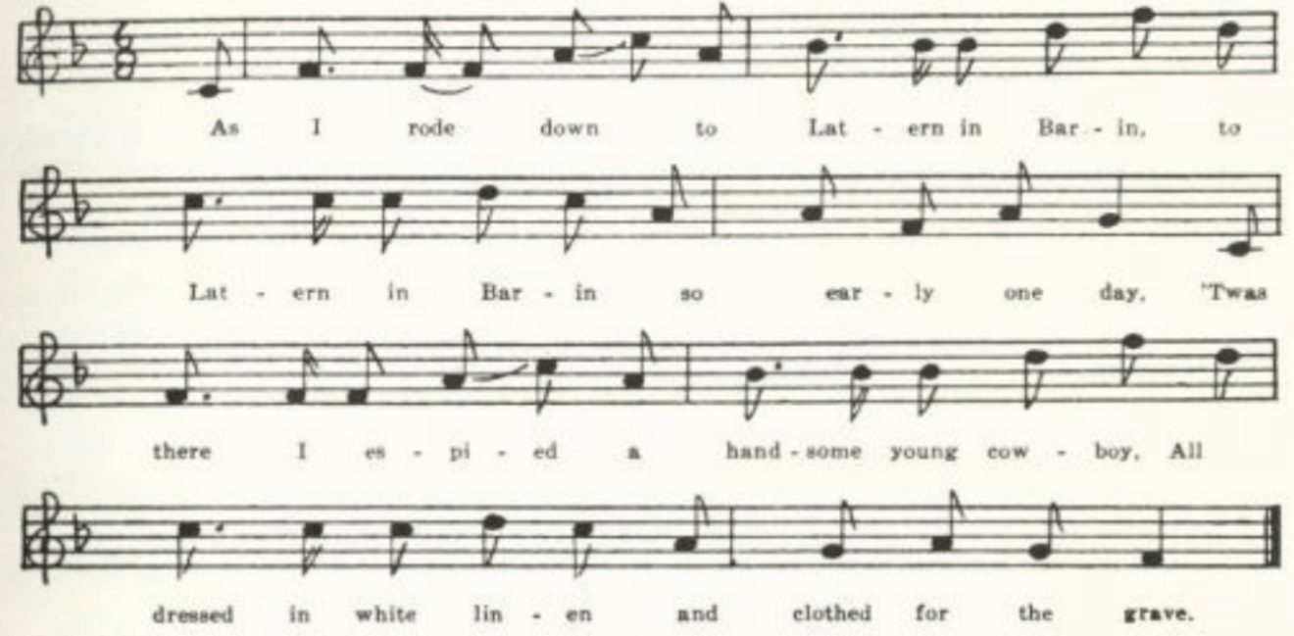
As I rode down to Latern in Barin
So early one day,
‘Twas there I espied a handsome young cowboy
All dressed in white linen and clothed for the grave.
Chorus:
‘Then play your fife lowly, and beat your drum slowly,
And play the dead march as you carry me along;
Go take me to the graveyard and place the sod o’er me,
For I’m a young cowboy, and I know I’ve done wrong.

‘’Twas once in my saddle I used to go dashing,
’Twas once in my saddle I used to be gay;
But first I took to drinking and then to card playing,
Got shot through the body, so now I must die.

‘Go gather all around you a crowd of young cowboys,
And tell them the history of this my fate;
Go tell them to stop their deep, deep drinking
And all their wild ways before it’s too late.

(396)
‘Go write a letter to my grayheaded mother,
And bear the news gently to my sister so dear.
But then there’s another far dearer than a mother;
She’ll bitterly weep when she knows I am here.

‘Go bring me a cup, a cup of cold water,
Of pure cold water,’ the poor fellow said;
But when I returned the spirit had departed
And gone to the Giver—the cowboy was dead.

F
No title. Reported by Miss Pauline Pfeiffer in 1918 as learned at Piggott, Arkansas, from Mrs. Will Reves, ‘who got it from her father, who lives in Kentucky.’

So early one mornin’ I went cow lowin’,
So early one morning I went over there.
I met a young cowboy all dressed in white linen,
With clear blue eyes and dark wavy brown hair.
Chorus:
‘Beat the drum lowly, play the fife sadly,
Play the dead march as they carry me on.
Take me to the graveyard, pour the sod o’er me;
For I’m a young cowboy, I know I’ve done wrong.’

G
‘Old Laredo.’ Communicated by Miss Beulah Wohlbeck in 1934, who had it from an uncle, about sixty years old, living in Morgan County.

As I rode out in the streets of old Laredo,
As I rode out in Laredo one day,
I saw a young cowboy all wrapped in white linen,
All wrapped in white linen and as cold as the clay.

‘I see by your outfit that you are a cowboy,’
These words he did say as I boldly stepped by.
‘Come sit down beside me and hear my sad story,
For I’m shot in the breast and I know I must die.

‘Once I was a cowboy and used to go dashing,
Once I was a cowboy and used to go gay;
Went first to hard drinking, then to card playing,
Am shot in the breast and am dying today.

(397)
‘Go carry the news to my dear old father,
Go carry the news to my sister so dear,
But there is still one that is still dearer than either
That would be a-weeping if she knew I was here.

‘Go get six cowboys to carry my coffin,
Go get six pretty maidens to carry my pail,
Put bunches of roses all over my coffin,
Put roses to deaden the clouds* as they fall.

‘Go gather around you a crowd of young cowboys
And tell them the story of this my sad fate;
Tell one another before they go farther
To quit their wild roving before it’s too late.

‘Go beat the drum slowly and play the fife lowly,
Go play the dead march as you carry me along,
Go take me to the churchyard and lay the sod o’er me,
For I’m a young cowboy, and I know I’ve done wrong.

‘Go bring me a cup, a cup of cold water
To cool my parched lips,’ the cowboy said.
Before I had turned, the spirit had left him.
And gone to its giver. The cowboy was dead.

We beat the drum slowly and played the fife lowly
And bitterly wept as we carried him along,
For we all loved our comrade so brave, young, and handsome,
For we all loved our comrade although he’d done wrong.

H

‘The Dying Cowboy.’ From the MS ballad-book of Mrs. John Singleton, of Randolph County, lent to me by her son, Dr. Ralph Singleton, of the Connecticut Experiment Station, in 1938. The entry in the ballad-book was made about 1891. The text does not differ essentially from A.

The Dying Cowboy

Lomax has this in CS 366-8, The Dying Ranger, and Finger in FB 170-3; Cox gives a tune and one stanza from West Virginia (FSWV 28). I have not come upon it elsewhere. The Missouri text was communicated to me in 1909 by Professor W. L. Howard, who said he ‘learned it almost twenty years ago in southwest Missouri.’

(398)
Oh, the sun was setting in the west,
And it fell over the lingering way,
To the branches of the forest,
Where a wounded cowboy lay.
Neath the shade of a palmetto
And beneath the sultry sky,
Far away from his loved old Texas
They laid him down to die.

His comrades gathered round him
To hear what he might say,
And the tears rolled down each manly cheek
As his life-blood ebbed away.
One loved friend and companion
Was kneeling by his side
Trying to stop the life-blood flowing,
But alas, in vain he tried.

When to stop the life-blood flowing
They found ‘twas all in vain,
The tears rolled down each manly cheek
Like showerings of rain.
Up spoke the noble cowboy,
Saying, ‘Do not weep for me;
I’m crossing the deep, dark river
To a country that is free.

‘Gather closer round me, comrades,
And hear what I shall say,
For I’m going to tell a story
As my spirit flies away.
Far away in Northwest Texas,
Up in that good old State,
There’s one who for my coming
With a weary heart will wait.

‘I have a fair young sister,
She’s all my joy and pride;
I’ve loved her from her childhood,
For I had none else beside.
I’ve loved her as a brother,
And with a brother’s care
I’ve tried in grief and sorrow
Her simple heart to cheer.

‘When our country was invaded,
And they called for volunteers,
She threw her arms around my neck
And bathed me with her tears,
Saying, “Go, my darling brother,
Drive those Indians from our shore.
My heart will need your presence
But our country needs you more.” '

‘My mother she lies sleeping
Beneath the churchyard sod,
And many a day has passed away
Since her spirit went to God;
Our father he lies sleeping
Beneath the dark blue sea;
I have no other kindred,
There’s none but Nellie and me.

‘Come closer to me, comrades,
And listen to my dying prayer:
Who will be to her a brother
And shield her with his care?’
Up spoke the noble cowboys
And answered one and all,
‘We’ll be to her as brothers
Till the last of us shall fall.’

A fleeting smile passed over
The dying cowboy’s head,
One last convulsive shudder,
And he lay there dead.
Far away from his darling sister
They laid him down to rest,
With his saddle for a pillow
And his gun across his breast.

(399)
Cowboy’s Challenge

Sent to me some twenty-five years ago (I failed to note the date) by Mrs. W. B. VerSteeg of St. Louis with the following explanation: ‘A Missouri cattle herders’ song which is or rather was sung some thirty years ago, as a sort of lure to start a fight t test their strength, when the herders met for a good time. It was a challenge to combat, and continued with a clog-like dance and clank of spurs till the singer found a man brave enough to accept his challenge. This is from an eye-witness.’ Compare Mark Twin’s account of two river braggarts in Life on the Mississippi, Ch. III, and ‘The Bad Man from Brazos,’ CS 138.
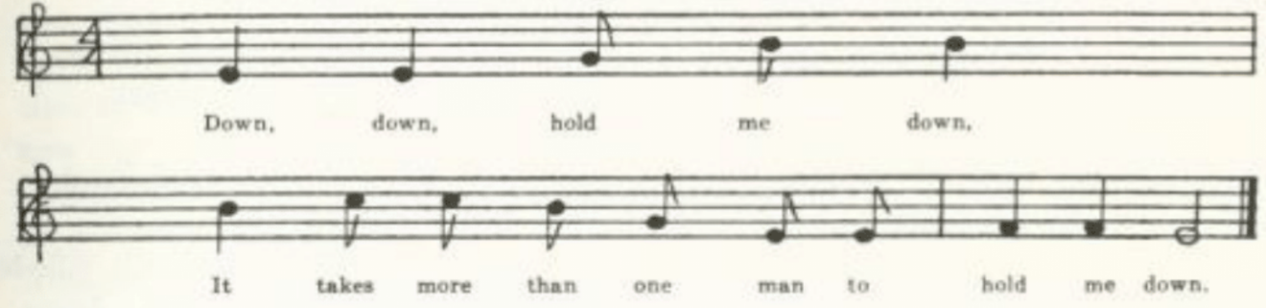
(Music)

Down, down hold me down,
It takes more than one man to hold me down.

Down, down, hold me down,
It takes more than two men to hold me down.

Three men etc.

Sam Bass

For the career of this outlaw of the Southwest—second in popular fame only to Jesse James, and like him unconquerable except by the treachery of one of his gang—see PFLST III 226-30 and FB 65-71. A text from the Ozarks is give by Randolph in OASPS and it is to be found without specific locale in CS 150-2, ASb 422-4, ABFS 126-8, and Margaret Larkin’s Singing Cowboy 161-4. Miss Pound, who prints the CS version in ABS 149-52, says that its authorship is credited in Thorp’s Songs of the Cowboys to ‘John Denton, Gainesville, Texas, 1879.’ The Missouri collection has one nearly full text and two fragments.

A
‘Sam Bass.’ Three stanzas (the first, second, and fourth of B) written down for me in 1905 by Finis Dean, being what he could remember from the singing of his mother, who was reared in Carroll County. Sam went to Texas ‘a ranger for to be.’

(400)
B
‘Sam Bass.’ From George Williams, Bollinger County, 1906, who writes: ‘This song I heard sung by the boys in the country several years ago—I don’t remember who sung it first. I once saw it in print among a collection of songs, but the people in the country did not learn it there.’

Sam Bass was born in Indiana,
It was his native home.
At the age of seventeen
Young Sam began to roam.

He first came out to Texas
A cowboy for to be.
A kinder-hearted fellow
You hardly ever see.

Sam once dealt in race stock,
One called the Denton Mare.
He matched her at scrub races
And carried her to the fair.

Sam used to coin the money
And spend it very free;
He always drank good whiskey,
Wherever he might be.

Sam left the Collins ranch
In the merry month of May
With a herd of Texas cattle
The Back Hills for to see.

Sold out in Custer City
And then got on a spree.
A harder set of cowboys
You hardly ever see.

On their way back to Texas
They robbed the N. P. train.
They split up in couples
And started out again.

Joe Collings and his partner
Were overtaken soon;
With all their hard cash money
They had to meet their doom.

Sam met his fate at Round Rock
On July the twenty-first;
They pierced poor Sam with rifle-balls
And emptied out his purse.

Now poor Sam’s corpse,*
And Piper’s in the quay,
And Jackson’s in the bushes
A-trying to get away.

Jim Murphy borrowed Sam’s good gold
And did not want to pay;
The only way he saw to win
Was to give poor Sam away.

He sold out Bass and Barnes
And left their friends to mourn.
Oh, what a scorching Jim will get
When Gabriel blows his horn!

*Miswritten, apparently, for ‘Now poor Sam’s a corpse.’

C
‘Sam Bass.’ The first four stanzas, which was all Professor J. D. Elliff could remember in 1918. He knew it in Macdonald County. In this version Sam went to Texas ‘a teamster for to be.’

(401)
Jesse James

Probably the most famous son of Missouri—after Mark Twain—is the bandit who, starting his career with Quantrill’s bushwhackers, became in the fifteen years following the Civil War the most notorious train- and bank-robber in the country. His career ended when, in 1882, he was shot treacherously by one of his own gang, Robert Ford, who was tempted by the $10,000 reward offered for the capture of James. The story goes that he was shot while hanging a picture on the wall of the house in St. Joseph in which he was living under the name of Howard. Most of the Jesse James songs seem to have sprung from one original, marked by the refrain about ‘that dirty little coward that shot Mr. Howard and laid poor Jesse in the grave.’ I was told years ago, that it was the work of a negro convict in the penitentiary, but I have never found any confirmation of this rumor nor anything definite about the time or the person of its making. The versions vary rather widely, emphasizing now one and now another of the incidents of his career or the sentiments of the singer about him. The variations are most noticeable in the texts fathered by Perrow in Mississippi (JAFL XXV 145-50) and by Odum and Johnson from southern negroes (NS 209-10) and in the North Carolina text in JAFL XXII 246. There are also songs that have no apparent connection with the vulgate ballad—two of which, found in Missouri, are appended. The claim to authorship—‘This song was made by Billy Gashade as soon as the news did arrive’—found in texts in CS and ABFS, and in Missouri—is a phenomenon familiar to students of earlier minstrel balladry and not unknown in later times; see p. 366 and JAFL XXII 87.
Jesse James has been reported as traditional song from West Virginia (FSS 216), Kentucky (JAFL XXV 146-7), Tennessee (JAFL XXV 146, XLIV 87-8, FSSH 320-2, ETWVMB 17-8), North Carolina (JAFL XXII 246-7, XLV 150, FSSH 323), South Carolina (ABS 145-6), Georgia (JAFL XXXIV 124), Mississippi (JAFL XXV 148-9, FSM 235-7), Louisiana (ABFS 131), Arkansas (OASPS 195), Missouri (JAFL XXV 47-8), Indiana (JAFL XXV 148), and Iowa (ABS 146, MAFLS XXIX 109-10) and without specific locale in JAFL XXIV 387, NS 209-10, ABFS 128-30) ASb 374-5, 420-1, CS 152-8, and Margaret Larkin’s Singing Cowboy 155-9. The Missouri collection has two fragments and one complete text from singing besides two texts from print. All represent what may be called the vulgate version. The printed texts are in both cases from pamphlets sold by street singers—what in an earlier time would have been called garlands. They are the same version, but not the same print. I give only the text from singing.

‘Jesse James.’ Sent to me in 1906 by George Williams of Bollinger County, who says: ‘This song I heard a country boy names Jim Burton sing some eight years ago. Many people in the country know it. I had never seen it in print till lately.’

(402)
Jesse James was a lad that killed many a man.
He robbed the Danville train.
But that dirty little coward that shot Mr. Howard
Has laid poor Jesse in the grave.

It was Robert Ford, that dirty little coward,
I wonder how he does feel;
For he ate of Jesse’s bread and slept in Jesse’s bed
And laid poor Jesse in the grave.
Chorus:
Poor Jesse had a wife to mourn for his life,
His children they were brave;
But that dirty little coward that shot Mr. Howard
And laid poor Jesse in the grave!

It was his brother Frank who robbed the Gallatin bank
And carried the money from the town.
It was at this very place they had a little chase,
For they shot Capt. Sheets to the ground.

They went to the crossing not very far from here,
And there they did the same;
With the agent on his knees he delivered up the keys
To the outlaws Frank and Jesse James.

It was on Wednesday night, the moon was shining bright,
They robbed the Glenville train.
The people they did say, for many miles away,
It was robbed by Frank and Jesse James.

It was on Saturday night, Jesse was at home,
Talking with his family brave.
Robert Ford came along like a thief in the night
And laid poor Jesse in the grave.

The people held their breath when they hears of Jesse’s death
And wondered how he ever came to die.
It was one of the gang called little Robert Ford,
He shot poor Jesse on the sly.

This song was made by Billy Gashade*
As soon as the news did arrive.
He said there is no man with the law in his hand
Can take Jesse James when alive.

*The name is LaShade in the two Missouri printed texts; but Gashade in CS and ABFS.

(403)
For the sake of completeness, two other pieces about Jesse James reported in Missouri are here given, tho they do not belong with the song so far considered.

‘A Missouri Ballad.’ Printed by Carl Brim in the University Missourian for 16 February, 1909, with the statement: ‘It was recited to me by an old settler in a southern county who vouched for its authenticity, and stated that it was well known in some parts of Missouri and Texas.’*

Jesse James was a bandit bold,
He and his brother Frank;
‘Twas in a town in Mexico
They played this daring prank.

They drove some ponies they wanted to trade
Across the greaser line,
And finished selling them one day
In June of 59.

There was a dance at the hall that trip
And the boys were feeling gay;
‘We’ll load our derringers,’ said Frank,
‘In case there comes a fray.’

*See Appendix, note 3.

All uninvited they reached the door
And tied their bronchs outside;
‘We’ll walk right in,’ they said, ‘to brave
Those all-fired greasers’ pride.’

Each chose a senorita fair,
And when the dance began
They footed the waltz so well they were
The envy of each man.

And when the wine got in their heads,
As sure as pipe-smoke curls,
They made no bones about their lips
But kissed a few of the girls.

At that the jealous men sneaked out
With treacherous looks at Jess;
‘What they want with us,’ Frank said,
‘A Texas steer could guess.’

Back came they with revolvers drawn
To shoot the light all out;
But Jess and Frank got out their guns
And made them face about.

Back through the swarthy crowd they strode,
Bold Jesse and his pared;
‘Untie the bronchs,’ his comrade said,
‘While I stand here on guard.’

Upon their mounts the heroes leaped,
To horse the greasers sprung;
‘And if they take us,’ Jesse said,
‘They’re sure to have us hung.’

But when they reached the Rio Grande
The James boys swam across;
The greasers stood upon the bank
Astounded at their loss.

The other has a somewhat more authentic tone.

No title. Given me in 1916 by Miss Mary Alicia Owen of St. Joseph, president of the Missouri Folk-Lore Society, with the notation: ‘I heard it from a man who dug some post-holes for us. He said everybody used to sing it.’

Jesse James was one of his names, another it was Howard.
He robbed the rich of every stitch. You bet, he was no coward.

His mother she was elderly, his father was a preacher,
Though some do say, I can’t gainsay, his mother was his teacher.

(404)
Her strong right arm it came to harm. Detectives blew it off, sir,
And killed her son, the youngest one. No wonder such she’d scoff, sir.

My Jesse dear, your mother here was taught more than she ought ter,
For Robert Ford, I pledge my word, has marked you for his slaughter.

For robbing trains Bob had no brain, unless Jess plainly showed him.
Our governor for peace or war explained this for to goad him.

So Robert Ford he scratched his gourd, and then he said ‘I’ll go you,
Give me a price that’s something nice, and then, by gee, I’ll show you!’

Then Governor C.* he laughed with glee and fixed a price to suit him,
And Bob agreed, with ready speed, to find Jess James and shoot him.

And then he did as he was bid and shot Jess in the back, sir,
Then ran away on that same day, for cash he did not lack, sir.

He did his best to live out west, but no one was his friend there.
‘You’ve killed your cousin,’ they went buzzin’, however free he’d spend there.

And then one day, the papers say, Bob Ford got his rewarding:
A cowboy drunk his heart did plunk. As you do you’ll git according.

*It was Governor Crittenden who offered the $10,000 reward for the capture of Jesse James.

The Meeks Family Murder

This is one of the very few ballads that belong exclusively to Missouri, and is at the same time a good illustration of the modern journalistic type of balladry. Nearly all the texts were secured by Miss Hamilton from her students at the Kirksville Teachers College in 1912-3, especially from Luther Crookshank, who knew Wallace, the alleged author of one of the versions. A study of the piece was published in 1914 in the Mid-West Quarterly (I 162-72); but since that periodical is probably not easily accessible, it seems best to give the text here, with a brief account of the facts in the case. William and George Taylor, brothers, were people of some prominence in Linn County, one a banker and the other a schoolteacher and both farmers. But they did not have a good reputation; George was believed to have killed a man in Stone County, and William to have committed arson in Browning (near the north edge of Linn County). In 1894 he was indicted for cattle-stealing. Gus Meeks of Milan (in the adjoining county to the north), who had been employed by Taylor in this business and convicted, made a confession in prison and was pardoned by the governor to testify against Taylor. Thereupon Taylor proposed to Meeks to find him a good job elsewhere. On the night of 11 May the Taylor

(405)
brothers appeared with a wagon and Team at Meek’s house in Milan and bundled him, his wife, and his three children into it to drive them to the promised new job. At the foot of Jeankins Hill, near Browning, the whole Meeks family (the Taylor believed) were killed, the bodies stuffed under a haystack on George Taylor’s farm near by. The Taylors then set fire to the stack to cover up the traces of their crime, and George harrowed the ground around the stack to obliterate the wheel-tracks. But the hay was damp and would not burn. Toward morning Nellie Meeks, one of the children supposed to be dead, recovered consciousness and crept to the house of a neighbor named Carter, revealing the crime. The Taylors fled, but were captured in August in Arkansas. They wee tried (under change of venue) in Carroll County and convicted; but George escaped before the time set for the execution, and has never been heard from since. William Taylor was hanged at Carrollton 30 April, 1896.
I have spoken above of ‘versions’ of the Meeks ballad. In fact there seem to have been two ballads made upon it, and perhaps three or four; but they are interrelated. I shall call them A, B, etc., distinguishing the different texts of each by arabic numerals. They come from nine counties in the northeast quarter of the state.

A1
No title given. Secured by Miss Hamilton in 1913 from Luther Crookshank of the Kirksville Teachers College, who said he knew it was written ‘by Arthur Wallace, a blind huckster who used to live at Eversonville, and traveled through Linn County.’ Wallace was not only a ‘huckster’ but also a traveling entertainer; he had a ‘tent show,’ in which he played the fiddle and sang. The last stanza shows that this was composed before the Taylors were captured in August, 1894.

About one mile from Browning,
Upon the Jenkins Hill,
Gus Meeks and family were murdered
By the Taylors, George and Bill.

The first they killed was Mr. Meeks;
And the woman began to cry
And beg them to spare her little ones,
But they told her all must die.

In vain they looked around
For their mischief to conceal’
So loaded them into a wagon
And drove to George’s field.

Next morning George was seen
With his team out in the field
Harrowing around the old straw stack
Where their victims were concealed.

But the hand of Providence was there,
As you all know very well,
To spare the life of the little one
On the murderers to tell.

And when she arose from her strawy grave
To Carter’s house she went
And told them of the tragedy
And the terrible night she had spent.

And when George Taylor hard of this
He told to his brother Bill
And told him of the mistake they had made:
‘There is one we did not kill.’

(406)
So the hustled around, as you all know,
And soon they left the town;
And every since been hunted for,
But still they can’t be found.

Now they are at large, and the officers seem
To think that they are gone.
And if ever they catch them desperate men
I shall complete my song.

A2
‘The Meeks Family Murder.’ From the manuscript ballad-book of Ada Belle Cowden of Woodlandville, Boone County, compiled about 1909; secured for me by Miss Lucy Laws of Christian College.

About one mile from Browning town, at the foot of Jenkins’ hill,
Took place this awful murder by the Taylors, George and Bill.
Gus Meek’s wife and children were taken from the home,
Were taken by those Taylors to meet their fatal doom.

They wrote Gus Meeks a letter telling him to be ready at ten
And try to leave the country to save his grace* from them.
How little did he think them* those Taylors, George and Bill,
That night would murder his family upon the Jenkins hill.

But the hand of Providence came to little Nellie and said,
Ere the break of morning a safe escape she made.
She came out of her straw-made grave and to Carter’s house she came
And told this mournful story, that adds to our country’s shame.

She stood before the doorway with that awful gash in her head;
While she sobbed and wept most bitterly these were the words she said:
‘Some very cruel men last night came and took us from our bed.
They shot our papa and mama, and thought us three were dead.

‘They put us in a wagon and took us to our straw-made grave.
How little did they think them their said little Nellie would save!
But Providence was against them; the righteous hand was there
And willed against those murders† little Nellie’s life to spare.’

Next morning after the murder George was seen out in the field
A-harrowing out the wagon tracks his mischief to conceal.
But this was all in vain, for nothing could they avail;
By J. E. South they were captured and taken to the Carrolton jail.

‘Once I had a dear mother, a mother kind and true,
But those wicked men they shot her, and shot my papa too.
Now I am an orphan, nobody cares for me.
May God’s blessing go with them wherever they may be.’

*Evidently ‘his grace’ his miswritten for ‘disgrace;’ and ‘them’ is perhaps for ‘then.’
†This no doubt should be ‘murderers.’

(407)
This opens like A1 but later passes over into the tradition of B.

A3
‘Meeks Murder.’ Given to Miss Hamilton in 1913 by Sam Wilson of the Kirksville State Teachers College. From Monroe County. ‘He and his sister learned it from some one else,’ Miss Hamilton writes, ‘not from print.’ Like A2, it begins with Wallace’s opening but passes over to the B tradition.
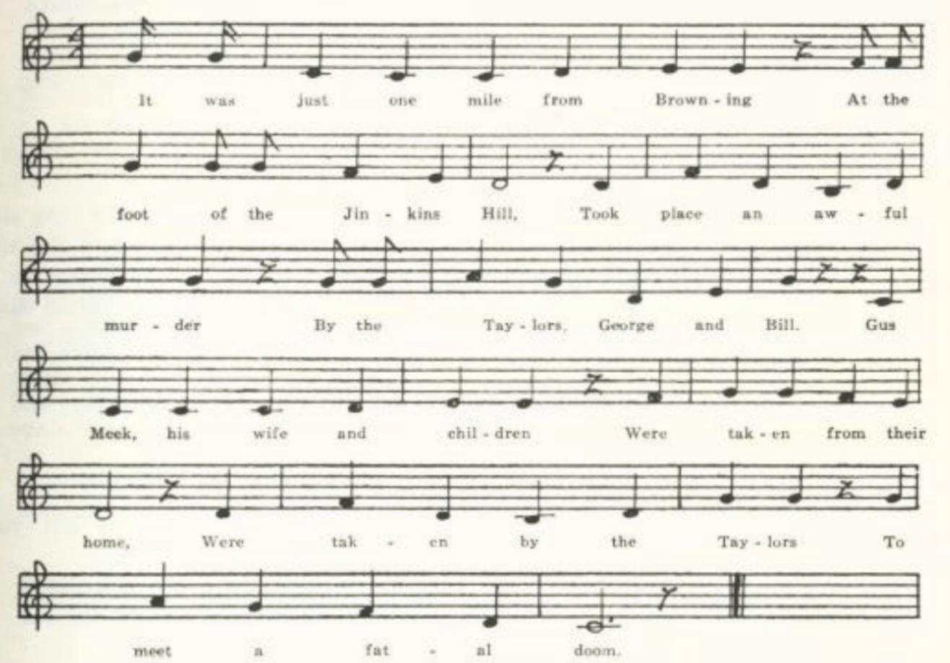
(Music)

It was just one miles from Browning,
At the foot of the Jinkins Hill,
Took place an awful murder
By the Taylors, George and Bill.
Gus Meek, his wife and children
Were taken from their home,
Were taken by the Taylors
To meet a fatal doom.

They wrote Gus Meeks a letter,
Told them to be ready at ten,
Told them to leave that country
To save disgrace from them.
How little did he think
That the Taylors, George and Bill,
That night would murder his family
At the foot of Jinkins Hill.

She stood beside the doorway
With an awful gash in her head,
She sobbed and wept most bitterly,
And these were the words she said:
‘Some very cruel men came
And took us from our bed;
They shot my mama and papa
And thought us three little ones dead.

(408)
‘They put us in a wagon
And started for a straw-made grave.
How little did they think, then,
Little Nellie God would save!
But Providence was against them,
The righteous hand was there,
And willed against them murderers
Little Nellie’s life to spare.’

Next morning after the murder
George was seen out in the field
Harrowing over his wagon-tracks
His mischief to conceal.
But that was all in vain, then,
For nothing could he avail;
By J. C. South they were captured
And taken to the Carrollton jail.

‘Once I had a mama,
A mama so good and so true,
But those wicked men shot her
And shot my papa too.
Now I am an orphan,
Nobody cares for me.
May God’s blessing go with me
Wherever I may be.’

B1
‘The Meeks Family.’ Two texts secured by Miss Hamilton at the Kirksville Teachers College from Agnes Shibley, one in 1912 and one in 1913, as current in Putnam County, do not differ greatly. I give that secured in 1912, with a few variants from the other. Miss Hamilton learned that at some time after the murders Nellie Meeks traveled with a ‘carnival’ company, singing a song about herself—much as prize-fighters, and others, have exhibited themselves before and since. This B form of the ballad, we may assume, is that made for her stage singing.

In Milan, Sullivan County,
There lived a family poor,
A father and a mother,
Three children around the door.

The father was sent to prison
For stealing he had done;
And, telling of some other,
A freedom he had won.

It was on the tenth of May
Two men to Milan came
And went unto the Meeks’
To murder them, they say.

They offered a thousand dollars,
A wagon and a team,
If they would leave the country
And never more be seen.

The mother says, ‘They’ll kill you;’
The father, he says, ‘Oh, no.’
So they bundled up the baggage
And started for to go.

They roamed along quite nicely
Until they came to Jinkens’ hill;
And there the Meeks were murdered
By Taylors, George and Bill.

‘I saw them kill mamma and papa,
And brother and sister too;
And then they tried to kill me,
And that is all I knew.

‘They took us to a straw stack
For a burial place to prepare.
O God, be with this orphant!
And he was with her there.’

(409)
Miss Shibley’s other text has in the third line of the penultimate stanza ‘And then they hit me one lick;’ and it adds the following at the end:

‘After the burial was over
And all had gone to their homes,
This poor little orphan
Was left in this wide world alone.’

B2
No title. Reported to Miss Hamilton in 1913 by Georgia Stauterman of the Kirksville Teachers College. Miss Stauterman had been teaching in Audrain County, where ‘this was sung at recess and at noon by five children of the Bryson family,’ one of whom, at Miss S.’s request, wrote it out for her. It corresponds pretty closely to B1 thru eight stanzas, but adds this:

‘And after the funeral was over
And all had gone to their homes,
This poor little orphan Nellie
Was left in the world alone.

‘Next morning after the murder
They were seen out in the fields
A-harrowing out their wagon tracks,
Their mischief to conceal.

‘So now I am an orphan;
Nobody cares for me.
May God be with this orphan,
Wherever she may be!’

B3
‘The Meeks Murder.’ A second text secured by Miss Hamilton in 1913 from Sam Wilson of Monroe County. It does not differ greatly from B1, but at the same time it does show how a text is remade according to the singer’s ideas.

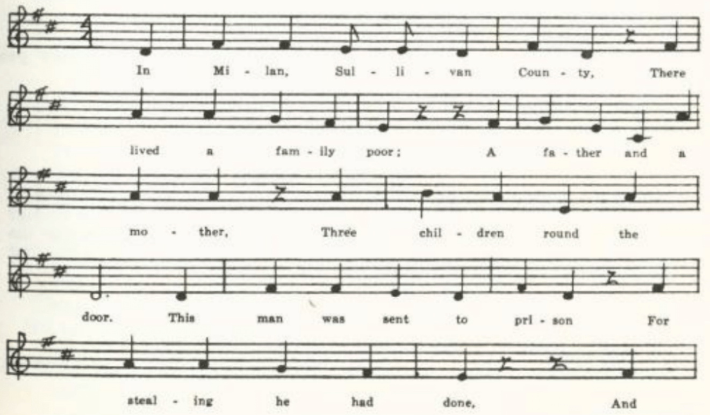
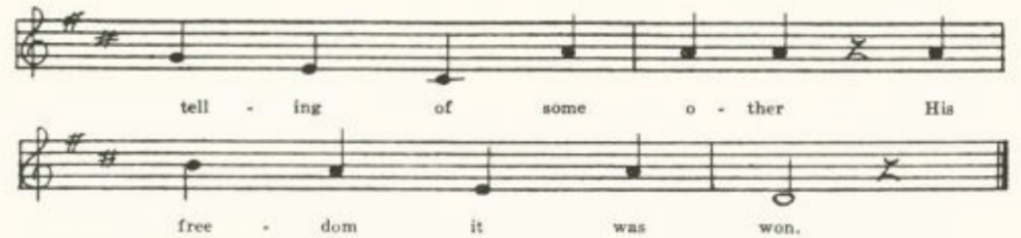
(410)
In Milan, Sullivan County,
There lived a family poor,
A father and a mother,
Three children round the door.
This man was sent to prison
For stealing he had done,
And telling of some other
His freedom it was won.

. . . . . . . . .
. . . . . . . . .

And thus the governor pardoned him
And sent him home to stay
Until he was needed farther
To swear before the court
Against the Taylor brothers
His country to support.

‘Twas on the night of May the tenth
Two men to Milan came
To get the Meeks family
And murder them the same.
They said they wanted to lease him
And tell him of their scheme;
They would give me a thousand dollars,
A wagon and a team.

The wife said, ‘They will kill you,’
But the father he thought no.
So they bundled up their baggage
And started off to go.
They traveled very nicely
Till near the Taylors’ farm;
And thus the murder ended
With but a slight alarm.

‘I saw them kill poor papa,
Dear mama and sisters too,
And then they tried to kill me;
And that was all I knew
Until we reached the straw yard
Our burial to prepare;
And God was there before me,
And God was with me there.

‘Kind friends and neighboring people,
Who in this world are poor,
Be kind and ever honest,
For honesty is sure.’

B4
No title. Reported to Miss Hamilton in 1913 by one of her students at Kirksville as known to his grandfather, A. B. Lipp of Adair County. The student said the author was believed to be one Elmer Pike, a farm-hand working near the scene of the murder. It is merely a fragment of B. Note the shift to the first person in the second stanza.

In Milan, Sullivan County,
There lived a family poor,
A father and a mother,
Three children round the door.

We rolled along right nicely
Till we came to the Jenkins Hill;
And there we were murdered
By the Taylors, George and Bill.

I saw them kill papa and mamma,
Then brother and sister too;
Then they tried to kill me,
And that was all I knew.

(411)
B5
The following fragment was brought to Miss Hamilton in 1913 by one of her students at Kirksville, C. J. McKenzie, who learned it in Knox County, ‘a long time ago, from his brothers and sisters.’ It seems to be an individual elaboration of a part of B.

I saw two lights a-burning, I knew not which to go,
For one was for the Taylors, and there I turned to go.
But God’s right hand was with me, so I turned the other way
And wandered to the neighbors’, just at the break of day.

I saw them kill dear mother, dear papa, sister too,
And then they tried to kill me, and that was all I knew.

C
‘Nellie’s Lament.’ Brought to Miss Hamilton in 1913 by Ethel Crouch of the Kirksville Teachers College, who secured it from Addie Yambert of Grundy County. ‘Someone sent it to her,’ Miss Crouch told Miss Hamilton, ‘a written copy; she does not know whether it has been in print or not. She says she got it from a cousin shortly after the murder.’ Like B, it is Nellie’s story, told by herself; but it is a quite different composition.

Once I had a mama, likewise a papa too,
Two darling little sisters, of course I loved them true.
But they were foully murdered, and I alone am left;
Of those I loved so dearly, alas, I am bereft.
Chorus:
Sad, sad to be a little orphan here,
No more to see my little sisters dear.
They are in heaven, the voices they are still.
The fatal blows were given upon the Jenkins Hill.

Full well do I remember, ‘twas in the lovely spring,
The earth was wrapped in slumber, the birds had ceased to sing,
The sun in all its beauty o’er hill and valley smiled,
Its gentle rays were shining upon an orphan child.

Next morning I awakened, my head was wrapped with pain,
I gazed in speechless wonder upon my kindred slain.
The sun in all its beauty o’er hill and valley smiled,
Its gentle rays were shining upon an orphan child.

I wandered to a cottage, and there I did relate
How they had been murdered, I felt an awful fate.
Then friends around me gathered; but I never more shall see
My sister and my parents that were so dear to me.

(412)
D
The following fragment, reported to Miss Hamilton in 1913 as all that was remembered by a washerwoman in Kirksville, may be an individual variant of A or B and may be a fragment of some other ballad on the subject; the lines do not appear in any other form of the ballad known to me.

They little dreaming, when they took their midnight flight,
That they would be murdered ere the morning light.

E
Finally, there is a Meeks ballad belonging by origin to the Meeks family. It is the work of George Meeks, brother of the murdered man; he had it printed and sold copies, or at least offered them for sale. Crookshank secured a copy from him in 1913. It relates the story in the fashion of journalistic balladry, and is made on the model and to the tune of Little Nell of Narragansett Bay. Since I have no evidence that it ever achieved circulation in ore populi I do not reproduce it here. It is interesting to note, however, that George Meeks did not miss the value of the sonorous and plaintive rime with which the A texts begin.

It was the wicked Taylors,
Whose names were George and Bill,
The authors of that tragedy
Upon the Jenkins Hill.

This rime occurs in three of Meek’s four stanzas.

Charles Guiteau

This is probably much more widely known than the record before would indicate, being a ‘goodnight’ made upon a memorable subject. I have found it recorded from singing in West Virginia (FSMEU 218), North Carolina (FSSH 331-3), Mississippi (FSM 238-9), Illinois (TSSI 172), Iowa (MAFLS XXIX 110-2), and South Dakota (ABS 46-8). There are four copies in the Missouri collection, coming respectively from Adair, Davies, Knox, and Ralls counties; but as they do not differ significantly I give but one.

‘Charles Guiteau.’ Sent to me by Mrs. Elmer A. McKay from Knox County in 1907.

Come all ye Christian people,
Wherever you may be,
And likewise pay attention
To these few words from me.
For the murder of James A. Garfield
I am condemned to die
On the thirteenth day of June
Upon the scaffold high.
Chorus:
For my name is Charles Guiteau,
And the name I’ll never deny,
Tho I leave my aged parents
In sorrow for to die.
Oh! Little did they think
While in my youthful bloom
I’d be taken to the scaffold
To meet my fatal doom.

(413)
It was down at the depot
I tried to make my escape,
But providence being against me,
I proved to be too late.
They took me to the prison,
All in my youthful bloom,
To be taken to the scaffold
To meet my fatal doom.

I tried to play off insane,
But I found that never would do,
For the people were against me,
I hadn’t any show.
Judge Cox he proved my sentence,
The clerk he wrote it down,
That I should go to the scaffold
To meet my fatal doom.

My sister came to the prison,
To bid me a last farewell.
Se threw her arms around me
And wept most bitterly.
Says she, ‘My darling brother,
This day you surely must die
For the murder of James A. Garfield
Upon the scaffold high.’

Maxwell’s Doom

On the fifth of April, 1885, at the Southern Hotel, St. Louis, Hugh Mottram Brooks, under the alias of Walter H. Lennox-Maxwell, killed C. Arthur Preller with chloroform and strangulation, and left the next day for San Francisco, whence he sailed for new Zealand. When his room at the hotel was opened, some days later, Preller’s body was found crammed into a trunk. Brooks was arrested before he left the ship at Auckland, extradited, and tried and convicted in the May, 1886, term of the St. Louis criminal court. His lawyers appealed the case to the Missouri supreme court, which affirmed the judgment, and then to the Supreme Court of the United States, which also (23 January, 1888) affirmed it. Both the murderer and the victim were Englishmen. Popular interest was greatly aroused, partly because the testimony included a confession secured from Brooks in jail by a detective who got himself imprisoned along with him for the purpose. The ‘goodnight’ commemorating the case apparently had some circulation in Missouri. The collection has two texts, holding pretty closely to a probable printed text (which I have found) but at the same time illustrating the way of the folk with ballad texts.

A
‘Maxwell’s Doom.’ From Ada Belle Cowden’s MS ballad-book, compiled about 1909 in Boone County.

I came to north America, Old England I forsook,
I took the name of Maxwell, alias U. M. Brooks.
I was so very reckless, a spendthrift too was I.
I murdered Arthur Preller my wants to satisfy.

(414)
My name is U. M. Brooks, my name I did deny.
I leave my aged parents in sorrow here to die.
How little did they think that I in all my youth and bloom
Would on the tenth of August meet my fatal doom.

I went down to the station, I boarded a Frisco train;
I knew that after such a crime I could not there remain.
The speed of the train so very fast, I thought that I was free;
I did not think they’d telegraph so far ahead of me.

I jumped abroad the big steamboat saying, ‘Now I know I’m free.’
An officer arrested me on the New Zealand sea.
They took me back to old St. Louis and placed me in a cell,
For the crime I had committed at the Southern Hotel.

I remember the last farewell to mother and sister so young,
How they pleaded with Governor Moorhouse that I might not be hung.
They would not even grant me time to have my father come
Across the briny water to say, ‘Farewell, my son.’

I put my hopes in heaven; all earthly joys have fled.
I know my friends will grieve for me long after I am dead
And laid to rest all in my peaceful grave.
I hope to meet in heaven and be forever blessed.

B
‘Maxwell’s Doom.’ From the MS song-book of Mrs. John Singleton (then Sallie Polson) of Jacksonville, Randolph County, sent to me in April, 1938, by her son Dr. Ralph Singleton of the Connecticut Experiment Station.

I came over to America,
Old England I forsook,
I took the name of Maxwell alias
Instead of H. M. Brooks.
I was so very reckless,
A spendthrift too was I.
I murdered Arthur Preller
My wants to satisfy.
Chorus:
My name is Hugh M. Brooks.
My name I did deny.
For the murder of Arthur Preller
I am condemned to die.
Little did my parents think
When in my youthful bloom,
That on the tenth of August
I’d meet my fatal doom.

I went down to the station,
I took the Frisco train,
For after such a crime committed
I could not here remain.
The speed of the train was very fast;
I felt that I was free;
I did not think they’d telegraph
So far ahead of me.

I stepped on board the old steamship,
I said, ‘I’m safe, I know.’
But the officers arrested me
Upon New Zealand shore.
They took me back to old St. Louis
And locked me in a cell
For the crime I had committed
At the grand old Southern Hotel.

(415)
I remember the last and final farewell
With mother and sister so young,
How they plead with Governor Morehouse
That I might not be hung.
But he would not even grant them time
To have my father come
To cross the briny waters
To say, ‘Farewell, my son.’

I put my trust in Jesus;
All earthly hope had fled.
I know my friends will grieve o’er me
Long after I am dead.
But when I’m laid away
Within my grave to rest,
I hope we’ll meet in heaven
And be forever blest.

Jim Fisk

The shooting of James fisk, Jay Gould’s fellow bandit in Wall Street, in the Grand Central Hotel, New York City, on the sixth of January, 1872, by Edward Stokes, his rival for the affections of the actress Josie Mansfield, aroused a great deal of excitement—not only because the actors in the drama had already been before the public a good deal, Fisk being popularly known as ‘Prince of Erie’, member of the Tweed ring, and corrupter of New York officials, but also because Fisk had mde himself popular among the rabble by his ostentatious liberality, having among other things sent a train-load of provisions to Chicago after the disastrous fire there a few months before. The following ballad is an evidence of this. The author seems to fear that Stokes, because of his money and social prominence, will not be convicted. As a matter of fact, he was not hanged, but was sentenced to life imprisonment. The ballad, then, we may suppose, was written before the outcome of the trial was known. It is built upon an older homiletic, ‘Remember the Poor,’ of which there are several copies in the Harvard Library. The Fisk ballad was printed by Wehman, number 352 in his series, to be sung to the tune of ‘Never Go Back on the Poor,’ which is sufficient evidence of its inspiration. It has been reported from traditional singing in Vermont (VFSB 75), Ohio (ASb 418-9), and Minnesota (Dean 30-1). The same refrain, ‘never go back on the poor,’ is used in another piece in Dean’s collection (116-7) which has no other connection with the Fisk ballad.

No title. Found by Miss Lowry in 1909 in a miscellany of MSS written by William Dresia, of near Columbus, Kansas, somewhere about 1875-80.

If you will listen a while I will sing you a song
Of this glorious land of the free,
The difference I will show ‘twixt the rich and the poor
In a trial by jury, you see;

If you have plenty of cash you can hold up your head
And walk from your own prison door;
But they will hang you up high if you have neither friend or gold,
Let the rich go, but hang up the poor.

(416)
In a trial of murder we have now,
And the rich ones get off slow but sure;
With their thousands to buy both the jury and judge
You can bet they’ll go back on the poor.

Let me speak of a man who is dead in his grave,
As good a man as ever was born.
Jim Fisk he was called, and his money he gave
To outcast, the poor and forlorn.
If a man was in trouble Jim Fisk would help him along
To drive the grim wolf from his door;
He strove to do right, though he might of done wrong,
But never went back on the poor.

Jim Fisk was a man who wore his heart in his sleeve;
No matter what people may say,
He done all his deeds, both the good and the bad,
In the broad open light of the day.
With his grand six-in-hand on the beach of Long Branch
He cut a big dash, to be sure;
But Chicago’s great fire showed the world that Jim Fisk
With his wealth still remembered the poor.

When the telegram came of the homeless that night,
They were starving to death, slow but sure,
With his lightning express nobly mined Jim Fisk
Flew to feed all the hungry and poor.

Now what do you think of this trial of Stokes,
Who murdered this friend of the poor?
If such men get free is anyone safe
To step outside their own door?
Is there one law for rich, is there one law for the poor?
It seems so, at least so they say.

If they hang up the poor why oughtn’t the rich
To be hung up the very same way?

Now don’t show any favor to friend or to foe,
To prince or to beggar at your door,
But the millionaire you must hang up also;
But never go back on the poor.

(417)
Martha Dexter

This was given to Miss Hamilton in 1910 by Nell Hudson, one of her pupils in the West Plains High School, as ‘sung to her by a friend.’ I have not succeeded in identifying either the time or the place of the incident recorded in it.*

Come, all ye young people of every degree,
And give your attention one moment to me.
See how a fair damsel, just in her bloom,
Was carried away by death and lies buried in the tomb.

She was as the flowers that bloom in the morn,
Her parents’ fond hope now blasted and gone;
The sweet stem is shaken, for death hath its bound;
The flower is forsaken and lies underground.

She was scarcely thirteen, obedient and kind,
Possessed by a ladylike temper and min.
The youngest of all, being beautiful and bright,
Her mother being dead, she was her father’s delight.

She started from home with a niece still more young
To pay a short visit beyond the Chimung;
To pay a short visit and then go and see
A sister, the mother of her company.

She paid the short visit and started again,
The next place appointed in spite of the rain;
The river had risen both rarely and high,
But little did she think that so soon she must die.

Her horse, being antic, a blunder it did make;
The girth of her saddle did instantly break
And plunged this fair maiden beneath the swift wave;
And none was there able poor Martha to save.

Her horse, running home, alarmed all her friends.
They rant to the river, while wringing their hands,
Crying, ‘o, my dear Martha, are you in that stream
And can we do nothing your life to redeem?’
She rose in the water, and some were so near
As her lamentations distinctly to hear:
‘O mercy! O mercy! Is there none to save,
And must I go down to a watery grave?’

(418)
She rose in the water and sank down again,
Never more to arise . . . . . . . . . . . .
To awake all the nations that sleep underground;
Then her body will arise and with them will be found.

The fish leave the water and seem in affright;
The birds have all flown with refuge more to light.
Loud pealings of cannons ascend to the skies—
They are trying her slumbering body to rise.

The river is covered with boats and with men,
They are trying her slumbering body to gain,
But all in vain till four days had expired.
Then three men, whom the people all of virtue admired,

Espied her caught fast on a mill-dam below.
Then quick with the news to her friends they did go.
Oh, see the poor father and hear his deep sighs
As he goes to the carriage and sees where she lies.

He raises his eyes to heaven in tears,
Crying, ‘O my dear Martha—but I can’t make you hear.
Are you my dear Martha so altered I see
Who I so fondly dangled on my knee,

‘Well pleased with the prattle while rolled in my arms,
And must you be food for the poor hungry worms?
Although she be dead may she never be forgot,
Her youthful companions be solemn in thought,

‘In Harterville churchyard in sadness repair;
It will not be long till we must be there.’

*See Appendix, note 4.

Harry Bale

This is reported from Pennsylvania (NPM 89-90) and Michigan (BSSB 110-2, JAFL XXXV 375—the latter by way of Minnesota), and Lomax gives it (CS 172-3), and Finger (FB 33-5). Shoemaker gives the name as Henry Bell, and says that it is from Canada, ‘the Muskoka district,; and was brought to Pennsylvania by Canadian lumberjacks. The scene is variously given, but generally with a like rime. I can find no Arcadia in a Lanier County in any of the states. The Vantle wheel does not occur in the other texts I have found, and I do not know what it means. Miss Pfeiffer said that the name was sometimes given as Bale, sometimes as Dale.*

*See Appendix, note 5.

(419)
‘Harry Dale.’ Communicated in 1918, thru Dr. J. W. Rankin, by Pauline Pfeiffer, who heard her pupils sing it at Piggott, Arkansas. It was a favorite with them, she says, and in one of their versions (the text of which she did not give) Harry Dale causes the death of another—but she does not explain how.

Come all kind friends and parents,
Come brothers one and all;
Attention pay to what I say;
‘Twill make your blood run cold.
‘Tis about a poor unfortunate boy,
Who was known far and near.
His parents raised him tenderly,
Not many miles from here.

In the township of Arcadia,
In the county of Laneer,
There stood a little shingle mill
Which had run about one year.
‘Twas where this terrible deed was done,
Which caused men to weep and wail.
‘Twas where this young man lost his life;
And his name was Harry Dale.

His occupation seemed to be
A sawyer in the mill.
He followed it successfully
For days and nights until
The time had come for him to die
And leave this world of care.
We know not when our time may come
And an earthly bed we’ll share.

On the twenty-second of April,
In the year of seventy-nine,
He went to the mill as usual,
No harm did he design.
In lowering the Vantle wheel
He threw the carriage in its gear.
It drew him into the saw
And it sawed him all severe.

It sawed him through the shoulder blade
And half-way down his back,
And he fell upon the floor
As the carriage it rolled back.
He started for his shanty door;
His blood was flowing fast.
He said to the ones who gathered round,
‘I fear this is my last.’

They sent for his brothers,
Likewise his sisters too.
The doctor came and dressed his wounds,
But, alas! it proved untrue.
And when his fatal wounds were dressed
He unto them did say:
‘I fear this is my last, dear . . . . . .
And I soon shall pass away.’

N father had poor Harry
To sit beside his bed,
No kind and loving mother
To soothe his aching head.
He lingered on that day and night
Until death had eased his pain.
His voice will never be heard of more.
He will never speak again.

The Iron Mountain Baby

On the fourteenth of August, 1902, a small satchel was dropped from a train on the Iron Mountain division of the Missouri Pacific railway near Irondale, Washington County. A farmer named Helms living in the neighborhood came upon it a few minutes later and found that it contained a living baby. He took it home, cared for it, and after a few years adopted the child, who grew up as William Helms. A dozen years ago young

(420)
Helms, then working on a newspaper at West Plains, was written up in the Kansas City Star(16 January, 1927). I had previously learned that the ballad about him was the work of J. T. Barton, a United Baptist preacher living at Buick in adjoining Iron County, and wrote to him about it. He told me that he made the song five days after the finding of the child, that he fitted it to the tune of ‘Hick’s Farewell,’ and that it was printed and sold ‘all over the country’ to raise money for the support of the child (The Helmses being poor country folk); that he ‘never charged anything’ for the composition of it. A rather complete account of the making of one ballad on a local happening. How widely and how long it was sung I do not know. The following text was sent me in 1909 by George Williams as sung by John Mayfield of Mayfield, Bollinger County.

I have a song I would like to sing,
It’s awful, and it’s true;
About a babe thrown from a train
By a mother, I know not who.

This little babe, but a few days old,
Was in a satchel lain;
Its little clothes around it folded
And thrown out from a train.

The train was running at full speed,
The north-bound number four;
And as they crossed Big River bridge
She cast it from the door.

A father unkind, a mother untrue,
But this I am bound to say:
It must have pierced a mother heart
To cast her child away.

The valise was fourteen inches long
In which the child was found,
Six inches wide, five inches deep,
And very closely bound.

They bruised its head, and hurt its arm,
The fall upon the ground.
A dear old man lived on a farm
This poor little baby found.

It was Bill Helm found this child;
He heard its helpless cry,
And took it to his loving wife,
Who would not let it die.

They washed and bathed its little head,
And soon they hushed its cry.
May God protect them while they live,
God help them when they die.

This little baby, bless its heart,
I cannot tell its name;
It has a mother to take its part,
A father just the same.

They call him William Moses Gould*
Because he has no name;
And if he lives to be a man
He’ll wear it just the same.

Come one, come all, attention give,
This lesson is for you;
Teach your children how to live
And tell them what to do.

This wicked world is full of sin.
God help us all to pray
And be prepared to enter in
The fold at judgment day.

(421)
The judgment day will come to all,
The rich as well as poor;
For God will take his children home,
For Jesus is the door.

This ends my song, my story’s told.
I’ll say to all goodby
Until we gather round the throne
In that bright home on high.

*William because that was Helms’s name; Moses because he was found, as it were, in the bulrushes; and Gould because Jay Gould was at that time the master of the Missouri Pacific road. Later he was known as William Helms.

The Brush Creek Wreck

On the morning of March 1, 1881, the west-bound passenger train on the Hannibal and St. Joseph Railroad (now part of the Burlington system) jumped the track just east of Bevier in Macon County, tumbling engine, baggage cars, and four coaches into the ditch. Ten persons wee injured, but no one was killed. Word was at once sent to Brookfield, Linn Cunty, the nearest division point, and a wrecking train, with derrick, section hands, and two doctors, was despatched to the scene. When it came to Brush Creek, about half-way to Bevier, this train (by reason, it was thought, of its speed and the consequent swaying of the derrick) tipped off the bridge into the stream, producing a wreck considerably more serious than that it was despatched to help. Five men were killed and fifteen injured, nearly all of them Brookfield people. The Brookfield Gazette immediately got out an ‘extra,’ from which the above particulars are taken. Of the origin and history of the ballad I know nothing. Very likely it had no wide currency; but it got at least as far as Kirksville, which is in the adjoining county to the north.

‘The Brush Creek Wreck.’ Secured by Miss Hamilton in 1913 from Earl Dille of the Kirksville Teachers College, who said his sister had learned it at Kirksville thirty-three years before.
Come all you railroad runners,
With you I’ll interfere,
To tell you of destruction
Near a coal town called Bevier.
The two o’clock express train
Was an hour behind the time.
She jumped the track at sunset
To leave a mournful crime.

They got old 22 engine
And sent her on the fly,
But little did those people think
They were going out to die.
It whistled for the signal
As they sailed across the ridge;
Just then the switch flew backwards
And sent them through the bridge.

Dick Ash, he stopped his engine
And ran back to the place
Where he heard the cries of ‘Murder,’
But he could not see a face.
His clothes he tore from breast to gore
And threw them on the deck
To help the killed and wounded
That lay beneath the wreck.

The first he found was Connor,
Grand foreman of the day,
Who was lying there beneath the wreck
And not one word could say.
There lay that noble doctor,*
‘Twould cause all tears to start,
He was down beneath the palace car
With a snag run through his heart.

(422)
Now when old Brookfield heard of this
She did all on earth she could,
Made ready for excursions
And sent for Doctor Wood;
She made a grand procession
With torchlight and the band;
But the cries of those poor widows
No human heart could stand.

Old Brookfield acted faithful
And no time did she roam,
Until she made excursions
And sent them to their home.

*Dr. O. H. Wood of Brookfield was one of those killed in the second wreck. But the palace car seems incongruous in a wrecking train. Indeed the balladist represents the ‘noble doctor’ as a victim of the first wreck, in which, according to the newspaper account, no one was killed. But sensational balladry must no be held too closely to account.

The Chatsworth Wreck

Chatsworth is in Livingston County, Illinois. The Chatsworth Plaindealer for 5 and 12 August, 1937, the fiftieth anniversary of the wreck, contains a detailed account of it by L. J. Haberkorn of that town, who took part in the rescue work fifty years before, and very kindly sent me a copy of his articles. On August 10, 1887, an excursion train from Peoria and way stations to Niagara Falls passed thru Chatsworth just before midnight—sixteen cars, two engines, and some eight hundred passengers. Just eyond the town a wooden bridge over a small gulley, only about twenty feet long and not visible till the train was close upon it, had burned, and the train plunged into the gap. Eighty-one were killed and three hundred and seventy-two injured. The Plaindealer for 12 August contains also the text of the ballad: ‘The Bridge Was Burned at Chatsworth (Words and Music by T. P. Westendorf).’ I know nothing further about it, except that it gained some currency, penetrating as far a St. Francois County, Missouri.

‘Chatsworth Wreck.’ Communicated to Miss Newell in 1913 by Ethel Chandler of Farmington, St. Francois County, as sung by her father.

From city, town, and hamlet
There came a happy throng
To view the great Niagara.
With joy they sped along,
The maiden and her lover,
The husband and the wife,
The merry pattering children
So full of joy and life.
Chorus:
But oh, how much of sorrow
And oh, how much of pain
Awaited those who journeyed
On that ill-fated train!

With the hand upon the lever
And eye upon the track
The engineer is standing
While shades of night are black.
They passed the town of Chatsworth
And rushed into the gloom.
Oh, could some power had stopped them
Ere they had reached their doom!

For see the smouldering embers
That lie along the ridge!
O God, in pity save them!
It was the railroad bridge.
Too late to turn the lever,
Too late to stop the train,
Too late to soothe the sorrow,
Too late to ease the pain.

A mighty crash of timbers,
A sound of hissing steam,
The groans and cries of anguish,
A woman’s dreadful scream;

(423)
The dead and dying mangled
With broken beams and bars;
An awful human carnage,
A dreadful wreck of cars.

Oh, honor to those heroes
Who flame and fury fought
All through that night of terror,
A glory dearly bought,
As over land and water
This thrilling message crossed:
‘The bridge was burned at Chatsworth;
One hundred lives were lost.’

The Burning of the Bayou Sara

For the identification of the ‘Bicera’ as the Bayou Sara I am indebted to Mr. H. W. Leyhe of the Eagle Packet Company, to whom I wrote at the suggestion of Mr. Edward Heckmann of Columbia; and for the date of the burning, which enabled me to find newspaper accounts of it, to Mr. Sam G. Smith of the Waterways Journal, St. Louis. The Bayou Sara was the queen of the Anchor Line fleet of river vessels, and was burned—a total loss—at the New Madrid levee on the night of Saturday, 5 December, 1885, when she had been in service a little more than a year. Sol Molting (or Matting) was probably, as Mr. Leyhe suggests, a roustabout. Certainly he was not one of the officers of the vessel, who are named in the account of the disaster given in the St. Louis Republican the following Monday.

‘The Bicera.’ Secured in 1914 by Professor J. S. Ankeney from the singing of an old negro riverman at Rocheport, Boone County.

Sol Matting he lied a-sleeping,
Poor boy was sleeping so sound,
When the fire took place in the deck-room
The night the Bicera burned down.
Chorus:
O! the Bicera she hollered,
O! the Bicera she moaned;
The City St. Louis did answer
The night the Bicera burned down.

When she left St. Louis
She had five hundred men;
When she got to New Mattick
She hadn’t but a hundred and ten.

Ain’t that a pity,
Ain’t it a sin and a shame,
The fire took place in the deck-room
The night the Bicera burned down.

(424)
The Bicera was a fine boat.
O! the Bicera she moaned;
But when she got to New Mattick
O! The Bicera was gone.

The Bicera was a fine boat,
Her smoke-stacks painted brown,
When the fire took place
. . . . . . . . .

O! Sol Molting he whooped and he hollered,
Sol Molting he hollered so strong;
When the fire took place in the deck-room
Poor Sol Molting was gone.

Bill Stafford

Certain songs current in different parts of the country might be classified as regional satire. One of the most widely known of these is Bill Stafford, sometimes called ‘The Arkansaw Traveler’ or ‘What Tom Saw in Arkansaw,’ or, with a change of name for the protagonist, ‘Stanford Barnes.’ It varies rather widely in different localities. Some of the texts suggest that it was originally a song of Irish navvies imported to work on railroads in Arkansas. Joyce has an Irish song of similar spirit (OIFMS No. 406), tho the subject here is a farm laborer, not a worker on the railway. The satire on Arkansas is reported from traditional singing in West Virginia (FSS 239-41), Kentucky (SharpK II 238, DD 152-3), Tennessee (JAFL XXVI 173), Mississippi (FSM 208), Alabama (ANFS 184), Illinois (TSSI 210-2), and Minnesota (Dean 8-9), and it is given by Lomax (CS 283-5) and by Milburn (The Hobo’s Hornbook 184-7). It is of course not to be confounded with the humorous dialog known as ‘The Arkansas Traveler.’

A
‘The Arkansaw Traveler.’ Communicated in 1906 by George Williams of Bollinger County, who says he heard it several years before sung by a ‘hired man,’ and that ‘the boys out in the country like to sing’ it.

My name is Sanford Barnes,
I come from Buffalo town;
I’ve traveled this wide world over,
I’ve roamed the world around;
I’ve had my ups and downs in life
And better days I’ve saw,
But I never knew what misery was
Till I went to Arkansas.

‘Twas in the year of ’82,
In the merry month of June,
I landed in Hot Springs
One sultry afternoon.
There came a walking skeleton,
Extended me his paw,
Invited me to his hotel,
‘The best in Arkansas.’

(425)
I followed my conductor
Unto his dwelling place.
There was misery depicted
In his melancholy face.
His bread it was corn hoecakes,
His beef I couldn’t chaw;
He charged me fifty cents for this
In the state of Arkansaw.

I started out next morning
To catch the early train.
He said I’d better work for him,
He had some land to drain.
He’d give me fifty cents a day,
My washing, board, and all;
He thought I’d be a different man
When I left Arkansaw.

I worked six weeks for this galoot.
Jess Harold was his name.
He was six feet seven in his height
And slim as any crane,
His hair hung in rat-tails
All down his lantern jaw;
He was the photograph of all those gents
Who live in Arkansaw.

He fed me on corn dodgers
As hard as any rock
Till my teeth began to loosen
And my knees began to knock;
I got so thin on sassafras tea
I could hide behind a straw.
You bet I was a different man
When I left Arkansaw.

Farewell to swamp angels,
The cane-brakes and the chills,
Farewell to sage and sassafras tea
And popcorn dodger pills;
If ever again I see that land
I will give to you my jaw,
For it’ll be through a telescope
From here to Arkansaw.

B
No title. Sent to me in 1908 by W. S. Johnson of Tuscumbia, Miller County, in the autograph of the professed author, T. W. Shelton, of Olean, in the same county. Shelton’s claim to the authorship is repeated in a newspaper print of this version which I had in a clipping (I think from the Miller County Autogram, but I failed to mark it), where it is signed T. W. S. The ascription probably means only that he was the recognized singer of it in Miller County. Shelton’s manuscript is an orthographic curiosity. I have not attempted to keep his spelling and punctuation, but have retained the idiom—including some passages that I am not able to interpret. The line and stanza division, and the indications of lacunae, are mine.

My name is Bill Stafford,
I was borned in Buffalo town.
For nine long years I was a ranger,
I roved this world around;
Through sorrow I see of was*
Some good times I have saw,
But I never knowed what misery was
Until I came to Arkansaw.

It was in 1871
. . . . . . . . . .
I landed in Van Buren
One sweltry afternoon.
Up came to me a walking skeleton
With his long lantern jaws;
He invited me to his hotel,
The best in Arkansaw.

(426)
He fed to me corn dodger
And beef I couldn’t chaw;
He taxed me fifty cents for this
In the state of Arkansaw.

It was to rise next morning early
To catch an early train.
He asked me for to stay and work for him,
That he had some land to drain;
He would give me fifty cents a day,
Both washing, lodging, board, and all,
‘And you will be a different man
When you leave Arkansaw.’

I worked six months and one day for this great big looks
A-draining of his land.
Jake here was his name,
Six foot seven inches standing in his boots,
As slim as any crane;
His picture is pictured upon his long gallering jaws,
His hair hung down in ringlets
Like rats’ tails on his long lantern jaws;†
He is the photograph of all the gents
That is raised in Arkansaw.

He fed to me corn-dodger pills
As hard as any rock,
Until my teeth began to loosen,
My knees began to knock.
I got so thin on sassafras tea
I could hide behind a straw;
By ging, I was a different man
When I left Arkansaw!

I went into a saloon,
I called for whiskey raw;
I got as drunk as blazes
In the state of Arkansaw.

I’ll bid farewell to those swamp angels,
Those cane-brakes and those chills.
If ever I see this again
I will give to you my paw;
It will be through a telescope
From here to Arkansaw.

*So the MS reads. The newspaper clipping has ‘Sorrow I’ve seen, and some good times.’
†The newspaper print reads here:
I worked six months and a day a-draining of the land.
Jake was his name, 6 foot 7 and slim as any cane,
His hair hung down in ringlets like rat-tails on his jaws—

Texan Boys

This is a Missouri form of a satire on frontier manners and conditions, a piece known in various parts of the country and generally aimed at a neighboring state or community. The texts vary rather widely but are none the less all modifications of one basic song depicting pioneer conditions. In Virginia (SharpK II 9) the satire is upon the girls ‘down below;’ in West Virginia (FSS 254) upon ‘the half-famine set, the ragged, the ugly, that dwell down below, called by the Irish the Tucky Ho crew;’ in North Carolina (SharpK II 6-8) upn the girls ‘just down below’ or upon ‘the Arkansaw boys;’ in Missouri (OASPS 219-20) upon ‘them Arkansas boys;’ in Nebraska (ASb 128-9) upon ‘the Kansas boys;’ in Wyoming (ABS 175-6) upon ‘the Cheyenne boys.’ Versions are reported also in CS 338-42, FSSM 56, Thorp’s Songs of the Cowboys 1-2, and Allsopp’s Folklore of Romantic Arkansas II 207.

(427)
‘The Texan Boys.’ From the manuscript ballad-book of James Ashby of Holt County, secured in 1906 by Miss Welty. The stanza division and the indication of lacunae are mine; the manuscript is continuous.

Come all ye Missouri girls and listen to my noise;
You must not marry these Texan boys.
For if you do your portion will be
Cold johnnycake and venison is all you’ll see.

They’ll take you out on the black oak hills,
And that so bitterly against your wills;
They’ll leave you there to starve in that place,
And that’s just the way with the Texan race.

Down in the mountains where they stay
The sun don’t shine till the middle of the day.
At the foot of each mountain they have a little field;
A peck to the acre is a very good yield.

It’s gravelly there, as sure as you’re born;
They have to carry dirt to cover up the corn.
A pumpkin or squash will grow very fine,
Or anything else that’ll grow in a vine.

. . . . . . . . . . . .
The house they live in is hewed out logs,
Hewed out logs and a puncheon floor,
A clapboard roof and a rawhide door.

When they go to milk they milk in a gourd,
Set it in the corner and cover it with a board.
Some get little and some get none,
And that’s just the way with the Texan.

When they go a-sparking what do you reckon they say?
. . . . . . . . . . . . . . . .
. . . . . . . ‘Daddy killed a deer.’
Next thing they say, ‘Guess I’ll take a cheer.’

. . . . . . . . . . . . . . . .
. . . . . . . . . . . . . . . .
. . . . . . . . . . . . . . . .
‘Madam, your johnnycake’s a-baking too brown.’

(428)
When they go to meeting what do you reckon they wear?
Their old leather coats, all pitch and tar,
Their old wool hats, more brim than crown,
Their old cotton socks, all ribbed up and down.

When the boys get hungry they bake their bread.
They build up a fire as high as your head,
Shovel up the ashes and roll in the dough;
The name that they give it is dough, boys, dough!

The following fragment, reported by Miss Hamilton in 1913 from Mary Morrison of Boone County, who heard it sung by ‘an old man from West Virginia,’ appears to belong to regional eulogy rather than satire:

As I went down in Georgia town,
A-sparking Georgia girls around,
Georgia girls none surpasses,
Sweet as sorghum ‘lasses;
Hope to marry before I die,
By and by, by and by.

Kansas

This is an adaptation to the purpose of regional satire of a widely known popular jingle, ‘Potatoes they grow small.’ S. Foster Damon in his Series of Old American Songs has a facsimile of a sheet music print of it issued by Atwill, New York, in 1844, with the title ‘The Wonderful Song of “Over There”’ and a note: ‘How it originated remains a mystery as yet.’ Barry, making some notes on my ballad list a good many years ago, wrote: ‘This is an Americanized version of an Irish song about the potato blight and famine of 1848, when the people did have to eat potatoes “tops and all”;’ but in view of the date of Atwill’s print this explanation will hardly stand. Hudson reports it as sung in Mississippi (FSM 216-7), but without any regional application; and Spaeth has it in Read ‘em and Weep 33-4.

A
‘Kansas.’ Communicated in 1906 by George Williams, Bollinger County, who did not remember from whom he learned it.

Potatoes they grow small in Kansas,
Potatoes they grow small in Kansas,
Potatoes they grow small and they dig them in the fall
And they eat them tops and all in Kansas.

(429)
The girls grow tall in Kansas,
The girls grow tall in Kansas,
The girls grow tall and they marry in the fall
And they part not at all in Kansas.

B
No title. Written down for me in 1934 by F. P. Batdorf, whose mother learned it when she was a little girl, about 1890, in Pettis County.

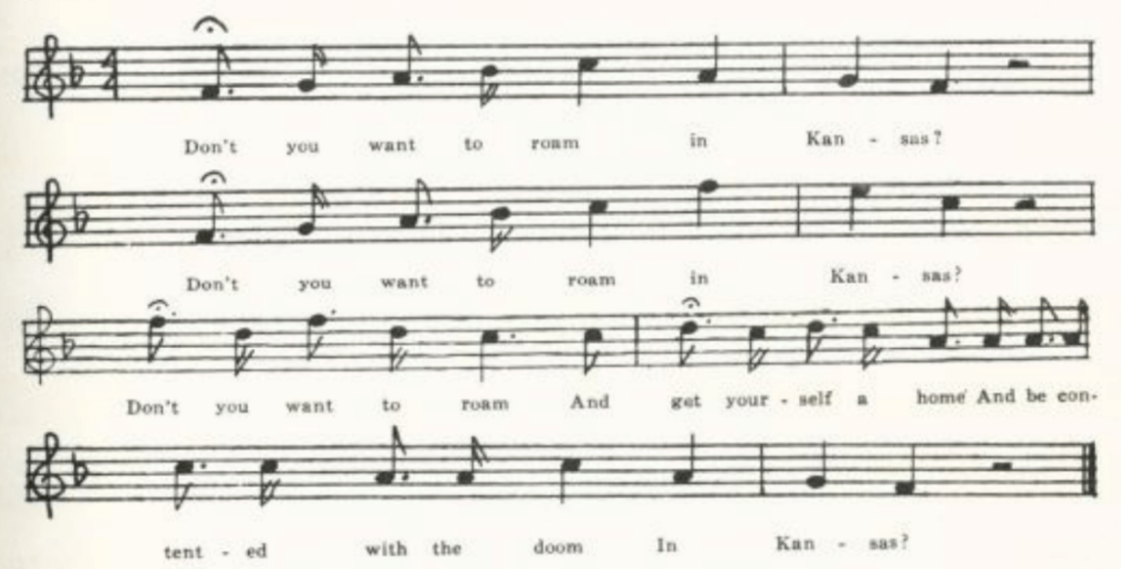
Don’t you want to roam to Kansas?
Don’t you want to roam to Kansas?
Don’t you want to roam
And get yourself a home
And be contented with the doom
In Kansas?

They chew tobacco thin in Kansas,
They chew tobacco thin in Kansas,
They chew tobacco thin
And spit it on their chins
And lick it in again
In Kansas.
Potatoes they grow small in Kansas,
Potatoes they grow small in Kansas,
Potatoes they grow small,
And they dig ‘em in the fall,
And eat ‘em skin and all
In Kansas.

(430)
Comical Ditty

A bit of social satire, not regional. From print, no doubt, tho I have found it only as a collector’s item. It is reported from tradition in West Virginia (FSS 253, with a widely different text), Texas (PFLST VI 236-7), Iowa (MAFLS XXIX 96-7), and Missouri (OASPS 220-1); Lomax has it (CS 256-8), and Barry knew it from Vermont. The following text was communicated in 1913 by James V. Billings of La Plata, Macon County.

Come all you young people, I pray you draw near,
A comical ditty you shortly shall hear.
The boys about here are beginning to advance
In courting the girls and learning to dance.
Chorus:
Du ra down down hi du ra down.

They will ride out in the morning with whip in their hand
Because their old dad owns a bit of poor land;
An old rusty watch and a silk jacket too,
And that in the fashion, or else it won’t do.

It’s now we will turn off from these frolicsome lads
And turn to the girls, who are ten times as bad.
Their old straw bonnets with ribbons they’ll trim;
They look like a crow set out on a limb.

They’ll daub on their powder and put on their paint,
They’ll go to a meeting as mute as a saint;
But when they get there, the truth I’ll disclose,
They are forming their plans how to take home their beaus.

Oh, when they catch one, how tickled they are!
They look all around and they primp and they stare;
They’ll keep him a-talking until it’s midnight,
And for fear he will go home they will hug him up tight.

They get up in the morning as cross as two sticks
And wish all the beaus were sent off to Old Nick;
And their old mother will say, while hurrahing them about,
‘You great lazy creatures, why don’t you get out?’

(431)
The Good Old Days of Adam and Eve

Catnach printed this as a stall ballad; I have not found it in the reports of ballad collectors. It is quite distinct from the folk-song ‘When Adam was first created,’ which was reported from Oxfordshire in 1913 (Folk-Lore XXIV 82), is one of the Allen Family Songs, was printed in The Social Harp (SFSEA 41, 74-5), and is to be found on a broadside in Harvard Library (25242 5.7, p. 45) under the title ‘The Honest Man’s Favorite.’

‘Good Old Days of Adam and Eve.’ Given me in 1910 by G. C. Broadhead, with the comment: ‘I heard this between 1838 and 1845.

I sing, I sing of days grown older,
When men and women were the bolder,
When cash was short and credit shorter
And out of malt we brewed our porter.
Sing high, sing ho, I grieve, I grieve
For the good old days of Adam and Eve.

Then our town was nothing but a village,
And the lawyers were too proud to pillage,
And we ate and drank in all its varieties
And didn’t care a hackle for temperance societies.

Then the young girls could grow a little wiser
By getting up early to see the lark rise, sir,
And they could, unless I am very much mistaken,
Have eaten for breakfast a pound of bacon.

Then in our town there were good people,
And on our church there was no steeple;
And the men went to bed all sober at night,
And the girls didn’t die by lacing tight.

Then this field was covered over
With a patch of wheat, or perhaps clover,
With here and there a tree for the cattle to get under
Out of the way of the lightning and thunder.

(432)
The Lords of Creation

This bit of feminine raillery is perhaps not traditional song, but at least it was sufficiently attractive to some one to be copied out in manuscript. I have not seen it elsewhere.

One of the pieces in a miscellany of MSS sent to me in 1907 by D. W. Parsons of Sweet Springs, Saline County. The MS was written, I judge, about the third quarter of the last century.

Ye lords of creation, men you are called,
You think you rule the whole.
You are much mistaken, after all,
For you are under woman’s control.
For ever since the world began
It’s always been the way—
Now did not Adam, the very first man,
The very first woman obey, obey, obey,
The very first woman obey?

Ye Lords who are present, hear my call.
I know you will quickly say:
Our size much larger, our nerves more strong,
Shall the stronger the weaker obey?
Now think not, though these words we hear,
We’ll mind one word you say;
For as long as a woman’s possessed of a tear
Your power will vanish away, away, away,
Your power will vanish away.

But should there be so strong a wight
As not be moved by tear,
Do not be astonished at the sight,
We still have no cause to fear;
Let us leave themselves to muse
Upon their fancied sway—
For as long as a woman’s possessed of a smile
She will certainly have her own way, her way,
She will certainly have her own way.

Now ladies, since I’ve made it plain
That the thing is really so,
We’ll not let them have their way,
But we’ll show them the way to go.

(433)
For ever since the world began
It’s always been the way,
And we’ll manage it so that the very last man
Shall the very last woman obey, obey, obey,
Shall the very last woman obey.

Song of the Times

Satire upon the various social types and callings is an ancient theme of balladry, as for instance in the Shirburn Ballads No. IX, which bears the date 1614. The song in the Missouri collection as relatives in other states—West Virginia (FSS 511-3), Mississippi (FSM 215-6), and the Lomaxes give it without localization, ABFS 322-4—which contain lines and stanzas in common with parts of the Missouri text. Partridge printed a form of it, No. 508 in his series. Its nature is such as to prompt the singer to local and personal adaptation. None of the texts known to me except the Missouri text satirizes religious denominations.

‘Song of the Times.’ Communicated by Mary L. Goodwin of Odessa, Lafayette County, in 1905.

Now a song I will sing you in jingles and rhymes
About matters and things in these curious times,
And a lesson to all I hope it will be
When I sing about things that I every day see.
These queer times, these queer times.

I see the little boys, just from their mammas,
Think themselves men because they puff their cigars.
They’d better be at home playing with toys
Than parading the streets and saying ‘I’m one of the boys.’
These fast times, these fast times.

And there’s the modern young lady, all the time reading sonnets,
Romances, and novels, and wearing queer bonnets;
She’ll screw up her waist till she cannot sneeze,
Wear a hump on her back, and a dress without sleeves.
These are queer times, these are queer times.

And I see the married ladies wear satins for dress
When their husbands are bankrupt and in great distress.
They had better be at home washing up dishes,
Darning old stockings, and mending their husband’s old breeches,
These hard times, these hard times.

(434)
There’s the blacksmith, who lives by the sweat of his brow,
And there’s the old farmer, who follows his plow;
Each a very good man, in his own conceit,
But get ‘em to trading, they both will cheat.
And it’s hard times, it’s hard times.

And there’s the Old Baptist; he’ll come on the stage,
He’ll open his book, and he’ll read you a page,
He’ll tell you a tale for you to go by,
But give him a chance, he’ll get drunk on the sly.
And it’s hard times, it’s hard times.

And the old Methodist, too, will exhort, and he’ll pray,
He’ll point you to heaven the straight, narrow way,
He’ll go to camp-meeting, he’ll shout and he’ll cry,
But in a horse-trade he will tell you a lie.
And it’s hard times, it’s hard times.
Next, the old Presbyterian, with grave, solemn face,
Will tell you salvation is all by God’s grace;
You’ll come when He ‘draws you’, you can’t come before,
But still, if you don’t come, to Hell you must go,
And this seems a hard case, a very hard case.

And now comes the Campbellite, preaching reform,
‘Repent and be baptized,’ in sunshine or storm;
He boasts of his ‘good works,’ owns to some evil too,
But all the good’s for himself and the evil for you.
And it’s hard times, it’s hard times.

And there’s the old doctor, I like to forgot.
I do not think in my soul he’s the worst of the flock
He’ll promise to cure you, for half you possess,
And when you are dead he will go for the rest.
Oh, it’s hard times, it’s hard times.

And lastly, the lawyer, as certain as fate,
Will have a fat slice in winding up your estate,
And his Honor, the Judge of the Probate, with ease
Gobbles up the remainder, in costs and in fees.
And then it’s hard times, it’s very hard times.

(435)
The Beaver Cup

This is reported by Henry from the southern Appalachians, SSSA 32; beyond that I have found no trace of it.

No title. Communicated in 1920 by Miriam Thurman of Wichita, Kansas, who said she learned it in her childhood.

I’ll sing you a song, I’ll sing you a song
About myself concerning
The beaver cap I used to wear
Before my locks’ returning.*
Tirry ol y fol y dol, tirry ol the day, sir.

I went to town, I bought me a cap;
I never wore a hat, sir.
The best old friend I ever had
Was that old beaver cap, sir.

I took it home that very same night,
I laid it on the bed, sir,
And every time I waked up in the night
I popped it on my head, sir.

I went out to work the very next day.
You bet I felt quite flat, sir.
And when I came in I set an old hen
In that old beaver cap, sir.

I took the eggs out one by one,
You bet I had some fun, sir,
I threw them at my mother’s head
And I banged her as she run, sir.

My father came home that very same night.
You bet he made me hop, sir;
He raised great blisters on my back
With that old beaver cap, sir.

Conclusion
I’ve sung you the song about myself,
About myself concerning
The beaver cap I used to wear
Before my locks’ returning.

*Possibly what is intended here is a reference to the singer’s hair turning grey; but I do not know how to construe it.

(436)
Sim and the Widow

Probably from the minstrel stage, but I have not come across it in print.

A
‘Seven Long Years Did Sim Court the Widder.’ Communicated by J. H. Craig of Bowling Green, Pike County, in 1905.

Seven long years did Sim court the widder,
Ho, ho, ho, ho, ho
Seven long years did Sim court the widder,
And seven long years and Sim didn’t git her.
Come a rye rye riddle dum-a-day

His mother was in need for want of a home,
And from that widder Sim stole a currycomb.

The widder’s son Bill was as spunky as a rat
And he made him bring that currycomb back.

Sim was made, as sure as you’re born,
And he jumped in the field and went to kickin’ up the corn.

O law, Sim, you need not fret,
That pretty little widder will have you yet.

B
‘Sim and the Widow.’ Communicated in 1916 by T. C. Wright of Tuscumbia, Miller County; from his father’s singing.

Seven long years did Sim court the widow,
Hu hu hu hu hu hu hu!
Seven long years did Sim court the widow
And seven long more and Sim didn’t get her.
Tum-a-row-row-riddle li-lu-day

Sim went down to set the wedding day;
Long came the widow raking up her hay.

Sim went hom and Sim went to bed
With a pain round his heart and a misery in head.

Sim went down to bring the cattle home,
And from that widow he stoled a currycomb.

(437)
The widow sent John, as spunky as a rat,
And made Sim bring that currycomb back.

Sim was mad as sure as you’re born.
He jumped into his field and he kicked up his corn.

When I was Single

Quite probably a printed stall ballad or a music-hall piece originally, but I have found it only as a collector’s item. It is reported from tradition in Oxfordshire (FSUT 111), Nova Scotia (BSSNS 347-8), Kentucky (FSMEU 211-2, BKH 85-6, JAFL, XLI 576—this last from Louisville negroes), Tennessee (ETWVMB 99-100), Mississippi (JAFL XXVIII 185), Texas (PFLST VI 253-4), Arkansas (Ozark Life for August, 1930), Nebraska (ASb 47), Wyoming (ABS 207), and it is included in ABFS and in the Combs and Shearin list.* It perhaps gave rise to, perhaps sprang from, a counterpart from the woman’s point of view, which was printed as one of ‘Sam Cowell’s 120 Comic Songs’ about 1850 (JFSS VIII 148-50) and has been reported as traditional song in this country in Virginia (SharpK II 34, SCSM 321), Kentucky (BKH 118, SharpK II 33-4), Tennessee (SharpK II 33), North Carolina (SharpK II 32), Michigan (KNR 299), and Iowa (MAFLS XXIX 92-3). I have an interesting text of it given me by Professor W. C. Etheridge from recollections of his childhood in North Carolina, and the following fragment from Missouri:

‘I Wish I were Single Again.’ Sent me in 1907 by Mrs. E. A. McKay of Knox City, Knox County, with the note: ‘There may be more I do not remember.’
The cows are to milk and the spring to go to;
The drunkard’s in his dramshop; Oh! what shall I do?
Oh! I wish I were a single girl again.

When I was single I lived at my ease;
Now I have married a drunkard to please.
Oh! I wish I were a single girl again.

If ever I am singe, single I’ll remain,
I’ll never be controlled by a drunkard again.
Oh! I wish I were a single girl again.

*’The Holly Twig,’ known in Virginia (SharpK I 341-3) and in Mississippi (FSM 174-5), the allied in theme, is a quite different song.

Of the more familiar piece presenting the matter from the man’s point of view there are three texts in the Missouri collection, all forms of one version, tho if one may

(438)
judge from the texts, not sung to one tune. Unfortunately I have not secured the tune of any of them.

A
‘I Wish I Was Single Again.’ From C. H. Williams, Bollinger County, 1906.

When my wife died, o then, oh then,
When my wife died, oh then, oh then,
When my wife died I laughed till I cried
To think I was single again.
Chorus:
When I was single, oh then, oh then,
When I was single, oh then, oh then,
When I was single my pockets would jingle,
I wish I was single again.

I went for the shroud, oh then, oh then,
I went for the shroud, oh then, oh then,
I went for the shroud and I felt mighty proud
To think I was single again.

I married me another, oh then, oh then,
I married me another, oh then, oh then,
I married me another; ‘twas the devil’s grandmother!
Oh, the world went wrong with me then.

B
‘When I Was Single.’ From D. W. Parsons, Sweet Springs, Saline County, 1911.

When I was single, oh then,
When I was single my pockets did jingle,
And I wish I was single again.

I married a wife, oh then,
I married a wife, she’s the plague of my life,
And I wish I was single again.

My wife she died, oh then,
My wife she died, and I laughed till I cried
To think I was single again.

(439)
I went for the coffin, oh then,
I went for the coffin, and like to died laughing
To think I was single again.

I went to the funeral, oh then;
The band did play, and I danced all the way
To think I was single again.

I married another, oh then,
I married another, she’s the devil’s grandmother;
And I wish I was single again.

So now, young men, take warning from me:
Be kind to the first, for the next may be worse,
And you’ll wish you were single again.

C
‘When I Was Single.’ Secured by Miss Hamilton in 1912 from a Mrs. Ballard of La Plata, Macon County, who said her father and mother knew it. This is the only text in the collection which agrees in stanza structure with the texts reported by other collectors.

When I was single oh then,
When I was single, oh then,
When I was single my pockets did jingle,
And I wish I was single again.

My wife she died, oh then,
My wife she died, oh then,
My wife she died and I laughed till I cried
To think I was single again.

I married me another, oh then,
I married me another, oh then,
I married me another, she’s the devil’s grandmother,
And I wish I was single again.

Young men, take warning from me,
Young men, take warning from me;
Be kind to the first, for the last is the worst;
And I wish I were single again.*

*An element frequent in texts from elsewhere (BKH, JAFL XLI, ETWVMB, PFLST VI, Ozark Life, ABFS), the attempt of the wife—sometimes the first wife, sometimes the second—to hang him, has been lost from the Missouri texts.

(440)
The Young Man who Wouldn’t Hoe his Corn

Evidently of American origin. It has been recorded from tradition in Vermont (VFSB 74), West Virginia (FSS 494), Tennessee (SharpK II 2580, Mississipi (FSM 200-1), Indiana (JAFL XXIX 181-2), Iowa (MAFLS XXIX 91-2), and Nebraska (ABS 110-1). I have not found it in print except in these collections. Barry found it in Vermont.

‘Young Man Who Did Not Hoe His Corn.’ Communicated by Mrs. Carrie Phelps of West Plains, Howell County, in 1905.

Come, girls, come and I’ll sing you a song
Concerning a young man who would not hoe his corn.
The reason why I could never tell,
For this young man was always well.

He planted his corn in the month of June.
In July it was knee high.
In September there came a big frost;
And this young man’s corn was lost.

He went to the fence and he peeped in.
The grass and the weeds were up to his chin.
The careless weeds they grow so high
Caused this young man for to sigh.

He went into his neighbor’s door,
Where had often been before;
And when the courtship she began,
Says, ‘Young man, have you hoed your corn?’

He hung his head and began to sigh,
Saying, ‘Madam, I’ll tell you why.
I tried and tried and tried in vain;
Don’t believe I’ll raise a single grain.’
‘Then what makes you ask me to wed
When you can’t raise your own corn bread?
Single I am, single I’ll remain.
A lazy man I won’t maintain.’

He picked up his hat and he went away,
Saying, ‘Madam, you’ll rue the day,
Rue the day as sue as you’re born,
Giving me the mitten ‘cause I didn’t hoe my corn.’

(441)
The Juice of the Forbidden Fruit

This I assume to have been originally a stage song, tho I do not know its history. It is No. 653 in Wehman’s series of slip ballads, with topical allusions to Beecher, Conkling, Blaine, Frank James ‘out on bail,’ Oscar Wilde, Grant, Mrs. Langtry. A cowboy text is reported from Texas (PFLST VI 199-200).

‘The Juice of the Forbidden Fruit.’ Reported from oral tradition in Bollinger County in 1906 by George Williams.

It was along about the time
That old mother Eve did climb
That apple tree against the law
And threw down the core
Which made her so sore
For her henpecked husband to chaw.
And ever since then
All manner of men
Have drunk the juice of the forbidden fruit.
. . . . . . . . . . . . . . . . . . . . .
There’s Henry Ward Beecher,
The Sunday school teacher,
Drinks what you call sassafras root;
But you can bet all the same
If it had the right name
‘Twould be the juice of the forbidden fruit.

Calomel

This satire upon the old-fashioned doctor has been reported, with considerable variations in the text, from North Carolina (JAFL XII 252-3, Spaeth’s Wee Some More, My Lady 203-4), Georgia (FSSH 412-3), Mississippi (FSM 217), and Iowa (ABS 126-7, MAFLS XXIX 100-1). The Missouri text is a fragment.

‘Calomel.’ Communicated in 1911 by G. C. Broadhead, from his early recollections.

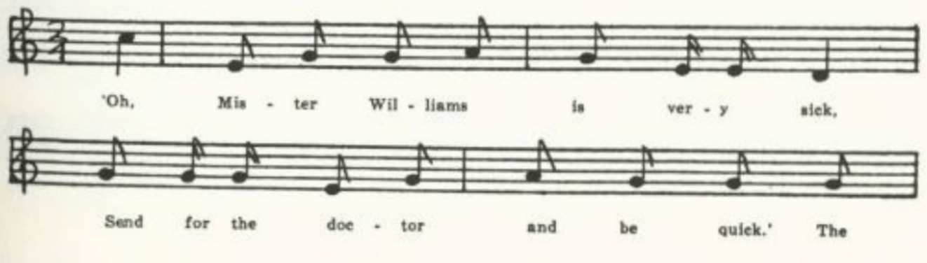
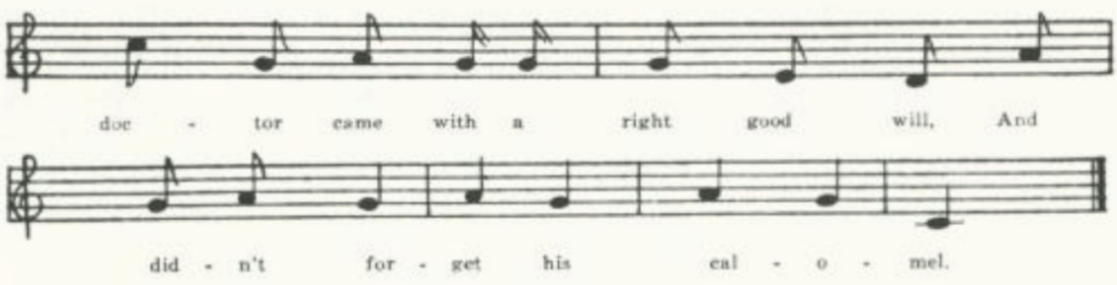
(442)
‘Oh, Mr. Williams is very sick,
Send for the doctor and be quick.’
The doctor came with a right good will
And didn’t forget his calomel.

The Steam Doctor

Dr. Samuel Thomson of Massachusetts (1769-1843), founder of a medical sect that bore his name and believed only in vegetable medecines, must also have been a great believer in sweating, to judge from the following fragment of a satire on his methods. ‘Lobelia’ was probably Lobelia inflata, popularly known as ‘Indian tobacco,’ which had emetic properties. Dr. Henry E. Sigerist of the Institute of the History of Medicine at Johns Hopkins University tells me that Thomson numbered his various medicaments and that ‘number six’ was ‘Gum Myrrh. Aromatic, astringent, tonic, stimulant, and antiseptic. To give tone to the stomach and bowles, and prevent mortification,’ as described in The Thomsonian Materia Medica. I have not found this bit of satire elsewhere, but presume that it was widely known in this country a hundred years ago. For the refrain line at the close see Song of the Times in this volume, p. 433.

No title. Communicated in 1911 by G. C. Broadhead of Columbia, who explained that the Thomsonians were commonly known as ‘steam doctors.’

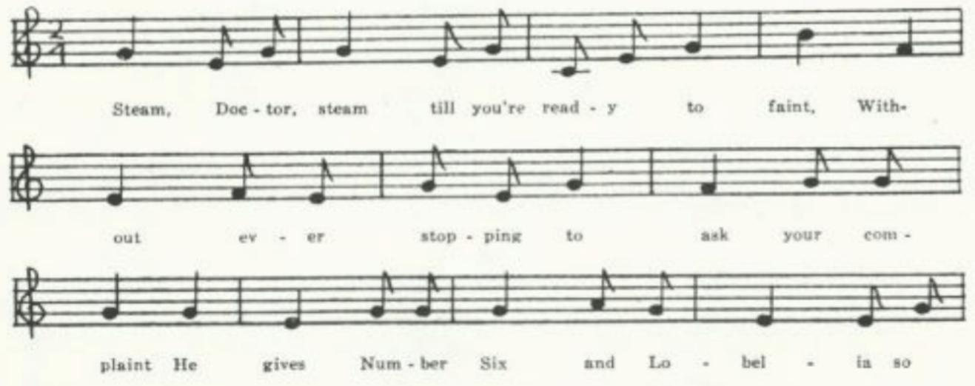
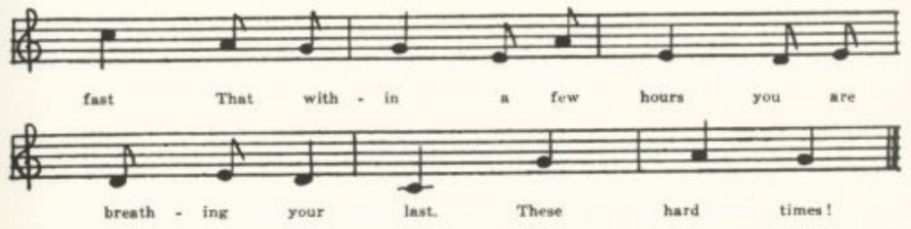
(443)
Steam, Doctor, steam till you’re ready to faint;
Without ever stopping to ask your complaint
He gives No. 6 and lobelia so fast
That within a few hours you’re breathing your last.
These hard times!

The Farmer and the Shanty Boy

Interesting as a representative in modern american balladry of the medieval débat type, for which see Kittredge’s note JAFL XXXV 400 and Paris, Origines de la Poésie lyrique en France au moyen Age 30. Tolman JAFL XXXV 399-400 points to an English parallel, ‘The Husbandman and the Servingman’; his other parallels belong rather with the regional satire pieces presented here on pp. 424-9. The American lumberman’s song is reported from Pennsylvania (NPM 215-7), Maine (MM 27-8), Michigan (JAFL XXXV 400-1), Iowa (JAFL XXXV 400-1), and Minnesota (BSSB 48-50, Dean 51-2). The following text is not strictly speaking from Missouri.

‘The Farmer and the Shanty Boy.’ Secured in 1912 by Miss Newell from the singing of a. F. Nelson of Madison, Wisconsin, who learned it in Michigan.

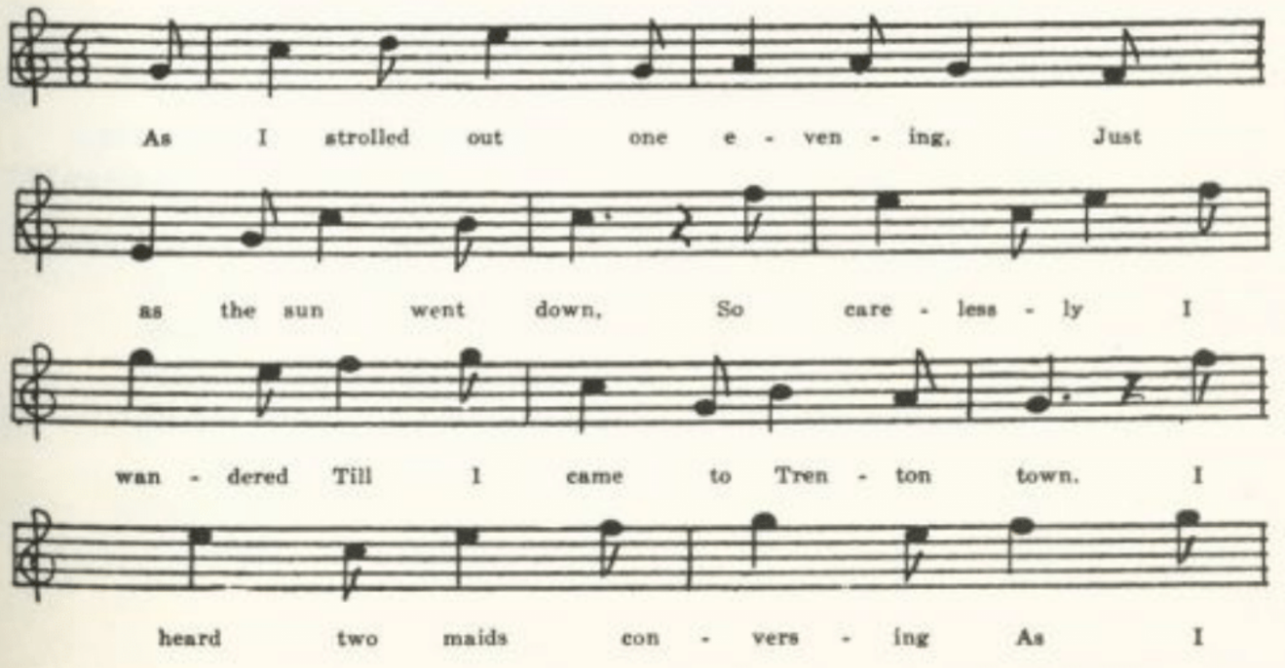
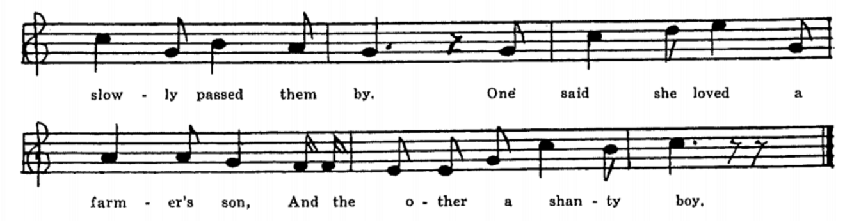

(444)
As I strolled out one evening
Just as the sun went down,
So I carelessly I wandered
Till I came to Trenton Town.
I heard two maids conversing
As I slowly passed them by.
One said she loved a farmer’s son
And the other a shanty boy.
The one that loved the farmer’s son,
These words I heard her say:
The reason that she loved him,
At home with her he’d stay.
He would stay at home all winter long,
To the woods he would not go.
And when the spring would come in his fields,
Then he would plow and sow.

‘All for to plow and sow his fields,’
The other one did say.
‘If his crops should prove a failure,
His debts he could not pay.
If his crops should prove a failure,
Grain markets being low,
The sheriff then would sell his grain
To pay the debts he’s owe.’

‘As for the sheriff selling grain,
That does not me alarm.
For there’s no use of being in debt
When you’re on a good farm.
You raise your grain all on your farm,
Don’t work through storm and rain,
While your shanty boy works hard each day
His family to maintain.’

‘Oh, how I love my shanty boy
Who goes off in the fall!
He is both stout and healthy,
And fit to stand a squall.
With pleasure I’ll receive him
In the spring when he comes down;
For his money with me he’ll share quite free,
While your mossback he has none.’

‘Oh, how you praise your shanty boy
Who goes off in the fall!
He’s ordered out before daylight
To stand the storms and squalls;
While happy and contented
My farmer’s son will stay
And tell to me some tales of love
While raging storms go by.’

‘Oh, I could not listen to the sill stuff
Your mossback has to say.
For some of them are green enough
That cows might eat for hay.
How easy it is to tell them
When they come into town;
For the little kids run after them
Saying, “Mossy, how are you down*?”’

‘Oh, what I have said of your shanty boy
I pray you’ll me excuse.
And from this silly mossback
I hope I may get free.
If ever I get free from him
With a shanty boy I’ll go,
And leave him broken-hearted
His field to plow and sow.’

(445)
Now here’s to good luck to rock and gin,
Those enterprising men.
. . . . . . . . . . . . . . .
. . . . . . . . . . . . . . .
And here’s to good luck to the shanty boys
That make the wild woods ring.
For they cut the pine in the winter time
And drive it in the spring.

The Old Section Boss

Familiarly known by its refrain line, ‘Jerry, go ile that car,’ this is a favorite with railroad men—especially, according to Sandburg’s informant, with workers on the Santa Fe. It is given in ASb (360-1) and by Dean (26-7).

‘The Old Section Boss.’ An imperfectly remembered text set down for me by Finis Dean of Carroll County in 1914.

Ah, I’ll sing you a song of the old section boss.
He’s a-lying very low.
He came from dear old Ireland
Some forty year ago.
He taught me of all the mysteries
Of the shovel and the old crowbar,
And it’s while the boys are a-tamping at the ties
It’s ‘Jerry, go ile up the cars.’

. . . . . . . . . . . . .
. . . . . . . . . . . . .
. . . . . . . . . . . . .
. . . . . . . . . . . . .
. . . . . . . . . . . . .
. . . . . . . . . . . . .
And when I am dead, place a frog at my head,
And Jerry, go ile up the cars.
. . . . . . . . . . . . .
. . . . . . . . . . . . .
. . . . . . . . . . . . .
. . . . . . . . . . . . .
With his old blue coat buttoned up to his throat
It’s over the road he’d go,
And while the boys are a-tamping at the ties,
It’s ‘Jerry, go ile up the cars.’
. . . . . . . . . . . . .
. . . . . . . . . . . . .
. . . . . . . . . . . . .
. . . . . . . . . . . . .

(446)
He’s a-going to pump her in just ahead of Number Ten,
For the distance is very far,
. . . . . . . . . . . . .
. . . . . . . . . . . . .

The Blind Fiddler

The following was no doubt made to be sung by fiddlers at street corners. I have not come upon it in print. ‘The Blind Boy,’ reported from Iowa (MAFLS XXIX 138-9), resembles it in that the singer has been blinded by a ‘hot iron chip’ from a forge, but he is not a fiddler and there are no verbal likenesses.

‘Blind Fiddler.’ From the MS ballad-book of Allen F. Wade of Daviess County, lent to me in 1923 by his daughter, who was then a student at the University of Missouri. The name at the end is presumably that of the person who wrote it out for Wade.

Farewell to my home, for I can no longer stay,
Hard times and misfortune have forced me away;
Hard times and misfortune has forced me to roam.
Now I am a blind fiddler and far from my home.
Chorus:
I have a wife, a child a-depending now on me
To share all my trouble, whatever they may be.
Hope they may be cheerful while I have to roam,
Oh, now I am a blind fiddler and far from my home.

I’ve been blind for thirty years, more than half of my life;
I’ve tried to make a living for my child and wife.
In order to accomplish this I am compelled to roam.
Oh, now I am a blind fiddler and far from my home.

I lost my eye in the blacksmith shop in the fall of ’56
While dressing of a key punch which was out of fix;
It bounded from the tongs and there it sealed my doom.
Oh, now I am a blind fiddler and far from my home.

I’ve been to San Francisco, I’ve been to Dix lane.*
He operated on one of my eyes, but nothing did I gain.
He told me I’d never see again and was no use to mourn.
Oh, now I am a blind fiddler and far from my home.
Mamie Bolas

*Possibly a place, but more likely the name of a surgeon; perhaps ‘Dick Slane.’

(447)
The Little Family

A biblical narrative of a type that goes back at least to the seventeenth century and is exemplified by the Resurrection ballad in Roxburghe Ballads I 388and a later stall print by Barr of Leeds in one of the British Museum collections, Bks.3.g.4. V270. This ballad on the raising of Lazarus, however, I have found only in America and there only as a collector’s item. The resemblance of the various texts suggests that it circulated in print, perhaps as a stall ballad, perhaps in a religious song-book; but there is enough variation to show that it has been subjected to the fortunes of oral transmission. It has been reported from Virginia (WSSU 195-7), SCSM 195-6), West Virginia (FSS 407-8), Kentucky (John C. Campbell, The Southern Highlander and his Homeland 185), Tennessee (JAFL XLVI 43-4, FSSH 417-8), Mississippi (FSM 212-4), and Ohio (JAFL XXIX 182-3, XXXV 388).

A
‘The Little Family.’ Copied by Miss Welty in 1906 from an old ledger which came into her hands while she was teaching at Brookfield, Linn County, and which had been used for a diary in Civil War times by a man named Sims. He had copied into it certain songs which pleased him. In this case he carefully indicated how he came by the song.

There was a little family
Lived up in Bethany.
Two sisters and a brother
Composed this family.
With singing and with praying,
Like angels in the sky,
At morning and at evening
They raised their voices high.
They lived in peace and pleasure,
Though poor for many years,
Although they laid up treasure
Beyond this vale of tears;
Though poor and without money,
This kindness made amends.
This house was always open
To Jesus and his friends.

But while they lived so happy,
So poor, so kind, so good,
Their brother was afflicted
And really throwed on bed.*
Poor Marthy and poor Mary
They weeped aloud and cried.
Their brother grew no better,
But lingered on and died.

When Jesus heard the tidings,
Though in a distant land,
How swiftly did he travel
Unto this lonely land!
When Marthy saw him coming
She met him on his way;
She told him how her brother
Had died and passed away.

When Mary saw him coming
She ran and met him too,
Fell at his feet a-weeping,
Rehearsed her tale of woe.
He cheered them and he blessed [them]
And told them not to weep,
For he had power in him
To raise him from his sleep.

(448)
He rolled away the cover
And looked into the grave,
And prayed to his dear father
Their blessed friend to raise.
Then Lazarus in full power
Came from the gloomy mound,
And in full strength and vigor
He walked upon the ground.

So if we but love Jesus
And do his holy will
Like Marthy and like Mary,
He’ll always use us well.
From death he will redeem us
And take us to the skies,
And then we’ll live forever
Where pleasure never dies.

Sung by C. S. Wilson
And Copied by permit
Monday August 21, 1865
At Mobile Ala
By E. J. Sims

B
‘Little Family.’ From C. H. Williams of Bollinger County in 1906, as known to his mother, who commented: ‘This song I learned from a young lady by the name of Mary Daw, when I was about six years old, in the state of Illinois.’ Omissions and additions, as compared with A, make it worth while to give this text too.

There was a little family
Who lived in Bethany.
Two sisters and one brother
Composed that family.

They lived in peace and pleasure
For many a long year;
In heaven they placed their treasure,
Beyond this vale of tears.

But while they wee so happy,
So good, and so kind,
Their brother was afflicted
And by disease confined.

Poor mother* and poor Mary,
They wept aloud and cried,
But still he grew no better,
And lingered long, and died.

They Jews they came to see them
Put Lazarus in the tomb,
And tried to show them comfort
And drive away their gloom.

When Jesus heard the tidings,
Far in a distant land,
How quickly he did travel
To see this loving band!

When Martha saw him coming
She met him by the way
And told him how her brother
Had died and passed away.

When Mary saw him coming
She ran and met him too;
Fell at his feet a-weeping,
Rehearsed her tale of woe.

When Jesus saw them weeping
He fell a-weeping too
And wept until they showed him
Where Lazarus was entombed.

He rolled away the cover,
Then looked up on the tomb,
And prayed unto his father
His loving friend to raise.

Then Lazarus in full power
Rose from the gloomy tomb,
And full of life and vigor
He walked upon the ground.

*Miswritten, or misheard, for ‘Martha.’

(449)
C
‘Little Family.’ Secured in 1921 thru Professor W. C. Etheridge from Professor R. T. Kirkpatrick, who had learned it from his kinsfolk in the Ozarks. A truncated form of A, tho it has lines 5-8 of the B text; it lacks altogether stanzas 4-6 of A.

Moses in the Bulrushes

Another biblical narrative, which I have found reported elsewhere only from Tennessee (SFSEA 55-6). Miss Lowry’s text covers only the first half of the song reported by Jackson.

‘By the Side of a River.’ Reported by Miss Lowry in 1905 as known by her aunt in Indiana.

By the side of a river so clear
They carried the beautiful child;
Mid the flags and the bushes in an ark of bulrushes
They left him so lonely and wild;
For the ruffians would come if he tarried at home
And murder that infant so dear.

By the side of the river so clear
The ladies were winding their way,
When Pharoah’s daughter stepped down to the water
To bathe at the close of the day.
Before it was dark, she opened the ark
And found a sweet infant was there.

By the side of the river so clear
That infant was lonely and sad.
She took him in pity and thought him so pretty
And made little Moses so glad.
She called him her own, her beautiful son,
And sent for a nurse that was near.

Away from the river so clear
They carried the beautiful child
To his own tender mother, his sister and brother,
And then he looked happy and smiled.
His mother so good did all that she could
To nurse him and teach him with care.

(450)
The Romish Lady

This is the American representative of a sixteenth century English ballad one line of which is quoted in Fletcher’s Knight of the Burning Pestle (V iii) and a later text of which was printed by Chappell in Roxburghe Ballads I 34ff. The heroine there, however, is ‘a lady’s daughter, of Paris properly,’ not a ‘Romish lady.’ The English ballad closely resembles, is possibly translated from the Dutch ‘Ds Geuzemädchen,’ printed by Hoffman von Fallersleben in the second edition of his Horae Belgicae. I have not found the English ballad reported as traditional song in modern times in England, but it is fairly well known in America, appearing in Virginia (SCSM 176-8), North Carolina (The Carolina Booklet XI 41), Mississippi (FSM 137-9), and Indiana (ABS 63-6, by way of Nebraska). Jackson (SFSEA 27-8) gives a full text from the Hesperian Harp, published at Philadelphia in 1848 and compiled by a Georgian. I have not elsewhere found it in print except in the publications of ballad collectors. A parody of it (ASb II, Folklore of Romantic Arkansas II 161), beginning

Oh, there was a moanish lady,
Lived in a moanish land,

is described by Sandburg as an ‘offshoot of the spiritual “Mourner, You Shall be Free” ’ and as ‘widely known for many years among barber shop harmonizers.’

A
‘The Roman Lady.’ From the manuscript ballad-book of James Ashby of Hold County, secured by Miss Welty in 1906. The ‘pompery’ of the first line is of course for ‘popery.’ The date at the end is that of the entry in Ashby’s book.

There was a Roman lady, brought up in pompery,
Her mother ofttimes told her she must the priest obey.
‘Oh, pardon me, dear mother, I humbly pray thee now,
For unto those false idols I can no longer bow.’

Assisted by a hand maid a bible she concealed,
And as she gained instruction the Lord his love revealed;
No longer would she prostrate to pictures made of gold,
And soon she was betrayed and her bible from her sold.

‘I’ll bow to my dear Jesus, and worship God unseen;
I’ll live by faith forever; the works of man are vain.
I cannot worship idols nor pictures made by man.
Dear mother, use your pleasure, but pardon if you can.’

(451)
The chains of gold so costly they from this lady took,
And she with all her courage the pride of life forsook.
Before the pope they brought her in hopes of her return,
And there she was condemned in horrid flames to burn.

Before the place of torment they brought her speedily,
And with lifted hands to heaven she there agreed to die.
Instead of golden bracelets in chains they bound her feet,
Crying, ‘Oh, my God, give pardon . . . . . .
(Bottom of page torn off here)

. . . . . . . . . . . . . . . .
. . . . . . . . . . . . . . . .
‘Yourselves you need to pity on Zion’s deep decay.
Young ladies, turn to Jesus, no longer make delay.

‘It was my cruel mother was on my ruin bent,
‘Twas her who did betray me; but I am innocent.’
In come her raging mother he daughter to behold,
And in her arms she brought an image decked in gold.

‘Oh, take from me those idols, remove them from my sight,
And restore to me by bible; in it I take delight.’
Soon as these words were spoken up stepped the man of death
And kindled up the flames to stop her immortal* breath.

‘Tormentors, use your pleasure and do as you think best.
I’m in hopes my blessed Jesus will take my soul to rest.
With Jesus and his angels I ever hope to dwell.
God pardon priest and people! I bid you all farewell.’
February 20/73

*Confusion of ideas here has led to the substitution of ‘immortal’ for ‘mortal.’

B
‘The Romish Lady.’ From the MS ballad-book of Mrs. Lida Jones of Dade County, secured for me in 1906 by Miss Lowry. Substantially the same text as E below, but the variants perhaps justify giving the text here.

There was a Romish lady, brought up in Popery.
Her mother always told her the priest she must obey.
‘Oh, pardon me, dear mother! I humbly pray thee now,
For unto these false idols I can no longer bow.’

(452)
Assisted by her handmaid a bible she concealed,
And there she gained instruction till God his love revealed.
No more she prostrated herself to pictures decked with gold;
But soon she was betrayed and her bible from her stole.

‘I’ll bow to my dear Jesus, I’ll worship God unseen;
I’ll live by faith forever. The works of men are vain.
I cannot worship angel, nor pictures made by men.
Dear mother, use your pleasure, but pardon if you can.’

With grief and great vexation her mother straight did go
To inform the Romish clergy the cause of all her woe.
The priests were soon assembled and for this maid did call
And forced her in the dungeon, to fright her would withal.

The more they strove to fright her soul the more she did endure;
Although her age was tender, her faith was strong and sure.
The chains of gold so costly they from this lady took,
And she with all her spirits the pride of life forsook.

Before the Pope they brought her, in hopes of her return,
And there she was condemned in horrid flames to burn.
Before the place of torment they brought her speedily.
With lifted hands to heaven she then agreed to die.

There being many ladies assembled at the place,
She raised her eyes to heaven and begged supplying grace.
‘Weep not, ye tender ladies, shed not a tear for me;
While my poor body is burning my soul the Lord shall see.
‘Yourselves you need to pity, and your deep decay.
Dear ladies, turn to Jesus, no longer make delay.’
In comes her mother her daughter to behold,
And in her hand she brought he some pictures decked in gold.

‘Oh, take from me those idols, remove them from my sight;
Restore to me my bible, in which I take delight.
Alas, my aged mother, why on my ruin bent?
‘Twas you that did betray me, but I am innocent.

‘Tormentors, use your pleasure and do as you think best.
I hope my blessed Jesus will take my soul to res.’
Soon as these words were spoken up came the man of death
And kindled up the fire to stop the mortal breath.

(453)
Instead of golden bracelets with chains they bound her feet.
She cried, ‘My God, give power! now must I die at last.
With Jesus and his angels forever I shall dwell.
God pardon priest and people! And now I bid farewell.’

C
‘The Romish Lady.’ Contributed by C. H. Williams, Bollinger County, in 1906. Somewhat truncated from A with the recombination of parts of stanzas so frequently found in oral tradition.

There was a Romish lady,
Brought up in Popery.
Her mother always taught her
The priest she must obey.
‘Oh, pardon me, dear mother,
I humbly pray tee now;
For unto these false idols
I can no longer bow.’

Assisted by her handmaid
A bible she concealed,
And there she gained instruction
Till God his love revealed.
No more she prostrated herself
To pictures made by man.
‘Forgive, my dearest mother,
And pardon if you can.’

Before the Pope they brought her
In hopes of her return,
And there she was condemned
In horrid flames to burn.
Instead of golden bracelets
With chains they bound her feet.
She cried, ‘My God, give power!
Now must I die at last.’

Soon as these words were spoken
Up stepped the man of death
And kindled up the fire
To stop her mortal breath.
‘With Jesus and his angels
Forever I shall dwell.
God pardon priest and people!
And now I bid farewell.’

D
‘The Romish Lady.’ From a miscellany of manuscripts sent to me in 1907 by D. W. Parsons of Sweet Springs, Saline County, in a hand apparently of the second half of the last century. Varies interestingly from A, especially at the close.

There was a Romish lady, whose friends all Papist were.
Her heart the Lord did open to seek his face by prayer.
She soon obtained her Savior, rejoicing in his name,
Renounced her former idols, content to suffer shame.

With weeping and with wailing her mother she did go,
Assembled all her kindred that they the truth might know.
And when they were assembled, the damsel they did call
And cast her into prison to frighten her withal.

(454)
The more they strove to frighten her, more firm she did endure.
Although her age was tender, her faith was fixed and sure.*
‘I value not your torment, your fire nor your flame;
I hope that Christ my Saviour will ease my mortal pain.’

Before the judge they brought her, hoping that she would turn;
And, when their efforts failed them, condemned her for to burn.
Took off her golden bracelets, with cords they bound her fast.
‘My Lord, oh, give me patience to die for thee at last.’

Then came her weeping mother her daughter to behold,
And in her hand she brought her a book covered with gold.
‘Take hence from me those idols, convey them out of sight,
And bring to me my bible, wherein I take delight.

‘Weep not for me, dear mother, I pray you be content.
You first informed against me when I was innocent.
Torment and do your office on me as you think best.
I hope that Christ my Saviour will take my soul to rest.

‘Young ladies of the city, mark well these words,’ said she.
‘Although I am to be burned, you need not pity me.
Yourselves you’ve need to pity, and mourn for your decay.
Amend you lives, fair ladies; I pray you don’t delay.

‘Farewell, my aged father, wherever you do lie.
You little think your daughter is now condemned to die.
In heaven among the angels I hope my soul will dwell.
So now, my dearest father, I bid you twice farewell.’

*The MS has ‘fixed on shure.’

E
‘The Romish Lady.’ Secured in 1912 by Miss Hamilton from Agnes Shibley of the Kirksville State Teachers College, who learned it from her mother.

There was a Romish lady
Brought up in pompery.
Her mother ofttimes told her
The priest she must obey.

‘Oh, pardon me, dear mother,
I humbly pray thee now,
For unto those false idols
I can no longer bow.’

With grief and great vexation
The mother straight did go
To inform the Roman clergy
That calls up all her woes.

The priests were soon assembled
And on this lady call.
They forced her [to] a dungeon
To fright her soul with awe.

(455)
The more they strove to fright her
The more she did endure;
For though her age was tender
Her faith was firm and sure.

The chains so golden and costly
They from this lady took,
And she with all her spirit
The pride of life forsook.

Before the pope they brought her
With hopes of her return;
But there she was condemned
In flames of fire to burn.

Then to the place of torment
They took her speedily.
With uplifted eyes to heaven
She thee agreed to die.

There being many ladies
Assembled at that place,
She raised her eyes to heaven
And begged supporting grace.

‘Weep not, ye tender ladies,
She not a tear for me,
For while my body’s burning
The Lord my soul shall see.’

Instead of golden bracelets
With chains they bound her fast.
She cries, ‘My God, give power,
Or I shall sink at last.’

Up came her aged mother
Her daughter to behold,
And in her hands she brought
An image decked with gold.

‘Oh, take from me that idol,
Remove it from my sight;
Restore to me my bible,
In which I take delight.

‘Alas, my aged mother,
Alas, how vile you’ve been!
It was you that did betray me
When I was innocent.’

Soon as these words were spoken
Up stepped the man of death
And kindled up the fire
To stop that virgin’s breath.

‘Tormentors, use you pleasure,
And do what you think best.
I hope the blessed Jesus
Will take my soul to rest.

‘Oh, pardon priest and people!
I bid you all farewell,
And with my blessed Jesus
I shall forever dwell.’

O Adam

The following curious bit Professor Raymond Weeks noted in the Mormon publication Times and Seasons (Nauvoo, 16 April, 1845), where it is given as the work of W. W. Phelps, Mormon editor and poet. It seems worth including here, not only because of the historic connection between the Mormons and the state of Missouri, but as a specimen of the mystery play in the nineteenth century. The conclusion is curiously unbiblical, and may be supposed to be the Mormon interpretation of the story.

(456)
Eve: O Adam, will you come with me?
For God has said that we are free
To all of Eden’s joys and powers,
To pluck and eat the fruits and flowers.
So we may cull the garden through
For flowers for me and fruit for you.

Adam: All save the tree of knowledge there
You may, my fairest of the fair.

Eve: O Adam, now ‘tis you and I;
For Satan said we should not die;
God never made a woman mute,
And I have eat forbidden fruit—
So now come eat with Eve your bride,
And feast your passions and your pride.

Adam: Yes, on the tree of knowledge there
I will, my fairest of the fair.

God: O Adam, Adam, where art thou?
For Paradise is blooming now;
Through endless realms the angels fly
To bring forth joys for you and I.
O have you hid yourself from me
For tasting that forbidden tree?

Adam: O yes, the tree of knowledge there,
And O! my fairest of the fair.

Eve: O Adam, Adam, must we go
Where thorns and thistles ever grow—
Where joys celestial never come,
Where sorrow will despoil our home—
O can we live and be forgiven
And gain our place once more in heaven?

Adam: Yes, for the tree of life is there
So come, my fairest of the fair.

Chorus: And multiply with joy and mirth
And beautify our mother earth.

Having so far overstepped the limits of folk-song, I am tempted to add another contribution from Times and Seasons—another of Phelps’s contributions, apparently, this time under the date 1 August, 1845:

(457)
The Cap Stone

Have you heard the revelation,
Of this latter dispensation,
Which is unto every nation.
O! prepare to meet thy God?
Chorus:
We are a band of brothers,
And we’ve rear’d the Lord a temple,
And the cap stone now is finish’d,
And we’ll sound the news abroad.

Go and publish how Missouri,
Like a whirlwind in its fury,
And without a judge or jury,
Drove the saints and spilt their blood?

Illinois, where Satan flatters,
Shot the prophets too, as martyrs,
And repeal’d our city charters,
All because we worship’d God.

Bennett, law, and many others,
Have betrayed our honest brothers,
To destroy our wives and mothers,
As a Judas did their Lord.

And their chief is Sidney Rigdon,
Who’s a traitor, base, intriguing,
And will fight at Armageddon,
When the fire comes down from God.

While the devil such me jostles,
With his “keys of conquest” morsels,
We’ll uphold the twelve apostles,
With authority from God.

And we’ll give the world a sample,
Of our faith and works most ample,
When we’ve finish’d off the temple
As a dwelling for the Lord.

And we’ll feed the saints that’s needing,
And improve our heats by weeding,
Till we make Nauvoo as Eden,
Where the saints can meet the Lord.

The Promised Land

Jackson, WSSU 232-3 and SFSEA 201, prints a text and tune of ‘The Hebrew Children’ from The Original Sacred Harp, where it is attributed to ‘Peter Cartwright, Amherst, Virginia, who lived 1785 to 1872,’ and later (WSSU 261-3) notes that it appeared in The Sacred Harp (1832) and in Southern Harmony (1835); and in SFSEA 200 he prints a tune and a fragment of text of ‘The Promised Land’ from The Social Harp (1855). White, ANFS 49-50, gives a text from The Southern Harmony and Musical Companion (Philadelphia, 1847) and speaks of ‘the preface to a former edition . . . dated Spartanburg, S.C., 1835.’ The song (for ‘The Hebrew Children’ and ‘The Promised Land’ are, textually at least, but variants of one song) would seem to have originated as a Southern camp-meeting hymn more than a century ago. And it spread all over the country. It was parodied in a satire on the faculty of Trinity College, Hartford, when I was a student there in the eighties. Even as a religious song it has undergone various modifications, as a comparison of the texts listed below will show. It has been reported as traditional song from Virginia (AMS 67), Kentucky (BKH 205-6), Tennessee

(458)
(JAFL XXVI 148), Alabama (J. Fischer & Bro.’s Choral Compositions No. 6749), Mississippi (JAFL XXVI 148), Indiana (ASb 92-3), Michigan (KNR 300), and among negroes (NS 144-5), ANFS 49-50), and is no doubt much more widely known than this list indicates. Of the two texts in the Missouri collection one professes to be in an American Indian tongue—what tongue I do not know.*

A
‘The Promised Land.’ Given to me in 1910 by G. C. Broadhead.

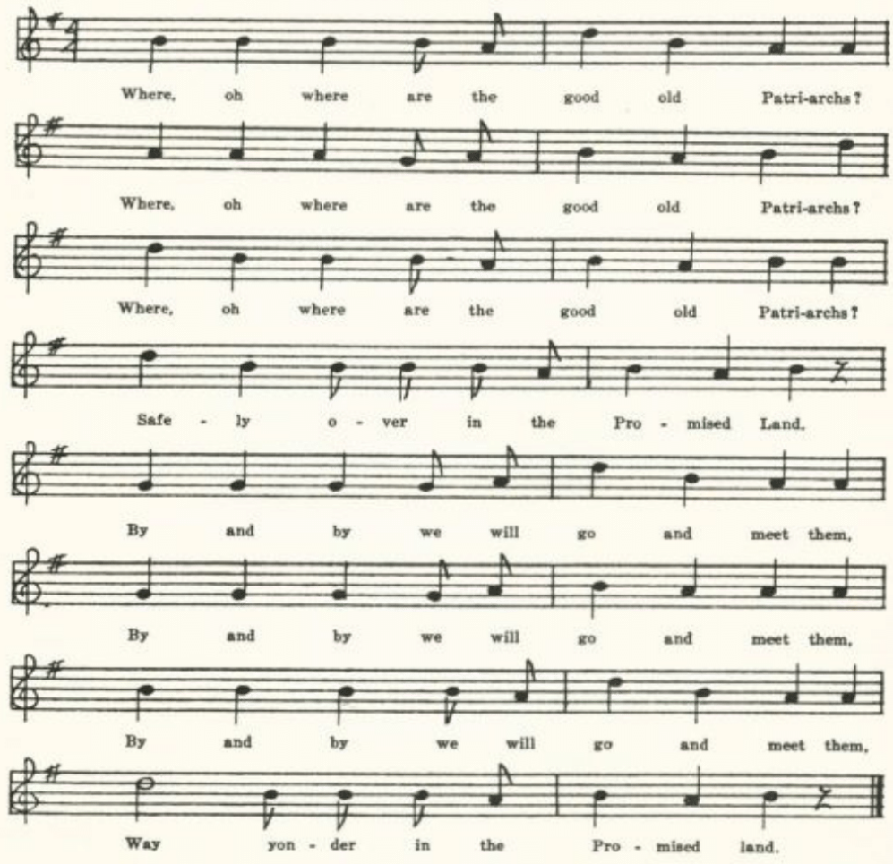
Where, oh where are the good old patriarchs?
Where, oh where are the good old patriarchs?
Where, oh where are the good old patriarchs?
Safely over in the promised land.

*Perrow JAFL XXVI 148 gives a version from American Indians in Mississippi which bears no resemblance to Missouri B.

(459)
By and by we will go and meet them,
By and by we will go and meet them,
By and by we will go and meet them,
Way yonder in the promised land.

Where, oh where is father Abraham?
Where, oh where is good old Moses?
Where, oh where are the Hebrew Children?
Way over in the promised land.
By and by we will go and meet them, etc.

Where, oh where is good old Shadrach?
Where, oh where is good old Meshach?
Where, oh where is good old Abednego?
Way over in the promised land.
They went through the fiery furnace,
They went through the fiery furnace,
They went through the fiery furnace,
Way over in the promised land.

Where, oh where is the Virgin Mary?
Where, oh where is the Virgin Mary?
Where, oh where is the Virgin Mary?
Way over in the promised land.
She went through much tribulation,
She went through much tribulation,
She went through much tribulation,
Way yonder in the promised land.

By and by we will go and meet her,
By and by we will go and meet her,
By and by we will go and meet her,
Way over in the promised land.

B
‘Indian Song.’ From C. H. Williams, known to his mother in Bollinger County. She thought that the meaning was ‘Where now is good old Moses,’ three times, then ‘Away over yonder in the promised land;’ then ‘By and by we’ll go and see him,’ three times, and then again ‘Away over yonder in the promised land.’ In other words, that it was a translation into the Indian tongue of the familiar camp-meeting song. Printed in JAFL XX 236.

Clo me sal sal mit a Moses
Clo me sal sal mit a Moses
Clo me sal sal mit a Moses
Hiclo piclo peace in-e-ay.

Clati clati-wamp pit-e-i pit-e-i-wa
Clati clati-wamp pit-e-i pit-e-i-wa
Clati clati-wamp pit-e-as-co by-way
Hiclo piclo peace in-e-ay.
Clo me sal sal mit a Daniel, etc.

(460)
The Wicked Girl

This and the following counterpart for the other sex are interestingly discussed in MLN XXVIII 1-5 by Barry, who prints four of the Missouri texts. He thought that the two were merely modifications of one original ballad, and that that with a female protagonist was the earlier form. It seems to be an American production.* It strongly recalls John Winthrop’s account (in his Journal for 30 March 1643) of the death of a young woman of Roxbury who could not secure saving grace by repentance. Jackson WSSU 189-94 prints three texts: one from the singing of a woman in Virginia, one from E. S. Ninde’s The Story of the American Hymn which Ninde thought came from Rhode Island ‘some years before the Revolution,’ and one from The Original Sacred Harp, where it is ascribed to John S. Terry, a singing teacher in Georgia and Alabama, and is dated 1869. This last text differs quite widely from the others. Whether or not it is of New England origin, it fitted well into the religious ideas of the ruder southern and western frontier and has been best remembered there. It has been reported also as traditional song from Jamaica (PMLA XXXIX 477-8, negroes), Rhode Island (MLN XXVIII 2), West Virginia (FSS 411-2), Arkansas (F. W. Allsopp’s Folklore of Romantic Arkansas II 162, negroes), Ohio (JAFL XXIX 192-3), Indiana (JAFL XXXV 426-7) and Iowa (ABS 111-2), and Hudson (JAFL XXXIX 175ff.) reports a sort of counterpart of it from Mississippi, in which as in Evan’s broadside, the girl is saved at the critical moment and now is ‘marching through Emanuel’s round up to the heavenly Canaan.’ Altho, as noted above, the Missouri texts have for the most part been printed before, all are given here for the sake of completeness.

*J. Evans of Long-Lane, London, printed a broadside (Harvard Library 25242.2, p. 22), ‘The Prodigal Daughter’ of somewhat similar import but with a more complicated and sensational plot. The wilful-wanton daughter, reproved by her parents for her behavior, plans to poison them so that she may be free and may inherit their money. The parents are warned by an angel in a dream. The poisoned food is given in the girl’s presence to a dog, which immediately dies; whereupon the girl falls into unconsciousness. Apparently dead, she is brought to the grave; but there recovers consciousness, tells of a vision she has had, repents, takes the sacrament, and lives ‘a Christian true’ ever after.

A
No title. Secured by Miss Gertrude Simmons in 1904 from Ethel Doxey of Carroll County, Arkansas. Printed by Barry, MLN XXVIII 3.

Young people hear, and I will tell:
A soul, I fear, has gone to hell,
A woman who was young and fair
Who died in sin and dark despair.

Her tender parents oft did pray
For her poor soul from day to day
And give her counsel, good advice;
But she delighted still in vice.

(461)
She would go to frolics, dance and play,
In spite of all her friends could say.
‘I’ll turn to God when I am old
And then he will receive my soul.’

At length she heard the spirit say:
‘Thou sinful wretch, forsake thy way;
Now turn to God, or you shall dwell
Forever in the flames of hell.’

‘No, I’m too young,’ thus she replied;
‘My comrades all would me deride.’
The spirit then bid her farewell
And thus consigned the wretch to hell.

It was not long till death did come
To call this helpless sinner home.
And while she was on her dying bed
She called her friends and this she said:

‘My friends, I bid you all farewell.
I die, I die, I sink to hell.
There must I lie and scream and roll,
For God will not receive my soul.

‘My tender parents,’ she addressed,
‘I hope your souls will both be blessed;
But your poor child you now my see
But soon shall be in misery.

‘My weeping mother, fare you well.
The pains I feel no tongue can tell.
Dear parents, your poor child is lost,
Your hopes they are forever crossed.’

B
‘The Dying Girl Unprepared to Meet her God. By Rev. J. H. Lewis.’ A single-sheet ballad which Mrs. C. W. Greene, of Columbia, found in the possession of her negro washerwoman, whom she had heard singing it. Printed by Barry, MLN XXVIII 2-3.

Young people who delight in sin,
I’ll tell you what I’ve lately seen—
A poor ungodly woman died,
Who said, in hell she soon would lie.
Chorus:
The downward road is crowded, crowded, crowded,
The downward road is crowded with unbelieving souls.

She danced and played her days away,
And still put off her dying day;
Her parents shed many a tear,
Their daughter was to them so dear.

On Friday morning she took sick
Her stubborn heart began to break.
She cried, ‘Alas my days are spent,
It’s too late for me to repent.’

Such ringing of hands,
Such gnashing of teeth—
No redemption—no relief.

She called her mother to her bed,
And these, her dying words, she said:
‘When I am dead remember well,
Your wicked daughter screams in hell.

‘Oh, mother, mother, fare you well,
Your daughter’s soul is damned in hell:
O father, father, fare you well,
Your daughter’s soul is damned in hell.

‘The tears you shed are lost for me,
My soul is lost—I plainly see
The aming* raft begins to roll,
And now I’m gone, a ruined soul.

(462)
‘Young people who doth slight the Lord,
Take warning by my dying word:
You may escape those burning flames,
Although I am damned to endles pains.’

She gnawed her tongue before she died,
She foamed and groaned, she screamed and cried,
‘Oh, must I burn forever more,
Till thousands and thousands of years are o’er?’

At length the monster death prevailed,
Her nails turned black, and her language failed:
Her eyes she closed, her heart strings she tore,
And the daughter is gone for evermore.

It almost broker her parents’ heart,
To see their child to hell depart:
Oh, is our daughter gone to hell?
Our grief so great no tongue can tell.

Good Lord, how her parents did moan,
To think their child was dead and gone;
‘Our daughter, oh, our daughter is dead,
Her soul is gone and her spirit fled.’

Young people, lest this be your case,
Now turn to God and seek his face;
Down on your knees for mercy cry,
Lest you in sin like the daughter die.

Price Five Cents.

*Presumably a misprint for ‘flaming.’

C
The following very full form was printed in the University Review (a magazine published by the University of Kansas City) III (1937) l83-5 as ‘an American folk ballad’ transcribed from the manuscript ballad-book of a Mr. Cook of Pittsburg, Kansas, written ‘more than eighty years ago.’ Note that here the girl’s state of mind is different.

Young ladies all attention give,
You who in wicked pleasures life;
One of your sex the other day,
Was called by death’s cold hand away.

This lesson she has left for you,
To teach the careless what to do;
To seek Jehova whilst you live,
And ever-lasting honor give.

A while before this damsel died,
Her tongue was speechless bound and tied;
At length she opened wide her eyes,
And said her tongue was liberized.

She called her father to her bed,
And thus in dying anguish said:
‘My days on earth are at an end,
My soul is summoned to attend

‘Before Jehova’s burning bar,
To hear my awful sentence there;
From meetings you have kept your child,
In pleasures wanton vain and wild.

‘To frolics you would let me go,
And dance my soul to sin and woe;
And now, dear father, do repent,
And read the Holy Testament.

‘Your head is blossomed for the grave,
You have a precious soul to save;
Teach your children to serve the lord,
And worship God with one accord.’

Her honored mother she addressed,
While tears were streaming down her breast;
She grasped her tender hand and said,
‘Remember me when I am dead.

(463)
‘Your aged years have rolled away,
And brought you to this present day;
Now take your dying child’s advice,
And turn from sin and avarice,

‘Before the golden bowl he broke,
Ere life’s fair cord receives the stroke;
Before death’s banners around you wave,
Before you are summoned to the grave.

‘I see no pleasures here on earth,
To trace my life back to my birth;
What would entice my soul to stay,
On this vain world another day?

‘Prepare yourself, Oh, mother dear,
For you are now on the frontier
Where everlasting time shall roll
Around my dead departing soul.’

Her weeping brother she addressed,
And thus her grieving tongue expressed:
‘Forsake your sins and turn to God,
And fear the vengeance of his rod,

‘For he will send you down to dwell,
Forever in the lake of hell;
Where fiery billows bursting roll
Around the never dying soul.

‘Life is the time to seek His face,
His gospel, mercies, and His grace;
His arms are now extended wide,
Come purchase peace, the prophet cried.

‘Now while you breathe the vital air,
Pour out your precious soul in prayer;
And pray in word, and act, and deed,
That Christ for your sins my intercede;

‘For you and for my sister dear,
That now are weeping round me here,
O, sister come and take your leave,
Don’t break your heart, I see you grieve.

‘Chilled are my limbs, the damps of death,
Run down my cheeks, and steal my breath;
See over my head, how angels shine,
In sparkling garments long and fine.

‘To soothe my parting spirit here,
And wipe away the briny tear;
And now my immortal soul shall rise
To God’s eternal Paradise.

‘Where crowds of angels round Him stand
And cherubs fly at His command;
And in the resurrection day,
When heaven and earth shall pass away,

‘I hope to meet you, far above,
Where all is joy, and peace, and love;
Once more, dear kindred, I must tell,
I bid you all a long farewell.’

At thus* she closed her eyes in death,
And thus resigned her mortal breath;
Under death’s solemn cypress shade,
They placed this young departed maid.

While friends and kindred wept around
To see her corpse laid in the ground;
A warning to the human race,
For all must go unto that place,

Unto the cold grave where silence reigns,
In death’s tremendous dark domains;
Young people now a warning take,
And from your wicked pleasures break.

*Miswritten, one supposes, for “And thus’ or ‘At this.’

(464)
D
The following was set down for me in 1934 by Miss E. M. Denny as all she could remember of a song she heard negroes sing in Randolph County ‘more than sixty years ago.’

O mother dear, O fare you well,
Your darling Betsy’s going to hell.
Such wringing hands, such gnashing teeth,
Saying ‘Way down in hell there’s no relief.’

Death is a Melancholy Call

A companion piece to the preceding, with a youth instead of a girl as the subject. See headnote to The Wicked Girl. All the texts known to me are from southern or western states. Missouri A and B wee printed by Barry, MLN XXVIII 4, and A also by Tolman, JAFL XXXV 423-4. It has been reported as traditional song from Tennessee (JAFL XLVI 44-5), North Carolina (TNFS 95, negro), Indiana (JAFL XXXV 423), and from the southern highlands without location by state (J. C. Campbell’s The Southern Highlander and His Homeland 186, AMS 69, NS 73—this last from negroes). The Tennessee and Indiana texts have the ‘awful, awful, awful’ refrain of Missouri A and C. Jackson (SFSEA 134), reports a similar but not the same song from Virginia.

A
‘Death.’ From the MS ballad-book of Mrs. Lida Jones, of Dade County, compiled probably in the eighties of the last century and secured for me by Miss Lowry in 1906.

Death is a melancholy call,
A certain judgment for us all.
Death takes the young as well as old
And lays them in his arms so cold.
‘Tis awful—awful—awful.
(Refrain line, repeated after each stanza)

I saw a youth the other day,
He looked so young, he was so gay,
He trifled all his time away
And dropped into eternity.

As he lay on his dying bed
Eternity begins to dread;
He cries, ‘O Lord! I see my state,
But now I fear I’ve come too late.’

His loving parents standing round
With tears of sorrow dropping down,
He says, ‘Oh father, pray for me;
I am going to eternity.’

His tender sister standing by
Says, ‘Dearest brother, you must die;
Your days on earth will soon be past
Down to the grave you must go at last.’

A few more breaths may be perceived
Before this young man takes his leave.
‘Oh, father, fare thee well!
I’m drawn by devils down to hell.’

The corpse was laid beneath the ground,
The loving sister standing round
With aching heart and troubled mind
To think her brother in hell’s confined.
Lucy Clary*

*The items in Mrs. Jones’s book are commonly signed, presumably by those who contributed the texts.

(465)
B
‘Death is a Melancholy Call.’ From George Williams, Bollinger County, 1906, who had it from his mother: ‘This I heard my mother sing. She learned it when she was a little girl after coming to Missouri, but doesn’t know from whom.’

Death is a melancholy call,
A certain judgment on us all;
It takes the young as well as old
And folds them in its arms so cold.

There was a youth the other day,
In bloom of health he looked so gay;
He trifled all his time away,
And now he’s going to eternity.

As he lay on his dying bed
Eternity he began to dread.
He said, ‘O Lord, I view my state,
And now I fear I’ve come too late.’

His loving parents standing round
Their tears were falling to the ground.
He said, ‘Dear parents, pray for me,
For now I’m going to eternity.’

His loving sister standing by
She said, ‘Dear brother, you’re bound to die.’
He said, ‘Dear sister, fare you well;
I’m dragged by angels down to hell.’

His corpse was laid beneath the ground,
With brothers and sisters weeping round,
With throbbing hearts and thinking minds
To think in hell their brother’s confined.

C
‘The Sinner’s Warning.’ Secured for Miss Hamilton by Agnes Shibley of the Kirksville Teachers College in 1911, ‘from Mr. Jenkins’ manuscript.’

Death is a melancholy call,
A certain judgment for us all.
It takes the young as well as the old
And takes them in his arms so cold.
And it’s awful, awful, awful.

I saw a youth the other day,
And in his bloom he looked so gay,
Who trifled all his time away
And sank into eternity.

When he was lying on his deathbed
Eternity he seemed to dread;
He says, ‘Dear Lord, I see my state,
And I am afraid I’ve come too late.’

With dear parents and friends a-weeping round,
With tears a-flowing to the ground,
He says, ‘Dear parents, pray for me,
For I am bound for eternity.’

A tender sister came weeping by.
Says she, ‘Dear brother, you are going to die.
Your joys are o’er, your days are past,
And you are a-going to your grave at last.’

A few more breaths he seemed to breathe
Before he took his final leave:
‘So, father and mother, fare you well;
I’m dragged by demons down to hell.’

His corpse was laid beneath the ground,
With brothers and sisters weeping round,
With aching hearts and troubled minds
To think their brother’s in hell confined.

‘Oh, my heart aches, and my heart mourns,
To see you all so unconcerned.
Repent, believe, while you have time,
Before you are in hell confined.’

(466)
Mourning Souls

This suggests, not only by its dialog form but also by its temper, the medieval soul-and-body dialogs, a form of balladry that persisted in England down to fairly recent times and is more than once represented in the stall ballad collections in the British Museum; see also Roxburghe Ballads II 490ff. But it is not really such, the dialog being, apparently, between the soul and its good angel. None the less, it is curiously suggestive of that most arresting version of the soul-and-body dialog. Vaughan’s The Evening-Watch. I have not found this piece recorded elsewhere as traditional song.

‘Mourning Souls.’ From the MS ballad-book of James Ashby of Holt County, secured for me in 1906 by Miss Welty.

‘Ah, poor souls, why cast you down,
And why art thou so sad?
And whilst your friends are standing round,
Hold up your drooping head.
Why do you so in trouble go,
And why so much distress?
Arise and to your Saviour go,
And he will give you rest.’

‘It is my sins that cast me down,
Temptation, pain, and woe;
And by my body I am bound
To suffer here below.
My sky is much beclouded,
My Jesus he is gone;
I fear I never more may see
The rising of the sun.’

‘Can you stay here and quiet be
In such a dreadful strait,
And do you not your dangers see,
A-living without grace?
Now is the time for to prepare,
While mercy may be found;
And Jesus he is pleading now,
Your cross be . . . . .’ (illegible)

The soul beheld its ruined state,
It wept, it groaned, it cried,
Saying, ‘Jesus, save me by thy grace,
For thou hast freely died.
Upon they mercies I am come,
Thy goodness I implore;
I know it’s just for thee to damn
My soul for evermore.’

At length the soul began to pray;
The cloud began to break,
And glory teeming from on high,
Which caused the frame to shake.
The load fell off, the tongue cried out,
‘Hail! Glory to the Lamb!
My Jesus he has set me free;
Salvation to his name!’

January 31st 1873
J. Ashby

(467)
A Wife Bereaved of her Husband

This and the following piece, akin in subject if not in poetic feeling to The Dove, are from the Civil War diary of Jacob Bess of Bollinger County, lent to me by his grandson, Professor Charles Bess of Flat River Junior College, in 1938.

‘A Wife Bereaved of her Husband.’

My head and stay is loof* away
And I am left alone.
My husband dear, who was so near,
Is took away and gone.

It grieves my heart; ‘tis hard to part
With one who was so kind.
Where shall I go to tell my woe
Or ease my troubled mind?

In wisdom’s ways we spent our days,
Much comfort we did find.
But he is gone, his glass is run,
And I am left behind.

Nought can I find to ease my mind
Of things which are below,
For earthly toys but vex my joys
And aggravate my woe.

But I’ll repair to Jesus, where
I’ll ease my troubled breast
And leave my sorrows all behind
And be for ever blest.

*So written, clearly, in the MS. Possibly some dialect form of ‘gelaufen’?

The Husband Lamenting the Death of the Wife

From the Civil War diary of Jacob Bess of Bollinger County. See preceding item.

Come, my der friends, and mourn with me
In my afflicted state.
I am bereaved, as you may see,
Of my dear loving mate.

Her heart was bound with mine by love
Good works for to maintain;
But she is gone to Christ above
Forever there to reign.

My loss is great to lose my mate.
I’m like the lonesome dove;
I’ll go alone and sigh and mourn
My dear and absent love.

My children cry, no mother by
To dandle on the knee;
The breach is great, it doth create
Much grief, as all may see.

But why should I lament my case,
Since God hath thought it best
To take her soul from hence away
To its eternal rest?

Since it is so, let sorrows go;
My God has sent his rod.
He doth his will; I must be still
And know that he is God.

(468)
The Railroad to Heaven

The locomotive and the iron road strongly impressed the popular imagination in the last century, and were turned to account in various hymns or religious songs in which the process of salvation was presented under the figure of a railway train. The following song corresponds, however, to none of those that I have found reported as popular song in America. Instead, it is a somewhat reduced and partly transposed form of ‘The Spiritual Railway,’ a broadside printed by Fortey (Brit. Mus. Bks.3.g.4., IV 131) and by Bebbington of Manchester (Harv. Libr. 25242.17, X 221). I suppose it was issued also by American ballad printers, but I do not happen to have found a copy.

‘The Way to Heaven—Song Ballad.’ From the MS ballad-book of Mrs. Lida Jones, compiled probably in the eighties of the last century in Dade County and secured for me by Miss Lowry in 1906. The name at the end is no doubt that of the person who provided Mrs. Jones with the text.

The road to heaven by Christ was made,
With heavenly truth its rails were laid;
From earth to heaven the line extends
To life eternal, where it ends.

The bible is the engineer,
Which points the road to heaven so dear;
Through tunnels dark and dreary here.
It does the way to glory steer.

God's love the fire, his truth the steam,
Which guards the engine and the train.
All you who would to glory ride
Must come to Christ, in him abide.

Repentance is the station then
Where passengers are taken in.
No fee for them to pay,
For Jesus is himself the way.

Come now, poor sinner, now the time.
At any station on the line.
If you repent and turn from sin
The train will stop and take you in.

And when we reach that heavenly land
We there shall dwell at God's right hand
On that delightful, happy shore
Where saints shall meet to part no more.
Della Jones

The Drunkard's Doom

This has been reported by collectors from West Virginia (FSS 403), North Carolina (BMFSB 34-5), Mississippi (JAFL XXXIX 170), the Ozarks (OASPS 210-1), and Ohio (JAFL XXXV 424-5, ASb 104-5). No doubt it circulated in stall and song-book print, but I do not happen to have found it there.

"The Drunkard's Doom.' Communicated by C. H. Williams of Bollinger County in 1905 from the singing of his mother, who had heard her brother sing it. The last line and then the last two lines of each stanza are repeated by way of chorus

(469)

I saw a man at early dawn
Standing by a grogshop door.
His eyes were sunk, his lips were parched;
I viewed him o'er and o'er,
I viewed him o'er and o'er,
His eyes were sunk, his lips were parched;
I viewed him o'er and o'er.

His little girl stood by his side.
And as to him she said,
'Father, mother lies sick at home
And sister cries for bread,'

He staggered off up to the bar,
Where he had been before,
And faltering to the landlord said,
'Oh, give me one glass more.'

The landlord arose at his command
And filled the liquid bowl.
He drank while wife and children starved
And ruined his own soul.

I passed the house one year ago.
No wife or children there;
They had gone before the murderer
And left this world of care.

Then come, you men, a warning take:
Just let the bowl alone.
"Twill drag you down to hell's dark gate
And ruin your own soul.

The Drunkard's Dream

Cox FSS 398 notes that this is frequent in the output of the ballad press, having been printed by Ryle, Such, Bebbington, Gilbert, and in this country by De Marsan and in The Singer's Journal. To this list may be added that it is No. 454 in Wehman's ballad series and appears also in Gems of Minstrel Song No. 1, p. 28, where a note says it was 'entered according to Act of Con- gress' in 1867 'in the Rhode Island District.' It has been reported as tradi- tional song from Newfoundland (BSSN 151-2), Virginia (SCSM 369-72), West Virginia (FSS 398-400), North Carolina (SCSM 366-8), Texas (PFLST

(470)

VI 125-7), and Missouri (Ozark Life V No. 8, p. 19*), and is given also in AMS 41 and in Spaeth's Weep Some More, My Lady 193. The Drunkard's Dream' reported by Henry (JAFL XLV 55-8, FSSH 378-81) from Tennessee and North Carolina has a like theme but is a quite distinct piece.

"The Drunkard's Dream.' From Mrs. George Barnett, Columbia, 1912.

'O Dermont, you look healthy now,
Your dress is neat and clean;
I do not see you drunk about.
Pray tell me where you've been?
Your family, too, they all look+
You used to use them strange,
But you have kinder to them grown.
How came this happy change?'

'It was a dream, a warning dream
That heaven did send to me
To snatch me from a drunkard's curse,
Grief, want, and misery.
My wages all were spent in drink,
My Mary's eyes did stream,
Till, like a beast, I fell asleep
And had this warning dream.

'I dreamed one night I staggered home.
Oh, what a wretched gloom!
My wife was gone; where could she be?
And strangers in the room.
I heard them say, "Poor thing, she's dead.
She led a wretched life.
'Twas grief and want that broke her heart
To be that drunkard's wife."

'I saw my children standing round.
I scarcely drew my breath.
They called and kissed that lifeless form
Now forever cold in death.
"Oh, father, come and wake her up!
The people say she's dead.
Make her speak and smile again;
No more we'll cry for bread."

"She is not dead!" I frantic cried
And rushed to where she lay.
I madly kissed those once warm lips
Now forever cold as clay.
"Oh, Mary, speak one word to me!
No more I'll cause you pain,
No more I'll grieve your loving heart
Or ever drink again.

"Oh, Mary, speak! "Tis Dermont's call."
"Why, so she spoke!" I cried.
And when I woke, my
Mary dear Was kneeling by my side.
I pressed her to my throbbing heart
While tears of joy did stream;
And ever since I've heaven blessed
For sending me that dream.'

*Randolph's note here tells of a printed copy he has seen, 'probably cut from some old farm magazine,' in which it is called 'an English song, as sung by Fred Hill, an English sailor on board the United States sloop-of-war Portsmouth, West Coast of Africa, 1850-which is probably not far from the date of its composition.
+There seems to be a lacuna here; but there is no break in the MS.

The Dramdrinker

Not traditional song, probably, but of sufficient appeal to James Ashby to prompt him to set it down in his ballad-book. I have not seen it elsewhere.

"The Dramdrinker.' From the MS ballad-book of James Ashby of Holt County, secured for me in 1906 by Miss Welty. It seems to be not in stanzas but in con- tinuous couplets.

(471)

"Good morning, Mr. Dramdrinker. How do you do?
How have you been since I parted from you?
How did you come by that bruise on your head,
And what makes your eyes so awfully red?'
The dramdrinker said, 'If you listen to me,
You'll hear what you'll hear and see what you'll see.
I had a mother; the grave is her bed.
I had a father; he sleeps with the dead.
Now they have gone, they have left me alone;
My tears are all shed on their graves and their tombs.
Fortune was mine, and I mounted her car.
Pleasure from virtue had beckoned me far,
But onward I went like an avalanche down
Till the sunshine of fortune was turned to a frown.
Fortune was gone, and I took to my side
A young and a lovely and beautiful bride;
But her I treated with coldness and scorn,
Tarrying out till the break of the morn,
Slighting her kindness and mocking her tears,
Casting a blight on her tender years.
Sad and forsaken and weary I left her
Till sorrow and care of reason bereft her;
And then, like a star as it falls from its pride,
She sank on the bosom of misery and died.
I had a daughter; she grew like a vine,
Fair as the rose of Damascus was mine;
Seventeen summers had shone on her brow;
The seventeenth winter beheld her laid low.
Now they are together, they lie side by side,
A father, a mother, a daughter, a bride.
They have gone, they have left me alone;
None of my friends or my kindred are known.
Kindred all dead and friends departed,
Sad and forsaken and desolate-hearted,
Having no care now for aught that is human,
Hated by man and detested by woman,
Bankrupt in fortune and ruined in name,
Onward I lead in the pathway of shame.
Go to your children and tell them the tale;
Tell them his cheek is livid and pale,
Go tell them his eyes are bloodshot and cold,
Tell them that his purse is a stranger to gold . . .’

(472)

The Gambler

This 'good-night,' which Miss Pound printed in her book of American ballads (ABS 130-1), seems to me to have in its bareness and in its refrain something like poetry. I have not found it elsewhere. Orlando Kay Armstrong's Old Massa's People (Bobbs-Merrill Co., 1931) presents one of the slaves await- ing sale at Savannah as singing

I don' mind dyin', but I got to go by myself,
I don' mind dyin', but I got to go by myself,
Oh, I don' mind dyin', if dyin' was all,
Lawd, I don' mind dyin', if dyin' was all!

and White (ANFS 78) gives among 'religious songs' sung by negroes in Dur- ham, North Carolina, the following lines, which seem to have some connection with the Missouri song:

You can play the ace and tray,
But it sho' will lead you astray,
It's awful sad when the Holy Ghost is gone.
. . . . . . . . . . . . . . . . . . . . . . . . . . .
You can play the ace and deuce,
But God'll ketch you with no excuse.
It's awful sad when the Holy Ghost is gone.

No title. Secured by Miss Frances Barbour in 1917 from the singing of Minnie Doyel of Arlington, Phelps County.

My father was a gambler, he learnt me how to play,
My father was a gambler, he learnt me how to play,
Saying, 'Son, don't go a-begging when you hold the ace and tray,
When you hold the ace and tray.'
Chorus:
Hang me, O hang me, and I'll be dead and gone,
Hang me, O hang me, and I'll be dead and gone;
I wouldn't mind the hangin', it's bein' gone so long,
It's layin' in the grave so long.

They took me down to old Fort Smith as sick as I could be,
They took me down to old Fort Smith as sick as I could be,
They handed me a letter saying, 'Son, come home to me,'
Saying, 'Son, come home to me.'

(473)
My father and my mother and my little sister makes three,
My father and my mother and my little sister makes three;
They all came up to the gallows to see the last of me,
To see the last of me.

They put the rope around my neck and drew me very high,
They put the rope around my neck and drew me very high,
And the words I heard 'em sayin' was 'It won't be long till he'll die,
It won't be long till he'll die.'

FOLK-LYRIC

Of the songs current among ballad-loving folk that may be classed as folklyrie (being expressions of mood, feeling, not stories) there is a confusing variety. Not held together by any definite story but employing a number of images, symbols, tropes that somehow convey the mood or feeling, they com- bine, resolve, and recombine these images with such freedom that it is often impossible to say definitely that two songs are variants of a single song. One is connected with another by the use of the same image in one place, and with another by the use of another image in another place, until a whole series is concatenated no one of which is a clearly defined unit. The likeliest thread to follow in investigating their relations is no doubt the tune, but that, unfortunately, is beyond my ability. I have fallen back, therefore, upon the images. or symbols as affording a sort of thread upon which to string them. They are almost exclusively love songs; most often of love denied or betrayed, but occasionally expressions of freedom recovered, in which the woman (or the man) says she (he) will love whom she (he) pleases, or that he (she) may love another for all she (he) cares. I deal first with those that most nearly ap- proach the status of definite unitary songs: The Unconstant Lover, Little Sparrow, and The Blue-Eyed Boy.

The Unconstant Lover

Fairly persistent elements in this are the comparison of the inconstant lover to a thief (riming conveniently with grief) and the warning not to set one's affections on a sycamore (or green willow, or other) tree, for its leaves will wither and die. Antecedents of this song in so far that they use one or both of these images have been noted in the Shirburn Ballads No. XLV, in the English stall ballads 'A Sailor was walking all over the Sands' (Harv. Libr. 25242.17 V 89 and X 156) and 'No, my love, not I' (Harv. Libr. 25242.2 67), in Scotland (Ord 130), in Sussex (JFSS I 208, III 223-5), in Dorset (JFSS III 90), as No. 1 in Baring-Gould's Garland of Country Songs (where see the bibliographical note), and in Ireland (OIFMS No. 167); and it is known in

(474)

this country in the Adirondacks (JAFL XXIX 200), Virginia (SCSM 280, 282, 314), West Virginia (FSS 425-6), Kentucky (JAFL XXX 349-50, TKMS 1-5, FSKM 34-8, BKH 119-20, SharpK II 14), Tennessee (ETWVMB 38, JAFL XLIV 84), North Carolina (JAFL XXVIII 159-60, XLV 105-6, SharpK II 14, BMFSB 28-9, MSHF 16-7, FSSH 256, 273-4, SCSM 278-9, 281-2), Georgia (JAFL XLV 105, FSSH 278), Mississippi (JAFL XXVIII 169-70, FSM 156), and Illinois (TSSI 136-8), and without precise location in the Ozarks (OASPS 187-8) and in the southern Appalachians (SSSA 2-3, 18-9, 33). The tree image is used also in the seventh stanza of the F version of The Night- ingale-see p. 243. In Kentucky and Tennessee this song is commonly called 'Old Smoky' and is compounded with elements from 'The Cuckoo' and 'The Wagoner's Lad.' Many of the texts listed above suggest that it is a develop- ment of the old and widely known cuckoo song, which rather strangely does not appear in the Missouri collection except in one of the texts of this song given below (B).

A

"The Onconstant Loveyer.' Contributed by G. C. Broadhead in 1911 from his recollection of many years before.

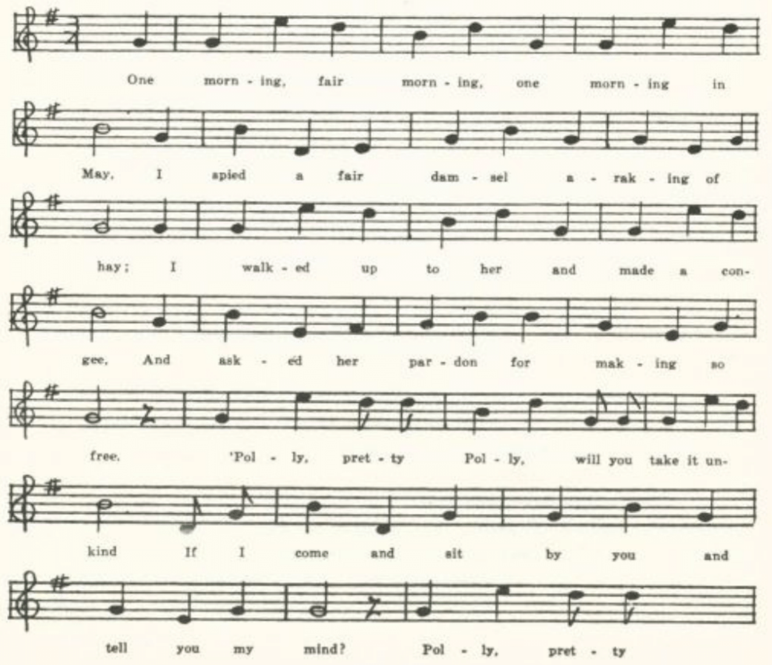
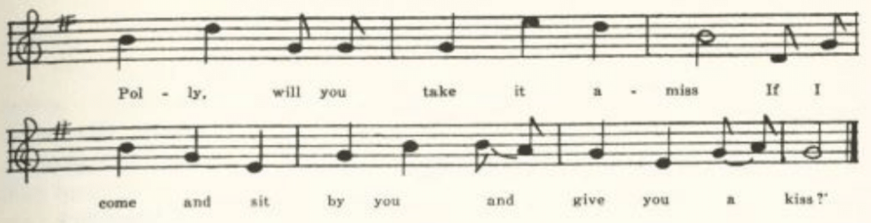
(475)

One morning, fair morning, one morning in May,
I spied a fair damsel a-raking of hay;
I walked up to her and made a congee,
And asked her pardon for making so free.

'Polly, pretty Polly, will you take it unkind
If I come and sit by you and tell you my mind?
Polly, pretty Polly, will you take it amiss
If I come and sit by you and give you a kiss?'

She hanged down her head and fetched a long groan
And said, 'I'm a poor girl afar away from home.
. . . . . . . . . . . . . . . . . . . . . . . . . . . . . . . . . . . . . .

. . . . . . . . . . . . . . . . . . . . . . . . . . . . . . . . . . . . . . +

Meetings for pleasure, partings in grief,
But an onconstant loveyer is worse than a thief.
A thief can but rob you of all that you have,
But an onconstant loveyer will tote you to your grave.

B

'Sweet William.' Secured by Miss Frances H. Miller in 1913 from Mrs. Charles Opel of Jefferson City, who 'was brought up in Missouri and . . . learned many of the ballads from her mother.' Note the final 'cuckoo' stanza.

To the meeting, to the meeting I'll go
To meet my sweet William so early, I know;
To meet him in the meadow it is my delight,
To sit and chat with him from morning till night.

This meeting is a pleasure, and parting is a grief.
And an unconstant lover is worse than a thief;
For a thief will but rob you and make you a slave,
But an unconstant lover will drag you to the grave.

*Half a stanza appears to be missing here. The theme of the 'poor girl far from home' appears in other connections; see below, p. 487.
+See Appendix, note 6.

(476)

Then the grave it will moulder and turn you to dust.
Oh, where is the young man that a woman can trust!
He will tell you fine stories to make you believe,
But there is not one in five hundred but what will deceive.

Come all you fair maidens, just listen to me:
Never hang your affections on a sycamore tree,
For the leaves they will but wither and the balls they will hang high.
My true love has forsaken me, and I cannot tell why.

If he has forsaken, why, I have forsworn,
And he is very much mistaken if he thinks I will mourn;
I'll dress up in my finery and go out for to see,
I'll pass as lightly by him as he can pass by me.

Oh, the cuckoo is a pretty bird, he sings as he flies,
He brings us glad tidings and tells us no lies,
He feeds on young birds to make him sing clear,
And when he sings 'Cuckoo!' the summer draws near.

C

'Forsaken.' Reported thru Miss Hamilton in 1913 by Mary Morrison of the Kirksville Teachers College, who learned it from a country girl in Boone County. A form of the song reported by Perrow from Mississippi in JAFL XXVIII 169-70.

Come all ye pretty fair maids, take warning by me,
Never place your affection on a sycamore tree;
For the leaves they will wither and the balls they will dust;
There ain't one boy in a thousand that a poor girl can trust.
Chorus:
Forsaken, forsaken, forsaken by one,
Never place your affection on a poor boy so free;
He's out on the water, he'll sink or he'll swim.
If he can live without me I can live without him.

Come all ye pretty fair maids, take warning by me,
Never place your affections on a poor boy so free;
He'll hug you and kiss you, and tell you more lies
Than the sand of the seashore, or the stars of the skies.*

*A favorite variant of this in the southern Appalachians (JAFL XXVIII 159-60, XLIV 84, BKH 119-20, ASb 243-5, SSSA 18-9, 33, FSSM 54) is
more lies
Than the cross-ties in the railroad or the stars in the skies.

(477)

Little Sparrow

This is a fairly stable and apparently American compound of age-old ele- Commonly the forsaken girl begins 'Come all ye fair and tender ladies' and proceeds to compare the fickleness of men to the stars of a summer morning that 'first appear and then are gone' or to a day that starts fair and then turns to rain. Then she wishes she were a little sparrow (sometimes swal- low) so that she could fly to him and nestle against his breast and, unbeknown, hear what he says. This sparrow motif has made its way into another song, the lament of a convict in the state prison (given by Sandburg, ASb 218-9, as known in Ohio), who if he had the wings of a sparrow would fly away to the arms of his mother and there lie down and die. Little Sparrow, under various titles and with considerable variation of texts but with one and generally both of the elements mentioned above, has been reported as traditional song in Vir- ginia (SharpK II 136, J. Fischer & Bro.'s Choral Compositions 6737, SCSM 313), West Virginia (FSS 419-21), Kentucky (LT 55-7, DD 82-3, FSKM 23-5, SharpK II 129, 132-5, FSSH 259-60), Tennessee (JAFL XLIV 101-2, ETWVMB 61, 98, SharpK II 128-30, FSSH 258-9, 260-1), North Carolina (SharpK II 128, 130, 131, 134, FSSH 257-8), Georgia (JAFL XXIX 200), Mississippi (FSM 167; see also 151), and Indiana (JAFL XXIX 183-4, compounded with. matter from The Butcher Boy). See also the last two stanzas of The Rambling Beauty C, above, and stanza 4 of The Blue-Eyed Boy A, below.

A

'Say Oh! Beware.' From the manuscript ballad-book of James Ashby of Holt County, secured in 1906 by Miss Welty.

Say oh, beware, ye pretty fair maidens,
Say oh, beware how you love men!
They are like stars of a bright sunny morning,
They appear but soon are gone.

As for myself, I once had a sweetheart,
Indeed I thought he was my own;
He went straightway and loved another,
That showed the love he had for me!

He said his heart did burn like fury
Whenever he my face did see.
I told him it was a mere pretension,
He never intended to marry me.

Alas, alas! it is all over,
And little he thinks on what is past;
In cubitt chains was linked to another
For life so long as it may last.

I wish I was a little black bird;
I quickly through this air would fly,
I'd fly straightway to my false-hearted lover
And hear his tale while I would cry.

And hear his tale while I would flutter
Upon his breast with tender tears.
I would ask him why he once did flatter
And tell so many deceitful lies.
Aug 6th 1877

*In Scotland (Ord 177) the concluding stanza of The Rambling Beauty has the
weather motif, but no bird.
+Read, of courses, 'Cupid's.'

(478)

B
'Warning.' From C. H. Williams, Bollinger County, 1906, who says: 'I was very young when I learned this and don't remember who I heard sing it first."'

Come all ye fair and tender ladies,
Take warning how you love young men;
They are like the star of a summer's morning,
First appear and then they are gone again.

Once I thought I had a lover,
Indeed I though he was my own;
Straightway he went and courted another
And left me here to grieve and moan.

I wish I were some little sparrow,
One of those would fly so high;

I'd fly away to my false lover
And when he talked I'd be close by;

All in his breast I would flutter
With my little tender wings,
Ask him whom he meant to flatter,
Whom he intended to deceive.

But as it is, I'm no sparrow,
Neither wings to fly so high.
I'll sit me down in grief and sorrow,
Sing, and pass my trouble by.

The Blue-Eyed Boy

Here divers images or motifs seem to have been gathered around a refrain stanza which gives the name to the song. I have found it reported from else- where only in Nebraska (ABS 212-3). In A the refrain stanza is not marked as such and the other elements are the hand and lips image (vaguely re- membered from The Lass of Roch Royal), the turtle dove, the green willow tree, and 'Must I go bound while he goes free?'; * in B, the lover going to sea, the value of a true friend, the little bird, and the refrain stanza; in C, the harp hung on the willow tree (which here has thrust the 'blue-eyed boy' stanza from its place as refrain), 'Must I go bound and you go free?', the value of a true friend, and the turtle dove. D lacks the 'blue-eyed boy' altogether, but I have included it here because of the 'Must I go bound' stanza; the other stanza belongs to the tradition of "There is an Alehouse in Yonder Town,' for which see the headnote to The Butcher Boy.

A

'Blue-eyed Boy.' Secured in 1909 by Miss Hamilton from Julia Rickman of the West Plains High School.
Oh, who, oh, who will be my friend,
Oh, who will take my lily-white hand,
Oh, who will kiss my ruby lips
When I go in a foreign land!

My father, he will be my friend,
My sister take my lily-white hand,
Some stranger kiss my ruby lips
When I go in a foreign land.

*Known also in Dorsetshire (JFSS VII 69), Virginia (TBV 269-70, SCSM 284-5, 319), and North Carolina (BMFSB 50-1, SCSM 288). It goes back at least to the seventeenth century; see Roxburghe Ballads VII 104-5.

(479)
Oh, bring me back my blue-eyed boy,
Oh, bring my darling back to me,
Oh, bring me back the one I love
And happy will I ever be.

If I had the wings of a turtle dove
I would fly away to the one I love,
I would fly to the one I love so dear
And talk to him while she is near.

I have not the wings of a turtle dove,
I cannot fly to the one I love;
But the loss of one is the gain of two,
And this is why I mourn for you.

Must I go bound while he goes free!
Must I love a fellow when he don't love me?
Or must I act the childish part
And love a fellow when he broke my heart?

Adieu, adieu, kind friends, adieu,
I can no longer stay with you.
I'll hang myself on a green willow tree
Unless he consents to marry me.

B

‘The Blue-eyed Boy.’ Secured by Miss Hamilton in 1910 from Grace Clemmons of the West Plains High School, who had it from a Mrs. Autherson, formerly of Wisconsin.

My lover told me last night
He'd take me across the deep blue sea;
And now he's gone and left me alone,
An orphant girl without a home.

Chorus:
Then bring me back the blue-eyed boy,
My love is like the little bird
Go bring my darling back to me;
Then bring me back the blue-eyed boy

Remember me and bear in mind
A good true friend is hard to find;
And when you find one good and true
Don't change the old one for the new.

And oh! how happy I shall be.
That flits about from tree to tree,
And when he is with some other girl
He doesn't even think of me.

C

'Adieu.' Communicated to Miss Hamilton in 1911 by Shirley Hunt of the Kirksville Teachers College. Note the eavesdropping' introductory stanza, a favorite opening for the pastourelle type of street ballad.

As I walked out one evening fair
To view the plains and take the air
I overheard a young man say
He loved a girl that was going away.
Chorus:
Adieu, adieu, my friends, adieu,
I can no longer stay with you.
I'll hang my harp upon the willow
And bid this lonesome world adieu.

Go bring me back that blue-eyed boy,
Go bring my darling back to me,

Go bring me back the one I love
And happy I shall always be.

Must I be bound and you go free?
Must I love one that don't love me?
Or must I act a childish part
And stay with one that broke my heart?

Sometimes you think you have a friend
And one you always can depend;
But when you think that you have got,
When tried will prove that you will not.

(480)

D

No title. Secured by Miss Hamilton in 1909 from Nita Stebbins of the West Plains High School, who described it as 'a country dance' which she learned 'from an old woman who used to live in the country.'

As I walked out one morning in May
Gathering flowers all so gay,
I gathered white and I gathered blue
And little did I think what love could do.

Must I go bound, must you go free,
Must I love a pretty girl that won't love me?
Oh, no! no! It never can be,
For love like thee never conqured me.

The False True-Lover

The Lass of Roch Royal, Child 76, still remembered not very long ago in Scotland (LL 59-63), has been found in America only in West Virginia (FSS 83-6, FSMEU 134-8) and seems there (see Cox's headnote) to have been de- rived from print. But the shoe-glove-band-father dialog that constitutes so striking a part of that ballad has wide currency, in various combinations, as an element of the floating love-lyric of American ballad singers (see Kittredge's note, JAFL XXX 304-5). As such it is reported from Maine (BBM 149-50), Virginia (FLJ VII 31, TBV 260-70, SCSM 122-6; also TBV 477, where it appears in connection with The House Carpenter), West Virginia (JAFL XXVI 181 in 'John Hardy,' FSS 87, 143, 413-4), Kentucky (BKH 131 in 'The Gambling Man'; Guy B. Johnson's John Henry 104, from a conviet in the Kentucky penitentiary), Tennessee (ETWVMB 72, JAFL XLVI 49-50 in a children's song), North Carolina (JAFL IV 156, XXII 240 in 'Kitty Kline', North Carolina Booklet XI No. 1, ASb 3-7, SharpK II 96, SSSA 24), South Carolina (SCB 152-3 in The House Carpenter), Mississippi (JAFL XXVIII 147-8, FSM 92-3 in 'Wild Bill Jones'), Ohio (Johnson's John Henry 98), Indiana (ASb 98-9), Missouri (SSSA 175-6, by way of Tennessee), California (ASb 126-7), the southern Appalachians (AMS 37), and in Spaeth's Weep Some More, My Lady 134-5 (again as part of 'Wild Bill Jones'). To the ques- tion about the lady's London band and her child's father American delicacy has preferred one about kissing her ruby lips. A memory of this motif has already appeared in The Blue-Eyed Boy A.

A

"The False True Lover.' Secured by G. W. Ridgway in 1906 from Mattie White of Rucker, Boone County.

(481)
'I am going away, my own true love,
To tarry for a while,
Though I'm coming back, my own true love,
It may be ten thousand miles.'

"Ten thousand miles, my own true love,
To Scotland, France, or Spain;
I never will be satisfied
Until I see your face again.

'I'll plant me a red and rosy bush
And a weeping willow tree,
And that will prove to this wide world around
That you have forsaken me.'

'If I forsake you, my own true love,
The regions they will burn,
The fire will freeze like ice, my love,
And the sun will refuse to shine."

'Oh, who will shoe my pretty little feet,
And who will glove my hand,
And who will kiss my red and rosy cheeks,
While you're in the distant land?'

'Your father will shoe your pretty little feet,
Your mother will glove your hand,
And I will kiss your red and rosy cheeks
When I return from the distant land."

'Oh, don't you see that pretty little girl
Spinning on yonders wheel?
Ten thousand worlds like this would I give
To feel as she does feel.

'Oh, don't you see that lonesome turtle dove
Sitting on yonders vine.
Lamenting over its own true love
As I do lament o'er mine?

'I wish to the Lord I had never been born,
Or died when I was young,
Than to be left in this wilderness of woe,
My love, while you are gone.'

'Oh, hush up, darling, don't break my heart,
For I hate to hear you cry.
Ten thousand true lovers has parted in this world,
And why not you and I?'

(482)

B

No title. From Ruth Sedwick, Mount Vernon, Lawrence County, in 1912. The first two stanzas are evidently imperfectly remembered, but I have not tried to amend them.

'You'll go away and come again.
Oh, if you go ten thousand miles
You'll go away and come again.

Oh, who will shoe my feet while gone,
Or who will glove my lily-white hand,
Oh, whilst thou art in a foreign land?'

'Your father, dear, will shoe your feet,
Your mother, love, will glove your hand;
And I will kiss your ruby lips
Oh, when I come from a foreign land.'

'Don't you see yon turtle dove
Flying from vine to vine,
Seeking for its own true love,
Oh, just as I seek for mine?

'I wish that I had never been born
Or died when I was young
And never lived to wet my cheeks with tears,
Oh, for the love of another woman's son.'

Under the Willow Tree

The willow is an ancient symbol of unrequited love. We all remember Desdemona's song, and that Ophelia was drowned hanging wreaths on a willow that grew 'aslant a brook.' Wearing the willow as a sign of love forsaken appears in Irish song (OIFMS No. 90), and in a Hampshire text of 'Polly's Love' (JFSS III 293) a girl who has died for love is promised burial 'in the banks of green willow.' There is an English stall ballad of 'The Willow Tree" * -not known traditionally, so far as I can learn, in this country-in which a lover who has lost gold, silver, and friends calls in vain to his love to take

*Printed by Such (Harv. Libr. 25242.17 XI 11) and by Hodges (Brit. Mus. Bks. 3. g. 4 VI 105) in London and by Cadman (Harv. Libr. 25242.17 VI 146) and Wheeler (Harv. Libr. 25242.27 151) in Manchester, and in this country in Grigg's Southern and Western Songster (Philadelphia, 1829) 66, Kennedy's American Songster (Baltimore, 1836) 160, and Turner and Fisher's Forget-Me Not Songster (Philadelphia and New York, about 1840) 42.

(483)

him in her arms, with the refrain 'here I lie alone to die beneath the willow tree.' The song in the Missouri collection is known also in Kentucky (BKH 126), Tennessee (ETWVMB 65), North Carolina (BMFSB 40-1), and Illinois (TSSI 228-9), and Sandburg ASb 314-5 prints a text given him by Gordon. For incidental use of the willow theme see also The Rambling Beauty B stanza 3, The Faultless Bride stanzas 5-6, The Butcher Boy C stanza 6, and The Nightingale A stanza 6 and F stanza 7; and compare also Jesus and Joses.

A

Under the Willow Tree.' From the manuscript ballad-book of Ada Belle Cowden of Woodlandville, Boone County, secured by Miss Lucy Laws of Christian College.

My heart is broken, I am in sorrow
For the only one I love.
I ne'er shall see his face again
Unless we meet in heaven above.

Chorus:
Then bury me beneath the willow,
Beneath the weeping willow tree,
And when he knows that I am sleeping
Then perhaps he'll come and weep for me.

They told me that he did not love me;
But how could I believe them true.
Until an angel came and whispered,
'He will prove untrue'?

Tomorrow was to be my wedding day;
But gone! oh, gone! oh, where is he?
He's gone to wed another bride
And all alone he has left me.

B
No title. Secured by Miss Hamilton in 1909 from Julia Rickman of the West Plains High School, who got it from 'a collection of old songs at home'-whether printed or manuscript I am not sure. Note that the role of the sexes is here reversed.

My heart is broken, I am sorry,
Over the one that I love.
I know that I shall never see her
Unless we meet in heaven above.

Chorus:
Bury me beneath the willow,
Beneath the weeping willow tree,
And when she knows that I am sleeping
Perhaps she'll sometimes think of me.

Once she told me that she loved me;
How could I think her untrue
Until an angel whispered softly,
'Oh, she does not care for you'

Tomorrow is our wedding day.
Where, oh, where is she?
She's gone to love another fellow.
Oh, she does not care for me.

(484)

Under the Willow

One of Stephen C. Foster's songs.

'Under the Willow.' Written down for Miss Hamilton in 1912 by Shirley Hunt of the Kirksville Teachers College, who had it from her mother, reared in Scotland County.

'Under the willow she's laid with care,'
Sang the lone lover while weeping,
'Under the willow, with golden hair,
My darling lies quietly sleeping.
Chorus:
'Fair, fair, with golden hair,'
Sang the lone lover while weeping,
'Fair, fair, with golden hair,
Yes, under the willow she's sleeping.

'Under the willow no song is heard
Near where my darling lies dreaming,
None save the song of some far-off bird
Where life and its treasures are streaming.

'Under the willow by night and day
Sorrowing ever I ponder,
Freed from a shadow of golden ray
Never again for to wander.'

*Misheard or misremembered. Foster's line runs:
Free from its shadowy, gloomy ray,
which is itself sufficiently inept.

Banishment

The turtle dove is the conventional symbol in folk-song of constancy in love, as the cuckoo is of inconstancy, and as such appears regularly in the closing stanza of The Butcher Boy and not infrequently in other songs: Bedroom Win- dow CD, The Sailor Boy A CE, The Dove, The Husband Lamenting the Death of the Wife, Fuller and Warren A C. Sometimes the dove is added to or con- fused with the sparrow (SharpK I 363, Virginia) or with 'a little fish' (BKH 130, Kentucky) or a nightingale (JFSS VIII 263, Norfolk); sometimes it is generalized into 'a little bird' (ASb 338, New York; BKH 130, Kentucky; JAFL XLV 78, Tennessee). But the favorite image is that of the little or lonesome turtle dove sitting on a tree or flitting from tree to tree or from pine
(485)
to pine or from vine to vine and mourning for its own true love. I have noted this image, with slight variations, in folk-song from Norfolk (JFSS VIII 263), Sussex (JFSS IV 286), Dorset (JFSS III 86), and Somerset (JFSS II 57); from the Province of Quebec (JAFL XXXI 176, learned from an Irish sailor); from New York (ASb 338, 'a little bird' here), Virginia (FLJ VII 31, TBV 271-2, SharpK I 362-3, SCSM 118-21, 316, 319), Kentucky (BKH 130, SharpK II 195), Tennessee (SSSA 175-6, by way of Missouri; JAFL XLV 78, 'a little bird' in this case; ETWVMB 72-3, FSSH 264-5), North Carolina (JAFL XXII 240-1, XLV 113, SharpK I 196-8, II 10), Mississippi (FSM 170), Cali- fornia (ASb 126-7), and without exact location in the southern Appalachians (SSSA 47, FSSM 14-5). None of these, however, is just the same song as the following. *

'Banishment. From the Civil War diary of E. J. Sims, sent to me in 1906 by Miss Welty from Brookfield, Linn County. The last word of each stanza is written out four times-not three, as one expects-and then the whole last line is repeated. It is crudely written. The line and stanza division, and the indication of lacunae, are mine.

My dearest dear, the time draws near
When you and I must part,
But little do you know of the grief and the woe
Of my poor troubled heart heart heart heart
Of my poor troubled heart.

Or what I suffer for your sake,
You who I hold so dear,
. . . . . . . . . . .
. . . . . . . . . . .
I've one request to make of you,
If I may be so bold:
To place a room within your heart
My secrets for to hold.
. . . . . . . . . . .
. . . . . . . . . . .
That this vain world may never know
How deep I am in love with you.

I wish my heart was made of glass,
That in it you might behold
Your name in secret there lies wrote
In letters bright as gold.

*See Appendix, note 7.

(486)
. . . . . . . . . . .
. . . . . . . . . . .
If I prove false to you, my love,
The raging sea will burn.

If I prove false to you, my love,
. . . . . . . . . .
. . . . . . . . . .
The crow that is so black
Will surely turn to white.

Oh, do you see your turtle dove
A-sitting on yonder barn,
A-mourning for its own true love
As I do mourn for mine?

The Dove

Reported as traditional song from Pennsylvania (JAFL XXV 276, by Barry, who points out the likeness of his first stanza to the corresponding stanza of a Welsh ballad printed in the Journal of the Welsh Folk-Song Society I ii 70), Virginia (SharpK II 197-8), Kentucky (DD 162-3, SharpK II 197), and Ten- nessee (SharpK II 197, ETWVMB 77, JAFL XLV 81-3, FSSH 267-9). The Missouri text and those in SharpK are fragmentary. Jackson SFSEA 63-4 prints a full text of nine stanzas from The Social Harp (published in Phila- delphia, 1855, but compiled by a Georgian) in which it is attributed to Wm. C. Davis. Jackson however, no doubt rightly, discredits this attribution, be- lieving it to be traditional folk-song.

No title. Secured in Nodaway County in 1906 by Miss Calla Varner from an old lady who 'once knew all The Dove. An old man from Virginia taught it to her when she was a child.'

Once while in a lonesome grove
Sang o'er my head a little dove,
Which for her mate began to coo;
Which made me think of my mate too.
Oh, little dove, you're not alone,
For I like you am forced to mourn;
For once like you I had a mate,
But now like you I mourn my fate.

. . . . . . . . . .
. . . . . . . . . .
Consumption seized her lungs severe
And played upon them one long year.

Grim death, grim death did not stop here.
I had a babe to me most dear.
Death like a vulture came again
And took away my little Jane.

(487)
Poor Stranger a Thousand Miles from Home

Less conventional than the mourning dove symbol, but more interesting, is an image expressive of escape from the confusion and frustration of actual experience, above and away, to a distant tree top or, more often, to a castle or a mansion on a mountain where (especially in American texts) one can hear the clangorous ery of the wild geese as they fly by in the night. It is admirably expressive of elevation, security, and stillness. In England it seems to have belonged originally to a particular ballad, 'Streams of Lovely Nancy,' the meaning and history of which are discussed by Miss Broadwood and Miss Gilchrist in JFSS IV 310-19. This ballad was printed by Pitts, Such, Catnach, and others and is traditional song in Sussex (JFSS I 122), Dorset (JFSS VII 59-60), and Somerset (NSS VII 16-8). In America the image is often (tho not always) associated with the theme of the 'poor stranger' or the 'wagoner's lad.' In this and other connections it is found in traditional song in Maryland (JAFL XXX 347-8, from New Hampshire), West Virginia (FSS 433-4), Ken- tucky (JAFL XX 268-9, BKH 141, FSMEU 222), Tennessee (ETWVMB 84, JAFL XLIV 84, FSSH 278), North Carolina (MSNC 9, JAFL XLV 110, SCSM 282, FSSH 274), and Illinois (TSSI 236-8), and appears without definite location in ASb 138, 285, 307, CS 254.

No title. Communicated to Miss Hamilton in 1909 by Hunter Jones of the West Plains High School.

One morning, one morning, one morning in May
I spied a fair damsel lamenting to say,
I spied a fair damsel lamenting to moan,
'For I'm a poor stranger a thousand miles from home.

Chorus:
'O Willie, O Willie, it's for your sake alone
I'd leave my kind mother, my father and my home
And go with you, dear Willie, a thousand miles from home.

'Oh, don't you remember, it was on a Saturday night,
The promise you made to me as by my side you sat?
You promised that you'd marry me. Go marry whom you please;
While my poor heart is breaking you're resting at your ease.

'I'll build me a castle on yonder mountain's height.
Where the wild geese may see me as they go passing by,
Where the wild geese may see me and hear me as I moan;
For I'm a poor stranger a thousand miles from home."

(488)

Down in the Valley

Here the mansion in the mountain is combined with another effective sense impression, that of listening from a mountain top to the passing of a train in the valley below. It has been reported from Kentucky (BKH 141, SHF 16-7) and (without the mansion) from Arkansas (Ozark Life for July, 1927); and the matter of the first, third, and fourth stanzas is in Lead Belly's Louisiana jail song (Negro Songs as Sung by Lead Belly 228-31). *

'Down in the Valley.' Communicated to Miss Hamilton in 1910 by Frank Jones of the West Plains High School.

Down in the valley, valley so low,
Late in the evening, hear the train blow.
The train, love, hear the train blow;
Late in the evening, hear the train blow.

Go build me a mansion, build it so high
So I can see my true love go by,
See her go by, love, see her go by,
So I can see my true love go by,

Go write me a letter, send it by mail,
Bake + it and stamp it to the Birmingham jail.
Birmingham jail, love, Birmingham jail,
Bake + it and stamp it to the Birmingham jail.

Roses are red, love, violets are blue.
God and his angels know I love you,
Know I love you, know I love you,
God and his angels know I love you.
*See Appendix, note 8.
+So written, clearly, in the MS; but probably 'date' is meant..

Bird in the Cage

This somewhat incoherent song combines the idea of security in a high place with the quite different image of a captive bird. Sandburg ASb 213 prints a text and tune from Kentucky.

'Bird in the Cage.' From the MS miscellany of William Dresia of Columbus, Kansas, sent to me by Miss Lowry in 1909.

(489)

Say that you love me,
Give my heart ease!
As soon as my back is turned
Love who you please.

Chorus:
Bird in the cage, love,
Bird in the cage, love,
Bird in the cage, love,
Singing so sweet.

Willy, my darly,
My darly dear,
If you don't love
Foolish I fear.

Build me a nest
In the tower so high
So I can see you
When you pass by.

I'll write you a letter,
Some two or three lines;
When you answer
Say you'll be mine.

My parents don't like you,
That you well know;
They say you are not worthy
To knock at my door.

I Wish I Was a Little Bird

Stanzas in which the lover (woman or man) wishes she (he) were a bird, a fish, a butterfly, etc., are a frequent element in the love-lyric of the folk. Besides the instances cited under Little Sparrow, examples have been recorded in Scotland (Christie I 223), Sussex (JFSS I 25), the west of England (Songs of the West No. 92), and Ireland (OIFMS No. 382). The song in the Missouri collection is perhaps most nearly allied to 'Kitty Kline,' texts of which from North Carolina are given by Louise Rand Bascom in JAFL XXII 240-1, or to 'Free Little Bird,' reported from Kentucky (BKH 130).

No title. Written down in 1909 for Miss Hamilton by Hunter Jones of the West Plains High School, who said he learned it 'from the hired girl.'

Wisht I was a little fish,
I'd swim to the bottom of the sea,
And there I'd sing my sad little song,
"There's nobody cares for me." *

I wisht I was a little bird,
I'd fly to the top of a tree
And there I'd sing my sad little song,
"There's nobody cares for me.'

I wisht I was a little boy
And learn how to rope a cow;
I'd learn how to put on a great many airs,
And then I'd learn to plow.

But as I am a little girl
I learn how to weave and spin,
Learn how to put on a great many airs
And learn how to fool the young men.

*In 'Kitty Kline' the refrain line runs
I can't stay hyar by myself.

(490)

Green Grows the Laurel

The refrain stanza so beginning has formed a fairly stable union with a stanza wondering why women love men and why men love them. The stall ballad of 'Cupid's Garden' (printed by Bebbington of Manchester; copy in Harv. Libr. 25242.27, p. 243) shows that the laurel is a symbol of virginity;

This maid she was a virgin
And did the laurel wear
. . . . . . . . . .
'For I mean to live a virgin,
And still the laurel wear."

In some texts (Evans's stall print, traditional versions from Yorkshire, West Virginia, Kentucky) it is contrasted with rue, which carries the opposite sig- nificance; more often the rime-word is 'dew,' and a Gloucestershire text has 'yew.' The song is found in stall print (Evans; Harv. Libr. 25242.2, p. 105), and is reported from tradition in Scotland (Ord 182), Yorkshire (JFSS I 246), Gloucestershire (JFSS V 70), West Virginia (FSS 417-8), Kentucky (SharpK II 211); the laurel part also in Newfoundland (BSSN 74-5), Nova Scotia (SBNS 40-1), Vermont (VFSB 113-4), and North Carolina (SCSM 331-2), and 'why women love men' in the Ozarks (OASPS 175). See also stanzas 8 and 10 of The Croppy Boy, p. 284.

A
'I Once Had a Sweetheart. From the MS ballad-book of Ada Belle Cowden of Woodlandville, Boone County, compiled about 1909.

I once had a sweetheart but now I have none,
And since he has left me I care for none;
And since he has left me, I'll have you all know
That men are deceitful, wherever they go.

Chorus:
Green grows the laurel all sparkling with dew,
I'm sorry, my love, for the parting with you.
I will stay our next meeting and hope you'll prove true;
We'll change the green laurel for the red, white, and blue.

I wrote my love a letter with roses entwined;
He wrote me an answer all bound in twine
Saying, 'Keep your love-letters and I'll keep mine,
Write to your sweetheart and I'll write to mine.'
(491)
I've ofttimes wondered why women like men,
Just as ofttimes wondered why men like them;
For by my own experience I very well know
That men are deceitful wherever they go.

B
'I Once Had a Sweetheart.' Secured by Miss Hamilton in 1910 from one of her pupils in the West Plains High School. The same text as A.

C
No title. Communicated in 1917 by Mrs. C. H. Williams, who had heard it sung some years before by a girl who worked for her mother.

Green grows, green grows, that sparkles the dew.
How long has it been, love, since I parted from you!
I hope the next meeting our love will prove true
And change the green laurels for the red, white, and blue.

I often have wondered why women love men,
And I often have wondered why men could love them;
But by experience I've found it quite true
That men are deceitful and women are too.

I once had a sweetheart but now I have none,
And since he's gone left me I care not for one;
And since he's gone left me contented I'll be,
For he loves another girl better than me.

I once had cheeks as red as a rose,
But now they're faded as the lily that grows,
That grows in the garden, has faded and gone.
That's what you get, love, for courting so young.

I passed by his window both early and late;
The look he gave me did make my heart ache,
The look he gave me ten thousand would thrill,
But he's a handsome man, and I love him still.

Adieu to Cold Weather

This is the Missouri representative of 'Farewell He,' No. XLIII of Baring- Gould's Garland of Country Song, of which, he says, there is a stall print by Catnach. In Baring-Gould's text the rime for 'common sense' is 'prudence,'
(492)
with a twisted accent; the Missouri 'impudence' is a better rime, and adequately expresses the temper of the song. I have not noted it elsewhere, tho there is a trace of it ('he is little and he is pretty') in 'To Cheer the Heart' (FSMEU 168-9, Kentucky) and a similar temper in an unnamed song from North Caro- lina (JAFL XLVI 35-6).

A
No title. From the MS ballad-book of James Ashby of Holt County, secured for me in 1906 by Miss Welty.

Adieu to cold weather, farwell to white frost,
I will cheer up my spirits since my old beau is lost;
I will sing and be happy as nightingale in May,
For I can get another, and he is not so far away.

Chorus:
If he is gone let him go, let him sink or let him swim;
As he does not care for me, why should I care for him?
I hope he may have good fortune and myself but better grace,
For I can get another far better in his place.

Oh, they say he loves another, and he true must be deceived,
For the fool must be mistaken if he thinks I am a-going to grieve.
For I will just let him know that I will go no more that way
To be scared by an owl that seldom flies by day.

Oh, he is little and he is witty and he dresses so very neat!
Oh, isn't it a pity that he uses so much deceit?
Oh, isn't it a pity how deceitful he can be?
For I'm sure he loves another and he has quite forsaken me.

Come all you that is lovesick and cured cannot be,
I will tell you of a remedy that quite.
Two grains of reason, three grains of sense,
A pound of resolution, twice that of infidence.*

B
'Adieu to Cold Weather.' Sent in by Miss Antoinette Taylor of Bartold, St. Louis County, in the autograph of a woman who worked for her. It is sub- scribed: 'Written by Mrs. Betsy Edwards, Learned to me in 1868 By my school- teacher Mr. Benjamin Kenter, in Phelps Co. Mo.' The text does not differ significantly from A.

*Miswritten, evidently, for 'impudence."
(493)
C
"The Independent Girl.' From the MS song-book of Allen F. Wade of Coffeys- burg, Daviess County, lent to me by his daughter in 1923. It is subscribed: 'Written by Allen F. Wade, May 11, 1886.' The text does not differ significantly from that of A and B, except that the comparison of the recreant lover to an owl has fallen out.

Love Me or No

Another song of the independent girl. The second stanza is similar to one in 'First I Loved Thomas,' recorded from Surrey in JFSS V 174:

First I loved Thomas and then I loved John,
And then I loved William, he's a clever young man;
With his white cotton stockings and his low ankle shoes;
And he wears a blue jacket wheresoever he goes.

But the English song ends with the lover's assertion of constancy.

'Love Me or No. From the MS ballad-book of Ada Belle Cowden of Wood- landville, Boone County, secured for me by Miss Laws of Christian College.

Will sing you a song, the best in my heart,
For I know very truly I have a sweetheart.
Have a sweetheart and I hope he'll prove true;
But if he won't love me, kind sir, won't you?

Chorus:
Love me or no, love me or so,
I don't care a straw whether you love me or no.
Love me or no, love me or so,
I dont care a straw whether you love me or no.

Oh, why not love Willie, or Charley, or Dan?
Oh, why not love Walter, that handsome young man?
I'll love him a little to make his heart ease,
And when his back is turned I'll do as I please.

I'll grieve when I'm lonely and sigh when I'm sad.
But what's the use of grieving? He's only a lad,
Only a lad, a silly one too.
If I should grieve what good would it do?

I've love in my pockets and love in my heart,
For the boys that love me, I'll share them their part.
This lesson has been learned from the verses above.
Say, girls, don't you think it's jolly to love?
(494)
Beautiful Light o'er the Sea

I have not found this maudlin effusion elsewhere, unless it is to be considered a form of 'The Prisoner's Song,' for which see BSSNS 303, MAFLS XXIX 49.

'Beautiful Light o'er the Sea.' From the MS ballad-book of Ada Belle Cowden of Woodlandville, Boone County.

I was out last night a-drinking,
I was out the night before,
But if I ever get sober
I'll never get drunk any more.
Chorus:
Beautiful light o'er the sea, o'er the sea,
O beautiful light o'er the sea,
O beautiful light o'er the sea, o'er the sea,
There's someone waiting for me.

I wish I had the wings of an angel,
The voice of annovling* dove,
I'd sail this wide world over
And sail to the one that I love.

I wish I had someone to love me,
Someone to call me their own,
Someone to guide and protect me,
Someone to see me safe home.

*So in the MS. I have no suggestion to offer.

The Frog's Courtship
For the early history of this nursery song, perhaps the most widely known in the language, see Kittredge's detailed bibliographical note in JAFL XXXV 394-9. L. W. Payne in PFLST V 5-48 gives an account of the 'thirty- odd versions' he found in Texas, dividing them into six types on the basis of the form of refrain used (one form, not represented in the Texas or in the Missouri collection but familiar to me in childhood and widely sung-reported as folk-song from Wiltshire (FSUT 133-4), Nova Scotia (BSSNS 373-4), and Virginia (JAFL VIII 159-60)-the 'heigh ho, says Rowley' form, he consid- ers not true folk-song but rather a music-hall piece). The Missouri collection has representatives of three of these types, which for convenience I shall num-
(495)
ber. I is the 'kimonaro' or 'kimo' refrain. I have found this reported as folk-song from Vermont (SHV 18-21), New York (JAFL XLII 298-9, FSSH 396-7, 398), Maryland (SSSA 230), Virginia (SharpK II 312, 320; TNFS 156-7 has the burden but the frog and mouse have disappeared), Kentucky (LT 25-9, JAFL XLI 574, negro, the burden only), Alabama (ANFS 176, negro, the burden only), Arkansas (Folklore of Romantic Arkansas II 194), Texas (PFLST V 23-4), and without definite location in AMS 98-9 and SSSA 1. II is the 'Kitty alone' form. This is reported from Scotland (JFSS II 226) and from the west of England (GCS), from Virginia (SharpK II 323, SCSM 247-8), Kentucky (LT 22-4, SharpK II 321), North Carolina (MSNC 32-5), and Texas (PFLST V 18-23), and what look like derivatives of it from New- foundland (BSSN 90) and Vermont (BFSV 122). III is the 'm-hm' form- the favorite, especially in the South. It is reported as traditional song from Nova Scotia (SBNS 194-5), Pennsylvania (JAFL XXXV 393-4), Virginia (SharpK II 319), West Virginia (FSS 471-2), Kentucky (TKMS 86-93, DD 154-5, SharpK II 315-8, TNFS 50), Tennessee (FSSH 394), North Carolina (SharpK II 312, 313, 319, SCSM 245-6, FSSH 392-3, ANFS 218), Georgia (JAFL XLII 299-300, AMS 78-9, FSSH 395-6), Alabama (TBSSG 15-6), Mississippi (JAFL XXVI 134-5, FSM 282-3), Texas (PFLST V 35-45, TNFS 46-8), Ohio (JAFL XXXV 392-3), and Michigan (JAFL XXXIII 98), and without location in ABFS 310-3.

IA
"The Frog He Did A-wooing Ride.' From G. C. Broadhead, Columbia, 1911. Known to him in his boyhood, 'before 1840.'"
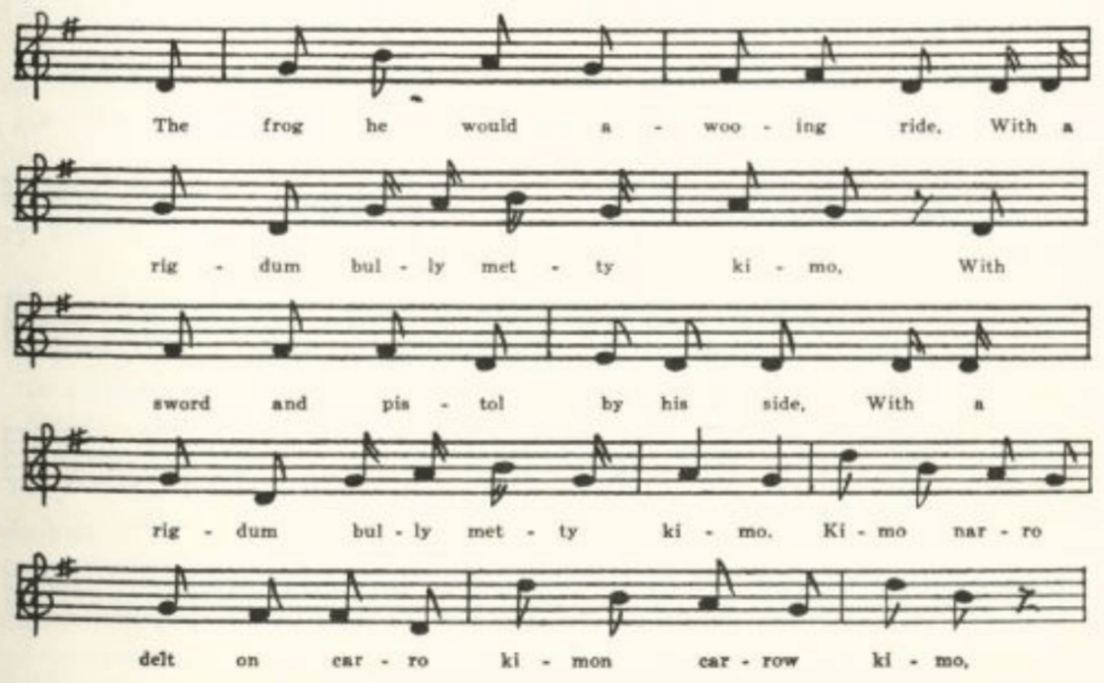
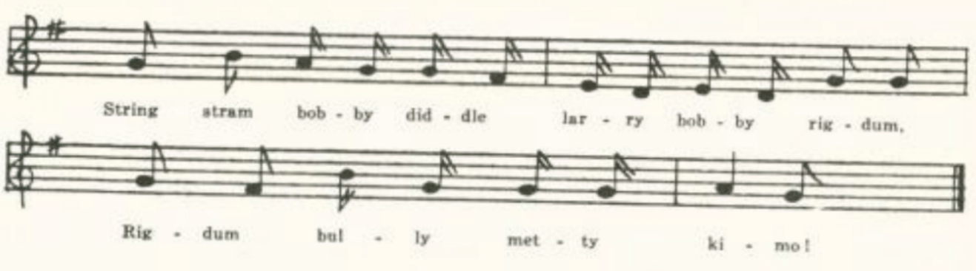
(496)

The frog he did a-wooing ride
With a rigdum bully metty kimo
With sword and pistol by his side
With rigdum bully metty kimo
Kimo narro delt on carro, kimon carro kimo,
String stram bobby diddle larry bobby
rigdum,
Rigdum bully metty kimo.

The frog he rode to the mouse's hall
And there he did very loudly call:

'Oh, Missy Mouse, are you within?'
'Yes, kind sir, I sit and spin.'

And just as they began to chat
In walked Miss Puss and Cat.

The cat she caught the rat by the crown,
The kit she tossed the mouse up and down.

The frog he swam across the lake
And there was swallowed by a snake.

IB
No title. Given me by Miss Jessie Blair of Sedalia, Pettis County, in 1913; but I failed to ask her about its antecedents.

There was a frog lived in a well,
Tummarinktum-bobanibakimo
And in the house he came to dwell,
Tummarinktum-bobanibakimo.

Kimo, karo, kill him, Maro,
Hieram a stream stram
Bobinabo, hara bona rig,
Tummarinktum-bobanibakimo.

II
'Frog Went A-Courting.' From Cynthia Wilkes (now Mrs. W. I. McHarg) of Columbia, learned from her mother.
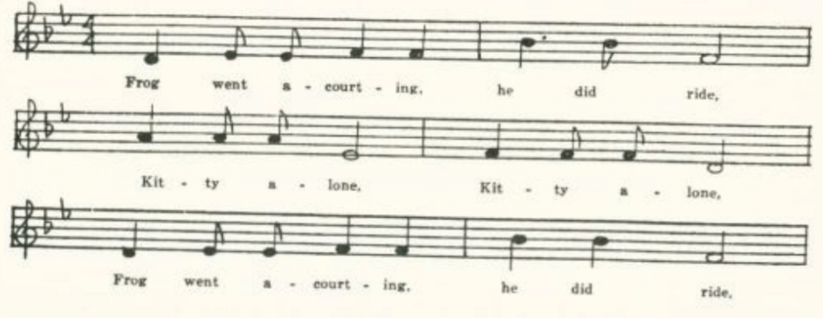
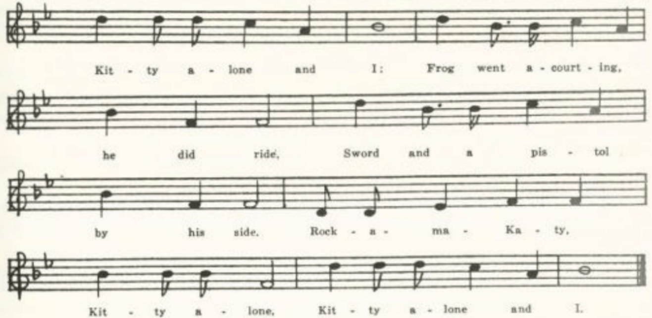
(497)
Frog went a-courting, he did ride,
Kitty alone, Kitty alone.
Frog went a-courting, he did ride,
Kitty alone, and I;
Frog went a-courting, he did ride,
Sword and a pistol by his side.
Rock-a-ma-Katy, Kitty alone,
Kitty alone and I.

He rode till he came to Lady Mouse' hall;
There he did both knock and call.

'O, say, Miss Mouse, are you within?'
'Yes, kind sir, I sit and spin.'

'O say, Miss Mouse, will you marry me?
A very kind husband I will be.'

'Not without my Uncle Rat's consent
Would I marry the President."

Uncle Rat he gave his consent,
And the wedding feast was a great event.

The first that came was a big fat toad,
And with him he brought a wagon load.

The next that came was a bumblebee;
He brought his fiddle across his knee.

The next that came was Major Dick;
He ate so much it made him sick.

The saddle and bridle are laid on the shelf;
If you want any more you can sing it yourself.

IIIA
No title. Reported by Miss Norville as set down for her by one of her pupils in Chillicothe, Livingston County, in 1907. The child had learned it from her father, 'who sang it in school in Missouri when he was a boy.'

Mr. Frog went a-courting, he did ride—
um-huh,
Mr. Frog went a-courting, he did ride
With a sword and pistol by his side—um-huh.

He rode up to Miss Mousey's den.
Said he, 'Miss Mousey, will you let me in!'

'Raise up the latch and walk right in,
For here I sit alone and spin.'
(498)
He took Miss Mousey upon his knee.
Said he, 'Miss Mousey, will you marry me?'

'Not without Uncle Rat's consent
That I should marry the President."

Made Uncle Rat laugh and shake his fat sides
To think his niece should be a bride.

Next day Uncle Rat he went to town
To buy his niece a wedding gown.

Oh, where shall the wedding supper be?
Way down yonder in a hollow tree.

Oh, what shall the wedding supper be?
A slice of bread and a cup of tea.

The first one to come was a bumblebee
With a cornstalk fiddle upon his knee.

The next one to come was Mr. Flea,
And he was to dance with Miss Mousey.

The next one to come was a big black bug,
And he flew around the old brown jug.

The last one to come was a big fat duck,
And he ate all the others up.

IIIB
No title. Communicated to Miss Hamilton in 1911 by Veronica Burns of the Kirksville Teachers College.

Mr. Frog went courting his bride—uh-hu
Mr. Frog went courting his bride
With sword and pistol by his side—uh-hu

'O say, Miss Mouse, will you marry me?
We'll live in the timber in a hollow tree."

O where, O where will the wedding be?
Down in the timber in a hollow tree.

First came in was Madame Flea,
And she danced a jig with the bumblebee.

The next came in was a little black bug
With a whiskey bottle and a vinegar jug.

The next came in was a little black dog,
And he barked at a frog in a hollow log.

They all went sailing o'er the lake
And got swallowed up by a big black snake.

The ancient book lies on the shelf,
If you want any more you can sing it yourself.

IIIC
'Uncle Rat. From Sister St. John of St. Louis, a student at the University in 1914.

Uncle Rat he took a ride—huh-hoom
Uncle Rat he took a ride,
Sword and pistol by his side—huh-hoom

He rode up to Miss Mousie's door.
'Say, Miss Mousie, will you marry me?'

Where shall the wedding dinner be?
Down in yonder old oak tree.

What shall the wedding dinner be?
Two little beans and a black-eyed pea.

The first that came was a little black bug
With whiskey in his jug.

The next that came was a bumblebee
With a thistle in his knee.
(499)
The next that came was a butterfly;
He viewed the crowd and then went by.

Uncle Rat went to the lake—
The first thing he knew, he was swallowed by
a snake.

Then Miss Mousie she did cry
To think her husband had to die.

Then they laid him on the shelf—
If you want any more you may sing it
yourself.

IIID
"The Froggie's Courtship.' Communicated in 1914 by Celestine McDonald of Vernon County. An incomplete copy, not differing significantly from IIIA.

Two stanzas with no refrain indicated were reported in 1917 by C. H. Williams from the singing of his mother in Bollinger County when he was a child. Various other animals come in with gifts for the wedding.... It was a play song.' Observe that the frog and the mouse have been lost sight of.

Mr. Johnny rode over his girl for to see.
He said, 'Pretty Polly, will you marry me?'
'Yes. Oh, where will the wedding be?'
"Way down yonder in a hollow tree.'

First came in was a bumblebee
With a fiddle on his knee.
Next came in was a right black snake
With a plate of wedding cake.

Billy Boy

Another nursery classic. I have found it recorded as traditional song in Dorset (JFSS VIII 210-1), Worcestershire (FSE IV 6-8), Ontario (JAFL XXXI 78, 160-1), Vermont (VFSB 162-3), New York (FLSH 208-9, 236), Pennsylvania (NPM 116-7), Virginia (SharpK II 39, SCSM 297-8), West Virginia (FSS 284-8), Kentucky (LT 14-7, BKH 105), Tennessee (ETWVMB 45, FSSH 384-6), North Carolina (North Carolina Booklet XI No. 1 30-1, SharpK II 38-9, TBSSG 18, FSSH 383-4, SCSM 298), Georgia (FSSH 384, 386-7), Mississippi (FSM 278-80), Missouri (Ozark Life VI No. 2), Michigan (JAFL XXXIII 92-3, KNR 299), Illinois (TSSI 190-2), Iowa (MAFLS XXIX 24-7), and Nebraska (ABS 231-2), and without specific location in ABFS 320-2. Most (not all) of these texts have a refrain 'She's a young thing and cannot leave her mother' or the like, and a fantastic calculation of the girl's age. Otherwise the texts may vary considerably. Stanzas 3 and 5 of the Missouri texts, especially stanza 5 of A, suggest The Old Man's Courtship.
(500)
A
'Billy Boy.' Reported by Mrs. George H. Barnett in 1913 as sung by Mrs. Sarah Henry, who learned it in Saline County about 1865-70. The repeats, printed here in the first stanza only, run thruout.

'Where have you been, Billy boy, Billy boy,
Where have you been, charming Billy?'
'I've been to seek a wife, she's the joy of my life,
She's a young thing, too young to leave her mother.'

'Did she bid you come in?'
'She bade me come in, with a dimple in her chin.'

'Did she set you a chair?'
'She sat me on a chair with a courteous so near.’*

'Did she sit close to you?'
'She sat as close to me as the bark on a tree.'

'Did she light you to bed?'
'She lit me to bed with a nightcap on her head.'

'Can she make a cherry pie?'
'She can make a cherry pie as quick as a cat can wink its eye.'

'How tall is she?'
'She's as tall as any pine and as straight as a pumpkin vine.'

‘How old is she?’
‘She’s twice six, twice seven, twice twenty, and eleven.’

B
'Billy Boy. Contributed by Sister Helen Marie, a student at the University of Missouri in 1914.
'Oh, where have you been, Billy boy, Billy boy,
Oh, where have you been, charming Billy?'
'Oh, I've been to see my wife,
She's the joy of my life,
She's a young thing and cannot leave her mother.'

'Did she ask you to come in?'
"Yes, she asked me to come in,
She's a dimple in her chin.'

*So in Mrs. B.'s MS.
(501)
'Did she set for you a chair?'
'Yes, she set for me a chair
While she combed her golden hair.'

'Can she make a cherry pie?'
'She can make a cherry pie
Quick's a cat can wink its eye.'

'Can she make a feather bed?'
'She can make a feather bed
That's as high as your head.'

'Don't you wish she would come home?' '
Yes, I wish she would come home,
Never, never more to roam.'

Tom Bo-lin

For the earlier history of this song, very familiar in England, see Halli- well's Popular Rhymes and Nursery Tales 271, Miss Gilchrist in JFSS VIII 137- 41, and Mabbott in Notes and Queries for 16 July, 1927. It goes back at least to the sixteenth century, and seems to have been originally a satire on the un- couthness of Scotchmen; later, perhaps as early as the seventeenth century, it was adapted (as 'Brien O'Lynn,' 'Barney O'Lynn,' etc.) to express a like feeling about the Irish. It probably has no connection with the Child ballad of Tam Lane. It has been reported by folk-song collectors from Scotland (Christie I 193), Lancashire (JFSS VIII 137-8), Gloucestershire (FSUT 181- 2), Vermont (VFSB 178-9), New York (FLSH 211-2), Kentucky (SharpK II 202-3), Tennessee (JAFL XXVIII 156), and Texas (PFLST VI 235, X 168). The first of the following stanzas from Missouri is found in most ver- sions; the other I have not seen elsewhere. The points chosen for satire vary rather widely.

No title. Secured by Miss Hamilton in 1912 from Mary Morrison of the Kirksville Teachers College, who traced it back to her great-grandmother, born near Richmond, Virginia, in 1801.

Tom-bo-lin had no breeches to wear;
He bought a sheepskin to make him a pair.
With the skin side out and the woolly side in,
Make a fine summer suit for Tom-bo-lin.
Larry-ho-ho, ho-larry-ho.
(502)
When you go to old Ireland, you know,
This is the way to milk an old ewe:
One at the head and one at the hams,
Two little boys to knock off the lambs.
Larry-ho-ho, ho-larry-ho.

Old Woman All Skin and Bone

A text of this thrill-producer for the nursery is given in Chappell's Nursery Rhymes 32, and a text from Oxfordshire is recorded in Folk-Lore XXIV 81. In this country it has been recorded in Vermont (VFSB 180-1), Pennsyl- vania (JAFL XXVI 142-3), West Virginia (FSS 482-3), Kentucky (JAFL XXVI 143; Perrow notes that it 'is known traditionally also in East Tennes- see'), North Carolina (North Carolina Booklet XI No. 1), and Mississippi (FTM 43).

A
"There was an Old Woman.' Communicated by Mrs. L. D. Ames of Columbia, Boone County, in 1917. Regarding the refrain, which follows each line but the last, Mrs. A. notes that the syllables 'are nasal sounds, made with the mouth closed. They are the expression that Missourians use colloquially to denote assent.' I print them here only for the first couplet.

There was an old woman lived all alone,
Umph-humph, umph-humph!
She was nothing in the world but skin and bone.
Umph-humph, umph-humph!

One day the old woman went to church
To hear the parson pray and preach.

When she got to the stile she stopped to rest a little while;*
When she got to the door she stopped to rest a little more.*

When she opened the door she saw a corpse upon the floor.*
She asked the preacher if she would look like that.

He told her yes and scared her to death!

*Each of these lines is probably a couplet in itself. Of the conclusion Mrs. A. says that it is 'delivered as an exclamation instead of being sung. Very exciting to young children.'
(503)
B
'Mrs. Jones.' Sent to me in 1917 by Miss Jane D. Johns of St. Charles as known by her uncle Douglas Voss Martin, in his boyhood in Virginia. The burden. is repeated after each couplet, with a shouted 'boo!' at the end.

There was an old woman, her name was Jones,
And she was nothing but skin and bones.
Hm-mmmm-mmmmm.

She thought she'd go to church one day
To hear the parson preach and pray.

But when she got to the church stile.
She thought she'd rest a little while.

And when she got to the church door
She thought she'd rest a little more.

She looked up, she looked down;
She spied a corpse upon the ground.

The worms crept in, the worms crept out,
And made the woman sing and shout.

The woman to the parson said: '
Will I look so when I am dead?'

The parson to the woman said:
'Yes, you'll look so when you are dead."
Hm-mmmm-mmmmm.
Boo!

C
"There Was an Old Woman.' Reported by Miss Leah Yoffie of the Soldan High School, St. Louis, as sung by one of her students at a Y.W.C.A. camp in Kirkwood. I have followed Miss Y.'s MS; the burden seems to be irregularly introduced.

There was an old woman all skin and bones ooh, ooh
That took it into her head one day
To go and hear the preacher pray oooh, oooh
When the old woman had walked a mile oooh, ooooh
She thought she'd stop and rest a while ooh, ooooh
Then when the old woman reached the church door
She thought she'd stop and rest some more oooooh, ooooooh
When she woke the preacher looked her in the eye:
"What will you do when you shall die?' ooooh, ooooh
(504)
Race of the Terrapin and the Deer

For the wide diffusion of this folk-tale over the face of the earth see the references in Stith Thompson's Motif-Index of Folk-Literature IV (Indiana University Studies XXI, 1934) 256-7. It is a favorite with American Indians and with negroes. Thompson in an earlier work, European Tales among the North American Indians (Colorado College Publication, Language Series II No. 34, 1919) 441, 448-9, believed that these American versions were derived from European (in this case Spanish) sources. Still earlier, when I sub- mitted the Missouri text to J. R. Swanton of the Bureau of American Ethnology in 1913, he wrote to me that 'no one seems to know whether it is Indian, Negro, or white,' and that he did not recognize the words of the chant as Indian. For notes of its occurrence in American collections see the references to Thompson's works given above. I have not found the terrapin's chant in any other text that has come to my eye.

'Race of the Terrapin and the Deer.' Communicated in 1910 by G. C. Broad- head of Columbia as one of his childhood recollections.

A terrapin challenged a deer for a race. Said he could beat him running.
The deer laughed at him. Finally he consented. The terrapin spoke to
other terrapins, and arranged that near the road a terrapin should place himself concealed—every few feet there was a terrapin. The deer started walking slowly.
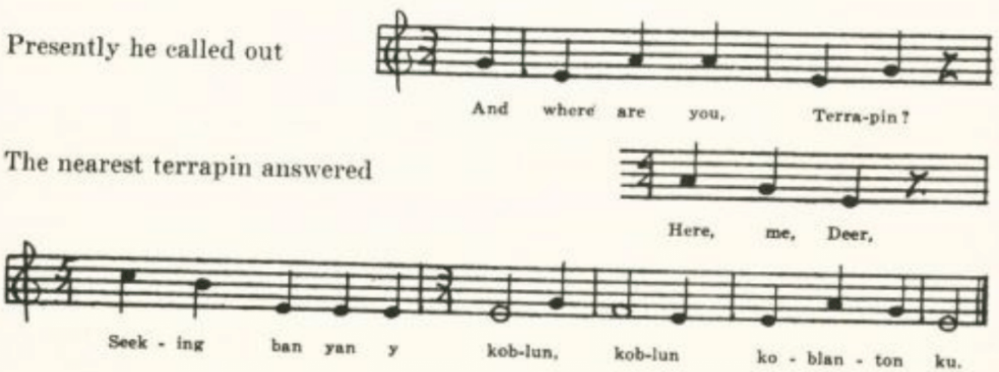
The deer trotted a little faster, again called out, and the nearest terrapin answered. 'Well, I must hurry,' said the deer. So he ran faster, stopped, and called. Got the same answer. Then he ran faster, with the same result. At last he ran and ran until he fell exhausted.
(505)
Zip Coon

The following is certainly a memory of the negro minstrel song so called, altho the name does not appear in the Missouri text and the contributor thought it might be 'an old negro folk-lore song.' 'Zip Coon' was, according to S. Foster Damon, who reproduces an 1834 sheet music print of it in his Series of Old American Songs, 'judged by longevity, the most successful of the early burnt- cork songs.' Broadhead's tune, however, seems to bear no close resemblance to that in the 1834 print.

No title. Set down in 1912 by G. C. Broadhead, Columbia, from his recollec- tions of many years earlier.
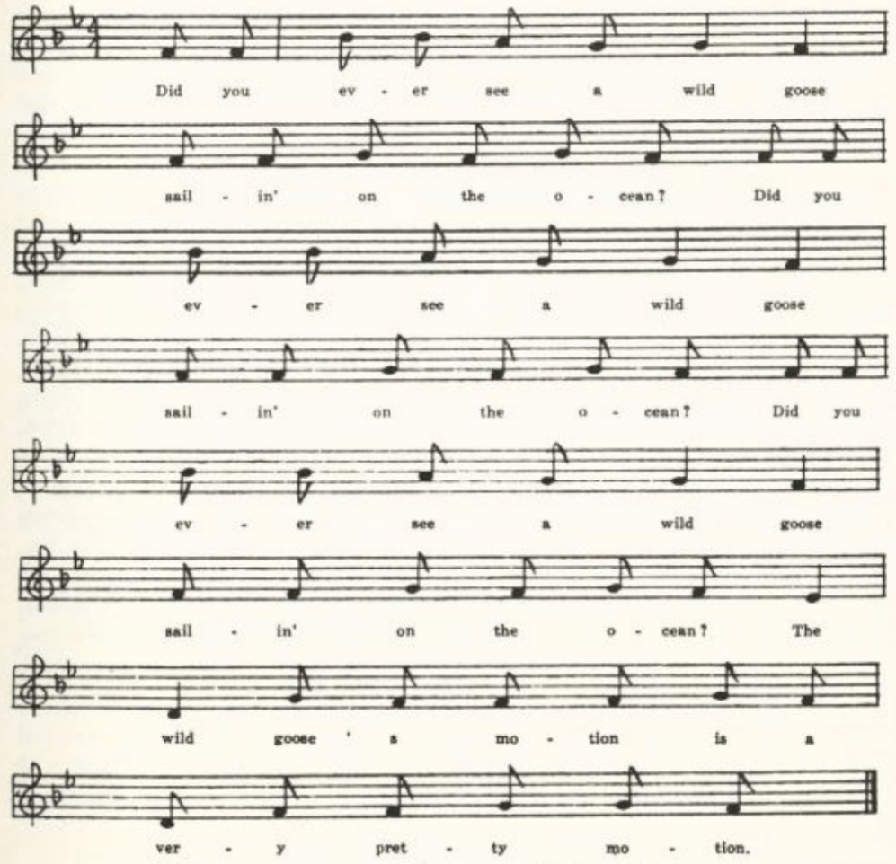
Did you ever see a wild goose sailin' on the ocean?
Did you ever see a wild goose sailin' on the ocean?
Did you ever see a wild goose sailin' on the ocean?
The wild goose’s motion is a very pretty motion.
(506)
Did you ever see a wild goose beckon to a swallow?
Coopie-coopie-coopie, coopen-coopie-coopie-collow.

Old Sukie Blueskin she loves me;
She asked me down to her house to take a cup of tea.

And what do you think old Sukie had for supper?
Chicken foot and sparrow-grass without any butter.

If I was the President of these United States
I'd eat molasses candy and swing upon the gates.

SINGING GAMES

Of the several singing games in the collection I have selected a few for presentation on account of their general currency.

Madam, I Have Gold and Silver

In Missouri this seems to be nothing more than a courting dialog of two or at most three stanzas, the core of what appears elsewhere at greater length and under various titles. I find the dialog reported as traditional song in Lin- colnshire (Roxburghe Ballads VIII 852), Norfolk (ECS 91), Essex (JEFDSS I 134), Sussex (JFSS IV 297-8), Hampshire (FSE III 41-2), Wiltshire (FSUT 196-7), Shropshire (Miss Burne's Shropshire Folk-Lore 551-2), Ontario (JAFL XXXI 49), Vermont (VFSB 154-5), Massachusetts (JAFL XXIV 341-2, from Ireland), West Virginia (FSS 317-8, 465-6), Kentucky (TKMS 98-101, ASb 144), North Carolina (JAFL XLVI 36-7), and Mississippi (FSM 151-2). There is an echo of it also in Death and the Lady (100EFS 52-3), where the lover offers gold and pearl but is rejected by the lady because she must prepare for death; and another in the Missouri text of The Quaker's Wooing, given on p. 265. The Missouri fragments are much alike. I give the fullest, which has a preliminary stanza. B, from the West Plains High School, has only the two stanzas of dialog and has 'ships on the ocean' in place of 'worlds of treasure.' C is but a single stanza, the same as the second of A.

'Dance up.' Communicated in 1911 by G. C. Broadhead of Columbia.

Dance up to that entire stranger
With the sunflower on her shoulder.
Now to the girl with the yellow cloak
And the hole in the heel of her stocking.

'Madam, I have gold and silver,
Madam, I have house and land;
(507)

Madam, I have worlds of treasure,
All that I want is your fair hand.'

'What care I for your gold and silver?
What care I for your house and land?
What care I for your world of treasure?
All that I want is a handsome man.'

A Paper of Pins

A wooer makes a series of offers, arranged in the order of climax, which the lady successively rejects, up to the last item. The series varies widely. In this country it generally begins with a paper of pins, and a like item appears also in Scotland and Northumberland; in the west of England it is 'a cushion full of pins' or a diamond or silver pin, and does not begin the series. Two English forms, one in which the wooer sends his man John with the offerings and one in which he offers 'the keys of Canterbury' (or of heaven, or the bells of Canterbury), are not recorded from American song. Neither is the romantic form, where the series ends with his offer of the key of his heart and her acceptance thereof. Instead, the series in American versions ends, with few exceptions, satirically with the offer of the key of his chest, which the lady eagerly accepts only to be in turn denied. Is this an evidence of that 'acrid Asiatic mirth' which Kipling ascribes to the American spirit? In five, perhaps six, American texts (DD 160-1, JAFL XLIV 103-5, ABFS 323-4, MSHF 10-1, FSSH 291-3, and perhaps OASPS 217-9) there is contamination with a form of the 'I wouldn't marry' theme, for which see pp. 262-3. The song is reported from tradition in Scotland (JFSS II 85-6), Northumberland (County Folk-Lore IV 142-4), Wiltshire (FSUT 80-2), Cheshire (ECS 33), Somerset (FSSom Nos. 63, 114, JFSS II 87-8, VII 92-3, NSS I 18-9, V 20-3), Devonshire (Songs of the West No. 22 and note), Jamaica (JSS 66-8, negro), Vermont (VFSB 160-1), Virginia (SharpK II 47-8, SCSM 307-8), Kentucky (BKH 82-3, 152-3, DD 160-1, SharpK II 49), Tennessee (MSHF 10-1), North Carolina (JAFL XLIV 103-5, SharpK II 45-7, 48-9, TBSSG 20-1, FSSH 291-3, SCSM 299- 300), Georgia (JAFL XXIX 198-9, XLV 118-9, FSSH 294-5), Mississippi (FSM 167-9, 276-7), Louisiana (ABS 226-8), the Ozarks (OASPS 217-9), Indiana (JAFL XLIX 260-2), Illinois (TSSI 192-5), Iowa (MAFLS XXIX 42), and without specific location in AMS 52-3 and ABFS 323-4. And it is doubtless even more generally known than this list indicates.

A
No title. Secured by Miss Hamilton in 1909 from Fannie Watts of the West Plains High School, who learned it from 'a girl in Oklahoma.'
(508)

'Say, miss, I'll give you a paper of pins,
If you will tell me how love begins,
If you will marry, miss,
If you will marry me.'

'I will not accept your paper of pins,
I will not tell you how love begins.
I'll not marry, sir,
I'll not marry you.

'Say, miss, I'll give you a coach of six
With every horse as black as pitch.

'Say, miss, I'll give you the key to my heart,
That we may marry and never part.

'Say, miss, I'll give you the key to my chest,
To go to my money at your own request.'

(Here the response changes to)

'I will accept the key to your chest,
To go to your money at my request,
I will marry you, sir,
I will marry you.'

(And he retorts)

'Ha, ha, ha, money is all,
Woman's love is nothing at all.
I'll not marry, miss,
I'll not marry you.'

B
No title. Secured by Miss Hamilton in 1909 from John Bostic of the West Plains High School, whose grandmother used to sing it to him. It is not clear whether he used the opening stanza of A or not; but he knew the following stanzas:

I'll give you a little lapdog,
That may lie in your lap when you go abroad,
If you will marry me, miss,
If you will marry me.'

'I'll not accept the little lapdog
That may lie in my lap when I go abroad,
And I'll not marry you, sir,
And I'll not marry you.'

'I'll give you a dress of red
And will stitch it with a golden thread.

'I'll give you a dress of green,
That yau may look like any queen.

'I'll give you a coach of four,
That . . . . . . . . . .
. . . . . . . . . . . .
That . . . . . . . . . .

'Aha, my dear girl, if money is all,
I'll not marry you at all.
And I'll not marry you,
And I'll not marry you."

C
'I'll Give to You a Paper of Pins.' Communicated by Miss Leah R. C. Yoffie in 1916 as known to her in her childhood in St. Louis.

'I'll give to you a paper of pins,
To show you how true love begins,
If you will marry me, me, me,
If you will marry me.'

'I don't accept your paper of pins,
To show me how true love begins,
For I won't marry you, you, you,
For I won't marry you.'
(509)
'I'll give to you a dress of red,
. . . . . . . . . .

'I'll give to you a dress of green,
To make you look like any queen.

'I'll give to you a golden chair,
To sit in the garden and get fresh air.

'I'll give to you a silver spoon,
To feed your baby in the afternoon.

'I" give to you the key of my chest,
To have all the money at your request.'

This last offer the lady accepts; whereupon
he declares

'I won't give you the key of my chest,
To have all the money at your request,
And I won't marry you, you, you,
And I won't marry you.'

Old Grumbler

This widely known children's singing game varies little in text except in the name given to the one who is 'laid in his grave.' It is reported from Suffolk (JFSS V 296, ECS 94-5, 'Oliver Cromwell'), Derbyshire (JFSS V 295 'Sir Roger'), Oxfordshire (FL XXIV 82 'Oliver Cromwell'), Vermont (VFSB 182-3 Tommy'), Massachusetts (JAFL XIII 230-1 'Little Johnny Wattles'), Kentucky (JAFL XXVI 144 'Old Grimes', BKH 186 'Old Grumbler', SharpK II 370 Tommy'), Tennessee (JAFL XLIV 95, FSSH 408-9, 'Old Robin,' FSSH 408 'Old Growler'), North Carolina (JAFL XXXIV 112-3 'Grandaddy', XLIV 95 'Old Growler', SharpK II 370 'Old Billy Apple Tree'), Mississippi (FSM 284-5 'Old Grampus'), Texas (PFLST VI 229-30 'Columbus,' 'Old Crummy,' 'Old Crumpy', TNFS 136-7 'Old Ponto'), Ohio (JAFL XXXV 407 'Old grand- daddy'), Illinois (TSSI 195-6 'Poor Robin', 196-7 'Old Johnny'), Kansas (KHQ VII 268 'Old Robin,' 'Old Roger'), and Nebraska (ABS 232-3 'Poor Robin'). The Massachusetts text seems to have retained something of the historical memory suggested by that from Suffolk; in it 'Little Johnny Wat- tles... went to Whitehall, And there he fell sick among them all.' But I do not find that it ever had any political or historic significance.
A
No title. Given to me in 1912 by Miss Ethel J. Berry of Pawnee, Oklahoma, then a student at the University of Missouri.

Old Grumbler was dead and laid in his grave,
Hum-haw, and laid in his grave.
An apple tree grew at the head of his grave,
Hum-haw, at the head of his grave.

When the apples were ripe and commenced to fall
'Long came an old woman and gathered them all.
(510)
Then up jumped Old Grumbler and gave her a knock
Which made the old woman go hippity-hop.

She hobbled along to a strawberry hill
And there she sat down to make her last will.

B
No title. Communicated in 1913 by DeW. Clinton Collins of Lathrop, Clinton County.
Old daddy he's dead and laid in his grave,
Old daddy he's dead and laid in his grave,
Old daddy he's dead and laid in his grave,
Ho............ho............ho.

An apple tree sprang up by his head,
The apple tree grew till it grew tall,
And on the tree the apples did grow,
In the fall the apples got ripe,
When the frost came the apples fell,
An old woman came to pick them up,
Old daddy he rose and gave her a knock,
The old woman ran with a skippity hop,
If you want any more, sing it yourself,
If you want any more, sing it yourself,
If you want any more, sing it yourself,
Ho..........ho..........ho.

C
No title. Reported by Miss Leah R. C. Yoffie in 1916 from memories of her childhood in St. Louis. 'Old Humpty;' ends with 'made the old woman go hippity hop.'
(511)
D
'Old Grumble.' Communicated in 1917 by Mrs. L. D. Ames of Columbia, whose great-grandparents came from Virginia and Kentucky.

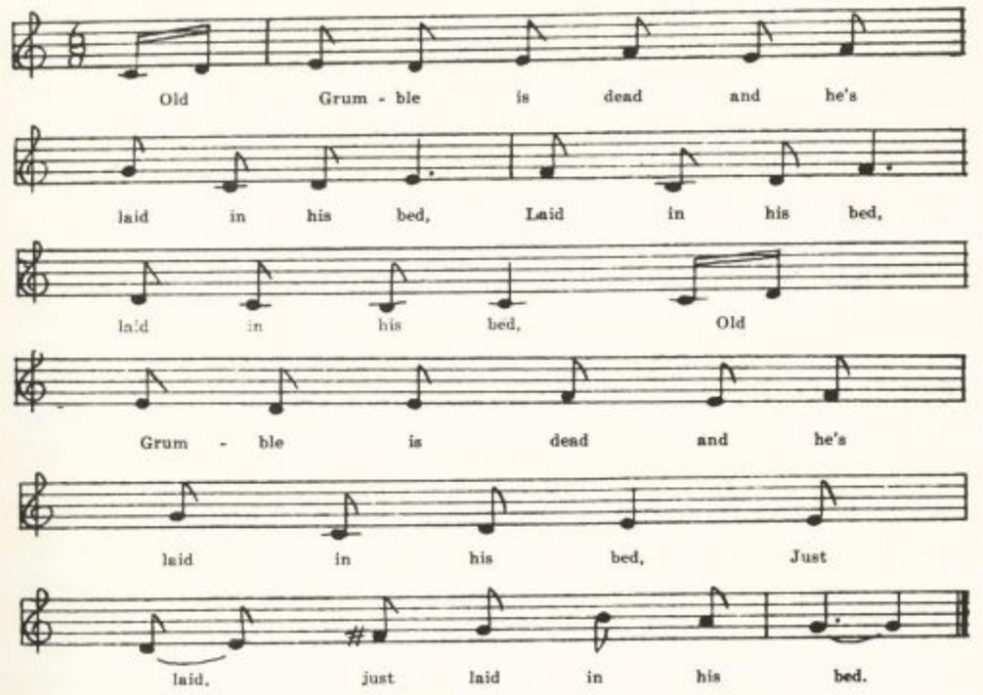
Old Grumble is dead and he's laid in his bed,
Laid in his bed, laid in his bed,
Old Grumble is dead and he's laid in his bed,
Just laid, just laid in his bed.

There grew an old apple tree out of his head,
The apples grew ripe and were ready to drop,
There came an old woman to pick them up,
Old Grumble got up and gave her a whack,

It made the old woman go hippity-hop,
Hippity-hop, hippity-hop,
It made the old woman go hippity-hop,
Just hippity, hippity-hop.
(512)

PLAY-PARTY SONGS

The play-party is, essentially, a substitute for or rather a camouflage of a dancing party, developed in communities where a moral or religious taboo has been attached to the word dance. As such it is, I believe, an American phenomenon. Many of the songs and actions of the play-party are also chil- dren's singing games. Probably in some cases the children's games have been carried on into maturer years, and in other cases the children have adopted the practices of their elders. No hard and fast line can be drawn between chil- dren's games and play-parties.
Children's games have been collected and studied in the British Isles by Lady Gomme (The Traditional Games of England, Scotland, and Ireland, 1894- 8) and in America by W. W. Newell (Games and Songs of American Children, 1903). In recent years many studies of the play-party in particular localities have been made. One of the earliest of these was Mrs. L. D. Ames's "The Missouri Play-Party,' published in JAFL XXIV (1911) 295-318, thirty-three- texts most of them with tunes, supplemented three years later by Miss Goldy M. Hamilton's "The Play-Party in Northeast Missouri,' JAFL XXVII 289- 303, thirty-eight texts. Special reports, mostly in JAFL, have now covered most of the territory in which the play-party flourished, which is the midwestern states, from Michigan to Texas and from Kentucky to western Nebraska and Idaho. Quite recently the whole subject has been thoroly studied by Professor B. A. Botkin of the University of Oklahoma in The American Play-Party Song (University Studies of the University of Nebraska XXXVII, Lincoln, 1937). which contains 'over a thousand variants of one hundred and twenty-eight play-party songs,' many of them with the tunes, found in Oklahoma. The texts and tunes are much the same everywhere. It does not seem necessary, therefore, to repeat here the findings in Missouri.

The Twelve Days of Christmas

Of the various traditional cumulative number songs-The Dilly Song. The Twelve Joys of Mary, The Twelve Days of Christmas-all of which have been reported from one place or another in this country, the Missouri collection. has only the last.* This has been recorded also, with some differences in the series of items, in Scotland (Robert Chambers, Popular Rhymes of Scotland (1870 ed.) 42-3), Northumberland (County Folk-Lore IV 138-9), Somerset (JFSS V 277-8, 282, FSSom LI, LII), Cornwall (JFSS V 279), Vermont (VFSB 86-7), Massachusetts (JAFL XIII 230, XVIII 56-9, from the Allen Songs, XXX 365-7, with a valuable note by Kittredge), New York (FLSH 198-9), and

*Mr. Vance Randolph has, however, a very interesting text of the Dilly Song which he found in the Ozarks and which will presumably appear in his forthcoming collection of Ozark songs.
(513)
Tennessee (JAFL XLVI 46-7). A similar series is applied to the twelve months of the year in French Switzerland (A. Rossat, La Chanson Populaire dans la Suisse romande 106).

No title. Communicated in 1904 by W. S. Johnson as sung by an acquaintance of his, Mrs. M—, in Tuscumbia, Miller County.

The first day of Christmas my love she sent to me
A partridge on a pear tree.

The second day of Christmas my love she sent to me
Two turtle doves, and a partridge on a pear tree.

The third day of Christmas my love she sent to me
Three French hens, two turtle doves, and a partridge on a pear tree.

The fourth day of Christmas my love she sent to me
Four collie birds, three French hens, two turtle doves,
and a partridge on a pear tree.

The fifth day of Christmas my love she sent to me
Five gold rings, four collie birds, etc.

The sixth day of Christmas my love she sent to me
Six geese a-laying, five gold rings, etc.

The seventh day of Christmas my love she sent to me
Seven swans a-swimming, six geese a-laying, etc.

The eighth day of Christmas my love she sent to me
Eight deers a-running, seven swans a-swimming, etc.

The ninth day of Christmas my love she sent to me
Nine wolves a-howling, eight deers a-running, etc.

The tenth day of Christmas my love she sent to me
Ten ladies dancing, nine wolves a-howling, etc.

The eleventh day of Christmas my love she sent to me
Eleven lords a-limping, ten ladies dancing, etc.

The twelfth day of Christmas my love she sent to me
Twelve bulls a-bellering, eleven lords a-limping, etc.
(514)
The New Year's 'Sermon'

There are few traces of the Christmas season mummers of the old country in Missouri. In 1909 Miss Antoinette Taylor of St. Louis County published (JAFL XXII 389-93) a version of the St. George play secured from a student in the St. Louis Central High School; but it was a memory, not a performance, the student having learned it from her father, an Englishman, who had taken part in performances at his home in Worcestershire some thirty-five years be- fore. The New Year's day observance described below appears, on the other hand, to be native to Missouri-similar, and perhaps genetically related, to the French custom reported in the next item. It was given me by C. H. Williams in 1917 as a custom observed in Bollinger County.

A New Year's 'Sermon' was always 'preached' by someone in the crowd of New Year's shooters that went from house to house. It was frequently of great length, often requiring from fifteen minutes to half an hour for the 'preacher' to repeat it. This he did in a stentorian voice, which could easily be heard a quarter of a mile away. I can recall only these lines from one of the various 'sermons' commonly used in the community in which I lived.

Hello, Mr. Jones!
Hello, Mr. Jones!
We wish you a happy New Year—to you and your wife and your
sons and your daughters and all that are in your house.
And if our wishes find you good,
‘Tis better than the year before the flood.
Time and its moments speed away,
First by the hour and then by the day,
. . . . . . . . . . . . . . .

. . . . . . . . . . . . . . .
Heat up your coffee and cut your pie,
Soon you'll hear the powder fly.
Stand your cider-jugs all in a row,
Soon you'll hear the muskets blow.

At the close of the 'sermon' the guns of the party were discharged. After that the shooters were invited into the house to have something to eat and drink. After a short time the 'shooters' went on to the next house, where the performance was repeated.
(515)
FRENCH SONGS

The French were the earliest white settlers of Missouri, and, as has been shown in Dr. W. A. Dorrance's interesting study*, French is still the language of some of their descendants. He gives numerous specimens of their folk-tales and several folk-songs, among them

La Guignolée (La Gaie-Année)

Of this the Missouri collection has the following text and tune, contributed in 1914 by Mrs. Edward Schaaf of St. Mary's, Ste. Genevieve County, who is herself a descendant of Francois Vallé, the Commandant of Ste. Genevieve at the end of the eighteenth century.

'La Gui-Année.' Mrs. Schaaf says: "The music is entirely traditional .. Even the man who leads with the violin has no written notes. He told me, when I asked him for a copy of the notes: "We learn it from each other." Generally there is only one violin, sometimes two; the players march with the band. The air is very simple; really nothing but a chant. And the dance is really not a dance, just a sort of shuffling march to keep time with the music. The members of the band always wear masks, and are supposed not to be known. . . . The favorite costume is that of an Indian chief.... It is quite likely that the custom and the costumes are a mixture of French and Indian.'
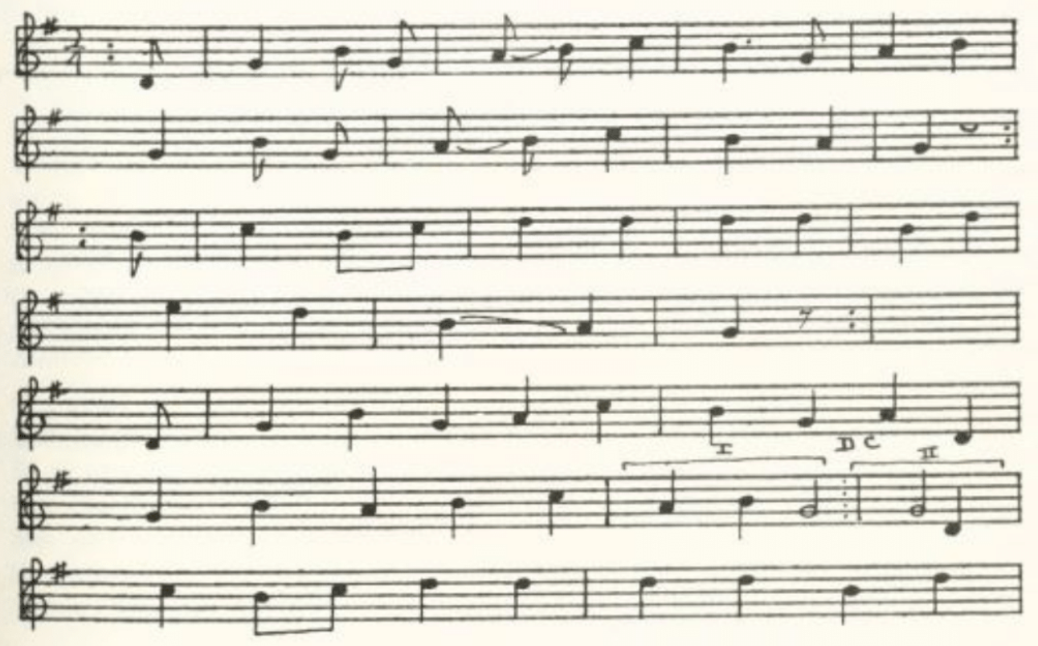
*The Survival of French in the Old District of Sainte Genevieve,' University of Missouri Studies X No. 2, 1935.
(516)
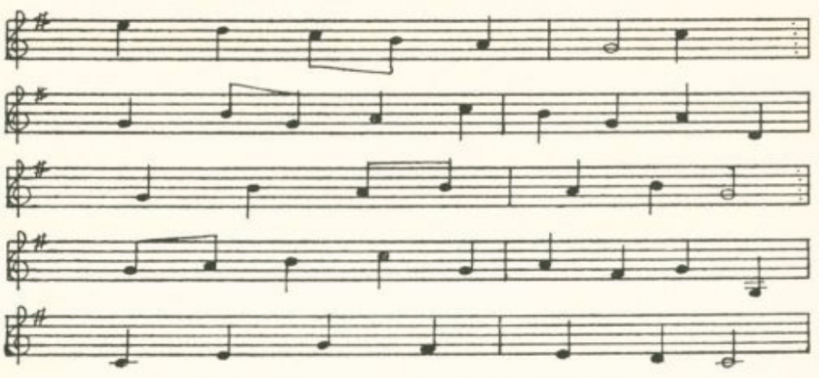
Bonsoir, le maitre et la maitresse
Et tout le monde du logis.
Pour le dernier jour de l'année
La Guiannée vous nous devez.

Si vous n'avez rien à nous donner,
Dites nous le.
Nous vous demandons seulement une échinée;
Une échinée n'est pas grand chose.
Elle n'a que quatre pieds de long;
Et nous en ferons une frieassée
De quatre-vingt-dix pieds de long.

Si vous n'avez rien à nous donner,
Dites nous le.
Nous vous demandons seulement la fille ainée,
Et nous lui ferons faire bonne chère.
Nous lui ferons chauffer les pieds.
Nous lui ferons faire bonne chère,
Nous lui ferons chauffer les pieds.

Quand nous fûmes au milieu des bois
Nous fûmes à l'ombre.

J'ai attendu le coucou chanter
Et la colombe;
Et le rossignol du vert berceau
Va aller dire à ma maitresse
Que j'ai toujours le coeur joyeux.

Et j'ai toujours le coeur joyeux,
Point de tristesse.
Mais ces jeunes filles qu'ont pas d'amants
Comment font elles?
Ce sont les amoureux qui les réveillent
Et qui les empêchent de dormir.

En suppliant la compagnie
De vouloir bien excuser*
Si nous avons fait quelque folie—
C'était pour vous désennuyer.
Une autre année nous en prendrons garde,
Si nous avons l'honneur de revenir.

Bonsoir, le maitre et la maitresse
Et tout le monde du logis.

*Or De bien vouloir nous excuser.
(517)
The Returned Soldier

A French folk-song in which the soldier returns in the guise of a wander- ing musician not to his sweetheart but to his parents. Not given by Dorrance.

No title. Sent in 1916 by Mrs. Schaaf of St. Mary's as a fragment of which she hoped to be able to secure the whole, but did not.

'Pourriez vous en passant
Loger un musicien en passant?'
'Rentrez dans la maison et faites comme chez vous;
On a un garçon au service.'

'Dans quel régiment est il, votre enfant?
Est-ce-qu'il est dans le régiment d'Italie?'
'On ne sait point. Peut-être
Qu'il est mort dans quelque compars.'

'Chère maman, cher papa,
C'est votre enfant qui vous donne les bras.
Grace à Dieu! Il m'a conservé
De revenir à vous soulager.'

Mione

A French cumulative song of apparel. Not given by Dorrance. It was sent to Mrs. Schaaf in 1919 by E. G. McCormick of Farmington, St. Francois Coun- ty, the county adjoining Ste. Genevieve. The name, which McCormick wrote that he did not know how to spell and he believed was 'the French for Leona," seems rather to be a form of Mignonne. Since the French of the manuscript is not infrequently quite unconstruable, I have in some places—not all—emended it to bring it more nearly into accord with French grammar and idiom. One suspects, also, that in the song as sung the cumulative repetition is more systematic.

Si j'avais les beaux souliers  Que ma Mione m'a donnés,  Si j'avais les beaux souliers  Que ma Mione m'a donnés.  Mes souliers sont rouge.  Si j'avais les beaux souliers  Que ma Mione m'a donnés, | Si j'avais les beaux bas  Que ma Mione m'a donnés,  Si j'avais les beaux bas  Que ma Mione m'a donnés,  Mes beaux bas diamant!  Mes souliers sont rouges  Que ma Mione m'a donnés.  Si j'avais les beaux souliers  Que ma Mione m'a donnés!
(518)
Je veux de bien la belle culotte  Que ma Mione m'a donnée;  Ma culotte à courtes bottes,  Mes beaux bas diamant!  Mes souliers sont rouges  Que ma Mione m'a donnés.  Si j'avais les beaux souliers  Que ma Mione m'a donnés!  Si j'avais la belle chemise  Que ma Mione m'a donnée,  Si j'avais la belle chemise  Que ma Mione m'a donnée,  Ma chemise de peau bisquain,  Ma culotte à courtes bottes,  Mes bas diamant!  Mes souliers sont rouges  Que ma Mione m'a donnés.  Si j'avais les beaux souliers  Que ma Mione m'a donnés!  Si j'avais le beau gilet  Que ma Mione m'a donné,  Si j'avais le beau gilet  Que ma Mione m'a donné!  Mon gilet de papier,  Ma chemise de peau bisquain,  Ma culotte à courtes bottes,  Mes bas diamant!  Mes souliers sont rouges  Que ma Mione m'a donnés.  Si j'avais les beaux souliers  Que ma Mione m'a donnés!  Si j'avais le beau capot  Que ma Mione m'a donné,  Si j'avais le beau capot  Que ma Mione m'a donné!  Mon capot d'peau d'veau, | Mon gilet de papier,  Ma chemise de peau bisquain,  Ma culotte à courtes bottes,  Mes bas diamant!  Mes souliers sont rouges  Que ma Mione m'a donnés.  Si j'avais les beaux souliers  Que ma Mione m'a donnés!  Si j'avais la belle cravate  Que ma Mione m'a donnée,  Si j'avais la belle cravate  Que ma Mione m'a donnée!  Ma cravate d'peau d'rat,  Mon capot d'peau d'veau,  Mon gilet de papier,  Ma chemise de peau bisquain,  Ma culotte à courtes bottes,  Mes bas diamant!  Mes souliers sont rouges  Que ma Mione m'a donnés.  Si j'avais les beaux souliers  Que ma Mione m'a donnés!  Si j'avais le beau chapeau  Que ma Mione m'a donné,  Si j'avais le beau chapeau  Que ma Mione m'a donné!  Mon chapeau des copeaux,  Ma cravate de fourrure rat,  Mon capot d'peau d'veau,  Ma gilet de papier,  Ma chemise de peau bisquain,  Ma culotte à courtes bottes,  Mes bas diamant!  Mes souliers sont rouges  Que ma Mione m'a donnés.  Si j'avais les beaux souliers  Que ma Mione m'a donnés!
The second line, often repeated, is in McCormick's manuscript always 'ma Mione. moi donner; but the meaning seems to be as I have written it. 'Bisquain' is sheepskin cured with the wool on. 'Peau de rat,' Dr. Dorrance tells me, means coon-skin. Some of the other articles I can only guess at. Does 'gilet de papier' mean that he lined his waistcoat with paper for warmth? Were his 'bas diamant' diamond-clocked stockings? Was his 'culotte à courtes bottes' ('a courte botter' in the manuscript) a sort of breeches worn with low shoes? And was his 'chapeau des copeaux' a hat trimmed with shavings of some sort?
(519)
Chanson de L'Annee du Coup

The following dramatisation of an item in Missouri history is not, so far as I know, present folk-song, nor is it now rescued from manuscript. But apparently it was folk-song, of a sort, a hundred years ago. The text, attributed to J. B. Trudeau, schoolmaster of St. Louis at the time of the occurrence, was printed by Judge Wilson Primm in the St. Louis Weekly Reveille for 17 February, 1845, and reprinted, with the tune from Primm's manuscript, by W. G. Breckenridge in the Missouri Historical Society Collections IV 295ff. (1914). It appears to have been retained in memory from 1780 to 1845—at least in Judge Primm's memory. It has something of the interest attached to the Civil War camp songs recorded earlier in the present volume.
In May, 1780, St. Louis, then a small frontier settlement officially under the government of the Spanish at New Orleans but claimed also, it would seem, by the newly formed United States, was attacked by a force of French Canadians and Indians instigated by the British—and with the connivance, it was popularly believed, of the Spanish lieutenant-governor Leyba. At least he took no steps to protect the town. The attackers were driven off by the arrival of General George Rogers Clark. The chanson is in the form of a dialog between the governor (at New Orleans, presumably) and a messenger bringing news of the fight. The Calve of the penultimate strophe is explained as follows by the author of Life and Scenery in Missouri: Reminiscences of a Missionary Priest (Dublin, 1890), which contains interesting details of the raid and part of the song:

A young man, named Calve, was found dead; his skull had been split open, and a tomahawk on the blade of which had been written the word 'Calve' was sticking in his brain. He was supposed to have fallen by the hand of his own uncle.

Le Gouverneur  Courrier, qu'y a-t-il de nouveau?  Tu parais trouble du cerveau:  Les Illinois sont-ils conquis?  Les Anglais ont-ils pris le pays?  Tu parais tout déconcerté;  Quel grand malheur est arrivé?  Le Courrier  Grand General, tout est perdu,  S'il n'est promptement secouru:  Nous avons été attaqués,—  Nous sommes encore menacés;  Beaucoup de monde ont été tués  Sans pouvoir secours leur donner. | Quand l'ennemi a paru,  Aux armes chacun a couru.  Habitans, bourgeois, jolis gens,  Vous vous battrez vaillament—  Mais la defense a été donnée  De ne point sortir des tranchées.  Le Gouverneur  Que faisaient-ils en ce moment:  Etaient-ils tous sans sentiment?  N'aviez-vous pas ce grand Leyba,  Et ce fameux Cartabona;  Aussi bien que votre  Major Et toute la garde du fort?  Que faisaient-ils en ce moment?  Etaient-ils tous sans sentiment?
(520)
Revenez, canaille, revenez!  De longtemps vous ne nous surprendrez! Nous avons dans notre rempart,  Pour conserver notre étandard,  Un Commandant brave et prudent  Qui vous étrillera vaillament!  Calve, un petit chaudronnier,  Se croirait-il brave guerrier  Pour avoir fait assassiner | Son neveu, pauvre infortuné?  Pour voir ses parents, ses amis Abandonnés, dans la prairie,  A des barbares pleins de furie?  Canadiens, sans coeur, sans honneur. Faites égorger vos frères, vos soeurs; Vous vous êtes ensuite échappés  Par une fuite précipitée.

(521)
APPENDIX

Editors’ Note: The process by which this book has been reprinted does not make possible any but very minor revisions in the text of the original edition. For this reason, the following notes, which the author left in manuscript form and which he would undoubtedly have included in a second edition, are given in this supplement. They have been slightly revised and are reproduced with the kind permission of his son, Mr. Henry M. Belden, Jr.

- Martin Parker (first half of the seventeenth century) has a ballad, The Lover’s Joy and Grief (printed in Roxburghe Ballads I 599-603), of which the burden is ‘but locks and bolts doe hinder.’ It has no story, being merely the lover’s lament because his love’s people have locked her away from him; but the situation is the same, and it is not unlikely that the traditional ballad carries a memory of Parker’s piece. Or is the traditional ballad older and did Parker simply remake it into a lover’s monolog?
- Barry in The Maine Woods Songster p. 34 gives a text substantially the same as that in the Missouri collection, tho with numerous minor variations, and notes:
Words by Sarah T. Bolton, e. 1870;

Tune by J. P. Webster, composer of

The Sweet By and By
but goes on to say that his text (except the sixth stanza, i.e. the last half of the third stanza in the Missouri collection, which he takes from a sheet music print of 1870) and tune are from a Maine singer.
- Professor John Robert Moore, of the University of Indiana, wrote to me after my collection was published that he was the Carl Brim mentioned in the Missourian. He was a student here at the time and much interested in ballads.
- (Miss) Kay Dealy, 3315 North Sixteenth Street, Philadelphia, to whom I was referred by Alan Lomax, writes to me 13 May 1941 that she has traced this son to its source—or rather to its scene and time. She represents her grandmother as singing it but being rather vague as to the time and place of its occurrence; she thought the place was ‘Factoryville, Pennsylvania.’ Whereupon Miss Dealy set out, on the clue of ‘Chemung.’ The place she found to be East Waverly (present name, Wilawanna) in the Chemung valley, not far from Elmira, New York—just at the NewYork-Pennsylvania border, I judge. The girl’s name was Martha Decker. She is buried there with the date of death on the tombstone, August 1, 1842, and the statement that the girl was ‘aged 12 years 1 mo. And 24 d’s.’ A few old people there knew the story, and one of them had the piece in print in the form of a clipping of a ‘Poem Asked For’ but without date or other means of tracing it. Miss Dealy was told that East Waverly (Wilawanna) used to be called Factoryville. (It is Harterville in the Missouri text.)

(522)
Miss Dealy in her story gives only bits here and there of the piece, bits that accord well enough with the Missouri text; but they do not include the name Factoryville. She says the piece has third-one stanzas; the Missouri text has only fourteen and a half (four line) stanzas. If however she reckons two lines to the stanza the figures are not so much out.
The piece has all the marks of being the work of some professional ballad-maker, and it was no doubt printed at the time or shortly afterwards, perhaps as part of the stock in trade of the author, who was in all probability also an itinerant singer. It could have got to Missouri either by memory or in print—most likely in the print of an itinerant singer, like the man that supplied Chandler of Farmington with some of his texts.
- According to Emelyn Gardner, Ballads and Songs of Southern Michigan, the song is well known in Michigan. She gives two texts and describes two others. The name is given as Harry Bail. It was a real occurrence, tho she does not date it. The county is Lapeer, on the east side of the lower peninsula.
- Dr. Belden’s notes supply the missing half stanza:
She hanged her head down and fetched a long groan
And said, ‘I’m a poor girl afar away from home
You promised that you’d marry me. Go marry whom you please;
While my poor heart is breaking you’re resting at your ease.’
- This appears also in FSSH 269-70 under the title My Dearest Dear, six stanzas, somewhat less fragmentary than the Missouri text. From Varnell, Georgia, 1929.
- There is a text of this from Georgia in Henry’s Sons Sung in the Southern Appalachians which is shorter and has some variations. It is the wind that blows instead of the train. No mention is made of the jail tho the letter is mentioned.

(523)

INDEX

An index of ballad and song titles (both those in the collection and those referred to in the headnotes), contributors, and counties of Missouri represented. Titles are in boldface type. Occasionally a familiar line is given as a means of identifying a song when the title locally given might not be sufficient. The county is not always specified in the text, but here, for convenience, the county and not the town is given. Thus West Plains items appear under Howell County, Farmington items under St. Francois County, and so on. A few places outside Missouri, which have furnished notable matter for the collection, are included. The articles, a, an, the, are disregarded in alphabetizing. For the works of other collectors see the list of Abbreviations following the preface.

Abbie Summers 326
Abbreviations xvi-xx
Adair County 182, 327, 410, 412, 421
Adieu 479

Adieu, adieu, hard was my fate 136
Adieu to Cold Weather 421

Allenbrand, A. E. 144, 219, 220, 331
‘All on the mountains high’ 287
All on account of a bold lover gay 208-9
All round my hat 165
Ames, Mrs. L. D. 65, 502, 511, 512
Andrew Jackson’s Raid 297
‘And we hunted and we found’ 247-8
Andy Bardan 88
Ankeney, J. S. 423
Annie of the Vale 222
Annie with the Veil 222
Arkansas xi, 117
The Arkansas Traveler 424
Ashby, James xiii, 20, 52, 76, 103, 120, 146, 154, 156, 161, 166, 172, 183, 192, 199, 214,
289, 337, 375, 379, 381, 427, 450, 466, 470, 477, 492
‘As I rode down to LaFerry, Laferry’ 394
‘As I rode down to Latern in Barin’ 395
As I rode down to Letheric Barren’ 393
‘As I walked down the Curtis Viron’ 394
‘As I went down in Georgia town’ 428
‘As I went down to a London barroom’ 394
Atkeson, Mary Meek 106
Atkeson, Virginia Wheat 106
At the Sign of the Apple 258
Audrain County 394, 409
‘Away in the depths of the forest’ 294

The Babes in the Wood 106-7
The Bad Man from Brazos 399
The Bailiff’s Daughter of Islington 68-9
Ballad-books, manuscript xi, xiii; see also under Allenbrand, A. E.; Ashby, James;
Cowden, Ada Belle; Dresia, William; Jones, Mrs. Lida; McAnally, James;
McWilliams, Miss; Singleton, Mrs. John Ballard, Mrs. 270, 328, 439
The Bamboo Briars 110
Bangum and the Boar 29
Banishment 484-6
The Banks of Claudy 154-5
The Banks of Dundee 137-9
The Banks of the Nile 178
Barbara Allen 60-5
Barbara Allen’s Cruelty 61
Barbara Ellen 63
Barbary Allen 64, 65
Barbery Allen 61
Barbour, Frances, 16, 65, 86, 110, 126, 159, 265, 472
Barbra Allen 62
Barnett, Mrs. George H. 13, 34, 84, 98, 136, 210, 262, 276, 279, 470, 500
Barney O’Lynn 501
Barton County 144
Barton, J. T. 420
Batdorf, F. P. 215, 276, 429
Bates County 106
The Battle of Elkhorn Tavern 368-9
The Battle of Fredericksburg 383
Battle of Pea Ridge 368
Baxter County, Arkansas 304
Beach, M. F. 353, 354, 355
Beautiful light o’er the sea 494
The Beaver Cap 435
Bedford, Elizabeth 270
Bedroom Window 188-23
Berks County, Pennsylvania 238
The Berkshire Tragedy 133
Berry, Ethel J. 409
Bess, Charles 57, 467
Bess, Jacob 57, 467
Betsy from Pike 343-5
Bevier, Mrs. 51
The Bicera 423
Bill Stafford 424-6
Billings, James V. 430
Billy Barlow 253-5
Billy Boy 499-501
Billy Grimes 251-2
Bingaman, Fred 233
Birdie darling 210
Bird in the Cage 488-9
The Bitter Withy 102
Black-eyed Susan xii
Blackfoot Rangers 354
Black Jack Daley 74

Black Jack Davy 74
Blair, Jessie 496
The Blind Boy 446
The Blind Child 275-6

(524)
The Blind Fiddler 446
The Blind Girl 275-6
The Bloody Miller 133
The Blue-eyed Boy 478-80
Blue, J. W. 31
Bolinger County xi, 21, 50, 53, 62, 95, 122, 149, 207, 237, 261, 271, 274, 276, 277, 278,
298, 326, 337, 339, 342, 390, 394, 400, 401, 420, 424, 428, 438, 441, 448, 453, 459,
465, 467, 468, 478, 514
Bond, Emma 127
Bonny Barbara Allen 65
The Bonny Blue Flag 357-9
The Bonny Lass o’Fyvie 169
Boone County 34, 42, 65, 84, 125, 141, 143, 187, 206, 209, 217, 221, 327, 406, 413, 428,
461, 474, 480, 483, 490, 493, 494, 502
Bostic, John 508
Boundy, Emma 144
Bowman, Mrs. 149
Bracey on the Shore 284
The Bramble Briar 109-11
Brant, Carrie 294
A Brave Irish Lady 111-8
Brennan on the Moor 284-6
Bresnehen, Vivian 35, 84
Brien O’Lynn 501
Brim, Carl 403
‘Bring me back my blue-eyed boy’ 479
A Brisk Young Sailor 203
Broadhead, G. C. 30, 32, 53, 247, 253, 256, 259, 266, 431, 441, 442, 458, 474, 495, 504,
505, 506
The Broken Engagement 212-3
Brother Green 377
The Brown Girl 39, 42, 45, 111
Browington, Vermont 251
The Brush Creek Wreck 421-2
Buchanan County 403
‘Buck and Breck’ 341
Buena Vista 340-1
‘Build me a nest in the tower so high’ 489

The Burning of the Bayou Sara 423

Burnwell 286
Burns, Veronica 43, 498
Burton, Jim 401
The Butcher Boy 186, 201-7, 478
The Butcher’s Boy 206
By the Side of a river 449

California Boy 189
California Song 352
Callaway County 394
The Call of Quantrell 353-4
Calomel 441-2
The Cambric Shirt 1, 3
Camden County 231

The Campaign of 1856 341
Cape Ann 247
The Capstone 457
Careless Love 202
Carleton, Will xii
Carrington, Will J. 240, 292, 355
The Carrion Crow 270-1
Carroll County 43, 74, 171, 199, 286, 303, 340, 342, 388, 399, 445
Carroll County, Arkansas 39, 119, 124, 207, 301, 337, 356, 357, 360, 362, 368, 460
Carver, Mrs. 317
Case, Mrs. Eva Warner xi, 21, 26, 29, 45, 58, 64, 68, 84, 93, 99, 107, 114, 120, 125,
138, 150, 227, 242
Casey, Josephine 29
Chandler, Ethel 349, 376, 385, 422
Chandler, Mrs. 63, 278, 328, 395
Chandler, T. B. 82, 142, 218, 298, 319, 372
Chanson de Pannes du coup 519
Chapman, H. A. 90, 102, 331
The Charge at Fredericksburg 383
Charles Guiteau 412-3
Charming Beauty Bright 164-5
Charollet 316
Chase, Edward 253
Chase, Jennie F. 135, 253
The Chatsworth Wreck 422-3
Chiles, E. E. 66, 394
Christian County 270
The Churlish Husband 225
Classification of ballads xiv
Clay County 112, 122
Clemmons, Grace 167, 216, 377, 479
Clinton County 17, 49, 52, 61, 70, 80, 139, 155, 186, 201, 203, 229, 231, 255, 318, 383,
510
Cochrane, L. D. 338
Coffman, Homer 250, 342
Cole County 132, 179, 206, 226, 240, 292
Collins, DeW. C 510
Columbus, Kansas xi, 46, 86, 115, 121, 126, 133, 162, 164, 176, 190, 207, 211, 222, 223,
235, 240, 269, 280, 284, 307, 317, 329, 349, 415, 488
‘Come, all ye fair and tender ladies’ 477, 478
Come all ye poor men of the North 348-9
‘Come, all you girls of a rambling nature’ 192
‘Come, ye Americans, and tremble’ 295
Comical Ditty 430
A Constant Wife 168
Cook, James 271
Cook, Mr. 462
Cooper, Mrs. J. T. 136
Corder, Charlotte F. 72, 148, 205, 326
Corrin, Mrs. 148
Cosby, Byron 313
Cotton, Stella 61
Courting the widow’s daughter 248-9
Courting too slow 196-7
The Cowboy 393
Cowboy’s Challenge 399
The Cowboy’s Lament 395
The Cowboy Song 394
Cowden, Ada Belle 42, 125, 141, 206, 209, 327, 406, 413, 483, 490, 493, 494
Craig, J. H. 263, 326, 436
Crane, M. E. 391
Crookshank, Luther 125, 405, 412

(525)
The Croppy Boy 283-4
Cross, Mary 124
Crouch, Ethel 411
The Cruel Father, or Deceived Maid 201
Cruickshank, Earl xi, 46, 86, 115, 121, 126, 133, 164, 176, 190, 269, 282, 284, 307, 317,
323, 329
The Cuckoo 474
Custer’s Last Fight 383

Dade County xi, 106, 126, 149, 152, 173, 275, 310, 319, 326, 389, 393, 451, 464, 468
Dance up 506
Dandoo 92
Dane County, Michigan 128
Darby and Joan 225
Daviess County 180, 192, 412, 446, 493
Davidson, Owen 98
Davis, Mabel 8, 315
Davis, Mary 312
Davy Crockett 339
Dean, Finis 75, 171, 199, 286, 303, 340, 342, 388, 399, 445
Death 464
Death-doomed xii
Death is a Melancholy Call 464-5
Death of William and Nancy 122
the debat type 266, 351, 378, 443
The Deceased Maiden Lover 203
DeCou, Jacob 288
Denny, Eleanor M. 28, 464
The Derby Ram 224-5
‘Did you ever see a wild goose sailing on the ocean?’ 505
Died for Love 203
Dillard, Mrs. Charles 207, 321
Dille, Earl 421
Dilly Song 512
Dog and Gun 229-31
The Dove 486
Down by a drooping willow 326
Down by the weeping willows 326
‘Down, down, hold me down’ 399
Down in the valley 488
Doxey, Ethel 39, 119, 124, 217, 356, 368, 460
Doxey, Mrs. S. H. 301
Doyel, Minnie 16, 65, 86, 110, 126, 159, 472
The Dramdrinker 470-1
dream of white swine and bed full of blood 48, 49
The dreary Black Hills 349-50
Dresia, William 162, 207, 211, 222, 223, 235, 240, 280, 349, 415, 488
The Driver Boy 127
The Drooping Willow 327
The Drowsy Sleeper 118, 120, 123
The Drunkard’s Confession 321
The Drunkard’s Doom 468-9
The Drunkard’s Dream 469-70
Duncan, Mrs. J. T. 122
The Dying Brother 350
The Dying Californian 350-1
The Dying Cowboy 388, 389, 390, 393, 394, 397
The dying girl unprepared to meet her God 461
The Dying Girl’s Message 217-8
The Dying Message 217
The Dying Nun 218-9
The Dying Ranger 397

Early, early in the spring 163-4, 202
Earnest, Bertha 215, 218, 329
Edward Hollander 128
Edwards, Mrs. 151, 231, 242, 492
Edwin in the Lowlands Low 127-8
The Elfin Knight 1-3
Ella Lea 211-2
Elliff, J. D. 249, 258, 400
Elliott, Allie 352
English Club xi
Erin’s green shore 282-3
Etheridge, W. C. 184, 437, 449
Every night when the sun does in 202

Faded Flowers 216-7
Fair Chrlotte 313
Fair Eleanor 43
Fair Ellener 41
Fair Fannie Moore 139-41
Fair Margaret and Sweet William 37, 48-52
The False-hearted Lover 199
The False Knight upon the Road 4
The False Lover Won Back 78
The False True-Lover 480-2
Fannie Moore 140
Farewell He 491
Fare you well, my darling 380-1

The Farmer and the Shanty Boy 443-5

A Farmer’s Boy 272-3
The Farmer’s Curst Wife 94-7
The Fatal Wedding 141-3
‘Father, father, build me a boat’ 187, 188, 190
Father Grumble 225-8
The Faultless Bride 165-6
The Fight at Bunker Hill 383
The Finished Letter 213-4
‘The first day of Christmas my love she sent to me’ 513
The Flag with the thirty-four Stars 382
The Flash Lad 136
Florella 322, 323, 324-30
Florilla 327
The Flying Cloud 128-31
Folk-Lore Society (English), xiv
Folk-Lyric 473-94
Fond Affection 209-10
Fore, Harry 39, 134, 144, 194, 273, 336
Forsaken 476
‘For to plow and to sow and to reap and to mow and to be a farmer’s boy’ 272
Frances she shot Albert 331
Frankie and Albert 330-3

Frankie and Johnny 330
Frazier, Capt. Joseph 312

French Songs 515-20

(526)
Free Little Bird 489
The Frog’s Courtship 270, 494-9
The Frog he did a-wooing ride 495

Frog Went a-courting 496
The Frozen Girl 310
Frye, Vera 151, 207, 317
Fuller and Warren 302-7

The Gambler 472-3
The Gambling Man 374
Geist, Robert 90
Gentry County xi, 39, 135, 144, 194, 219, 220, 273, 321, 336
Geordie 76-8
Georgia 77
The Girl I Left behind me 198
Give the Dutch room 373-4
Glaze, T. D. 338
Gold 347-8
The golden ball 66
The Golden Glove 229
The Golden Vanity 97-100
The good old days of Adam and Eve 431
Goodwin, Mary L. 433
The Goose Hangs High 372-3
Grabeel, Rosa 314
Graham, Locksley 164
Grapurchat 57, 60, 66, 70, 79, 203
The Gray Mare 235-6
Gray, Mrs. S. M. 310
Green Bay, Wisconsin 167, 216
Green Beds 160-2
Green, Georgia 153
Greene County 62, 215, 218, 309, 329, 377, 461
Greene, Mrs. C. W. 461
Green grows the laurel 490-1
The Greenland whale fishery 104-5
Griffen, Mamie 394
Grooms, Mrs. Jewell 65, 90
Grundy County 411
The guerrilla boy 374-7
Gunnerson, Flora 265

Gypsy Davy 75
The Gypsy Laddie 73-6
The Gyptian Laddie 75

Hamburg, Arkansas 170, 197, 222, 295, 297, 298, 300
Hamilton, Goldy M. xi, 3, 7, 8, 43, 51, 54, 56, 62, 63, 74, 77, 80, 98, 101, 104, 109, 125,
127, 131, 137, 140, 144, 147, 153, 158, 167, 168, 169, 180, 182, 188, 196, 200, 207,
208, 211, 216, 219, 220, 231, 233, 236, 245, 255, 261, 265, 266, 270, 283, 291, 292,
293, 299, 300, 314, 315, 31, 321, 327, 328, 334, 342, 345, 347, 350, 352, 353, 354, 355,
364, 369, 371, 372, 377, 382, 404, 405, 407, 408, 409, 410, 411, 412, 417, 421, 428,
439, 454, 476, 478, 479, 480, 483, 484, 487, 488, 489, 491, 498, 501, 507, 508, 512
The Hangman’s Tree 66
Happy Land of Canaan 363-4
Heard of Hearing 265
Hard Times 248
Harper, Nellie 62, 265
Harrison Campaign Song 335, 336
Harrison County xi, 1, 21, 26, 28, 45, 58, 64, 68, 84, 93, 99, 107, 114, 120, 125, 138, 150,
227, 242, 338
Harry Bale 418-9
Harry Bell 418
Harry Dale 419
Haskell, Walter 54
‘Have you heard the revelation?’ 457
The Hebrew Children 457
‘Heigh ho, says Rowley’ refrain 494
Henry Green 321
Henry Martin 87-9
Henry, Mrs. Sarah 210, 262, 276, 279, 500
Hogan, David 74, 236, 245, 300, 342
Hollenbeck, Dorys 245
Holt County xi, 20, 52, 76, 103, 120, 144, 146, 154, 156, 161, 166, 172, 183, 192, 199,
214, 289, 337, 375, 379, 381, 427, 450, 466, 470, 477, 492
‘ “A home, a home,” plead a little girl’ 277
Hommell, James G. 207, 237, 310
The House Carpenter 79, 80, 82, 84, 86
Howard County 178, 340, 343, 348, 351, 353, 354, 355
Howard W. L. 309, 397
Howell County xi, 3, 51, 54, 56, 62, 74, 77, 80, 98, 104, 109, 127, 137, 147, 153, 158,
160, 168, 169, 180, 188, 207, 208, 225, 233, 236, 245, 251, 265, 266, 283, 292, 299,
300, 314, 315, 316, 334, 342, 417, 478, 480, 483, 487, 488, 489, 491, 506, 508
Hudson, Nell 417
Humphrey, C. E. 226
Humrickshausen, Mrs. 316
Hunt, Shirley 131, 140, 144, 196, 211, 327, 350, 479, 484
The Hunters of Kentucky 298-9
Hunting with a Dog and Gun 231
The Husband’s Departure 378-9
The Husband Lamenting the Death of the Wife 467
Husted, Sylvia 291
Hyder, Mabel 112

‘I am an orphan left alone’ 278
‘I care for nobdy, no, not I, if nobody cares for me’ 271
‘If I had the wings of a turtle dove’ 479
‘I’ll build me a castle on . . . 487, 488
‘I’ll eat when I’m hungry, and drink when I’m dry’ 374, 376
‘I’ll sell my frock, I’ll sell my wheel’ 282
I’m despised for being poor 194-5
‘I’m the daughter of Daniel O’Connell’ 283
The Independent Girl 493
Indiana 62, 88
The Indian Lass 143
Indian Song 459
In good old colony times 268, 269
‘In Jersey City where I did dwell’ 204, 205, 206
In Jessie’s City 202

(527)
‘In London City’ 202, 206
‘I often have wondered why women love men’ 491
I once had a sweetheart 490, 491
The Irish Girl 292-3
The Irish Lady 117
The Irish Wash-Woman 293
Iron County 420
The Iron Mountain Baby 419-21
The Isle of St. Helena 146-7
It is Finished 214
It was on one Munday morning 178
I’ve just got in across the plains 345-6
‘I was of late at a noble wedding’ 166
‘I wish I had someone to love me’ 494
I wish I was a little bird 489
I wish I was single again 437, 438
‘I wish I were some little sparrow” 478

I won’t be a nun 266-7

‘I wouldn’t have an old maid’ 283
I wouldn’t marry . . . . 262-3
‘I wouldn’t mind the hangin’, it’s bein’ gone so long’ 472

The Jacket so Blue 301
Jack Munro 171-7
Jack Munroe 175
Jack the Sailor 173, 176
James Bird vii, 296-7
James Harris (The Daemon Lover) 79-87
Jasper County 312
The Jealous Lover 213, 324-30, 325, 327, 328, 329
‘Jeff Davis built a wagon’ 364
Jefferson County 66
‘Jerry, go ile that car’ 445
Jessie James 341, 401-4
‘Jesse James was a bandit bold’ 403
‘Jesse James was one of his names’ 403
Jesus and Joses 102
The Jew’s Garden 70, 72
Jim Fisk 415-6
Jimmy Rando 28
Joe Bowers 341-3
Joe Jimmy Murphy 291
Joe Slinsworth 362-3
John Grumlie 225
Johnnie 180
Johnny Doyle 165
Johnny German 155-6
Johnny Sands 237-9
Johns, Jane D. 4, 228, 264, 268, 503
Johnson County 23, 136
Johnson, W. S. xi, 18, 32, 38, 61, 80, 92, 119, 163, 194, 195, 196, 204, 207, 212, 213,
225, 239, 259, 322, 325, 425
The Jolly Miller 271
Jones, Frank 488
Jones, Hunter 168, 169, 487, 489
Jones, J. F. 164
Jones, Mrs. Lida 106, 126, 152, 173, 275, 310, 319, 326, 389, 393, 451, 464, 468
Journal of the Folk-Song Society xiv
The Juice of the Forbidden Fruit 441
Kansas 428-9
Kansas City 207, 237, 238, 287
Kate and her Horns 231-2
Katie and Willie 215
Katie’s Secret 215
Keeley, Mrs. Mary Paxton 54, 238
Keith, Alexander xiv
Kelley’s Irish Brigade 355-6
Kenosha, Wisconsin 272
Kentner, Benjamin 492
Kentucky 88
Kimonaro 270
‘Kimonaro’ refrain 495, 496
Kinder, Jasper 372
King David had a pleasant dream 170
Kinkade, Leroy 28
Kirkpatrick, R. T. 184, 449
Kirksville State Teachers College xi, 9, 43, 101, 131
Kirtley, Alice 33
‘Kitty alone’ refrain 495, 496
Kitty Kline 489
Koepp, Mrs. W. P. xi
See also Newell, Colquitt
Knox County 2, 411, 412

Lackey Bill 342
Lady Isabel and the Elf-Knight 5-16
The Lady Leroy 171, 180-2
Lady Margaret 50
Lady Margarette 51
Lafayette County 72, 148, 205, 326, 433
La Guignolee (Gaie-Annee) 515-6
‘land of the Savory’ 169
The Lass of Mohee 144
The Lass of Roch Royal 55, 478, 480
The Last Fearful Foe 387
The Last Fierce Charge 383-7
Last Friday evening 194
Late Battle in the West 371-2
“Late in the evening, hear the train blow’ 488
Lawrence County 43, 482
Laws, Lucy 75, 88, 125, 141, 187, 209, 327, 406, 483, 493
Leathers, Inez 372
Lee, L. W. 178, 340, 348
Lemo 329
Leo Frank and Mary Phagan 325
Letson, Edina 334, 364, 369, 371, 380, 382
Lewis County xi, 86, 269
Lewis, Mrs. Mollie 72
The Lexington Mailler 134, 155
Lichtenberg, Mrs. J. S. xi
See also Case, Mrs. Eva Warner
‘Lie up nearer, brother, nearer’ 350
The Life of Georgia 76
Lily Dale 347
The Lily of the West 132-3
Lincoln County 316, 328, 337
Linn County xi, 35, 84, 125, 327, 378, 404, 405, 421, 447, 485
Lipp, A. B. 410
Lisbon 171, 177-9
The Little Babes in the Woods 106
The Little Brown Jug 261

(528)
The Little Family 447-9
Little Matthy Groves 58
Little Mohea 143-5
Little Mohee 144
Little Momee 144
Little Musgrave and Lady Barnard 57-60
Little Rosewood Caskey 220
Little Sparrow 477-8
Livingston County 31, 41, 144, 279, 281, 294, 310, 497
Locks and Bolts 168-9
The Lone Prairie 387-92
The Lonesome Scenes of Winter 195-6
The Lone Widow 56
‘Look’ee there!’ 246-8
Looking for Poppies 252-3
Lord Lovel 52-4
Lord Randal 24-8
The Lords of Creation 432-3
Lord Thomas 38, 39
Lord Thomas and Fair Annet 37-48
Lord Thomas and Fair Ellen 43
Lord Thomas and Fair Eleanor 46
Lorena 222
Lovana 223-4
Love in the Tub xii, 233-5
Love me or no 493
The Lover’s Lament 164, 198
The Lover’s Lament for her Sailor 167-8
The Lowlands 98
Lowry, Ethel xi, 46, 62, 86, 106, 115, 121, 133, 149, 152, 162, 164, 176, 178, 190, 211,
222, 223, 235, 240, 269, 275, 280, 282, 284, 304, 307, 310, 318, 319, 323, 326, 329,
340, 341, 343, 348, 349, 389, 393, 415, 449, 451, 464
Lusk, Grace 237

Macdonald County 249, 258, 400
Macon County 77, 200, 328, 421, 430, 439
Madam, I have gold and silver 506-7
‘made the old woman go hippity-hop’ 510, 511
Madison County 135, 175, 328
Madison, Wisconsin 128, 206, 443
The Maid Freed from the Gallows 66-7
The Maid of Prairie du Chien 201
The Maid on the Shore 107-9
Manes, Paul J. 231
The Mantle of Green 151-2
Manuscript ballad-books xiii, and see under ballad-books, manuscript
Maries County 90, 215, 276
Martha Dexter 417-8
Martin, Douglas Voss 4, 228, 264, 268, 503,
Martin, Mrs. Frank xi, 23
See also Williams, Maude
Martin, Nellie 205, 326
Mary and Willie 152-3
Mary in the Silvery Tide 126-7
Mary of the Wild Moor 207-8
Mary’s Dream xii
The Masterpiece of Love-Songs 103
Matlock, Mrs. Betsie 151
Matlock, Mrs. Lydia 242
Maumee 143
Maumee 144
Maxwell’s Doom 413-5
Mayfield, John 420
Mayhew, Carl 109

McAfee’s ConfessionB 317-21

McAnally, James L. 334, 352, 364, 369, 371, 380, 382
McClard, Addie 135
McCormick, E. G. 517
McHarg, Mrs. W. I. 496
McDonald, Celestine 25, 189, 499
McInfee’s Confession on the Gallows 319
McKay, Mrs. E. A. 2, 412, 437
McKenzie, C. J. 411
McWilliams, Miss 345, 347
The Meeks Family 408
The Meeks Family Murder 404-12
The Merchant’s Daughter 109
The Mermaid 101-2
The Merry Golden Tree 99
‘m-hm’ refrain 495, 497, 498
migonne 517
The Miller and his three Sons 244-6
Miller County xi, xii, xiii, 18, 32, 38, 61, 80, 92, 119, 163, 194, 195, 196, 204, 207, 212,
225, 239, 259, 322, 363, 366, 373, 425, 436
Miller, Frances H. 132, 179, 206, 475
The Miller’s Will 244
A Miner’s Song 347
A Missouri Ballad 403
Missouri Folk-Lore Society xii
Missouri School of Mines 102, 331
Mistletoe Bough xii
Mohee 144
Molly and William 178
Momee 143
The Monkey Turned Barber 249-51
Monroe County 407, 409
Montana 164
Moore, Gladys 78
Moore, John Robert 31, 78, 207, 321
Morgan County 190, 396
Mormon pieces 455-7
Morrison, Mary 428, 476, 501
Morrow, Ben 240, 292
Moses in the bulrushes 449
Mother and Daughter 266
The Mountains of Pomeroy 286
The Mower 300
The Murdered Wife 318

Mrs. Jones 503
‘Must I go bound and you go free?’ 478, 479, 480
‘My name is Daniel Martin’ 368
My Rambling Young Son 28
My Sad Story 192
My Sister Kate 21
Mystery play 455

Nancy of Yarmouth 336
Nardin, George F. 394

(529)
Nellie’s Lament 411
Nelson, A. F. 128, 206, 443
Nelson, Selma Elizabeth 215, 276
‘Never hang your affections on a sycamore tree’ 473, 476
Newell, Colquitt xi, 63, 82, 128, 142, 206, 218, 241, 274, 278, 298, 304, 319, 328, 349, 372, 376,
385, 395, 422, 443
See also Koepp, Mrs. W. F.
In Newry Town 136
The New Year’s ‘Sermon’ 514
The Nightingale 239-44, 252, 474
Nodaway County 39, 339, 391, 486
Norville, Josephine 41, 144, 266, 272, 279, 281, 294, 310, 497
Novinger, Irma 327

O Adam 455-6
‘O birdie, I am tired now’ 279
Oh, bury me not 391
The Ocean Burial 387, 388
The Ocean Dead 388
‘Oh, little dove, you’re not alone’ 486
Olathe, Kansas 287, 359
The Old Bachelor 263
‘Old Benton had a daughter’ 341
Old Crumbly Crust 227
The Old Elm Tree 221
The Old Farmer in the Countree 18
Old Grimes is Dead 258-9
Old Grumble 511
Old Grumbler 509-11
Old Honest Abe 356-7
Old Laredo 396
The Old Man In the North Country 17

The Old Man’s Courtship 264
The Old Man Who Lived in the Wood 228
Old Packingham 298
Old Rosin the Beau 255-8
Old Rosin the Bow 256, 257
The Old Section Boss 445-6
The Old Shawnee 134
Old Smoky 474
Old Song 125
‘old Sukie Blueskin’ 506
Old Woman all skin and bone 268, 502-3
The Old Woman and the Devil 96
The Old Woman of Slapsadam 237
Oliver Cromwell 509
Oliver, Rebecca 561
Oma Wise 322-4
The Onconstant loveyer 474
One morning in June 151
One Morning in May 240, 241, 242
On the Banks of A-Dundee 137
On the Banks of the old Pedee 134
Opel, Mrs. Charles 132, 179, 475
The Orphan 278-9
The Orphan Girl 277-8, 279
Our Goodman 89-91
Over the hills at the poorhouse 280-1
Over there 428
Owen, Mary Alicia xii, 403
The Oxford Girl 133-6, 322
Ozarks xii, xv
‘a package of old letters’ 220
Packard, Eva 203
Packenham 298
Packing Ham 298
Paddy Darry 293
Paper of Pins 265, 507-9
Paragould, Arkansas 265
Parsons, D. W. 62, 231, 244, 248, 266, 432, 438, 453
Patient Grissel motive 178
Pearl Bryan 322, 325, 330
Peggy Walker 198-200
Pendergrass, Beulah 117
Perry County 50, 122
Perry, Mrs. Isaac 231
Pettis County 53, 429, 496
Pfeiffer, Pauline 262, 329, 396, 419
Phelps County 16, 65, 86, 110, 126, 151, 159, 231, 242, 250, 342, 472, 492
Phelps, Mrs. Carrie 160, 225, 440
Phelps, W. W. 455, 456
Piggott, Arkansas 262, 329, 396, 419
Pike County 167, 263, 326, 436
Pittsburg, Kansas 462
Plains of Mexico 340
Play-party songs 512
The Plymouth Tragedy 165
Polly and William 9
Polly Oliver 171, 183-5
Poor Stranger a Thousand Miles from Home 487
Potatoes they grow small 428, 429
Pound, Louise 339, 391
Prentice’s Drinking Song 259-60
‘A pretty fair maid down in the garden’ 149, 150
The Pretty Golden Queen 6
Pretty Mary 126
The Pretty Mohea 144
Pretty Oma 322
Pretty Peggy O 169
Pretty Peggy of Derby 169
Pretty Polly 16
The Prodigal Daughter 460
The Promised Land 457-9
Proud Nancy 195
Put me in my little bed 279-80
Putnam County 10, 63, 291, 408

The Quaker’s Wooing 265

Race of the Terrapin and the Deer 504
The Railroader 377
The Railroad to Heaven 468
Raise the Window 218
the raising of Lazarus 447
Ralls County 124, 313, 412
The Rambling Boy 136-7, 202
The Rambling Beauty 191-3
The Rambling Cowboy 342
Randall Rine 286
Randolph County 28, 275, 312, 397, 414, 464
Rankin, J. W. 419
Ranordine 286

(530)
Ray County 25, 113, 123, 255
Regional satire 424-9
Returned lover theme 148-66
The Returned Soldier 517
Reyes, Mrs. Will 396
Reynard 246
Reynard Dine 286
The Rich Irish Lady 115
Rickman, Julia 7, 80, 147, 158, 231, 478, 483
Riddle ballads 1-4
Ridgway, G. W. 217, 221, 480
Rinor 286
Rinordine 286-8
The Robber 136
Robbins, Mrs. Eliza 104, 251
Roby Gen. W. A. 170, 197, 295, 297, 298, 300
Rode, Helen 137, 207, 316
Rogger the Miller 236
The Rolling Stone 351-2, 378
The Roman Lady 450
Root, Abe, or die 361-2
Root hog or die 334
Rose and briar ending 52, 53, 61, 62, 64, 65
The Robing Journeyman 374
A Robing Soldier 376

The Sailor Boy 180, 186-91
The Sailor’s Return 150
Sailor Song 149
The Sailor’s Trade 188
St. Charles County 224, 228, 264, 268, 503
St. Francois County xi, 63, 82, 142, 144, 218, 241, 274, 278, 298, 304, 319, 328, 349,
376, 385, 395, 422, 517
Ste. Genevieve County 96, 515, 517
St. Louis 265, 508, 510, 519
St. Louis County 503
Saline County 13, 62, 210, 231, 244, 248, 262, 266, 276, 279, 432, 438, 453, 500
Sally Sailsworth 114
Sam Bass 399-400
Sanford Barnes 424
Saugerties, New York 310
Say Oh! Beware 477
Schaaf, Mrs. Edward 96, 515, 517
Scotland County 140, 144, 211, 327, 484
Scott, J. G. 50, 122
Scott, Lillian 78, 207
Scott, Mrs. 175
The Seaman’s Complaint 163
Sea Storm 336
Sedwick, Ruth 53, 64, 387, 482
Sessen, George 266
The Seven King’s Daughters 13
‘Seven long years I’ve served my trade’ 260
Seven long years did Sim court the widow 436
Sewall, Helen 312
Sexton, George E. 353, 354, 355
Shabby De-Rue 262
The Shannon Side 286
Sharp, Cecil J. xiv
The Sheffield Apprentice 131-2
Sheffield Park 202
Shelman, Mrs. Eliza E. 339, 391
Shelton, T. W. 425
She never blamed him 324
Sherman, G. B. 53
Shibley, Agnes 9, 10, 63, 77, 101, 125, 200, 291, 293, 408, 454, 465
Shipwreck 101
‘shot their fat hog right through the heart’ 270
Shrum, Ode 144
Shule Aroon 281-2
Shuttee, Harry 316
Shuttee, Nannie 283
Siege of Vicksburg 369
‘Si j’avais les beaux souliers’ 517
The Silver Dagger 118, 122, 123-6
Sim and the Widow 436-7
Simcoe, Ontario 288
Simmons, Emma Gertrude xi, 39, 119, 124, 207, 301, 337, 356, 357, 360 361, 362, 368,
460
Sims, E. J. 378, 447, 485
‘Since there’s none that’ll marry me’ 263
Singing games 506-11
Singleton, Mrs. John 375, 397, 414
Singleton, Ralph 275, 397, 414
The Sinner’s Warning 465
Sir Andrew Barton 87
Sir Hugh, or, The Jew’s Daughter 69-73
Sir Lionel 29-31
Sister Helen Marie 500
Sister St. John 498
Skidmore, Mark 62, 377
Smith, Hugh Allison 31
Smith, Juliet L. 25
Smith, Seba 308
Social satire 430-43
‘So early one mornin’ I went cow lowin’ ‘ 396
The Soldier 103, 170
The Soldier Boy 148
The Soldier Boys 385
A Soldier’s Homeless Boy 274
A Soldier’s Poor Little Boy 273-5
The Soldier’s Wooing 103-4
Sommers, Helen J. 339
Sommers, J. M. 317
Song of the Times 248, 433-4
Sons of Columbia 304
‘So said the blackbird to the crow’ 32
Southern Girl’s Song 360
The Southern Oath 359-60
The Southern Wagon 364-6
‘Speak a little louder, sir, I’m very hard of hearing’ 364
The Spiritual Railway 468
Springfield Mountain 299-300
Stauterman, Georgia 409
Stebbins, Nita 56, 480
The Steam Doctor 442-3
Sterling Price 355
Stewart, Francis 31
Stoddard County 151, 207, 317
Stone County 78, 207, 321

(531)
Stout, Minnie 144
Streams of Lovely Nancy 487
Street, W. T. 304
Strickland, Nora 51, 180, 292
Strong, Belle 287
Swansea, Massachusetts 253
The Sweet Dundee 138
A Sweetheart in the Army 148-51
Sweet Larilla 329
The Sweet Trinity 97
Sweet William 475
Sweet William and Lady Margaret 49

Taggart, G. 287, 359
Tallent, Henry 237
Tallent, Newton E. 278
Taney County 387
The Tavern 258
Taylor, Antionette 151, 231, 242, 492, 514
Texan Boys 426-8
The Texas Rangers 336-9
Texican Ranger 337
‘That dirty litle coward that shot Mr. Howard’ 401, 402
‘Then beat the drum lowly and play the fife slowly’ 393, 395, 396, 397
There is an Alehouse in yonder Town 201, 202
‘There’s a little old man lives in the west’ 92
‘There’s but three things I ask for love, ‘Tis my coffin, shroud, and grave’ 209
There was an old woman 502, 503
There was Three Worms on Yonder Hill 202, 203
‘These queer times, these queer times’ 433
Thomas, Mrs. J. 149
Thou hast learned to love another 211
The Three Black Crows 32
Three Jolly Welshmen 246-8

The Three Ravens 31-3
The Three Rogues 268-9
The Three True Lovers 43
Thurman, Miriam 435
Time enough yet 197-8
Times and Seasons 455, 456
‘Tis awful, awful, awful’ 464, 465
Tom Bo-lin 501-2
Trooper and Maid 35
True Sailor Boy 190
Turley, Mrs. 241, 274
The Turtle Dove, or the Butcher Boy 206
the turtle dove 120, 121, 187, 189, 190, 202, 204, 205, 478, 484
The Twelve Days of Christmas 512-3
The Two Brothers 33-4
The Two Sisters 16-24

Uncle Rat 498
Uncle Tahiah 294-5
The Unconstant Lover 473-6
‘An unconstant lover is worse than a thief’ 475
Under the Weeping Willow 329
Under the Willow 484
Under the Willow Tree 482-3
The Unfortunate Lad 392
The Unfortunate Rake 136, 392-7
‘Vain Waterloo’ 151
Van Wormser, Mary 77, 188, 208
Varner, Calla 39, 486
Vaugh, Mason 376
Vaughan, Mr. 38, 204, 259, 322
Vernon County 25, 189, 270, 339, 499
VerSteeg, Mrs. W. B. 293, 399
Vicksburg Campaign 369, 371
Victorious March 369-71
Villikens and his Dinah 147
Villikings and Dinah 147

Wade, Allen F. 180, 192, 446, 493
The Wagoner 300-1
The Wagoners 300-1
The Wagoner’s Lad 474
waist and fingers motive 171, 173, 174, 175, 176, 177, 179
Wallce, Arthur 404, 405
Walt, Marie 299
Ware, Eva 313, 327
The War in Missouri in ’61 366-7
Warning 478
Warren and Fuller 304, 307
War Song of the Revolution 295
Washington Cunty 419
Waters, Tom, fiddler 18, 61, 119, 163, 194, 195, 196, 207, 212, 213, 225, 325
Watts, Arretta 316, 328, 337
Watts, Fannie 507
Waugh, J. W. 321
Waugh, Mrs. J. W. 328
‘Way yonder in the promised land’ 459
The Way to Heaven 468
The Wealthy Merchant 172
Webb, Violet 43
Weeks, Raymond 455
Weeping Kate 215
Weeping sad and lonely 381
Weese, W. J. 167
Welch, J. N. 250
‘We’ll change the green laurel for the red, white, and blue’ 490
Welty, Lois xi, 20, 52, 76, 103, 112, 120, 144, 146, 154, 156, 161, 166, 172, 173, 183,
192, 199, 214, 289, 337, 375, 378, 379, 381, 427, 447, 450, 466, 470, 477, 485, 492
The West Countree 21
The Whale Song 104
‘What care I for your gold and silver? All that I want is a handsome man’ 507
What’s the matter now? 255
What Tom saw in Arkansaw 421
When Adam was first created 431
‘When Arthur ruled this land’ 268
When I left the States for gold 347
When I was single 437-9
‘When the gold fever raged I was doing very well’ 347
When this cruel war is over 381
When this old hat was new 336

(532)
‘Where, oh, where are the good old patriarchs?’ 458
Whipple, Mrs. W. J. 237, 268
White, Mattie 142, 143, 217, 221, 480
Whitlock, Jeff 224
Wichita, Kansas 435
The Wicked Girl 460-4
A Wife bereaved of her Husband 467
The Wife of Auchtermuchty 225
The Wife of Kelso 237
The wife of Usher’s Well 55-7
The Wife Wrapt in Wether’s Skin 92-4
Wilkins and Dinah 147-8
Wilkinson, Fred 3, 104, 251
William and Dinah 147
William Hall 156-60
William Riley 289-90
William Taylor 171, 182-3
Williams, Alfred xiv
Williams, C. H. xi, 50, 53, 62, 95, 122, 124, 175, 207, 277, 326, 337, 390, 394, 438, 448,
453, 459, 468, 478, 514
Williams, George xi, 21, 53, 144, 149, 237, 261, 274, 276, 278, 298, 327, 339, 342, 390,
400, 401, 420, 424, 428, 441, 465
Williams, Hattie 274
Williams, Jesse 170, 197, 222, 295, 300
Williams, Maude xi, 6, 17, 38, 49, 52, 61, 70, 80, 139, 155, 186, 201, 203, 229, 296, 309,
318, 383
See also Martin, Mrs. Frank
Williams, Mrs. C. H. 491
Willie came over the ocean 7
Willing the Mill 245
willow 166, 192, 206, 240, 483, 484
Wilson, Sam 407, 409
The Wily Auld Carle 237
Winona, Minnesota 237, 268
‘with his old grey beard newly shaven’ 264
The Wittam Miller 133
Wohlbeck, Beulah 65, 65, 151, 190, 207, 317, 396
A Woman and the Devil 95
The Woman to the Plow 225
Wounded Spirit 196
Wright, Flora 182
Wright, Myrtle 113, 123
Wright, T. C. 363, 366, 373, 436

Yambert, Addie 411
The Yankee Man of War 379-80
Yeater, Frances 12, 53
The Yellow Golden Tree 97
Yoffie, Leah R. C. xii, 65, 224, 237, 268, 503, 508, 510
Young, C. A. 54, 238
Young Brinnon on the Moor 286
Young Charlotte 308-17
The Young Girl Cut Down in her Prime 393
Young Hunting 34-7
Young Jack the Farmer 171
Young Jimmy the Miller 235
Young Johnie 160
Young Johnny 161, 162
Young Kate 231
“A young lady standing in her garden’ 149

The Young Man who wouldn’t Hoe his Corn 440
Young William 184
The Youthful Damsel 177
Zip Coon 505-6

