Handlist of presentations
at the 2025 meeting of the Missouri Folklore Society,
the Elfindale Mansion, Springfield, MO
November 7-8

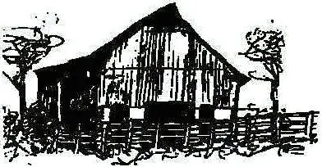

We want to flag two large-group sharing events, both on Saturday morning::

Rachel Gholson is organizing an oral history session for the annual meeting in 2025, providing attendees with a unique opportunity to explore and share the personal narratives and lived experiences that shape our identities as folklore presenters, curators, community leaders, students, and scholars while members of the Missouri Folklore Society. This oral history ―taping‖ session is designed to preserve and celebrate the rich legacy of us and MFS. This interactive session will feature you: the members of our Missouri Folklore Society community sharing stories about your journeys with MFS by inviting audience participation and aiming to foster intergenerational dialogue, ensuring that the voices of both emerging and established members are heard and remembered. Please, consider what MFS has meant and currently means to you between now and November. Then, come and share pivotal moments, challenges, and transformations membership in the organization has offered you. Or if you cannot attend in November, please contact Rachel (RGholson@MissouriState.edu), so your experience can be included in the MFS oral history.

Lyn Wolz & Adam Davis: The Missouri Folklore Society: Our History and Our Future

Come share your memories of 48 years of the activities of our beloved society. Many of us were at the first MFS organizational meeting at the University of Missouri in Columbia in 1977. Called by Dolf and Becky Schroeder, it began the Society’s impressive record of activities, including the three-day annual meeting that was held in a different part of the state each year, our printed annual journal, our printed then digital quarterly newsletter, and many other productions and events.

It's now time to consider the future of the society, so bring your ideas, your energy, and your willingness to engage each other in productive discussions.

Our special lunch presentation on Friday:

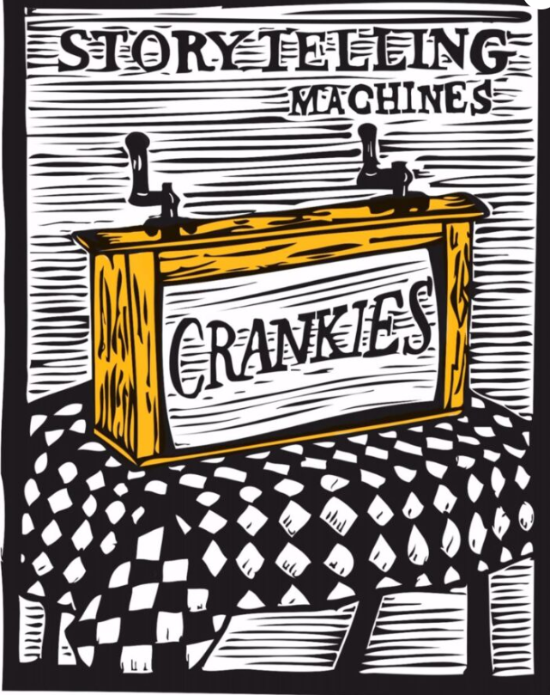

Sandi Green Baker: A Ghostly Love Story in Motion: The Crankie of Lady Margaret

Artist Sandi Green Baker invites you to experience the magic of a Crankie, a hand-cranked storytelling machine that brings art, music, and folklore to life. Dating back to the 1700s and revived in recent years, the Crankie uses a scrolling illustrated story inside a small theater box, often paired with live music and puppetry.

For this performance, Sandi illustrates the haunting Child ballad “Lady Margaret,” a ghostly love story rendered in bold, woodblock-inspired art. She is joined by her daughter, Re Baker Dietz, who creates shadow puppetry, and Charlie Becker, who performs the ballad a cappella. Sandi will also share the fascinating history of the Crankie, her creative process, and the journey behind bringing Lady Margaret to life — a performance that blends tradition, storytelling, and timeless emotion.

Mike Calvert: The World War Two History of the Women at the Lake City Army Arsenal
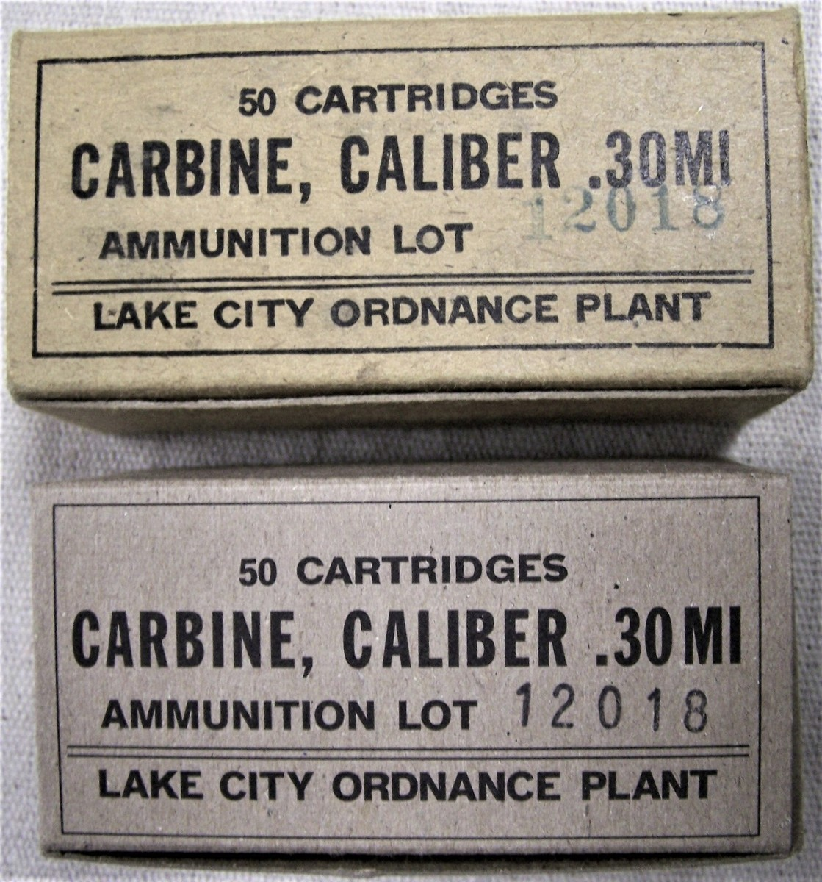

As our nation mobilized for the task of winning World War Two untold numbers of women left their homes for the first time and joined the work force. In the next four years they would perform with great efficiency the manufacturing jobs that until that time were performed by men. This is the story of one such set of women. Prior to the beginning of the war, in eastern Jackson County a great arsenal was constructed to produce the ammunition needed to defeat the Axis Powers. Thousands came from all walks of life and each with their own story to do their bit to bring their boyfriends, sons and husbands back to their home alive. This is the story of those unsung heroes.

Liz Faries: The Clarinet, the Two-Dollar Piano and the Cello in the Corner
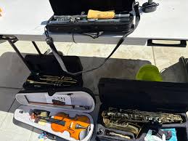

This presentation focuses on three instruments that were given a second chance to benefit others. We have had programs featuring musicians, programs focusing on the words or tunes, but few on the instruments themselves. As Burl Ives often sang, “Music alone shall live.” The instruments we play help make that happen. I was inspired to submit this proposal due to Betty C. Henderson’s book on her husband’s obsession with used cars. My husband’s world was folklore, the songs that lived, and purchasing well-used instruments at auctions.

Carol Fisher: Thanksgiving Memories

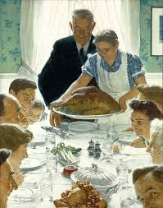

Let’s gather around the table and explore our Thanksgiving Day history and then share memories of this special family day. We will remember favorite family dishes, family bonding, trips to and from our Thanksgiving and how they have changed or not changed over the years. Who knows.....There may even be some tasty treats available to get you started thinking about and planning your Thanksgiving Day 2025!

John Fisher: From Slavery to Philanthropy: The Charles and Betty Birthright Story

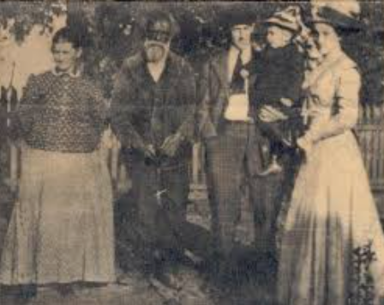

Charles and Bettie Birthright were born into slavery, owned by different people. They married and after the Civil War were able to establish themselves in Clarkton, Missouri where they became prominent citizens and acquired some measure of wealth. On the death of Bettie, who survived Charles, their estate was left to Stillman College in Tuscaloosa, Alabama where a building has been named in their honor. Throughout their lives, they maintained a close relationship with the family of their former owners.

Michael Fraser: Remembering Master Ozark Square Dance Fiddler, the late Bob Holt, and his Contributions the Missouri Folk Arts “Master/Apprentice” Program.
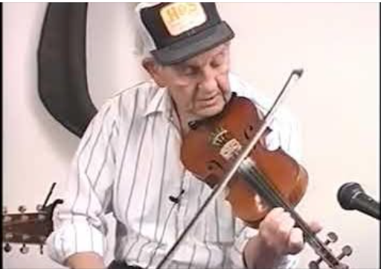

Michael’s presentation will focus on his journey into the Ozark Highlands where he became infatuated with the landscape, culture and music of the region. His voracious desire to learn how to play traditional Ozark Fiddle Music led to an opportunity to study with Master Ozarks Square Dance Fiddler, Bob Holt, through the Missouri Art’s Council’s “Master/Apprentice” Program. Topics covered during the presentation will include Michael’s journey into the Ozark’s, landscape and culture plus the dynamics of the Master/Apprentice Program. Nuances of Ozark fiddling will also be demonstrated.

Rachel Gholson: Ozarks Folkways and Film: A Select History

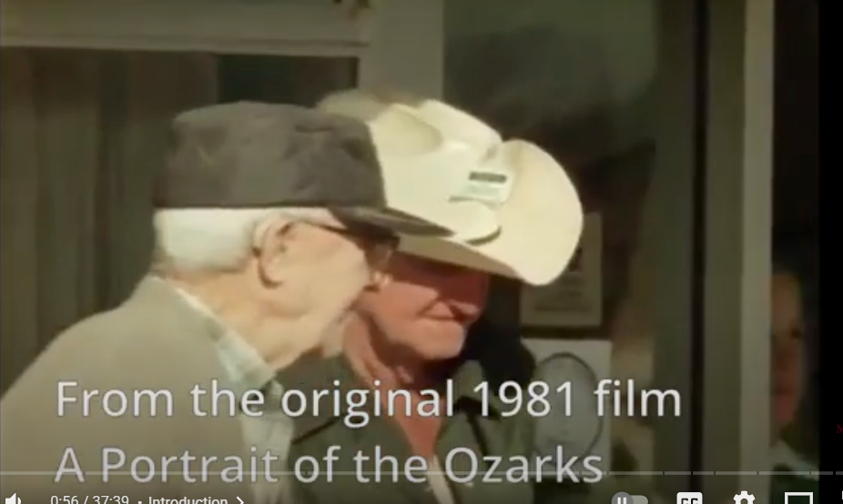

This presentation explores how film has helped tell the story of Ozarks culture, focusing on projects created at Missouri State University. From early documentary efforts in the 1980s to more recent films, these works have captured everyday traditions—music, storytelling, crafts, and celebrations—and shared them with wider audiences. Over the decades, filmmakers at MSU have not only recorded important aspects of regional life but also shaped how the Ozarks are seen and understood beyond the region. This talk traces that history and highlights key moments when film brought local voices and experiences into focus. By looking at how these projects connect the past and present, the presentation shows how visual storytelling continues to play a vital role in preserving and celebrating Ozarks folkways for future generations.

Hayden Head and Curtis Copeland: In Randolph’s Footsteps: Recording the Ozarks for a New Generation

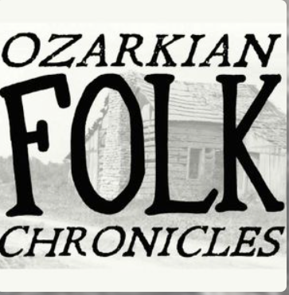

The Ozarkian Folk Chronicles Podcast is a storytelling project celebrating the people, traditions, and creativity that make the Ozarks unique. This presentation will share the project’s mission to keep regional stories alive. We’ll explore how episodes are created — from finding guests to capturing their voices — and highlight some of the most memorable stories shared so far. Participants will come away with a deeper appreciation for the living culture of the Ozarks and ideas for how similar storytelling projects can build community, preserve heritage, and spark curiosity about the everyday traditions that shape who we are.

Julie Henigan: The Irish Keening Tradition as Performative Poetry

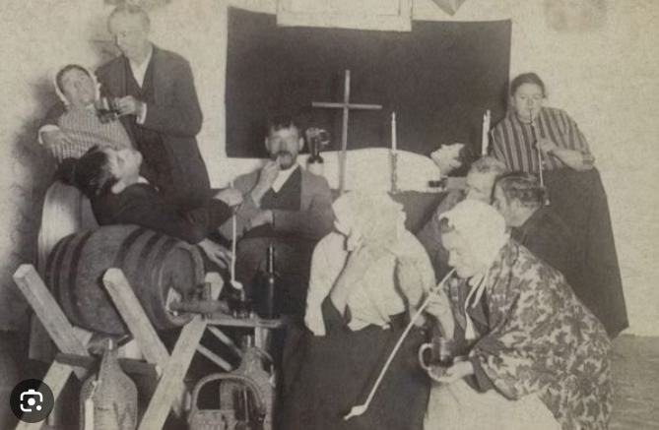

While this presentation will give only the merest hint of the artistry of the ancient keening tradition of Ireland, I plan to illustrate--with the assistance of three sound recordings and my knowledge of the subject--how keeners, whether paid professionals or family members, employed well-worn musical and poetic conventions to express their own or a family’s grief at wakes or funerals. Since actual recordings (or even transcriptions) of keens (known as caointe in Irish Gaelic) are extremely rare, we will be listening to recordings of laments recreated by those who knew the tradition first-hand. Some of them are rudimentary; but others, like that reenacted by Seán Ó Conghaile, of Carna, Co. Galway, display true improvisatory artistry and reveal the interrelation of song and spoken word in oral performance. For communities in which keening women were not available (or affordable), even a verse from what is termed a “death song” could be used, a practice which I shall illustrate.

Julie Henigan, Judy Domeny Bowen and Dave Para: Max Hunter and his Legacy in Song
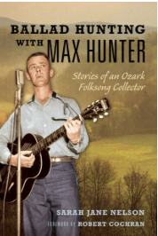

This double-session combination of performance and panel discussion will feature three singers (Judy Domeny Bowen, Julie Henigan, and Dave Para) whose lives were greatly influenced by Max Hunter and the songs in his voluminous collection. Each of the three singers will describe their relationship to Max Hunter and his collection, play two or three songs drawn from it, and discuss the impact of these songs on their musical and personal lives.

Lisa Higgins: Rooted, Practiced, Sustained—Missouri’s Dynamic Traditional Arts
(keynote address)

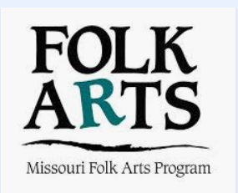

Academic and public sector programs in Folklore/Folk Arts/Folklife/Traditional Arts/Oral Tradition have a long history in the Show Me State. Milestones include the hiring of H.M. Belden at Mizzou in 1895; establishment of the Missouri Folk-Lore Society in 1906; the first presentation of the National Folk Festival in St. Louis in 1934; publication of Ballads and Songs Collected by the Missouri Folk-Lore Society in 1940; incorporation of Missouri Friends of the Folk Arts in 1973; the kernel of an idea for the Missouri Cultural Heritage Center in 1978; and the emergence of the Missouri Folk Arts Program as a Missouri Arts Council/Museum of Art & Archaeology partnership in 1993.

Like the folklife of our state, these individuals, entities, and terminology are dynamic—waxing and waning, reviving and declining, retired and rewired.

Lisa L. Higgins, PhD, longtime director of the Missouri Folk Arts Program, will consider the roots, practices, and sustained threads of traditions in Missouri’s academies, public sector, and traditional communities.

Phillip Howerton: Poetry In Place

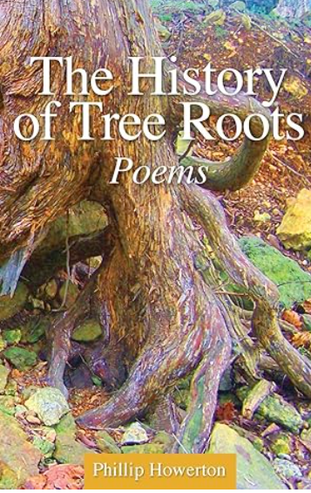

The sixth-generation Ozarker will read a selection of poems that engage numerous elements of Ozarks folklore and rural lifestyles, such as hand-dug wells, a variety of plants and animals, aspects of farming, abandoned buildings, fence posts, and cemeteries. These poems explore a sense of place and a sense of loss, the demise of the small farm communities, the persistence of stereotypes, and the awareness of relentless change. Some of these poems are taken from his two collections, The History of Tree Roots and Gods of Four Mile Creek. This reading and discussion will be supplemented with photographs and artifacts.

Kaitlyn McConnell: Seeing Community Through the Lens of Ozarks Alive
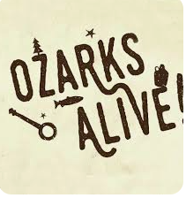

The founder and host of the cultural preservation project Ozarks Alive spends many miles wandering the Ozarks to share and save its stories. Along the way, she has found many forms of community that help form the bonds of where and who we are. In this talk, she will share some of the most memorable themes and stories from these travels, as well as how food can bring us together through her most recent undertaking, the Ozarks Pie Project.

Chris Otto: Native Americans’ Presence and Legacy in Missouri
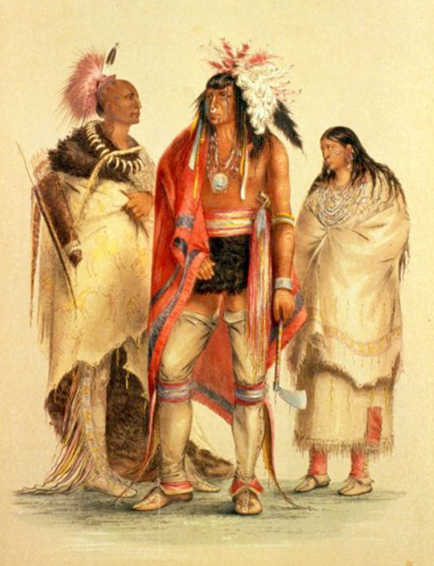

Native American presence has left a lasting legacy on Missouri’s landscape, culture, and history. The very name “Missouri” comes from the Missouria tribe, meaning “people with dug-out canoes,” and many rivers, cities, and counties—such as Osage, Neosho, and Nodaway—also reflect Indigenous origins. Long before European settlement, Native peoples built thriving communities, as seen at sites like Towosahgy and along ancient trade routes that later shaped major trails and towns. Indigenous languages, stories, and symbols continue to influence Missouri’s folklore and place names, while museums and parks preserve this heritage through education and commemoration. Although many tribes, including the Osage, Otoe-Missouria, and Shawnee were displaced during the 19th century, their cultural influence endures through ongoing preservation efforts, annual events, and partnerships that honor Missouri’s deep Native roots.

Dave Para: Mysterious Life and Song of Doodlebug

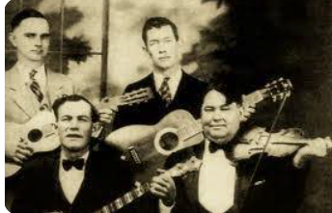

Composed by Charles Ernest Moody, “Song of the Doodle Bug” was recorded by his band, the Georgia Yellow Hammers, in Atlanta, 1928. The song’s subject is a typical southern child’s activity concerning the doodle bug, or ant lion, that includes singing to the bug. The recorded song has a line in the second verse that has eluded discernment by several folksingers. We will attempt a crowd sourced interpretation. No animals will be injured during the presentation.

Susanna Reichling: Examining the Folk Wisdom of Springfield’s Bluesman, Doc Dasher

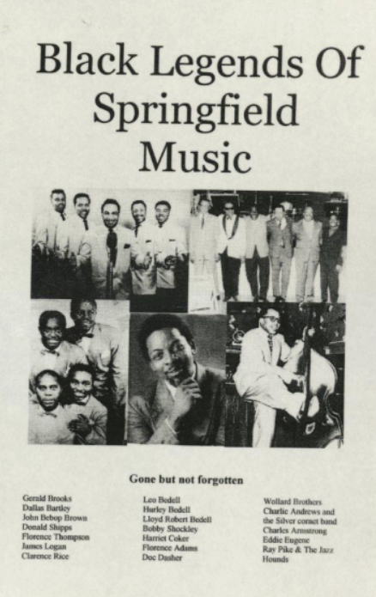

Doc Dasher was an African-American bluesman who began his career in the early 1900s, traveling across the country on the vaudeville circuit. After a stop in Springfield, Missouri during the summer of 1928, he decided to settle down, and remained in the area until his death in 1987. Although he estimated he had written 300-400 songs throughout his lifetime, there are only four known recorded examples of his work. In this presentation, we will listen to two of those recordings (“Evolution Mama,:” Columbia 1925 and “You Got Something I Want,” Ebony 1951) and read a sampling of his many words-of-wisdom contributions to the Springfield News-Leader (1929-1933)

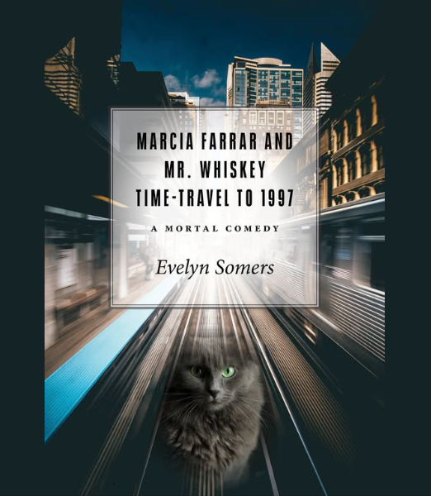
Evelyn Rogers: Time-Traveling Cats and Homicidal Maniacs: a book talk and short reading

Marcia Farrar and Mr. Whiskey Time-Travel to 1997 is a debut novel set around 2018 in the fictional town of Round Stone. Briefly, the titular character is a single mom of an illegitimate son, Howie, who has just graduated from local Holliday College and been offered, mysteriously, a linguistic fellowship in a dangerous part of the world where a homicidal maniac has built a death prison and is gleefully executing people by the thousands. After Howie leaves for the fellowship, Marcia’s dog dies, her chest freezer is stolen, and when she takes the dog to be cremated, the ashes that are returned turn out not to be the dog’s. By an unexpected concatenation of events, they reconstitute into a cat, Mr. Whiskey, who can time-travel and aids Marcia on a series of absurd but deadly serious adventures. My presentation will include a few lines of plot summary and brief reading.

Lyn Wolz: When You Were in College, Did You Major in “Coffeehouse” Like I Did?

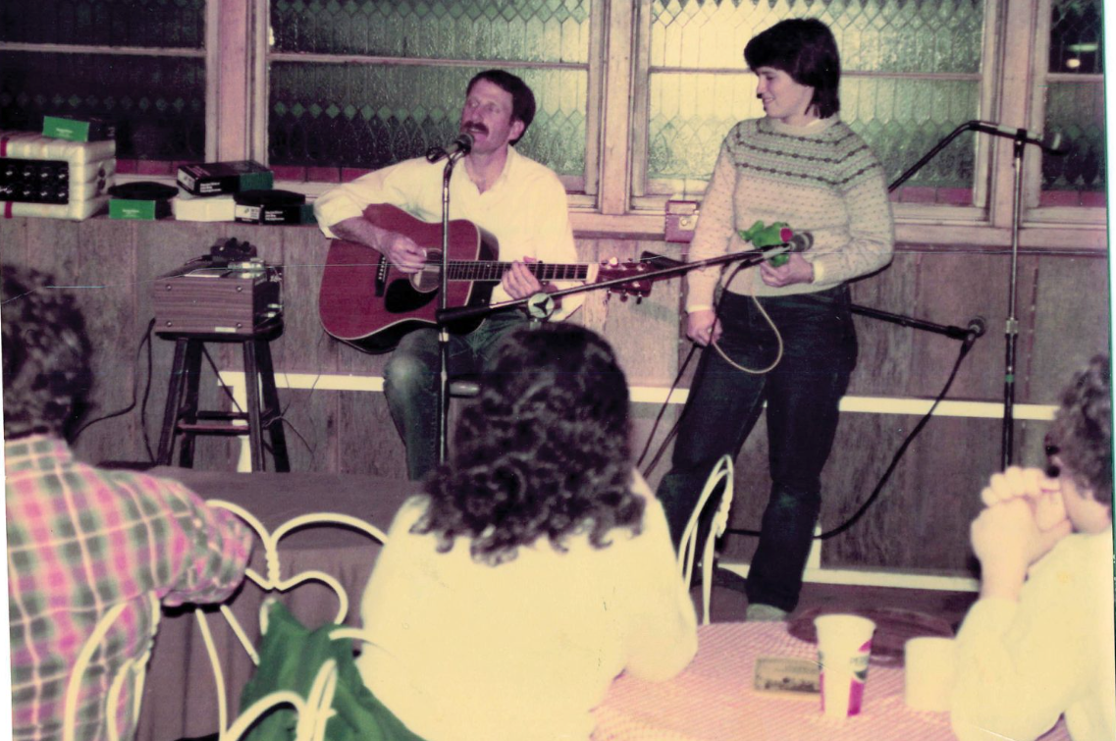

This will be a remembrance session with all of us sharing our memories of the time we spent at our favorite coffeehouses and other venues when we were in college, places where the music was more important than anything else and we had “all the time in the world” to hang out with friends, learn to perform, and enjoy ourselves immensely. If you had experience with this type of situation, whether it was in Columbia, Kansas City, Springfield, St. Louis, or elsewhere, come to share your memories with us. Bring photos, posters, recordings, and anything else you’d like to share. (If you can no longer keep these materials safely, we can deposit them in the MFS archive or in any of the six statewide State Historical Society of Missouri archives after this session.)

