**Lenten Lore**

*notes for a lecture by Adam Brooke Davis, Truman State University*

Remember our *three approaches to folklore*--

**Who: American Roman Catholics; to a lesser extent, Anglican/Episcopalians & Lutherans; some structural and functional resemblance with Muslim Ramadan, Jewish Yom Kippur**

**What: the penitential season leading up to Easter**

**How: in families & congregations, to some extent institutionally (parish schools) and by mass media, later appropriated by non-Catholics and commodified by municipalities (New Orleans, St. Louis, Vienna)**

Remember also, three phases of a folklore fieldwork project:

**Collect** (see images below for genres of the WHAT)

**Classify** (is this is religious lore, behavioral, material, or customary? Holiday/calendrical? Different analyses will result)

**Analyze** (what structural features and dynamics? What functions? How is the customary lore of the Christian Lent structurally and functionally like and unlike classical and pre-Christian Germanic spring festivals? To what extent are the formal and functional similarities likely to result from **derivation from a common source**, and to what extent do they represent **independent inventions** in response to universals of human biology and its relation to natural cycles?)

Etymology -- OE **lencten**, literally “lengthening” (of days) = “spring,” latter term literally “the time when things jump up out of the ground”): mirrored in the Catholic Church’s liturgical year (*liturgy*, “stuff the people do”)

Thematic elements to watch for:

-cyclic treatment/enactment of death -- solemnity and sorrow, self-denial, renunciation, penitential ascesis, but, paradoxically, *also* hedonism and excess in physical pleasure; note that folklore is often a channel for regulating oppositions and tensions, paradoxes and transgressive impulses in tension with official and institutional norms and culture.

Themes:

-renewal of life

-resurrection

-fertility

-suspension or imposition of restrictions on behavior, especially self-restraint in matters of sex, alcohol and food, public and private;

-*inversion behaviors* challenging usual rankings per gender, class, institutional authority, even human/animal.

Most obviously, we see solemn observance of specific religious traditions, with institutional patterns (**conservation**) and local **variation**.

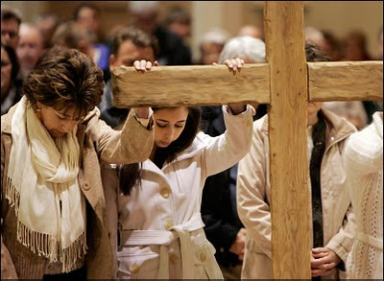

Fasting regulations in the early Church were non-institutional, but rather local and highly varied – the Lenten fast might mean total abstinence from food, or diet might be restricted to dry bread only, or exclude all flesh, or treat fish, poultry, dairy and eggs differently from red meat. It might last a day, or forty days, or forty hours, or be suspended at sunset, or on Sundays. As with the institution of sainthood, the local and informal was codified and made authoritative.

<http://www.newadvent.org/cathen/09152a.htm>

**Easter** as observed normatively throughout the US was historically family-oriented, rather sedate and even formal. It has proved remarkably resistant to commercialization. *Hedonism* is strictly caloric and itself almost ceremonial – the decorous excess of jellybeans. Renewal themes are linked to new clothing, and especially to white dresses.

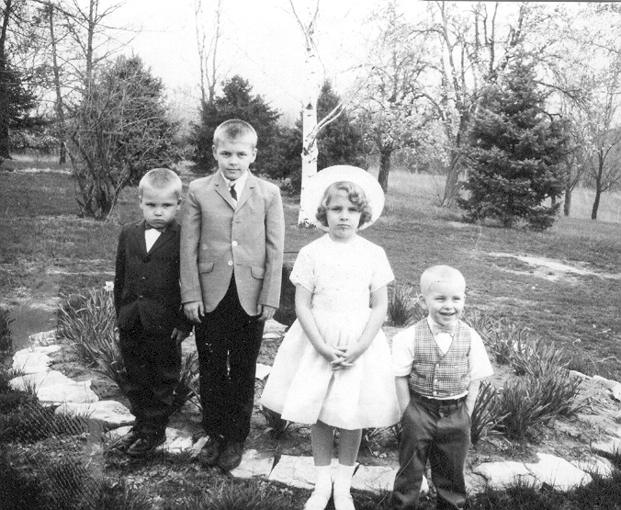

*Far right, your humble lecturer: Druid Farm, Creve Coeur, April 18, 1965*

The usual Easter parade is linked to mate-identification and courtship, but quite restrained.



But consider the wide variation **parascripture** and **paraliturgy** bring to institutional norms, and less decorous behaviors – especially *syncretic* ones, absorbing non- or pre-Christian behaviors – are easily observed.

In the Southwest, liturgical dance rooted in Native American traditions is permitted outside the physical church, seldom within.

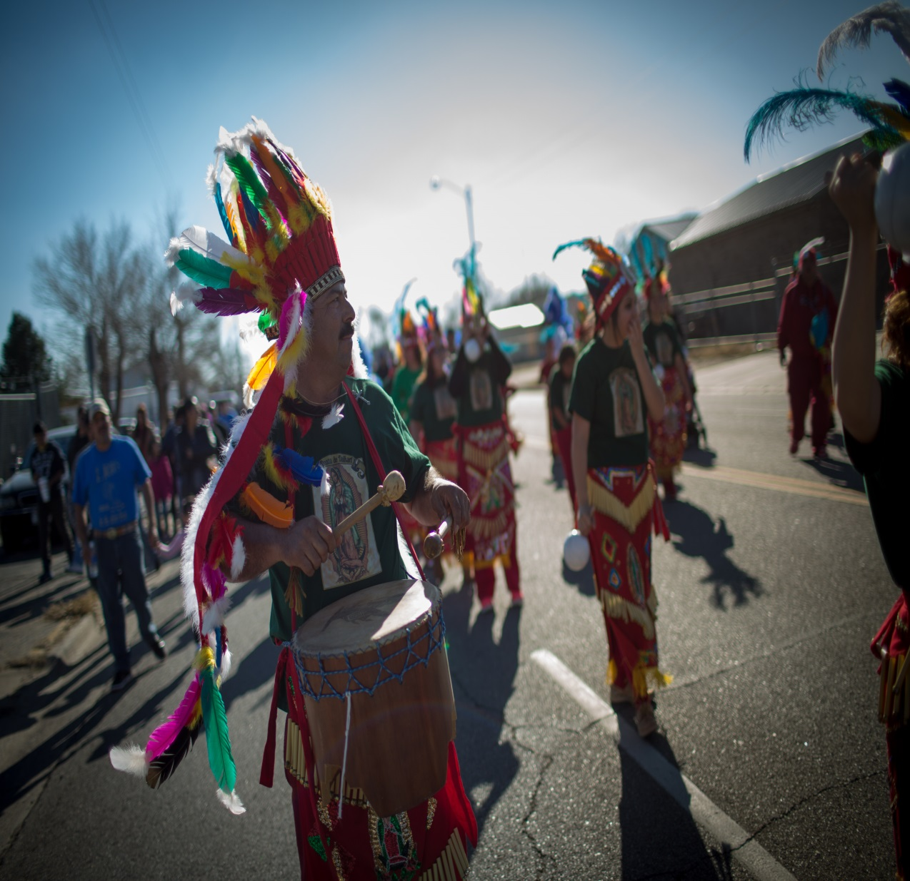

The liturgical calendar emphasizes cyclic repetition, especially cycles of extinction and renewal.

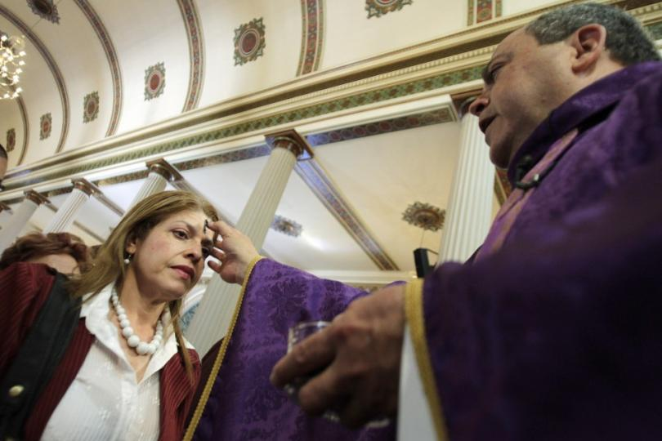

Ash Wednesday, presaging the beginning of Lent, derives its materials (ashes) from ...

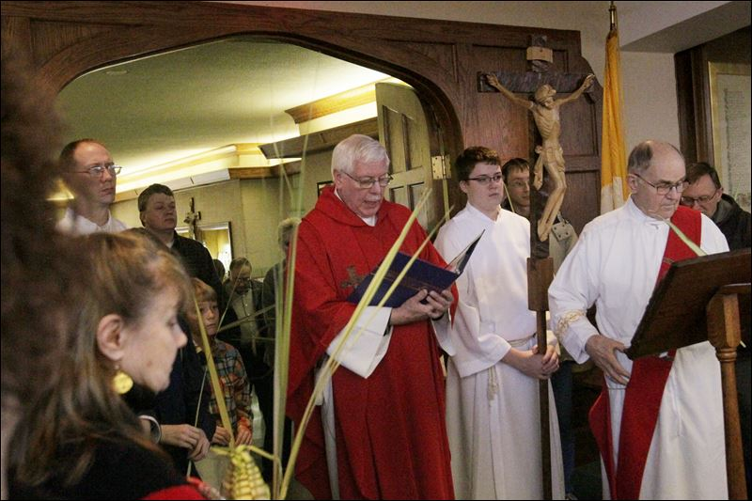

… the previous year’s Palm Sunday, marking the final phase before Easter. These days generate related but independent material lore…

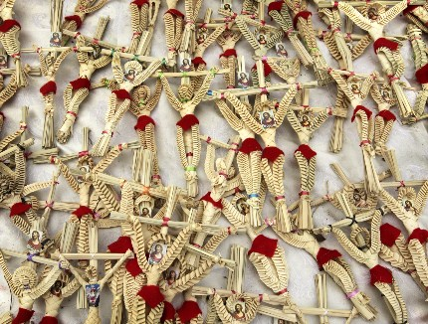

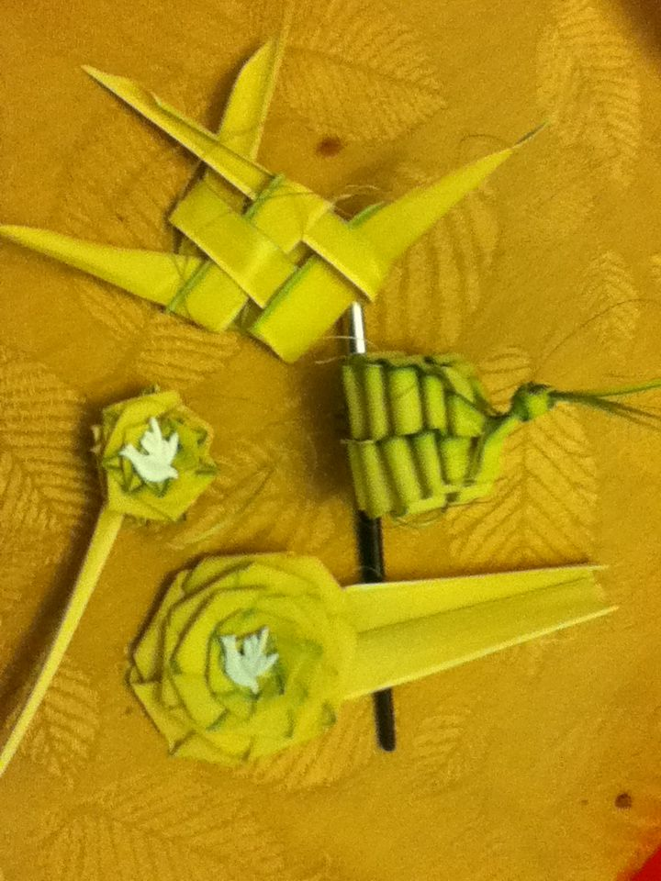

Specialized foods repeat the imagery and social dynamics: resurrection motifs, consumptional excess, special roles, gendered public foolishness:

**King Cake**



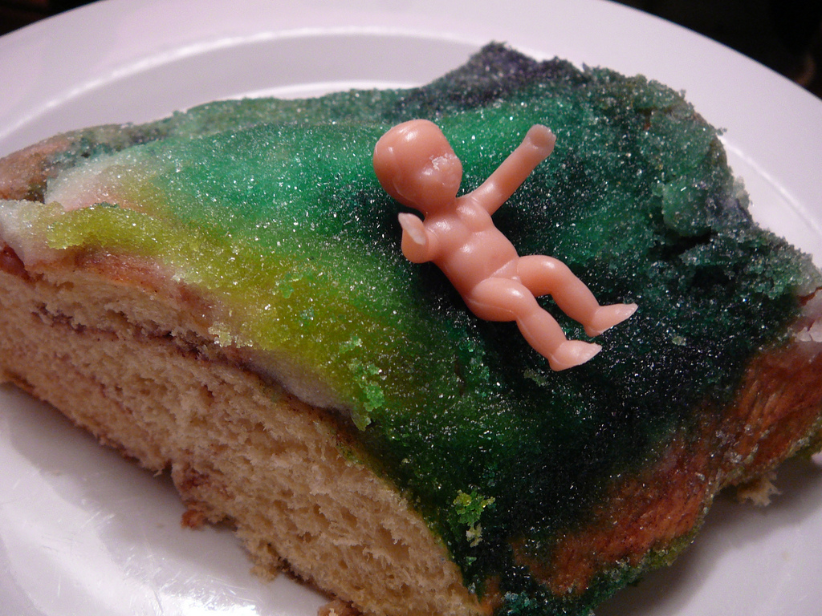

**Shrove Tuesday, aka Pancake Tuesday**

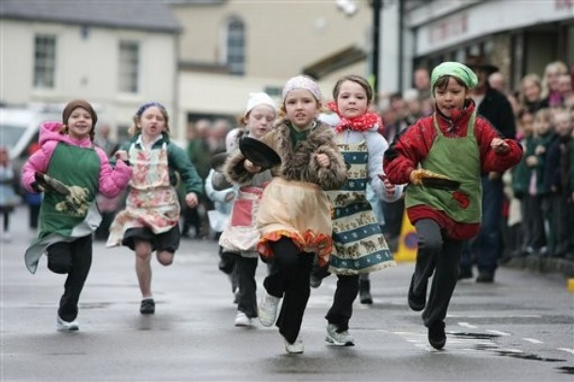

**Pazci – “not just another jelly donut.” Well, at least it’s not on *pazci day*  in Detroit or Chicago.**

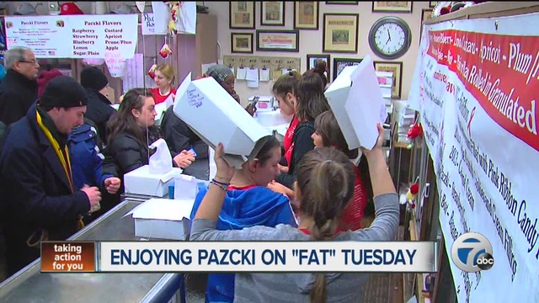

**Back to basics:**

**the local, intimate, rural Lent and Mardi Gras**

**The ParishFish fry, when the Knights of Columbus do their thing**: duly noted: meta-folklore claims that fish-for-lent originated with the Parisian fish-mongers. The parish fish-fry is not actually a penitential meal, but a site of reunion and fellowship.

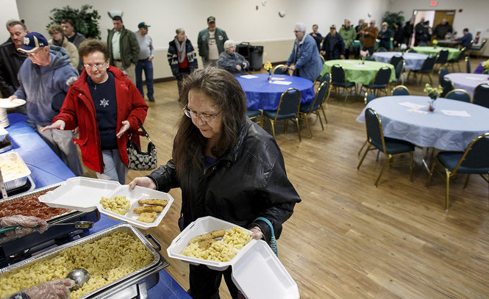

Enormous local variation in fasting, abstinence (including “breaks” from giving up whatever you gave up for Lent), veiling of images, removal of cushions, footwashing (and its reform, per institutional role and gender)

**Carneval** (one of many etymological stories, i.e., folk etymologies in the folklorist’s sense, derives it from *carne – vale – farewell to flesh [both meat-eating and bodily pleasure]*): the raucous pre-lent hedonism and release are usually seen in the context of the “pressure-valve” and “social gyroscope” analogies – but in a religious context.



**Public nudity** – excessive exposure of the private self – is as durable an element as **public disguise** – the concealment of what is normally exposed, and the resulting problematizing of individual and social identity, of what is public and what is private. They are mirror images of one another. Body painting is a paradox of nudity and concealment.

Behaviors which are normally and normatively forbidden are permitted *or even compulsory* in liminal times: for Orthodox Jews, among whom problem drinking is rare, two proverbs: “It is a mitzvah to get drunk at Purim.” “Even the rabbi should get so drunk at Purim he cannot tell ‘blessed-be-Haman’ from ‘cursed-be-Mordecai’” (a highly transgressive inversion of the names of biblical hero and villain).

**Commodification**, making a commercial product of a folk behavior – fundamentally changes its nature. Add in **boosterism** – Mardi Gras long ago became a Nawlins trademark and tourist-draw. Compare “Fair St. Louis” -- once the socially- and racially-tinged “Veiled Prophet” event, a mating-ritual for the upper crust in the “Northwesternmost Outpost of the Confederacy.” This was a festival of *re-asserting* order, however. Below, the first VP, an unambiguous Klansman, explicitly charged with putting down the city’s emerging unions and preserving its class structure. The debutante parade was routinely attacked by urchins with pea-shooters, and this may actually have been a functional part of the ritual, allowing the lowly to vent in controlled ways, maybe even a ritual exposure of the powerful to the non-powerful, acknowledging the limits of patience. “There are more of us than there are of you, your majesty.”

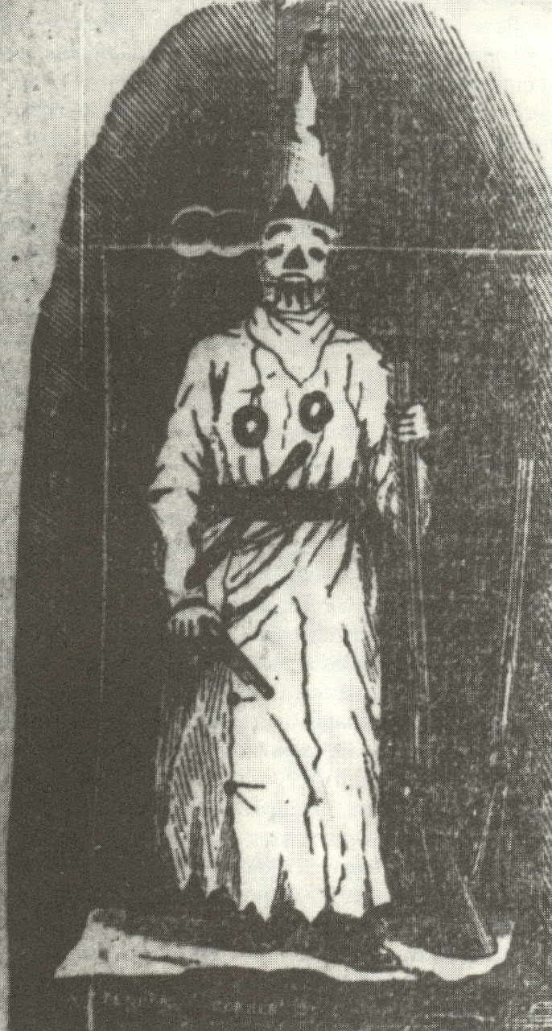

Below, a more recent Prophet. With the same mission (?) The event has not really been democratized. It’s still the debutante ball; the “queen of love and beauty” is a pretty thinly disguised rite-of-spring figure.

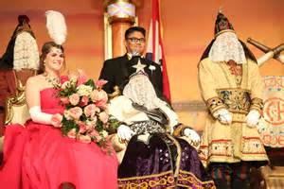

Let’s note: before the mass commercialization and commodification of the big city, tourist-oriented Mardi Gras, intimate little parishes had their masked festivals where one wore something as small as a domino mask, and there was an expectation that we all pretend we don’t know who’s behind it. This is the one time of year when you might tell your boss what you really think, or reveal to your secret crush how you feel. That’s a good example of a functionality that disappears in a different context.



**Mass culture** strips the original fertility symbolism of all meaning, though the idea of consumptional **excess** is retained. Which is highly functional in a capitalist and consumerist society, although concerted marketing efforts to make turn Easter into a second Christmas, requiring extravagant gift-giving, have not succeeded.

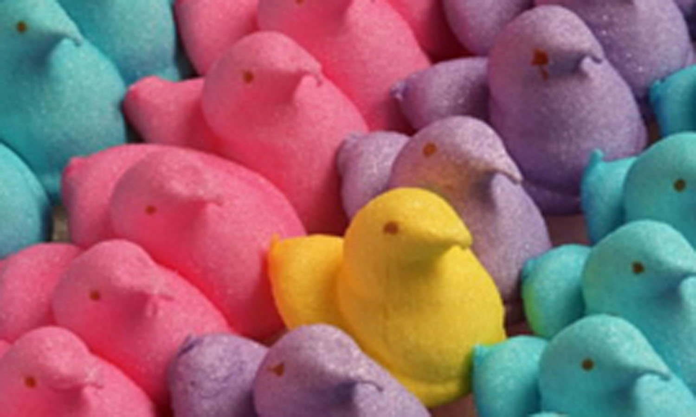

Classical antecedents:

Ancient Rome and the month of fevers (February):

**Lupercalia: hedonistic release, fertility, dionysiac episode in apollonian society**

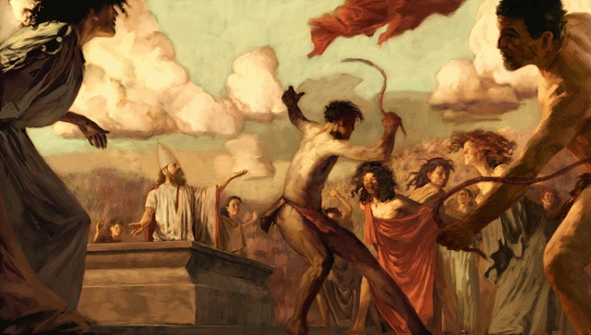

“The sacrificial feast followed, after which the Luperci cut thongs from the skins of the animals, which were called februa, dressed themselves in the skins of the sacrificed goats, in imitation of Lupercus, and ran round the walls of the old Palatine city, the line of which was marked with stones, with the thongs in their hands in two bands, striking the people who crowded near. Girls and young women would line up on their route to receive lashes from these whips. This was supposed to ensure fertility, prevent sterility in women and ease the pains of childbirth.”

**Candlemas/groundhog day (Imbolc, St. Brigid’s Day)**: resurrection imagery, fertility imagery

The overlay seems irreverent, but at several levels, the correspondence is real.







**Germanic Fasching** *(< “Fastnacht,” night before the fasting time):* animal-form masks and parades; human sexual urges, prominent in the spring, unite us so intensely and irrationally with the beasts that we are forced to question whether there’s actually such a huge difference. See the “reverdie” opening of the medieval poems *Canterbury Tales*, or *Sumer is icomen in*.

It has elements of other festivals of inversion (class authority, gender authority, institutional authority) and dissolving lines of demarcation between social categories, or proper venues for certain kinds of behavior (public/private) – cp Hallowe’en. Often features “festival of fools” elements.

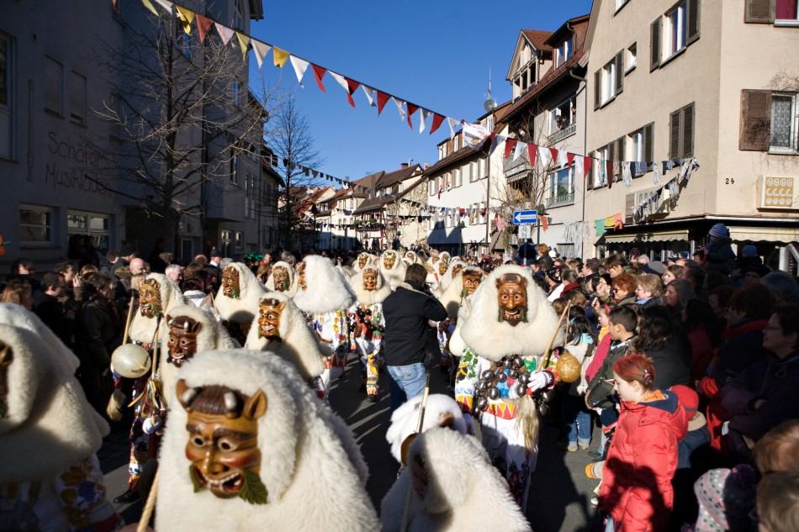

The panic over the groping of German women by immigrant men during the Christmas festivals of 2015 is made somewhat paradoxical by the fact that young German men *routinely* behave that way – *on New Year’s Eve at a festival held outside a train station*. Which is ***not*** to say such conduct is in any way acceptable, but it does call attention to a distinction being made. One can read it as simple xenophobia, but also as resentment of the presence of outsiders at an insiders’ rite.

**Ballsaison Wien:** essentially a mating ritual (and many marriages have come from meetings at these events); this is the other extreme of response to becoming aware of the fuzziness of the human/animal split – rather than inviting in chaos (xάος), they double down on formality, kosmos (κόσμος). Go back and look at the Veiled Prophet again.

Significantly, there are balls for virtually all occupations and social classes: the Opernball of course, but also the Firefighters and even the Chimneysweeps.

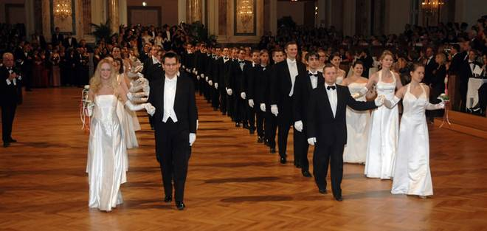

**Inversion festival, nominal and ceremonial anonymity, authorized misbehavior:**

**When rule-breaking is permitted, or even expected, is it rule-breaking? This is the perverse proposition of Euripides’ *The Bacchae*: it is a sacred duty give in to Bacchus – periodically, to agree to go insane; sanity depends on it.**

Below: scandalous painting from 1885 (distributed as a postcard in 1902). Does the mask do much to conceal identity? Everyone knew it was the opera singer Marie Renard. And yet it is strongly associated with temporary (that is, time-bounded, liminal) release from sexual restrictions. Oscar Wilde: “Man is least himself when he talks in his own person. Give him a mask, and he will tell you the truth.”

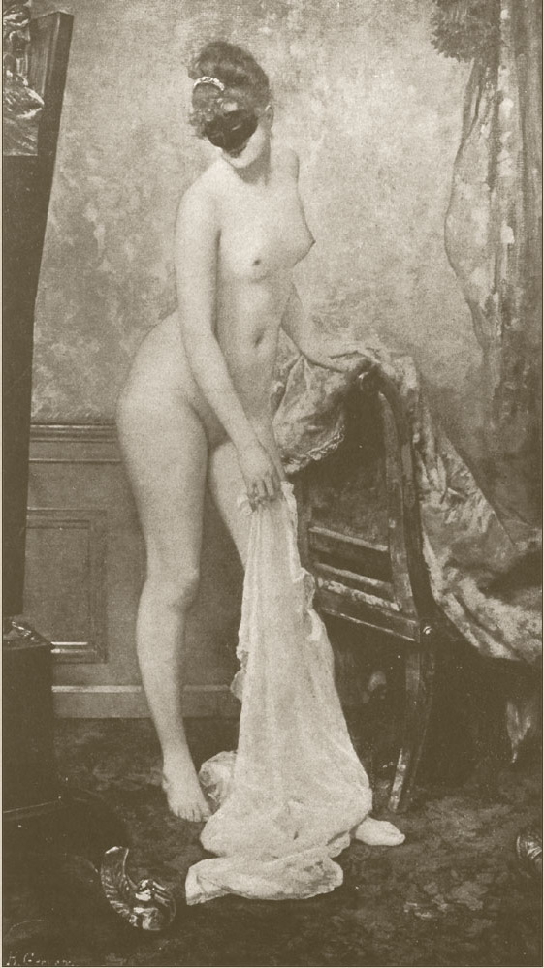

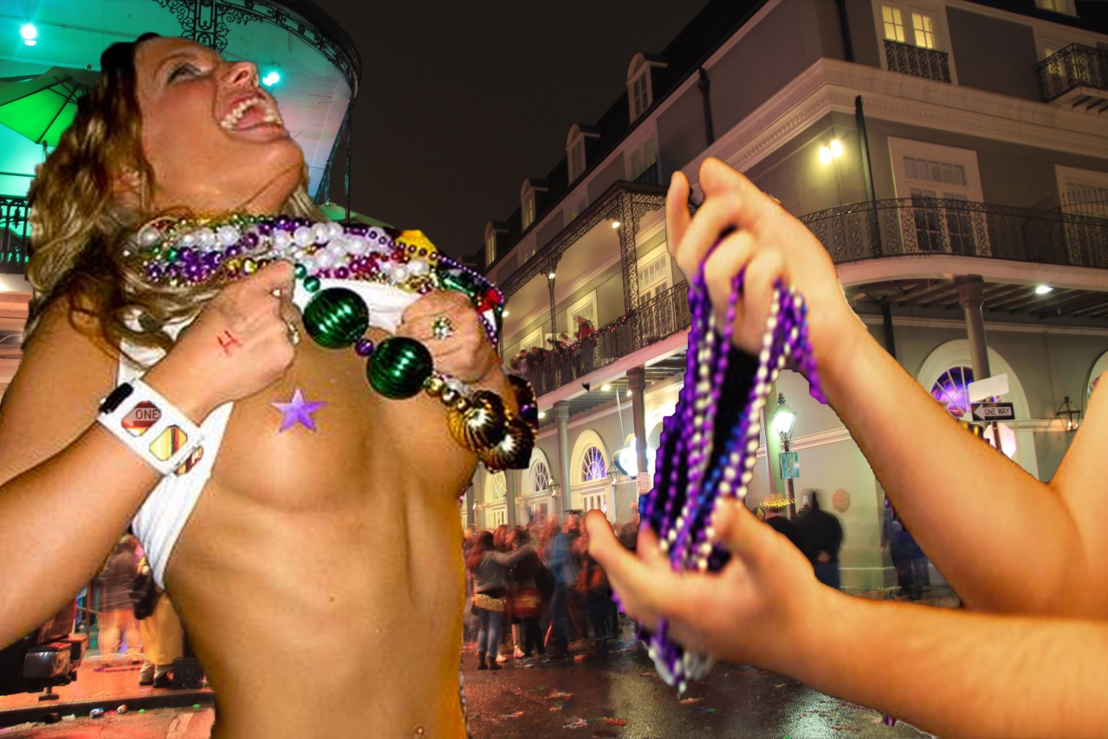

**Mardi Gras** – an atavism, a distortion. There’s no reason to believe these people are devout Catholics, intending to start forty days of self-denial the next morning. The flashing custom has been documented since at least 1889; there is some view that it has always been tourist behavior, outsiders seeking liminal space to do what is not perrmitted in home-space (c.p., “what happens in Vegas…”) The collective “beads-for-boobs” provocation to self-exposure has been described as a kind of ritual quasi-prostitution, possibly with the legendary suspension of rules governing exclusivity of sexual access for childless women during certain inversion festivals. Those are unsubstantiated claims, to be treated as primary folklore rather than as ethnography.

Although the nearest Celtic feast to this date is Imbolc, the behaviors described are linked to Celtic Samhain (near Hallowe’en, another complex of pagan/Christian/commercial), surrounding which there is no end of bullshit.

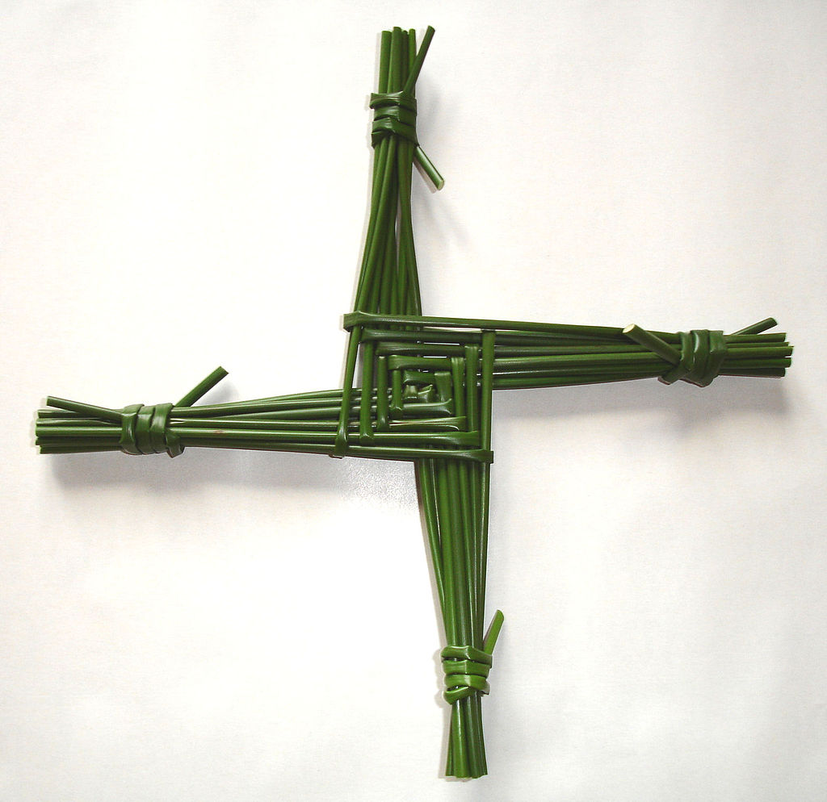

How far back does the connection of fertility, sexual nonrestraint and life-renewal-after-winter go? The semantic and phonological convergence of Germanic Eostar/Ostara, East Semitic (Babylonian) Ishtar, and Northwest Semitic (Palestinian) Astarte, defies chance (the Hebrew Queen Esther is also somewhere in there). Methodologically, the logic of connection here is the Mass Analysis that gives us the proto-language Nostratic, rather than that of Phonological Correspondence Rules, that can only take us as far back as Proto Indo-European. If you want to prove it’s imaginary, just come up with an equal number of examples of a consonantal framework like –s-t-r- that means “god of volcanoes.” Or “lord of dairy products.”

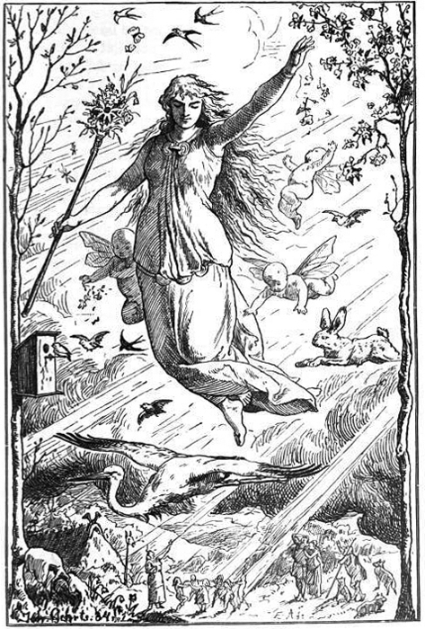

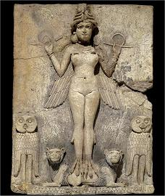

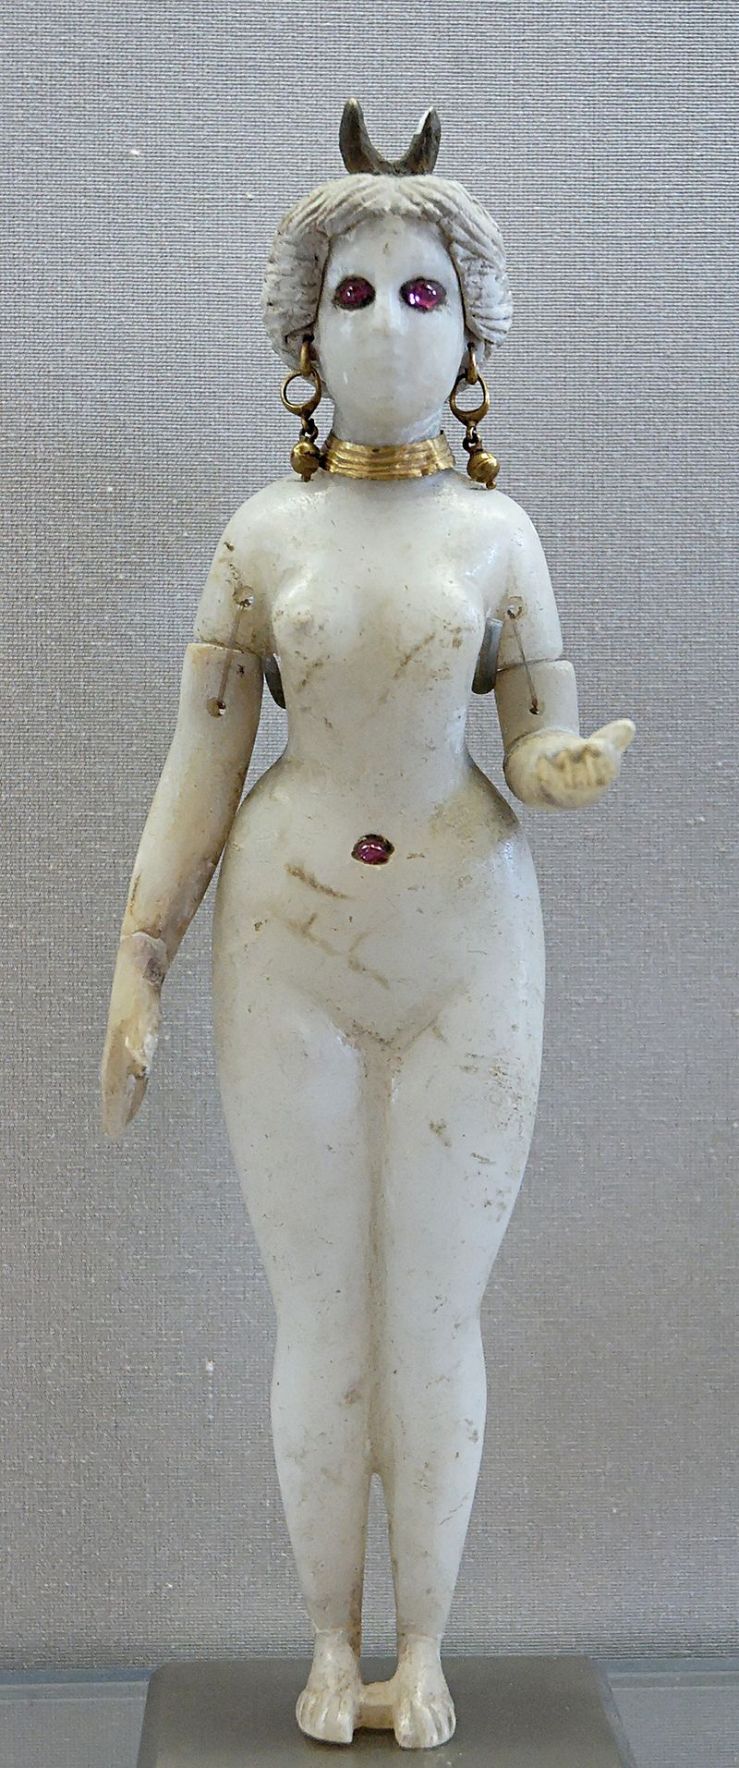

But in case the arc looked like descent of the sacred into the profane, here’s a plausible case of the reverse:

The crescent moon imagery associated with the BVM is often seen as an example of Christianity’s well-documented syncretism – absorption of non-endemic beliefs, imagery, rites.



And *syncretism* – the cobbling together of tradition out of rags and scraps of other traditions – that’s the story of lentenlore.