**Missouri Folklore Society Annual Meeting  
October 17-19 2024**

### Woodneath Library Center, Mid-Continent Public Library Kansas City, Missouri



Zoe Aldrich, Truman State University

"Bingo as Community and Third Place: A Study of Wednesday Night Bingo at the El Kadir Shrine Club, Kirksville"

Olivia Altomari, Truman State University

"The Veiled Prophet: A Folklore Analysis"

The paper explores the complex legacy of the Veiled Prophet organization, a secretive group founded in 1878 in St. Louis. Known for its annual parade and ball featuring the mysterious Veiled Prophet, the organization has faced scrutiny for its elitist, racist and sexist history. This paper examines the contrasting perception of the Veiled Prophet, incorporating folklore from both insiders and outsiders. It analyzes the organization's origins, drawing parallels to the New Orleans carnival society and the Mystick Krewe of Comus. Through interviews and historical accounts, including those by Thomas Morris Spence III and Lucy Ferriss, the paper reveals how the Veiled Prophet has been both a symbol of elite exclusivity and a target of criticism. It highlights the enduring tensions between tradition and modernity, and the ongoing debate about the organization's place in modern society.

Tyler Bichsel, Truman State University

"The Buffalo Are Gone: Bringing Oklahoma Folklore and History to the Page" A reading and discussion from a portfolio of fiction and poetry in connection with Midwestern culture, history, and the creation and use of folklore.

Hailey Boss, Truman State University

"Kindergartners for World Peace: A Study of Children's Beauty Pageants in the Midwest"

Beauty pageants are often seen as a frivolous display of expensive clothing, unrealistic beauty standards,and potential exploitation. This field study explores such themes, specifically study children's beauty pageants in the Midwest. Participants' experiences give perspective on the relationship among beauty pageants, gender roles/dynamics, the beauty industry and society as a whole.

The Buffalo Soldiers Storytelling Panel

Fred Jones - "Life and Times of Parker Robbins"

Lloyd Stevens - "Spanish American War"

John Bruce - "Who Are the Buffalo Soldiers"

raildrifter43@yahoo.com;lloyd.e.stevens@hotmail.com;fjsr51@yahoo.com

Dr. Diane Mutti Burke, UMKC "The Border Wars and their effect on the KC Region"

muttiburked@umkc.edu

Diane Mutti Burke is Professor of History and Director of the Center for Midwestern Studies and Co-Director of the Center for Digital and Public Humanities at University of Missouri-Kansas City.  Her research focuses the Civil War era in general with a an emphasis on the history of the Missouri-Kansas border region.  She is the author of *On Slavery’s Border: Missouri’s Small-Slaveholding Households, 1815-1865* (University of Georgia Press, 2010) and co-editor of *Bleeding Kansas, Bleeding Missouri: The Long Civil War on the Border* (University Press of Kansas, 2013) and *Wide-Open Town: Kansas City in the Pendergast Era* (University Press of Kansas, 2018).  Her talk will focus on her new research on the refugee crisis that emerged in the Missouri-Kansas border region due to a Union military occupation and pro-Confederate guerrilla insurgency during the Civil War.

Mike Calvert, President, Civil War Roundtable of Western Missouri, Vice President

Friends of the National Frontier Trails Museum

"BLOOD! BLOOD! A Terrible Killing Affray at Independence"

Come join this local historian for a tale of old slights settled and wrongs avenged When it was over the citizens of Independence could finally walk the streets of the town without fear. The Last Gunfight on the Independence Square!

mwcal53@aol.com

Curtis Copeland

"Mildred Quit Hollering and other Ozark Folktales:" Vance Randolph's work in the Ozark region.

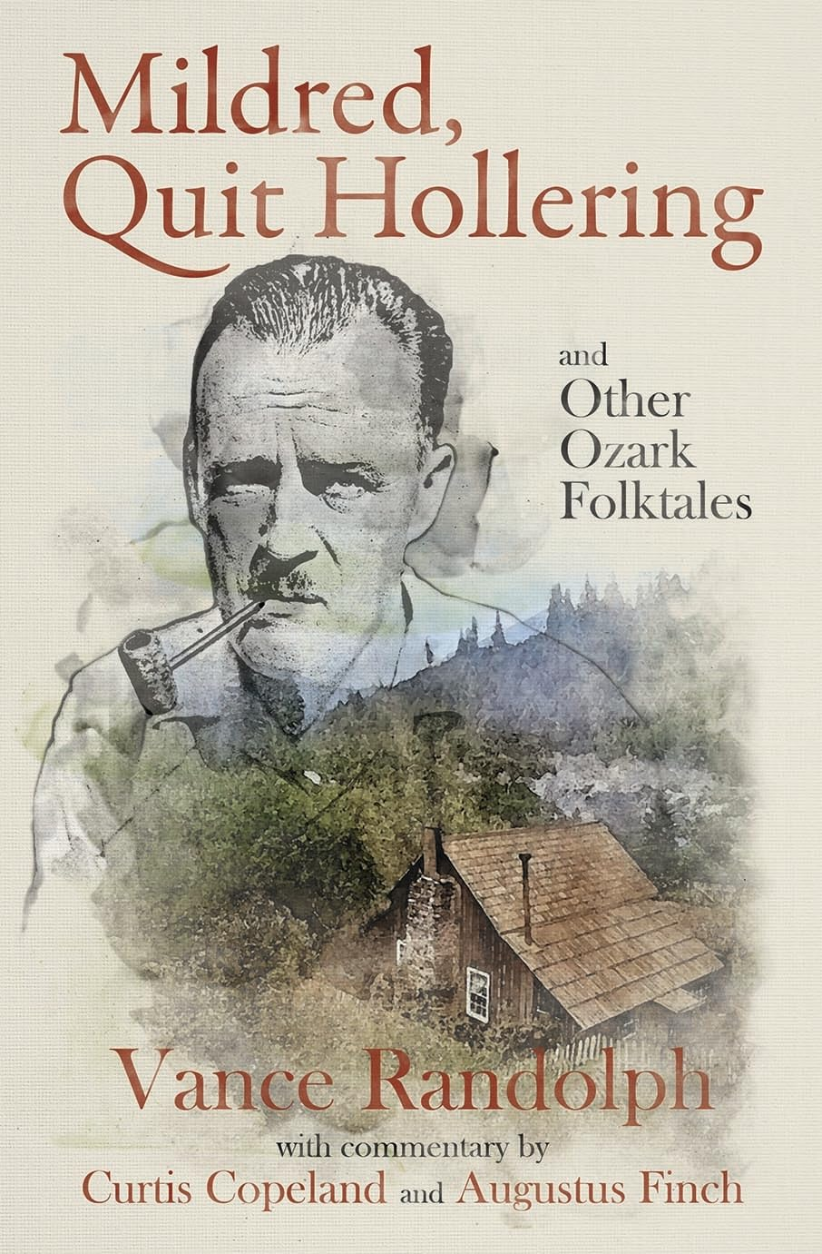

An in-depth look at Randolph and a biographical introduction to several of Randolph's informants whose stories are included in *Mildred, Quit Hollering --* how the book came about and how it is structured. Copies will be available.

Adam Davis, Truman State University

Variants,old and new, of Aarne-Thompson Taletype 237, The Animal that Talked Too Much"

Jourdan Louranse Lourdes Devereaux, Founder, NorthAmericanFrench.com

Noun-Syntagm Alternation in Missouri French Folklore



This study explores how emphatic elements which can start or end sentences, called syntagms, are positioned within Missouri French, drawn from a corpus of oral folktales. These syntagms, used for emphasis (e.g., "He speaks too much, him" versus "Him, he speaks too much"), are central to the analysis. A custom-built tool using machine learning was created to help identify these emphatic structures within the corpus. The study examines three key patterns: SUBJ pron V (subject-pronoun-verb), pron V SUBJ (pronoun-verb-subject), and pron V OBJ (pronoun-verb-object). Using a combination of traditional close reading and statistical analysis, the research highlights two constructions: SUBJ pron dzire, typically used in reported speech, and poss NOM c’est N, used when naming or introducing someone or something. A statistical model reveals that these emphatic syntagms are more likely to appear at the beginning of a sentence, except when they are pronouns. Other variables, such as plurality or tense, did not significantly influence syntagm positioning.

j.devereaux.24@abdn.ac.uk

Dr.  Sandra Enriquez, Historian, UMKC: "Latinx presence and influence in Kansas City"

Dr. Sandra Enríquez is a social historian of modern United States history with particular research and teaching interests in Chicanx and Latinx history, urban history, borderlands, social movements and public history. She is currently working on a manuscript project tentatively titled ¡El Barrio No Se Vende!: Urban Redevelopment and Community-Controlled Preservation in El Paso, Texas, which examines grassroots preservation efforts to keep Mexican American neighborhoods from the bulldozer.

[enriquezs@umkc.edu](mailto:enriquezs@umkc.edu)

Carol Fisher, Kennett, MO

"Let's Time Travel Back to 1887: Housekeeping and Dinner Giving in Kansas City, Missouri"

Most charity cookbooks focus primarily on the kitchen, on recipes/cooking tips, and less information regarding housekeeping duties. A group of Presbyterian women in Kansas City worked on this project, with the profits of the book "devoted to the advancement of Presbyterianism, and benevolent institutions in this city." Charity cookbooks also record history through ads of businesses locatted in their town or city. Now it's time to step out of the smart kitchens and smart homes and time travel back to Kansas City homes 137 years back, and check out some food and housekeeping lore.

John Fisher, Kennett, MO

Railroad Building and Town Names in the Southeast Missouri Lowlands in the Late Nineteenth and Early Twentieth Centuries

The Southeast Missouri lowlands underwent dramatic changes in the late 19th and early 20th centuries after railroad building opened up a means of transporting lumber from the huge tim ber resources in the region. New towns sprang up along these routes. The names were derived in several different ways. This paper examines how some of these names originated and discusses their significance.

Dr. Rachel Gholson, Missouri State University

"The Filipina Phoenix: An Ozarks Story" -- part II

Excerpts of an oral history present the story of an eldest child’s journey from the Philippines to the Ozarks. (The Phoenix herself plans to attend!) Josie’s life story is one of repeated rebirths followed by travel. She began her journey as a babe in a Japanese internment camp during WWII; at age 14 she moved to a large city to attend school. After passing her exams, she applied to work in the US and arrived in Chicago. Marriage took her to Illinois, Virginia, California and then to the Missouri Ozarks following the turn of the 21st century. Discussion of Filipino foodways -- there will be *food* to sample!

Hayden Head, PhD, Professor Emeritus of English, College of the Ozarks, Co-host, Ozarkian Folk Chronicles podcast

In February of 2024, Curtis Copeland and I launched a podcast, the Ozarkian Folk Chronicles, that focuses on the folk culture of the Ozarks. In addition to the interviews we have conducted, we have also presented episodes drawn from Randolph’s volumes of folk stories and superstitions: the belled buzzard, the granny woman, and planting and gardening superstitions, among many others.

The episode on planting superstitions particularly caught my attention. One of Randolph’s folktales describes the fertility “rite” of a backwoods couple who have intercourse in a plowed field to ensure the fertility of the crop. Homer refers to a similar rite in Book V of *The Odyssey*: A goddess, Demeter, has intercourse with a mortal, Iasion, in a “thrice-plowed field”; Zeus promptly kills the man with repeated thunderbolts. Clearly, Homer is teaching a lesson: Mortals better not have sex with immortals.

The questions I would like to explore are, do Randolph’s folktales taken as a whole also contain some implicit “lesson”? Does the very designation, “folk tale,” imply a value judgment? Finally, does the act of writing or recording introduce a value that may or may not have existed in oral storytelling?

Mark Livengood, Story Center Director

**The Story Center and Cultural Conservation**

Libraries have traditionally helped people connect with the published expressions of others, but the Story Center at Mid-Continent Public Library originated in 2013 when a different question was asked:  What if the Library also helped people to identify, develop, and share their own stories?  This question turned the focus away from consumption toward creation, evolving into the mission of the Story Center to help people create, share, and connect with stories.  While fulfilling this mission by providing learning opportunities and resources, the Story Center also encourages and perpetuates traditional tangible and intangible cultural heritage, including oral storytelling and the stewardship of a historic property listed on the National Register of Historic Places.  This presentation, which concludes with a tour of the historic Woodneath home, describes the role of the Story Center as an agent of cultural conservation.

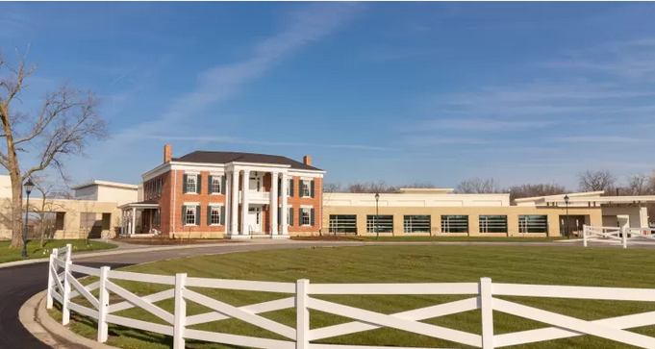

Dave Para, Albuquerque NM

"The Ballad of Seth Davey," AKA "Whiskey on a Sunday" and "Come Day Go Day" was written by English folksinger Glyn Hughes in the 1950s. It describes a streetsinger in Liverpool in the early 20th century who entertained children by singing minstrel songs and dancing home-made dolls on a plank. The song is well-known among Irish singers, some of whom have changed place-names to ones found in Dublin. Davey was a real person, although his background is something of a discussion. Dave will sing and discuss the song by Hughes as well as the minstrel song most associated with Davey.

Chris Otto, Jefferson College

The Cherokee Princess Myth and the Trail of Tears State Park in Missouri

This presentation will examine the legend of Princess Otahki, “Cherokee royalty” buried at the Trail of Tears State Park near Cape Girardeau Missouri. The fictional character “Princess Otahki” became embedded in the culture and even served as the mascot for women’s athletic teams at Southeast Missouri State University. During the session, we will examine the real story of Nancy Bushyhead Walker Hildebrand and the proliferation of the Cherokee Princess myth. Finally, the talk will conclude with a discussion of why so many Non-Native people claim Cherokee ancestry – a phenomenon known as Cherokee Syndrome.

Michael Pritchett, UMKC

"50 Years After: Myth, Lore and Legend of Manson, the SLA and Patty Hearst"

Based on research for a novel about Patricia Hearst and Charles Manson (*Tania the Revolutionary*), the paper delves deep into the facts and fiction surrounding the events of five years (1969 to 1974) including the rise of the Manson Family cult, the Tate/LaBianca murders, the political actions of the Symbionese Liberation Army and the kidnapping, capture and trial of heiress Patty Hearst, events that the writer Joan Didion blamed for the death of the social reforms of the 1960s.

Jana Russon

The fine art photographer and writer will display and discuss an item of family- and folkore, the childhood chair that belonged to her great-great grandmother.

Jill Silva, "A History of KC BBQ"

Jill Silva is an award-winning food journalist, restaurant critic and editor. She was the food editor for The Kansas City Star newspaper for more than two decades. In 2004, she received a James Beard Award, considered an industry Oscar, among numerous other prestigious recognitions. She has been a certified Kansas City Barbeque Society judge and written extensively on barbecue. She is working on a documentary about the history of Kansas City barbecue with Pilsen Co-op. She curated the invitation of barbecue restaurants invited to serve at the 2024 U.S. Conference of Mayors. She was a judge for the NFL Draft barbecue experience.

Rich White and Alice Nathan: "Rich Tales and White Lies" ...Stories -- some personal, some outrageous! This team has a long association with the Story Center and River and Prairie Storyweavers, a local group of very active storytellers.