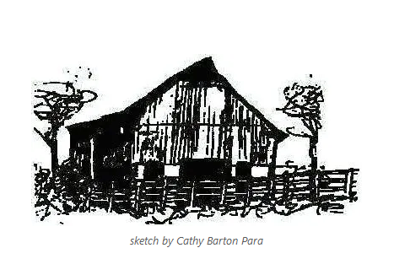

**Annual Meeting, The Missouri Folklore Society**

November 2-4, 2023

Nelson Memorial United Methodist Church

407 E Spring Street,

Boonville, MO

**Thursday November 2**

5 pm:

room 1: Board of Directors meeting

Dinner on your own

7 pm - 10 pm

room 1: jam & singalong -- bring instruments, bring voices!

**Friday, November 3**

8 am-9 am

room 1: open

room 2: open

9 am- 10 am

room 1:

**Rachel Gholson (Missouri State University): "The Filipina Phoenix: An Ozarks Story"**

*Excerpts of an oral history present the story of an eldest child’s journey from the Philippines to the Ozarks. Josie’s life story is one of repeated rebirths followed by travel. She began her journey as a babe in a Japanese internment camp during WWII; at age 14 she moved to a large city to attend school. After passing her exams, she applied to work in the US and arrived in Chicago. Marriage took her to California and then to the Missouri Ozarks following the turn of the 21st century.*

room 2:

**Vicki Hobbs: The Disappearance of Black Landowners in Boone County’s Cedar Township**

*Just downriver from Boonville, between the Missouri and Perche Creek floodplains, lies Boone*

*County’s Missouri Township. This was the destination of many early settlers who, along with their enslaved, headed west from Virginia, Kentucky, and Tennessee in search of good land and a prosperous future. While those goals were met by the area’s prominent families, the fate of their enslaved servants was far less secure. With emancipation came Black land ownership and the rise of several rural Black communities in and around Missouri and Cedar Townships, but the disappearance in the early 1900s of the area’s Black landowners remains a largely unexplored subject. This paper and PowerPoint presentation will delve into the possible reasons and engage participants in a discussion of several case histories.*

**Ginger Hendrickson, Emeritus Faculty, Missouri State University**

*"Growing Up in Harry Truman's Independence: A Remembrance"*

*Bess and Harry Truman influenced multiple generations of residents after his years in the White House--most for the positive, but for some difficult.*

10 am -11 am

room 1:

**Dave Para: The Oral Transmission of the Fiddle Tune “Squirrel Heads and Gravy:” An Example of Fake-Lore**

*I continue to believe that I could have been the second person to have heard this tune composed and played by Chris Germain in the late 1970s, but it was years before I heard it again played by folks who had no idea of its origin. It was Chris’ plan to pass this tune off as traditional, and it seems to have worked well.*

**Susan Bryson & Lyn Wolz: Fish Tales, Bumper Crop, Killer Rabbits: a look at humorous postcards**

room 2:

**John Fisher: The Civil War in the Missouri Bootheel: The Legend of Billie Dement**

*Life in the Missouri Bootheel, like most of Missouri, was difficult during the Civil War. The region suffered significantly from the actions of guerrilla groups representing both the North and the South. More than having strong national or ideological loyalties, many groups simply used the war as an excuse for malicious behavior. Such gangs were sometimes referred to as "bushwhackers," taking food, clothing and other supplies from businesses and individuals and leaving destruction behind. In November 1863 a teenage boy named Billie Dement was found hanged along a road near present-day Campbell. Several versions of the story of his death were told and woven into the folklore of Dunklin County. This paper examines who he might have been and the reasons for his hanging. A granite marker was erected in 1941 to mark the site.*

12 noon

room 1: lunch

1 pm - 2 pm

room 1:

**Lucy McCormick (Truman State University): Cultural Catholicism in St. Louis and the Function of Non-traditional Traditions**

**Gracie Doolin (Truman State University): Librarians and Language: Finding the Folkgroup**

room 2:

**Judy Domeny: Life On The Goat Farm**

*Longtime MFS member, Judy Domeny Bowen, raises Boer goats. Find out what a Boer goat is and listen as she shares  her writings detailing her life on a rocky Ozarks farm.*

2 pm - 3 pm

room 1:

**Brett Rogers: Abt in Boonville: the Buildings of Our Lives**

*A study of local work by prominent architect Ludwig Abt.*

**Bola Ojo & Mark Morgan (University of Missouri School of Natural Resources): Yoruba Animal Folklore**

*Yoruba is a West African ethnic group who mainly inhabit portions of Nigeria, Benin, & Togo. Some of their beliefs and perceptions about animals have been passed down from one generation to the next through storytelling and eyewitness accounts. This folklore describes the relationship between humans and animals, in addition to taboos associated with these interactions. According to legend, animals are spiritual beings that occupy a special place in human existence, hence Yoruba people attach much importance to them. For example, animals can communicate certain events to humans before they occur. Such omens are why some Yoruba traditions are deeply rooted in animal folklore.*

room 2:

**Meredith Ludwig: Lives We Weave -- A Cultural Celebration**

*Selected Video Shorts from Ottawa County, Oklahoma*

3 pm - 4 pm

room 1:

**Wayne Lammers: The McMahon Fort: a Lost Fort of the Lamine**

*An account of the attack and total destruction by Indians on the 1814 Lamine settlement, Fort McMahan. Boonville’s historian Bob Dyer contacted me in his search for Fort McMahan about 30 years ago. He had located on a map where he thought the fort was located. In 2018 & 2019, we explored the site with metal detectors.*

**Michael Dickey: Owls in American Indian Lore**

*This overview will examine how owls figured in the beliefs and lore of several different American Indian nations.  Some  saw them as harbingers of evil, others as messengers of the Creator.  Emphasis will be on the lore of the Osage nation, once the predominant tribe of Missouri.*

room 2:

**Carol Fisher: Let’s Write Some Family Folklore: A Buffet of Family Stories**

*Writing up family folklore is a great way to record and preserve family history. It can also be a fun and enjoyable experience. Fisher has written her family folklore individually and also has successfully encouraged “family group writing” activities for many years. She will share examples of her family’s folklore in the first half of the session. In the second half, she will help attendees try some of her family folklore writing techniques. YOU DO NOT HAVE TO BE A PROFESSIONAL WRITER TO START THIS JOURNEY!! It’s all about sharing the stories that count. Come join the fun!*

4 pm -5 pm

room 1:

**John C. Fisher: The 1939 Southeast Missouri Sharecropper Demonstration**

*The drainage and clearing of the lowlands in the Missouri Bootheel during the first two decades of the twentieth century opened thousands of acres of new land for agriculture. Simultaneous with this, the boll weevil had devastated cotton production in the traditional cotton growing regions of the South. The boll weevil had not made an impact in the Bootheel and upper delta yet thousands of sharecroppers migrated into the region looking for farms where they could continuing sharecropping cotton. Plummeting prices in the 1930s reduced cotton profitability making the life of the sharecropper even more difficult.*

*Unintended consequences of government programs left many sharecroppers without housing. Their plight led to the formation of the Southern Tenant Farmers Union in Tyronza, Arkansas and eventually to a roadside demonstration in 1939 along highways 60 and 61 in Scott, New Madrid, Pemiscot, and Mississippi counties that drew national attention to the sharecropper system.*

room 2:

**Margot McMillen: Ghosts on Reddit: Storytelling in a New Medium**

5 pm - 6 pm

room 1:

**John Shewmaker:** *The customs of school teaching as folklore in practice, specifically PerCents Correct as a universal but miserable excuse for a metric.*

The presentation covers a means for academic measurement that does not involve percents correct. If time permits, I will offer an exercise in Precision Teaching methodology.  The use of the Standard Celeration Chart will be covered. Audience participation encouraged. Everyone is expert in school teaching, either as purveyor or customer!

room 2:

**Rachel Gholson: workshop on foraging and making cordage**

*In 2021 I was encouraged to look into food foraging on Instagram by a past folklore student who introduced me to Alexis Nicole (@blackforager) during magnolia blooming season. This led to a summer in 2023 of learning foraging for clothes dyeing and cordage making. Based on these 3 experiences, I propose that becoming a topical or dedicated Instagram follower is so closely akin to an informal apprenticeship in folklore that the process should be studied under the nomenclature, self-directed apprenticeship.*

6:00 pm: room 1: dinner followed by keynote address:

***Greg Olson: 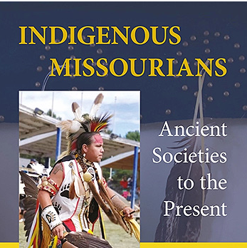Points, Pots, Pipes, and Powwows***

*History books tend to include Missouri’s Indigenous population only during periods when they were a threat to the state’s white settlement. These histories overlook the fact that Native people have lived here for at least twelve thousand years and continue to call Missouri home today.*

*Historian Greg Olson will talk about the centuries of Indigenous presence in the state. He will discuss the inventiveness and adaptability that have enabled Missouria’s Indigenous population to change and evolve in the face of the extreme challenges they encountered. Olson will show how this resilience, allowed Indigenous people and their traditions to survive in Missouri in the twenty-first century.*

**Friday evening after dinner -- jam and auction with Judy Domeny!**

**Saturday, November 4**

room 1: open

room 2: open

9 am - 10 am

room 1:

**Chris Otto (Jefferson College): The Potawatomi Trail of Death**

*While the most infamous instance of Indian removal involved the Cherokee Nation and is often referred to as the "Trail of Tears," similar removals were happening throughout the United States, including in Missouri. These removals resulted in significant hardships and suffering for Indigenous communities as they were forcibly uprooted from their homes and ancestral lands. The Potawatomi Trail of Death recognizes the forced removal of the Potawatomi Indians from north central Indiana to eastern Kansas in the fall of 1838. The trail begins at the statue of Chief Menominee south of Plymouth, Indiana, extends east to west on Old Highway 24 running through Palmyra, Paris, Moberly, Huntsville, Keytesville, Brunswick, Carrollton, Richmond, Lexington, Independence, and Grand View, MO and ends at the St. Philippine Duchesne Memorial Park south of Osawatomie, Kansas. This presentation will examine the Potawatomi Trail of Death and Missouri history.*

room 2:*open*

10 am-11 am

room 1:

**Evelyn Rogers, host: Fraud, Tragedy, & War: Three Missouri Novelists Turn Historical Events into Compelling Stories**

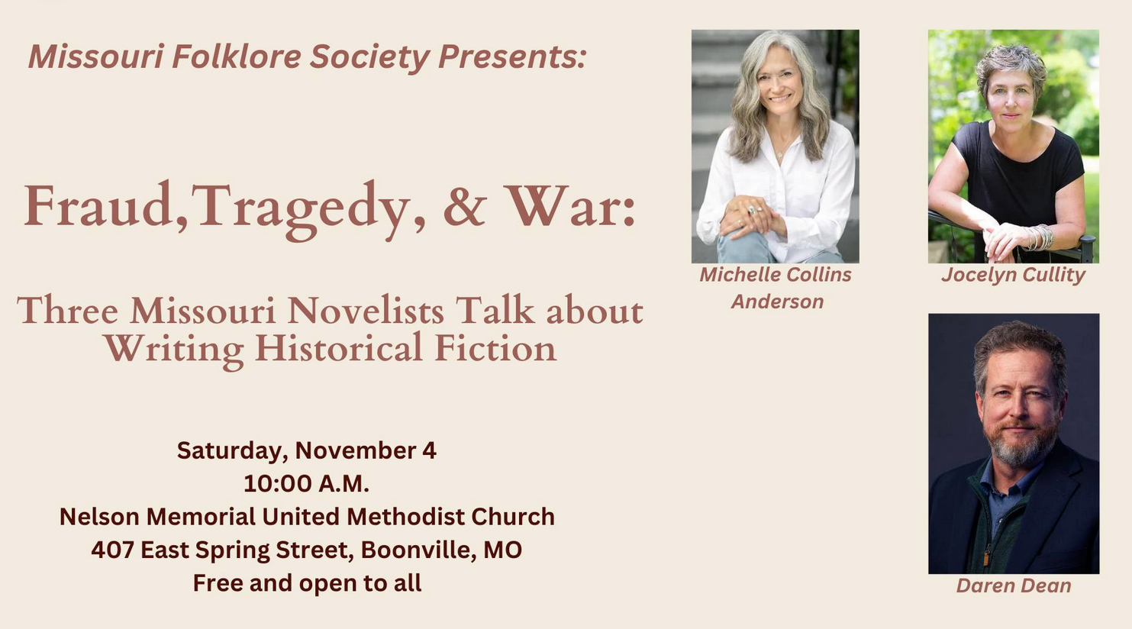

11 am:

room 1: **general membership meeting** and adjournment until next year at the Story Center (Mid Continent Public Library, Kansas City)

*version 3.0*